Critically Reflecting on Multi‑ and Interdisciplinary Working in Implementing the Humber Health Partnership Digital Strategy
I confirm this essay is my own original work and does not include text created by a generative artificial intelligence tool

  - Shaun Burgess (2516958) Date: 22/04/2026

Contents
Introduction 1
Stakeholder Analysis within a Complex Organisational Context 1
Structuring Stakeholder Engagement for Complex Change 3
Communication, Elicitation and Clarification in Practice 4
Reflecting on Consensus, Challenge and Groupthink 5
Evaluation 5
Reference 6

Introduction
In this reflective essay, I critically consider the methods of multi- and interdisciplinary working required to successfully implement the Humber Health Partnership (HHP) Digital strategy 2025 - 2028. In Coursework one (CW1), I argued that the strategy had several strengths, particularly its clear focus on digital foundation, interoperability, data use and digital inclusion, but I also identified weaknesses around governance clarity, workforce capability, and implementation readiness.
I consider this important because digital transformation in healthcare is never solely a technical exercise. The HHP strategy itself recognises that digital is delivered across multiple teams and services, and without concerted effort across the entire group, the organisation is unlikely to deliver the scale of change required (Humber Health Partnership, 2025a). This is consistent with social-technical thinking, which argues that digital transformation succeeds when technical, social, organisational and cultural factors are considered together rather than in isolation (Greenhalgh et al., 2017). On reflection, I have come to the view that stakeholder involvement is an ongoing process rather than a series of separate activities. The way stakeholders are identified influences how they are engaged, how communication occurs, and whose views are heard during delivery.
To further structure this reflection, I explicitly draw on the Non-adoption, Abandonment, Scale-up, Spread and Sustainability (NASSS) framework (Greenhalgh et al., 2017).

Stakeholder Analysis within a Complex Organisational Context
The strategy recognises a wide range of stakeholders, but it does not always explain clearly who matters most and why. It identifies staff, patients, partners, care groups, services, digital teams and the wider integrated care system as part of the change (Humber Health Partnership, 2025a). However, the scale and complexity of this environment are not fully explored.
As noted in CW1, the partnership covers two trusts, five main hospital sites, over 200 applications and several digital delivery routes, with expenditure both inside and outside the digital directorate (Humber Health Partnership, 2025b, 2025a). This contributes to a highly complex stakeholder environment, with different priorities, organisational culture and levels of influence. Viewed through the NASSS framework, this complexity sits primarily within the organisations and adopter system domains.
On reflection, I agree that internal stakeholders, such as the executive team, digital teams, clinicians, operational managers, and frontline staff, are central to success. However, the strategy does not clearly differentiate among strategic sponsors of digital change, operational drivers, and those who must live with its consequences daily. Senior leaders may focus on strategic goals, resilience and productivity. Clinical staff are more likely to be concerned with safety, usability and disruption to their workflows. Technical teams often prioritise system architecture, cyber security and long-term support.
I also believe some stakeholder groups deserve more attention than the strategy gives them. One example is organisational development and workforce education. While the strategy mentions digital skills and training, the impact of low confidence and limited digital maturity is significant. If staff struggle to use existing systems, educators, trainers, and business change facilitators are not optional extras; they are critical to successful delivery.
Another group that needs stronger emphasis is patients and citizens, particularly in the context of digital inclusion. The strategy states that inclusion is important, but this cannot be achieved through principles alone. It requires direct and ongoing engagement with people most at risk of exclusion, such as those with low digital confidence, accessibility needs, or limited access to devices or connectivity (Xue et al., 2026). From a NASSS point of view, digital inclusion is not just about the condition or people using the technology. It involves the wider system, including socio-economic factors and expectations placed on patients as digital users. Failure to adequately engage these groups risks non‑adoption and downstream abandonment, even when technologies are technically sound.
My professional experience has also reinforced my understanding of the risks of treating stakeholders as a single group. Technical sign-off does not always mean services are ready, and operational readiness does not automatically mean users feel confident. In multi-site digital and infrastructure changes, I have observed technically sound solutions struggle when service managers, users, or support teams do not fully understand the impact and support arrangements. During a SafeQ printer upgrade project I led across multiple hospital sites, although the technical implementation was approved, some clinical areas were unclear about the impact of short device outages and how printing continuity would be managed, leading to increased concern during the early stages of the change window. Based on my experience, this reflects the readiness and governance risks identified in CW1, which emerge most clearly during delivery rather than strategy development.
If I were strengthening the stakeholder analysis and the HHP strategy, I would group stakeholders more clearly based on their levels of influence, interest, dependency, and lived experience of change. This would help identify who needs to be closely involved in decisions, who is essential for adoption, and whose experience should be used to test assumptions. Figure 1 illustrates this relationship.

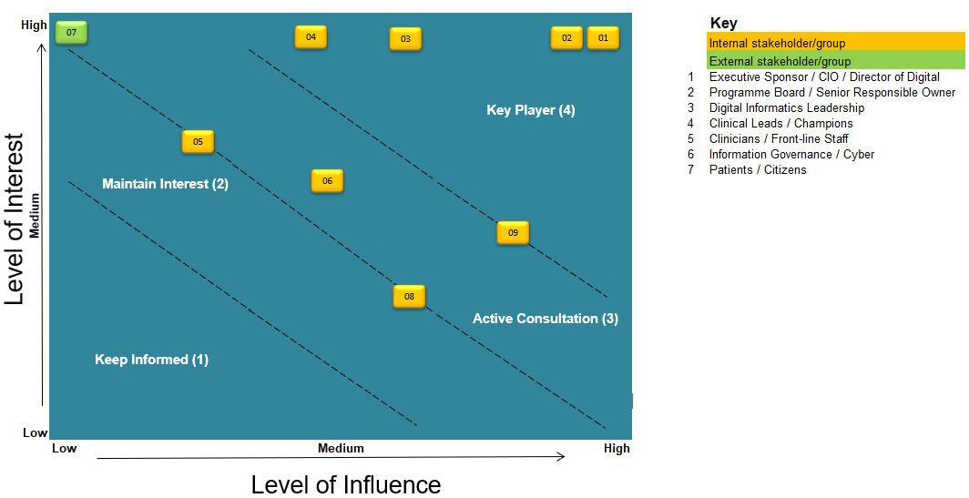
Figure 1. Maps key stakeholders according to their relative levels of influence and interest within the HHP digital strategy. Adapted from (ABUHB, 2025).

Structuring Stakeholder Engagement for Complex Change
Once stakeholders are identified, the next issue is how to engage them. I believe effective engagement should be staged. Some engagement is more effective within professional or service groups, where individuals feel more comfortable raising concerns. At other points, shared discussions are necessary because digital change depends on coordination across teams and organisations.
The HHP strategy reflects this by emphasising clinical and operational leadership (Humber Health Partnership, 2025a). I strongly agree with this, as in healthcare, change must be delivered with services rather than imposed upon them. However, engagement only works when the approach fits the purpose.
For example, early discussions about clinical workflows are often more effective in small, focused speciality groups. Decisions about investment priorities or governance changes are better handled in mixed forums where trade-offs can be explored. Within my role, I have seen the value of this staged approach. Smaller discussions with service leads are more effective at identifying risks, testing assumptions, and revealing issues that might not emerge in larger meetings. During a pre-change discussion with service leads ahead of a planned infrastructure change, concerns were raised about access to clinical systems and local workflows that had not been recognised during initial planning. These risks were addressed and mitigated before being taken to the wider governance forum. Governance forums are then better suited for confirming decisions and ensuring accountability. When this order is reversed, less visible risks are easily overlooked.
The literature supports the need for purposeful engagement in large digital programmes (Cresswell, Bates and Sheikh, 2013; Greenhalgh et al., 2017). However, this often assumes organisations have the capacity to sustain engagement, which may not reflect the operational pressures within HHP.
Building on this reflection, a tiered engagement and governance model could be proposed for HHP. At its foundation would be service‑level forums focused on lived experience and workflow, feeding into cross‑organisational design groups that balance clinical, operational and technical perspectives. Strategic governance forums would then focus on prioritisation and risk rather than detailed design. This approach would formalise how different voices influence decisions at different stages, reducing reliance on informal power.
I also believe engagement must continue throughout delivery. The strategy refers to engagement with more than 600 staff and patient representatives (Humber Health Partnership, 2025a). However, a one-off consultation is not the same as sustained involvement. Successful implementation would require repeated engagement through discovery, design, readiness, go-live and benefits review.

Communication, Elicitation and Clarification in Practice
In digital change, communication is often treated as a one-off activity rather than an ongoing part of delivery. Messages can be accurate, yet ineffective if they are late, too technical, or too generic. In my experience, communication works best when it is layered. Operational teams need clear and practical information. During a multi-site infrastructure change, I used a combination of targeted emails to clinical leads and wider communications, such as intranet updates and on-screen ticker tape notifications, to ensure staff were aware of the change. A formal service impact briefing was also disseminated to all services via the Chief Operating Officer, ensuring consistent messaging at the organisational level. This approach enabled operational teams to understand the practical impact on their services while ensuring broader user awareness across sites. Users mainly want to know what is changing, when it will happen, what the risks are, what they need to do, and how to get help if something goes wrong.
I have also learned that eliciting feedback and checking understanding are not the same thing. Questions need to be specific, such as how workflows might be affected, what happens out of hours, or what support is needed during transition. These questions help reveal the difference between surface agreement and real readiness. Reflecting on this, I believe the HHP strategy would benefit from a stronger focus on user-led design in practice, not just in principle. The strategy acknowledges that some systems are difficult to use because users were not involved early enough (Humber Health Partnership, 2025a).
However, a potential unintended consequence of increased engagement is engagement fatigue (Cresswell, Bates and Sheikh, 2013). In large organisations such as HHP, asking the same services repeatedly to contribute to multiple initiatives risks disengagement over time. I have also learned that engagement methods should reflect people’s confidence and seniority. Some people contribute easily in meetings, while others are more comfortable in smaller sessions or through written feedback. Silence should not be assumed to mean agreement, as it often reflects uncertainty or lack of confidence. This has made me more deliberate about following up on discussions and checking understanding after meetings.

Reflecting on Consensus, Challenge and Groupthink
A further issue is the balance between consensus and groupthink. Alignment is important for delivery, but consensus becomes risky when it discourages challenge, a pattern closely associated with groupthink (Janis, 1972). In my experience, this is most likely when timelines are compressed, decisions are driven by senior roles, and there is strong confidence in technical solutions. This was evident during a time-critical firewall infrastructure change I was involved in, where decisions were largely shaped by senior and technical stakeholders, and opportunities for broader challenge were limited. In these situations, people with practical insight may decide not to speak up.
For this reason, inclusion cannot be left to goodwill; it needs structure. This includes good chairing, clear agendas, early sharing of information, clear invitations to challenge, and different ways of giving feedback. Separating exploratory discussions from decision-making meetings can also help ensure quieter voices are heard. In practice, I used smaller, structured sessions with service leads before formal governance meetings to create space for individuals who may be less confident to contribute, particularly where more dominant professional voices are present. It is also useful to actively ask what might go wrong by considering who could be disadvantaged and what assumptions are being made about capability, workflows, or system integration.
A counter‑argument to this approach is that excessive challenge may slow decision‑making in already constrained operational environments. However, my experience suggests that early, structured challenge often prevents far greater delays later, particularly where rework or loss of clinical confidence occurs.
Above all, I believe that people should feel safe to challenge. When they trust that concerns will be taken seriously, engagement is more honest and useful. When decisions feel premeditated, participation becomes a box-ticking exercise. For a strategy of this scale, psychological safety is essential for effective delivery.

Evaluation
Drawing on the NASSS framework, Table 1 summarises how key domains of complexity appear within the HHP and the associated risks
Table 1. Application of the NASSS framework to the Humber Health Partnership. Adapted from (Greenhalgh et al., 2017).
NASSS Domain | HHP Context | Key Risk
Adopters | Variable digital confidence | Non-adoption
Organisation | Multi-site, fragmented governance | Delayed delivery
Wider Context | Digital exclusion | Inequitable outcomes

Reflecting on the HHP digital strategy has reinforced my view that successful digital transformation depends less on the ambition of the strategy and more on the quality of stakeholder working used to deliver it. The strategy identifies many real challenges, including fragmented systems, poor integration, low digital confidence and user frustration. Overall, this suggests that stakeholder analysis needs to go beyond lists. It should identify who carries delivery risk and who may be overlooked. Engagement should be planned and meaningful, communication should be clear and continuous, and elicitation should be structured to uncover real concerns rather than superficial agreement.
Application of the NASSS framework indicates that HHP’s digital ambitions sit within a highly complex organisational and adopter context. Without deliberate structures to support interdisciplinary working, the risks of non‑adoption, delayed scale‑up or partial abandonment remain significant. Most importantly, inclusive implementation requires deliberate effort. Consensus is valuable only when it allows challenge. By combining the strategic intent assessed in CW1 with structured, psychologically safe engagement during delivery, the HHP strategy is more likely to achieve outcomes that are usable, legitimate and sustainable in practice.

Reference
ABUHB (2025) “Stakeholder Matrix.” Available at: Internal organisational document, unpublished (Accessed: April 22, 2026).
Cresswell, K.M., Bates, D.W. and Sheikh, A. (2013) “Ten key considerations for the successful implementation and adoption of large-scale health information technology,” Journal of the American Medical Informatics Association, 20(e1), pp. e9–e13. Available at: https://doi.org/10.1136/amiajnl-2013-001684.
Greenhalgh, T., Wherton, J., Papoutsi, C., Lynch, J., Hughes, G., A’Court, C., Hinder, S., Fahy, N., Procter, R. and Shaw, S. (2017) “Beyond Adoption: A New Framework for Theorizing and Evaluating Nonadoption, Abandonment, and Challenges to the Scale-Up, Spread, and Sustainability of Health and Care Technologies,” Journal of Medical Internet Research, 19(11), p. e367. Available at: https://doi.org/10.2196/jmir.8775.
Humber Health Partnership (2025a) “Digital Strategy 2025-28.” Available at: https://www.nlg.nhs.uk/wp-content/uploads/2025/07/Digital-Stategy-2025-2028.pdf (Accessed: February 26, 2026).
Humber Health Partnership (2025b) “GROUP STRATEGY.” Available at: https://www.nlg.nhs.uk/wp-content/uploads/2025/07/Group-Strategy-2025-2028-1.pdf (Accessed: March 26, 2026).
Janis, I.L. (1972) “Groupthink (Irving Janis).” Available at: https://med.stanford.edu/content/dam/sm/pedsendo-1/documents/Groupthink_by_Iriving_L_Janis_Summary_pd.pdf (Accessed: April 20, 2026).
Xue, Z., Zhou, N., Wu, Y. and Qi, H. (2026) “Digital exclusion in healthcare services: a scoping review,” International Journal for Equity in Health, 25(1), p. 37. Available at: https://doi.org/10.1186/s12939-025-02755-1.

