Effective Team Working and Communication
Lecturer name: Akash Puranik
Student name: Nicusor Ionut Aliu
Student ID: 2131114
Module code: BMSW4002

Executive summary
In the case study, the team leader Tom and the rest of the team are seen to work ineffectively mostly due to the defective team formation strategy. Forming is the primary and most crucial stage of successful teamwork. Moreover, insufficient communication channels and interpersonal communicative skills have collectively resulted in conflicts among the members. The theories and models stated to act as the foundation of successful teamwork. Though team members and working environment can vary, the theories and models can become handy for leaders such as Tom to perceive his team members’ objectives, create a team accordingly, and delegate jobs more relevantly. This report includes relevant theories and models pertinent to the issues identified in the case study.

Table of contents

Executive summary 2
Table of content 3
1.0. Introduction 4
Overview of Team Working 4
2.0. Model of teamwork 6
3.0. Role for creating effective teams 8
4.0. Impact of effective teamwork on team success 10
5.0. Conclusion 11
6.0 Reference List 12

1.0. Introduction
The modern world is constantly changing into a more digitised, globalised, and dynamic business environment that calls for innovative ways of business setting. For this, organisations solely rely on their small or big teams. The need for effective team formation and team working is crucially increasing. The key purpose of team formation depends on the business and its environments, but the key purpose is to boost productivity, connecting more among the organisational structures and intriguing dynamic decision-making. In this report, the overview of team and teamwork has been discussed. The common characteristics and hassles in the way of creating an effective team have been portrayed. For showing the process of team development and team roles, Tuckman’s model and Belbin’s Team Role have been mentioned respectively. Finally, the advantages of effective team working and issues identified in the case study have been briefly explained.

Overview of Team Working
A team is defined as several people with relevant skills, dedicated towards common goals and purposes, and approaching the motto they hold committed to. Teamwork means stimulating several people towards a common goal along with balancing the strategies and emotions of the team members. Bringing out the best of the team members in the tracking down of that common goal is also a crucial factor of teamwork. Teamwork provides advantages by creating a common floor to acquire personal and organisation objectives.
The key characteristics of teamwork are:
- A clear and definite set of goals and directions (Knippenburg, and Schnippers, 2007)
- Adept leadership so that the goals, direction emphasis can be balanced inside and outside of the team
- Realistic and relevant tasks for working along with constant challenges for the development of individuals and the team.
- Suitable resources that assist in the smooth performing of tasks including materialistic, human, and financial resources altogether.
- Assisting healthy work environments, such as skilled management that ensures suitable strategy making and decision implementation.
To create and establish a team-centered work culture in any organisation, a leader has to make a constant effort to establish an understanding and transparent communication system that will motivate the team members on every level. By gaining knowledge and working hand in hand with team management factors, leaders can take apt initiatives while making the team forming strategy in the organisation. To make an effective team, the first and foremost factor needed is communication and transparency. Through this communication system, leaders can convey their organisational purpose and job description down in the hierarchy (Griffith and Dunham, 2015). This will also create awareness among the employees, making them more empowered and confident to practice their responsibility, along with initiatives to achieve organisational purpose. Again, establishing accountability and commitment, skillful delegation according to strength, avoiding micromanagement, being supportive towards the employees during the forming and norming periods, forming a practice of innovation and ideas, etc. are major factors contributing to effective teamwork (Gregory, 2013).

2.0. Model of teamwork
The situation as stated in the case shows crucial conflicts team relations are formed and modified along the way of cost-cutting strategies and emphasis on strengthening portfolios rather than achieving team objectives. Tuckman’s Model can be considered for the development of Tom’s team as the model explains every phase a team moves from commencement to the successful accomplishment (Wheelan, 2016).
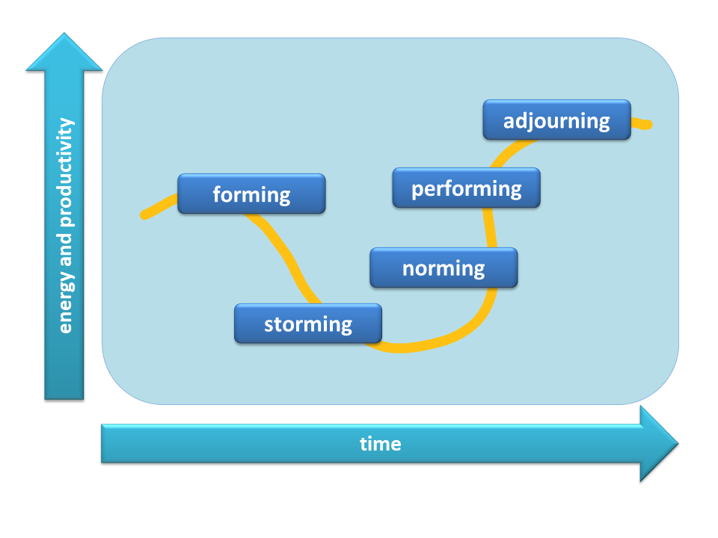
Figure: Tuckman’s Model
Source: (Molleman, 2005)
- During the team forming phase, members are more likely to look forward to the only leader for gathering information and guidance. Mr. Tom should clearly state the job description along with the benefits that come with accomplishing the job.
- In the Storming phase, members get more fixated on their progress as their tendency of surviving as the fittest. Dissemination of information should be assured by each member along with co-operation and mutual encouragement.
- Norming is the stage where previously gained experience and relationships make it easier to opt for taking new challenges and making new ideas into reality. If Mr. Tom can practice a style that calls for solutions from the members rather than only himself, both time and money will be saved.
- When a team has reached the performing stage, it is flying to its full potential. Healthy communication, conflicts, and facing challenges skillfully results in almost automated successes. However, a leader like Mr. Tom with other members should ensure the area of validation is firm for every individual effort.
- Adjourning is the final stage where already relationships have been formed in the team and now a loss of termination is felt. It is important for individual recognition, gratefulness, and mutual take-away from the team for future benefits (Molleman, 2005). Especially for an orgnaisation like Amazon where teams are constantly formed and reformed for international business, knowledge gained from teams is crucial for the members as well as the company itself.
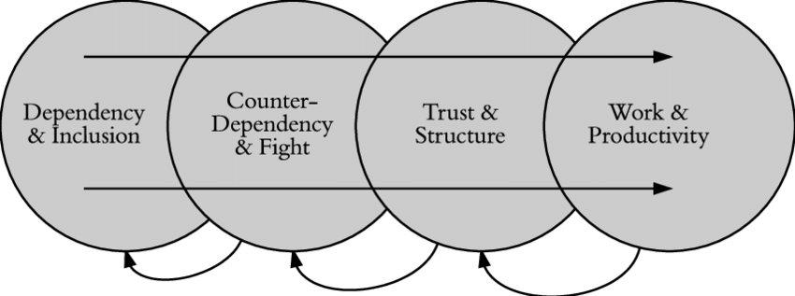
Figure:Wheelan’s model of Group Development
Source: (Wheelan, 2016)
There is another model known as Wheelan’s Model that explains the team relationships along the journey and changes in their behavior.
- The first stage of this model identifies a single member who develops the whole group. This member is treated as the leader and “pseudo-work” such as sharing relevant information is done within the group.
- Conflicts and disagreements are common in the second stage. The challenge is to work for common objectives along with healthy conflict resolution (Molleman, 2005).
- In the third stage, negotiations about team roles, strategy, and processes are developed. Hence, relationships are made strong.
- The crucial issues and challenges have been already solved in the fourth stage. Members can channel their maximum energy into achieving objectives.

3.0. Role for creating effective teams
Belbin identified three categories of team roles, each having three different roles relevant to the behavioral and communicative strength of members. The Belbin Team Roles needed to create an effective team are briefly discussed below:
- Shaper: The extroverted and dynamic person who directs others, enjoys taking risks, and can push others in challenging times. However, they might seem dominating and unknown to others’ feelings.
- Implementer: These people turn ideas into reality with their organizing and implementing skills. Their setbacks can be reluctance towards flexibility and changes.
- Completer-finisher: Minute details, perfectionism, and fast delivery are looked after by this category of people (Griffith and Dunham, 2015). They can have a hard time delegating jobs resulting in unnecessary stress.
- Coordinator: Traditionally known as the leader or chairperson, they are adept listeners, calm-minded, and guides. This can, however, end in manipulative nature.
- Team workers: These are the flexible, capable and diplomatic members who assist others in achieving the team objectives. Their common setbacks are indecision and lack of commitment.
- Resource Investigators: Information is a crucial factor for team success that is gathered this type of member (Wheelan, 2016). Their weakness is the tendency to lose interest fast and optimism.
- Plant: The creative personnel with continuous idea-generating ability are the plants. However, they can be impractical, lack communication ability, and can be loners at times.
- Monitor-Evaluator: Being the critical thinkers of every team, they are apt at weighing the pros and cons of every idea before turning it into reality. They are, however, not good as innovators and motivators (Knippenburg, and Schnippers, 2007).
- Specialist: These members have the professional skills needed to implement a project. But, their contribution can be somehow limited as they focus on their expertise field only.
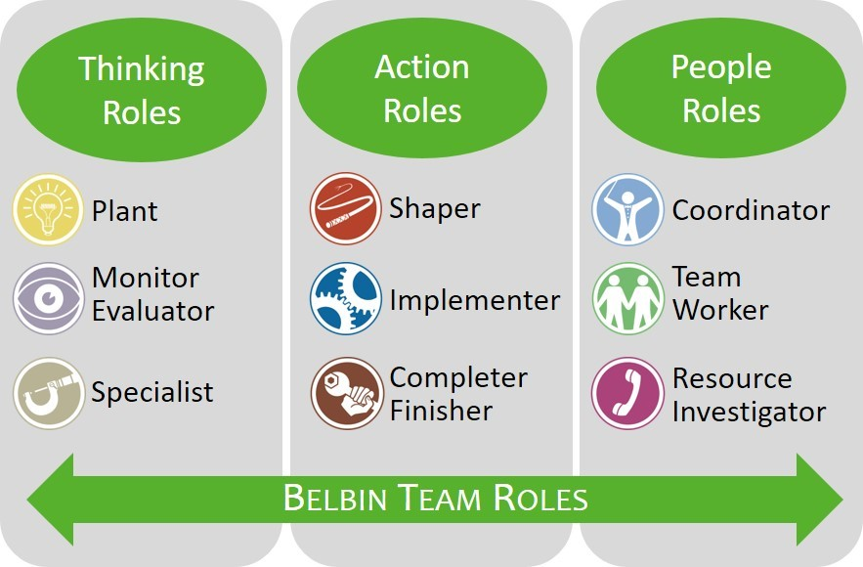
Figure: Belbin Team Roles
Source: (Gregory, 2013)
Knowing Belbin Team Roles while selecting and forming a team can be useful as it will bring more synchronization within the team, having skills needed from every area. The leader cannot do everything at a time, which calls for the importance of variety among the group members. However, the behaviors and efforts of members change with time, and relationships and formation will not fully help in achieving team goals.

4.0. Impact of effective teamwork on team success
Effective teamwork gives a boost to motivation and employee confidence. This happens only in a team where team members tend to accept their fallibility and carry on. Verbal and body language along with choosing the right words make other members confident to express their opinions at crucial times (Pentland, 2008). This is a factor to build a team safely in the long run.
Working towards a common purpose or objective comes with having a crystal clear concept of the priorities of each and every member (Gregory, 2013). When the collective purpose is done right, all the team members can do their job in sync, resulting in a successful teamwork. Teamwork also emboldens taking productive risks within the group. A simple belief held by team members is important for risk-taking, and without risk, success is uncertain (Wheelan, 2016).
Teamwork also expedites innovation and creativity. Also, as seen in the Belbin Team roles, not all members play the role of innovation. A healthy balance between innovation, idea generation, weighing the feasibility of each idea, making strategies, and implementation is needed to establish a set of defined purposes. This can be only done when the leader can set and communicate his priorities and perceive the reflexes of his members.
The scenario portrayed in the case refers to the initial problems during the team formation. According to Tuckman’s model states that during forming stage, members act as if they carry the baggage of past team experience. They will also carry the present experience gained from the team (Griffith and Dunham, 2015). As Tom’s approach to his team members was not aptly conveyed during the forming period, the members have carried this along the way, affecting the whole teamwork. This has also led to the unaccepting tendency of the members about their differences and continuous disagreement.
A suitable channel of communication is crucially important not only for the job description but also for interpersonal communication among the members (Benoliel and Schechter, 2018). Tom had not explained clearly about the team roles, job description, and the collective team purpose. It is also important here to look at the individual purpose and the benefit gained from working on this team. It is the responsibility of the team leader to communicate the costs and benefits of each of the roles played by the members (Pentland, 2008). Rather, commitment issues might arise. Team members such as Mihaela and Spencer are unknown of the credits and advantages they would get from their job. As a result, they are not being fully committed to the teamwork, affecting the collective team outcome.

5.0. Conclusion
Ensuring team psychological safety is an important factor for a successful teamwork output. It creates long-term influence by connecting psychological safety with collective performance. Hackman (2002) suggested in the early 21st century that in future, business organisations in the future would depend more and more on teamwork for expanding business globally. It is also seen that organisations that can utilise teamwork in the right direction are more expert at developing business strategies and desired results. Because of the increase of globalization and digitization, organisations have to focus on innovative ways for acquiring and maintaining trading success. Fast changing and dynamic work environment call for rethinking the team forming, developing, and retaining strategies.

6.0 Reference List
Benoliel, P. and Schechter, C., 2018. Teamwork doubting and doubting teamwork. Improving Schools, 21(3), pp.225-239.
Gregory, H., 2013. Teamwork. North Mankato, Minn.: Capstone Press.
Griffith, B., and Dunham, E., (2015), Working in Teams: moving from high potential to high performance Los Angeles: SAGE Publicación.
Ingvaldsen, J., Holtskog, H. and Ringen, G., 2013. Unlocking work standards through systematic work observation: implications for team supervision. Team Performance Management: An International Journal, 19(5/6), pp.279-291.
Hackman, J, R. (2002). Leading Teams. Setting the stage for Great Performances. Boston. Harvard Business School Press.
Molleman, E., 2005. The multilevel nature of team‐based work research. Team Performance Management: An International Journal, 11(3/4), pp.113-124.
Pentland, A., (2008), Honest Signals, Cambridge, MA, MIT Press.
Van Knippenburg, D. and Schnippers, M.C. (2007) Work group diversity. Annual Review of Psychology
Wheelan, S.A., (2016), Creating Effective Teams, 5th edn, London: SAGE.

