Name: | Mike Wakelyn
Student ID: | 1707800
Module Name: | Application Development (ACCA5012)
Tutor Name: | Dr Kemi Ademoye

Assignment: Application Development Concepts, Responsive Web Design and Web Application Development

Submitted on: 08/12/2019

Abstract
This report details the design and development of a responsive web site that follows the below criteria:
- Includes a form of JavaScript interactivity
- Consumes a JavaScript based web application programming interface (API)
- Developed with a mobile first, responsive strategy
Accompanying the report is a list of ten recent (2019) web development trends. Also included is a detailed discussion and evaluation of one of these trends, Progressive Web Applications (PWA).
This is followed by a requirements analysis that takes in to account the above criteria, a design and implementation section, an evaluation and a conclusion. Screenshots of the completed website, test cases, code validation and contrast testing results are also included.

For more information on the author, please visit the below LinkedIn profile:
www.linkedin.com/in/mikedwakelyn
Table of Contents
Assignment: Application Development Concepts, Responsive Web Design and Web Application Development 1
Abstract 2
Table of Abbreviations 4
1. Introduction 5
2. Web Application Development Concepts 5
2.1. Progressive Web Apps – Deeper Analysis 6
2.1.1. Progressive Web Apps - Advantages and Disadvantages 6
2.1.2. Progressive Web Apps - Conclusion 7
3. Requirements 8
3.1. Limitations 9
4. Design and Implementation 9
4.1. Core Design Features 9
4.2. CSS Classes 10
4.2.1. Bootstrap CSS Classes 10
4.2.2. Custom CSS Classes 10
4.2.3. Other CSS Classes 11
4.3. Media Queries 11
4.4. JavaScript Functionality 12
4.1.1. Map.js 12
4.1.2. Contact.js 12
4.5. Website Screenshots 13
5. Evaluation 16
5.1. Test Case – Contact Form 16
5.2. Test Case - API 16
5.3. Accessibility Checker 17
5.4. CSS Validation 17
5.5. Future Recommendations 17
5.5.1. Google Maps API 17
5.5.2. Content position and resizing 18
6. Conclusion 18
7. References 18
8. Appendices 19
7.1. Appendix A. 19
8.2. Appendix B. 21

Table of Abbreviations

Abbreviation | Full Description
API | Application Programming Interface
CSS | Cascading Style Sheets
HTML | Hyper Text Markup Language
NHS | National Health Service
PWA | Progressive Web Application
SBU LHB | Swansea Bay University Local Health Board
UWTSD | University of Wales Trinity Saint David

Introduction
Responsive web design is achieved using HTML and CSS to manipulate a website based on the size of the viewport on which it is being consumed. That is to say:
‘A website should look good on any device’ [1]
As stated by w3schools.com, it is necessary to pass instructions to browsers on how to control the dimensions and scaling of the page and achieve responsiveness. This is done by adding the following <meta> element to all pages:
<meta name="viewport" content="width=device-width, initial-scale=1.0">

The task set was to design and implement a responsive web site with concepts that achieved the above ethos. Using a mobile-first approach, developers were to produce a site with a minimum of six pages that responded to a change in viewport size (e.g. switching from a large screen to a mobile device). This was to include defined media queries to manipulate the page at appropriate breakpoints
Additionally, the site was to include an example of JavaScript functionality, such as a validated form or interactive feature, as well as consume a web API.
Providing that the above features were included, it was agreed that the remaining pages could be of a static nature with no interactive features, although they were to remain relevant to the content of the site.

Web Application Development Concepts
In 2019, there are a number of web application development trends that one can expect to see more prevalently throughout the World Wide Web. Below is a list of the Top 10 Web Application Development Trends in 2019, according to valuecoders.com [2] followed by a detailed discussion of one of these trends, Progressive Web Applications (PWA).
- AI based chatbots
- Motion UI
- Blockchain
- Video content and backgrounds
- Single e-commerce network
- Augmented and virtual reality
- Single-page Websites
- Progressive web apps
- Push notifications for websites
- Social selling

Progressive Web Apps – Deeper Analysis
Progressive Web Apps (PWA) are applications that have evolved from older concepts, such as Progressive Enhancement (PE), where add-on technologies are layered to provide improved user experience.
An example of PE as given by Robert Reinhardt in his journal article ‘Progressive Web Apps: A New Hope’, are websites that offer images or videos in multiple formats utilising the optimal format for the device or browser on which it is being viewed [3].
According to Google Developers and as discussed in the Google IO ’19 conference:
‘Progressive Web Apps are a user experience that have the reach of the web and are reliable, fast and engaging’ [4].
Reliable means that when the PWA is launched from the user’s home screen it loads instantly. To achieve this, JavaScript “service workers” cache key resources which eliminates the dependence on the network.
Once loaded, expectation is that they run fast and efficiently, with minimal scrolling and quick-to-respond interfaces. Google analytic figures provided by Google Developers state that ‘53% of users will abandon a site if it takes longer than 3 seconds to load’ [4].
Progressive web applications can be installed on the user’s home screen, without need for an app store and can even offer features such as push notifications and immersive, full screen browsing previously only offered by native applications.

Progressive Web Apps - Advantages and Disadvantages

Listed below are some of the advantages and disadvantages to developing and using PWA’s in website design.

Advantages
- No app store download required
PWA’s are simply accessed from a website, meaning there is no need to download a native client to the device, while at the same time providing many native app features
- They consume less real estate
Beyond cache memory, they occupy almost no storage space

- They can be added to a web browser home screen
This allows simplified and faster repeat access when required

- Offline or cached content
Service workers allow caching of key features that can be used when there is no network connectivity, as well as improving the apps responsiveness and further speeding up repeat visits

- They can consume API’s, such as Background Fetch
This API provides background downloading of media files while the user navigates to other areas of the site, app or even leaves the site completely

- They consume less data
PWA’s are only accessed when a user visits a website so there is no background data consumption

Disadvantages
- Inability to perform certain functions
Some hardware features, such as sensors cannot currently be fully utilised, although it is possible to delegate authentication to the device itself from a PWA
- PWA’s are not available on the app stores
As both an advantage (see above) and a disadvantage, no app store presence means that there is no catalogue of apps that a user can refer to. With an app store, users are able to search a term and find relevant apps (e.g. Meditation), this is not achievable yet with PWA’s (beyond a search engine)
- Limited confidence in the source of the app
There is understandably high confidence in apps downloaded from a store. An iOS app from Apple’s App Store is subject to rigorous legitimacy checks, whereas installing a PWA from a well masked suspicious website could provide unknown access to cameras, GPS or other features

Progressive Web Apps - Conclusion
PWA’s marry web availability and convenience with native application experience. They are designed to replicate many of these native features and bring them to a website or an existing web application.
Although not without disadvantage, PWA’s have improved user experience by making websites more dynamic, with offline modes and API consumption. Although native apps are currently preferred, improvements and developments of PWA’s by Google and its peers seem on trend and it appears that Progressive Web Application development is on the rise.

Requirements
As stated in section one, developers were required to design and build a responsive website that both consumed a JavaScript API and contained one or more separate JavaScript driven features.
The website was designed as part of a graded assignment for the UWTSD module, Application Development, with the subject matter and content left to the discretion of the developer. In this instance, the site was designed to imitate a public facing information point for Swansea Bay University Local Health Board (SBU LHB), although never intended for actual public viewing.
This decision was intended to eliminate development time dedicated to inventing content and allow developers to focus on achieving the below requirements. All sources of content are referenced both in the attached acknowledgements section and a separate, plain page of the website designed specifically to list references.
The below analysis explores the requirements in detail
- Mobile-first development strategy
The site should be implemented with mobile-first design concepts in mind. This is to say that the site should first display correctly on the smallest expected viewport and scale upwards.

Using media queries with defined breakpoints, ensures that content remains appropriately placed on a variety of viewports.
- Browser independency

The site should work well and display correctly, regardless of the browser in which it is being viewed. There are a number of browser on the marker, such as Google Chrome, Apple Safari and Windows Internet Explorer.
- Interactive JavaScript functionality
As well as being responsive, there should be at least one feature that offers some JavaScript functionality. This could be a validated form, a game, a quiz or any other JavaScript driven feature.
- Consumption of a JavaScript API

Finally, a JavaScript web API features should be included. This is a web based software application or tool that has been designed and released by a third party. Examples includes but is not limited to Google Maps, Flickr and YouTube.

Limitations
Due to the technical environment available to the developer, there were a number of limitations that need to be considered.
- The site was developed and stored locally on a Windows based device with no access to any devices running other platforms, such as Apple. As a result, browser independence testing only achievable on Google Chrome, Windows Internet Explorer and Windows Edge.
  - Limited user privileges on the Windows device prohibited the installation of other browsers.
- At the time of writing, the site developer and author of this report is managing a developing career, a change in employment with significant work commitments outside of core working hours, as well as national travel and a young family. This had a significant impact on availability and introduced substantial time constraints.

Design and Implementation

4.1. Core Design Features

In designing a website for SBU LHB, there were a number of core design features that were decided upon before any of the application was built.
The colour scheme was chosen to give a clinical ambiance to the pages and is carried throughout the entire website. The blue and white colours are recognised around the United Kingdom as a representation of clinical and/or medical environments, in particular the National Health Service.
It was decided that there would be a standardised navigation bar throughout in order to provide a consistent and familiar feel, regardless of which page was being viewed. Nested in the navigation bar is the operational branding logo of SBU LHB.
The above concept of consistency and familiarity was also applied to the page footer. The use of defined CSS classes with which to style these features was necessary and a FontAwesome Bootstrap “cheat-sheet” [5] was used to create the social media icons. It was decided that the contact details would also be present within the footer throughout the site. The operational logo for NHS Wales as a whole was included.
To further impose consistency, a standardised fixed image was implemented that would form the background to each page when it was viewed. On the homepage, a “Contact Us” button is placed in the centre of the viewport when the page is loaded to facilitate visitors who wish to make a brief visit in order to get in touch with the organisation.

CSS Classes
Listed below are the core design classes used in both CSS files:

Bootstrap CSS Classes
- “Navbar” - Group
  - Navbar: used to colour the background, add padding and change he font size of the navigation bar across the entire site.
  - Navbar-brand: Used to style the SBU corporate branding logo in the navigation bar
  - Navbar-default (list items and on hover effect): Used to style the list items, or navigation buttons as well as manipulate that style on hover, or when the mouse is cursor is placed on the list item
  - Navbar-collapse: Used to create and style the collapse of the navigation bar in to a “hamburger” style menu at a certain breakpoint.
- “Padding”
  - Used to wrap the text containers on the first page and allow styling to be applied uniformly.

Custom CSS Classes
- “RowXcolumnY” - Group
  - Group of classes used to create the desired grid layout for the “Board Members” page. X and Y are supplemented with the row and column numbers. E.g. Row1column2, row2column1 etc.
- “Fling-minislide” - Group
  - Group of classes that enables a set of images to be animated to change at set intervals. Using the “nth-child(n) function, the images are set to display for five seconds each. The @keyframes function controls their opacity during the transition.
- “Findus-map” – Group and “map” ID
  - This group of classes styles the text that accompanies the API map on the Find Us page.
  - The #map ID also serves to position the API map on the page.
- “Footer”
  - Class used to maintain the consistency of the footer throughout the site
- “Contentalign” – Group
Used in contact.css, this group aligns, resizes and styles the fields of the Contact Us form on the Contact Us page.

Other CSS Classes
- “Fa” – Group
  - Group of classes included in the FontAwesome CSS that is referenced on each page. It provides the styles for social media icons in the footer.

Media Queries
In order to manipulate the page at different viewport sizes, it is necessary to use a CSS functions call Media Queries. Listed below are the media queries implemented along with justification for the breakpoints.
- @media (max-width: 1880px)

When the viewport size reduces to 1880px or below, this media queries activates and has two roles. Firstly, resize the box containing the text directions on the Find Us page to 800px x 100px. Secondly, manipulate the size, position, padding and alignment of the mini slide on the About Us page.
- @media (max-width: 950px)
At a viewport size of 950px, remove the brand image in the navigation bar to allow a cleaner view of the page on a smaller device
- @media (max-width: 768px)
At 768px, change the font size of the landing text, the font size and padding of the social media icons, the font size of the image reference on the home page and adjust the size of the NHS Wales icon in the footer.
- @media (max-width: 375px)
At a viewport size of 375px (mobile device), further manipulate the text on the landing page, social media icons, the footer icon and padding classes. This query also resizes the <iframe> video embedded from YouTube on the homepage.

The decisions around where to set the breaking points was taken using the Google Chrome developer tools. The viewport was resized and the viewport sizes at which the changes were required was noted and used.

JavaScript Functionality
Two separate JavaScript files were used to add interactivity to the web page.

Map.js
- Function createMap()
This function references a tag ID of “map” within the page HTML. This ID holds the API key for the Google Maps API. The function then sets the default location to SBU headquarters and a default zoom of 17. It also sets the map view to hybrid.

The Google Maps geo-location API shows a map of SBU headquarters. There are variables set in the JavaScript that hold the latitude and longitude of the location.

Contact.js

- Function validation()
This function validates the contact form on the Contact Us page. There are a number of variables that reference the HTML ID’s of the fields on the page. An IF statement then checks the fields when “Submit” is clicked to ensure the values entered meet the criteria. If the criteria is not met, the function displays a relevant error message, whereas if the criteria are met, a success message is displayed and the form is submitted.

Website Screenshots
Index.html - Top
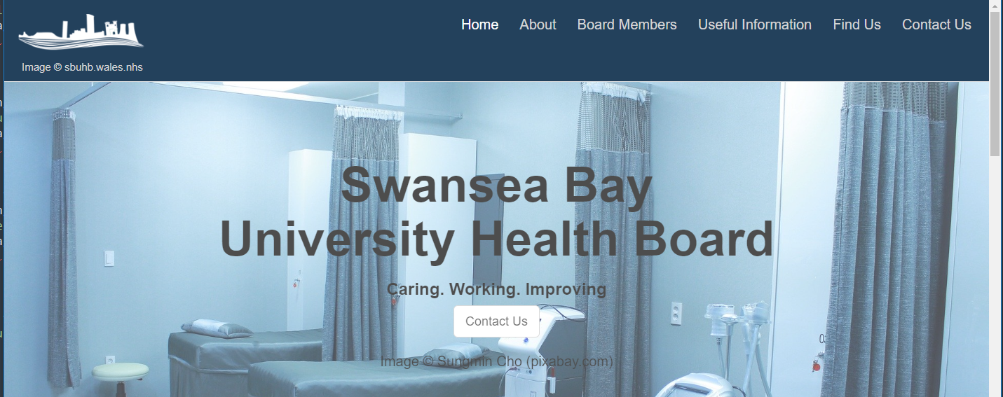

Index.html - Bottom
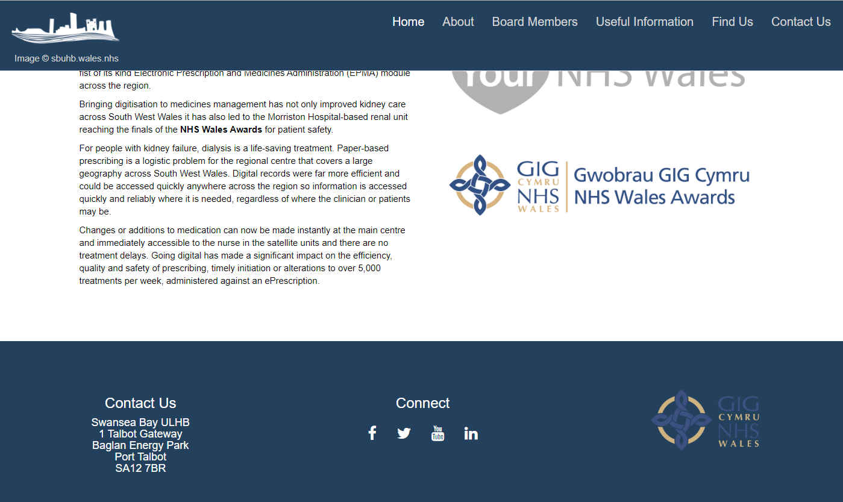

About.html
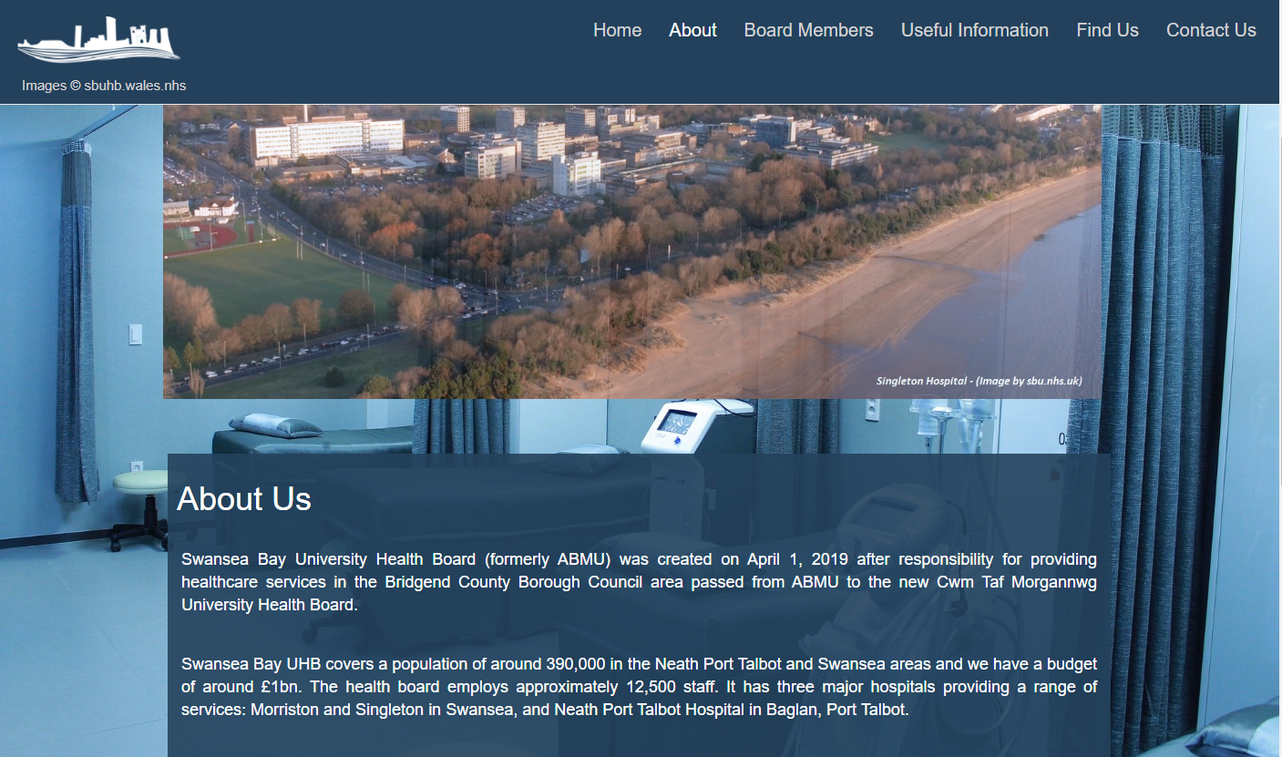

Board Members


Useful Information
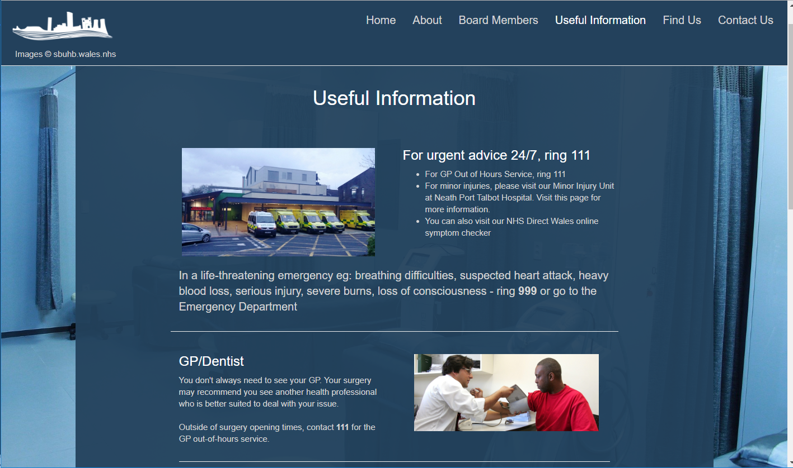

Find Us
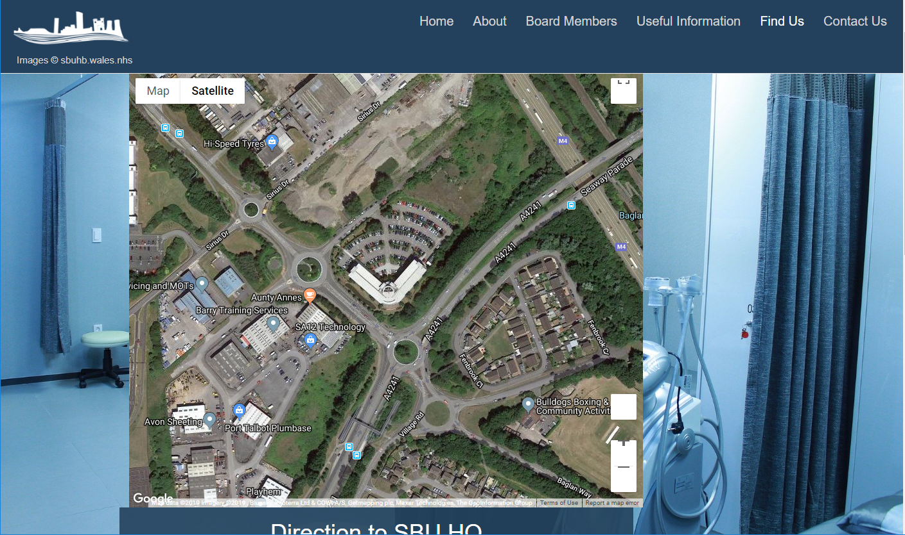

Contact Us
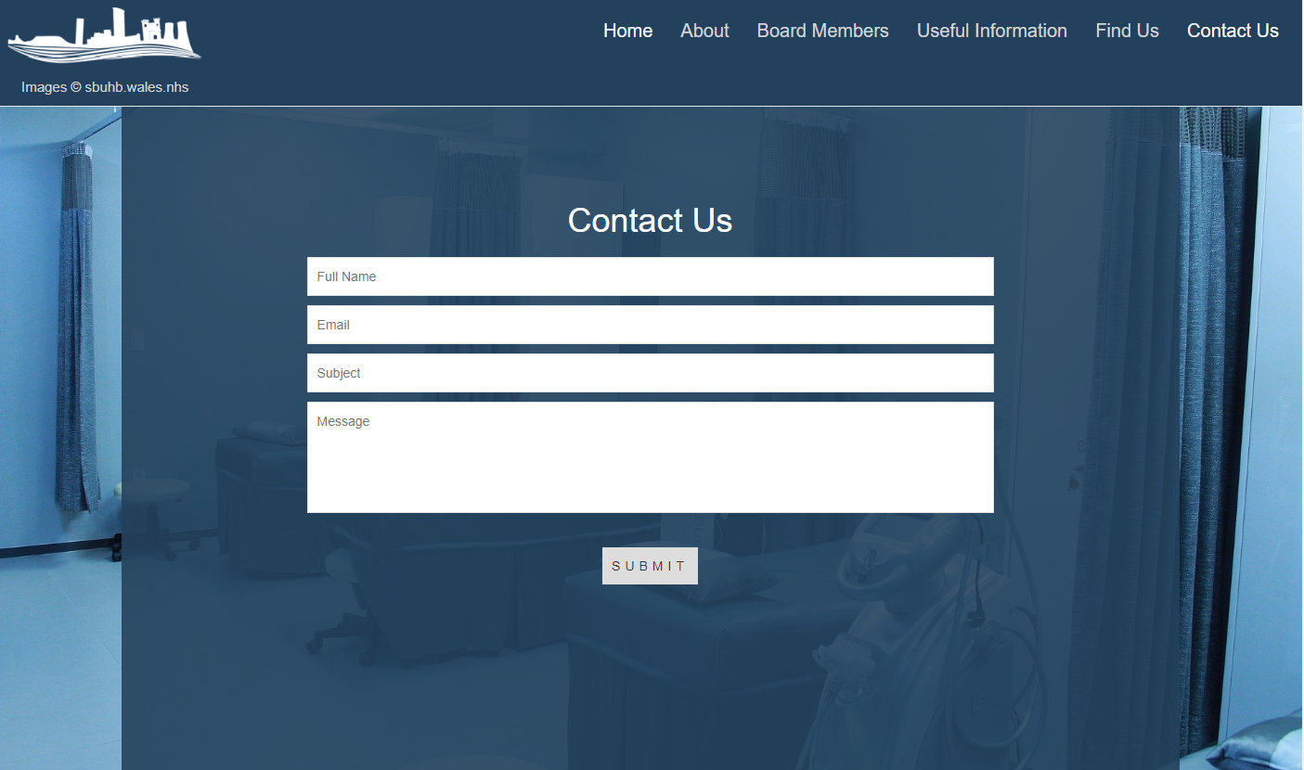

Evaluation

5.1. Test Case – Contact Form

Appendix A is a test case for the contact form validation. The test case addressed the fields sequentially and tests that the JavaScript function validates as the user moves through the form.

Test Case - API

Appendix B is a test case for the Google Maps geo-location API. It addresses the variables used to set the location to ensure that they centre the map on the correct coordinates.

Accessibility Checker

Once the website was complete, an accessibility check was done using https://contrastchecker.com/. The result, shown below illustrates a 10.59 contrast ration which is acceptable, as shown by the green markers at the bottom of the image.
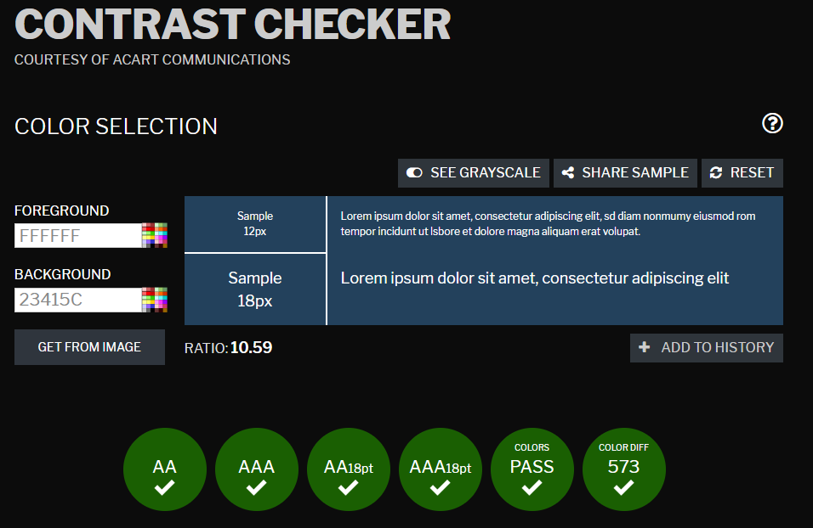

CSS Validation

Both CSS files used in the development of the website were successfully validated using http://jigsaw.w3.org/css-validator. As such, the CSS validation logo is displayed in the navigation bar on each page.

Future Recommendations

Given the time constraints evident throughout the development of the website, there are a number of improvements that could be made with more development time available.

Google Maps API
The API implemented for this project is relatively simple. It simply consumes a key from Google Maps and displays a location at a set zoom level. An improvement to this would be the ability to view all main hospital sites and enter their own location, allowing them to plot a course to their site of interest.
During the development stages, the position of the zoom in/out and full screen tools became misaligned. Although the tools still work, this is also a feature that should be addressed as a future improvement.

Content position and resizing
Another improvement would be to the content positioning upon resizing. It is possible that future developments and skill improvements would allow for a more dynamic scaling strategy to ensure content is positioned perfectly for every viewport size.

Conclusion
To conclude, the task set was to develop a website that responded to a change in viewport size. Whilst all of the targets where achieved to a lesser or great extent, time constraints and external factors prevented the developer from adding “finesse” and creating a fully responsive website.
HTML, CSS, JavaScript and API development is a multi-language science. As well as this, a level of artistic flare and attention to detail is required in order to capture a users’ attention long term, however development trends, such as PWA’s are improving user experience and making responsive and interactive website design more accessible.

References

[1] W. Schools, “HTML Responsive Web Design,” 2018. [Online]. Available: https://www.w3schools.com/html/html_responsive.asp. [Accessed: 07-Dec-2019].
[2] M. Malhotra, “Top 10 Web Application Development Trends 2019,” 2019. [Online]. Available: https://www.valuecoders.com/blog/technology-and-apps/top-web-application-development-trend-in-2018/. [Accessed: 23-Nov-2019].
[3] R. Reinhardt, “Progressive Web Apps: A New Hope,” Google, no. December, p. 1, 2018.
[4] “Progressive Web Apps | Google Developers.” [Online]. Available: https://developers.google.com/web/progressive-web-apps/. [Accessed: 23-Nov-2019].
[5] “cdnjs.com - The best FOSS CDN for web related libraries to speed up your websites!” [Online]. Available: https://cdnjs.com/. [Accessed: 07-Dec-2019].

Appendices

7.1. Appendix A.

Test Scenario | Test Case | Pre-conditions | Test Steps | Test Data | Expected Result | Actual Result | Pass/Fail
Check Form Validation Functionality | Check response on entering an invalid Full Name | Contact.js referenced in contact.html  Function validation() in contact.js  Name length < 5 | Enter Full Name length < 5 characters  Click “Submit” | Full Name: “Bob” | Error:  “Name must be more than 5 characters” | Error:  “Name must be more than 5 characters” | Pass
Check Form Validation Functionality | Check response of leaving Full Name empty | Contact.js referenced in contact.html  Function validation() in contact.js  Name - empty | Ensure Full Name field is empty  Click “Submit” | Full Name: blank | Error:  “Name must be more than 5 characters” | Error:  “Name must be more than 5 characters” | Pass
Check Form Validation Functionality | Check response of entering a valid Name | Contact.js referenced in contact.html  Function validation() in contact.js  Name length >= 5 | Enter Full Name length >=5 characters  Click “Submit” | Full Name: “Bob Test” | Validated field. Validation moves on to next field | Validated field. Validation moves on to next field | Pass
Check Form Validation Functionality | Check response of entering an invalid Email | Contact.js referenced in contact.html  Function validation() in contact.js  Email = incorrect format (- @) | Complete Name field  Enter invalid Email (absence of @ symbol”)  Click “Submit” | Email: “bob.test#email.com” | Error:  “Please enter a valid email address” | Error:  “Please enter a valid email address” | Pass
Check Form Validation Functionality | Check response of leaving Email empty | Contact.js referenced in contact.html  Function validation() in contact.js  Email field - empty | Complete Name field  Ensure Email field is empty  Click “Submit” | Email: blank | Error:  “Please enter a valid email address” | Error:  “Please enter a valid email address” | Pass
Check Form Validation Functionality | Check response of entering a valid Email | Contact.js referenced in contact.html  Function validation() in contact.js  Email = correct format (@) | Complete Name field  Ensure Email field contains accepted email format (@)  Click “Submit” | Email: “Bob.Test@mail.com” | Validated field. Validation moves on to next field | Validated field. Validation moves on to next field | Pass
Check Form Validation Functionality | Check response on entering an invalid Subject | Contact.js referenced in contact.html  Function validation() in contact.js  Subject = blank | Complete Name, Email fields  Ensure Subject field is empty  Click “Submit” | Subject: blank | Error: “Subject cannot be blank” | Error: “Subject cannot be blank” | Pass
Check Form Validation Functionality | Check response on entering a valid Subject | Contact.js referenced in contact.html  Function validation() in contact.js  Subject = not blank | Complete Name, Email fields  Ensure Subject field is not empty  Click “Submit” | Subject: “Test” | Validated field. Validation moves on to next field | Validated field. Validation moves on to next field | Pass
Check Form Validation Functionality | Check response on entering an invalid Message | Contact.js referenced in contact.html  Function validation() in contact.js  Message length < 20 characters | Complete Name, Email, Subject fields  Enter Message length < 20 characters  Click “Submit” | Message:  “This is a message”.  Length = 17 chars | Error:  “Message must be more than 20 characters” | Error:  “Message must be more than 20 characters” | Pass
Check Form Validation Functionality | Check response on entering an invalid Name | Contact.js referenced in contact.html  Function validation() in contact.js  Message = blank | Complete Name, Email, Subject fields  Ensure Subject field is empty  Click “Submit” | Message: blank | Error:  “Message must be more than 20 characters” | Error:  “Message must be more than 20 characters” | Pass
Check Form Validation Functionality | Check response on entering an invalid Message | Contact.js referenced in contact.html  Function validation() in contact.js  Message length > 20 characters | Complete Name, Email, Subject fields  Enter Message length > 20 characters  Click “Submit” | Message:  “This is a message too”.  Length = 21 chars | Validated field. Validation moves on to next field | Validated field. Validation moves on to next field | Pass
Check Form Validation Functionality | Check response on completing form and clicking submit | Contact.js referenced in contact.html  Function validation() in contact.js  All fields complete and validated | Complete all fields  Click “Submit” | Notification:  “Form submitted successfully. Thank you for your feedback” | All fields validated.  Form submitted | All fields validated.  Form submitted | Pass

Appendix B.

Test Scenario | Test Case | Pre-conditions | Test Steps | Test Data | Expected Result | Actual Result | Pass/Fail
Check API Latitude and Longitude Variables | Check variable value works and is called | map.js referenced in findus.html  Function createMap() in map.js  Variables set correctly:  let lat = 51.613795;  let lng = -3.814200; | Load findus.html | Page load | Map centred on variable coordinates:  SBU HQ | Map centred on variable coordinates | Pass
Check API Latitude and Longitude Variables | Check variable value works and is called | map.js referenced in findus.html  Function createMap() in map.js  Variables set correctly:  let lat = 37.8196;  let lng = -122.4785; | Load findus.html | Page load | Map centred on variable coordinates:  Golden Gate Bridge, CA | Map centred on variable coordinates | Pass

marking criteria and Student FEEDBACK

This section details the extent to which the assessment criteria are demonstrated by you, which in turn determines your mark. The marks available for each category of skill are shown. Lecturers will use the space provided to comment on the achievement of the task(s), including those areas in which you have performed well and areas that would benefit from development/improvement.

Common Assessment Criteria Applied (Assignment 1) | Marks available | Marks  awarded
1. Engagement with Literature Skills

A very good discussion of the chosen application trend, PWAs, and particularly the section on the advantages and disadvantages. The overall description of PWAs and required background from a relevant peer-reviewed study is limited. (Grade mark: 62.00%) | 25 | 15.5
2. Knowledge and Understanding Skills

3. Cognitive and Intellectual Skills

A detailed set of test cases has been developed particularly for testing the contact form, but as your "Find Us" functionality was fixed, i.e. hardcoded, there was a limit in terms of what to test. The evaluation is okay and mainly focuses on using tools to evaluate the site. I would have expected you to pick up on some of the responsive issues mentioned below in your evaluation. Relevant and good recommendations for improvements have been discussed. (Grade mark: 72.50%) | 20 | 14.5
4. Practical Application Skills

A very good attempt featuring a website with well-thought-out content and some simple JavaScript functionality. There were, however, some issues with the responsiveness of some pages i.e. the About and Find Us pages in particular. This was mainly as a result of using fixed pixel (px) units for these elements or their parent elements. Recall that a key feature of responsive design is replacing fixed units with flexible units and particularly for media content. Also, your use of media queries meant you unintentionally overwrote the styles for smaller devices. See your report for more details. Some good use of JavaScript functionality has been implemented on the website, although I would have liked to see more interactive functionality for the user. The map functionality is rather basic - see suggestions for improvement in your report. For your JavaScript event handlers, use the addEventListener method to bind your event handlers as this is much better practice than using HTML event attributes. (Grade mark: 69.00%) | 50 | 34.5
5. Transferable Skills for Life and Professional Practice

The report is well written and presented. (Grade mark: 90.00%) | 5 | 4.5

Assignment Mark (Assessment marks are subject to ratification at the Exam Board. These comments and marks are to give feedback on module work and are for guidance only until they are confirmed. ) | Late Submission Penalties (tick if appropriate) |  | 69%
 | Up to 1 week late (40% Max) |  | 69%
 | Over 1 week late (0%) |  | 69%

