

Postgraduate/Distance Learning
Assignment coversheet & feedback form

THIS SHEET MUST BE THE FIRST PAGE OF THE ASSIGNMENT YOU ARE SUBMITTING (DO NOT SEND AS A SEPARATE FILE)

For completion by the student:
Student Name: Catherine Beckham

Student University Email: 2408152@student.uwtsd.ac.uk
Module code: HPCA7015  Module title: Foundations in Cultural Astronomy and Astrology | Student ID number:  2024 0815 21 |  |  | Educational support needs:  No
Assignment title: Essay 2

Assignment due date: 28 November 2024
This assignment is for the 1st [✓] 2nd 3rd 4th 5th 6th module of the degree
I confirm that this is my original work and that I have adhered to the University policy on plagiarism.
Signed …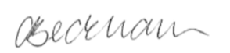……………………
Email submission: if you are submitting this form via email, please tick this box [✓] (as a substitute for your signature) to confirm that you agree to the above declaration.
Assignment Mark
1st Marker’s Provisional mark
2nd Marker’s/Moderator’s provisional mark
External Examiner’s mark (if relevant)
Final Mark

NB. All marks are provisional until confirmed by the Final Examination Board.

For completion by Marker 1 :
Comments:

Marker’s signature: |  |  | Date:
For completion by Marker 2/Moderator:

Comments:

Marker’s Signature: |  | Date:
External Examiner’s comments (if relevant)

External Examiner’s Signature: |  | Date:

Skyscapes and Self

‘Be clearly aware of the stars and infinity on high. Then life seems almost enchanted after all.

This essay will discuss Vincent van Gogh’s quote in relation to personal observations and lunar phases as recorded in a sky journal, examining how this activity can be viewed as a cultural practice that enhances our understanding of our place within the world. By using an analytical framework, this essay will explore the notion that sky gazing is not just about gathering meteorological and astronomical data; rather it is a process that functions as a significant cultural and philosophical mirror.

Methodology for Sky Journal  The journal drew upon the framework outlined by Mats Alvesson and Kaj Sköldberg. | Appendix 1: Data Overview  Moon’s position at 12:00 noon daily from 17th September to 18th October 2024. | Recording Equipment  Mobile Phone: iPhone 11, Camera, Notes and Voice Memo, Stellarium App, Pen, Paper & Paper Journal

Journal Entry
Date: 17th September 2024, 11:24
Location: National Library of Wales
Moon: Full Moon, 15° Pisces opposite Mercury, square Jupiter and conjunct the Sun.

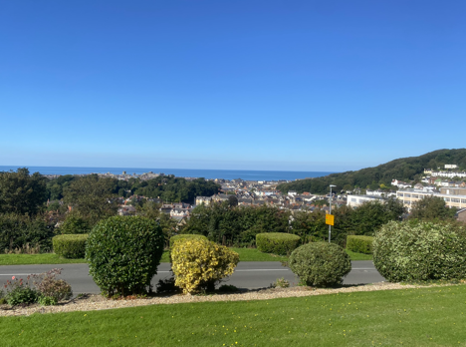 | 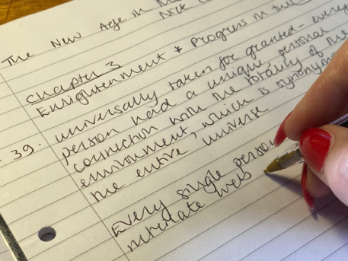
National Library of Wales 11:24 | Notes taken by author 11:30

A beautiful blue-sky day with not a cloud to be seen. A day spent in the National Library of Wales, making notes while reading Nick Campion’s book ‘The New Age in the West’.

Reflection:
The calm sea and sky gave me a sense of stillness and the architecture of the library added to a sense of heightened beauty. This experience of serene beauty resonates with the same sense of wonder and infinity that Van Gogh described in his letter to his brother Theo, written in 1880.
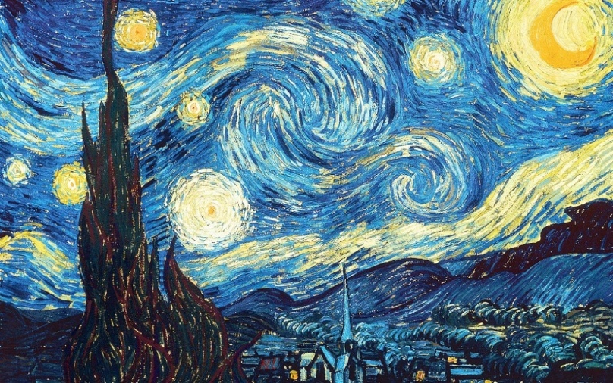
Vincent Van Gogh The Starry Night (1889) Oil on Canvas 73.7 cm x 92.1 cm Museum of Modern Art

The Van Gogh Museum in Amsterdam highlights The Starry Night (1889) which portrays the nocturnal sky above Saint-Rémy-de-Provence as one of his most renowned artworks. Throughout his work Van Gogh engages with themes of the sublime. Steeped in the Romantic tradition, Van Gogh saw nature, particularly the night sky as a conduit for transcendence and emotional expression. The stars in his paintings are not mere astronomical entities, but are laden with symbolic meaning, representing hope, infinity, and the sublime.

Through his letters and his painting, he invites us to contemplate, perhaps that stars are not just celestial bodies but are gateways to understanding life’s enchantment, something infinitely larger than ourselves, encouraging wonder and curiosity.

In her analysis Van Gogh’s Agony Lauren Soth interprets The Starry Night as a fusion of imagination and symbolism, heavily inspired by the colour and dynamic spontaneity found in the art of Eugène Delacroix. Soth argues that Van Gogh intended this painting to be a work meant to elevate and provide comfort. Furthermore, she proposes that it acts as a form of religious art, serving as a vehicle for Van Gogh’s spiritual inclinations after his disillusionment with the Church.

The Starry Night serves as an example of how art interprets the sky, capturing its movement and endlessness. In today’s world, although our understanding of the sky is bolstered by technology and scientific data, we continue to connect with the wonder and emotional depth that Van Gogh expressed. This transition from a solely artistic, emotive view to one that combines beauty with scientific exploration reflects a significant change in how we perceive the world.

Journal Entry
Date: 26th September 2024, 18:41
Location: Promenade Jetty, Aberystwyth
Moon: Waning Crescent, 23° Cancer sextile Uranus, trine Neptune, opposite Pluto square Chiron

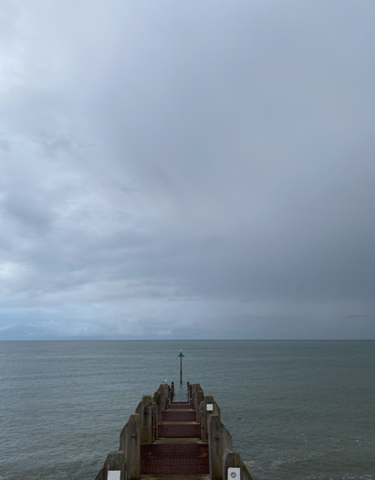 | 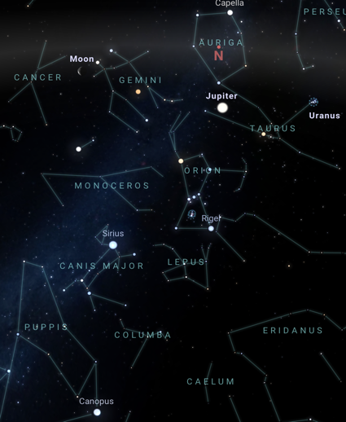
Aberystwyth Jetty 18:23 | Data taken from Stellarium-web.org
It’s 18:23 and fish pie is in the oven. The sun is due to set at 19:04, just when dinner is about to be served – how inconvenient. Anyway, I’ll nip out and take a photo for the Sky Journal.

Reflection:
This entry certainly captures the mundane daily tasks of life and clearly there is evidence that the sunset was clashing with family mealtime! I was more preoccupied with focusing on the screen as what I wanted to find out, lay behind the clouds. Using the Stellarium app on my phone revealed the position of the moon in relation to the constellation of Cancer and Gemini and the position of Jupiter in Gemini. Whereas Van Gogh’s quote evoked existential depths, my journal captured rather a mundane moment where the sky didn’t quite stir the same depth of emotion! However, it did reflect contemporary society and served to illustrate our current relationship with technology and screens when observing the natural world.

In the mid-19th century, there was also a period of rapid technological evolution as evidenced by the advent of railways, steamships, photography, the telegraph and subsequently, cinema. It was a time heralded as the age of Modernism and occurred during Van Gogh’s lifetime. These technological innovations not only transformed the landscape but also impacted society and culture and contributed to a new awareness of time’s relativity. In his book The Culture of Time and Space, 1880-1919 Stephen Kerr discusses how perceptions of time evolved to be seen as elastic, subjective and increasingly shaped by technological advancements. This resonates with Van Gogh’s ideas in the post-impressionist pursuit of capturing the essence of existence rather than its mere representation. In Van Gogh’s work the sky often symbolises the infinite, embodying the vastness of time and space, beyond human comprehension. This reflects how cultural perceptions can redefine our understanding of time.
Journal Entry
Date: 27th September 2024, 18:46
Location: Promenade Jetty, Aberystwyth
Moon: Waning Crescent, 9° Leo square Venus, trine North Node

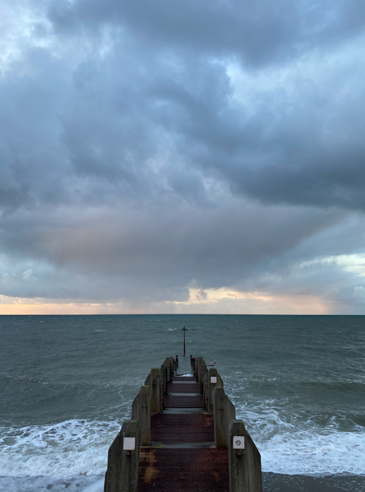 | 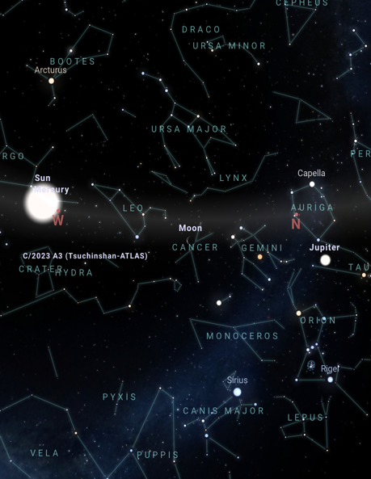
Jetty, Aberystwyth 18:46 | Data taken from Stellarium-web.org

I particularly like the dark cloud. It looks rather ominous, and so I titled it ‘Independence Day’ after a Will Smith movie! The Moon is now in Leo and Mercury appears to have moved closer to the sun. In this screen grab, I can also see Mars in Gemini. Lots of new names of constellations to learn.

Reflection:
The ominous cloud formation has a foreboding appearance evoking a theme of conflict and defiance. The cloud could be seen as an embodiment of tension, one of impending confrontation, perhaps reflective of the emotional turmoil experienced by Van Gogh during his period of confinement, when he conceived of his idea for The Starry Night.

Lauren Soth in her analysis, connects The Starry Night to Van Gogh’s contemplation of Christ in Gethsemane, which he was contemplating around the summer of 1888, suggesting a thematic link between his personal anguish and the biblical narrative of suffering and redemption. Soth suggests that Van Gogh’s vision of the Gethsemane scene evolved into The Starry Night (1889) using the colour blue to symbolise Christ and yellow for the comforting angels. The painting is also imbued with symbolism as exemplified by post-impressionism. She points out that when Van Gogh painted this, the moon was not the crescent that appears in the painting. It is depicted in the upper right-hand corner of the canvas painted with an exaggerated swirling. She states it was painted between 16th and 18th June, when the moon was still in its full phase and was gibbous in shape, between a full and half circle.
Journal Entry
Date: 28th September 2024, 15:07
Location: Blackfriars Bridge, London
Moon: Waning Crescent, 20° Leo sextile Jupiter, square Uranus trine Chiron

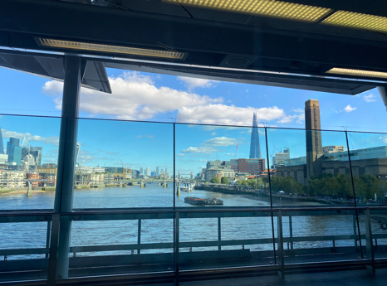 | 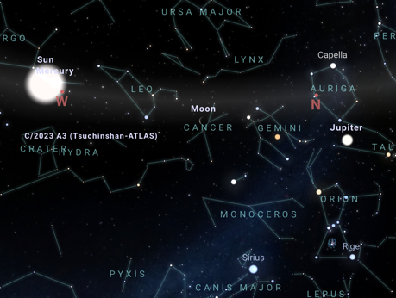
Blackfriars Bridge, London.15:07 | Data taken from Stellarium-web.org

This is what interrupted my schedule – a trip to Brighton – but I could see no reason not to photograph the sky in a different location. This time Mercury was much closer to the Sun – the Moon looked as though she was advancing towards the constellation Leo. I loved the view from Blackfriars Bridge. The sky was blue. There were fluffy clouds. And I had reconnected with my sister and boy .. did we have a laugh!

Reflection:
What I can see here is a change in perspective, gone are the dark clouds, serving to remind me that the sky is always changing. The bridge serves as a metaphor, a crossing point, linking me back to my past with my brother and sister and bringing moments of joy. The moon was continuing her journey as was I, thus serving to remind me ‘do not focus on what you imagine is lost, remember the love that endures’.

Alfred Whitehead (1861 – 1947) a prominent philosopher and mathematician had a significant impact on understanding the nature of reality, particularly through his development of process philosophy that posits the idea that becoming, rather than being, is the primary mode of existence.
In Essays in Science and Philosophy, he introduces the notion of Solus cum Solo (Alone with the Alone) – emphasising the deep solitude of personal morality as each person faces the universe in isolation yet is part of a greater existential or mystical unity. He further goes on to state that the universe can be understood through two distinct lenses: World of Change and World of Value.
Inspired by Plato and Aristotle, he argues that individual identities are forged as life unfolds dynamically, in the World of Change whereas in the World of Value, eternal principles and the concept of immortality are realised, suggesting that one’s identity harmonise with timeless values. In the section Mathematics and the Good he reflects on how both Plato and Aristotle through their different approaches were instrumental in shifting human thought from concrete experience to abstract concepts, heralding an epoch where abstraction became a tool for understanding the world. Therefore, Whitehead’s concepts help interpret the personal journey as a philosophical process where one navigates change while holding onto values that transcend time.

Journal Entry
Date: 2nd October 2024, 18:53
Location: St Barts Hospital, London
Moon: New Moon, 11° Aquarius trine the Sun square Mars

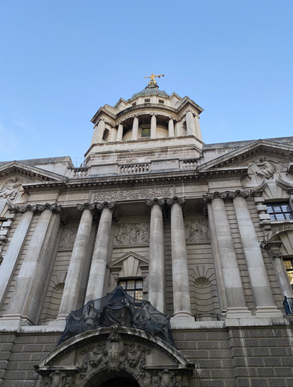 | 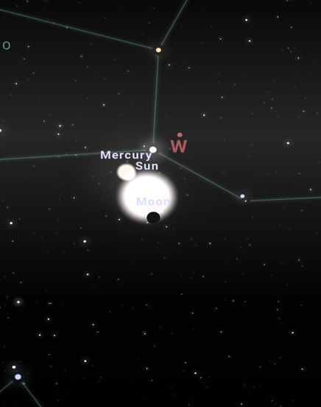
St Barts Hospital, London. 18:53 | Data taken from Stellarium-web.org

The new moon was particularly notable because it coincided with an annular solar eclipse. This evening, I was in London. I took the photograph outside St Barts Hospital, enroute to St Bartholomew The Greater – a Norman Church in the City of London where I went for an evening of poetry and song, courtesy of The Blake Society.

Reflection: The new moon with a solar eclipse is a rare event. Usually at a new moon it is too dark to be observed in the sky, but with a solar eclipse it appears illuminated. This interplay of light and shadow, hidden and seen, symbolises that the lunar phase in its regularity and change, echoes the cycles of life, providing a framework and understanding that time is not just linear, but also can be a spiral of recurring themes.

The event of the New Moon invites a broader contemplation, of how such natural phenomena might inspire cultural, artistic, and spiritual reflections in our secular age. In Culture and the Death of God Terry Eagleton examines culture in its widest scope, including both high art and everyday practices, but is sceptical about their ability to embody the role once held by religion. He invites us to consider whether our intellectual faculties are a cosmic coincidence or if they carry a deeper philosophical or spiritual significance. Eagleton challenges us to reflect on the source and intent of human knowledge in a time when traditional religious frameworks have declined.

The beauty of the new moon illuminated by a solar eclipse is a reminder that despite the void left by the decline of religious influence, moments such as this serve as an opportunity for us to look beyond the secular and revalue where our intellectual and spiritual insights originate.
This essay has explored Van Gogh’s statement in relation to the phases of the moon and sky journaling, demonstrating that gazing skyward is an act steeped in cultural, emotional, and philosophical resonance. It transcends mere scientific observation, echoing Van Gogh’s own life where the sky was not just a canvas for painting but a medium for expressing the ineffable. This analysis combines personal reflection with scholarly insight from:

- Soth who interprets Van Gogh’s work as a blend of imagination and symbolism, viewing The Starry Night as an artwork meant to elevate and comfort.
- Kern who discusses how 19th-century technological advancements informed a new understanding time, introducing concepts of elasticity echoing Van Gogh’s depiction of timelessness and infinity.
- Whitehead offering a philosophical lens that draws on the ideas of Plato and Aristotle to explore how philosophy navigates the process of change while holding onto values that transcend time.
- Eagleton who challenges us to reconsider how culture can fill the spiritual void left by diminishing religious frameworks.
Through sky journaling, this essay advocates that we engage in a dialogue with the cosmos, finding enchantment in the mundane and perhaps, as Van Gogh might have hoped, a sense of connection to the infinite.

Bibliography

Primary sources
- Sky Journal
- Photographs

Secondary Sources
Soth, Lauren. “Van Gogh’s Agony.” The Art Bulletin 68, No. 2 1986 P. 301–13.

Books
Campion, Nicholas, The New Age in the Modern West: Counterculture, Utopia and Prophecy from the Late Eighteenth Century to the Present Day. London: Bloomsbury. 2015.
Eagleton, Terry, The Idea of Culture. Oxford: Blackwell Publishers. 2000.
Kern Stephen, The Culture and Time and Space 1880 – 1918. London: Harvard University Press. 2003
Mats Alvesson, and K. S. &., Reflexive Methodology - 2nd Ed.: New Vistas for Qualitative London: Sage Publications. 2009.
Ronald De Leeuw and Arnold Julius Pomerans. The Letters of Vincent Van Gogh London: Penguin Books. 1997.
Whitehead Alfred North, Essays in Science and Philosophy. London: William Brendon and Son. 1948

Websites
https://www.metmuseum.org/art/collection/search/702709

https://moonphases.co.uk/moon-calendar

https://stellarium-web.org/

https://www.vangoghmuseum.nl/en/collection/s0168V1962

Appendix 1
The table tracks the Moon's orbit around Earth from September 17, 2024, to October 18, 2024, detailing its daily position and phase transitions.

Methodology:
Observation time: | The Moon's position was recorded at 12:00 PM (noon) local time daily.
Lunar Phase: | The phases of the Moon were noted, transitioning from Third Quarter to New Moon, First Quarter, and back to Full Moon.
Position: | The Moon's position in degrees was measured, indicating its position relative to the constellations.
Aspects | Astrological aspects formed by the Moon to other celestial bodies were logged.
Lunar Phases

Waning: | Begins post-Full Moon, where the visible portion of the Moon decreases nightly until it reaches the New Moon phase.
New Moon: | Occurs when the Moon is positioned between the Earth and Sun, becoming invisible in the night sky.
Waxing: | Starts after the New Moon, with the illuminated portion increasing daily until the next Full Moon.

Lunar Cycle
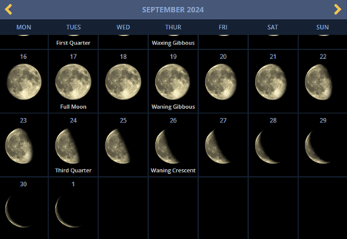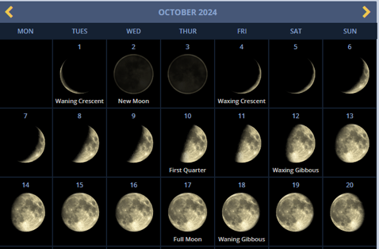
Images taken from https://moonphases.co.uk/moon-calendar

 | Lunar Phase | Constellation | Degree
17-Sep | Full Moon | Pisces | 15
18-Sep |  | Aries | 1
19-Sep | Waning Gibbous | Aries | 16
20-Sep |  | Taurus | 1
21-Sep |  | Taurus | 15
22-Sep |  | Gemini | 0
23-Sep |  | Gemini | 14
24-Sep | Third Quarter | Gemini | 27
25-Sep |  | Cancer | 11
26-Sep | Waning Crescent | Cancer | 23
27-Sep | Waning Crescent | Leo | 6
28-Sep | Waning Crescent | Leo | 18
29-Sep |  | Virgo | 0
30-Sep |  | Virgo | 12
1-Oct |  | Virgo | 24
2-Oct | New Moon | Libra | 6
3-Oct |  | Libra | 18
4-Oct | Waxing Crescent | Libra | 29
5-Oct |  | Scorpio | 11
6-Oct |  | Scorpio | 23
7-Oct |  | Sagittarius | 5
8-Oct |  | Sagittarius | 18
9-Oct |  | Capricorn | 0
10-Oct | First Quarter | Capricorn | 13
11-Oct |  | Capricorn | 26
12-Oct | Waxing Gibbous | Aquarius | 10
13-Oct |  | Aquarius | 24
14-Oct |  | Pisces | 9
15-Oct |  | Pisces | 24
16-Oct |  | Aries | 9
17-Oct | Full Moon | Aries | 18
18-Oct | Waning Gibbous | Taurus | 9

Appendix 2
Journal Entry
Date: 17th September 2024
Location: National Library of Wales
Data: The Moon was in its Last Quarter Phase, 15° Pisces opposite Mercury, square Jupiter and conjunct the Sun.

A beautiful blue-sky day with not a cloud to be seen. I day spent in the National Library of Wales, making notes while reading Nick Campion’s book New Age in the West. I had written from Chapter 3: Enlightenment and Progress in the 18th Century.

‘It was universally taken for granted – every person had a unique, personal connection with the totality of the environment, which is synonymous with the entire universe.’

I enjoyed reading about the 18th century intellectual revolution, the advent of telescopic gravitational theory and Sir Isaac Newton’s gravitational theory as set out in Philosophiae naturalis principia maethmatica (1687).

Note for further research: The concept of the ‘Great Chain of Being’.

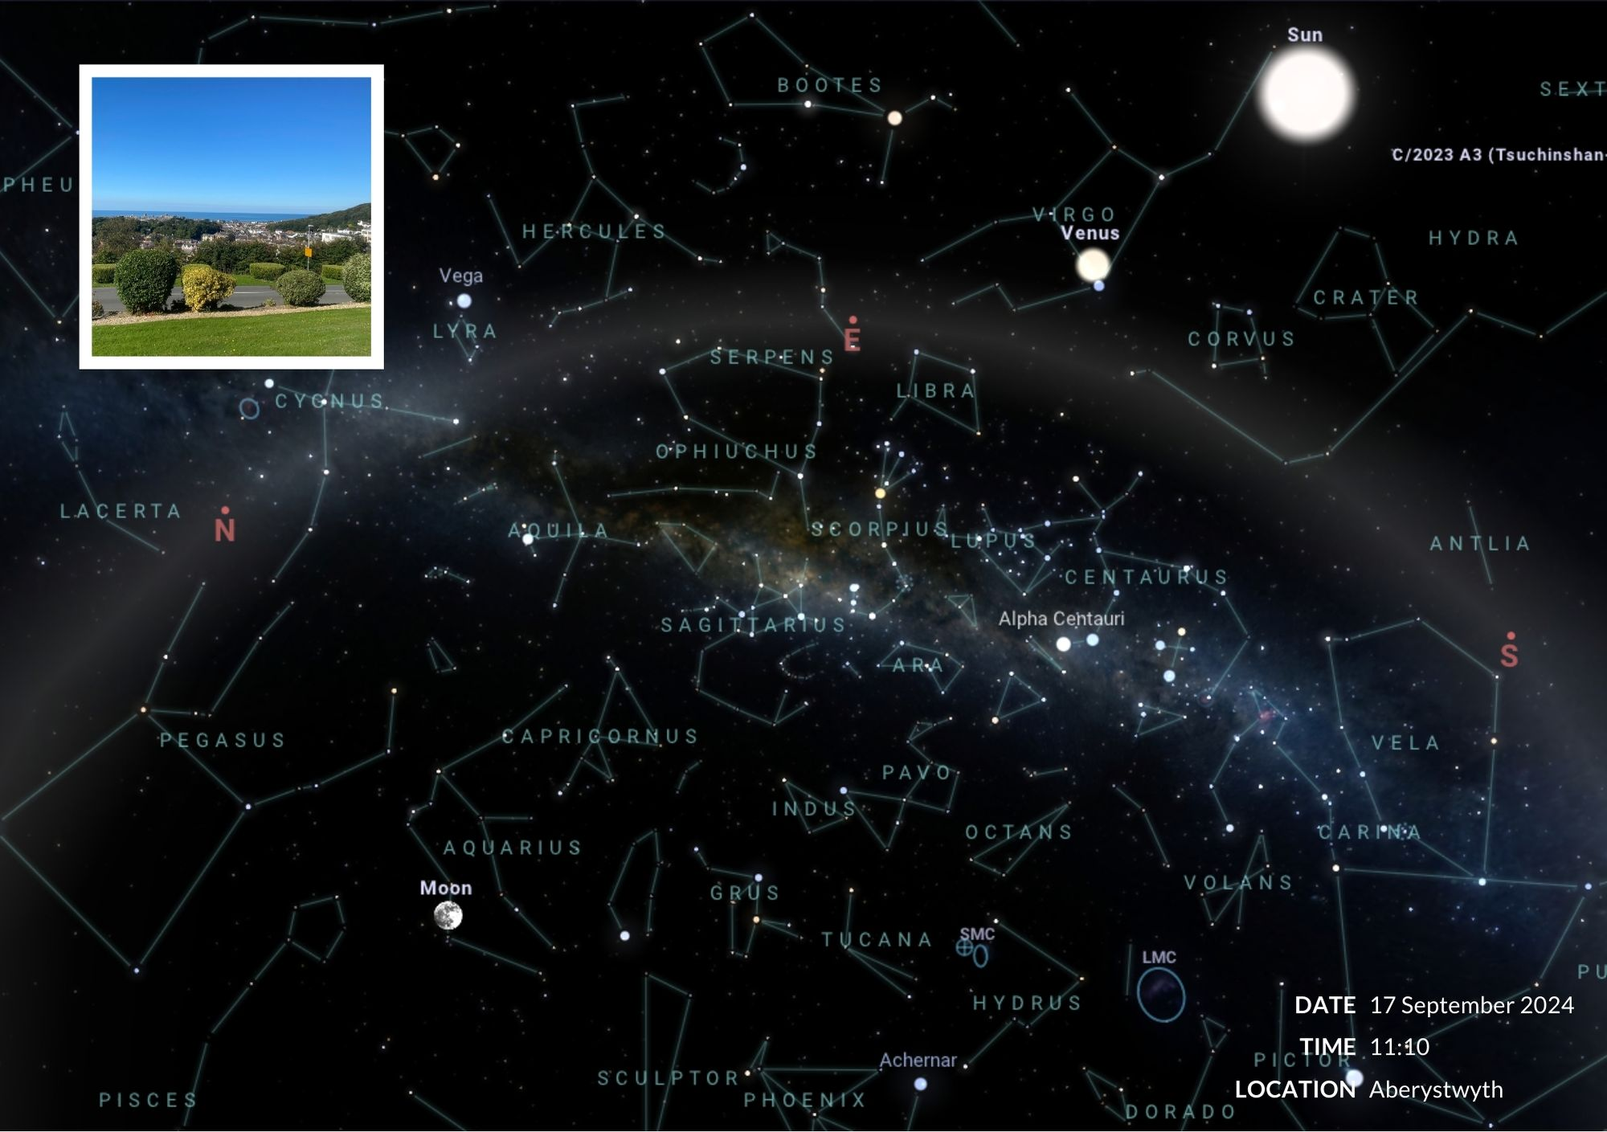

Journal Entry
Date: 26th September 2024
Location: Promenade Jetty, Aberystwyth
Data: The Moon was in its Waning Phase, 23° Cancer sextile Uranus, trine Neptune, opposite Pluto square Chiron

It’s 18:23 and fish pie is in the oven. The sun is due to set at 19:04, just when dinner is about to be served – how inconvenient. Anyway, I’ll nip out and take a photo for the Sky Journal Assignment. I took a photo at 18:41.

Later on:
It wasn’t a particularly warm and beautiful evening, and I was keen to get back to the kitchen to serve dinner. Looking at the sky, it was heavy with clouds and the sea looked uninviting – green and cold. I certainly wouldn’t want to fall into the water from the jetty. I saw Jim and Steve Bailey on the way back – they were keen to know what I was up to.

At 18:41 after taking the photo, I recorded a voice memo into my phone:

It’s 18:41 and it’s raining a little bit. I have just come out to photograph the sky and do you know what? I looked at my phone to take the photograph and I didn’t even look at the sky. You can hear the sound of the sea and there are a few seagulls flying around. To my left is the Pier and to the right is Constitution Hill. Right ahead of me I have got the jetty – because I thought that would make a nice photograph and looking up at the sky, it’s all grey. There is a little bit of cloud to the left and the horizon is a dark grey and then it sort of lightens up a little bit to the left just over the Pier. It’s not the most inviting of environments to be in looking at …. As opposed to my phone I can see that it is pretty grey, pretty dull, no stars in the sky so that’s it really. I have looked at the sky, I have taken a photo, I have written my thoughts about the day and there’s a baby seagull making a flight. I love the sound of the sea. And then there are cars and people and then there is .. well, friends to bump into, conversations to have, stories to tell, who knows? It’s another day here in Aberystwyth, the place that I love. Right, off for dinner, bye bye.

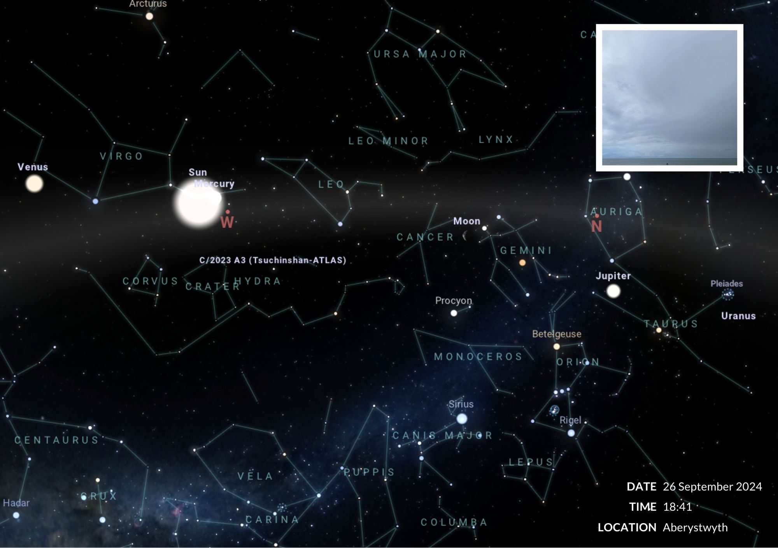

Journal Entry
Date: 27th September 2024
Location: Promenade Jetty, Aberystwyth
Data: The Moon was in its Waning Phase, 9° Leo square Venus, trine North Node

I can see that the position of the moon has shifted from one side of Cancer to the other. I particularly liked the photo of the cloud. It looked rather ominous, and I titled it ‘Independence Day’ after a Will Smith movie.

It also reminded md of the day we arrived in Naples back in 2016, very oppressive clouds above.

Mercury appeared to have moved closer to the sun. In this screen grab, I can also see Mars in Gemini. Lots of new names of constellations to learn.

It is 6:09 and I have an hour before the sun sets. Tomorrow, I travel to London and then on to Brighton to see my brother Johnnie. That means that I must start my packing and find time to speak to Johnnie this evening. I do not have to worry about cooking dinner this evening because we have yesterday’s leftover dinner. Today my school friend Carole came to visit with her mum Susan, and we had a wonderful reunion reminiscing about the old days. After lunch of homemade soup and toast with tea and chocolate bar, we were joined by my Mum, who was absolutely overjoyed to see Carole and Susan. Isaac finished college at 4 PM and, then Carole took everyone home back to Barmouth.
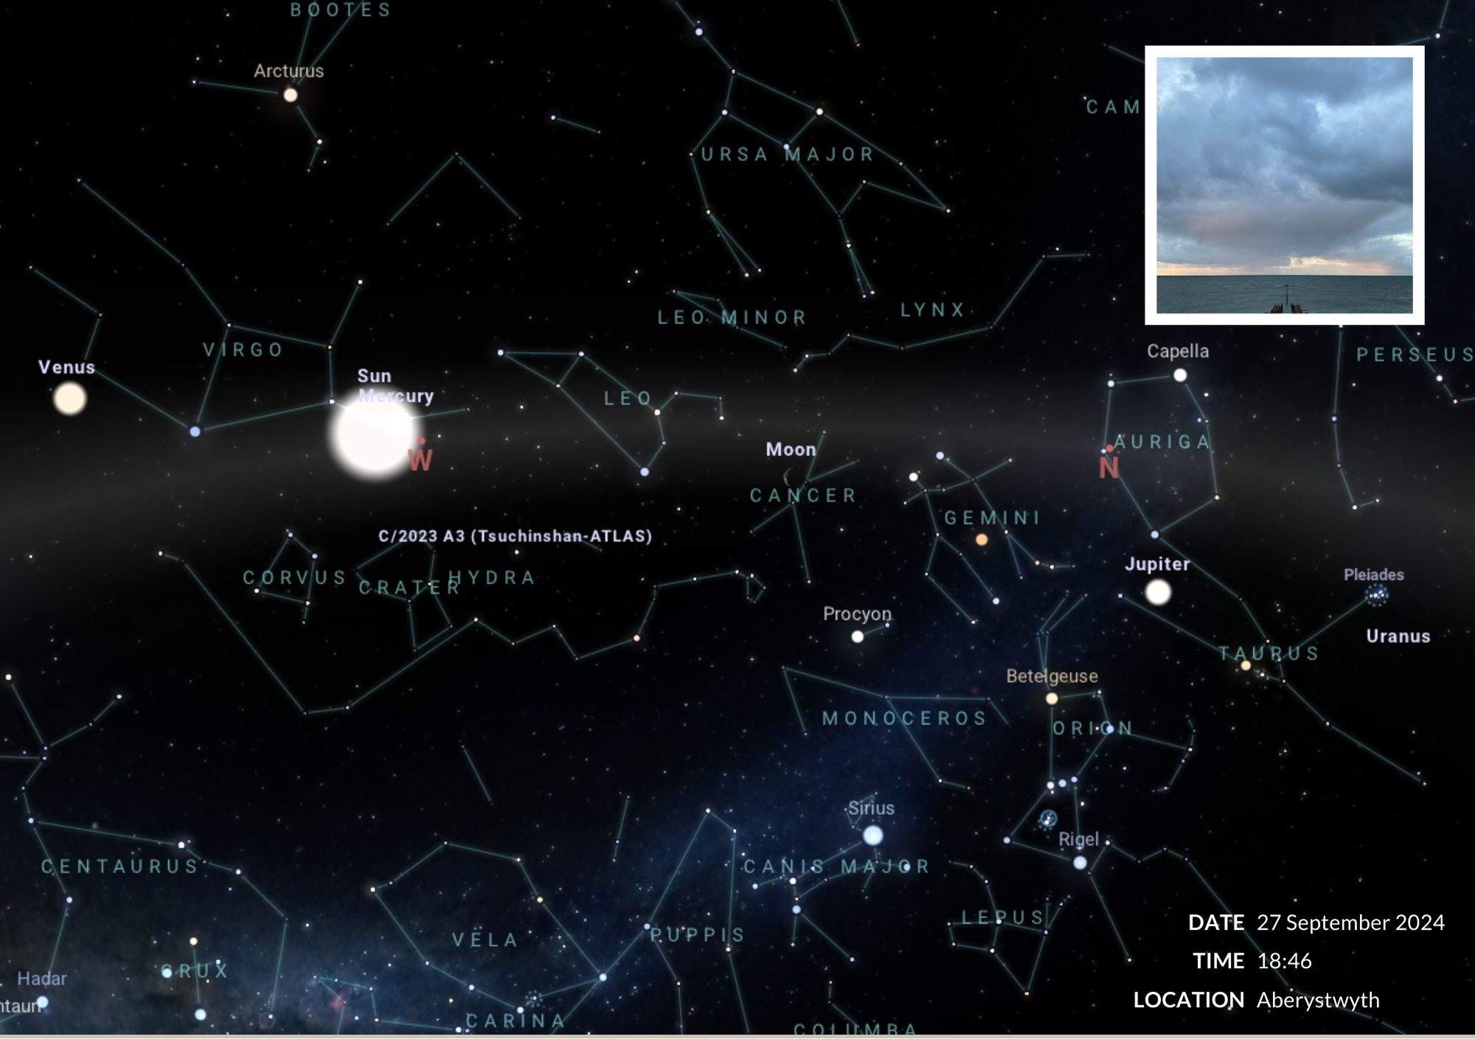

Journal Entry
Date: 28th September 2024
Location: Brighton
Data: The Moon was in its Waning Phase, 18° Leo sextile Jupiter, square Uranus and trine Chiron

This is what interrupted my schedule – a trip to Brighton – but I could see no reason not to photograph the sky in a different location. This time Mercury was much closer to the Sun – the Moon looked as though she was advancing towards the constellation Leo.

I loved the view from Blackfriars Bridge. The sky was blue. There were fluffy clouds. And I had reconnected with my sister and boy! Did we have a laugh!

Walking back from Johnny’s flat to my Airbnb I was worried and hoped that I wouldn’t get assaulted, attacked or mugged. I took a risk and took my phone out and used it to take a screen grab of the sky, using Stellarium. A father and his 8-year-old son walked by and were intrigued to see what I was doing. We ended up having a lovely chat and he told me that he had seen a comet it the sky and found it thrilling.

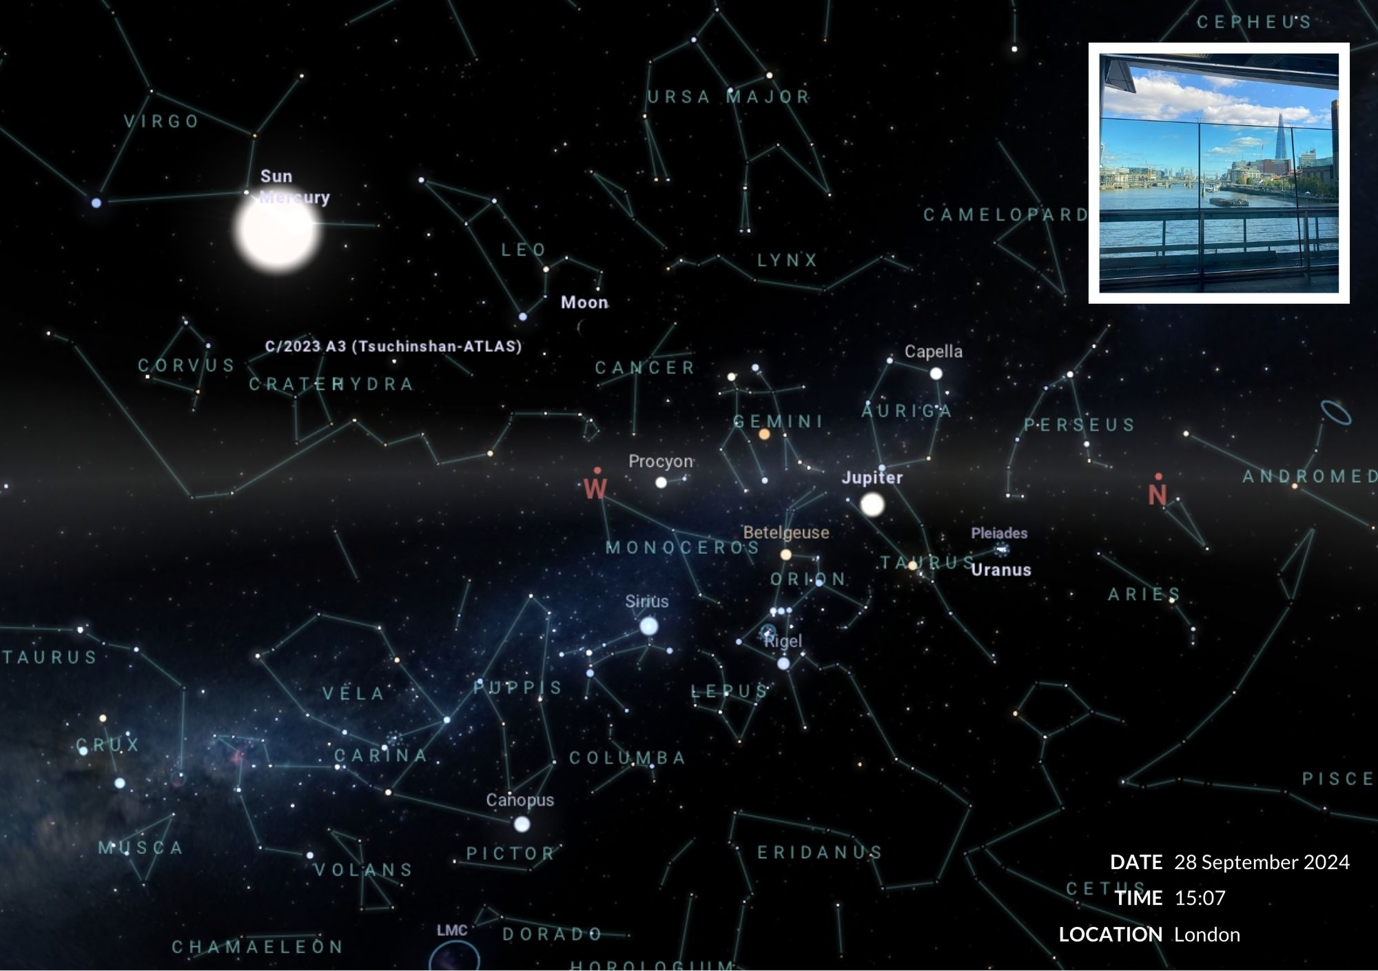

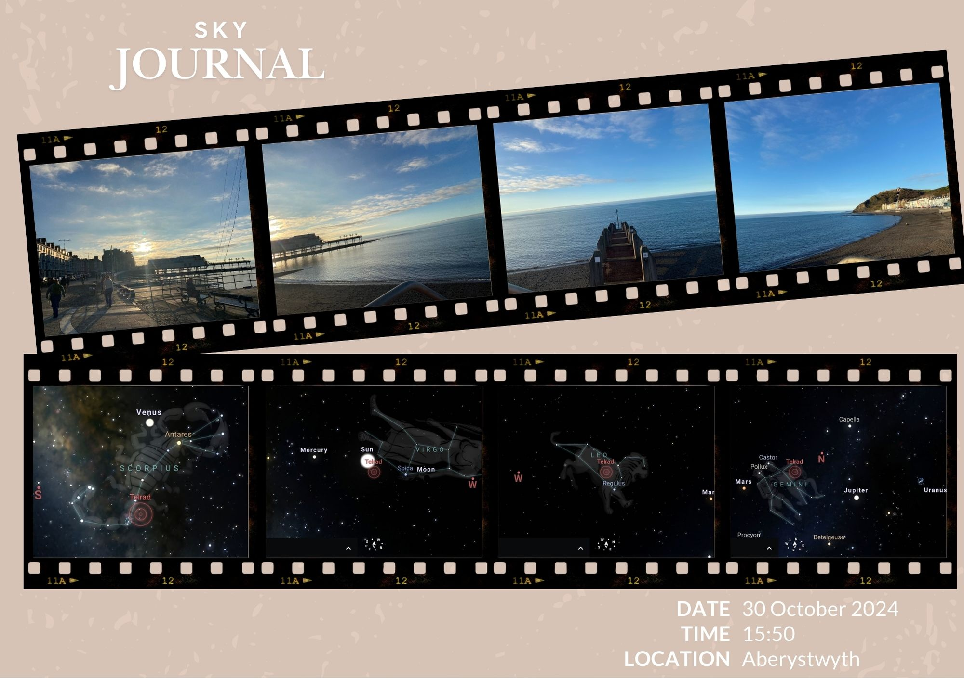

Final Reflection

During the process of my journal, I have:

- Gathered empirical evidence of the sky, phases of the moon, the constellations and the movement of the Sun, Moon, Mercury, Venus and Mars.
- There are new names of planets and constellations I need to research.
- When I saw a crescent moon one evening, I could actually see it as a sphere that was shaded out on one side.
- I have read about Vincent van Gogh and his time in ARLES and I know a bit more about him.
- I have also read some essays by Professor Alfred North Whitehead on science and philosophy – which are fascinating – if not a bit tricky to follow.
- I have some themes – or buckets – to fill with evidence and I’m gradually getting a plan together.
- I need to read a few more journals, get some secondary sources.
- The incident in Brighton. Walking back from Johnny’s flat to my Airbnb I was worried and hoped that I wouldn’t get assaulted, attacked or mugged. I took a risk and took my phone out and used it to take a screen grab of the sky, using Stellarium. A father and his 8-year-old son walked by and were intrigued to see what I was doing. We ended up having a lovely chat and he told me that he had seen a comet it the sky and found it thrilling. That was a truly shared moment, that reassured me there is protection – even when one feels alone – yes – on your own temporarily, we are all still connected to each other and the stars.

Gogh, Vincent van, and Ronald de Leeuw. The Letters of Vincent Van Gogh. London: Allen Lane, Penguin Press. 1996. Print. P. 392.
Mats Alvesson, and K. S. &., Reflexive Methodology - 2nd Ed.: New Vistas for Qualitative. London: Sage Publications. 2009.
Campion, Nicholas. The New Age in the Modern West: Counterculture, Utopia and Prophecy from the Late Eighteenth Century to the Present Day. London: Bloomsbury. 2015.
Gogh, Vincent van, and Ronald de Leeuw. The Letters of Vincent Van Gogh. London: Allen Lane, Penguin Press. 1996. Print. P. 392.
https://www.vangoghmuseum.nl/en/art-and-stories/stories/all-stories/where-is-the-starry-night
Soth, Lauren, Soth, Lauren. ‘Van Gogh’s Agony’. The Art Bulletin 68, No. 2 1986. P. 301–13. https://doi.org/10.2307/3050939.
Kern Stephen, The Culture and Time and Space 1880 - 1918 (2003), Ch 4 The Nature of Time London: Harvard University Press. 2003
Soth, Lauren. “Van Gogh’s Agony.” The Art Bulletin 68, no. 2 (1986): P. 301–13.
Whitehead, Alfred North. Essays in Science and Philosophy London: William Brendon and Son. 1948 P. 85
Eagleton, Terry. The Idea of Culture Oxford: Blackwell Publishers. 2000 P.12
Newton, Isaac. Philosophiæ naturalis principia mathematica. Londoni: Jussu Societas Regiæ ac typis Josephi Streater, prostant venales apud Sam. Smith ..., 1687. Print.
This could serve as a meta-narrative framework. Further Research: Lombardo, Paul A. “The Great Chain of Being and the Limits to the Machiavellian Cosmos.” Journal of Thought 17, no. 1 (1982): 37–52.

