

Certificate of Higher Education in Skills for the Workplace

Student Name: | Condratenco Ecaterina
Student Number: | 1915920
Module No: | BMSW4001_LON
Module Title: | Academic and Employability Skills
Lecturer: | Nadeem Mirza

Contents
Introduction: 3
Time Management: 3
Paraphrasing: 5
CV writing: 6
Cover letter writing: 7
Conclusion: 8
References 10
Appendix 1 11
Appendix 2 12

Introduction:
In 2020 at the 17th of February I started to learn at University of Wales Trinity Saint David. The course that I have chosen is the Certificate of Higher Education in Skills for the Workplace. And this event divided my life into two parts: before and after. Of course, I have not finished this University yet but still, I have already a lot of knowledge that has changed my life. In this report, I would like to describe the most significant things that I have learned on the lessons at Academic and Employability Skills. Here I will talk about the time management, paraphrasing, CV writing, Cover letter and Reflective writing.

Time Management:
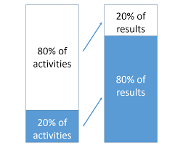
At the first week of our study, we were learning about the time management. Lecture was telling us about the Pareto principle 80/20 (Picture 1). "The 80/20 Principle asserts that a minority of causes, imputes effort usually lead to a majority of the results, outputs or rewards" (Koch, 1998, p.4). Therefore, we figured out what Procrastination is and delved into the Time Management Matrix by Stephen R. Covey in detail.
Picture 1
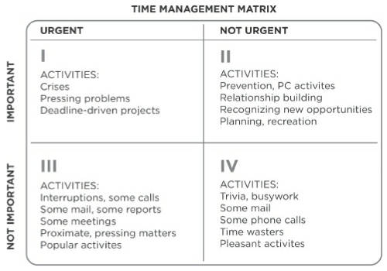
Picture 2 (Covey, 1990, p.151)
And finally, at this lesson, we got acquainted with the Eisenhower method as well.
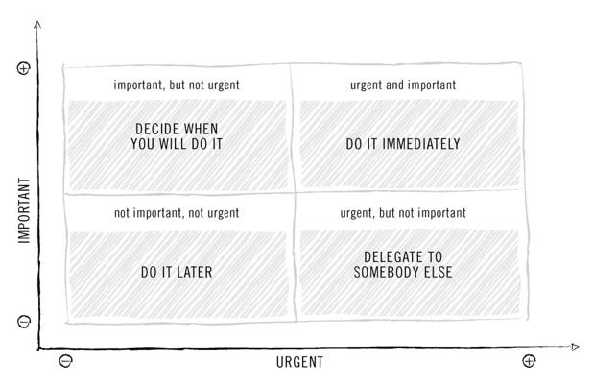
Picture 3 (Krogerus and Tschappeler, 2011, p.10)
When I heard about the topic at the beginning of the lesson, I thought that it would be a boring lecture for me, because I had known a lot about the Time Management. But during the session, I felt completely lost and frustrated, and at the same time very excited. Why? Because it was a lot of new information for me. I had never heard about Procrastination before, and I found the Pareto Principle very difficult to understand. My brain was very hard in the moment of listening to the explanation of this principle, and I think that even now I do not understand till the end how I can apply this principle in my life. The Time Management Matrix and the Eisenhower method were not so hard in understanding. I had a keen interest in these two methods and I think my colleagues as well, because we had very interesting and emotional discussions.
After that lesson, I had realized why we had learned about the Time management at the beginning of our study. Thanks to my good listening skills, responsibility and analytical thinking I had been involved in active discussions about this topic, that allowed me to make a much clearer picture of what the Time Management is. That day I had an interesting and complementary information and I found it very useful for improving my studies and for the private life. I had not applied it straight away in my everyday life at that moment, because probably I needed more time to make some more mistakes before having to realize how important is to implement this knowledge in my real life. Also, I have understood that it was a big mistake from my side to think that I knew everything about the Time Management. It is all the time something that I do not know and that can be very interesting and useful information.
Nowadays I use the Time Management Matrix and Eisenhower Method in my preparation for assessment time in University. I use this matrix and methods to achieve my goals in private life. And of course, I will use it at my workplace, because it makes me more organized and it is saving my energy from doing things that will not make my life better.

Paraphrasing:
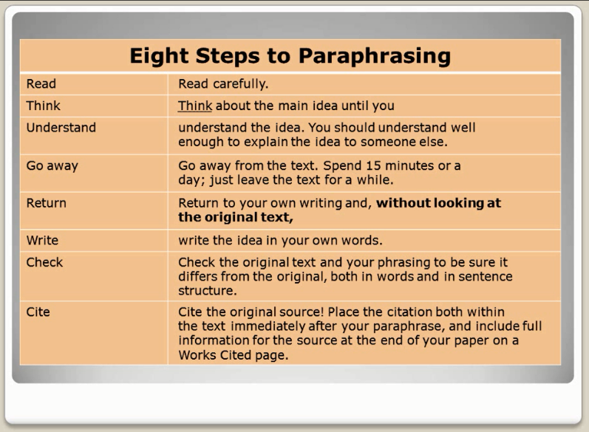
At the fifth week of our study, we were learning about the Paraphrasing. Before that lesson, of course, I knew something about that topic, because I was using paraphrasing at the school and in my private life. For me to paraphrase was just to retell the story, movie or some paragraph with other words but with the same meaning. I was quite surprised why at the University we had to talk two hours about Paraphrasing. But the session was very interesting for me, as usually. I found out that I was mixing these two concepts: Paraphrasing and Summarizing. "'Paraphrase' is derived from Greek. It simply means "equal sentence"" (Narayanacharya, 1998, p.137). It means that you need just put a passage in your own words. Summarizing it is something similar, with one main difference: you need to put in your own words just the main ideas, to paraphrase just the main points. For me, finding out about this difference was equal to a scientific discovery. That day we were learning also about 8 steps to Paraphrasing: Read, Think, Understand, Go away, Return, Write, Check, Cite. We were looking as well at some techniques which were helping to present the same meaning differently (using synonyms, changing word class, changing word order). I was so happy to understand this concept of Paraphrasing. But not everything was so smooth. I thought that paraphrasing would be easy for me. I was wrong. At the end of the lesson when we were doing a few exercises in the class, I found out that paraphrasing someone's words was very hard for me. We were discussing possible barriers to paraphrasing with the lecturer and my classmates. As a result, we found out that barriers to Paraphrasing were:
Picture 4
- for 99% of the group English language was not their native language
- most of us had a poor English vocabulary with synonyms for the words
- lack of knowledge of English grammar
- lack of practice of Paraphrasing.
That day our lecturer said to us, that the best action what can we take to resolve these barriers is practising, practising, and one more time practising. At the same session, we were discussing why is so important to have this skill of Paraphrasing and where we can use it.
At that lesson, my connection with Paraphrasing was not closed. At the end of the first term at our University, I have understood how crucial was to have and develop the Paraphrasing skill. It was important for my study needs and good professional future. Why? Because I needed to paraphrase the passages from the articles and books for all my assignments. In the Academic and Employability Skills assignment, I was making my Personal SWAT Analysis and I had created my Personal Development Plan (see appendix 1). I have understood that the Paraphrasing skill is a vital skill for my dream job, because it will help me to write an e-mail, make a presentation or memos quickly and easily. It will make me more competitive in the work field.
Nowadays I still use Paraphrasing almost every day. This skill now is much better than it was before. At the end, I do not work as a Personal assistant (see appendix 1) because of COVID-19 my dreams have changed, but still, I am using Paraphrasing almost every day.

CV writing:
"A CV is essentially a document that charts the course of your life – more specifically, your work life – for the purpose of gaining employment" (Talabi, 2011, p. XV) that was my knowledge before I had attended the class and that in England when you apply for several jobs you need to create all the time different CV for each position. From the beginning of the lesson, I was very excited about this topic. I was very happy to have it. Why? All my life I had a complicated relationship with CV writing. Thank God my friends helped me to do my CVs. It was before I have moved to London. Here I was lucky as well and I was applying everywhere with my old CV by European standard, which is opposite to UK standards. This story finished when I remained without a job because of the COVID-19. At this moment I understood that I need another job with a better position and for this I need to create a good CV.
Second week, second term. Finally, I was waiting for the lesson of CV writing. I liked the session. It was a lot of joy and it was interesting for me to hear the experience of my colleagues. We were talking about personal brand development, about some elements of a professional CV, about CV presentation and Formatting. I was surprised that there is no need to write my address, age, gender and marriage in the CV. Before I thought it is "must be" information. Our lecturer told us the top tips of personal statement and gave some very useful examples. During that lesson, I found out the difference between my old and new CV styles. UK style of CV in comparison with European style provides details about Personal Statement, hobbies & interests. Also, it is no need to write all your work experience, just that one that is relevant to the applied position.
At the end of that lesson, I was very happy because finally, I had a clear idea of how a good CV should look. On the other side, I was a bit upset because I had recognized that it was still complicated to write it. Personal statement part and skills description were the most problematic for me.
Today I can report that I have received a lot of new knowledge about CV writing. It makes my everyday life much easier. I will apply this knowledge when creating my CV.

Cover letter writing:
May be for someone it will be funny or even strange to realize that I did know nothing about Cover letter writing before attending the class. When I had applied for some prestigious positions, I discovered Cover letter for the first time. I did not apply for certain positions because a Cover letter was required. So, 3rd week, 2nd term, when the lecturer named the topic of the lesson I thought: "oh my god, it will be a boring lesson, I do not have any experience to share and why we need to lose two hours of our life for so unimportant things?". My colleagues had the same mind. Many of my classmates were thinking that Cover Letter is something not unuseful in our life. We had actively discussed our opinions. Finally, our lecturer together with some other students provided many rational arguments about the importance of Cover letter and I had changed my mind. "A covering letter is a professional business letter which provides an employer with an introduction to an accompanying CV." (Morgan, 2017, p. 339) We had analyzed the difference between CV and Cover Letter. I liked the phrase that CV is our bones but Cover Letter ensure muscle and linkage. It is not the same stuff, and we do not need to repeat information from our CV. Also, we found out that first 30 seconds play a crucial role the recruiter's decision to continue reading the Cover Letter. That is why, it is so important: to know whom you address this Cover letter to, to introduce yourself and to sell yourself. We had discussed with the group how is it important to make a small research about the company you are applying for and to write more specifically what can you do for the company. Lecturer paid our attention to the last component of the letter "call to action". The most important part of that lesson was practising. I was writing the first Cover Letter in my life (see appendix 2).
That session was useful and practical for me: plenty of new knowledge and discoveries. I have understood why I did not receive answers from many prestigious positions I was applying before. To write a good Cover Letter is not so easy, but a good position deserves these efforts.

Conclusion:
To sum up, all the sessions described above were useful and appropriate for me. Program of the course was well organized with the necessary knowledge for private and professional life. I am very grateful to the University's professors for offering us such an opportunity to learn these important and interesting topics as Time Management, Paraphrasing, CV Writing and Cover Letter Writing. Of course, there were different other topics with no less significance, but these four impressed me the most.

References
Koch, R. (1998) The 80/20 Principle. The secret of achieving more with less. London: Nicholas Brealey Publishing.
Morgan, P (2017). The Business Student’s Guide to Employability. London: Sage.
Narayanacharya, M.V. (1998) Prosody. Rajamundry: Rohini Publications.
Picture 1: Available at: https://ghanatalksbusiness.com/2016/11/7-mental-models-you-should-know-for-smarter-decision-making/attachment-mm3/ (Accessed: 29 July 2020)
Picture 2: Covey, S.R (1990) The seven habits of highly effective people: restoring the character ethic. New York: Fireside Book.
Picture 3: Krogerus, M. and Tschappeler, R. (2011) The Decision Book. Fifty models for strategic thinking. London: Profile Books.
Picture 3: Eight Steps to Paraphrasing ppt (2011). Youtube, 04 November. Available at: https://www.youtube.com/watch?v=BVrGMShuABI (Accessed: 29 July 2020)
Talabi, M. (2011) 7 keys to a winning CV: how to create a CV that gets results. Great Britain: Harriman House.

Appendix 1
Personal Development Plan (PDP)
Goal | To work as a Personal Assistant in London
What skills and knowledge to learn? | - Knowledge Microsoft Packages  - Paraphrasing and Summarizing, academic writing.  - Knowledge in travel and expense systems  - Upper-intermediate English (spoken and writing)
How to acquire these skills and knowledge? | - To find and download the handbooks for Microsoft Office, Excel, PowerPoint, Outlook, and start practicing.  - To paraphrase and summarize one article each day.  - To install and start using program Concur.  - - to start the course on Skyeng.  - to look movie on English with subtitles.  - to start from the beginner to learn English grammar from the book.
What resources do I need? | I need free time.  I need concertation and focus on my goal.
Time Schedule for every skill and knowledge | - One month.  - Six months.  - One month  - Six months
When the realization of the plan starts? | - 11.05.2020  - 11.05.2020  - 22.06.2020  - 22.06.2020
When the realization of the plan finished? | - 11.06.2020  - 11.10.2020  - 22.07.2020  - 22.11.2020
Completion | □__________ Date  □__________ Date  □__________ Date

Appendix 2
Cover Letter.
Dear Mr Davies,
I wish to apply for the role of Exam Assistant, currently being advertised on linkedin.com.
I had given a good customer experience and business results during all my careers through effective Time Management, organization and analytical skills. My strengths and experience are a perfect match for the Exam Assistant requirements, and will bring significant contribution and positive value to Group Ltd.
In my previous position as a Spa Attendant, I was using a careful and individual approach to each client. While I collaborate effectively within a group, the same time I have independent motivation. Moreover, I am competent in social media, all office techniques and I know four languages.
Opportunity to work with you is interesting for me because my goals align with Group Ltd.'s mission. Also, my organization, communication skills and analytical thinking will be a good support for your continued organizational efforts.
To get a deeper understanding of my professional skills, please, take a look on my enclosed resume.
I am grateful for your time and subsequent response.
Sincerely,
Ecaterina Condratenco

