Aimee Thomas
History Independent Project
(HPHI5018)
University of Wales Trinity Saint David
Thomas Jansen
04.05.2025
To what extent did Victorian philanthropy help or hinder the ‘Common prostitute’.
The nineteenth century saw a huge change in society, through votes for women, workers’ rights and society’s approach to the poor. Throughout this research there will be a focus on Victorian philanthropic movements and an evaluation of the philanthropy movement’s contribution or hindrance towards the impoverished working class. During this time there were important societal developments which changed class relationships and structures, with organizations such as the Ladies National Association for the Repeal of the Contagious Disease Acts (LNA) and the National Vigilance association (NVA) being formed. These developments were supported and encouraged by works of philanthropy. In the Victorian period philanthropy became increasingly popular for the upper-middle class, and Karen Halbersleben remarks that ‘Victorian philanthropy confronted the vast social and moral problems of a rapidly industrialising society.’ Middle class Victorians were eager to contribute to the improvement of society through the work of philanthropy and according to Brian Harrison this helped to bring society’s faults to light, ‘philanthropists brought drunkards, lunatics, orphans, prostitution, tramps and sweeps into the sphere of public concern’. Victorian middle-class women, many of whom were Evangelical Christians, had an active part in the work of philanthropy. They drew on Evangelical Christian and middle-class values to save the impoverished working class. Through active participation in charities many Victorian women were inspired to come out of the private sphere of the home and became more involved in the public sphere. Here they developed new skills and an interest in working for what they thought of as a just cause.
One such cause was the plight of prostitutes. Prostitutes at this time were regarded as pitiable and fallen women, they represented a moral failing of society. Legislation at the time such as the Contagious Diseases Act of 1864 served to make the issue of prostitution more visible through the controversial and excessive targeting of ‘suspicious’ women. Charitable women groups took up the cause, but their success was hampered by the complex issues surrounding prostitution and a focus on the symptoms rather than the underlying cause of the problems facing women in poverty. Whether the women’s movements helped or hindered women’s autonomy is debated and women tended to be held solely responsible for a societal problem. There appears to be less focus on reforming male behaviour. However, the women’s movements demonstrate the early organisation of women in support of women, which later takes fuller form in the women’s suffrage movement.
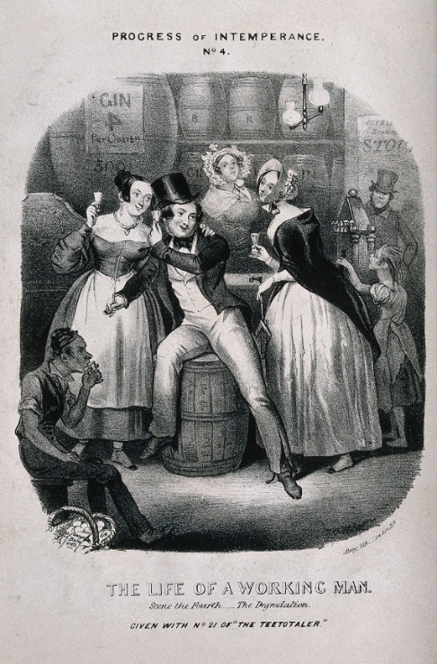
Figure 1, A drunken man surrounded by women in a dingy alehouse. Lithograph, c. 1840, after T. Wilson., Wilson, T.C (Contributors), ‘The life of a working man’, (1840?), The Wellcome Collection.

In the nineteenth century philanthropy became a matter of ‘social standing and social ambition’ for the middle classes. F. K. Prochaska explains that ‘To the Victorian mind, philanthropy was a form of enlightened self-interest. Voluntary action not only provided moral and social benefits to the giver, but it acted as a guard against the State’s standardizing tendencies’. Harrison further comments how Victorian philosophy focused primarily on the poor, ‘Philanthropic bodies tended to concentrate only on the respectable poor...’. During this time, middle class women began to engage more with philanthropy and the day-to-day activities of philanthropic movements. Through their increased involvement in activities outside the home and in wider society, Victorian ideology of the public and private spheres was challenged. In the Victorian period, Victorian values and ideology dictated a divide between male and female roles, with the public sphere for men and the private sphere for women. Anne Digby explains the difference, ‘public sphere (viewed as a masculine domain concerned with paid work and national politics), and the private sphere (viewed as a female domain concerned with home and family)’. Charities began to take advantage of women’s growing interest in the public sphere and as such nineteenth century philanthropy became female dominated or as Digby describes, ‘womanized’ and so began the process of societal changes targeted for women’s rights. This is demonstrated through the case of prostitution and the repeal campaign for the Contagious Disease Acts that discriminated against women in Victorian society.
In the world of the middle and upper classes, prostitution became a matter of fascination and disgust. Due to the new industrial era prostitution became part of public consciousness as urbanisation brought the working class in contact to the higher classes, and according to Judith Walkowitz, ‘highly visible symbol of the dislocation attendant upon the new industrial era’. As such prostitution had become known as the ‘Great Social Evil’. In the nineteenth century prostitution was not illegal within Great Britian, the term ‘Common prostitute’ did not hold a clear legal definition. According to Walkowitz the term, ‘Common prostitute’, was mostly related to ‘women who solicited men in public thoroughfares.’ Walkowitz further describes how the authorities’ approach towards prostitution was to keep them contained and unseen from the public eye,
Authorities were mainly concerned in imposing a certain level of public decorum on prostitutes, to contain them within certain areas, and to break up collusions between prostitutes and thieves. To do so, they entered into some accommodation with streetwalkers, permitting them to ply their trade as long as they were not public nuisances.
The middle and upper classes of Victorian society viewed prostitutes as fallen women who were seduced by their upper-class employers, which Walkowitz comments,
Writers on prostitution acknowledged that members of their own class were often responsible for these women’s initial downfall. According to their accounts, ladies’ maids and other upper servants fell victim to middle-class seduction and betrayal, whereas the demand for prostitution came largely from men of the propertied classes.
As such female philanthropists began to engage with the morality of prostitution. According to Emma Liggings, ‘Feminist accounts of prostitution tended to promote the importance of philanthropy and to stress woman's vital role in 'leading [the prostitute] back to a better life’’. Yet philanthropists viewed working women, who resisted the charitable help, as ‘degraded’ but, as Liggins argues perhaps this could be the fault of philanthropy. Many working class people, according to Harrison, disliked philanthropists involving themselves in their daily lives with the arrogance of their circumstances, ‘some working class people disliked being visited in their homes by philanthropists who displayed great ignorance to the problems they faced’.
Victorian prostitutes were mainly working-class women who sought to make ends meet and also to achieve independence. Due to the economic strain on working class women, some of them gravitated towards the profession as in this period there were limited work opportunities for women. Commonly prostitutes entered the profession in their late teenage years, most of those women came from a broken home or travelled from the countryside and had little or no help from their families, to make ends meet. Kathryn Gleadle describes how early feminists saw these women as victims of the ‘epitome of society patriarchal sexual hierarchy’. As such many campaigns, such as the Contagious Disease Act repeal, sought to help these women but did not understand why they rationally made the decision to engage with sex work. The profession was mostly active in port cities such as Liverpool and Plymouth and ‘pleasure resorts’ as in port cities there was potentially a large cliental made up of naval officers and working men. In bigger cities, such as London, prostitutes would be seen soliciting outside theatres or in pubs. The lithograph, figure 1, is one of a series of six that shows a working man’s downfall through drink. He is surrounded by women with an implication of being tempted while inebriated. According to Walkowitz, after some time, most of the young girls would leave the profession to find a more respectable occupation or to settle down.
Prostitution was often a temporary occupation that allowed working women to achieve their independence and control over their life. However, they continued to still operate under male dominance and class constraints within a patriarchal society. Soliciting or ‘street walking’, while it had a certain appeal for young women who wanted to have control over their lives, always came with a threat of constant danger as Walkowitz describes,
As a temporary occupation, streetwalking did, however, have severe drawbacks: it did not free women from a life of poverty and insecurity, and further subjected them to physical danger, alcoholism, venereal disease, and police harassment.
The threat of danger that surrounded prostitutes at this time expanded with the epidemic of venereal disease in the mid-Victorian period. Venereal disease became a serious health issue for the population of Britain, British officials blamed prostitutes as the main cause. To combat venereal diseases, such as gonorrhoea and syphilis, government officials introduced the Contagious Diseases Acts in 1864 which continued to be extended until it’s repeal in 1886.
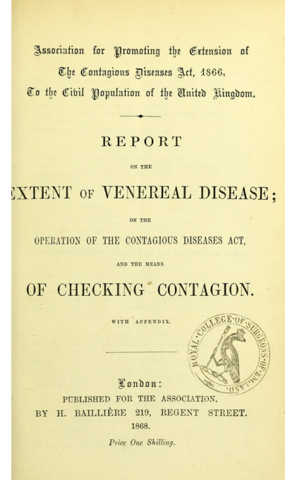
Figure 2, Report on the extent of venereal disease, on the operation of the Contagious Diseases Act, and the means of checking contagion : with appendix / Association for Promoting the Extension of the Contagious Diseases Act, 1866, to the Civil Population of the United Kingdom., Association for Promoting the Extension of the Contagious Diseases Acts (Publisher), ‘Medical Heritage Library’, (1868), The Wellcome Collection.

The Contagious Diseases Act were a set of legislation that discriminated and endangered women in mid-Victorian Britain. The revised report of the 1866 Contagious Diseases Act, figure 2, was published in 1868 by H. Bailliere, Report on the Extent of Venereal Disease; on the operation of the Contagious Diseases Act and the means of checking contagion. Association for promoting the extension of the Contagious Diseases Act, 1866, to the Civil Population of the United Kingdom. The report supported the extension of the legislation and civil powers contained within the Acts. The Acts were enforced primarily through the scrutiny and policing of prostitutes, putting the focus and blame almost entirely onto women. The Act allowed forced medical inspection of women suspected of prostitution which is supported in page 13 of the report, ‘33. Common prostitutes should be subject to a compulsory periodical medical examination, and to compulsory detention in hospital as often as they are found diseased, and as long as they continue so’. This was mostly enforced, specifically, in garrison and naval port towns in the late 1860s and early 1880s. There were clearly problems with this as it allowed any women under suspicion to be targeted. In Page 16 of the report the police were given powers to regulate areas that were favoured by prostitutes,
41. The Association desires the suppression, by police regulations, of the open profligacy of the streets, which offers so great a temptation to the young and thoughtless. This has resulted from the operation of the contagious diseases Act at Plymouth.
This was particularly a problem as there was no clear definition of a prostitute. Gleadle comments how the Acts further restricted and humiliated women from middle- and working-class backgrounds. This generated an outcry from the public in 1869, mainly from women, which is demonstrated by figure 3.

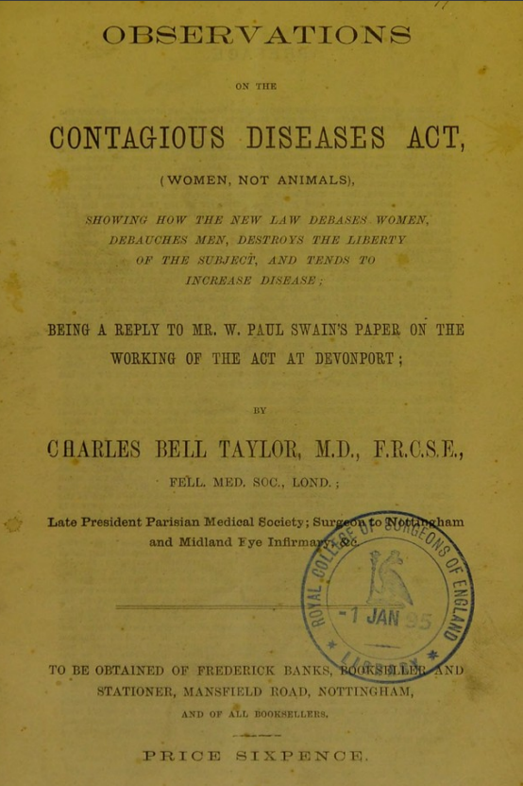
Figure 3, Observations on the Contagious Diseases Act (women, not animals) : showing how the new law debases women, debauches men, destroys the liberty of the subject, and tends to increase disease, being a reply to Mr. W. Paul Swain's paper on the working of the Act at Devonport / by Charles Bell Taylor, Taylor, Charles Bell (author), ‘Medical Heritage Library’, (1869), The Wellcome Collection.

The paper, figure 3, is called Observations on the Contagious Diseases Act (women not animals) : showing how the new law debases women, debauches men, destroys the liberty of the subject, and tends to increase disease, being a reply to Mr. W. Paul Swains paper on the working of the Act at Devonport, was published by Charles Bell Taylor in response to the effects of the Contagious Diseases Act on women in Victorian society.The article supports Gleadle’s comment on how the Act further humiliated women as Charles Bell Taylor comments,
Under the provisions of the Contagious Diseases Act, any women whom a policeman may choose to designate, or affect to believe to be a prostitute, without proof, without evidence, trail, or conviction, is liable to be arrested, taken before a magistrate, and condemned to three months’ imprisonment with hard labour, which may be repeated indefinitely, that is, for life, if she decline to submit (for at least a year, in company with the vilest prostitutes) to a frequently repeated violation of her person with a surgical instrument.
Charles Bell Taylor had accurately described how with no clear definition of a prostitute, seen in figure 2, further affected, humiliated and placed Victorian women in danger from all classes.
I repeat, and defy contradiction, that there is no definition of prostitution whatever given in connection with this Bill, the spies have nothing to guide them in their selection of victims ; and I am informed that one of these officials recently told a girl that his reason for arresting her was that he had seen her twice at a concert. One witness, in his evidence given before the Parliamentary Committee, said that prostitution was more a matter of mannerism that anything else. No proof is required. Suspicions, just or unjust, aroused by worthy or unworthy motives, are all that is necessary to condemn the best women in the land ; and if she happens to be penniless and friendless so much the worse for her.
The publication of figure 3, encouraged repeal movements such as the National Anti-Contagious Diseases Act Extension Association (the National Association). However, as nineteenth century philanthropy became ‘womanized’, many women of all classes became involved in the campaign to repeal the Contagious Diseases Acts, such as the Ladies National Association for the Repeal of the Contagious Disease Acts (LNA).
The LNA became an important contributor to the repeal of the Contagious Diseases Acts. A protest letter was published in the Daily News in December 1869 with 124 signatures, claiming that the Acts discriminated against women. Walkowitz, quoted from the letter, details that
The acts violated the “legal safeguards hitherto enjoyed by women in common with men’; they allowed police absolute power over women; they “‘punish the sex who are the victims of vice and leave unpunished the sex who are the main causes both of the vice and its dreaded consequences’’; they made vice safe and smoothed the “path of evil” for “our sons’; and they failed as moral and sanitary legislation.
The majority of middle-class women, who actively engaged with the repeal movement, were not new to the philanthropic work in prostitution. One of the Key contributors to the cause was Josephine Butler, she became the leader of the LNA and actively tried to address the political question of prostitution. According to Liggins,
Josephine Butler, whose prominent campaigning for repeal from the 1870s onwards included nursing dying prostitutes in her own home, spoke of 'this wonderful and beautiful solidarity of the women of the world before God' and challenged entrenched views of the fallen by highlighting 'the sacredness of every woman even at her lowest, most degraded, and most despised estate'. Her belief in the reclamation of prostitutes enabled by sisterhood between middle and working-class women was not shared by other philanthropists of the time, nor were such positive images of 'degraded' women always endorsed.
The campaign saw a positive result in 1883 which abolished the compulsory examination of women under the Act. The Contagious Disease Acts, like the 1866 extension, were further repealed in 1886 which stopped compulsory medical examinations and the police abuse of power over women, mainly working-class women. Even so Harrison comments on philanthropic works, by the middle class, as having an agenda attached to some of their causes. For example, the LNA did help working class women gain back their autonomy, but the campaign also allowed middle class women to actively engage and assert themselves in conversations of politics and women’s rights.
The LNA and the National Association were both dissolved after the Acts were repealed although both organisations, according to Walkowitz, ‘absorbed into the National Vigilance Association, a more prurient moral reform group that eschewed the feminist and constitutional goals of the repeal movement’. The National Vigilance Association (NVA) continued to work with prostitutes and offered support from indecent sexual assault, ‘seduction’ and rape. However, the NVA continued to follow and create the same atmosphere that the Contagious Disease Act legislation tried to impose on Victorian women, instead the NVA primarily regulated working women. The NVA continued to focus on working class women through surveillance and control over their sexuality as the stereotype of ‘diseased’ prostitutes continued to be perpetrated. The NVA began ‘to regulate street prostitution and music halls, to ban obscene books and close brothels’ through The Criminal Law Amendment Act 1885. The Act allowed persecution of brothels within Britain, this put pressure on landlords to be wary of potential lodgers. This began to hinder working women as landlords would refuse to rent to ‘suspicious’ women which continued the stereotype of single women, or women in general, being up to no good. Lucy Bland comments how this began to effect housing and women,
This created a housing problem not only for women working as prostitutes and living in lodging-house brothels, but also for any women living with other women, and even women living on their own, although the latter did not constitute a ‘brothel’.
This created a dangerous position for prostitutes who saw their independence being stripped away and as such were recruited under pimps or ‘bullies’ to gain protection and housing to work. The closure of brothels saw women and children thrown on to the street with some being sent to prison for vagrancy. Moreover, Bland describes how the Act targeted lower -class brothels but the upper-class brothels or ‘fashionable houses’ remained untouched from the 1885 Amendment Act, which created a double standard. The NVA were ignorant to the effect on prostitutes and primarily remained focused on eradicating brothels and sex work through the prostitutes rather than the male clientele. Also, the view of the ‘reclaimable’ and the ‘non-reclaimable’ prostitutes continued, this illustrates an unawareness of the main issue that surrounded prostitution as, ‘Their story is not one of opportunity and entrepreneurship, but rather of survival’. Bland further summaries the extent to which the NVA hindered these women,
In their attempts to challenge the practice of prostitution, and to protect the innocent victim (the reclaimable prostitute and the respectable women on the street), they ended up both denying other’s women agency- their ability to act on the world- as well as controlling those women they defined as ‘unreclaimable’.
As such Victorian philanthropy hindered prostitutes and created an uncomfortable atmosphere to which has followed into the twenty-first century.
The nineteenth century saw the beginning of societal transformation driven by works of philanthropy. The case study of prostitution highlights the hindrance of some certain charity efforts from the middle class. Female benefactors, such as Josephine Butler, actively engaged with prostitution but, mostly addressed the symptoms rather than the underlying issue. The middle class's perceptions of prostitution were founded on a lack of understanding of working-class realities. Most middle-class philanthropists viewed prostitutes as victims rather than women endeavouring to live. The dangerous rhetoric of the Contagious Disease Act of 1864 provoked a backlash against its discrimination which targeted predominantly working women, prompting female philanthropists to establish the LNA to challenge and repeal the oppressive legislation. This enabled women to reclaim their liberty, but with the repeal of the Contagious Disease Act in 1886, the NVA continued to regulate prostitution themselves, perpetuating the restrictive legislation they had previously annulled. This further impeded prostitutes as the primary objective of the NVA was to eliminate prostitution itself rather than address the main cause or focus on the male clientele. This situation placed prostitution in a dangerous space, particularly due to the Criminal Law Amendment Act, which resulted in numerous women and children being displaced into the streets following the closure of brothels and the pressure exerted on landlords at this time. Numerous female benefactors advocated for women’s rights yet also exacerbated the plight of those in need by a profound ignorance to the realities that surrounded prostitution, there by created a more precarious environment for sex workers.

Reference List:
Association for Promoting the Extension of the Contagious Diseases Acts, Report on the
extent of venereal disease, on the operation of the Contagious Diseases Act, and the means of checking contagion : with appendix / Association for Promoting the Extension of the Contagious Diseases Act, 1866, to the Civil Population of the United Kingdom. London: H. Baillière, (1868). Public Domain Mark. Source: Wellcome Collection. <https://wellcomecollection.org/works/bqwxzmxt> [accessed: 22 April 2025].
Bland, Lucy, Banishing the Beast: English Feminism and Sexual Morality 1885-1914 (London: Penguin Books, 1995).
Caine, Barbara, Victorian Feminist (New York: Oxford University Press, 1992).
Davis, Tracy C., ‘Actresses and Prostitutes in Victorian London’, Theatre Research International, 13.3 (1988), pp. 221–34, <doi:10.1017/S0307883300005794>.
Digby, Anne, ‘Victorian Values and Women in Public and Private’, Proceedings of the British Academy, 78 (1992), pp. 195–215 <78p195.pdf>[accessed: 7 April 2025].
Gleadle, Kathryn, British Women in the Nineteenth Century. (Hampshire: Palgrave, 2001).
Harrison, Brian, ‘Philanthropy and the Victorians’, Victorian Studies, 9.4 (1966), pp. 353–74 < https://www.jstor.org/stable/3825816>[accsessed: 15 April 2025].
Halbersleben, Karen I, ‘Philanthropy’, in Victorian Britain: An Encyclopaedia, ed. By Sally
Mitchell (London: St James Press, 1988), pp.595-597.
Liggins, Emma, ‘Prostitution and Social Purity in the 1880s and 1890s’, Critical Survey, 15.3 (2003)<doi:10.3167/001115703782153510>.
Prochaska, F.K, Philanthropy and the Hospitals of London: The King’s Fund, 1897-1990, Online (Oxford: Oxford Academic, 2011) <https://doi.org/10.1093/acprof:oso/9780198202660.001.0001>.
The Wellcome Collection, ‘A Drunken Man Surrounded by Women in a Dingy Alehouse. Lithograph, c. 1840, after T. Wilson.’,(2025) <https://wellcomecollection.org/works/mnnfhdek>[accessed: 22 April 2025].
The Wellcome Collection, ‘Observations on the Contagious Diseases Act (Women, Not Animals) : Showing How the New Law Debases Women, Debauches Men, Destroys the Liberty of the Subject, and Tends to Increase Disease, Being a Reply to Mr. W. Paul Swain’s Paper on the Working of the Act at Devonport / by Charles Bell Taylor.’, Wellcome Collection, (2025) <https://wellcomecollection.org/works/x6dd692a>[accessed: 22 April 2025].
——, ‘Report on the Extent of Venereal Disease, on the Operation of the Contagious Diseases Act, and the Means of Checking Contagion : With Appendix / Association for Promoting the Extension of the Contagious Diseases Act, 1866, to the Civil Population of the United Kingdom.’, Wellcome Collection, (2025) <https://wellcomecollection.org/works/bqwxzmxt> [accessed 22 May 2025].
Taylor, Charles Bell, Observations on the Contagious Diseases Act (women, not
animals) : showing how the new law debases women, debauches men, destroys the liberty of the subject, and tends to increase disease, being a reply to Mr. W. Paul Swain's paper on the working of the Act at Devonport / by Charles Bell Taylor. Nottingham: To be obtained of Frederick Banks, (1869). pp. 3-4. Public Domain Mark. Source: Wellcome Collection. <https://wellcomecollection.org/works/x6dd692> [accessed: 22 April 2025].

Walkowitz, Judith R., Prostitution and Victorian Society: Women, Class, and the State (Cambridge: Cambridge University Press, 1980) <https://hdl.handle.net/2027/heb00983.0001.001>[accessed: 22 April 2025].

Brian Harrison, ‘Philanthropy and the Victorians’, Victorian Studies, 9.4 (1966), pp. 353–74 (p. 362)< https://www.jstor.org/stable/3825816>[accsessed: 15 April 2025].
Karen I. Halbersleben, ‘Philanthropy’, in Victorian Britain: An Encyclopaedia, ed. By Sally Mitchell (London: St James Press, 1988), pp.595-597 (p.595).
Harrison, ‘Philanthropy and the Victorians’, p. 362.
Kathryn Gleadle, British Women in the Nineteenth Century. (Hampshire: Palgrave, 2001), pp. 99–100.
F.K Prochaska, Philanthropy and the Hospitals of London: The King’s Fund, 1897-1990, (Oxford: Oxford Academic, 2011), p. 3 <https://doi.org/10.1093/acprof:oso/9780198202660.001.0001>.
Prochaska, Philanthropy and the Hospitals of London: The King’s Fund, 1897-1990, p. 3.
Harrison, ‘Philanthropy and the Victorians’, p. 371.
Anne Digby, ‘Victorian Values and Women in Public and Private’, Proceedings of the British Academy, 78 (1992), pp. 195–215 (p. 195) <78p195.pdf>[accessed: 7 April 2025].
Digby, ‘Victorian Values and Women in Public and Private’, p. 202. Halbersleben, ‘Philanthropy’, in Victorian Britain: An Encyclopaedia.pp.595-597.
Judith R. Walkowitz, Prostitution and Victorian Society: Women, Class, and the State (Cambridge: Cambridge University Press, 1980), p. 32 <https://hdl.handle.net/2027/heb00983.0001.001> [accessed: 22 April 2025].
Walkowitz, Prostitution and Victorian Society, pp. 30–31.
Walkowitz, Prostitution and Victorian Society, p. 14.
Walkowitz, Prostitution and Victorian Society, p. 14.
Walkowitz, Prostitution and Victorian Society, p. 34.
Emma Liggins, ‘Prostitution and Social Purity in the 1880s and 1890s’, Critical Survey, 15.3 (2003), p. 40, <doi:10.3167/001115703782153510>.
Liggins, ‘Prostitution and Social Purity in the 1880s and 1890s’, p. 41.
Harrison, ‘Philanthropy and the Victorians’, p. 371.
Walkowitz, Prostitution and Victorian Society, p. 22.
Walkowitz, Prostitution and Victorian Society, p. 18-19. Walkowitz, Prostitution and Victorian Society, pp. 15–16.
Gleadle, British Women in the Nineteenth Century., p. 99.
Gleadle, British Women in the Nineteenth Century., p. 99.
Walkowitz, Prostitution and Victorian Society, p. 22.
Tracy C. Davis, ‘Actresses and Prostitutes in Victorian London’, Theatre Research International, 13.3 (1988), pp. 221–34 (p. 225), <doi:10.1017/S0307883300005794>.
The Wellcome Collection, ‘A Drunken Man Surrounded by Women in a Dingy Alehouse. Lithograph, c. 1840, after T. Wilson.’, (2025) <https://wellcomecollection.org/works/mnnfhdek>.
Walkowitz, Prostitution and Victorian Society, p. 18.
Walkowitz, Prostitution and Victorian Society, pp. 30–31.
Walkowitz, Prostitution and Victorian Society, p. 31.
Walkowitz, Prostitution and Victorian Society, p. 48.
Walkowitz, Prostitution and Victorian Society, p. 99.
The Wellcome Collection, ‘Report on the Extent of Venereal Disease, on the Operation of the Contagious Diseases Act, and the Means of Checking Contagion : With Appendix / Association for Promoting the Extension of the Contagious Diseases Act, 1866, to the Civil Population of the United Kingdom.’, Wellcome Collection (2025) <https://wellcomecollection.org/works/bqwxzmxt> [accessed 3 May 2025].
Association for Promoting the Extension of the Contagious Diseases Acts, Report on the extent of venereal disease, on the operation of the Contagious Diseases Act, and the means of checking contagion : with appendix / Association for Promoting the Extension of the Contagious Diseases Act, 1866, to the Civil Population of the United Kingdom. London: H. Baillière, (1868). p.13. Public Domain Mark. Source: Wellcome Collection. <https://wellcomecollection.org/works/bqwxzmxt> [accessed: 22 April 2025].
Digby, ‘Victorian Values and Women in Public and Private’, p.200.
Association for Promoting the Extension of the Contagious Diseases Acts, Report on the extent of venereal disease, on the operation of the Contagious Diseases Act, and the means of checking contagion : with appendix / Association for Promoting the Extension of the Contagious Diseases Act, 1866, to the Civil Population of the United Kingdom. London: H. Baillière, (1868). p.16. Public Domain Mark. Source: Wellcome Collection. <https://wellcomecollection.org/works/bqwxzmxt> [accessed: 22 April 2025].
Gleadle, British Women in the Nineteenth Century., p. 100.
The Wellcome Collection, ‘Observations on the Contagious Diseases Act (Women, Not Animals) : Showing How the New Law Debases Women, Debauches Men, Destroys the Liberty of the Subject, and Tends to Increase Disease, Being a Reply to Mr. W. Paul Swain’s Paper on the Working of the Act at Devonport / by Charles Bell Taylor.’, Wellcome Collection, (2025) <https://wellcomecollection.org/works/x6dd692a>.
Charles Bell Taylor, Observations on the Contagious Diseases Act (women, not animals) : showing how the new law debases women, debauches men, destroys the liberty of the subject, and tends to increase disease, being a reply to Mr. W. Paul Swain's paper on the working of the Act at Devonport / by Charles Bell Taylor. Nottingham: To be obtained of Frederick Banks, (1869). pp. 3-4. Public Domain Mark. Source: Wellcome Collection. <https://wellcomecollection.org/works/x6dd692a> [accessed: 22 April 2025].
Charles Bell Taylor, Observations on the Contagious Diseases Act (women, not animals) : showing how the new law debases women, debauches men, destroys the liberty of the subject, and tends to increase disease, being a reply to Mr. W. Paul Swain's paper on the working of the Act at Devonport / by Charles Bell Taylor. Nottingham: To be obtained of Frederick Banks, (1869). p. 6. Public Domain Mark. Source: Wellcome Collection. <https://wellcomecollection.org/works/x6dd692a> [accessed: 22 April 2025].
Walkowitz, Prostitution and Victorian Society, p. 93.
Digby, ‘Victorian Values and Women in Public and Private’, p. 202. Walkowitz, Prostitution and Victorian Society, p. 91. Walkowitz, Prostitution and Victorian Society, p. 93.
Walkowitz, Prostitution and Victorian Society, p. 93.
Barbara Caine, Victorian Feminist (New York: Oxford University Press, 1992), p. 170.
Liggins, ‘Prostitution and Social Purity in the 1880s and 1890s’, p. 40.
Walkowitz, Prostitution and Victorian Society, pp. 98–99.
Walkowitz, Prostitution and Victorian Society, p. 99.
Harrison, ‘Philanthropy and the Victorians’, p. 364.
Walkowitz, Prostitution and Victorian Society, p. 99.
Lucy Bland, Banishing the Beast: English Feminism and Sexual Morality 1885-1914 (London: Penguin Books, 1995), p. 397.
Liggins, ‘Prostitution and Social Purity in the 1880s and 1890s’, pp. 42–43.
Liggins, ‘Prostitution and Social Purity in the 1880s and 1890s’, p. 40. Bland, Banishing the Beast: English Feminism and Sexual Morality 1885-1914, p. 101.
Bland, Banishing the Beast: English Feminism and Sexual Morality 1885-1914, p. 101.
Bland, Banishing the Beast: English Feminism and Sexual Morality 1885-1914, p. 101.
Bland, Banishing the Beast: English Feminism and Sexual Morality 1885-1914, p. 102.
Bland, Banishing the Beast: English Feminism and Sexual Morality 1885-1914, p. 102.
Walkowitz, Prostitution and Victorian Society, p. 31. Bland, Banishing the Beast: English Feminism and Sexual Morality 1885-1914, pp. 122–23.
Bland, Banishing the Beast: English Feminism and Exual Morality 1885-1914, p. 123.

