Web Concepts

Author: Gareth James
Student Number: JAM20852577
Course: HND Applied Computing
Module: Introduction to Web development and Database Concepts
Due Date: 11/01/2021

Contents
Web Concepts 1
Introduction 3
Requirements 4
Implementation 5
Index Page 5
Appliances Page 5
Equipment Page 6
Behaviour Page 6
Contact Us Page 7
Validation 8
HTML Validation 8
CSS Validation 9
Evaluation 10
Usability & Utility 10
Fighting Welsh Fire Usability & Utility Evaluation 11
Accessibility 12
Fighting Welsh Fire Accessibility Evaluation 12
Search Engine Optimisation 13
Fighting Welsh Fire SEO Evaluation 13
Bibliography 14

Introduction
Contained within this report is a detailed summary on the design choices related to the production of a 5-page web development task. The website in question is focused on giving a brief introduction to the Welsh Fire and Rescue Services and the equipment they use. The website was designed to be minimalistic, accessible and professional in nature. This report will include the design requirements, implementation and evaluation.

Requirements
The website that has been designed is titled “Fighting Welsh Fire”. The subject matter of the website is the three Fire and Rescue Services located within Wales and a brief overview of what appliance capability they hold along with some of the most used equipment.
The primary target audience of this website is people who either are interested in learning more about the fire services that protect them in their day-to-day life, people who have research tasks to complete with regards to understanding public services and their capabilities or potentially people who work in other fire and rescue services who would be better equipped in their roles from studying the way other services meet the same tasks and requirements.
The overall goal of the exercise was to produce a functional and professional styled website that was well designed, functional, fit for purpose and attractive.

Implementation
In this section of the report, I will show a snapshot of each page of the website “Fighting Welsh Fire”.

Index Page
Home page of the website detailing the different brigades in wales.
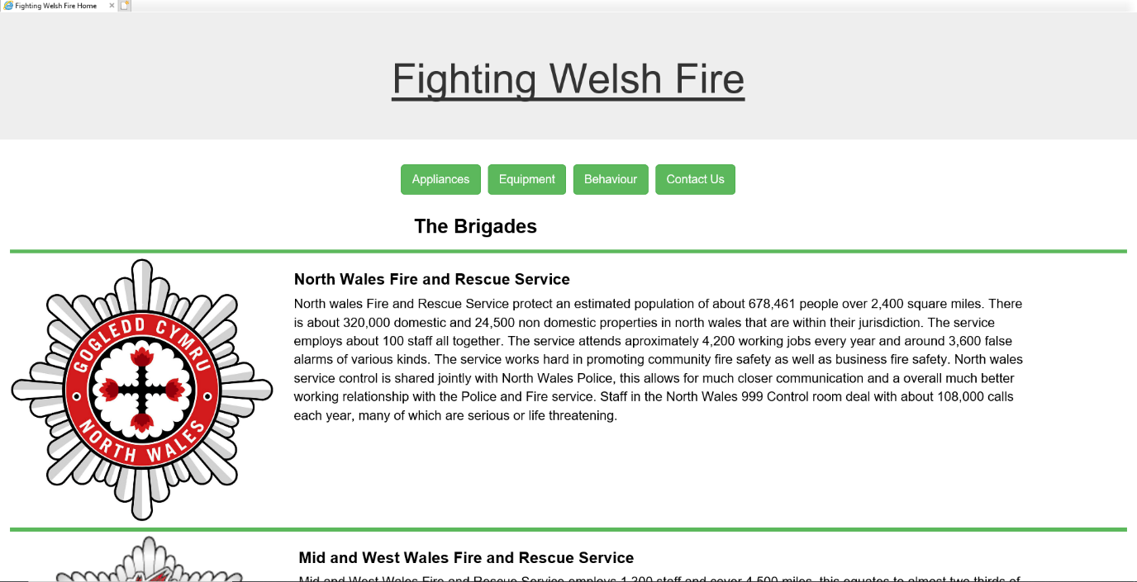

Appliances Page
Appliance page showing all the different vehicles available in the brigades.
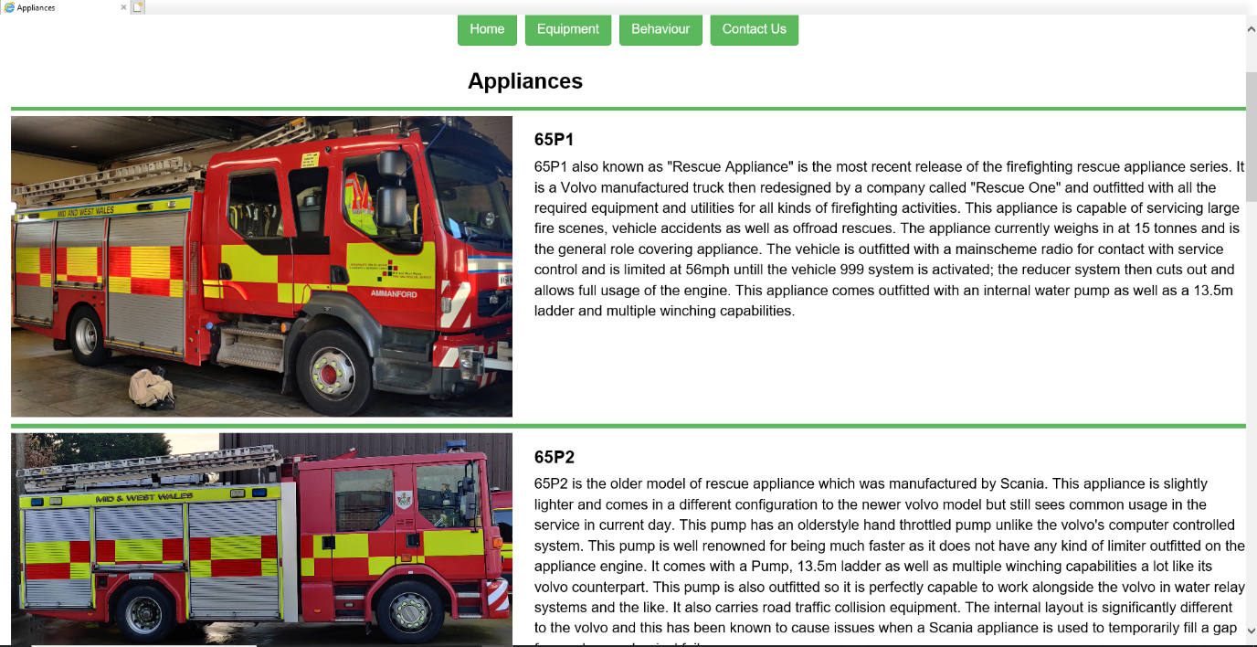

Equipment Page
Equipment page showing the different equipment used in the brigades.
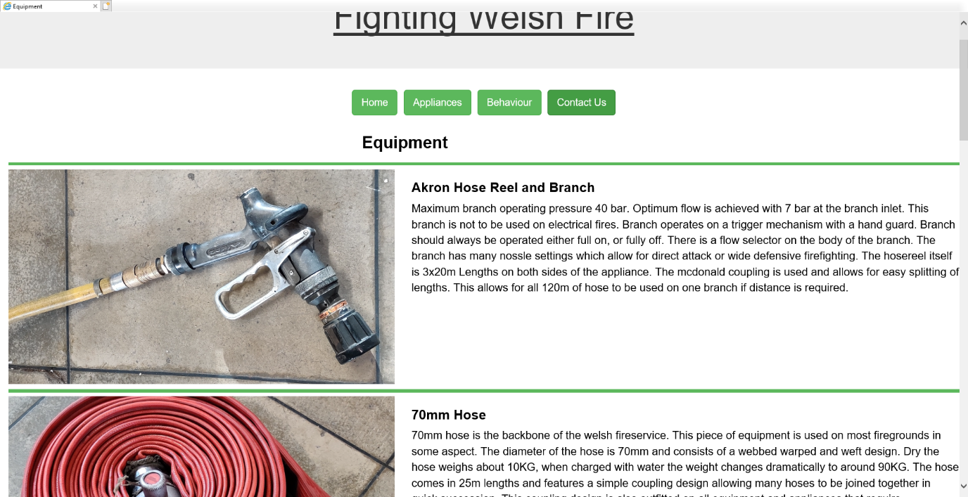

Behaviour Page
Behaviour page showing the different types of fire behaviour.
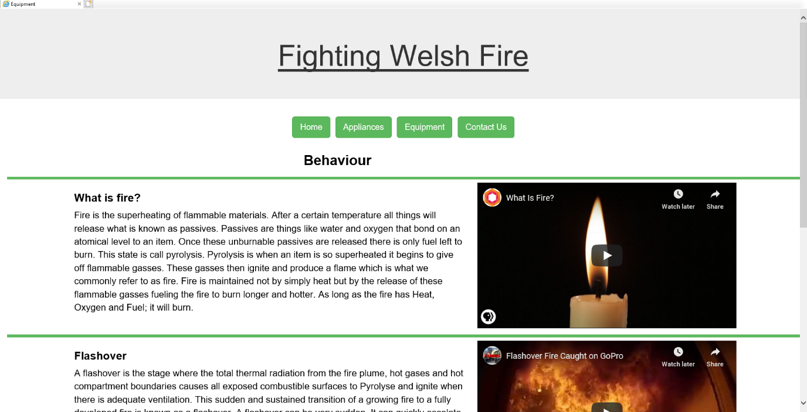

Contact Us Page
A contact us page allowing you to provide contact details to each brigade as well as a look at the embedded twitter feeds.
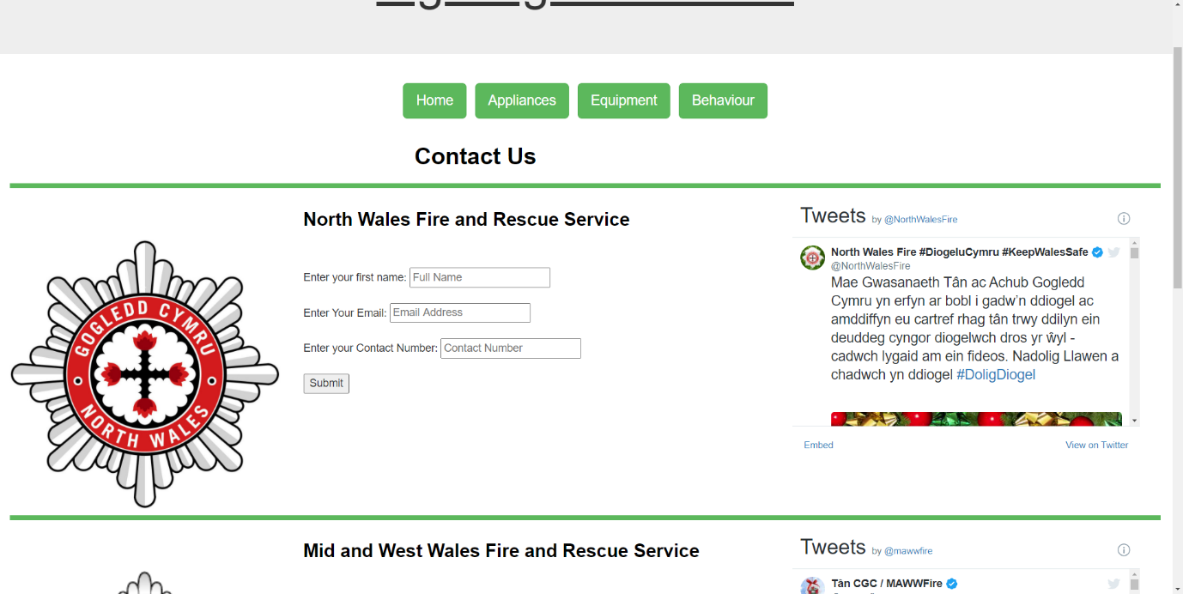

Validation
During this section of my report my website code, both HTML and CSS were run through a validator to check for any errors within the code itself. Validators are a brilliant way to allow a computer to search through vast amounts of code and find errors a human may miss repeatedly. The errors located by a validator still have to be checked and resolved by a human interaction. The reports provided can be seen below.

HTML Validation
Screenshot of HTML Validation using [1] “http://validator.w3.org/"
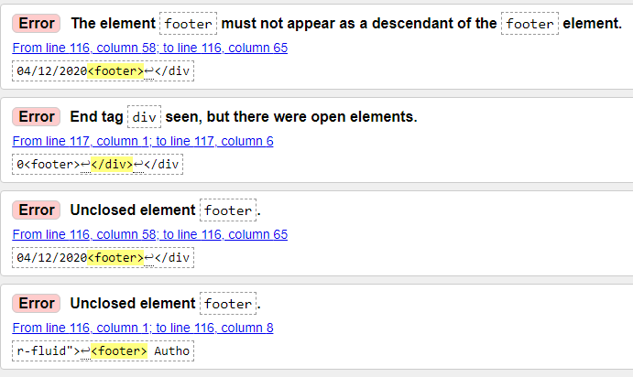
The first, third and fourth errors were all solved by closing the footer tag with </footer> at the end of the footer instead of unintentionally ending the footer with <footer>.

CSS Validation
CSS Error Validation using [2] “http://jigsaw.w3.org/css-validator/"
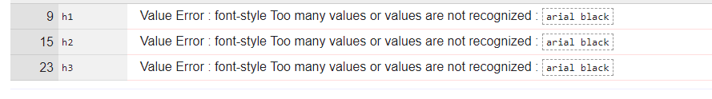
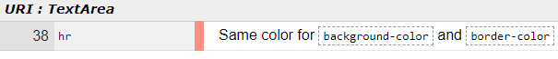
The CSS errors relating to the text font were solved by changing the font from arial black to something recognised by the CSS system. The same background and border colour were used with the intention of creating one block coloured button.

Evaluation
When designing a website constant evaluation is vital to success. In this section of the report, I will detail my evaluation on specific vitally important parts of the web development process.

Usability & Utility
[3] Usability and Utility directly refer to how easy something is to use and how effective it is at its intended task. [3] “One big aspect of website usability is responsive design. Responsive design addresses the idea of making websites usable by different devices…” Usability in its most basic form refers to how easy something is to use. Is the design appealing, does it suit its intended purpose, does the colour scheme suit the role it is intended to fit appropriately? The simplest evaluation of this individual point is, would people of all age ranges and cultural backgrounds be able to sit down and interact with the website that has been designed, navigating, and understanding what the designer has built and why. Does it match and combine with the Utility of the website effectively? In the scope of this task a big usability point is does the Bootstrap allow the webpage to resize to fit reasonably with in all sizes of devices intended to view it. [3] “From small details like text layout to broader design issues like responsive design, improving website usability improves the bottom line of a website..” Usability is essentially how nice a website is to use.
[4] Utility is how effective something is at the task it was designed to do. If the website is designed to provide information, then does it provide relevant information. Is the information easy to read, does it flow nicely? Is the layout effective at helping you move from one block of information to the other? Can it be searched in any meaningful way? When a video is embedded into a website it becomes a utility, this means the video should be relevant to the topic being discussed on the website and ideally should do so in a meaningful way. Images, navigation and webforms are also very important parts of a website's utility. [4] “Does a website do what it should do? Does a website offer the tools visitors will expect to find when they visit? Utility is a measure a website's functionality… “The key to all these items is are they fit for the purpose they are intended to serve, is it functional? [12] “Not all navigation models are created equal. There are different types of web sites that will require a different navigational scheme.” This comes down to understanding the utility of a website and why we choose specific navigational systems to allow better use of a website.

Fighting Welsh Fire Usability & Utility Evaluation
With regards to the usability and utility of the “Fighting Welsh Fire” website I believe that the visual design is effective for the information providing role it is intended to fill. The design is simple but effective and easy to follow. The navigation is equally simple and easily extended as well as the pages themselves. The index page provides a brief overview of each of the brigades within the service on a very minimalistic style. The Appliances and Equipment pages are simple in structure allowing for potentially endless modularity. More can be added to both pages which is generally very useful in the design of websites, especially those relating to the provision of information. The behaviour page allows for both embedded videos and images to be added to the aside section which again allows for simple modularity in the webpage itself. The contact us page provides a simple to follow format which is echoed from the index page allowing the reader to simply continue reading instead of re-learning the structure of the pages themselves.
To improve the websites utility, it would be likely be beneficial to provide more content on each page such as a longer list of appliances and equipment as well as contact information for the brigades themselves on the contact us page. Another positive change to the design of the overall website would be to provide split sections for each brigade in the footer and button links to their social media such as Facebook, Twitter and Instagram accounts. It would also be a positive change to add some form of logo or emblem to the right-hand corner of the title space on each page which in turn would provide more content as well as fill the headspace making for a fuller feel. It also bears thinking about if the pages increase with in the website a re-evaluation of the navigation bar would be required.

Accessibility
[5,6] Accessibility is a vital part of web development. The key and most basic concept of web development accessibility is can everyone use my website equally? The goal is to provide an all-inclusive atmosphere within websites allowing people with hearing and visual disabilities to utilise the website to the fullest degree possible. It is very difficult to account for physical disabilities, but we still aim to provide an equal experience for all users. People who are colour-blind can often experience things in an entirely different way because people lack appreciation for the difficulties it can cause. This principle is the same with hearing deficiencies, people tend to forget how much we rely on our auditory senses and the data we receive from that. Something as simple as words being spoken in a video can become a significant challenge for some people on some websites. We can meet these challenges in all kinds of ways. There is the ability to assess your websites functionality for people with colour-blindness [8] and there are ways to provide text alongside audio to allow people with audio deficiencies to garner the same level of content as everyone else. We can even help those with visual based disabilities by providing adequate labelling and documenting while producing a website. [15] “Text alternatives convey the purpose of an image or function to provide an equivalent user experience.” If we design our websites in smart ways and put the effort in to ensure every image and video we utilise is labelled, we can offer people with visual disabilities the best chance of hearing and understanding our content too.
[7,9] There is a document called “WCAG 2.1” which gives fantastic guidelines not only to accessibility within the realm of web development but that can be used for all levels of computer-based programming. The "World Wide Web Consortium (W3C)” set fantastic standards and we as web developers should all strive to follow those standards to provide inclusion to all. [15] “Content that flashes at certain rates or patterns can cause photosensitive reactions, including seizures. Flashing content is ideally avoided entirely or only used in a way that does not cause known risks.” There is also a responsibility from web developers to be aware of genuine health risks associated with some content to some people with disabilities.

Fighting Welsh Fire Accessibility Evaluation
The “Fighting Welsh Fire” website has been designed with accessibility in mind. The website is very colour-blindness friendly and has been tested to be so. There is a clear structure designed so it can be followed easily and logically by any reading software and all images and videos are titled to be clear to anyone who needs to know what they are and what they show. One significant downside to the websites design are the videos within the behavioural section are pulled from an online external source. The videos are not produced by the designer. This has sadly resulted in only one of the three videos available having closed captions. This is something that could be improved upon either by applying to add closed captions to the videos themselves or producing videos inhouse for the purpose you require.

Search Engine Optimisation
[10,11,13] Search engine optimisation in its most basic form is how to heighten the visibility of your website in the various search indexes such as google and yahoo. The base principle is that google uses various small spider-bots that gradually find their way through all sorts of websites on the internet indexing them via specific criteria. [11][13] "Search engine ranking factor survey data has shown that getting external links is the single most important objective for attaining high rankings." One of the biggest criteria to improving your standing is having a trusted website link to your website. To profit off this system search engines/indexes such as google will provide the ability to pay for better ranking within the system. This means that corporations with sufficient resources can pay to keep their websites very visible when certain things are searched for with in a search engine, however you can still do very well to keep yourself up on the list by sticking to easy to find guidelines on the internet. The guidelines are set forth by studying the behaviour of these spider-bots and understanding how specific things weigh in against their coding. [14] “on-site SEO is less about keyword repetition or placement and more about understanding who your users are” There is however some limitations set in place for these bots such as not being able to search for hyperlinks within flash or java plugins. They will not search and index hyperlinks that are placed with in a search function internally on a website and will often not index more than 150 pages per website, though this programming does depend on the traffic of the website itself.
This system also links into domain names and just about everything on a coding level of a website. The spiders will read and determine the value of a website by how well it is designed and coded therefor projecting it higher or lower on the searching index.

Fighting Welsh Fire SEO Evaluation
To improve the “Fighting Welsh Fire” website as far as search engine optimisation goes it would be prudent to have an efficient domain-name that ends with a top-level domain tag such as .com or .net. It would also be beneficial to use broader page names allowing for significant more traffic, although this is not always the best policy as the aim is to get traffic that utilise the web page and not traffic that is fooled or just passes by. It would also be beneficial to be linked to by trusted websites with regards to a firefighting website being hyperlinked too somewhere on the websites for the 3 firefighting brigades would provide a massive boost in trustworthiness for the website increasing its height on the search engine index.

Bibliography

[1] http://validator.w3.org/
Used as a validator to check for errors in my HTML Code.

[2] http://jigsaw.w3.org/css-validator/
Used as a validator to check for errors within my CSS Code.

[3] https://www.techopedia.com/definition/23903/website-usability
Used to understand the term website usability.

[4] http://www.affordableusability.com/usability/utility.html
Used to understand the term website utility.

[5] https://www.bbc.co.uk/gel/guidelines/how-to-design-for-accessibility
Used to understand the term accessibility.

[6] https://www.w3.org/WAI/
Used to develop understanding of accessibility.

[7] https://www.w3.org/TR/WCAG21/
Used to understand the guidelines of web accessibility

[8] http://juicystudio.com/services/luminositycontrastratio.php
Used to for assessment of website colour accessibility.

[9] https://www.w3.org/WAI/fundamentals/components/
Understanding what the guidelines of web accessibility entail.

[10] https://searchengineland.com/guide/what-is-seo
Used to understand what search engine optimisation is.

[11] https://moz.com/learn/seo/what-is-seo
Used to further understand what search engine optimisation is.

[12] Web Site Usability Report for Harvard University by Kenneth R. Pierce Page 11
Understanding website Utility.

[13] https://moz.com/learn/seo/external-link
Researched further understanding SEO.

[14] https://moz.com/learn/seo/on-site-seo
Researched for understanding SEO.

[15] https://www.w3.org/WAI/fundamentals/accessibility-principles/
Understanding the health risks and impacts associated with web development.

