

University of Wales Trinity Saint David
Electrical Engineering
AC Response of an RLC Network

Author: Oliver Kucyj
Student number: 1910808
Course: B.Eng Electrical and Electronic Engineering
Module Code: ACDA5001
Lecturer: Dr Steve Mosey
Date: 10th April 2022

Table of Contents
1 Abstract 3
2 Introduction 4
2.1 Basic Overview of the RLC Circuit and the Powers Present 4
2.2 Power Factor 5
2.3 Correcting the Power Factor 5
3 Methods used Throughout the Report 6
3.1 Proteus Circuits 6
3.2 Formulae Used 7
3.2.1 Calculating the Phase Angle in Proteus 7
3.2.2 Calculating Power Values, Power Factor, and the Phase Angle 7
3.2.3 Calculating a Suitable Capacitor Value 8
3.2.4 Calculating the Resonant Frequency 8
3.2.5 Calculating the Q Factor 8
3.2.6 Calculating the Impedance after PFC 8
3.2.7 Calculating the Capacitor and Inductor Currents 9
4 Simulation, Calculation and Graphical Results 10
4.1 Proteus Simulation Results 10
4.2 Calculation Results 11
4.3 Graphical Results 11
5 Discussion of the Results 14
5.1 Discussion of the Results to the Proteus Simulations 14
5.2 Discussion of Capacitance vs Power Factor 14
5.3 Phasor Diagrams 14
5.4 Resonant Frequency and the Q Factor 15
5.5 Maximum Power Transfer 15
Conclusion 16
References 17

1 Abstract
Throughout this report the concepts of power factor correction are investigated and tested. The report investigates what power factor correction is, why it is important and how it is achieved. It also investigates the theory behind how it works and what happens within the RLC network when it is achieved. The theoretical side of these concepts are researched before calculations, simulations and graphs are used to test the theory.

The main objective is to develop a thorough understanding of power factor correction and the theory behind it.

2 Introduction

2.1 Basic Overview of the RLC Circuit and the Powers Present

The circuit being analysed is an RLC circuit which contains resistive, inductive, and capacitive elements. The resistive and inductive elements represent a motor winding, and the capacitive element represents a power factor correction (PFC) capacitor added to improve the power factor.

Active, Reactive, and apparent power are the three types of power present in an AC circuit

Active power does ‘real work’, such as generating heat or creating light. This is caused by resistive components. It is required for the circuit to function and cannot be reduced through PFC [1].

Reactive power is caused by reactive components and does not complete any ‘real work’. It is purely used for energy storage in devices such as inductors and capacitors. It is required to generate an electromagnetic field. Wasted reactive power flows back to the source [2].

Apparent power is the total power flowing between the source and the load. It relates to the reactive and the active power. If either of these powers change, the apparent power changes too.

The three powers can be expressed using the power triangle, shown in figure 1. This shows that if the reactive power is reduced, so is the apparent power.

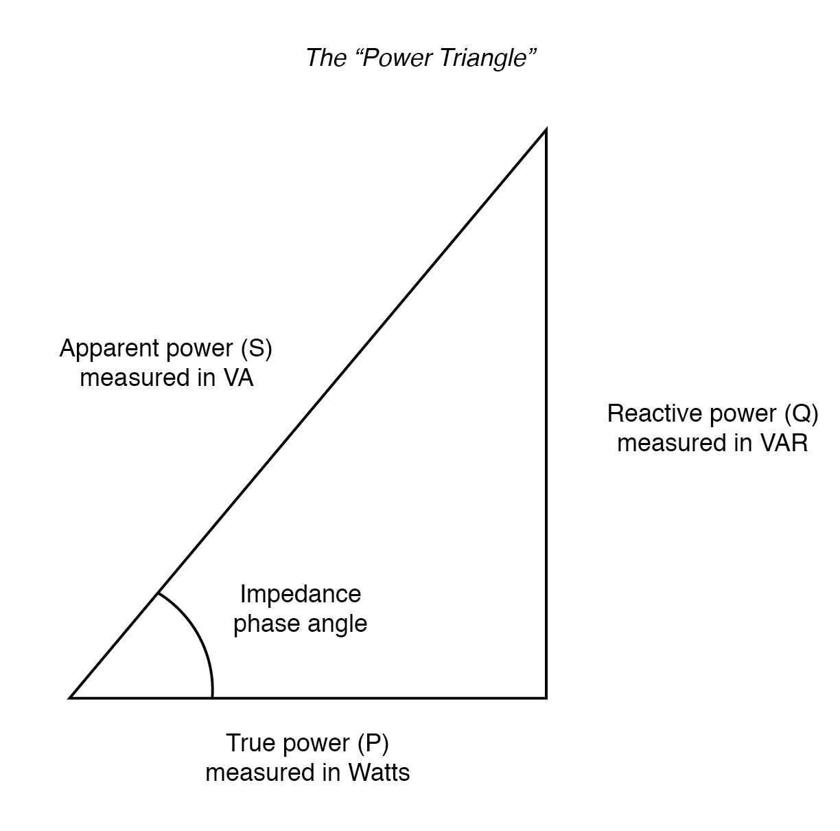

Figure 1 – the power triangle [3]

2.2 Power Factor

The power factor is a measure of how efficient a system is in terms of how much power is wasted [4]. It is active power divided by the apparent power. The power factor value will always be between 0 and 1 since active power cannot be higher than the apparent power. A high power factor means there is a low reactive power, meaning less power is wasted through being returned to the source. Having a high power factor means more useful power can be delivered to the consumer because the power lines and generators will be rated to a maximum apparent power. With a power factor of 0.5, only 50% of the transferred power is active power. This will cause additional transmission line losses and add extra, unnecessary loading on the distribution system. The increased supply current also causes a larger voltage drop making regulation more difficult [5]. Many providers will penalise commercial customers for having a poor power factor because of this, since most customers are billed for active power rather than apparent power.

2.3 Correcting the Power Factor

To improve the power factor, reactive power must be minimized. Reactive power is 90 degrees out of phase with the voltage. Inductive and capacitive currents are out of phase in opposite directions, meaning they are 180$°$ out of phase with one another and have opposite signs. An inductive current causes the supply current to lag the voltage. A capacitive current will cause the supply current to lead the voltage. When these are equal, they cancel each other out [6]. When they are equal, the supply current is in phase with the voltage, meaning the circuit is purely resistive and has no reactive power. The power factor becomes one, known as unity.

Most industrial installations will have a highly inductive load due to transformers and motors. Capacitors are added in parallel to cancel out these inductive loads and minimize the reactive power. A high power factor can sometimes be difficult to achieve due to the number of variables involved, such as component tolerances, component availability, supply voltage variations and load impedance variations. In large installations, power factor correction units, such as the one shown in figure 2, are used. These systems can monitor the power factor and switch capacitors on/off to maintain a high power factor. These devices can be very expensive, so it is important to consider whether the energy savings justify the investment.
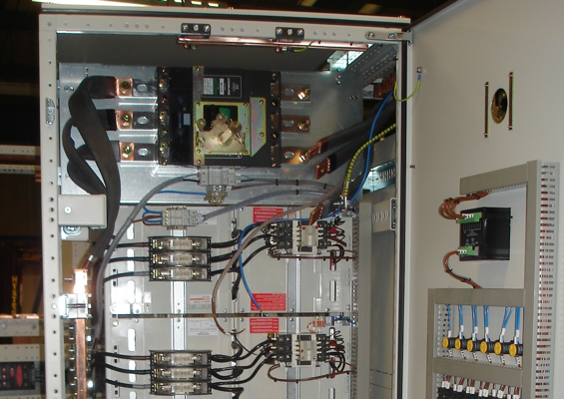
Figure 2 – Power factor correction unit [7]

3 Methods used Throughout the Report

3.1 Proteus Circuits

Figure 1 shows the circuit in Proteus before PFC. R1 represents the source resistance and R2 represents the load resistance. L1 is the inductive load. In this circuit, there is no power factor correction capacitor. Figure 2 shows the circuit with a PFC capacitor added in parallel with the load which was calculated using the formulas in section 2.2.3.

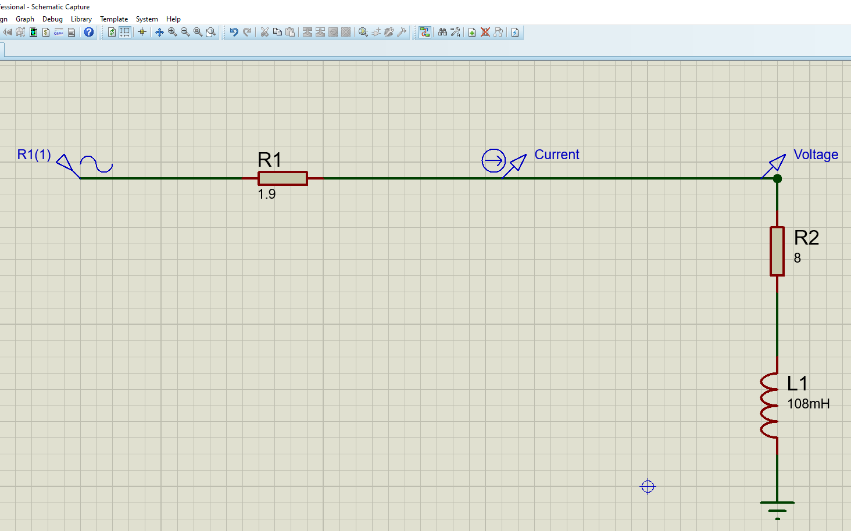
Figure 3 – RL Circuit in proteus

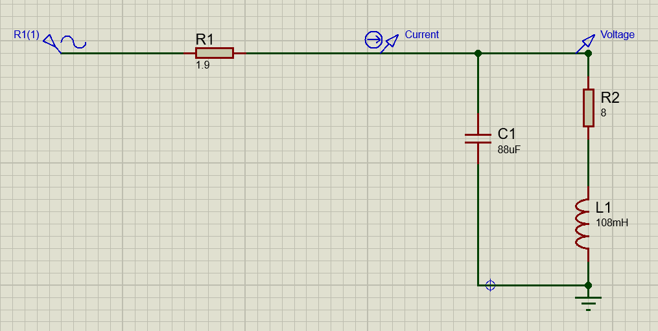
Figure 4 – RLC circuit in proteus

3.2 Formulae Used

There are many formulae which are used in this report. These are shown in this section with a brief description of what is being calculated.

3.2.1 Calculating the Phase Angle in Proteus

To do this, the time difference between the peak current and peak voltage must be measured. The formula is shown below.
$$Phase angle=\frac{t}{T}x360$$

3.2.2 Calculating Power Values, Power Factor, and the Phase Angle

To calculate the power values, the rectangular representation of apparent power (S) should be calculated. This is the product of the load voltage and supply current. From S, the real value represents the active power, the imaginary value represents reactive power, and the absolute value represents apparent power. The angle from the polar representation is the phase angle.

$$Inductive Reactance, X_{L}=2πfL$$

$${Load impedance, Z}_{RL}=R+jX_{L}$$

$${Total impedance, Z}_{Total}=R_{SRC}+Z_{RL}$$

$$Load voltage, V_{Load}=V_{S}x\frac{Z_{RL}}{Z_{Total}}$$

$$Supply current, I_{S}=\frac{V_{Load}}{Z_{Total}}$$

$$Apparent power, S=P+jQ=V_{Load}xI_{S}$$

$$Real power=P$$

Reactive power = Q

$$Apparent power, \left|S\right|=\sqrt{P^{2}+Q^{2}}$$

$$Phase Angle=\tan^{-1}{\frac{Q}{P}}$$

$$Power Factor=\frac{P}{\left|S\right|}$$

3.2.3 Calculating a Suitable Capacitor Value

To provide a unity power factor the capacitive current must be equal to the inductive current. By finding the inductive current and substituting it for capacitive current, the required capacitor value can be found.

$$I_{RL}=\frac{V_{Load}}{Z_{RL}}$$

The result of this will return a complex number. The inductive current (I_{L}) is represented by the imaginary number. I_{L} must equal I_{C} so the formulae below can be used.

$$X_{C}=\frac{V_{Load}}{I_{C}}$$

$$X_{C}=\frac{V_{Load}}{I_{L}}$$

$$C=\frac{1}{2πfX_{C}}$$

This will provide the required capacitor value to theoretically provide a unity power factor

3.2.4 Calculating the Resonant Frequency

The resonant frequency is the frequency at which the reactive current resonates between the inductor and the capacitor. There are two methods of calculating this. This paper will use the more advanced, more accurate version of the formula since it considers the resistance of the circuit.

$$f_{0}=\frac{1}{2π}x\sqrt{\frac{1}{LC}-\frac{R^{2}}{L^{2}}}$$

3.2.5 Calculating the Q Factor

The Q factor is the magnification factor between the supply current to the reactive current.

$$Q=\frac{X_{L}}{R}$$

3.2.6 Calculating the Impedance after PFC

To calculate the load voltage after power factor correction, Z_{RLC} must be calculated. This is used instead of Z_{RL} throughout the rest of the calculations.

$$X_{C}=\frac{1}{2πfC}$$

$$Z_{RLC}=\frac{Z_{RL}x-X_{C}}{Z_{RL}+-X_{C}}$$

3.2.7 Calculating the Capacitor and Inductor Currents

The capacitor and inductor currents must be calculated to create the phasor diagrams. The real value will be plotted on the horizontal axis and the imaginary value will be plotted on the vertical axis.

$$I_{RL}=\frac{V_{Load}}{Z_{RL}}$$

$$I_{C}=\frac{V_{Load}}{X_{C}}$$

4 Simulation, Calculation and Graphical Results

4.1 Proteus Simulation Results

Figures 4 and 5 show the results from the two Proteus simulations, with the second graph proving that the power factor correction reduced the phase angle between current and voltage.
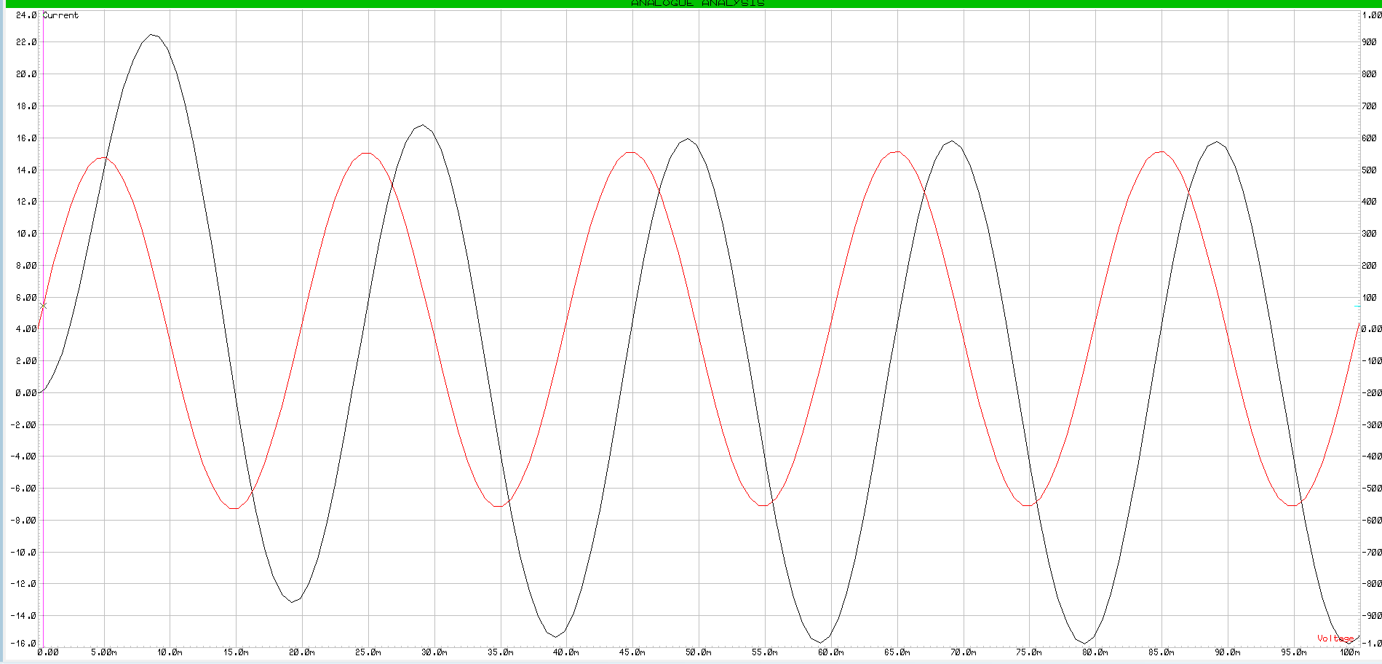
Figure 5 – Voltage and current comparison without PFC
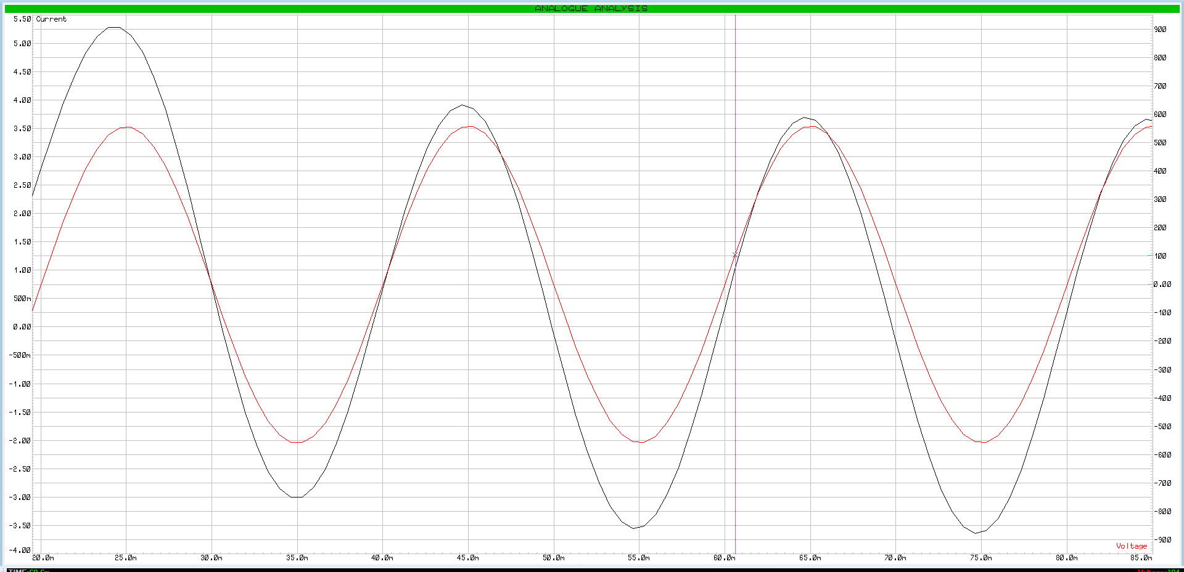
Figure 6 – Voltage and current comparison after PFC with an 88$μF$capacitor

Before power factor correction, the phase angle is -71.98$°,$meaning the power factor is 0.31 lag. After PFC, with an 88$μF$ capacitor, the phase angle is +12$°$, meaning the power factor is 0.98 lead. The PFC capacitor was slightly larger than needed, causing the current to lead the voltage.

4.2 Calculation Results

The results to the calculations are listed below.

Active power = 1668.51W
Reactive power = -4075.35 VAr
Apparent power = 4403.68 VA
Phase angle = -70.73$°$
Power factor = 0.38 lag
PFC capacitor = 87.76$μF$

The following calculations were complete with an 88$μF$ capacitor.

Resonance = 50.26Hz
Q factor at 50Hz= 4.24
Capacitor current = 10.92A
Inductor current = -11.03A
Supply Current = 2.58A
Product of Q factor and supply current = 10.94A

4.3 Graphical Results

Figures 6-10 show the graphs created for this report. Since the resonant frequency of the circuit is 50Hz, there are only 3 phasor diagrams. Figures 7-10 were all plotted using an 88$μF$ capacitor value.

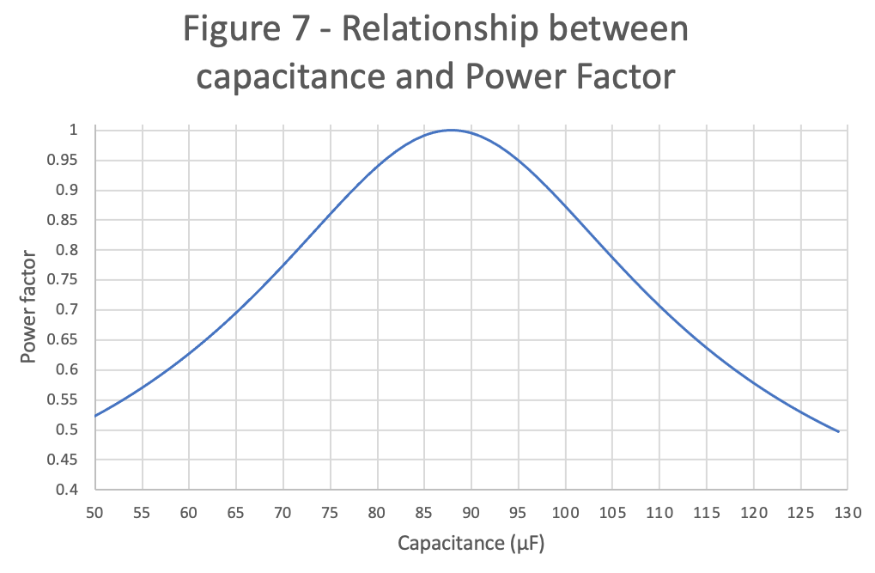

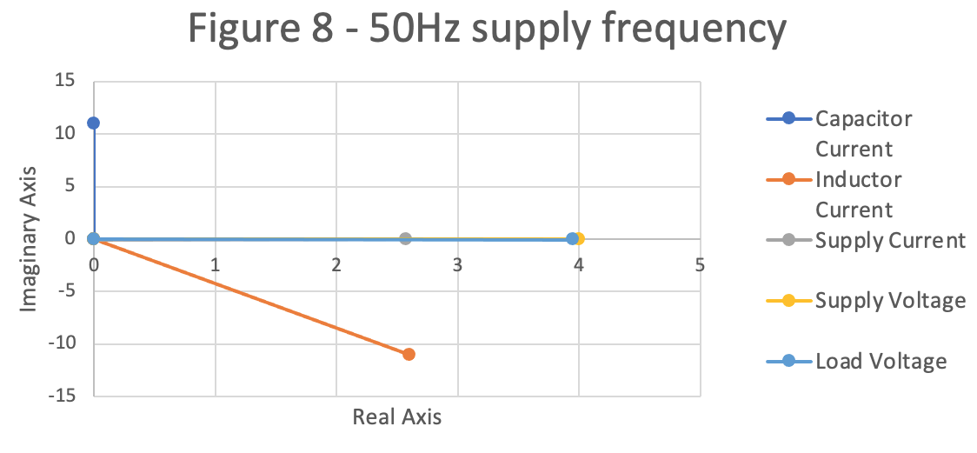

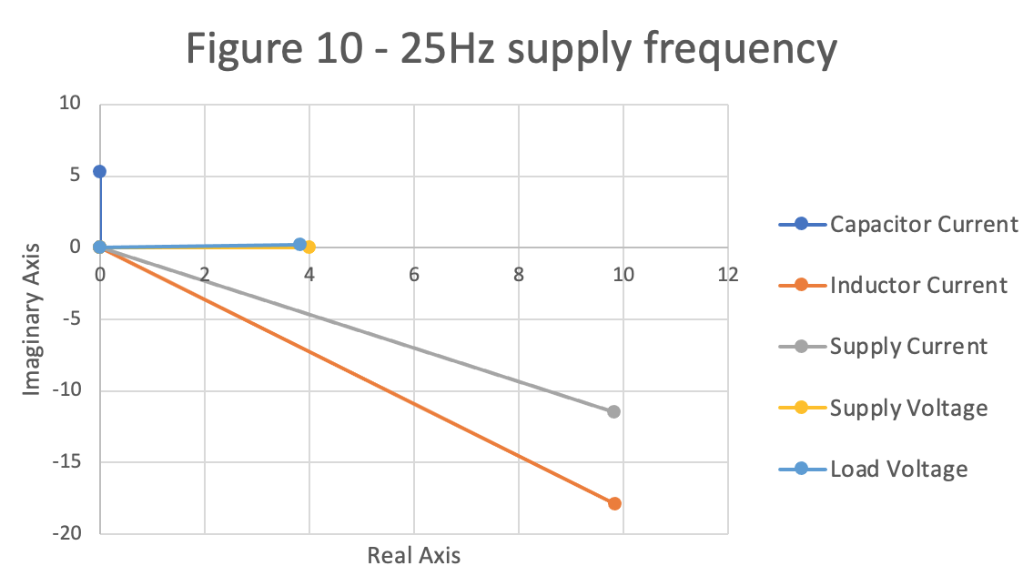
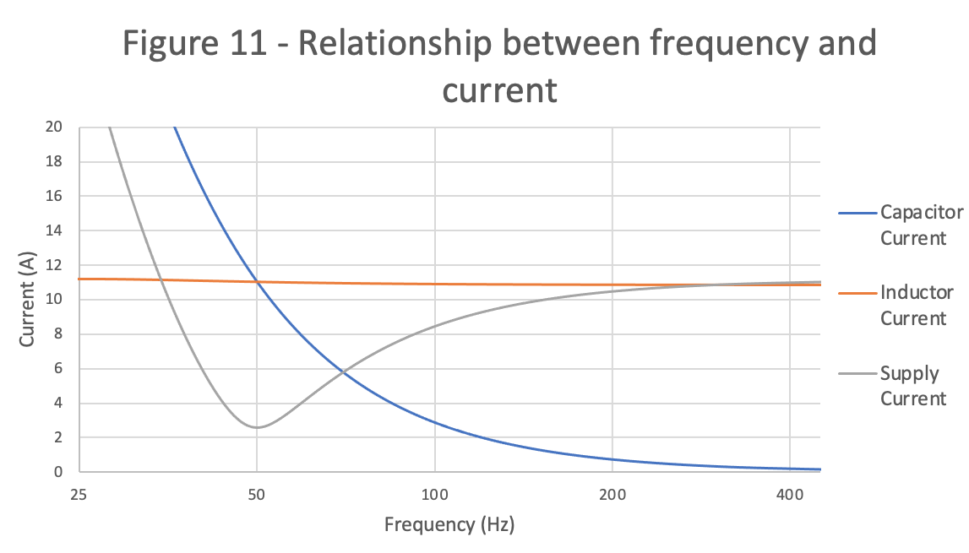

5 Discussion of the Results

5.1 Discussion of the Results to the Proteus Simulations

Figure 5 shows the circuit simulation results with no PFC. It shows that the current has a large phase difference and is ‘lagging’ the voltage. This was expected as explained in section 2.3. Figure 6 confirms that once the PFC capacitor is added, the phase angle is greatly reduced, however by not as much as calculated. This could be due to rounding/measurement errors. It is also known that theoretical calculations do not always match practical simulations as ‘ideal’ components do not exist.

The simulation results also show that the current has a much higher peak on the first cycle before gradually ramping down to a steady peak current. This is known as the inrush current and is due to the inductive load. When the inductor is first powered, there is zero back EMF (electromotive force) to oppose the supply so higher currents are allowed to flow. Once the magnetic field is established, the back EMF is produced, opposing the incoming supply, and limiting the current [8]. It is due to this surge that high inductive loads, such as quartz heaters, require C or D type breaks to prevent nuisance tripping.

5.2 Discussion of Capacitance vs Power Factor

Figure 6 shows the relationship between the power factor and the capacitance. The power factor peaks above 0.95 over a relatively small range of capacitance. This supports the point made in section 2.3, where it was stated that it is very difficult to maintain a power factor over 0.95 in actual installations. The power factor peaks across this range of capacitance because it is the area where the resonant frequency is closest to the supply frequency.

5.3 Phasor Diagrams

The phasor diagrams from figures 8-10 demonstrate how the supply frequency affects the power factor. When the supply frequency is equal to resonance the phase angle between the voltage and supply current is zero and the inductive/capacitive currents are equal. When the supply frequency is increased, the capacitive current increases and the inductive current decreases, causing a leading power factor. The opposite happens when the frequency is decreased, creating a lagging power factor [9]. When this happens, the inductive/capacitive currents are no longer equal, and the reactive power is increased. On the phasor diagrams, the reactive current is the difference between the supply current and the load voltage on the vertical axis.

5.4 Resonant Frequency and the Q Factor

When the power factor is at or close to unity, two circuit conditions are met. The first condition is the supply frequency being equal to the resonant frequency. The second condition is the energy stored in the inductor and the capacitor are equal [10, p.322]. This causes the circuit to resonate. When this happens, the energy stored in the circuit resonates between the inductor and capacitor, with no wasted power being returned to the source. Under this condition, the circuit is purely resistive with apparent power and supply current being minimized. The resistance of the circuit is now known as the dynamic resistance. The current through the inductor and capacitor becomes much higher than the supply current. This magnification is known as the Q factor and was calculated in the results.

Due to the high current flowing between the inductor and capacitor, it is important to install them as near to each other as possible to minimize power losses through the resistive cables.

The theory discussed in this section is supported by the results in section 4.2 and by figure 11. Figure 11 shows that when the resonant frequency is 50Hz, the two reactive currents are equal, and the supply current is at its lowest.

5.5 Maximum Power Transfer

Maximum power transfer in AC circuits is the point at which the maximum magnitude of power can be transferred from the source to the load. This is achieved by following the maximum power transfer theorem. This states that maximum power is transferred when the load impedance is equal to the complex conjugate of the source impedance. Essentially, this means that the source and load resistance must be equal, and the source and load reactance must be equal in value with opposite signs so that they cancel each other out.

The RLC circuit in this report has no source reactance. By correcting the power factor to unity, the load also has no reactance, which will increase the maximum power which can be transferred since one of the two criteria for maximum power transfer is met. The load resistance is still different to the source resistance, so maximum power is still not transferred. This is not a bad thing because when the maximum power is transferred, the circuit efficiency is limited to a maximum of 50% because half of the supplied power is dissipated in the source [11]. Having a higher ratio between the load resistance and the source resistance will increase the circuit efficiency because a higher percentage of the power delivered is dissipated in the load.

Conclusion
Throughout this report, the theory behind power factor correction has been investigated and tested using simulations, calculations, and graphs. The results achieved from these tests have supported the theory which was postulated in the introduction. It has demonstrated that inductive and capacitive currents are 180$°$ out of phase with each other, meaning the signs are opposite and they cancel each other out. It has also proven that for PFC to be achieved, the supply frequency must be equal to the resonant frequency. This method is how PFC is achieved to minimize wasted power and reduce the power specifications of an AC network to help lower the cost involved for both the consumer and the provider. There are fine margins with PFC though and it can be difficult to maintain a power factor above 0.95. To accommodate this, PFC units are available which can switch capacitors in/out of a circuit to ensure the optimum power factor is maintained despite a varying load and supply.

One more important finding of this report is that when the power factor is at or close to unity, the current flowing through the circuit is much higher than the supply current. This must be considered when designing the circuit.

References
[1] The Electricity Forum, “Active Power,” The Electricity Forum. [Online] Available: https://www.electricityforum.com/active-power#:~:text=Active%20power%20is%20the%20power,the%20electric%20circuits%20or%20load [Accessed Apr. 03, 2022].

[2] P. S. Filipski, Y. Baghzouz and M. D. Cox, "Discussion of power definitions contained in the IEEE Dictionary," in IEEE Transactions on Power Delivery, vol. 9, no. 3, pp. 1237-1244, July 1994, doi: 10.1109/61.311149.

[3] All about circuits, “True, Reactive, and Apparent Power,” All about circuits. [Online] Available:
https://www.allaboutcircuits.com/textbook/alternating-current/chpt-11/true-reactive-and-apparent-power/#:~:text=Power%20merely%20absorbed%20and%20returned,referred%20to%20as%20apparent%20power [Accessed Apr. 03, 2022].

[4] M. Malengret and C. T. Gaunt, "Active Currents, Power Factor, and Apparent Power for Practical Power Delivery Systems," in IEEE Access, vol. 8, pp. 133095-133113, 2020, doi: 10.1109/ACCESS.2020.3010638.

[5] M. Nasiri, M. Rostami and Seyed Hamid Fathi, "Parallel and series harmonic resonance prevention by anti-resonance hybrid capacitor system for power factor correction," 2010 5th IEEE Conference on Industrial Electronics and Applications, 2010, pp. 1023-1027, doi: 10.1109/ICIEA.2010.5515774.

[6] E. Csanyi, “Reactive power and power factor correction essentials to ALWAYS keep on mind,” Electrical Engineering Portal, 2019. [Online] Available: https://electrical-engineering-portal.com/reactive-power-power-factor-correction [Accessed Apr. 06, 2022].

[7] Kane Engineering, “Power Factor Correction Equipment,” Kane Engineering. [Online] Available: http://www.kane-engineering.co.uk/power-factor-correction-equipment [Accessed Apr. 07, 2022].

[8] D. Collins, “What is inrush current in an AC motor and why does it matter,” Motion Control Tips, 2020. [Online] Available: https://www.motioncontroltips.com/what-is-inrush-current-in-an-ac-motor-and-why-does-it-matter/ [Accessed Apr. 08, 2022].

[9] Learn about Electronics, “Parallel Resonance,” Learn about Electronics. [Online] Available: https://learnabout-electronics.org/ac_theory/lcr_para_103.php [Accessed Apr. 08, 2022]

[10] E. Hughes, J. Hiley, K. Brown, and I. M. Smith, Hughes electrical & electronic technology, 12th ed. Harlow: Pearson, 2016.

[11] M. Robbins, “Maximum Power Transfer and Impedance Matching,” Ultimate Electronics. [Online] Available: https://ultimateelectronicsbook.com/maximum-power-transfer-and-impedance-matching/ [Accessed Apr. 09, 2022].

