Assignment:
Database Design & Implementation

COURSE: BSC Applied computing
Module NaMe: Database and application development
Module Code: ACCA5026
Lecturer: DR FAHAD AHMED
submission DATE: 14 august 2026
date submitted: 14 AUGUST 2026

Trinity saint david University of Wales (London Campus)

Meliha Redzhep (2416885)



Table of Contents:
Introduction: 6
Part A: Database Design: 7
Introduction: 7
Entity Relation Diagram (ERD): 7
Database Normalisation: 8
Database implementation: 10
Database and table creation: 10
Database Creation: 10
Creation of Database Tables: 10
Table Structure: 11
Database Tables: 11
Doctor: 11
Department: 11
AuditLog: 11
Appointment: 12
Admin Staff: 12
Treatment: 12
Prescription: 12
Patient: 12
Feedback: 13
DoctorSchedule: 13
Constraint Implementation: 13
Foreign Key (FK) constraint showing rejection of an invalid PatientID: 13
Sample data population: 13
Sample data is being inserted into tables: 14
DoctorSchedule: 15
AdminStaff: 15
Patient: 16
Doctor: 16
Department: 17
Prescription: 17
Treatment: 18
Appointment: 18
Feedback: 19
Database testing and validation: 19
Patient table: 20
Appointment table: 20
Retrieve Patient, Doctor, and Appointment Information: 21
Retrieve Appointment and Patient Treatment Information: 21
Retrieve Treatment and Prescription Information: 21
Invalid Patient ID: 22
Invalid Feedback Rating: 22
Duplicate Patient Email: 23
Stored Procedures: 23
AddPatient Stored Procedure: 24
AddPatient Stored Procedure Test: 24
AddAppointment Stored Procedure: 24
AddAppointment Stored Procedure Test: 25
DeleteAppointment Stored Procedure: 25
DeleteAppointment Stored Procedure Test: 25
UpdatePatientPhone Stored Procedure: 25
UpdatePatientPhone Stored Procedure Test: 25
Transactional scenario: 26
BookAppointment (START TRANSACTION, COMMIT): 26
Call BookAppointment: 26
Successful Appointment Booking: 27
Booking added to DoctorSchedule: 27
Triggers and auditing: 27
Patient INSERT Trigger: 28
Patient INSERT Trigger – Audit Log Test: 28
Appointment UPDATE Trigger: 28
Appointment UPDATE – Audit Log Test: 29
Appointment DELETE Trigger: 29
Appointment DELETE Trigger – Audit Log Test: 29
Functions: 29
Patient Appointment Count Function: 30
Calculate Age Function: 31
Performance Tuning: 31
Index Creation: 32
Index Verification: 32
Conclusion: 33
Part B: Database Driven Website 34
Development Environment and Database Connectivity: 34
MedAssistClinicDB: 35
Database Connection: 35
Homepage: 36
User Login and Dashboard: 37
Login page: 37
Dashboard (After Patient has created an account and logged in): 37
Patient Registration and Database Insertion: 37
Empty Patient Registration form: 38
Completed Patient Registration form: 38
Patient added into Database: 39
Doctor Information and Search Functionality: 39
Doctors: 40
Search Functionality: 40
Book Appointment – Create Operation: 40
Viewing and managing Appointments: 41
View Appointments before a booking: 42
View Appointments after a booking: 42
Edit Appointment – Update Operation: 42
Before Edit: 42
After Edit: 43
Updated appointment: 43
Cancel Appointment – Delete Operation: 43
HTML and PHP Integration - Patient Feedback: 44
Feedback Form HTML: 45
Security and Prepared Statements: 45
Prepared statement preventing SQL injection in appointment creation: 46
SQL injection attempt typed into the appointment booking form: 46
Website rejecting SQL injection due to prepared statements: 46
Database remains intact after SQL injection attempt: 47
Evaluation of Database- Drive Website: 48
Conclusion: 49
References: 50

Introduction:
Databases are essential to contemporary information systems, they allow businesses to easily store, organise, and retrieve data while preserving accuracy, security, and consistency [1]. Well-designed database systems facilitate everyday business activities, enhance decision-making, and minimise redundant data, through organised relational models. Additionally, database-driven web applications offer effective ways to search, update, and manage records while enabling users to engage dynamically with stored information.
There are two sections to this report. The design and implementation of a relational database for MedAssist Clinic are the main topics in Part A. This includes database modelling, normalisation, implementation, testing, transaction management, triggers, stored procedures, functions, and performance tuning. The creation of a PHP-based database-driven website that showcases dynamic content retrieval, CRUD functionality, search capabilities, and security precautions against SQL injection is shown in Part B.
Together, these parts show how web technologies, SQL programming, and database design concepts may be applied practically to create dependable, secure, and effective information systems.

Part A: Database Design:

Introduction:
A private medical facility, ‘MedAssist Clinic’ provides outpatient services such as general consultations, referrals to specialists, and diagnostic evaluations. Manual and paper-based procedures are harder to handle as the clinic grows, which might result in problems including redundant records, inaccurate data, and ineffective appointment scheduling. The clinic needs a centralised relational database that can safely store patient details, schedule appointments, record treatments, and support several authorised users in order to increase operational efficiency.
The design and execution of a relational database created to satisfy the clinic's operating needs are presented. Before providing an Entity Relationship Diagram (ERD) and talking about the normalisation procedure to Third Normal Form (3NF), it analyses the business processes and identifies the necessary entities and relationships. Database tables, constraints, sample data, stored procedures, triggers, functions, and transaction management strategies are all demonstrated during the installation phase. Lastly, database testing and performance optimisation are shown to display that the system upholds data integrity, facilitates effective query execution, and meets the clinic's functional needs.

Entity Relation Diagram (ERD):
The MedAssist Clinic database is conceptually represented by the Entity Relationship Diagram (ERD), which also shows the connections between the major entities [2]. Department, Doctor, DoctorSchedule, Patient, AdminStaff, Appointment, Treatment, Prescription, Feedback, and AuditLog are the 10 entities that make up the design. The clinic's primary functions, such as patient registration, doctor management, appointment scheduling, treatment documentation, prescription administration, feedback gathering, and database auditing, were chosen to be represented by these entities.
Foreign keys provide relationships between related entities, whereas primary keys uniquely identify records within each entity [3]. For instance, DepartmentID ties physicians to their department, whereas PatientID, DoctorID, StaffID, and ScheduleID link an appointment to the appropriate patient, doctor, administrative staff member, and schedule. Therefore, rather than considering each table as a separate data source, the ERD represents the actual workflow of the clinic.
Additionally, the relationships facilitate the division of operational data. While prescriptions are related to treatments, treatment information is tied to an appointment rather than being kept directly inside the Appointment entity. Similarly, feedback is linked to both the patient and the appointment from which it originated. Information may be maintained independently and accessed via relational queries thanks to this separation, which also minimises duplication.
The AuditLog entity is kept apart from operational records so that the changes produced by database triggers are recorded without affecting the underlying patient, appointment or treatment data. As a result, the finished ERD sets the relationships that are later enforced by foreign-key constraints and provide a clear design for the relational implementation.
My ERD:
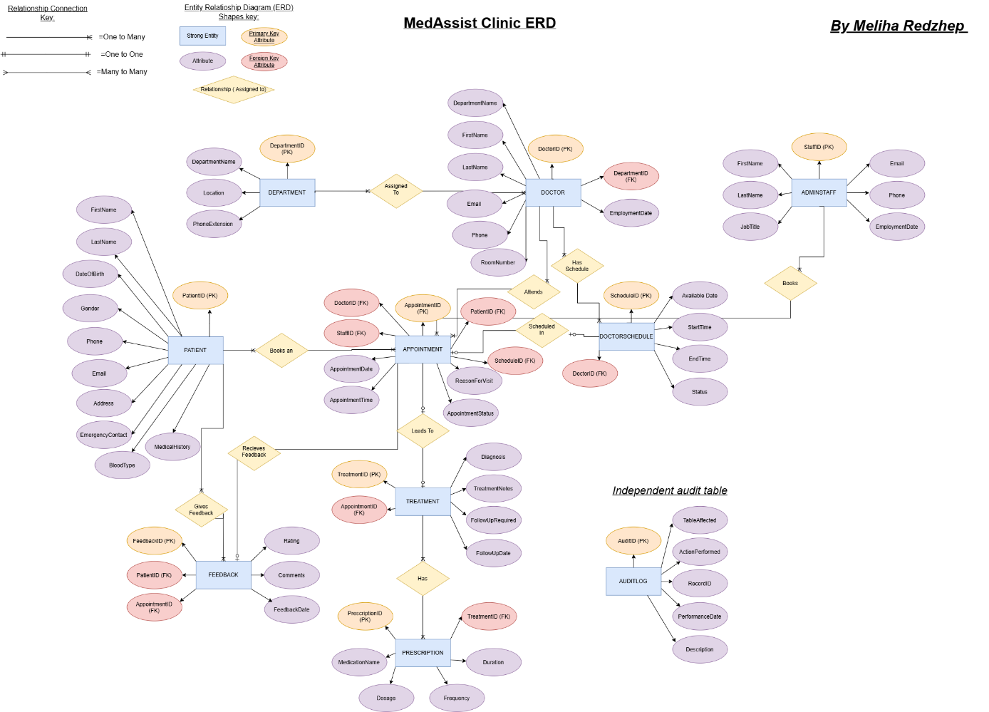
Link to my ERD:
Assignment ERD.drawio (1).png

Database Normalisation:
The MedAssist Clinic database was normalised to avoid insertion, update, and delete anomalies, as well as needless data duplication. Due to patient, appointment, and treatment, information must be consistent, this is especially crucial for a clinic. The database design was created to fulfil Third Normal Form (3NF) and adheres to relational database design standards [4]. Functional dependencies, normalisation, and relational database design as essential elements of database creation. Normalisation and relational database design are well-known subfields of database theory.
First Normal Form (1NF):
The database satisfies First Normal Form because attributes are kept as individual, atomic values and each table contains entries designated by a primary key [5]. There has been no usage of repeating groupings. For instance, appointments are kept as distinct entries, but individual data like FirstName, LastName, DateOfBirth, Email, and MedicalHistory are preserved in the Patient table. This eliminates the need to store numerous values in a single field and enables the insertion, updating, and retrieval of individual patient or appointment records.
Second Normal Form (2NF):
Due to non-key attributes relying on the whole primary key of its connection, the design satisfies Second Normal Form [5]. PatientID, DoctorID, AppointmentID, and TreatmentID are examples of single-column IDs used in the database. This means that attributes like a patient's contact information depend on the patient's identity, whereas appointment details depend on the AppointmentID.
Additionally, the separation of entities also prevents attributes from being dependent on unrelated identifiers. For instance, department details are not repeatedly saved for each doctor; instead, department information is maintained in Department.
Third Normal Form (3NF):
The design fulfils Third Normal Form because non-key attributes rely on their own table's main key rather than another non-key attribute [5]. For instance, DepartmentID determines DepartmentName, Location, and PhoneExtension. In similarity, DoctorID determines a doctor's name, contact details, and date of employment.
Information about appointments and treatments is also kept apart as they cover distinct phases of the clinic procedure. While treatment attributes reflect the final diagnosis, comments, and follow-up needs, appointment attributes describe the planned consultation. This structure guarantees that data is kept in the most suitable relation and minimises redundancy.

Database implementation:
The relational database was implemented using MySQL through phpMyAdmin within UniServerZ [6]. The conceptual entities identified in the ERD were translated into ten related tables. Each table uses a primary key to uniquely identify its records, with the main identifiers configured as auto-incrementing integers. This allows new records to receive unique identifiers without requiring the user to manually assign primary key values, creating an efficient system.
Foreign keys were implemented to establish relationships between parent and dependent entities. For example, Appointment contains foreign keys referencing Patient, Doctor, AdminStaff and DoctorSchedule. Doctor references Department, Treatment references Appointment and Prescription references Treatment. These relationships enforce referential integrity by ensuring that dependent records reference valid related records.

Database and table creation:
The database and its ten relational tables were created in phpMyAdmin using SQL statements. Successful execution confirmed that the database objects were created without SQL errors. The resulting tables correspond to the entities represented in the ERD, providing the foundation for sample data population, testing and further database functionality.

Database Creation:
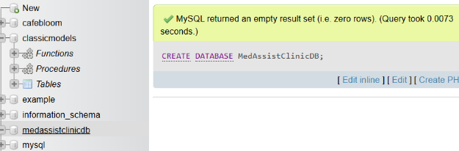
The successful creation of MedAssistClinic database.

Creation of Database Tables:
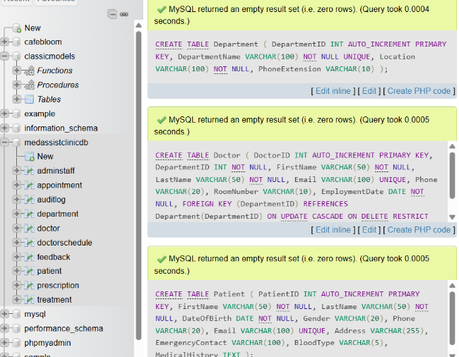

Table Structure:
The table structures demonstrate how the ERD was translated into an implementable relational schema. Each entity has a dedicated table with an appropriate primary key (PK), while attributes have been assigned suitable SQL data types. Primary identifiers are configured as auto-incrementing integers where needed, which allows new records to receive unique identifiers automatically.
Required attributes and nullability settings were also defined to support consistent data entry, while default values were applied where appropriate. The table structures therefore provide a direct connection between the conceptual design and its physical implementation.

Database Tables:
This shows the structure of the implemented database tables, including fields, data types, primary keys, foreign keys and relevant constraints.

Doctor:
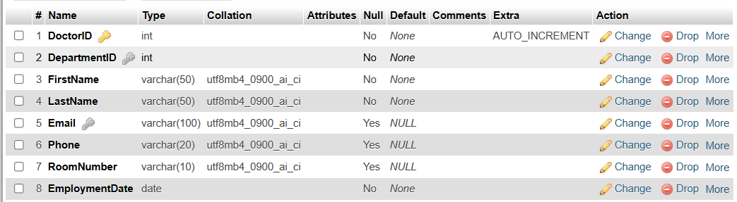

Department:
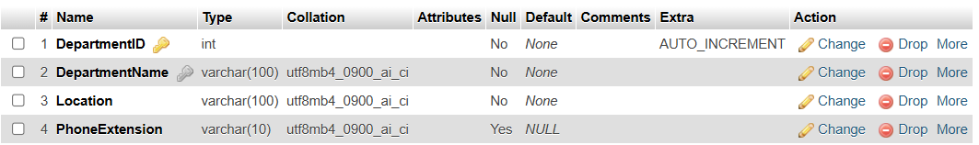

AuditLog:
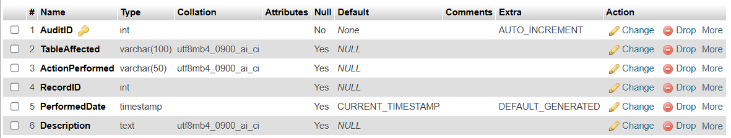

Appointment:
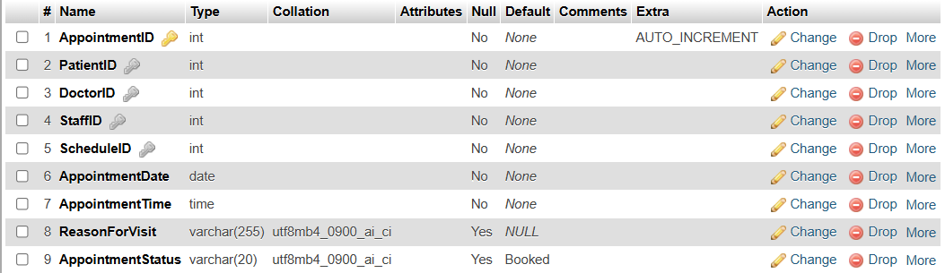

Admin Staff:
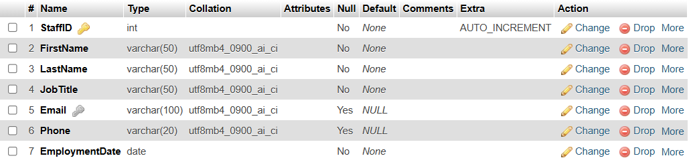

Treatment:
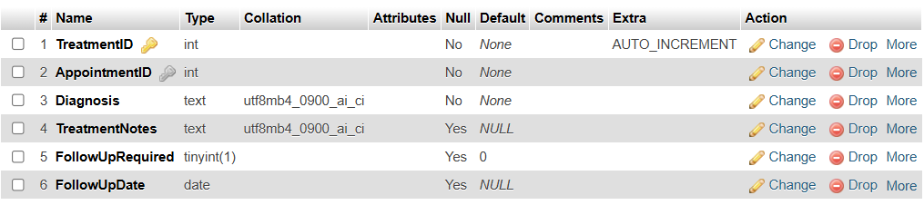

Prescription:
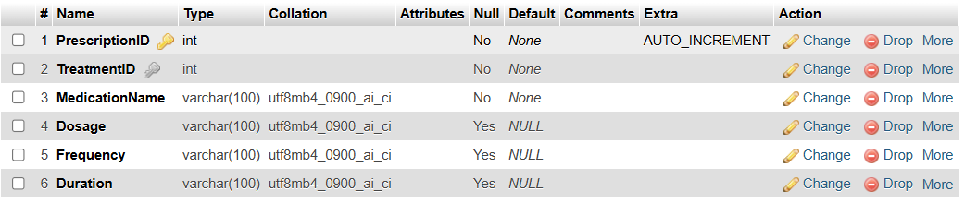

Patient:
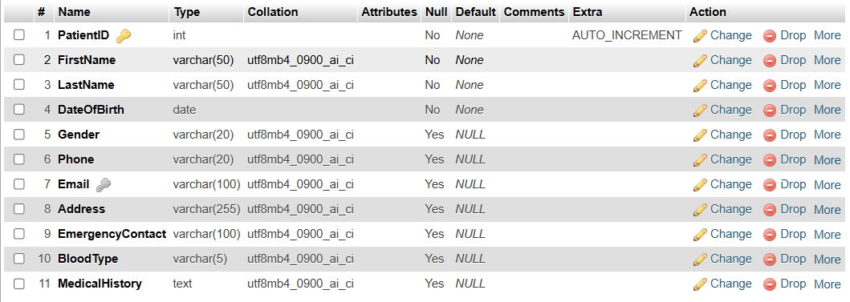

Feedback:
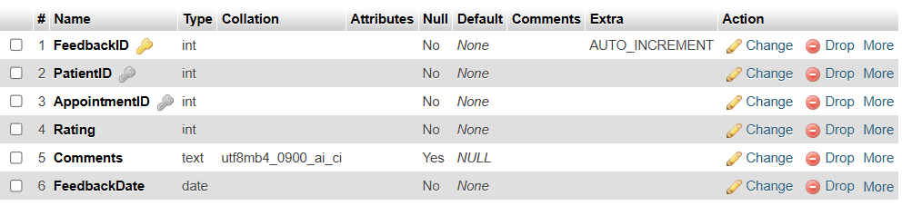

DoctorSchedule:
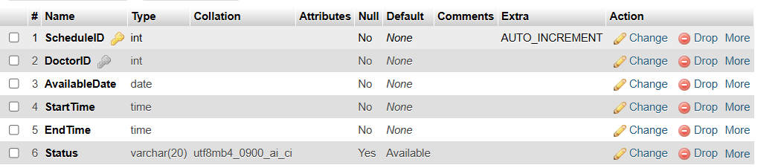

Constraint Implementation:
Integrity constraints were implemented to prevent invalid or inconsistent information from being stored. Foreign key constraints are particularly important because they maintain valid relationships between related entities. For example, Appointment.PatientID references Patient.PatientID, meaning an appointment cannot be created for a patient who does not exist in the Patient table, which will result in an error.
The constraint was tested by deliberately attempting to create an appointment using a non-existent PatientID. The database rejected the operation and returned a foreign key constraint error. This provides practical evidence that referential integrity is actively enforced.

Foreign Key (FK) constraint showing rejection of an invalid PatientID:
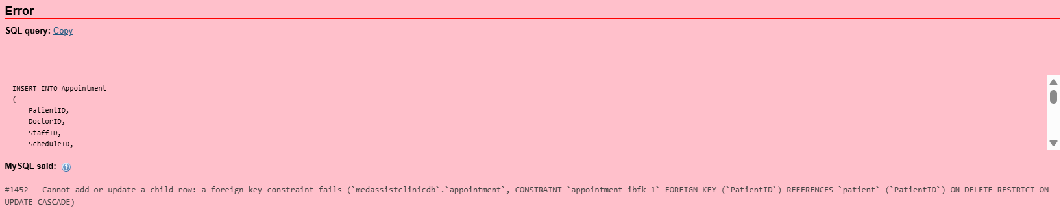
The database is rejecting an appointment containing an invalid PatientID, confirming that the foreign key constraint prevents references to non-existent patient records.

Sample data population:
Realistic sample data was populated across the relational tables to provide a suitable dataset for testing the database. The records represent different aspects of the clinic's operations, including patients, doctors, departments, administrative staff, doctor schedules, appointments, treatments, prescriptions and feedback. Most tables contain around 15 records, with variations where appropriate to the relationships represented.
The sample data was designed to preserve valid foreign-key relationships. For example, appointment records reference existing patients, doctors, staff members and schedules, while prescriptions reference existing treatments. Dates, times, statuses and descriptive values were populated realistically so that the queries and tests could demonstrate meaningful and realistic results.

Sample data is being inserted into tables:
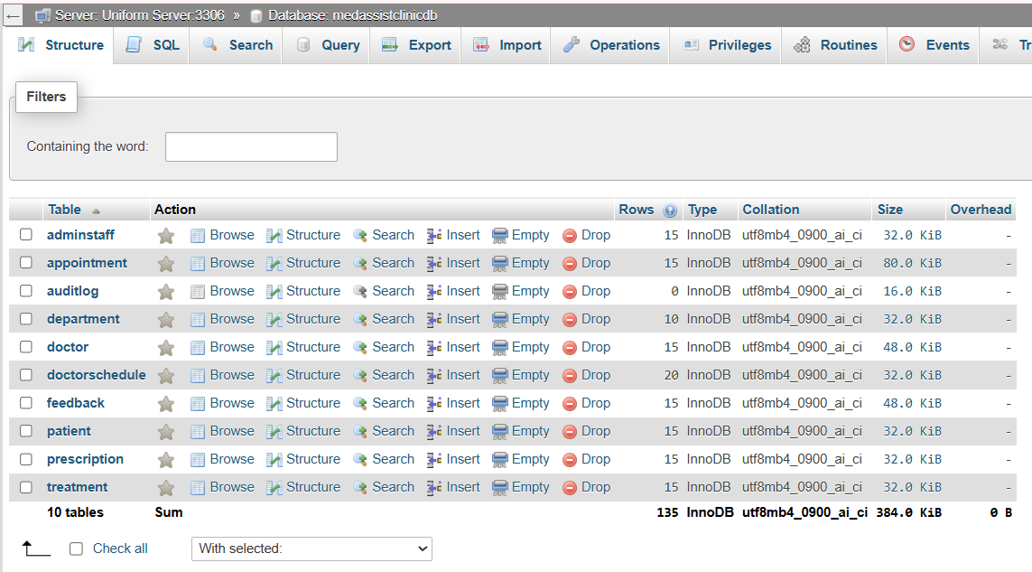

DoctorSchedule:
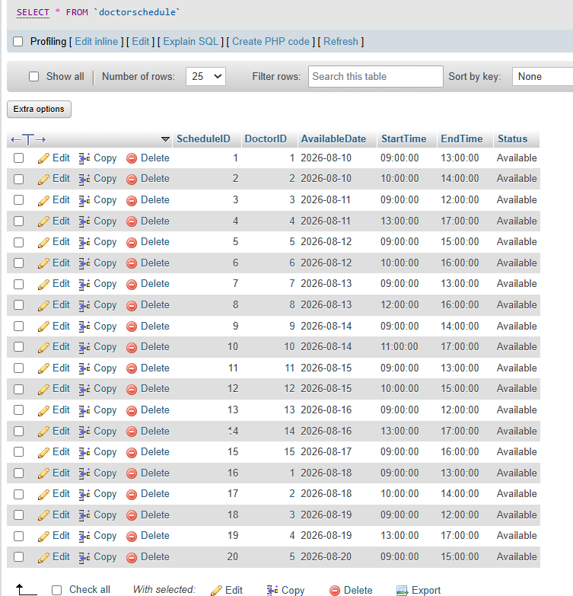

AdminStaff:
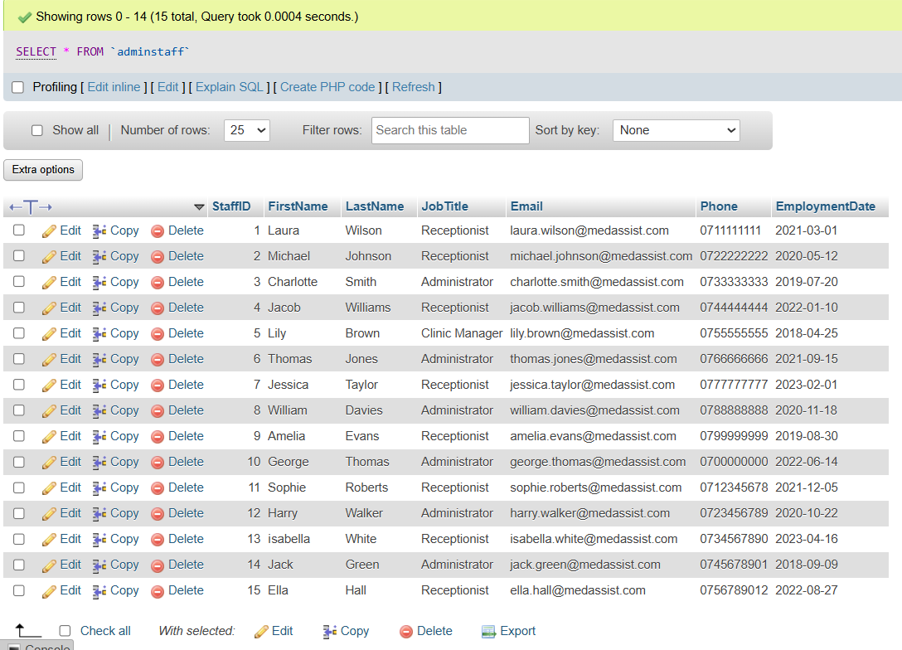

Patient:
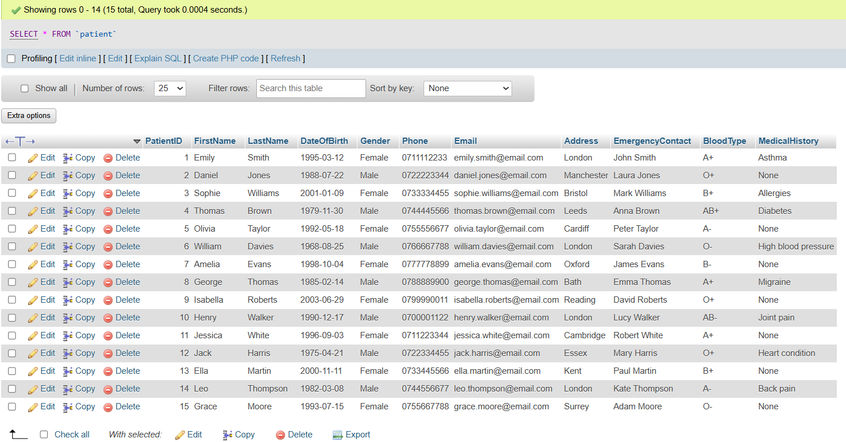

Doctor:
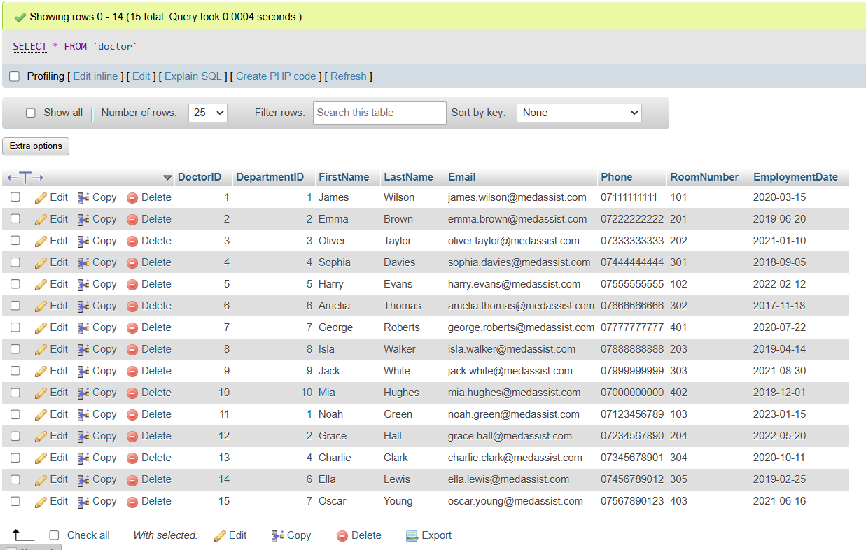

Department:
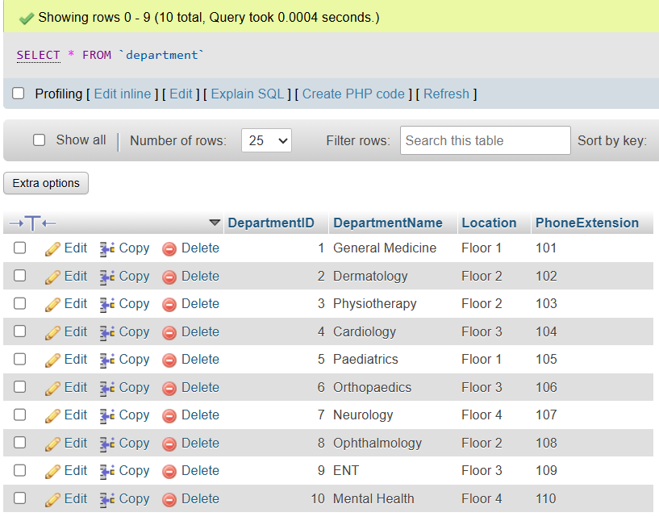

Prescription:
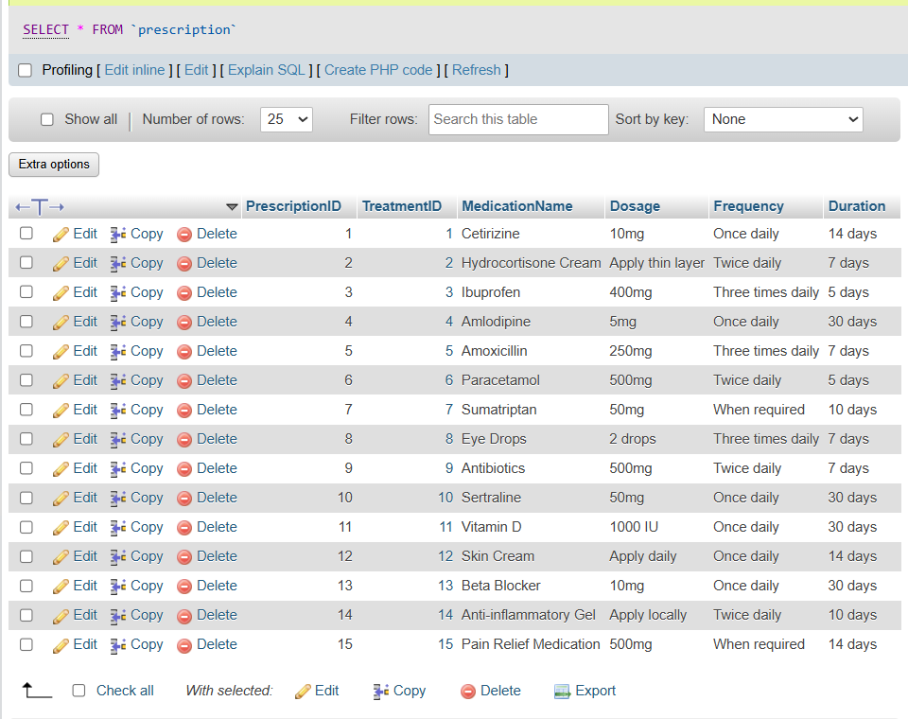

Treatment:
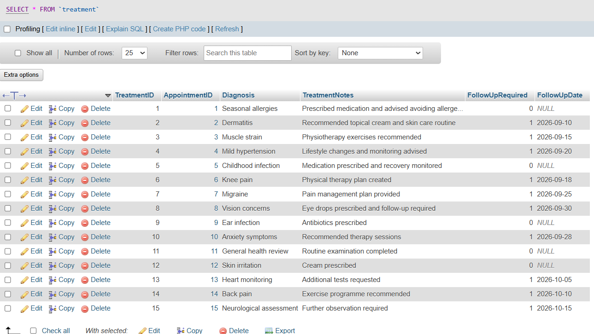

Appointment:
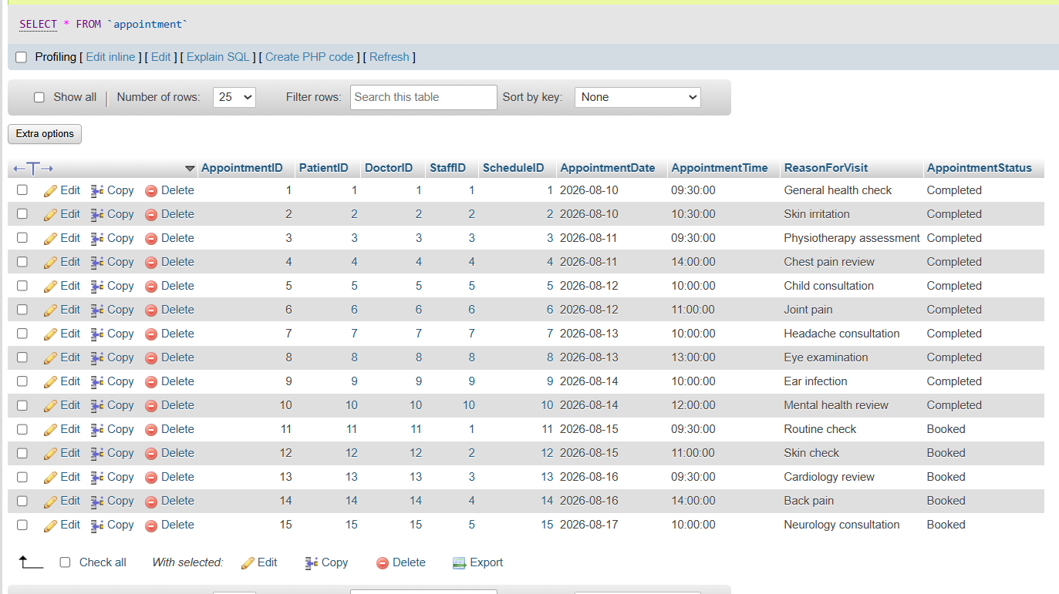

Feedback:
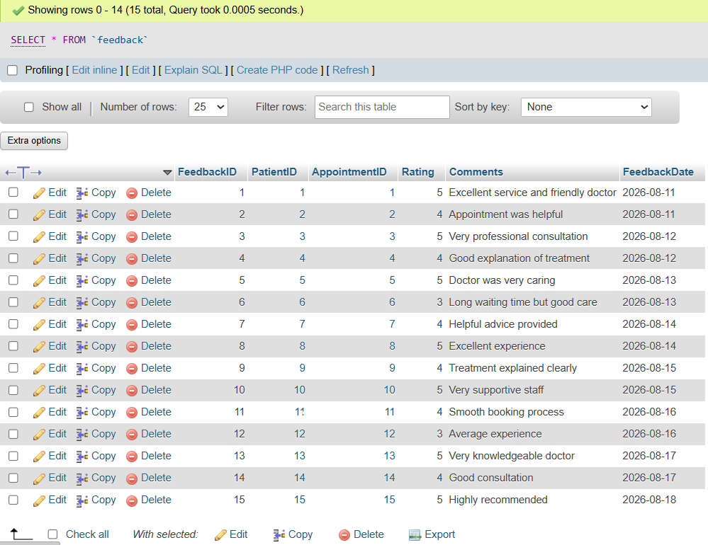
The populated datasets provide realistic records for testing relationships, constraints, stored procedures, transactions, triggers, functions and queries.

Database testing and validation:
Testing was conducted to verify both the functionality of the database and the integrity mechanisms implemented within it. SQL queries were used to retrieve information across related tables, demonstrating that the foreign-key relationships could be used effectively to obtain meaningful information. Tests included combinations of treatment and prescription data, patient and appointment information, and doctor and appointment information.
Invalid-data testing was also performed. Repeated attempts to insert duplicate patient email addresses and invalid feedback ratings were rejected by the database. A further test attempted to create an appointment using a non-existent patient identifier (PatientID), confirming that foreign-key enforcement prevented the invalid record from being stored. These tests demonstrate that the database does not only retrieve information correctly but also actively protects the integrity of stored data.

Patient table:
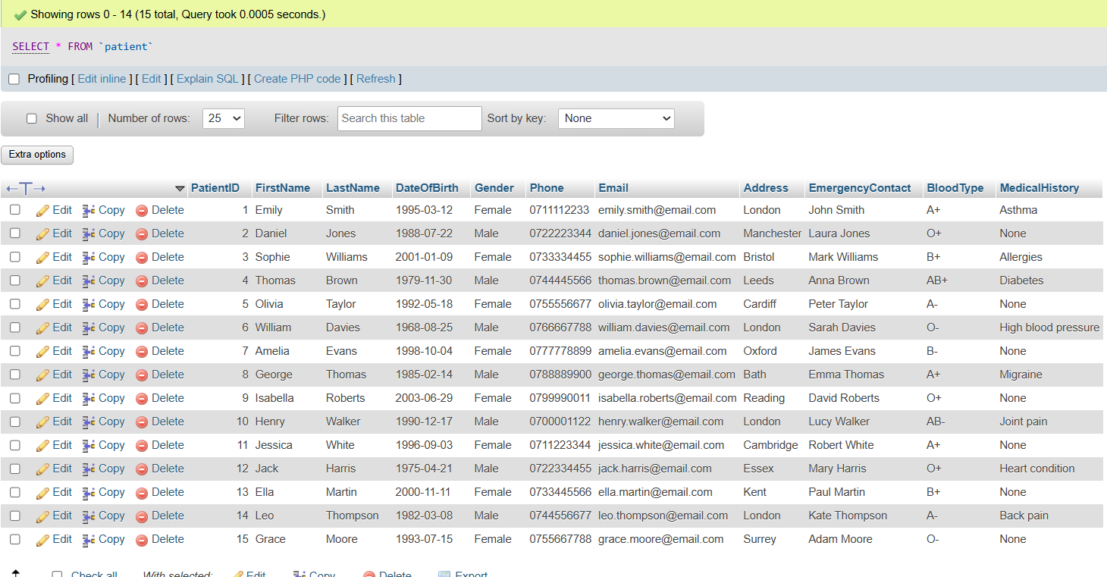

Appointment table:
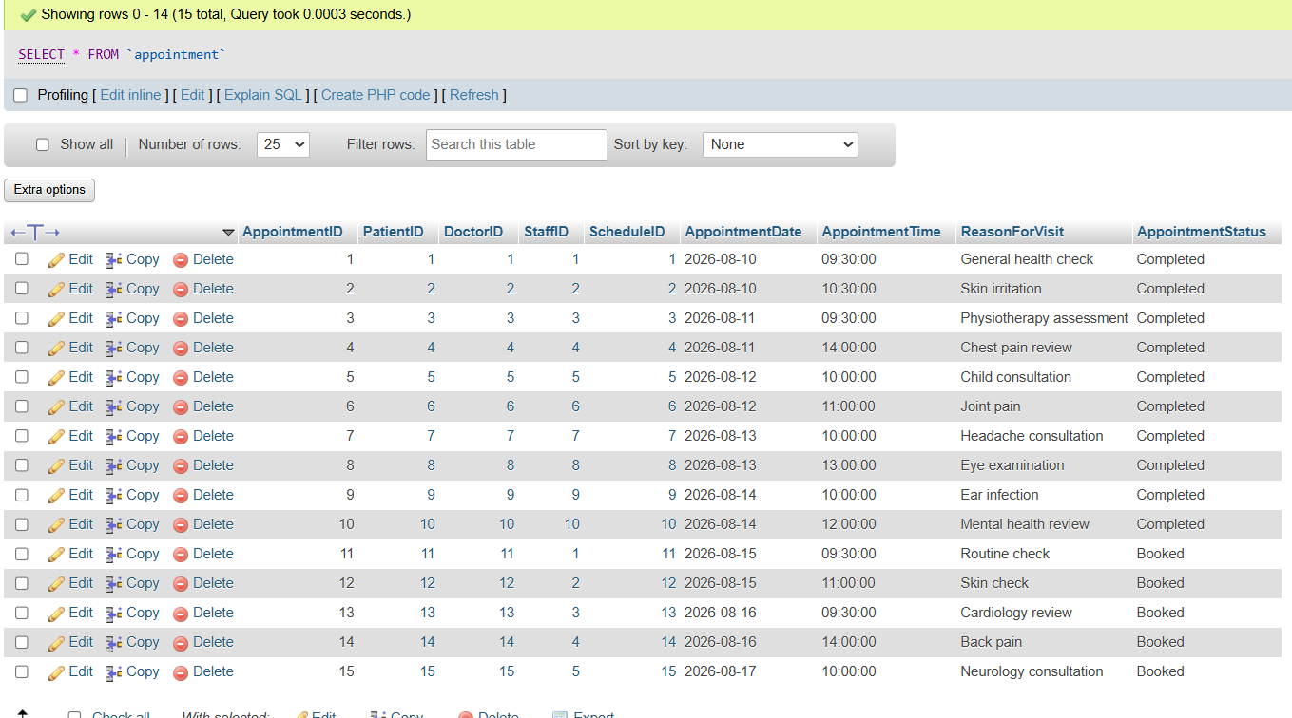

Retrieve Patient, Doctor, and Appointment Information:
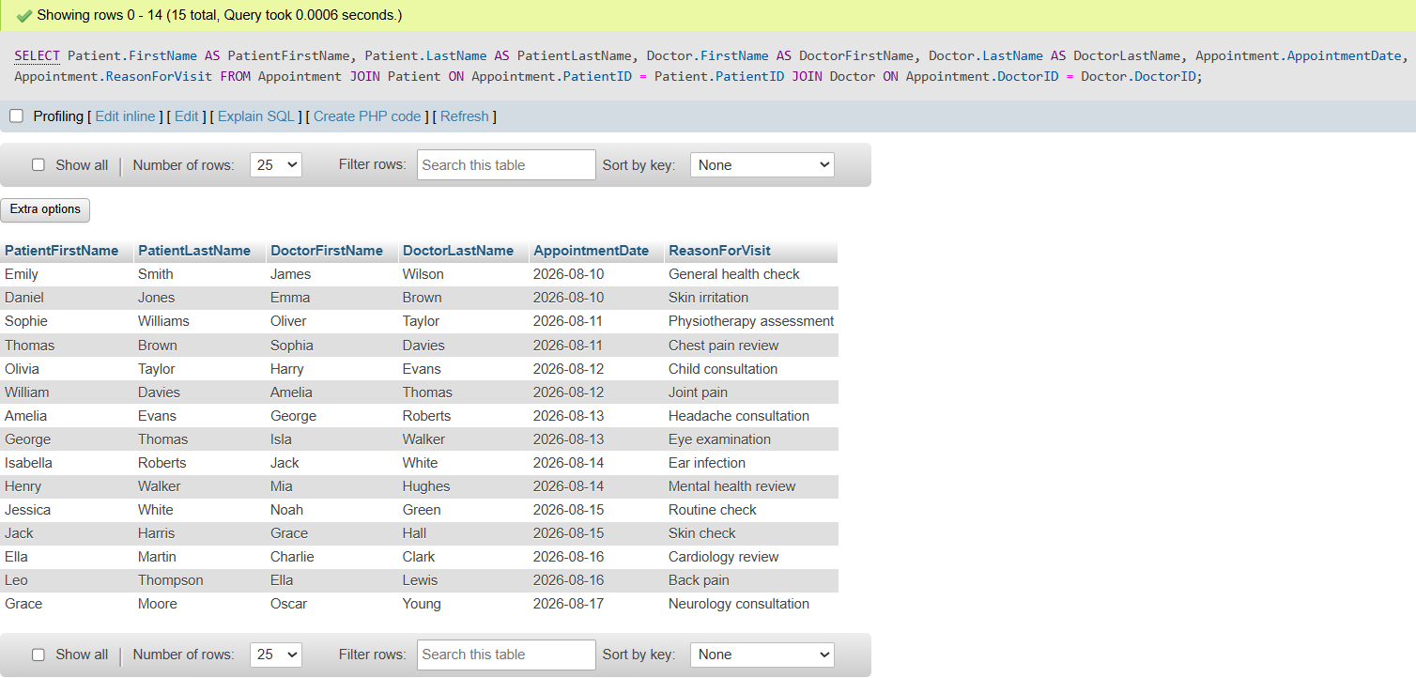

Retrieve Appointment and Patient Treatment Information:
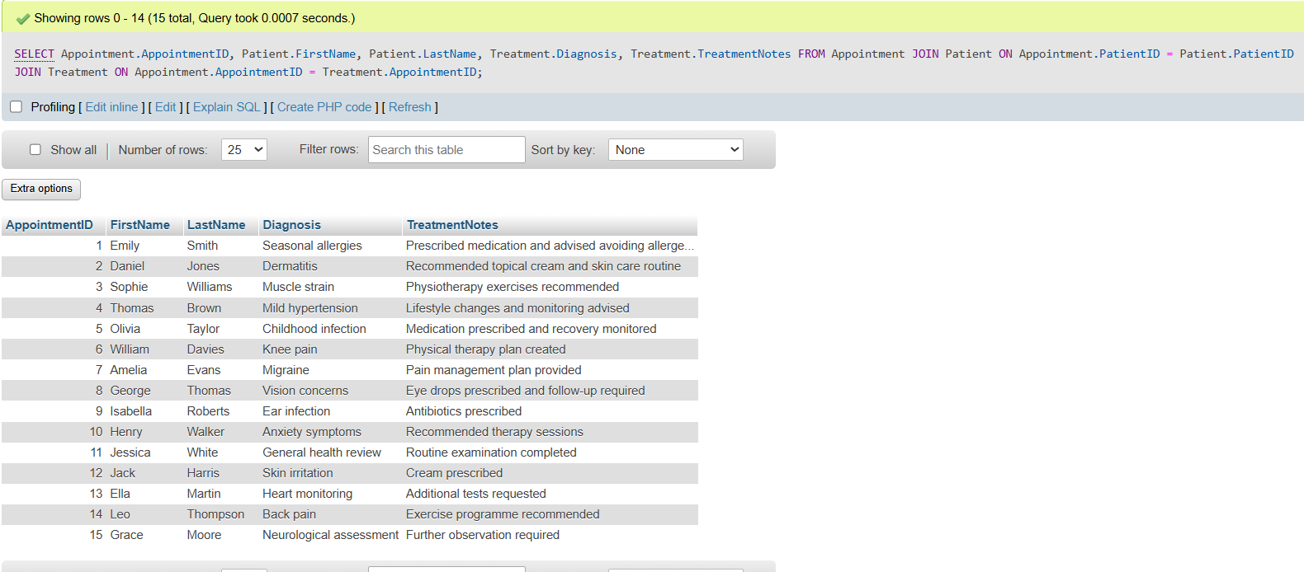

Retrieve Treatment and Prescription Information:
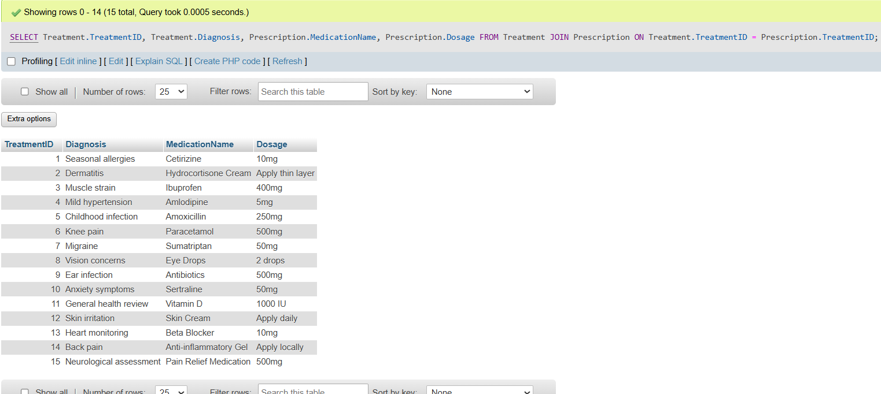

Invalid Patient ID:
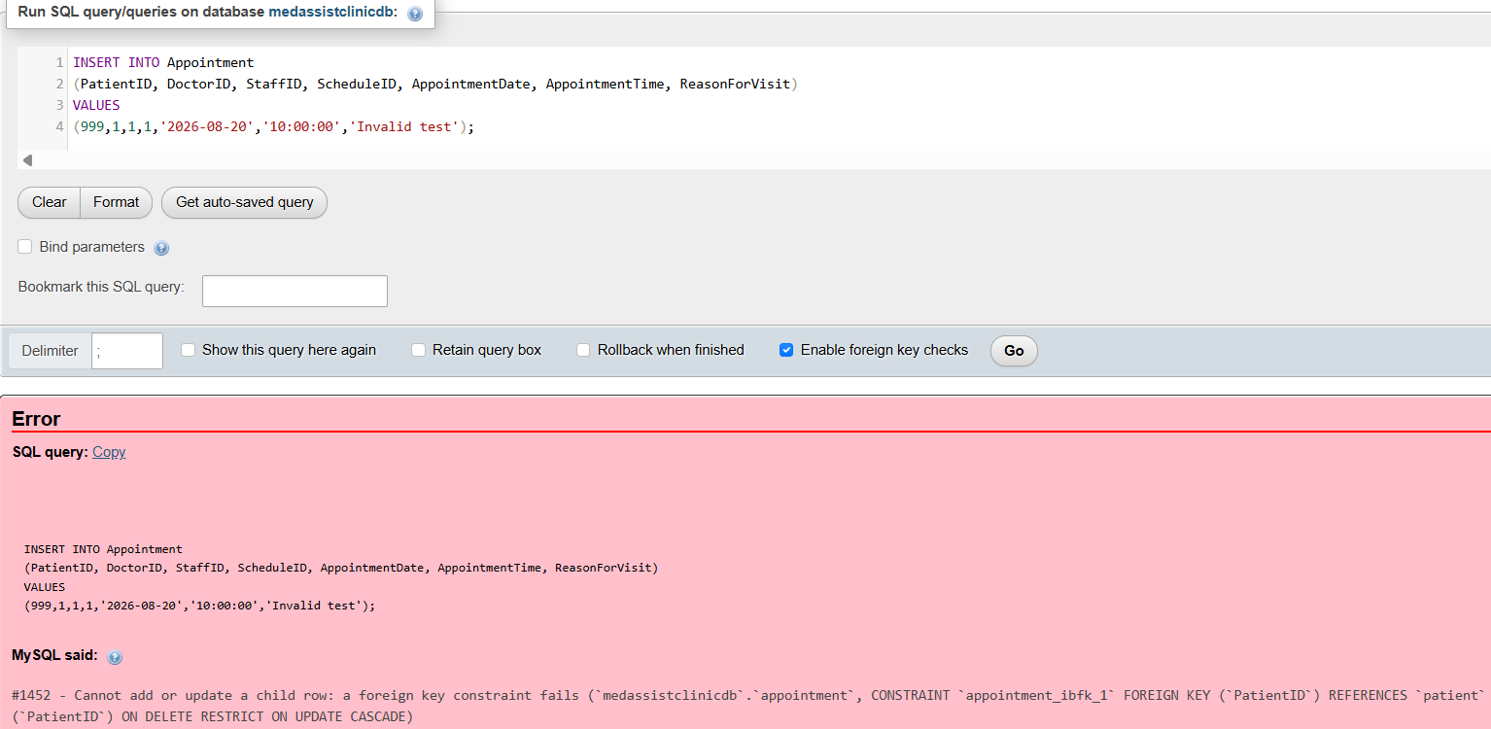

Invalid Feedback Rating:
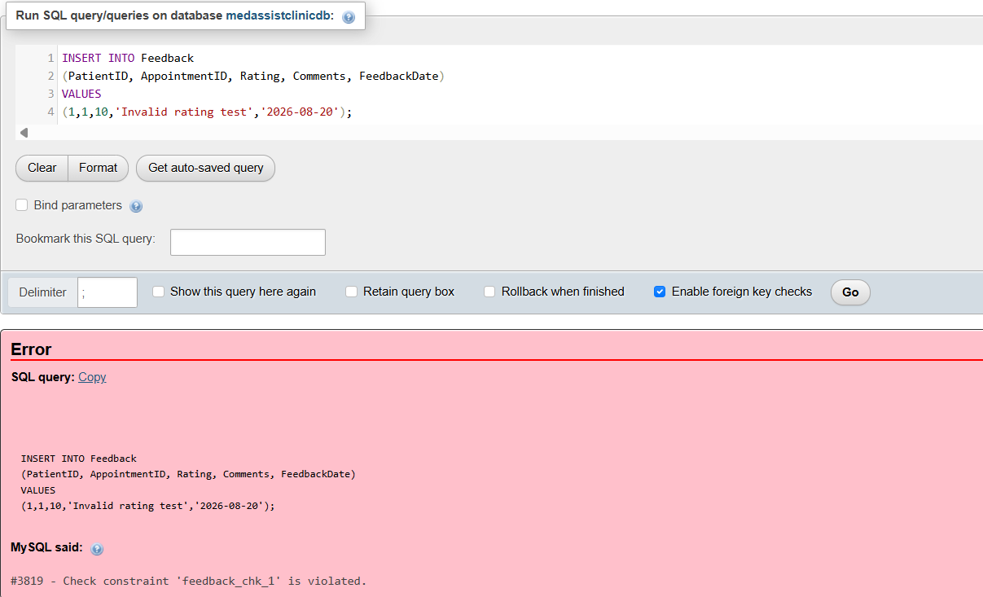

Duplicate Patient Email:
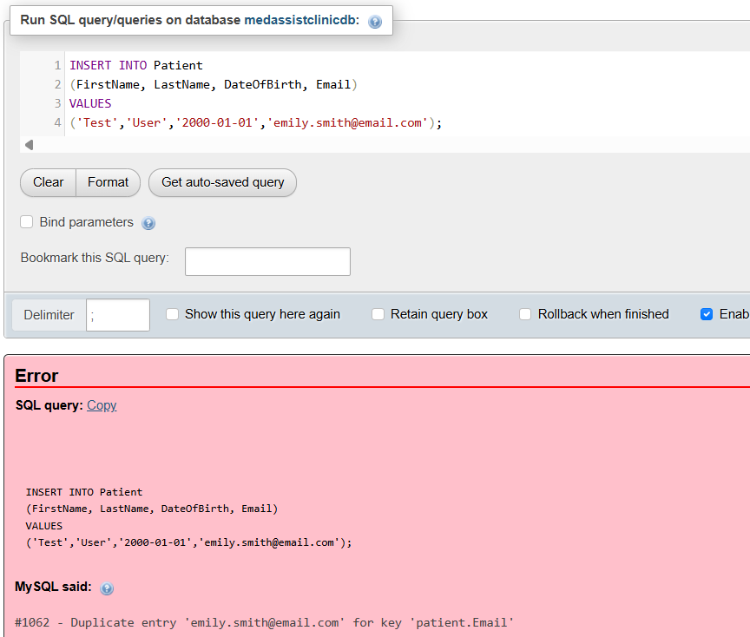
The testing demonstrates the successful execution of valid queries and the rejection of invalid data, providing evidence that the implemented database rules operate as intended.

Stored Procedures:
Stored procedures were implemented to provide reusable operations for common database tasks. The procedures include adding patient records, creating appointments, deleting appointments and updating patient contact information. These operations reduces the need to repeatedly write the same SQL statements and provides a controlled method for carrying out common database operations.
The AddPatient procedure demonstrates the insertion of a new patient using supplied parameters, while AddAppointment provides a structured method for creating appointment records. DeleteAppointment allows an appointment to be removed using its identifier, and UpdatePatientPhone demonstrates how an existing patient's contact information can be modified.
Each procedure was tested using valid data and the resulting database records were checked to confirm that the intended changes occurred. This demonstrates that the procedures are reusable and provide practical alternatives to repeatedly executing individual SQL statements.

AddPatient Stored Procedure:
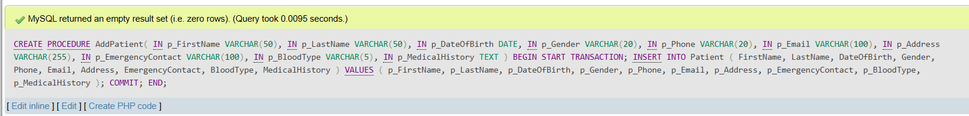

AddPatient Stored Procedure Test:
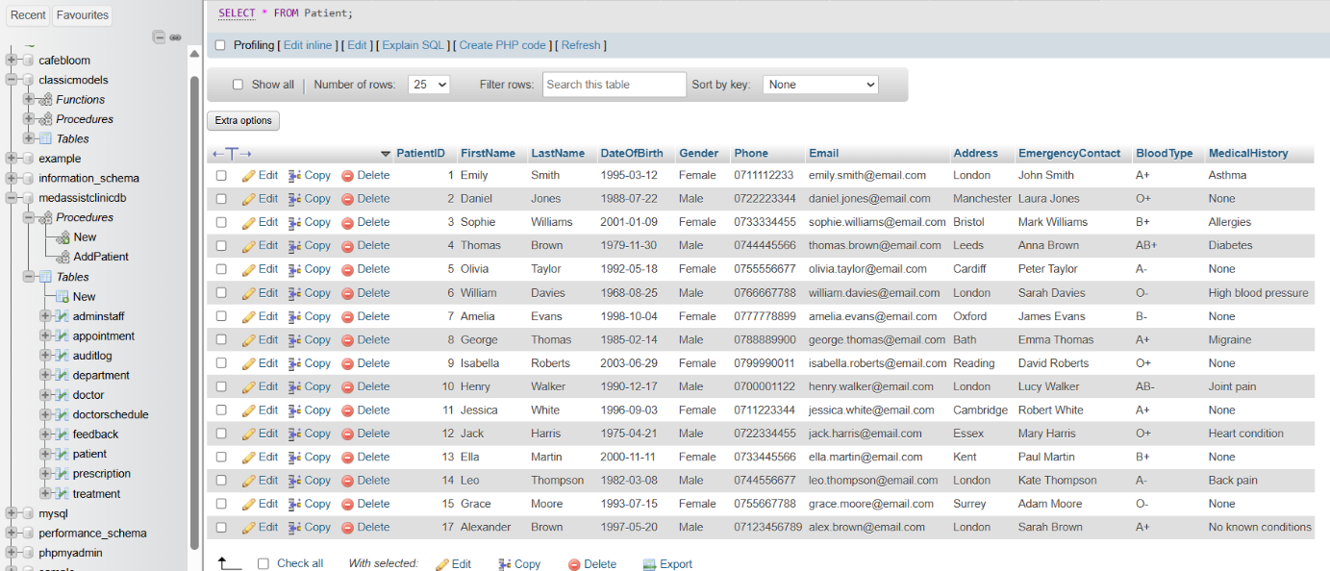

AddAppointment Stored Procedure:
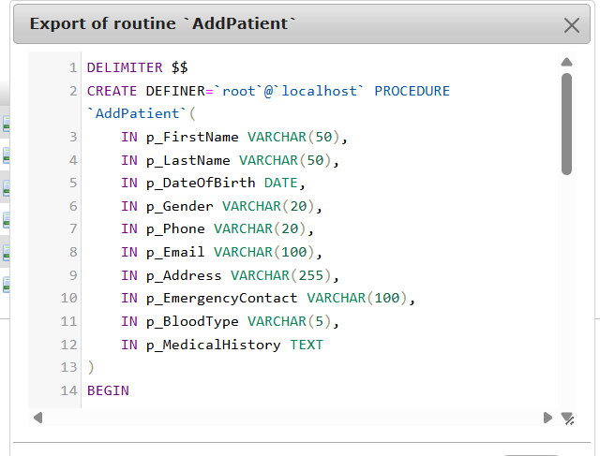

AddAppointment Stored Procedure Test:
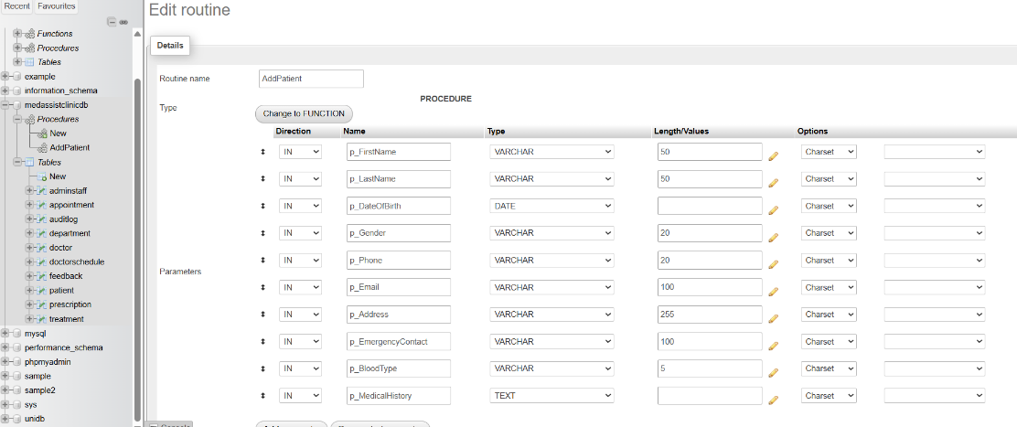

DeleteAppointment Stored Procedure:

DeleteAppointment Stored Procedure Test:
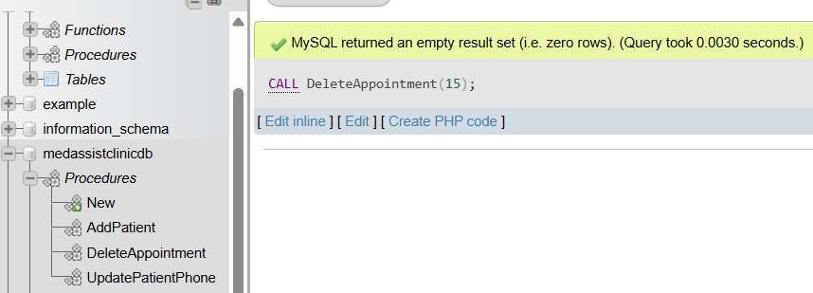

UpdatePatientPhone Stored Procedure:

UpdatePatientPhone Stored Procedure Test:
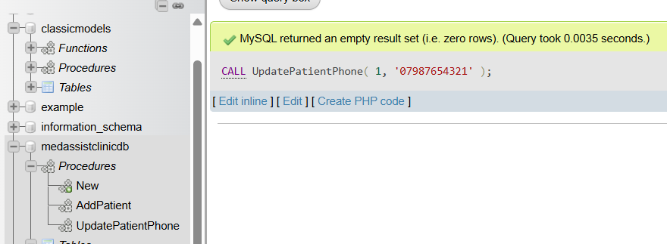
These display the implemented stored procedures and their successful execution against the MedAssist Clinic database.

Transactional scenario:
A transactional scenario was implemented using the BookAppointment stored procedure to ensure that related appointment operations are treated as a single body of work. The procedure creates an appointment and updates the corresponding doctor schedule. Due to this, operations are dependent on one another, because if you allow one to succeed while the other fails, this could leave the database in an inconsistent state.
Transaction control was implemented using START TRANSACTION, COMMIT and ROLLBACK. When all required operations succeed, the transaction is committed and the changes become permanent. If an exception or error occurs, the transaction is rolled back so that partial changes are not retained.
The transaction was tested using both valid and invalid data. The successful test confirmed that the appointment was created and the schedule updated. A second test used an invalid patient identifier, causing the operation to fail. Verification confirmed that the appointment was not retained, demonstrating that the rollback mechanism protected database consistency.

BookAppointment (START TRANSACTION, COMMIT):
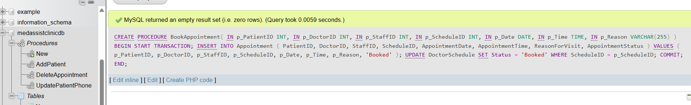

Call BookAppointment:
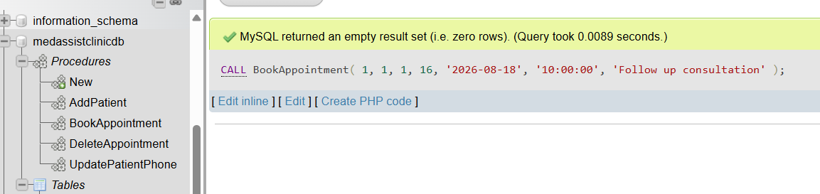

Successful Appointment Booking:
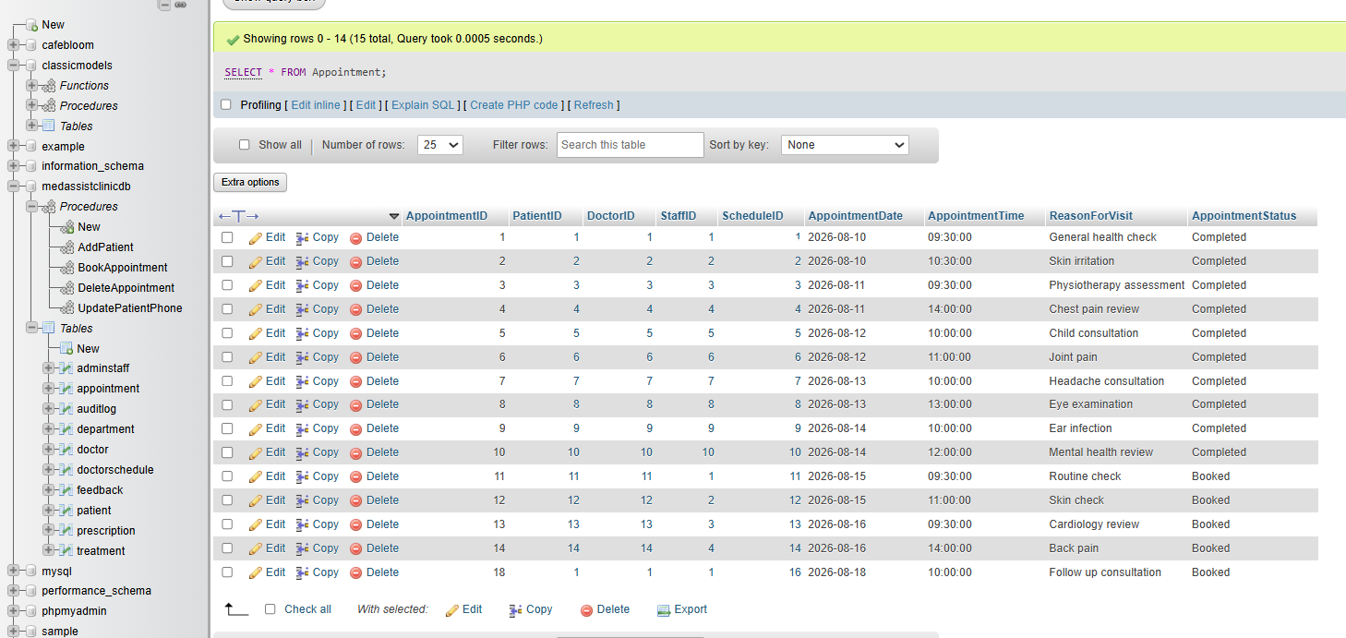

Booking added to DoctorSchedule:
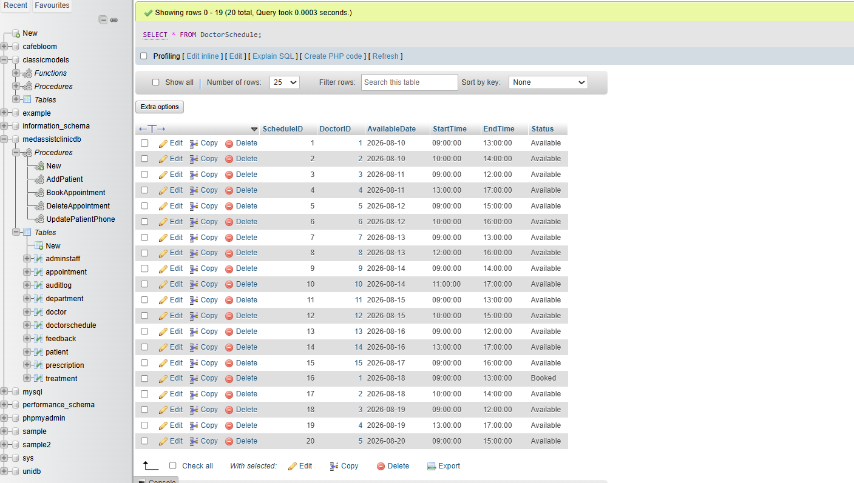
These demonstrate the transaction tests, including successful execution.

Triggers and auditing:
Triggers were implemented to automatically audit important database changes. Unlike manually creating audit records, triggers respond automatically when specified database operations occur. This ensures that relevant changes can be recorded consistently without relying on users or application code to remember to create an audit entry.
The implemented auditing was tested for insertion, updating and deletion operations. For example, when a new patient was inserted, the corresponding trigger created: an AuditLog record containing information about the affected table, the action performed, the record identifier and a description. Updating appointment information similarly generated an audit entry identifying the update operation.
This provides improved accountability because changes can be recorded automatically as they occur. The separate AuditLog table also keeps audit information distinct from operational data, which is consistent with the separation represented in the ERD provided earlier.

Patient INSERT Trigger:
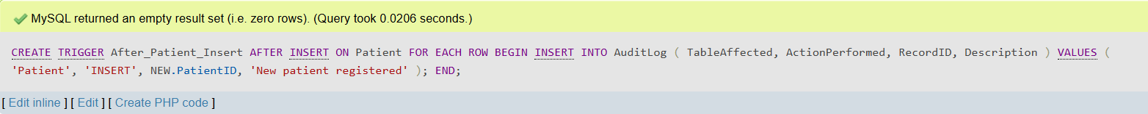
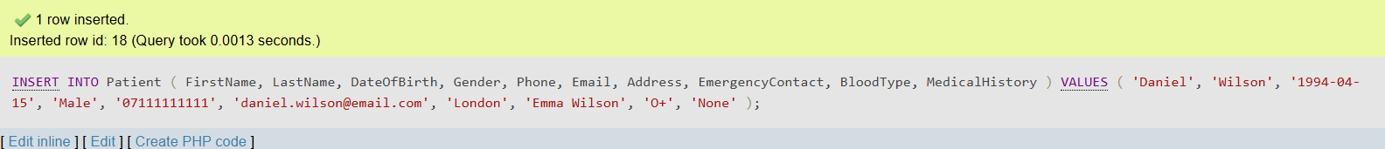

Patient INSERT Trigger – Audit Log Test:
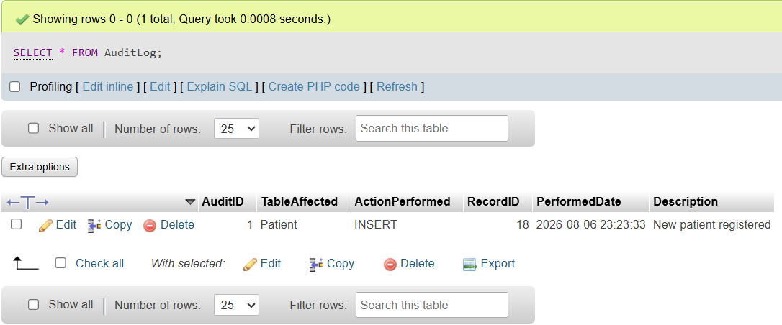

Appointment UPDATE Trigger:
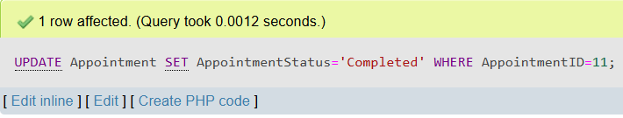

Appointment UPDATE – Audit Log Test:
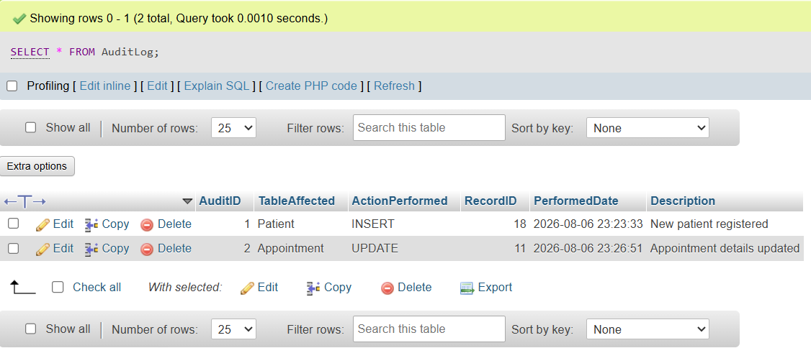

Appointment DELETE Trigger:

Appointment DELETE Trigger – Audit Log Test:
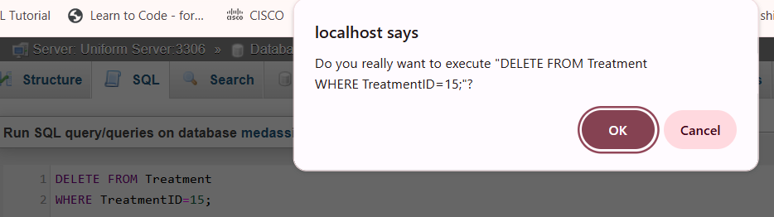
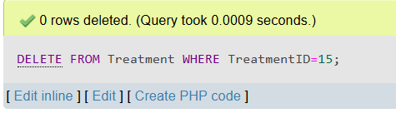
These display the automatic generation of audit records following database operations, confirming that the triggers operate as intended.

Functions:
Stored functions were implemented to provide reusable calculations that can be incorporated into SQL queries. Two functions were demonstrated: CalculateAge, which calculates a patient's current age from their date of birth, and the appointment-count function, which determines the number of appointments associated with a patient.
Centralising these calculations within the database avoids repeatedly implementing the same logic in separate queries. The resulting values were displayed alongside patient information, demonstrating that the functions execute correctly and can be incorporated into larger SELECT statements.
This improves consistency because the same calculation logic can be reused whenever the information is required.

Patient Appointment Count Function:
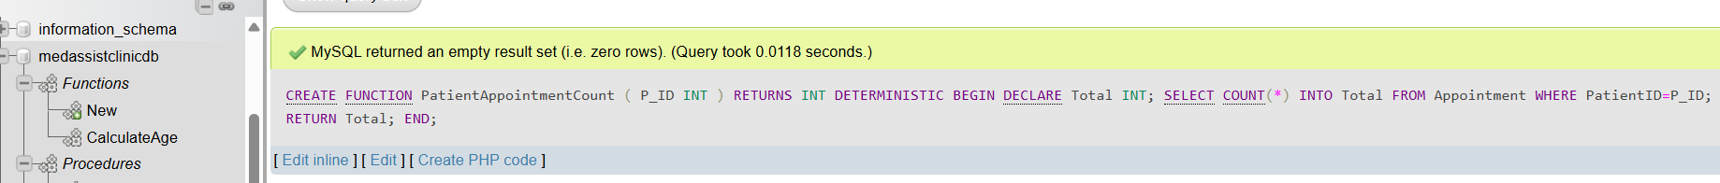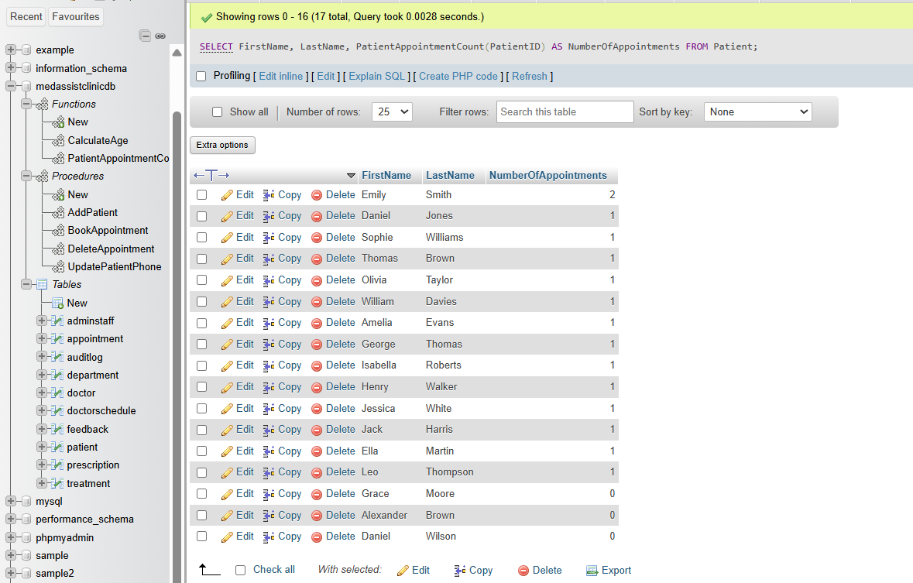

Calculate Age Function:
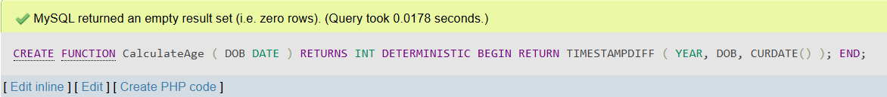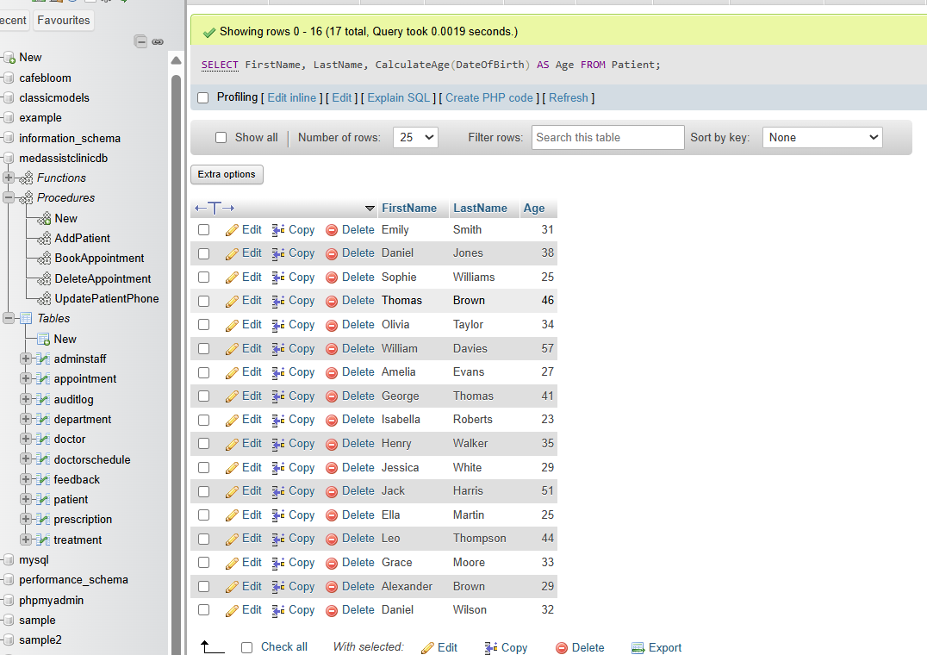
The functions therefore improve consistency and provide reusable database-level logic for calculations that may be required in multiple contexts.

Performance Tuning:
Performance optimisation was considered by identifying attributes which are likely to be used frequently for searching, filtering and relational operations. Secondary indexes were created on Appointment.PatientID, Appointment.AppointmentDate and Doctor.DepartmentID to support common appointment and doctor-related queries.
Indexing foreign-key and frequently searched attributes can reduce the amount of data that the database engine needs to examine when retrieving records. The implemented indexes therefore provide a performance improvement as the database grows and the volume of records increases.
The index structures were inspected using SHOW INDEX to verify that the intended performance structures had been successfully created. This provides evidence that the optimisation was not only planned but implemented within the database.

Index Creation:
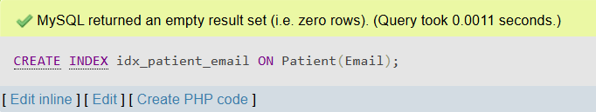
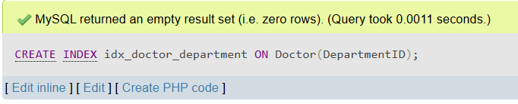
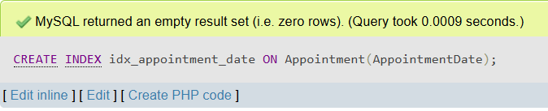
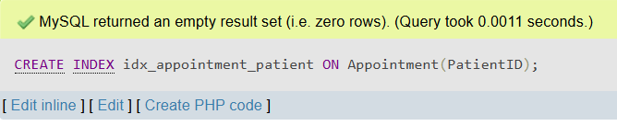

Index Verification:
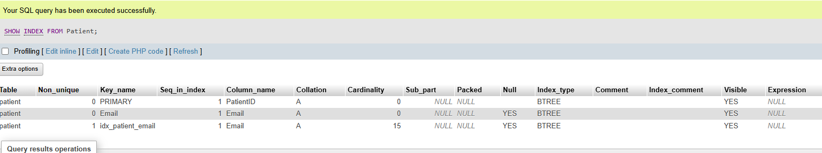
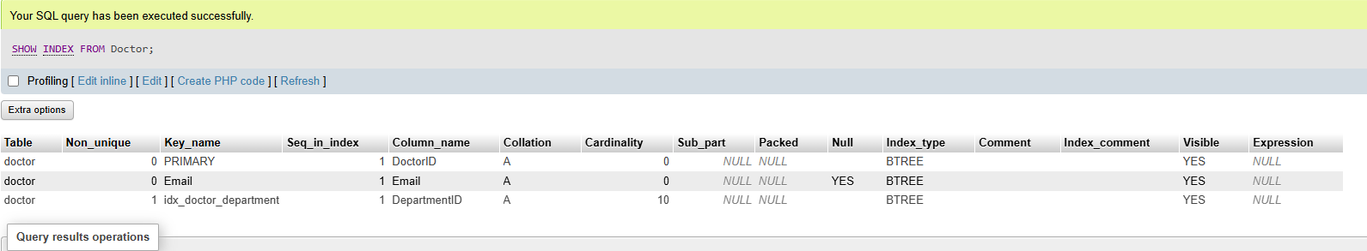
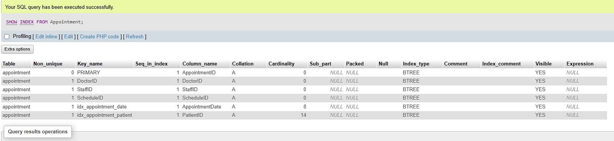
The screenshots show the implemented indexes on the selected appointment and doctor attributes, confirming that the intended performance structures exist.

Conclusion:
The MedAssist Clinic database has been designed and implemented as a relational solution supporting the clinic's core operational requirements. The ERD establishes the required entities and relationships, while normalisation to 3NF reduces unnecessary duplication and supports consistency. The implemented MySQL database contains ten related tables covering patients, doctors, departments, appointments, schedules, treatments, prescriptions, feedback, administrative staff and auditing.
Primary keys, foreign keys and integrity constraints provide mechanisms for maintaining valid data, while realistic sample data enabled the database to be tested through both valid and invalid operations. Stored procedures provide reusable database operations, while the BookAppointment procedure demonstrates how related changes can be managed as a transaction. Triggers provide automatic auditing, stored functions demonstrate reusable calculations and secondary indexes support performance-critical queries.
The database could be extended further for a real healthcare environment through more comprehensive transaction error handling, stronger audit information, role-based access control, encryption and additional security controls. Nevertheless, the implemented solution demonstrates the key relational database principles required for the MedAssist Clinic scenario and provides a strong foundation for the database-driven website developed in Part B.

Part B: Database Driven Website
Part B builds directly on the MedAssist Clinic database created in Part A by developing a fully functional, database-driven website using PHP, MySQL, HTML and CSS. The aim of this section is to demonstrate how a relational database can be integrated into a practical web application, allowing users to interact with stored information through a user-friendly interface rather than through SQL commands.
The website was developed locally using UniServerZ, with all project files stored inside the MedAssistClinic folder within the www directory. This setup allowed PHP pages to run through the Apache server and communicate with the MySQL database. PHP was chosen as the server-side language because it can process form submissions, validate user input, execute SQL queries and dynamically generate webpage content.
A central design decision was to build the website around the existing MedAssist Clinic database rather than creating new or unrelated tables. This ensures that the website directly demonstrates how the relational structures from Part A operate within a real application. The system uses patient, doctor, appointment and feedback data, and provides full CRUD functionality: creating new records, retrieving stored information, updating existing entries and deleting records when required.
The final application consists of multiple PHP pages, each responsible for a specific function: homepage, registration, login, logout, dashboard, doctor listings, appointment management (view, book, edit, cancel) and feedback submission. A separate HTML feedback form was included to show how client-side input can be passed to a PHP processing script. A shared CSS stylesheet ensures consistent styling across all pages, giving the website a unified and professional appearance.
Overall, the website demonstrates key concepts of database-driven development: establishing a secure connection to MySQL, retrieving and displaying dynamic content, processing user input through forms, performing CRUD operations, implementing search functionality and applying basic security measures such as prepared statements to prevent SQL injection.

Development Environment and Database Connectivity:
The website was developed using PHP, HTML, CSS and MySQL, with UniServerZ providing the local Apache and MySQL servers. All project files were placed inside the MedAssistClinic directory within the www folder, allowing them to be accessed through localhost [7]. This follows the standard workflow used throughout the module.
A dedicated db.php file was created to handle the database connection. Storing the connection code in one place avoids repetition and makes the application easier to maintain. Each PHP page includes this file using require_once, ensuring that all database operations use the same connection.
The website acts as a bridge between the user and the database. When a user submits a form, PHP receives the input, validates it and executes the appropriate SQL query. When information needs to be displayed, PHP retrieves the relevant records and embeds them into the webpage. This demonstrates how PHP and MySQL work together to support dynamic, data-driven applications.

MedAssistClinicDB:
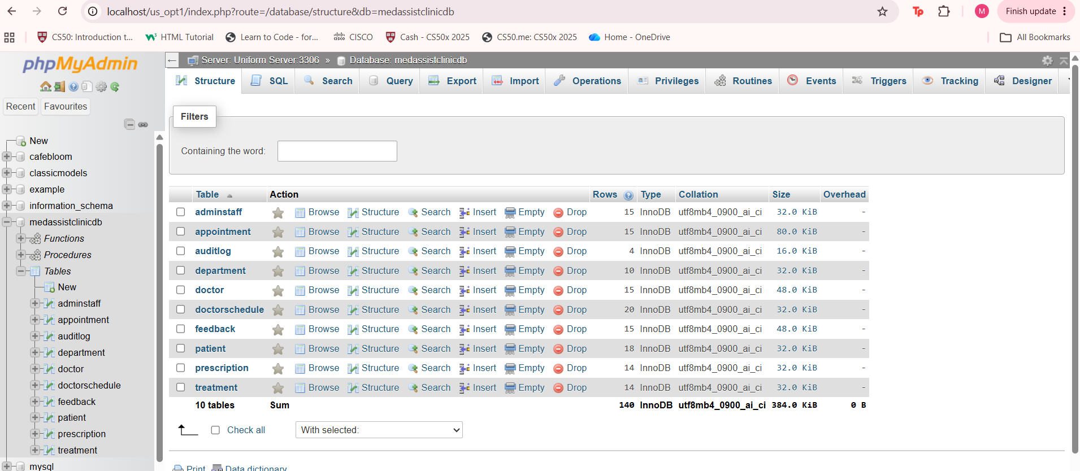
PHP, HTML, CSS file created to produce the Database-Driven Website:
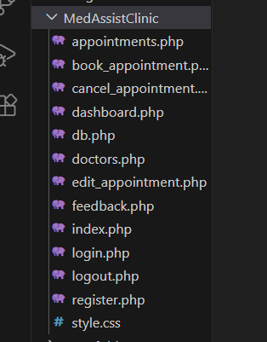

Database Connection:
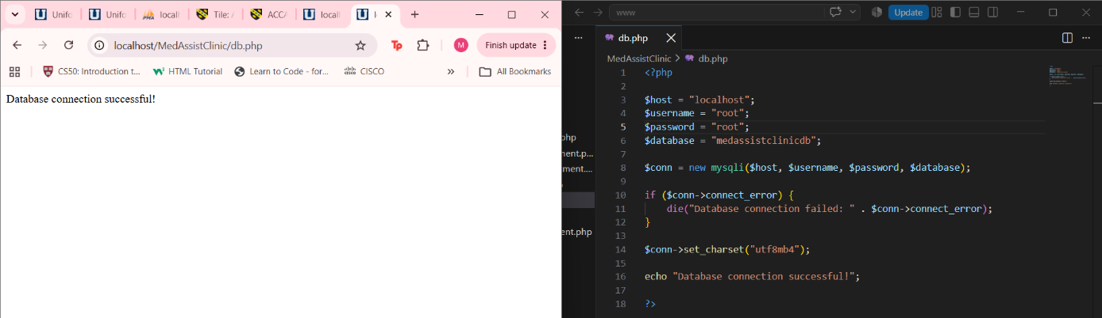
This highlights the PHP database connection used by the MedAssist Clinic website. The connection provides the communication layer between the website and the MySQL database, allowing the pages to retrieve and manipulate database records.

Homepage:
The homepage serves as the main entry point to the website. It provides navigation links to the doctor listings, appointment features and feedback form. Due to the website using PHP rather than static HTML, content can be personalised, for example, displaying patient-specific information once a user logs in.
A shared CSS stylesheet ensures that the homepage and all other pages follow a consistent design, including the navigation bar, buttons, form layout and content containers. This helps the website feel cohesive and improves usability.
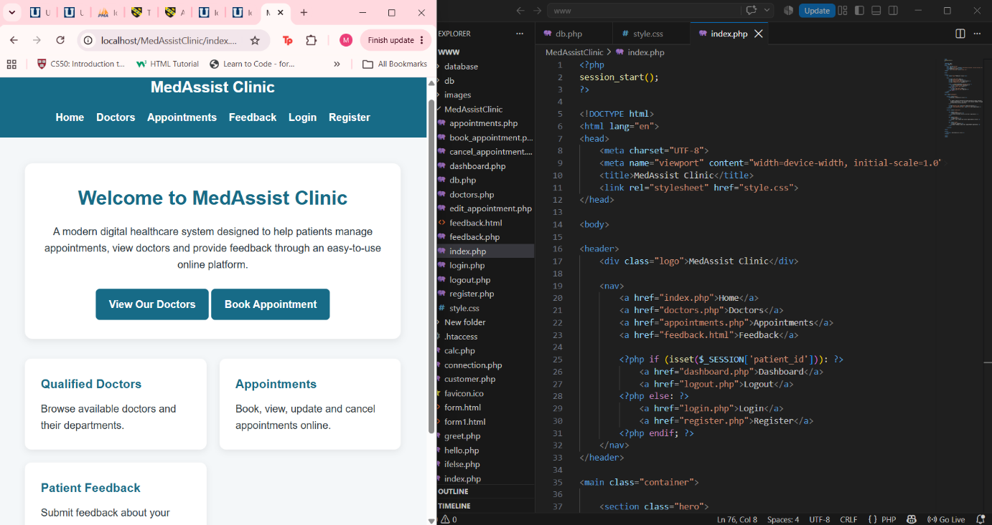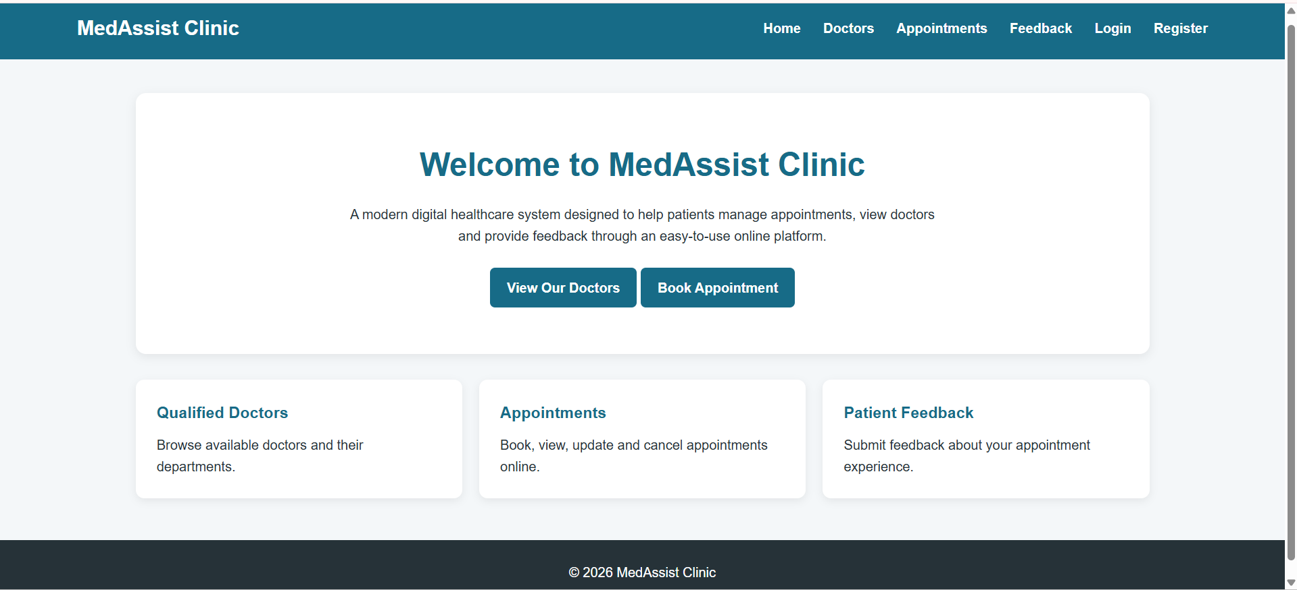
This demonstrates the completed MedAssist Clinic homepage and navigation structure. The page provides access to the main website functionality while maintaining a consistent visual design across the whole website.

User Login and Dashboard:
A login system was implemented to ensure that only registered patients can access appointment-related features. The login page checks the user’s credentials against the Patient table. Once authenticated, PHP sessions are used to keep the user logged in while navigating between pages.
The dashboard displays personalised information based on the logged-in patient’s database record. This demonstrates dynamic content retrieval, as the displayed information changes depending on which patient is logged in. Logout functionality was also implemented to end the session and return the user to the homepage.

Login page:
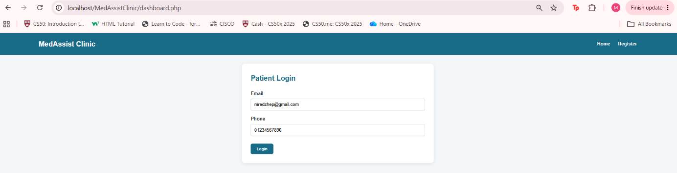
The patient login interface used to authenticate registered users.

Dashboard (After Patient has created an account and logged in):
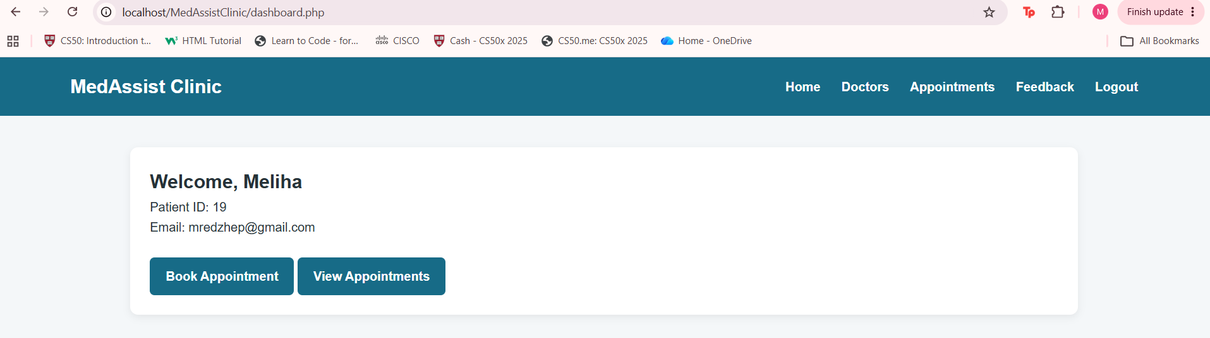

Patient Registration and Database Insertion:
The registration page allows new patients to create an account. This demonstrates the Create operation in CRUD [8]. The form collects patient details, and PHP validates the input before inserting the new record into the Patient table using an SQL INSERT query.
The database screenshot provides additional evidence that the operation was successful because the newly registered patient can be seen within the Patient table.

Empty Patient Registration form:
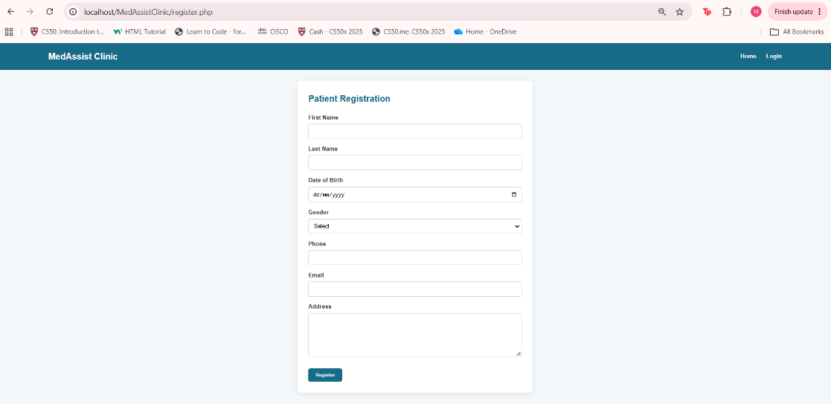

Completed Patient Registration form:
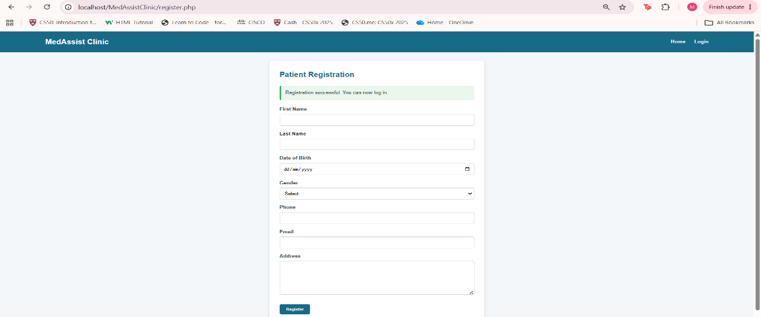
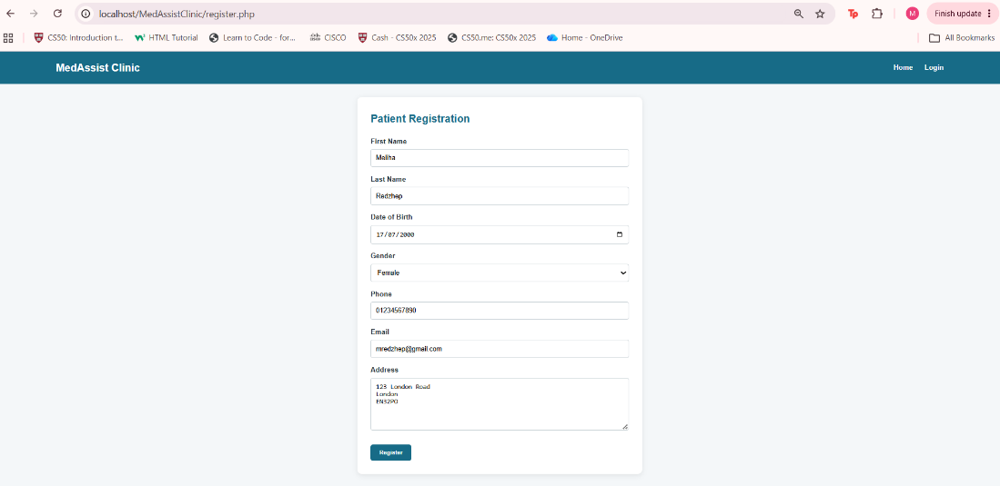

Patient added into Database:
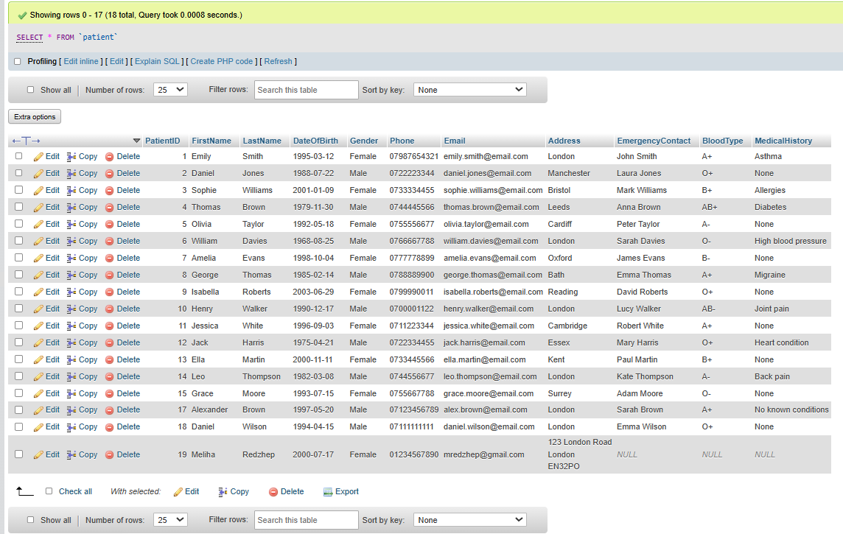
This implementation demonstrates how the website provides a more accessible method of interacting with the database whilst still maintaining the underlying relational structure established in Part A.

Doctor Information and Search Functionality:
The Doctors page demonstrates the Read operation [9]. PHP retrieves doctor records from the database and displays them dynamically. This allows users to browse available doctors without manually checking the database.
A search feature was also implemented. Users can enter a search term, and PHP filters the doctor records using a SQL query. This improves usability and demonstrates practical use of database queries within a web interface.

Doctors:
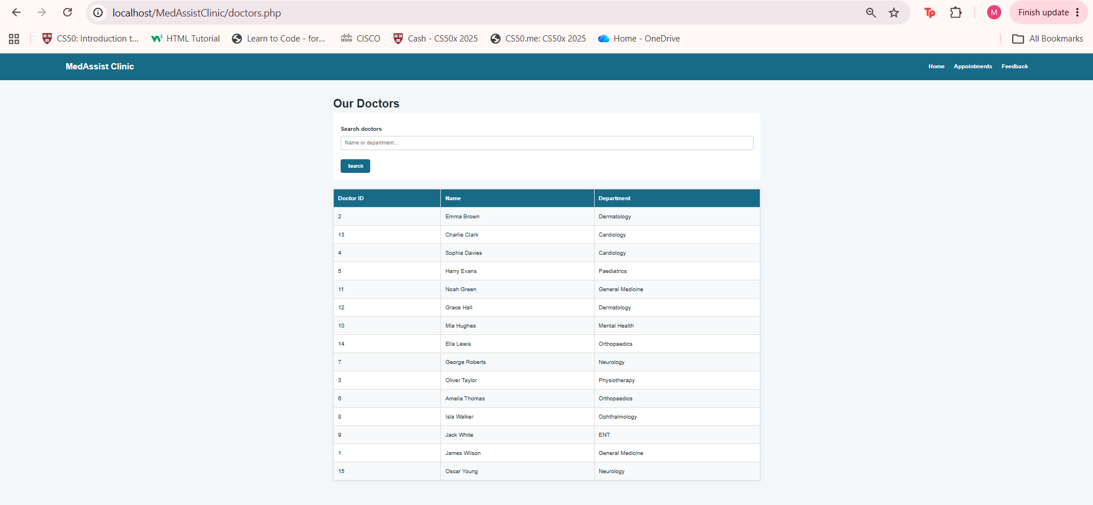
This displays the dynamic retrieval of doctor records from the MedAssist Clinic database.

Search Functionality:
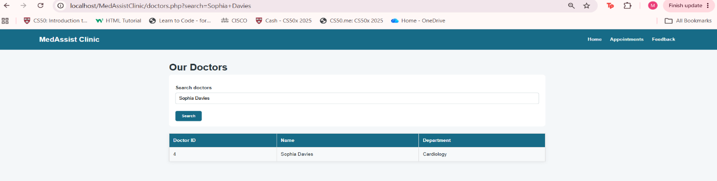
This demonstrates the search functionality, showing how users can filter the available doctor information rather than manually browsing all records.

Book Appointment – Create Operation:
The appointment booking page demonstrates another Create operation within the CRUD model [10]. Patients can select a doctor, choose an available schedule slot and provide a reason for their visit. When the form is submitted, PHP validates the input and inserts a new appointment record into the Appointment table using a prepared statement.
Due to appointments relying on several foreign keys like PatientID, DoctorID, StaffID and ScheduleID, the booking page must ensure that only valid identifiers are used. This reflects the relational structure established in Part A and shows how the website enforces database integrity through controlled user input.
The booking process also demonstrates how PHP can handle more complex operations involving multiple related tables. By retrieving doctor schedules and validating patient information, the system ensures that appointments are created accurately and consistently.
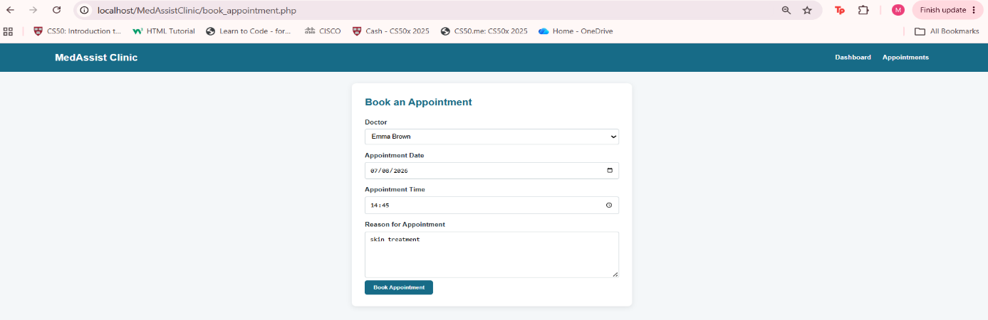
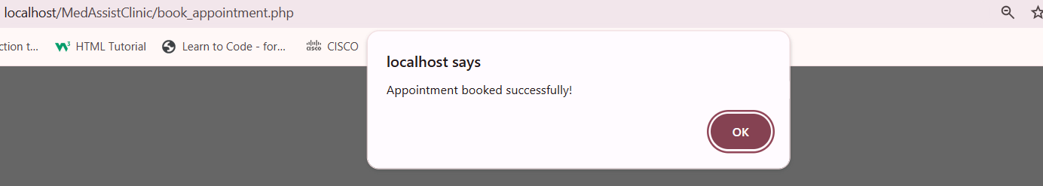
The successful creation of the appointment demonstrates that the website can interact with multiple related database entities while maintaining the relational structure of the database.

Viewing and managing Appointments:
The Appointments page demonstrates Read functionality by retrieving existing appointment records from the database and displaying them throughout the website. This provides a practical interface for users to view appointments without accessing phpMyAdmin directly.
The application also provides Update and Delete functionality through the edit and cancellation pages [11].
This creates a complete CRUD workflow:
CRUD operation | Website functionality
Create | Register patient / Book appointment
Read | Doctors / Appointments
Update | Edit appointment
Delete | Cancel appointment

This demonstrates that the application is capable of performing the four fundamental database operations through a web interface.

View Appointments before a booking:
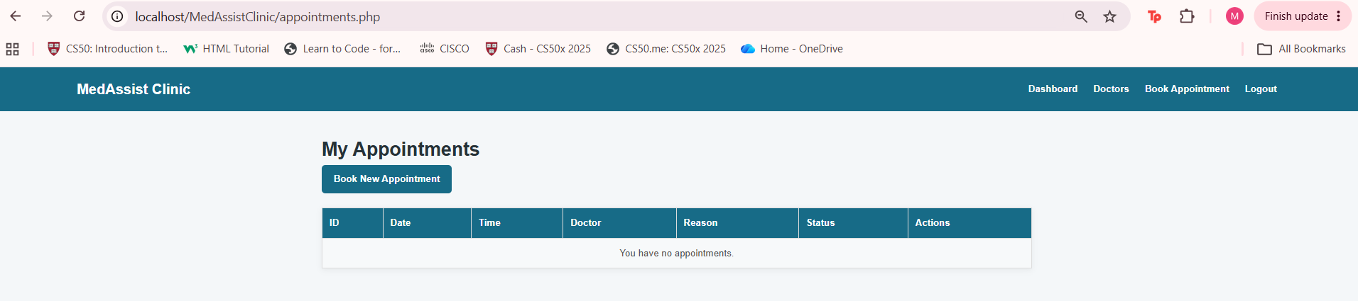

View Appointments after a booking:
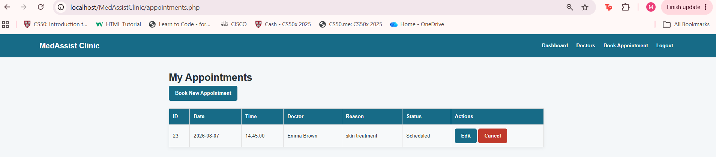

Edit Appointment – Update Operation:
The appointment editing feature demonstrates the Update component of CRUD [11]. Patients can modify certain details of an existing appointment, such as the date, time or reason for visit. When the form is submitted, PHP validates the new information and updates the corresponding record in the Appointment table using a prepared statement.
Screenshots showing the appointment before and after editing provide evidence that the update operation works correctly. This feature is particularly important in a clinical setting because patients often need to reschedule appointments due to changes in availability or personal circumstances.
The update functionality also reinforces the importance of maintaining referential integrity.

Before Edit:
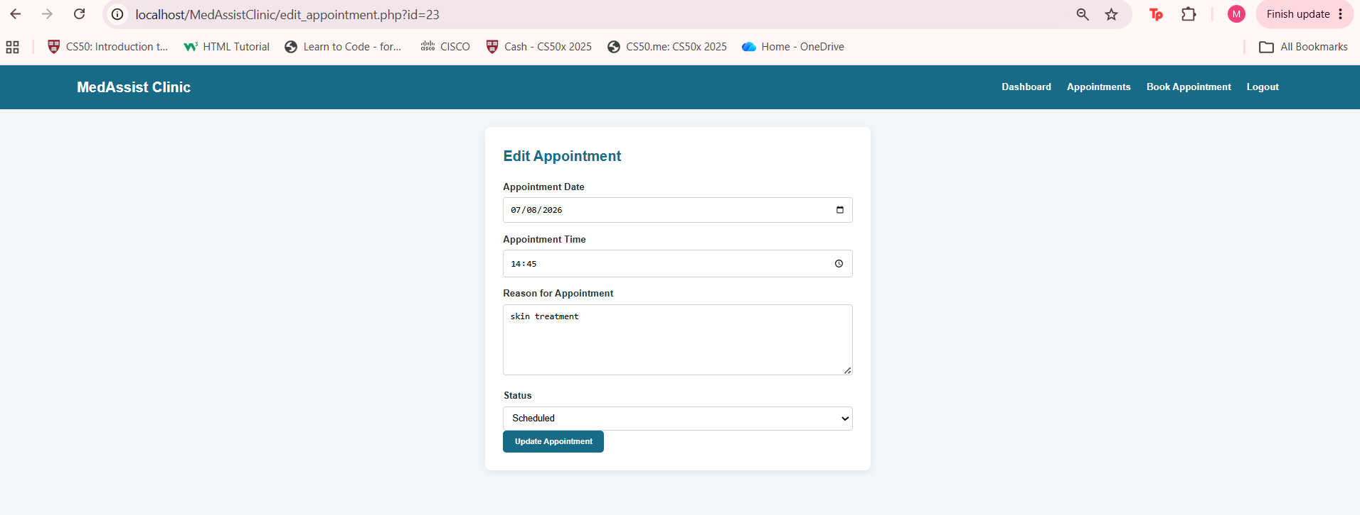
The original appointment information before modification

After Edit:
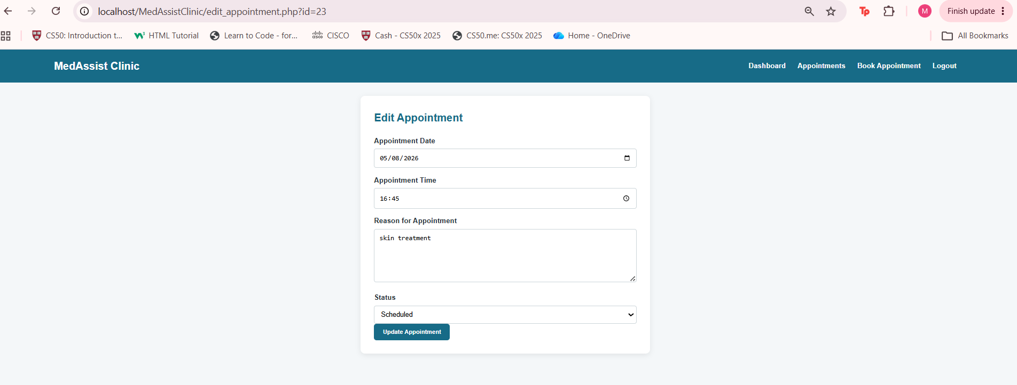
The changed appointment information following the update operation.
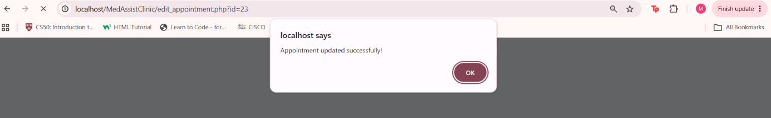

Updated appointment:
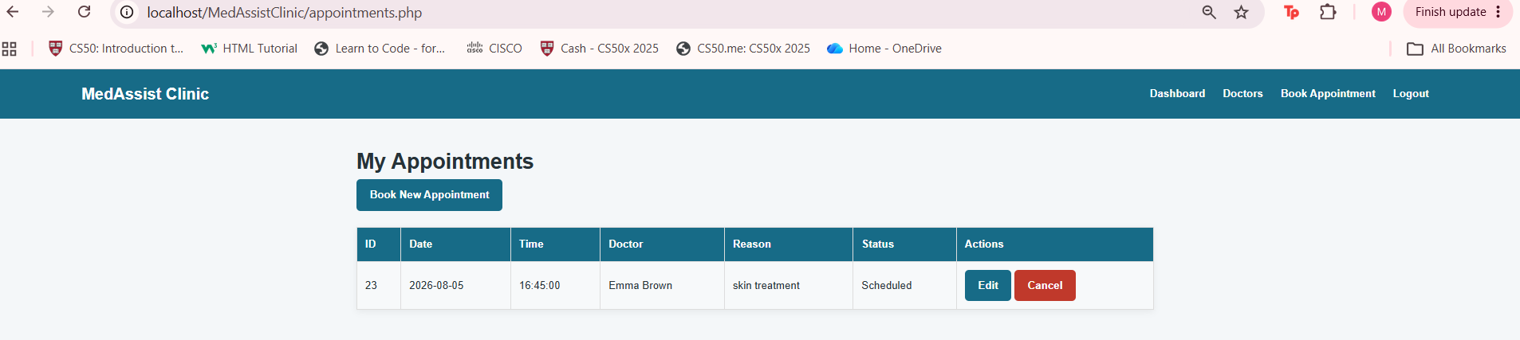
This confirms that the modified values have been successfully stored in the Appointment table.

Cancel Appointment – Delete Operation:
The cancellation feature demonstrates the Delete component of CRUD [11]. Patients can cancel an appointment by selecting it from their appointment list. PHP processes the request and removes the corresponding record from the Appointment table using a prepared statement.
A confirmation message is displayed to ensure that the patient understands the action taken. This mirrors real healthcare systems where users must be able to cancel appointments to free up schedule availability for other patients. The cancellation feature also demonstrates safe deletion practices.
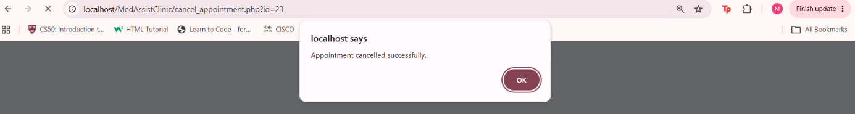
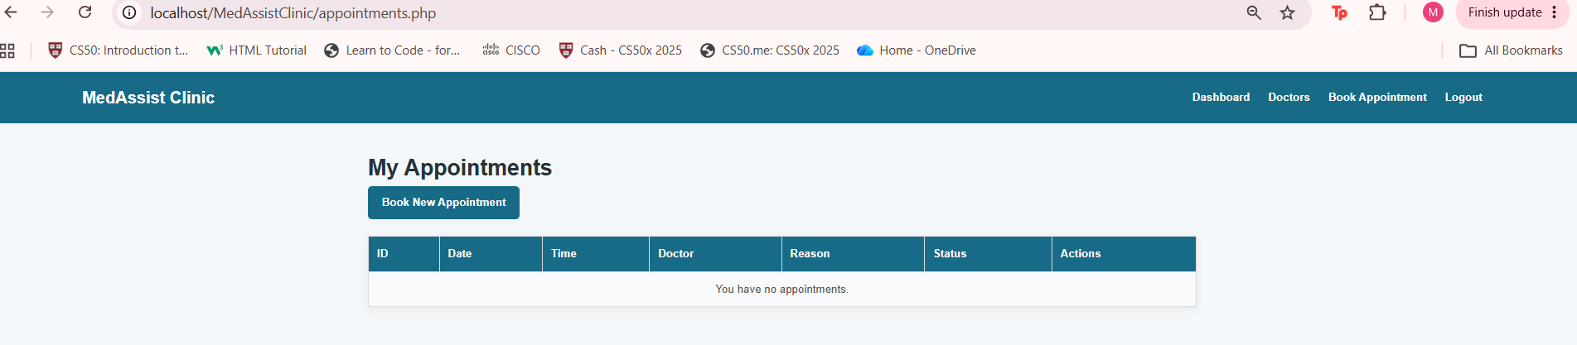
This displays controlled deletion of records using queries to prevent accidental data loss.

HTML and PHP Integration - Patient Feedback:
A feedback form was implemented to allow patients to submit ratings and comments about their experience. This demonstrates how the client-side HTML forms can interact with server-side PHP scripts [12].
The feedback form collects the patient’s ID, appointment ID, rating and comments. When submitted, PHP validates the input and inserts the feedback into the Feedback table using a prepared statement. This ensures that the feedback is stored securely and consistently.
The feedback system highlights the importance of user input validation. Ratings must fall within a valid range, and comments cannot be empty. This prevents invalid or incomplete feedback from being stored in the database.
The feedback feature also demonstrates how PHP can generate confirmation messages, improving user experience by clearly indicating whether the submission was successful.

Feedback Form HTML:
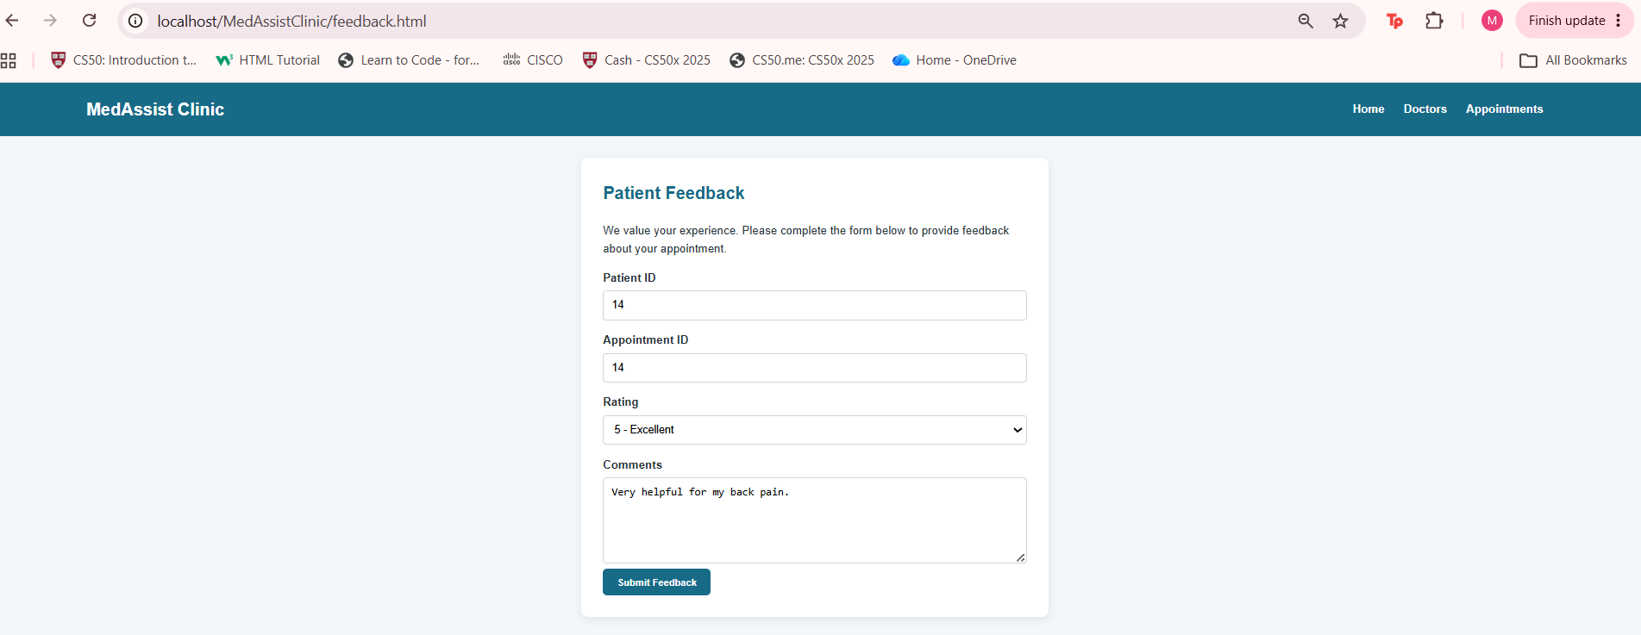
This displays the standalone HTML feedback form used to collect patient feedback.
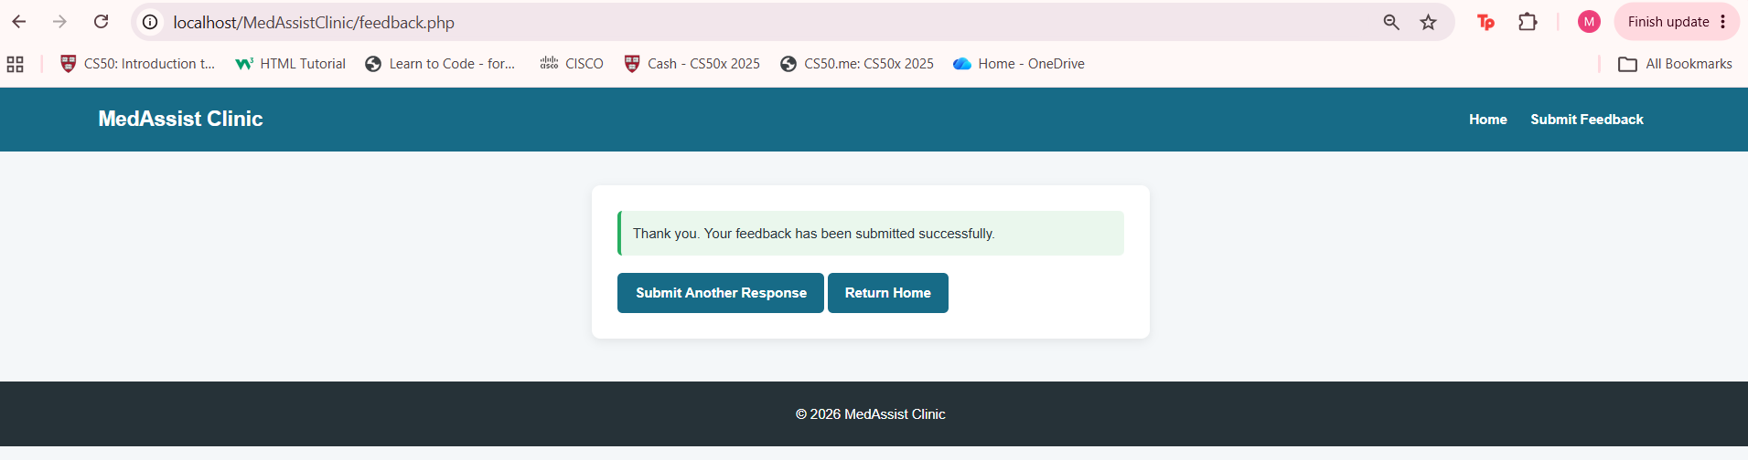
This demonstrates the PHP processing stage after the submitted feedback has been successfully validated and stored.

Security and Prepared Statements:
Security is a crucial aspect of any database-driven application. To protect the MedAssist Clinic website from SQL injection attacks [13], prepared statements were used throughout the system. Prepared statements ensure that user input is treated as data rather than executable SQL code, preventing malicious queries from altering the database.
To demonstrate this, an SQL injection attempt was performed by entering ' OR 1=1 -- into a form field [14]. The website accepted the input as plain text but did not execute any harmful SQL commands. A screenshot of the database confirmed that the injected text was stored harmlessly in the ReasonForVisit column, proving that the prepared statement successfully neutralised the attack.
This practical demonstration shows that the website is protected against one of the most common security vulnerabilities in web applications. It also reinforces the importance of secure coding practices when handling user input.

Prepared statement preventing SQL injection in appointment creation:
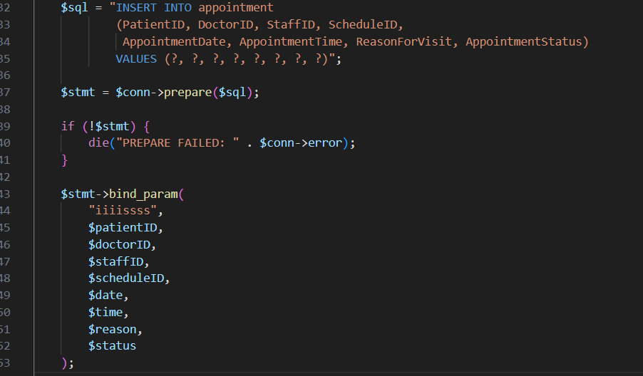

SQL injection attempt typed into the appointment booking form:
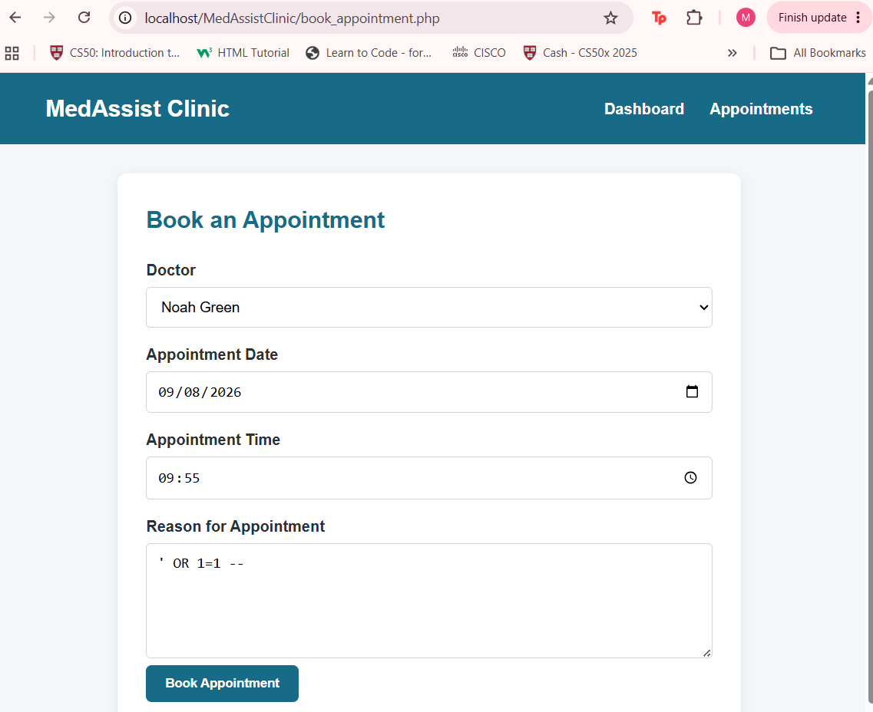

Website rejecting SQL injection due to prepared statements:
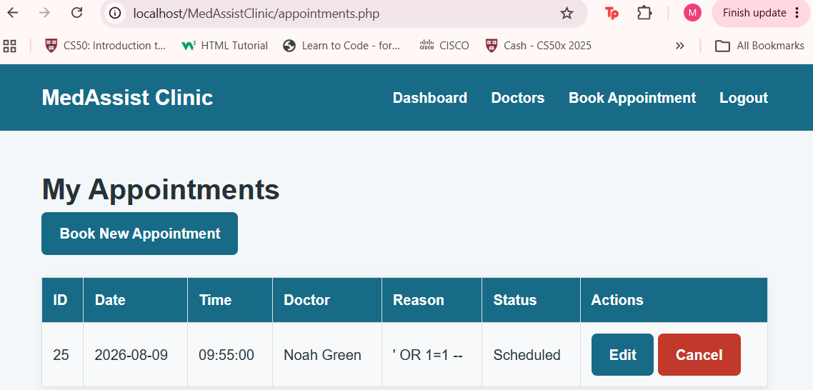

Database remains intact after SQL injection attempt:
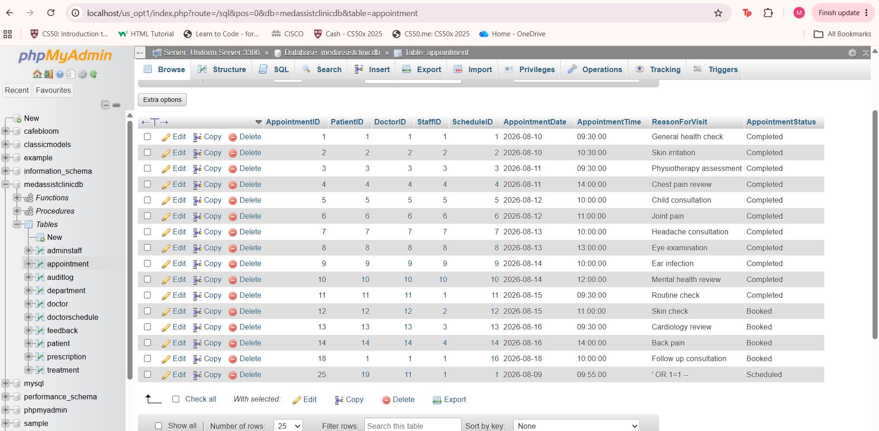
The phpMyAdmin screenshot shows the appointment table after an SQL injection attempt using ' OR 1=1 --. The injected text appears as plain input in the ‘ReasonForVisit’ column, which confirms that prepared statements prevented the SQL command from executing. The database structure and other records remain unaffected, demonstrating successful protection against SQL injection.

Evaluation of Database- Drive Website:
The database-driven website successfully demonstrates how the MedAssist Clinic system can operate through a practical web interface. The application connects directly to the relational database created in Part A and allows users to interact with stored information without needing technical knowledge or direct access to MySQL. Overall, the website performs well and meets the functional requirements of the brief.
One of the strongest aspects of the system is its consistent use of prepared statements. Every database operation including registration, login, appointment booking, editing, cancellation and feedback submission uses queries. This ensures that user input is handled safely and prevents SQL injection attacks. The security test, where malicious input was submitted and stored harmlessly as plain text, clearly shows that the system protects the underlying database.
The website also makes effective use of PHP sessions. Once a patient logs in, the system identifies the user and retrieves personalised information such as upcoming appointments. This demonstrates dynamic content retrieval and reflects how real clinical systems maintain user identity across multiple pages.
From a usability perspective, the website is easy to navigate. The layout is consistent, the CSS styling is applied across all pages, and the navigation bar provides clear access to the main features. The search functionality on the Doctors page improves accessibility by allowing patients to filter records rather than manually browsing all entries.
However, the system also has limitations that would need to be addressed in a real deployment. Passwords are currently stored in plain text, meaning the login system lacks hashing and encryption. Additionally, the website does not include role-based access control, so administrative staff and doctors do not have separate interfaces or permissions. Error messages could also be more detailed, especially when booking conflicts or invalid inputs occur.
Despite these limitations, the website demonstrates a solid understanding of PHP/MySQL development. It integrates relational data effectively, performs CRUD operations securely and provides a functional interface for interacting with the MedAssist Clinic database. The system meets the requirements of the module and provides a strong foundation for future improvements such as password hashing, multi-role access, enhanced validation and additional security features.

Conclusion:
This report has presented the complete development of the MedAssist Clinic system, covering both the relational database and the database-driven website. Part A focused on designing and implementing a structured MySQL database using ERD modelling, normalisation, table creation, constraints, stored procedures, triggers, functions and performance tuning. The database was built to support the clinic’s operational needs by maintaining data integrity, reducing redundancy and enabling efficient retrieval of related information.
Part B extended this work by integrating the database into a functional PHP-based web application. The website demonstrates how users can interact with stored data through registration, login, appointment management, doctor browsing and feedback submission. Dynamic content retrieval, CRUD operations and secure form processing show how relational database principles translate into practical web functionality. Prepared statements were used throughout the system to protect against SQL injection, and PHP sessions enabled personalised user experiences.
Together, both parts of the project illustrate the full lifecycle of database-driven development, going from conceptual design and relational modelling to implementation, testing and front-end integration. The system meets the requirements of the MedAssist Clinic scenario and provides a strong foundation for further enhancements such as password hashing, role-based access control, improved error handling and additional security measures.
Overall, the project demonstrates a clear understanding of database theory, SQL programming and web development. It highlights the importance of secure, well-structured data management and shows how relational databases can be effectively integrated into modern web applications.
The completed solution provides a reliable and functional prototype that reflects real-world clinical information systems and showcases the practical skills developed throughout the module.

References:

[1] | A. S. Gillis, B. Lutkevich and A. Hughes, “Database (DB),” TechTarget, 28 May 2024. [Online]. Available: https://www.techtarget.com/data-technologies/definition/database-DB. [Accessed 1 August 2026].
[2] | Anonymous, “What is an entity relationship diagram (ERD)?,” Lucid, [Online]. Available: https://lucid.co/diagram/erd/tutorial. [Accessed 1 August 2026].
[3] | Anonymous, “Difference between Primary Key and Foreign Key,” GeeksForGeeks, 29 August 2025. [Online]. Available: https://www.geeksforgeeks.org/dbms/difference-between-primary-key-and-foreign-key/. [Accessed 1 August 2026].
[4] | Anonymous, “Third Normal Form (3NF),” GeeksForGeeks, 25 July 2025. [Online]. Available: https://www.geeksforgeeks.org/dbms/third-normal-form-3nf/. [Accessed 2 August 2026].
[5] | P. Mohamadi, “Normalize Tables with Foreign Keys | Database Normalization,” Manifestly, 25 January 2025. [Online]. Available: https://www.manifest.ly/blog/normalize-tables-with-foreign-keys-database-normalization/. [Accessed 2 August 2026].
[6] | Anonymous, “PHP MySQL Database,” W3Schools, [Online]. Available: https://www.w3schools.com/php/php_mysql_intro.asp. [Accessed 3 August 2026].
[7] | Anonymous, “MySQL Improved Extension ¶,” PHP, [Online]. Available: https://www.php.net/manual/en/book.mysqli.php. [Accessed 3 August 2026].
[8] | S. Kharatbca, “What Is CRUD,” [Online]. Available: https://www.scribd.com/document/1048990207/What-is-CRUD. [Accessed 4 August 2026].
[9] | Anonymous, “CRUD Full Form,” GeeksForGeeks, 19 February 2024. [Online]. Available: https://www.geeksforgeeks.org/websites-apps/crud-full-form/. [Accessed 4 August 2026].
[10] | Anonymous, “SQL CRUD,” Georgia Tech, 2024. [Online]. Available: https://drcs.codes/databases/slides/sql-crud.pdf. [Accessed 4 August 2026].
[11] | Codecademy, “What is CRUD? Explained,” Codecademy, 2024. [Online]. Available: https://www.codecademy.com/article/what-is-crud-explained. [Accessed 5 August 2026].
[12] | Anonymous, “Handling External Variables (POST),” PHP, [Online]. Available: https://www.php.net/manual/en/reserved.variables.post.php. [Accessed 6 August 2026].
[13] | P. Thomas and S. Thakur, “SQL INJECTION PREVENTION,” ResearchGate, January 2025. [Online]. Available: https://www.researchgate.net/publication/387867308_SQL_INJECTION_PREVENTION. [Accessed 7 August 2026].
[14] | Anonymous, “SQL Injection,” W3Schools, [Online]. Available: https://www.w3schools.com/sql/sql_injection.asp. [Accessed 7 August 2026].

