This report aims to give to give the Senior Management Team a sound knowledge and understanding of evidence -based practice and certain approaches that can be taken to ensure effective critical thinking and decision making within the workplace.
A.C 1.1
Evidence based practice is defined as a process that can help to develop both knowledge and understanding by collecting evidence from a variety of sources that are dependable. This is crucial for people professionals and line managers to help them not only support current and future HR practice, but also helps them achieve better decision making, (Waite et al, 2021). The CIPD highlight the importance of evidence-based practice and recognises that as people professionals, we are often overwhelmed with facts, gossip, and rumours, all of which can be exhausting. As a result of being over-exposed to contradictory insights of what does and does not work in organisations, we often result to using mental shortcuts to help inform our decision making. However, although this can be efficient for us mentally, it is does not always allow us to make the best possible decisions due to exposing us to certain bias, (CIPD 2023). Rousseau and Briner identify four sources of evidence, (2014), which can help to inform sound decision making. These are scientific literature, organisational data, judgements from practitioners and leaders, and stakeholder evidence. With that in mind one of the most common models used for decision making is the rational model. This being a method of applying logical steps towards finding solutions to problems and can involve comparing certain data, facts, and non-biased research to help inform the best possible decisions, (Woerner, 2023). However, whilst there are benefits of using this model as a guide to inform decisions where factors such as time and cost are not an issue, there can be more complex problems, incomplete information, and conflicting goals of decision makers which can limit this model, (Jeanes, 2019). There are also limitations on evidence-based practice as a whole and people professionals should be thoroughly assessing any evidence they have gathered on its reliability and its trustworthiness. Those making evidence-based decisions should be following six steps to help ensure that the evidence gathered can help to inform sound decisions, (CIPD, 2023). This being:
Asking – Converting a problem into a question that is answerable.
Acquiring – Collecting evidence.
Appraising – Judging the validity of the evidence.
Aggregating – Pulling the evidence together.
Applying – Incorporating the evidence into the process of decision making.
Assessing - Evaluating the outcome of the decision made.
Barends et al, (2014), emphasise that evidence is not always perfect and can also be misleading, so we must be critically thinking and assessing all evidence gathered so we can remain asking four basic questions: Where and how is this evidence gathered? Is this the best possible evidence? Can we reach a conclusion based off this evidence? Could this evidence be bias in any way? By doing this, practitioners should be able to make a professional decision that is ethical, highlights best practice and avoids any form of bias that could be involved in this process.

A.C 1.2
There are several different analysis methods that can be used to help identify issues within organisations such as interviews, questionnaires, work - sampling and observations. A naturalistic observation method can be important as it can allow those in organisations to study the behaviour of employees whilst in a natural workplace setting without intervening and can provide in-sight into behaviours that come naturally to employees (McLeod, 2024). This can be beneficial to the organisation as it can help identify potential issues and challenges when it comes to certain employee’s behaviour within their natural working environment. In doing so, people professionals should be able to analyse the data recorded and make evidence-based suggestions on how to improve. However, this method can be limited, as observations are often conducted on a smaller scale and may lack representation of a specific sample, for example, age and gender. To help identify organisational issues, challenges, and opportunities further, practitioners should be using a range of analysis tools to help make strategic decisions. These could include SWOT analysis, a critical incident analysis, or PESTLE to name a few. To expand on the PESTLE analysis tool, this can be used when looking at external factors that can influence organisations and should be conducted regularly to help organisations gain an advantage in spotting early trends that could impact them, (CIPD, 2024). This includes political, economic, social, technological, legal, and environmental issues. If we apply this tool to the retail industry for example, we can identify that an economic risk would be the current cost of living crisis. As consumers are becoming more money conscious, they could be forced to look at cheaper competitors resulting in less sales for specific retail companies. The CIPD, (2024) expand further explaining that by using the PESTLE analysis tool, organisations can identify changes that could potentially interfere with future employment landscape and can provide vital information on the business direction, such as targets and potential future risks. Whilst this specific tool can be great for leaders and people professionals who are looking to encourage the development of both external and strategic thinking, the CIPD recognise that certain data could be based off assumptions and the pace of change can make it difficult to anticipate what could affect an organisation in the future. Therefore, leaders and professionals should be considering multiple tools and methods to help ensure organisational issues and potential threats are being identified correctly and sound suggestions for improvements are being made.
A.C 1.3

Critical thinking is a specific skill that people professionals need to use to make effective decisions within organisations. Howlett and Coburn, (2019), define critical thinking as the ability to think well, to reflect on the opinions, ideas, and arguments of others and to make good decisions. It is not uncommon to face problems in the workplace that ultimately need to be solved and so by applying critical thinking, professionals should be able to navigate through these problems more effectively and improve their ability to think rationally and identify well – reasoned arguments. By thinking rationally, people professionals should remove any emotions that are involved in decision making and base these decisions on evidence and logic. According to The CPD Certification Service, (2022), the main key principles of critical thinking are:
- To collect a range of information from various sources.
- Analyse sources and question the validity of this information.
- Form your own professional opinion.
- Address your own biases.
When applying critical thinking to your own or other ideas in the workplace, professionals should understand that one of the key principles of informing evidence-based decisions is validity and rationality. Therefore, they should carefully evaluate the evidence that has been put forward and should not be influenced by any form of bias or ‘cherry pick’ any evidence to inform a decision that is more favourable to that specific individual. Young, (2023), expands on this explaining that we should be engaging in collaborative problem solving to help recognize implications, consequences, and benefit from different perspectives. critical thinking is our primary defence against information that can be misleading and as a result can be crucial in everyday life to navigate through a complex world both personally and professionally.
A.C 1.4
Making effective decisions can be a challenge for line managers and leaders of organisations. The CMI, (2020), help provide professionals with a ‘decision making checklist’ which acts as a guide for those making crucial decisions. They highlight the importance of considering the impact of the decision being made, to communicate the decision effectively and to collect all the relevant information. Furthermore, there are a range of frameworks and decision-making models that can be applied to help ensure that effective decisions are being made and effective outcomes are achieved. The Six Thinking Hat approach was created by Edward de Bono and first appeared in his 1985 book of the same name. This technique is designed to encourage professionals to look at a problem in six different ways to help discuss a range of perspectives. (Elmansy, 2022).
The Six Hats are:
- White Hat – represents the facts and information.
- Yellow Hat – represents having an optimistic point of view and helps identify the benefits of a specific recommendation.
- Black Hat – represents the cons or cautions of a specific recommendation.
- Red Hat - represents understanding specific emotional responses.
- Green Hat – represents the creative thinking and helps focus on an innovative solution.
- Blue Hat – represents managing and overseeing any discussions.
By applying De Bono’s Six Thinking Hat technique to help inform decisions in the workplace, people professionals should be able to encourage a creative approach to finding a solution and enhance the quality of their decision making.
The Action Learning approach is a valuable way for leaders and those working in a HR function to get to the heart of real underlying issues within organisations and to present creative ways to resolve these. This approach brings together a small group of peers from different areas of the organisation to ask open questions regarding a specific issue and then allows them to attempt to solve it (Action Learning Centre, 2017). This approach can be extremely beneficial to leaders as it allows them to discuss and work through problems that they may not have been able to do on their own, opening their mind to different solutions, ideas, and outcomes. By discussing these issues with peers from different parts of organisations, it allows leaders to off-load openly without negatively impacting their own team and can also help assist them in gaining confidence to implement certain practices. (School for Social Entrepreneurs, 2017).
The best-fit model suggests that HR policies and procedures should be tailored and align with their specific organisational needs. To carry this out successfully, people professionals should be identifying their business strategy and understand both internal and external factors that might affect these. Secondly, HR practitioners should design and implement policies that reinforce these needs and strategies and thirdly, they should evaluate the outcome and impact of these policies and adjust where necessary (LinkedIn, 2023). By using this framework as an approach to make decisions, professionals can create a unique employer brand that can attract and retain employees and can also allow organisations to adapt to both internal and external environments as they change.

A.C 1.5
The CIPD, (2023) emphasise that an organisations success depends on the trusted relationship with employees, customers, suppliers, and the wider community, and it is vital that ethical values are applied when looking at organisational behaviour. Without this, organisations can find themselves damaging their reputation, disengaging employees, and harming their credibility.
Utilitarianism is a theory that the best action will maximise the most happiness or the well-being of the most people. Gustafson (2013) suggests that utilitarianism provides a guiding framework for organisations of decisions making and helps direct them towards more ethical behaviour. To apply this ethical approach to your organisations, leaders should identify the dilemma that needs to be addressed, generate possible solutions, compare their potential impact, and then select the solution that maximises the happiness of the most people. However, this ethical framework can also provide some moral challenges. For example, if we consider the subject of child labour the theory suggests that although in principle it would be better if a child did not need a job, if more good is created overall by giving a child a job, then it is right to do so, although morally and legally this is unethical.
To take a deontological approach to help inform decision making would be to ensure that ethical practices and regulations are strictly adhered to help underpin fairness and integrity. This could potentially help to inform moral decision making as line managers have clear policies and procedures to follow on what behaviour is considered right and wrong. Abbass, (2023), highlights that identifying right and wrong as a root cause is what separated deontology from other ethical practices. Abbass advises organisations to be in line with all their stakeholders and to be open and transparent surrounding decision making which as a result can set up a level of trust between them.
Rossi, (2023) suggests that Altruism should play an important role in informing our decisions and guiding our choices. By understanding the importance our decision making has on others, leaders can be challenged to refine their decision making to the perspective of others. Leaders can apply altruism to help influence decision making by fostering a positive workplace culture. If open door policies, employee help assistance programmes and general care for employee well-being are being implemented, employees will feel valued and supported which can lead to improved wellbeing and engagement (Safe Hands, 2023). When applying any ethical perspective to help inform decision making, people professionals should understand issues can sometimes be more complex than just doing the greater good for all, or to underpin a specific policy to help inform a decision. The CIPD, (2023) expand further to say that there is not always a ‘golden rule’ when it comes to workplace dilemmas or informing decisions due to the ever-changing world of work, however, people professionals should have the ability to be compassionate, fair, exercise situational judgement, and draw on both knowledge and sensitivity to inform moral decision making.

A.C 3.1
It is important for organisations to measure financial and non-financial performance as this enables leaders to identify what is running smoothly, but also what needs improving to help achieve organisational goals. They can measure financial performance by using Financial KPI’s, which are high-level measures of profits, expenses, revenue, and other financial outcomes. Gross profit financial measurements are used to help understand an organisations profitability, for example, if an organisation’s revenue for May 2024 is £15,000 and their costs of goods sold for that month stands at £8,000, they would have a £7,000 profit. Tamplin (2023) explains that by monitoring gross profit, leaders are able identify whether they need to either increase their prices or reduce costs, and this is generally considered as a very telling way of an organisations ability to generate profit. Whilst this metric is useful to gather information on the basic profitability of an organisation, it does not provide leaders with an understanding of why they may be underperforming. Tamplin suggests that leaders need to dig deeper and identify what organisations need to do to improve profitability, for example, do they have low gross profit because they are spending too much or because their products are priced too low?
Organisations could also benefit from undertaking a seasonality analysis when looking at financial performance. This refers to organisational and economical changes that are predictable over the course of a one-year period including calendar and commercial seasons (Keaton, 2020). For example, by undertaking a seasonality analysis on data from a retail organisation, leaders could identify a trend of a higher average spend per customer in the fourth quarter of the year. Keaton, (2020) argues that seasonality analysis is beneficial as it allows organisations to predict seasonal trends and therefore, adjust staff, costs, and revenue for that specific season.
An example of organisations measuring non-financial performance is through a Net Promoter Score, which is a metric used to measure customer satisfaction, loyalty and to gauge the quality of their customer service. Salesforce (2024) highlight the importance of using an NPS to gauge performance in comparison to other benchmarks for customer satisfaction, as this allows organisations to gather data on what customers think of their actual brand rather than an individual product or encounter. As a result, leaders can analyse their customer loyalty at any given moment to compare with competitors, attempt to change a negative perception and identify needs for growth. However, Stahlkopf (2019) suggests that humans are complex and contradictory. As an NPS presumes that we cannot be both promoters and detractors of an organisation, if a customer’s overall score is negative, any positive feedback could in theory be ruled out. Therefore, people professionals would need to understand their customers and the organisational goals to provide a beneficial framework.
By analysing feedback from stakeholders such as employees, leaders can gain an insight into their needs and expectations, preferences, satisfaction levels and as a result, can also drive organisational performance. (LinkedIn, 2023). They can collect this feedback effectively by conducting surveys, interviews, and ratings to name a few and to analyse this data is essential and can inspire organisations to produce better business models, improve goods and services and exceed expectations.
A.C 3.2
For people professionals to add value through their practices, it is important that they truly understand organisational goals and needs. If we take stakeholders into consideration, professionals must understand that line managers have different needs than entry level employees (Taylor and Woodhams, 2022). Practices such as implementing retention strategies, performance management systems, and encouraging a positive workplace culture can assist in championing better working lives and organisational goals. The CIPD (2023), highlight that strategic human resource management can add value to organisations as this focuses on supporting long term goals and to help ensure that different aspects of people management come together to drive organisational behaviour inline to meet and achieve targets.
By using analytics, people professionals can measure the value and quality of a workforce, estimate financial return on investment of change initiatives, demonstrate the impact of policies on the workforce and organisational performance and make evidence-based decisions (CIPD, 2023). By undertaking a cost-benefit analysis, leaders can measure the benefits of a decision against the cost associated with implementing certain practices and by doing so should be able to determine whether what they would like to implement into an organisation is financially feasible. Stobierski (2022), explains that business decisions are often complex and undertaking a data driven approach such as a cost-benefit analysis allows leaders to fully evaluate a decision free of biases, which in turn, offers evidence – based evaluations of specific practices.
If organisations have introduced initiatives to positively impact employee satisfaction, it is important that employees have effective channels for their voice to be heard. Practices such as employee programmes could also be measured through engagement and satisfaction surveys, without this, people professionals would not be able effectively measure how their initiatives have truly impacted their people. Furthermore, you can review these initiatives alongside your employees to help discuss achievements and growth but to also have honest feedback on what needs to be improved. (LinkedIn, 2023)

Task Two
The following report is a qualitative and quantitative data analysis review based off of the organisational data provided on gender, ethnicity, disability, salary difference across genders and overall salary paid by the organisation.

Gender
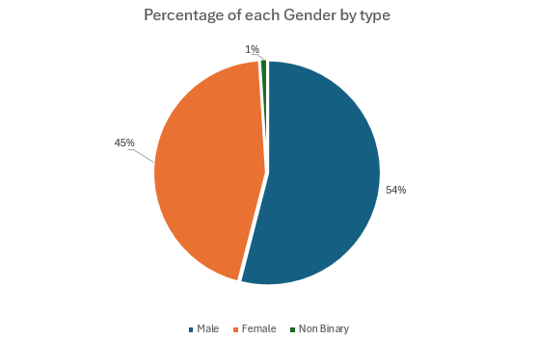

The above chart shows that across the organisation, 54% identify as males, 45% as female and 1% as non-binary. As 1% of the workforce identify as non-binary, this could suggest that the organisation does not promote gender inclusivity or have positive workplace culture in which everybody can thrive in. As there is legislation in place under the Equality Act 2010 which creates a duty for employers to actively encourage workplace diversity, employers could face legal action if any discrimination occurs towards any specific gender. Reeves (2023), suggests that organisations make their job adverts gender neutral, improve company culture and have clear policies and procedures for gender equality. A study by McKinsey&Company, (2019) found that companies with a wide gender diverse workforce were 25% more likely to have a higher profitability. Whilst there may be some financial implications in the form of the costing of recrutiment, the organisation should be actively encouraging gender inclusivity to help assist working towards a diverse workforce which as a result, can create a more diverse talentpool and higher profitability.

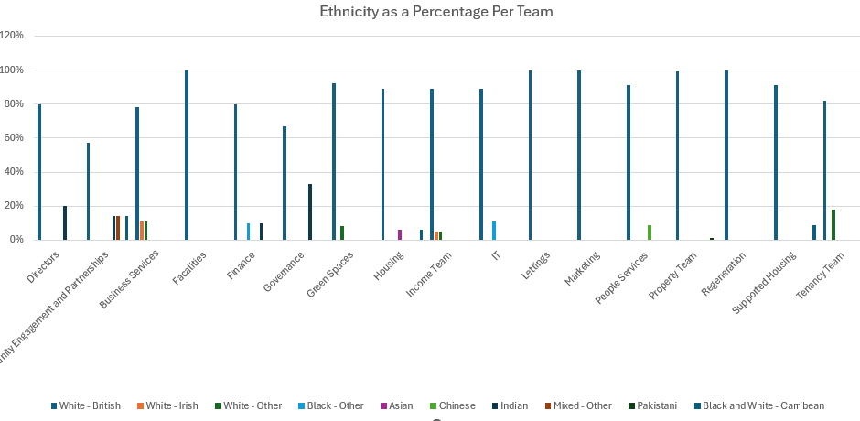
Ethnicity per team

The above diagram shows the different percentages of ethnicities per team across the organisation. We can see from the graph that ‘White – British’ ethnicity is the most common per team. This suggests that the organisation is not actively promoting a diverse workforce as each team within the organisation is at least more than 50% ‘White – British’. Research published by the CIPD (2017), showed that there is a significant lack of ethnic minorities being represented in organisations and suggest that employers who do not actively improve their workforce to be more diverse will be left with a limited talent pool and inequalities. To aid in improving diversity, people professionals should assist in building business cases, review recruitment practices to eliminate any form of bias or discrimination and assist line managers by conducting training workshops dedicated to eliminating bias within their teams, which as a result can benefit the organisation. There can be financial implications when investing in reviewing recruitment practices and implementing new recruitment strategies. For example, if an organisation would like to improve their engagement practices with potential candidates, these costs could include the development of engagement and communication tools.
Disability as an organisational whole and percentage per team
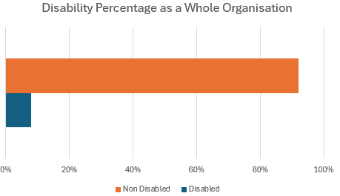

As shown in the graph above, based on the disability percentage as an organisational whole we can see that around 10% of employees have openly made the organisation aware of their disability. If we analyse further, an argument can be made that either the organisation is not promoting accessibility and inclusivity, or employees do not feel comfortable making their disabilities known. ACAS (2023), emphasises the importance of employers doing all they reasonably can to create a supportive environment for those with disabilities and highlight the legal responsibilities of this.
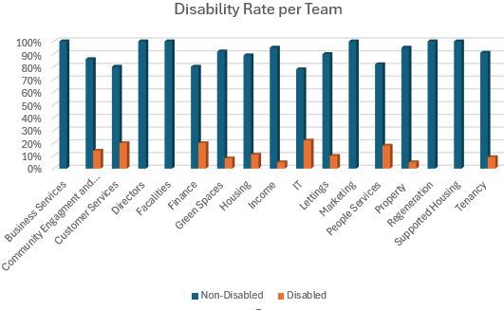
When analysing this per team, we can see that several teams do not have any identified disabled employees. In this instance, people professionals should be analysing job descriptions, workplace settings and other limitations that can hold individuals with a disability at a disadvantage within specific departments. However, this data may not be entirely accurate as employees do not have to let their employers know of any disabilities whether physical or hidden. People professionals should review organisational policies relating to disabilities, assess whether this is fit for purpose and keep up to date with good legal practice. Furthermore, they should develop an action plan to help change and identify whether reasonable adjustments can be made. Employers have a legal obligation to pay for any reasonable adjustments in the workplace whether this be changing recruitment processes, allowing a disabled person move to a more suitable area to work, or changing work related equipment (GOV, 2023).

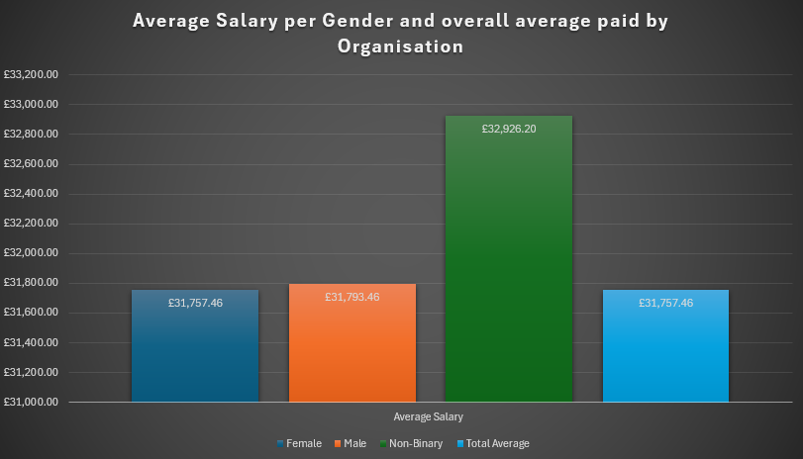
Salary difference across Genders and overall average salary paid by the organisation

The diagram above shows that male employees on average are paid slightly higher than female employees. If we analyse the data further to understand this gender pay gap, we could suggest that occupational segregation may be a catalyst. The CIPD, (2024) highlight that in the UK labour market, men tend to dominate certain job types and women others. To help identify why female employees have a lower salary on average, people professionals should also be identifying their full time to part time employee ratio and if there seems to be more female part-time employees find out reasons for this. For example, caring responsibilities.
To help improve the gender pay gap some suggestions could be put forward to leaders such as introducing transparency of promotion and reward processes, encourage potential salary negotiations, ensure a fair and non-biased approach is taken toward the promotion of employees and ensure flexible/part-time work is offered to all genders fairly. As a result of this, leaders should see higher staff morale, retention and a decrease in uncomfortable pay conversations (Equality and Human Rights Commission, 2018). Some financial implications of these suggestions could be that encouraging potential salary negotiations may result in organisations over-spending on wages.
Hybrid Working
The below graph shows feedback scores of 300 employees taken from a recent survey on hybrid working.

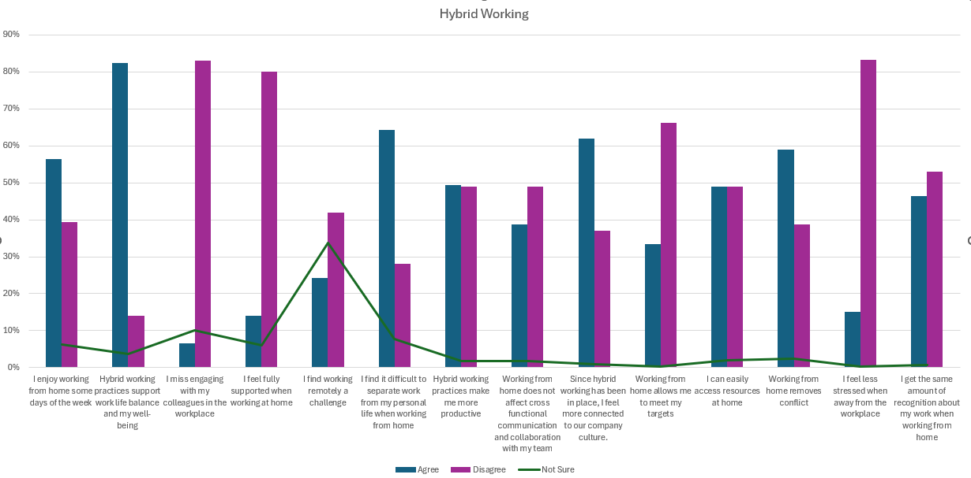
At face value, we can believe the consensus amongst employees surveyed suggests that hybrid working is beneficial for work-life balance and productivity. However, when analysing these results further, we can see that the data has provided us with some contradictory information. For example, the results show that working from home has a positive effect on most employee’s well-being, however, over 80% of the employees have said they do not feel less stressed. Miller, (2020) highlights that with employee surveys honest answers cannot always be guaranteed and if not everyone completes the survey results regarding a specific topic, this may be inaccurate. Furthermore, we can see from the data provided that over 80% of employees do not miss engaging with colleagues in the workplace, which suggests there is low team morale within this organisation. Therefore, people professionals should conduct more in-depth qualitative data approaches before making any evidence-based decisions on hybrid working such as, focus groups or interviews. These approaches can allow professionals to have a greater in-depth understanding on employees’ feelings and gain clarification on specific views when making decisions. Furthermore, people professionals should ensure that hybrid working allows fair oppourtunties and voice including establishing trust, fair distrubition of work and a review process for moniorting the effectiveness of hybrid working, (CIPD, 2024).

REFERENCE LIST
Abbas, J. (2023) Deontology in the Corporate World. Available at: https://dailytimes.com.pk/1133390/deontology-in-the-corporate-world/ (Accessed: 23 May 2024).
ACAS (2023) Talking about disability. Available at: https://www.acas.org.uk/supporting-disabled-people (Accessed: 6 June 2024).
Action Learning Centre (2017) What is action learning? Available at: https://www.actionlearningcentre.com/about-action-learningL (Accessed: 23 May 2024).
Barends, E et al. (2014) Evidence Based Management. Available at: Evidence-Based-Practice-The-Basic-Principles.pdf (cebma.org)(Accessed: 7 May 2024).
Beaver, S. (2023) 30 Financial Metrics and KPIs to Measure Success in 2023. Available at: https://www.netsuite.com/portal/resource/articles/accounting/financial-kpis-metrics.shtml (Accessed: 28 May 2024).
CIPD (2023) Building an evidence-based people profession. Available at: https://www.cipd.org/uk/views-and-insights/thought-leadership/insight/evidence-based-profession/ (Accessed: 5th May 2024).
CIPD (2023) Ethical practice and the role of people professionals. Available at: https://www.cipd.org/uk/knowledge/factsheets/ethics-role-hr-factsheet/#what-is-ethical-practice-in-organisations (Accessed: 23 May 2024).
CIPD (2023) Evidence based practice for effective decision making. Available at: https://www.cipd.org/uk/knowledge/factsheets/evidence-based-practice-factsheet/ (Accessed: 9 May 2024).
CIPD (2023) People analytics: Guide for people professionals. Available at: https://www.cipd.org/uk/knowledge/guides/analytics-practitioner-guide/#how-is-hr-using-people-analytics (Accessed: 30 May 2024).
CIPD (2023) Strategic human resource management. Available at: https://www.cipd.org/uk/knowledge/factsheets/strategic-hrm-factsheet/?_gl=1*b6bxtx*_ga*OTM3MTEzNjg3LjE3MDQ4MDcxOTg.*_ga_D9HN5GYHYY*MTcxNzA2NjUxOC4zLjAuMTcxNzA2NjUxOC42MC4wLjA. (Accessed: 30 May 2024).
CIPD (2024) Disability at work. Available at: https://www.cipd.org/uk/views-and-insights/cipd-viewpoint/disability-work/#:~:text=Ensure%20the%20culture%20of%20the,to%20people%20in%20senior%20roles. (Accessed: 6 June 2024).
CIPD (2024) Gender pay gap reporting. Available at: https://www.cipd.org/uk/knowledge/guides/what-is-the-gender-pay-gap?_gl=1*1nyxe64*_ga*MTYyOTA5MDQzNi4xNjc4MzcwNzg0*_ga_D9HN5GYHYY*MTY5NjI2NDI0Ni43MC4xLjE2OTYyMzY1MjMuNjAuMC4w (Accessed: 7 June 2024).
CIPD (2024) Hybrid working: Guidance for people professionals. Available at: Hybrid working: Guidance for people professionals | CIPD (Accessed: 8 June 2024).
CIPD (2024) PESTLE Analysis. Available at: https://www.cipd.org/uk/knowledge/factsheets/pestle-analysis-factsheet/#what-is-a-pestle-analysis-used-for (Accessed: 9 May 2024).
CIPD (2024) Race inclusion in the workplace. Available at: https://www.cipd.org/uk/views-and-insights/cipd-viewpoint/race-inclusion-in-the-workplace/ (Accessed: 6 June 2024).
CMI (2020) Decision Making. Available at: https://www.managers.org.uk/knowledge-and-insights/resource/decision-making/ (Accessed: 21 May 2024).
Elmansy, R. (2022) The Six Thinking Hats of Critical Thinking Available at: https://www.designorate.com/the-six-hats-of-critical-thinking-and-how-to-use-them/ (Accessed: 22 May 2024).
Equality and Human Rights Commission (2018) Closing the gender pay gap. Available at: https://www.equalityhumanrights.com/sites/default/files/closing-the-gender-pay-gap_0.pdf (Accessed: 7 June 2024).
GOV.UK (2023) Reasonable adjustments for workers with disabilities or health conditions. Available at: https://www.gov.uk/reasonable-adjustments-for-disabled-workers (Accessed: 6 June 2024).
Howlett and Coburn. (2019) Podcast 154: Critical Thinking [Podcast]. 5 November. Available at: https://www.cipd.org/uk/knowledge/podcasts/critical-thinking/ (Accessed: 21 May 2024).
Jeanes, E. (2019) A Dictionary of Organizational Behaviour. Oxford University Press.
LinkedIn (2023) Best Fit Model of HR Strategy. Available at: https://www.linkedin.com/advice/1/what-benefits-challenges-using-best-fit-model-hr-strategy (Accessed: 23 May 2024).
LinkedIn (2023) How to measure your people management impact. Available at: How to Measure Your People Management Impact (linkedin.com)(Accessed: 3 June 2024).
LinkedIn (2023) Stakeholder Feedback. Available at: https://www.linkedin.com/advice/0/how-do-you-use-stakeholder-feedback-enhance (Accessed: 28 May 2024).
McKinsey & Company (2020) Diversity Wins: How inclusion matters. Available at: https://www.mckinsey.com/featured-insights/diversity-and-inclusion/diversity-wins-how-inclusion-matters (Accessed: 3 June 2024).
McLeod, S. (2024) Observation Methods. Available at: https://www.simplypsychology.org/observation.html(Accessed: 9 May 2024).
Miller, B. (2020) Pros and Cons of Employee Surveys. Available at: https://hrdailyadvisor.blr.com/2020/09/28/pros-and-cons-of-employee-surveys/ (Accessed: 7 June 2024).
Reeves, J. (2023) Gender Diversity in the Workplace. Available at: https://croner.co.uk/resources/equality-discrimination/gender-diversity-in-the-workplace/ (Accessed: 3 June 2024).
Rossi, T. (2023) The Altruism Scale in Decision Making. Available at: https://www.linkedin.com/pulse/altruism-scale-decision-making-importance-greater-good-tito-rossi-owryf (Accessed: 23 May 2024).
Safe Hands (2023) How Altruism can enhance employees well-being. Available at: https://safehandsuae.com/how-altruism-can-enhance-employee-wellbeing/ (Accessed: 23 May 2024).
Salesforce (2024) Why Net Promoter Score (NPS). Available at: https://www.salesforce.com/uk/learning-centre/customer-service/calculate-net-promoter-score/ (Accessed: 28 May 2024).
School for Social Entrepreneurs (2016) What is action learning? 6 April. Available at: https://www.youtube.com/watch?v=IAJ0z_IdZXE&t=26s (Accessed: 23 May 2024).
Stahlkopf, C. (2019) Where Net Promoter Score Goes Wrong. Available at: https://hbr.org/2019/10/where-net-promoter-score-goes-wrong (Accessed: 28 May 2024).
Stobierski, T. (2022) Cost-Benefit Analysis: What It Is & How To Do It. Available at: https://online.hbs.edu/blog/post/cost-benefit-analysis (Accessed: 30 May 2024).
Tamplin, T. (2023) Gross Profit. Available at: https://www.financestrategists.com/wealth-management/financial-statements/gross-profit/#gross-profit-vs-net-income (Accessed: 28 May 2024).
Taylor, S. and Woodhams, C. (2022) Studying Human Resource Management. Third edition. Kogan Page
The CPD Certification Service (2022) How to develop critical thinking skills. Available at: https://cpduk.co.uk/news/how-to-develop-critical-thinking-skills (Accessed: 21 May 2024).
Waite, K. et al. (2021) People Practice a complete guide. Kogan Page.
Woerner, J. (2023) Rational Decision-Making Model. Available at: https://study.com/academy/lesson/the-rational-decision-making-model-steps-and-purpose-in-organizations.html#:~:text=The%20Rational%20Decision%2DMaking%20Model%20is%20a%20method%20of%20taking,other%20data%20to%20help%20choose. (Accessed: 7 May 2024).
Young, R. (2023) The Power of Critical Thinking. Available at: https://www.forbes.com/sites/forbescoachescouncil/2023/07/28/enhancing-decision-making-and-problem-solving/?sh=384448112d59 (Accessed: 21 May 2024).

