
E-portfolio evidence of learning
Changemakers: Building your brand for sustainable employment

November 1, 2022
BUSHRA KHAN
1818384
KENNEDY OBOHWEMU
Contents
Pitch 2
Overview 2
Further explanation 2
Main characters 3
Episodes 4
Reference list 7

Pitch

Overview
This documentary series is based on real life events and is called mental health and what it entails. This series shows in detail what young adults experience when it comes to daily life and the expectations they have regarding school, work, social life, and any other obstacles they may face. The purpose of this emotional documentary is to provide insight into mental illness's positive aspects as well as its negative ones. In any given year, one in four adults experiences at least one diagnosable mental health problem. Everyone can be affected at any point in their lives, no matter what their background is. More than a million people have mental health problems in the UK, making them the largest single cause of disability. (NHS, 2022) When surveyed from ages 5 to 19 in 2017, one in eight (12.8%) had a mental illness. Boys and girls had similar rates. (Sadler, K., Vizard, T., Ford, T., Goodman, A., Goodman, R. & , 2017) Problems with the transition from child-adolescent to adult mental health services have received the majority of attention from the UK's small regional response. (Malla, Iyer, McGorry, Cannon, Coughlan, Singh, Jones & Joober, 2015)

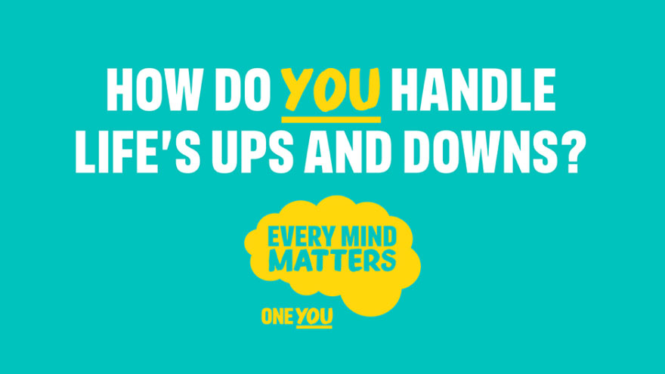
(nwas.nhs, 2019)

Further explanation
Studies show that young people rarely seek professional care, despite the significant frequency and burden of mental health issues among them. Understanding the barriers to getting help is the first step in increasing early access to mental health services and enhancing psychological well-being. When under psychological distress, young adults may find it difficult to get assistance from others. Because of stigma and unfavorable ideas about mental health and seeking help, young people may be hesitant to do so. Increasing public awareness of the services and resources available as well as implementing screening techniques for psychological distress in primary care settings may be necessary to improve mental health among young adults. (Salaheddin, Mason, 2016). Most universities and schools offer a free, private, on-site counseling service with trained counselors and psychotherapists that you can use. Student-led services are also provided by many student unions. You might prefer to discuss issues like stress and despair with another student, even when the engaged students are not trained, counselors. The student mental health charity in the UK is called Student Minds. Additionally, most colleges offer student nightline services. (NHS, 2020)
We conducted a systematic assessment of the existing literature on young people's perceptions of mental health services in the UK, and we thematically analyzed the results to investigate the causes of this and provide guidance for those creating services for young people. The opinions of 13 605 young people, including 625 who had used mental health services, were recorded in 31 studies, of which were found. Positive opinions on mental health professionals' traits and promoting independence have emerged. Negative opinions included the stigma, lack of knowledge, medicalization of their issues, and a discontinuity in care. (Plaistow, Masson, Koch, Wilson, Stark, Jones, Lennox, 2013).
I have briefly explained the main characters and their roles and the first 4 episodes that will be streamed online on channel 4. They are a duration of 30mins each airing from the 16th to the 20th of November. Bringing unheard voices to the forefront of national conversations, Channel 4 has been challenging with purpose and representing unheard voices as part of its mission. As the UK's youngest public service channel, they reach more 16-34-year-olds than any other commercial broadcaster across streaming and television. (Channel 4, 2022)

Main characters

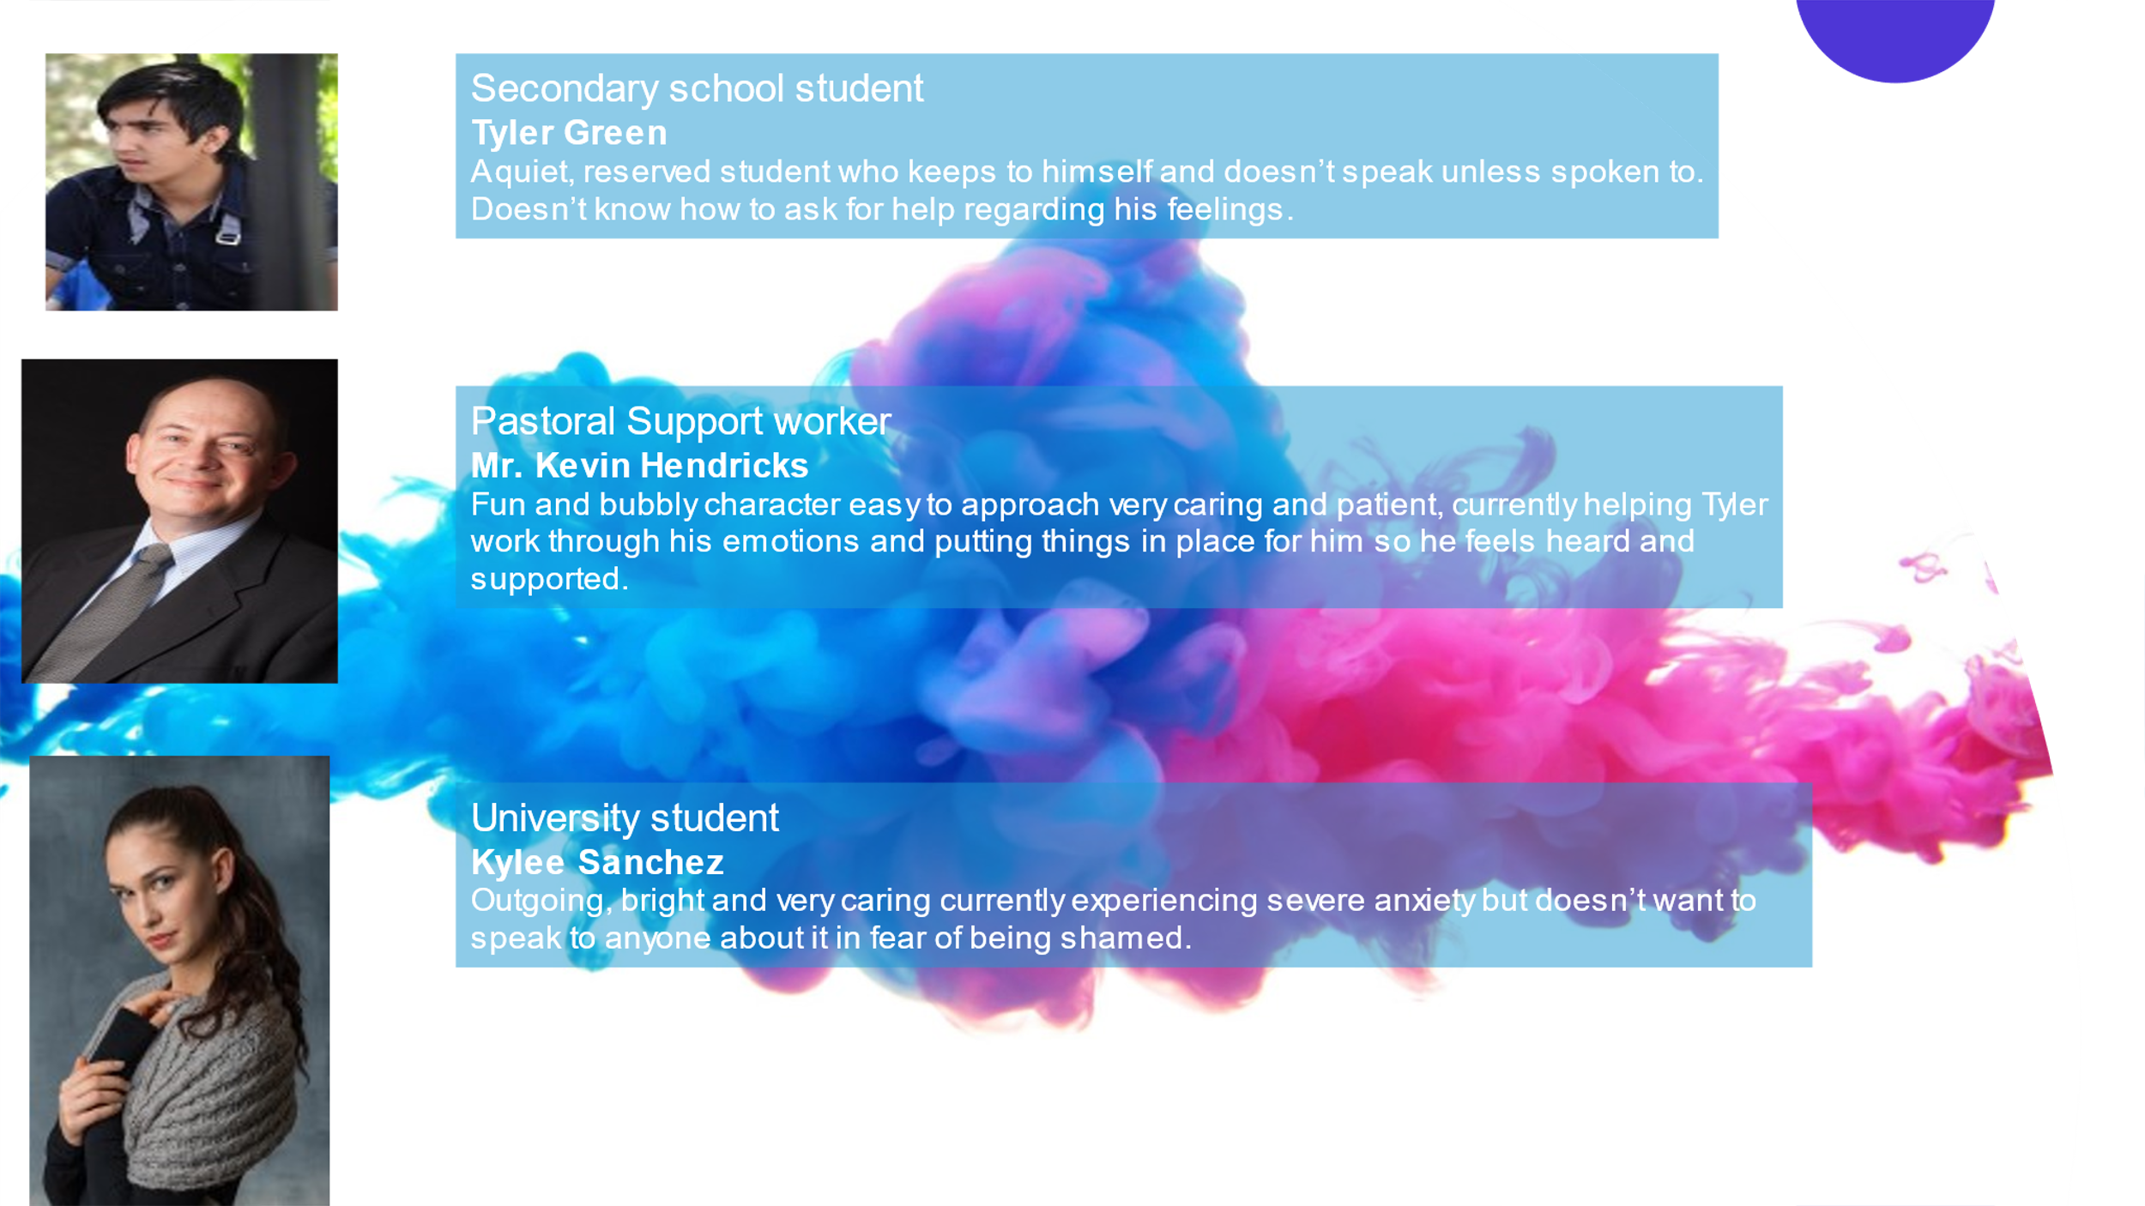

Episodes

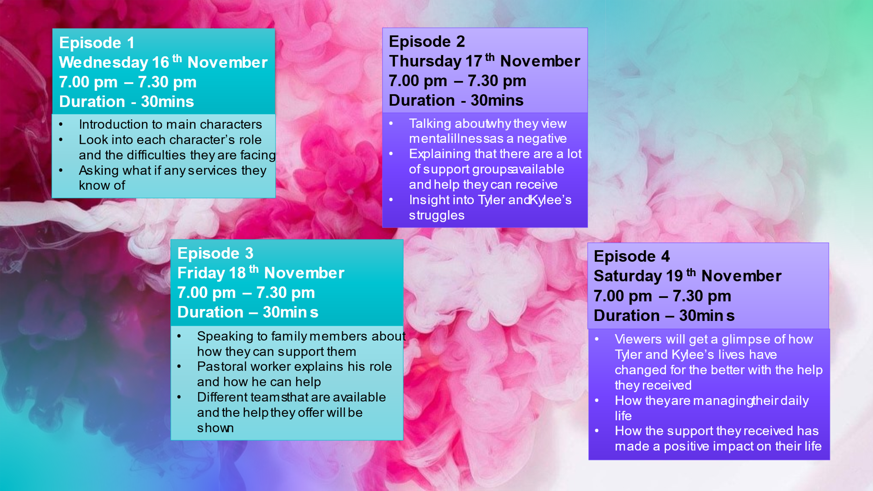

Reference list

- england.nhs. 2022. Adult and older mental health. [ONLINE] Available at: https://www.england.nhs.uk/mental-health/adults/. [Accessed 27 October 2022].
- channel4. 2022. About Channel 4. [ONLINE] Available at: https://www.channel4.com/corporate/about-4/who-we-are/about-channel-4. [Accessed 28 October 2022].
- nwas.nhs. 2019. Every Mind Matters. [ONLINE] Available at: https://www.nwas.nhs.uk/news/every-mind-matters/. [Accessed 29 October 2022].
- Identifying barriers to mental health help-seeking among young adults in the UK: a cross-sectional survey Salaheddin K, Mason B, British Journal of General Practice 2016; 66 (651): e686-e692. DOI: 10.3399/bjgp16X687313
- Young people's views. Early Intervention in Psychiatry Plaistow J., Masson, K., Koch, D., Wilson, J., Stark, R.M., Jones, P.B. and Lennox, B.R. Early Intervention in Psychiatry 2014; 8: 12-23. DOI: 10.1111/eip.12060
- nhs.uk 2020. Counselling for student mental health problems. [ONLINE] Available at: https://www.nhs.uk/mental-health/children-and-young-adults/help-for-teenagers-young-adults-and-students/student-mental-health-counselling/. [Accessed 1 November 2022]
- Sadler, K., Vizard, T., Ford, T. , Goodman, A., Goodman, R. & McManus, S. Mental Health of Children and Young People in England, 2017. Trends and characteristics. Leeds, UK: NHS Digital. [ONLINE]
- Malla, A., Iyer, S., McGorry, P. et al. From early intervention in psychosis to youth mental health reform: a review of the evolution and transformation of mental health services for young people. Soc Psychiatry Psychiatr Epidemiol 51, 319–326 (2016). https://doi.org/10.1007/s00127-015-1165-4

