Critical Film Analysis: The Pianist
How does the piano scene in The Pianist use sound and silence to construct Holocaust memory and cinematic realism?
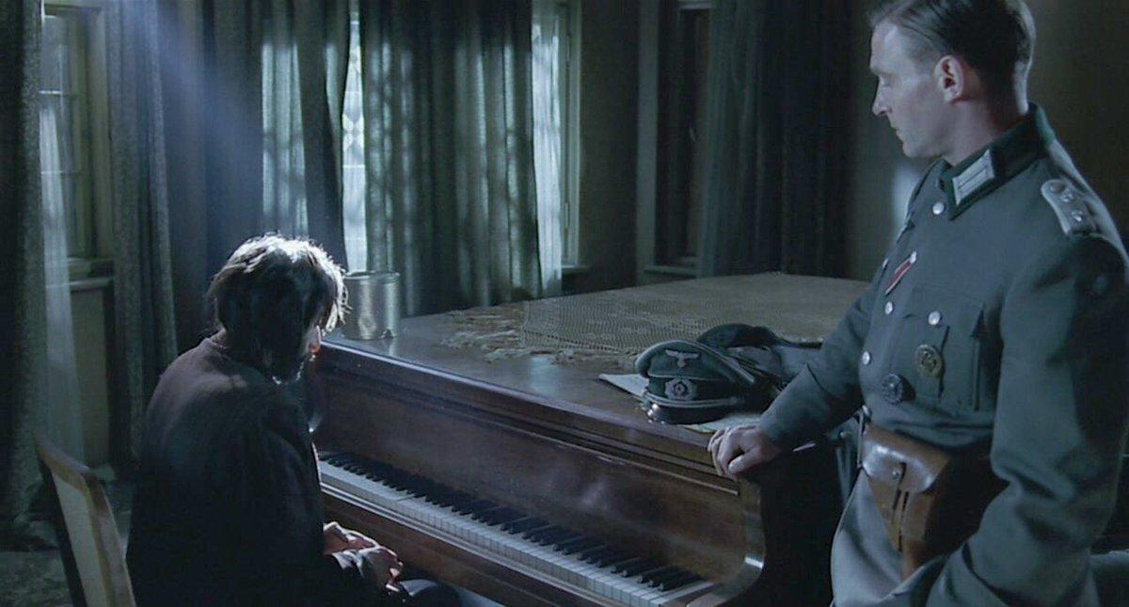
Figure: Image of the Piano scene encounter in the abandoned building with both the protagonist Szpilman and the German officer.
The Pianist by Roman Polanski, released in 2002 and considered one of the most important Holocaust films ever made, constructs Holocaust memory namely through restraint, not only visually but also narratively and most importantly, through careful usage of sound and silence. The scene in which Wladyslaw Szpillman, the main protagonist and Jewish survivor, is found in hiding by a German officer in an abandoned and bombed building, and is surprisingly asked to play the piano, results in the creation of a deeply moving encounter. In this scene, darkness, silence, and sound are not random stylistic choices but rather a very intelligent, sophisticated and carefully curated editorial decisions that shape how Holocaust memory is preserved and felt as opposed to simply understood. The scene is where realism, trauma and cinematic execution intersect. This raised questions about how the medium of film produces historical experience and memory through its careful usage of sound.
As a directorial choice, Polanski uses lighting that is saturated and a colour palette that is muted. The abandoned building scene reflects this directorial approach particularly well. The greyish walls, shadows and dark colours make the environment dull and reflective of difficulty, pain and hardship as opposed to warm colours and visual comfort. Instead of this being a random stylistic choice in terms of Mise en Scene, it is actually a conscious attempt to make the viewer feel in a sensory way, the deprived living conditions which Szpillman has to endure. Film scholar Andre Bazin claims that ‘depth of focus’ and unembellished realism bring the spectator into a closer and more intimate understanding and appreciation of the reality, when highlighting that for the viewer, ‘its structure is more realistic’. Polanski’s decision to avoid warm stylistic choices and dramatic lighting supports this Bazinian realism, where the viewer draws meaning from duration, texture, and physical space rather than through cinematic manipulation.
The building itself denotes ruined materiality as opposed to simply being a backdrop. The crumbling walls, broken furniture, and dust-covered surfaces are given extended screen time and focus. The idea highlighted by Siegfried Kracauer that film reveals overlooked physical reality is quite salient here, ‘many objects remain unnoticed simply because it never occurs to us to look their way.’ In this scene, objects like the piano are not introduced for narrative convenience, but instead exist within the decay of the building. Kracauer also argues that film captures reality ‘as it evolves in time,’ and Polanski’s long and unbroken takes reinforce this sense of temporal survival.
When the officer discovers Szpilman, the editing remains restrained. There is no rapid cutting or musical cue to show danger or relief. Instead, silence dominates. This silence is strategically employed, not as emptiness but as an editorial decision that forced the viewer into an uncertain state. The German officer’s unexpected level of restraint complicates the narrative of expectation, since a violent response which the viewer may be expecting, is withheld, but in a tense way. This withholding is pivotal to the scene’s ethical tension. Polanski refuses to resolve the encounter into either brutality or redemption.
Polanski includes sound gradually, and this transition in and out of sound, can be understood through Michel Chion’s concept of ‘added value,’ where sound ‘enriches a given image so as to create the definitive impression.’ Instead of simply accompanying the image, the piano scene, reconfigures it. The dusty and ruined room is brought to life acoustically and with a slight glimmer of light shining through the window as an additional prop for the life the music is injecting into the scene. Chion’s idea of synchresis, the connection between the sound and image, explains why the performance feels historically ‘real’ even though it is carefully constructed. It becomes impossible to separate the sound from Szpilman and the immediate space, which strengthens emotional realism.
Polanski’s editorial restraint, the long takes, minimal and carefully used score, and absence of non-diegetic music, also plays a salient role in creating historical memory. By opting out of using emotional manipulation through background score, the film embodies what Ian Gwinn describes as the production of historical meaning through ‘authenticity, empathy, and experience.’ The viewer is not told how to feel through the music, but rather, emotion emerges from the raw interaction between performance, silence, and space.
However, at the same time, this realism is not neutral. Oybek Aliqulovich Ostonov reminds us that ‘films are not always accurate or objective representations of historical events.’ The decision to incorporate an encounter that is morally ambiguous as this, where a Nazi officer becomes the listener as opposed to executioner, raises interpretive tensions. The scene risks aestheticisng and humanising historical violence by including a moment of artistic resonance within the backdrop of genocide. However, Polanski avoids projecting a definitively romantic conclusion. The officer’s restraint is not framed as redemption as though it is unsettling it remains temporary and within the wider context and backdrop of the more harrowing war frame on the outside.
This tension is central to Holocaust memory in cinematic representation. Alison Landsberg’s concept of ‘prosthetic memory’ is particularly useful here, which in a nutshell is that film allows the viewer to ‘suture himself or herself into a larger history,’ forming ‘a more personal, deeply felt memory of a past event through which he or she did not live.’ The piano scene has exactly this impact. Through Polanski’s execution of sound, the viewer is encapsulated into a cinematically produced memory of survival that feels both emotionally intimate but historically distant at the same time. The realist aesthetic helps to boost the emotional impact of the scene, especially when considering the physical details.
However, Landsberg also notes that such cinematic memory production carries ethical risk, especially when focussing on distortion and repetition, as ‘historical revisionism has been a powerful enemy of Holocaust memory.’ The beauty of the scene and its fragile music within the ruin and backdrop of genocide could be seen as a softening of a brutal historical memory. In addition, Landsberg also argues that cinema can create ‘the possibility of a responsible mass cultural transmission of memory.’ This scene lies within this tension. While it is emotionally accessible, it remains unsettling and unstable, and therefore it refuses closure.
This clearly reinforces the relationship between sound and silence. Cathy Caruth’s trauma theory is helpful here, especially her claim that catastrophic events ‘seem to repeat themselves for those who have passed through them.’ Szpilman’s performance is not simply expressive but actually a compulsive repetition of a pre-war condition and identity that no longer exists but that there is a longing for. His musical performance is rooted in a survival instinct as opposed to recovery. Caruth’s description of memory as ‘a series of painful events… entirely outside their wish or control’ resonates strongly here. Szpilman does not willingly or freely choose performance as a healing mechanism, but rather as a necessity within a broader unpredictable encounter and context.
The reaction of the officer further complicates interpretation. His silence during the performance becomes part of the wider soundscape of the scene. But the silence is not framed as absence but rather as power. It frames the music as something that is being temporarily allowed, observes, and most importantly judged. The talent of Szpilman creates a dichotomy of power in which the piano performance now questions whether the German officer is actually more powerful than Szpilman. There is an oscillating power imbalance that can be tipped either way depending on how one views the scene and the protagonists. However, within this imbalance, sound creates a fragile shared space and connection. Abrams’ argument that Holocaust cinema can include ‘acts of Jewish resistance’ is helpful here. Szpilman’s performance acts as a form of resistance, not through confrontation, but instead through cultural survival. Music indicates presence and survival where political existence is no longer an option.
Kracauer’s idea that the view enters a ‘dream-like state’ is also relevant here. The scene is not so concerned with narrative urgency, and so draws the viewer into an extended attentiveness. A simple piano melody becomes elongated cinematic time, where ‘a face… a street serving as a background… open up a dimension much wider than that of the plots which they sustain.’ The piano, the room and the two figures seem bigger than simple historical narrative and instead become historical remnants that are made both visible and audible.
Ultimately, Polanski’s editorial and directorial choices which include muted colour grading, restrained editing, diegetic sound focus, and the refusal of musical underscoring, construct a specific mode of Holocaust representation that is found in sensory realism. This aligns with Bazin’s idea of cinema evolving toward techniques that ‘respect reality,’ but also it exposes the limits of that realism. The scene is not reality itself, but a carefully curated and structured intervention that creates and produces emotional truth and empathy through aesthetic and cinematic control and mechanisms.
The piano sequence or scene therefore functions as a meeting point between silence and sound, history and film, trauma and performance. It demonstrates how Holocaust memory is not only preserved through narrative but constructed through sensory experience. Under Polanski’s direction and editorial choices, the abandoned building becomes an acoustic space of historical tension, where music does not heal or resolve trauma, but instead briefly suspends it for a short time
Bibliography:
Ayufa, Radya, ‘The Pianist – Finding Light Among the Dark’, EDSA UNAIR (16 April 2021) https://www.edsa-unair.com/2021/04/the-pianist-finding-light-among-dark.html [accessed 1 July 2026]
Abrams, Nathan, The New Jew in Film: Exploring Jewishness and Judaism in Contemporary Cinema (London: I.B. Tauris, 2012)
Bazin, André, What Is Cinema?, trans. by Hugh Gray, 2 vols (Berkeley: University of California Press, 1967), I
Bazin, André, What Is Cinema?, trans. by Hugh Gray, 2 vols (Berkeley: University of California Press, 1971), II
Caruth, Cathy, Unclaimed Experience: Trauma, Narrative, and History (Baltimore, MD: Johns Hopkins University Press, 1996)
Chion, Michel, Audio-Vision: Sound on Screen, trans. by Claudia Gorbman (New York: Columbia University Press, 1994)
Gwinn, Ian, review of Jerome De Groot, Consuming History: Historians and Heritage in Contemporary Popular Culture, Reviews in History, no. 825 (31 October 2009) https://reviews.history.ac.uk/review/825 [accessed 1 July 2026]
Kracauer, Siegfried, Theory of Film: The Redemption of Physical Reality (Princeton, NJ: Princeton University Press, 1997)
Landsberg, Alison, Prosthetic Memory: The Transformation of American Remembrance in the Age of Mass Culture (New York: Columbia University Press, 2004)
Ostonov, Oybek Aliqulovich, Mukaddas Ergashovna Abduraimova, Kuyliyev Tulkin, and Dilrabo Rominovna Kenjayeva, ‘The Role and Importance of Films in the Study of Historical Processes’, E3S Web of Conferences, 420 (2023), p. 1498
Polanski, Roman, The Pianist (2002) [film] (France, Germany, Poland and United Kingdom: R.P. Productions, StudioCanal, Heritage Films and Universal Pictures, 2002)

Radya Ayufa, ‘The Pianist – Finding Light Among the Dark’, EDSA UNAIR (16 April 2021) https://www.edsa-unair.com/2021/04/the-pianist-finding-light-among-dark.html [accessed 1 July 2026].
André Bazin, What Is Cinema?, trans. by Hugh Gray, 2 vols (Berkeley: University of California Press, 1967), I, p. 35.
Siegfried Kracauer, Theory of Film: The Redemption of Physical Reality (Princeton, NJ: Princeton University Press, 1997), p. 54.
Ibid., p. 41.
Michel Chion, Audio-Vision: Sound on Screen, trans. by Claudia Gorbman (New York: Columbia University Press, 1994), p. 5.
Ibid., p. 5-11.
Ian Gwinn, review of Consuming History: Historians and Heritage in Contemporary Popular Culture, by Jerome De Groot, Reviews in History, no. 825 (31 October 2009) https://reviews.history.ac.uk/review/825 [accessed 1 July 2026].
Oybek Aliqulovich Ostonov, Mukaddas Ergashovna Abduraimova, Kuyliyev Tulkin, and Dilrabo Rominovna Kenjayeva, ‘The Role and Importance of Films in the Study of Historical Processes’, E3S Web of Conferences, 420 (2023), p. 1498.
Alison Landsberg, Prosthetic Memory: The Transformation of American Remembrance in the Age of Mass Culture (New York: Columbia University Press, 2004), p. 2.
Ibid., p. 113.
Ibid., p. 111.
Cathy Caruth, Unclaimed Experience: Trauma, Narrative, and History (Baltimore, MD: Johns Hopkins University Press, 1996), p. 1.
Ibid., p. 2.
Nathan Abrams, The New Jew in Film: Exploring Jewishness and Judaism in Contemporary Cinema (London: I.B. Tauris, 2012), p. 94.
Siegfried Kracauer, Theory of Film: The Redemption of Physical Reality (Princeton, NJ: Princeton University Press, 1997), p. 303.
Ibid.
André Bazin, What Is Cinema?, trans. by Hugh Gray, 2 vols (Berkeley: University of California Press, 1971), II, p. 12.

