
Programme: Employability Skills

Module: Academic Skills for the Digital Era

Module code: BMSW4013

Assignment Title: Evidence of Learning (E-Portfolio)

“What are the challenges and opportunities for students in the digital era, and how can they adapt to succeed?”

Student Name: Elena Alexandra Benghiac
Student ID: 1812479
DATE: 16.08.2026

AI Acknowledgement
I confirm that I have not presented any AI-generated materials as my own work. I confirm that I have copies of my drafts, notes, and other resources I used, which I may be asked to provide as evidence.

Table of Contents
Component 1: Development of Academic Skills 4
1. Evaluating Academic Sources Using the CRAAP Test 4
2. Synthesis of Academic Sources 5
3. Identifying a Key Challenge and Opportunity 5
4. Academic Planning 5
References of component 1 7
Component 2: Application of Academic Skills 8
1. Introduction 8
2. Challenges for Students in the Digital Era 8
3. Opportunities in the Digital Era 9
4. How Students Can Adapt to Succeed 9
5. Conclusion 10
Reference of component 2 12
Component 3: Academic Poster: Communicating Academic Skills 13
References of component 3 17

Component 1: Development of Academic Skills

1. Evaluating Academic Sources Using the CRAAP Test
Factors | Source 1 | Source 2
Currency | Song et al. (2025) have published this article in 2025; hence, source 1 has high currency. | In June 2025, Zakir et al. published the second, hence this source has high currency and could examine the contemporary relationship between digital literacy and academic performance.
Relevance | Highly relevant, as this article sheds light on how digital learning can help undergraduate students to achieve academic excellence and strengthen learning performance. | Very high relevance, as this article finds the impact of digital literacy on the academic performance of students, which would provide in-depth evidence that would explain the reasons behind academic success.
Authority | Highly authoritative, as it was published in the behavioural science category by MDPI. | The credibility of the source is high, as multiple authors are involved in the journal publication.
Accuracy | The findings of this article are highly accurate, as a result derived from empirical research. | Highly accurate data based on empirical findings.
Purpose | Investigating the relationship between digital learning and academic success. | Investigating the relationship between digital learning and academic skill development.
Table CRAAP analysis

2. Synthesis of Academic Sources
Digital competence was central to both of these studies as an important element that leads to success in academic work. Song et al. (2025) have shown that it is advantageous to educate students in digital learning competence to enhance their academic performance during their undergraduate studies. Their results highlight students' capability to apply digital tools with competencies in learning. Likewise, it can be concluded that digital literacy is related to academic performance, as stated by Zakir et al. (2025). However, they dive deeper into the explanation by learning about mediators such as digital informal learning, self-efficacy, and digital competence. Both studies conclude that it is important that digital skills contribute to achieving successful learning outcomes. However, Zakir et al. (2025) build on the work of Song et al. (2025) and propose other mechanisms through which digital literacy can have a significant impact on academic achievement. The compilation of these sources gives a more comprehensive understanding of digital learning as competence does not necessarily mean achievement. Students should also possess confidence and be given a chance to learn informally via digital media.

3. Identifying a Key Challenge and Opportunity
One of the challenges for students is to gain digital competence so they can be good students. Student achievement and digital learning competence likewise have a connection, based on Song et al. (2025). Young people with less ability in their digital learning skills might thus struggle to achieve high levels of achievement. Another relationship between digital literacy, student self-efficacy, and digital competence is provided by Zakir et al. (2025), who showed that students who lack self-efficacy in digital learning face more difficulties. But there is a great opportunity for the effective use of digital technologies. On the other hand, the enhancement of the ability of humans to improve in digital learning can lead to an improvement in learning competence (Song et al., 2025). In this way, a focus on digital competence and confidence can have impactful educational opportunities.

4. Academic Planning
Task | Date/ Deadline
Data analytics | 17th September
Digital marketing strategy and planning | 30th September
Computational thinking | 10th October
Time management | 25th October

References of component 1
Song, Y., Lv, S., Wang, M., Wang, Z. and Dong, W. (2025) ‘The impact of digital learning competence on the academic achievement of undergraduate students’, Behavioral Sciences, 15(7), p.840. Available at: https://doi.org/10.3390/bs15070840
Zakir, S., Hoque, M.E., Susanto, P., Nisaa, V., Alam, M.K., Khatimah, H. and Mulyani, E. (2025, June) ‘Digital literacy and academic performance: the mediating roles of digital informal learning, self-efficacy, and students’ digital competence’, In Frontiers in education (Vol. 10, p. 1590274). Frontiers Media SA. Available at: https://doi.org/10.3389/feduc.2025.1590274

Component 2: Application of Academic Skills

1. Introduction
Digital learning in higher education helps transform communication, knowledge and education to complete academic activities. The digital learning process helps to create virtual environments and provide access to resources and lectures on a collaborative platform. Digital learning helps to enhance flexibility in the learning process and influences interactive learning methods to improve the experiences of students (Zou et al., 2025). Understanding the opportunities and challenges in the digital learning process is important for improving the quality of education among HE students. Opportunities help to identify areas for technology innovation to improve the level of flexibility, reduce costs, and increase accessibility of study materials for integrating the learning experience of students. In another way, identification of challenges in the digital learning process helps to build strategies to minimise privacy concerns, technical hazards, with the integration of staff training for enhancing students' involvement. The aim of this report is to build knowledge on challenges and opportunities in digital learning for higher education. This study focuses on determining the strategy for the adaptation of digital learning in higher education.

2. Challenges for Students in the Digital Era
Two challenges for students in the digital learning process include inconsistent internet access and communication barriers. During the COVID-19 pandemic, students faced difficulties accessing materials and attending classes on digital platforms at the correct time due to issues with internet connectivity. Moreover, the limited communication facilities during class through digital platforms have impacted the ability to manage each task and assignment accurately during the Employability Skills program. Yu, Bekerian and Osback (2024), mentioned that the lack of digital access and literacy among students creates disruption in the learning process. Nearly 826 million students are unable to access digital learning facilities due to the unavailability of computers, whereas 43%, concerning 706 million students, are unable to access the internet (UNESCO, 2026). This reflects the challenges of accessing the internet and computers for integrating the digital learning process as a significant consequence of poor technology infrastructure. In addition, Yu, Bekerian and Osback (2024), stated that communication barriers foster misinformation and disinformation that impact the accuracy of the digital learning process. Approximately 1.5 billion students are facing unprecedented disruption in the learning process due to barriers in the interaction process and information flow during the pandemic (UNESCO, 2026). This indicates that communication barriers and a lack of information flow impact the quality and accuracy of the learning process for students in higher education. Thus, the quality of the digital learning process has affected the accuracy and quality of the learning process due to facing challenges including no accessibility of the internet and computers and communication barriers by students.

3. Opportunities in the Digital Era
Key opportunities in the digital learning process include influencing flexible and personalised learning and collaboration. Personalisation and flexibility in digital learning by using AI-supported platforms influence the self-directed educational process by increasing accessibility of study materials and repeated access to lectures (Plooy, Casteleijn and Franzsen, 2024). In the virtual class, students are able to access learning materials with flexibility and improve efficiency by assessing real-time feedback to improve students' performance. For instance, LearnSmart assignments provide a flexible learning experience to students to enhance exam grades and academic performance (Plooy, Casteleijn and Franzsen, 2024). On the other hand, collaborative learning processes by using digital platforms provide opportunities to solve problems, sharing resources with improvements of the quality of study. Nearly 68% of students reported satisfactory learning experiences for office collaboration in digital learning that enhance their ability to think critically and solve problems in digital projects (Gabriel, 2025). This reflects the significant improvements in learning experiences by using digital platforms for collaboration with other students and educators to share information with proper communication. Thus, digital learning influences the opportunity for a collaborative learning process with a personalised experience for flexibility in access to study materials and lectures that enhance academic performance.

4. How Students Can Adapt to Succeed
Improve digital literacy and critical evaluation skills by accessing AI: The use of AI-driven solutions, including ChatGPT, helps to improve knowledge of using the digital learning platform and accessing adequate information for data analysis. ChatGPT supports the adoption of digital tools by critically analysing information, mainstreaming digital literacy (Moravec et al., 2024). Moreover, the capability of data analysis, improving knowledge in the specific context, is improved by using ChatGPT in the digital learning process. This reflects the effectiveness in improving conceptual thinking, data analytics, and research for enhancing academic performance. Moreover, improvements in digital literacy guided by the guide of AI help to minimise barriers in accessing adequate information and study materials and enhance the quality of study. In this regard, the use of AI with enhancements of digital literacy and critical evaluation skills can improve the efficiency of adaptability toward digital learning methods, with efficiency in accessing resources, and overcome communication barriers to achieve high academic performance.
Time management: Scheduling the study plan influences the self-regulated learning process to manage flexibility in the digital learning process. Scheduling helps to improve time management skills with the capability to manage studies for high academic performance (Adams and Blair, 2019). The ability to improve time management by proper study plan, with consideration of internet accessibility, can enhance the ability to attend class and access materials. After that, the proper evaluation of each piece of information and summary of class discussion can improve the quality of study to represent high academic performance. Students can manage the digital learning method by scheduling the study plan based on the time of internet accessibility, which represents time management capability and an opportunity to achieve high academic performance in higher education.

5. Conclusion
In conclusion, the digital learning process helps to increase flexibility and collaboration to access study materials and attend lectures, providing personalised experiences. The lack of internet and computer access and communication barriers impacts the accuracy and quality of studies by using digital learning platforms. The use of AI helps to improve critical evaluation skills and digital literacy. The scheduling of a study plan helps to improve the ability to manage the flexible learning process with proper time management. The improvement of digital literacy and critical evaluation skills is important for enhancing performance in the digital learning process. Moreover, the ability to manage time is important for improving involvement among students, with representation of high academic performance. The use of AI-driven solutions and effective study plans helps to improve adaptability to the digital learning process, overcoming issues including communication barriers, lack of access to resources, and capturing on opportunity related to flexibility and collaboration.

Reference of component 2
Adams, R.V. and Blair, E., (2019) ‘Impact of time management behaviors on undergraduate engineering students’ performance’, Sage Open, 9(1), p.2158244018824506. Available at: https://doi.org/10.1177/2158244018824506
Gabriel, S., (2025) ‘The Role of Digital Tools in Enhancing Collaborative Learning in Classroom Settings’, International Journal of Educational Research 1(1):26-32. Available at: https://doi.org/10.62951/ijer.v1i1.15
Moravec, V., Hynek, N., Gavurova, B. and Rigelsky, M., (2024) ‘Who uses it and for what purpose? The role of digital literacy in ChatGPT adoption and utilisation’, Journal of Innovation & Knowledge, 9(4), p.100602. Available at: https://doi.org/10.1016/j.jik.2024.100602
Plooy, E.D., Casteleijn, D. and Franzsen, D., (2024) ‘Personalized adaptive learning in higher education: A scoping review of key characteristics and impact on academic performance and engagement’, Heliyon, 10(21), pp.1-24. Available at: https://doi.org/10.1016/j.heliyon.2024.e39630
UNESCO (2026) Startling digital divides in distance learning emerge, www.unesco.org. Available at: https://www.unesco.org/en/articles/startling-digital-divides-distance-learning-emerge (Accessed: 13 August 2026).
Yu, J., Bekerian, D.A. and Osback, C. (2024) ‘Navigating the digital landscape: Challenges and barriers to effective information use on the internet’, Encyclopedia, 4(4), pp.1665-1680. Available at: https://doi.org/10.3390/encyclopedia4040109
Zou, Y., Kuek, F., Feng, W. and Cheng, X., (2025) ‘Digital learning in the 21st century: trends, challenges, and innovations in technology integration’, In Frontiers in Education, 10, p. 1562391. Available at: https://doi.org/10.3389/feduc.2025.1562391

Component 3: Academic Poster: Communicating Academic Skills
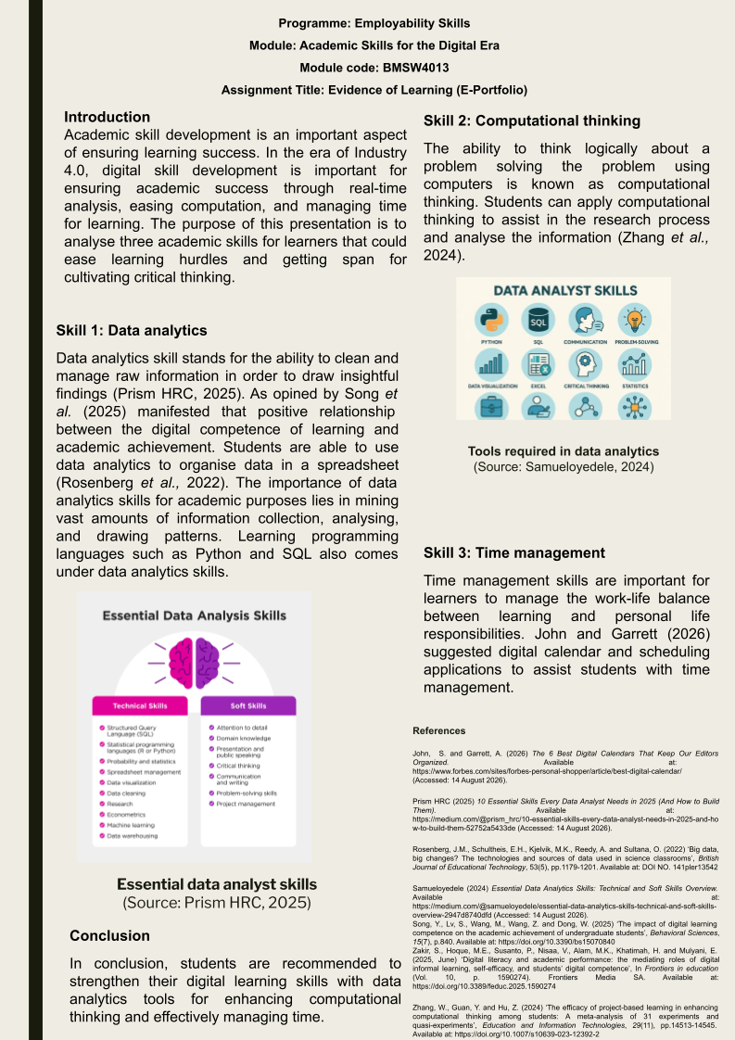
Speaker note
Skill 1: Data Analytics
The value of information analysis: students have come to face an increasing amount of digital data. It allows for systematic data collection, analysis, and interpretation by the pupils. Analytical skills will be applied to critical, effective thinking and the development of informed decisions through the use of evidence and credible, academically well-written research. Song et al. (2025) found a positive relationship between digital competence in learning and academic achievement. As opined by Samueloyedele (2024), digital literacy can be a part of informal learning and can become a powerful component in improving students' learning capability. It is possible to say that digital technologies are required to be used properly and in appropriate activities when learning. As per the findings of Rosenberg et al. (2022), students are able to use data analytics to organise data in a spreadsheet. They are able to read off the data from surveys, recognise trends, and understand statistics. Academic judgement will be needed; students will first have to analyse data sources. Competence can be enhanced by using simple statistical software and/or Excel on a regular basis. Data analytics can then aid in improving school development and digital confidence.
Skill 2: Computational Thinking
Computational Thinking is a systematic and logical way of thinking about a problem and solving it using computers. This is preferable because students might encounter academic challenges that could be of a complex nature. It facilitates students in dividing the bigger problem into smaller problems. This will help them to establish more specific and ordered patterns of actions in the classroom. The practice of dealing with digital competence is emphasised by Zakir et al. (2025) as a competence that is important in academic performance. In digital skills, they say that "cultivation of digital skills" is a tool that can be employed to improve learning. Findings of Zhang et al. (2024) state that students can apply computational thinking to assist in the research process and analyse the information. Be able to divide research questions into analytical tasks in a systematic manner. Students may also research a number of different solutions to a problem and examine them logically in sequence. These strategies may apply in setting up independent learning and academic problem-solving skills.
Skill 3: Time Management
Time Management" is a strategy adopted by students to effectively manage their work. That's why it's important, because students regularly complete assignments, exams, and individual work. Having effective planning in place lessens delays and promotes some uniformity in the use of the school's intellectual time. In Song et al. (2025), the role of digital learning competence for academic achievement is illustrated. This requires a set of good learning habits and digital skills. Digital calendar or scheduling applications can be used to assist students with time management (John and Garrett, 2026). They have to set times for conducting research, writing, planning revisions, and evaluations. Break down tasks into smaller assignments to make them manageable. Pupils will be encouraged to ensure work is valued, but be aware of regular work periods. This indicates that time management can enable students to have productive, sustainable school performance.
In digital learning, text analysis, using technology, and online communication are connected. They would not have data analysis support for an evidence-based analysis and academic decision. The use of computational thinking and structured approaches will develop logical problem-solving. Time Management will be used to ensure adequate time is allotted for these. These abilities can positively enhance digital learning competence and academic achievement. The significance of digital competence in the process of achieving successful learning has been emphasised by researchers Song et al. (2025). Therefore, once learned, these skills will help pupils to become confident, independent, and effective digital learners. By mastering time management skills, learners would get the opportunity to learn new skills and develop creativity. Along with developing data analytics and digital skills, time management is also important to ensure academic and study life balance. In view of the above, in order to sustain the data-driven digital learning environment, students need to learn data analytics for in-depth analysis of a topic from different perspectives, and strengthen computational ability for automating tasks in a logical, synchronised way with the help of time management competency.

References of component 3
John, S. and Garrett, A. (2026) The 6 Best Digital Calendars That Keep Our Editors Organized. Available at: https://www.forbes.com/sites/forbes-personal-shopper/article/best-digital-calendar/ (Accessed: 14 August 2026).
Prism HRC (2025) 10 Essential Skills Every Data Analyst Needs in 2025 (And How to Build Them). Available at: https://medium.com/@prism_hrc/10-essential-skills-every-data-analyst-needs-in-2025-and-how-to-build-them-52752a5433de (Accessed: 14 August 2026).
Rosenberg, J.M., Schultheis, E.H., Kjelvik, M.K., Reedy, A. and Sultana, O. (2022) ‘Big data, big changes? The technologies and sources of data used in science classrooms’, British Journal of Educational Technology, 53(5), pp.1179-1201. Available at: https://doi.org/10.1111/bjet.13245
Samueloyedele (2024) Essential Data Analytics Skills: Technical and Soft Skills Overview. Available at: https://medium.com/@samueloyedele/essential-data-analytics-skills-technical-and-soft-skills-overview-2947d8740dfd (Accessed: 14 August 2026).
Song, Y., Lv, S., Wang, M., Wang, Z. and Dong, W. (2025) ‘The impact of digital learning competence on the academic achievement of undergraduate students’, Behavioral Sciences, 15(7), p.840. Available at: https://doi.org/10.3390/bs15070840
Zakir, S., Hoque, M.E., Susanto, P., Nisaa, V., Alam, M.K., Khatimah, H. and Mulyani, E. (2025, June) ‘Digital literacy and academic performance: the mediating roles of digital informal learning, self-efficacy, and students’ digital competence’, In Frontiers in education (Vol. 10, p. 1590274). Frontiers Media SA. Available at: https://doi.org/10.3389/feduc.2025.1590274
Zhang, W., Guan, Y. and Hu, Z. (2024) ‘The efficacy of project-based learning in enhancing computational thinking among students: A meta-analysis of 31 experiments and quasi-experiments’, Education and Information Technologies, 29(11), pp.14513-14545. Available at: https://doi.org/10.1007/s10639-023-12392-2

