Programme: | BSc Health and Social Care
Module: | Changemakers: Building your Personal Brand for Sustainable Employment
Module code: | BMHP5015
Lecturer: | Olufemi Oluranti | Internal Verifier: | Dr Eleni Koutsogeorgou-Andreou
Assignment Title: | Component 2: Assignment (Report)

Table of Contents
1. Introduction 1
2. Job Advertisement 1
3. Job Role Employability Skills 1
4. Evaluation of Own Skills 2
5. Action Plan and Timeline 3
6. Building Personal Brand 5
7. Professional Identity 5
8. Building a Network for Successful Environment 5
9. Conclusion 6
References 7
Appendix 9

Introduction
This report is to examine the employability skills needed to work in the position of a Senior Healthcare Support Worker, in the UK health and social care industry. This job is a direct care job where the individual gives direct care to the patient, assists in the daily living activities, monitors the wellbeing of the patients, and collaborates with multidisciplinary teams (Nijhof et al., 2024). It plays a critical role in the provision of safe and person-centred care (NHS England, 2022). The reason I would like to do this role is due to my vast experience as a support worker and my passion to enhance dignity, independence and wellbeing of those who are vulnerable.

Job Advertisement
The job advertisement (NHS Jobs, 2026) that I am interested to apply is attached in Appendix.

Job Role Employability Skills
The job of a Senior Healthcare Support Worker involves the set of interpersonal, practical, and organisational employable skills in order to provide high-quality care to patients (The Royal College of Nursing, 2025). Communication is one of the most significant competencies given in the job description (NHS Jobs, 2026). These comprise the capacity to speak with clarity to patients, families as well as multidisciplinary teams. Communication should be effective since the job entails explaining care processes, updating patient status, and offering emotional comfort to vulnerable people (NHS, 2021). Lack of effective communication may lead to a dent in patient safety and trust.
Another essential skill is teamwork because the work will be related to collaborating with nurses, doctors, and other personnel of the care team (Woodward and Ruston, 2023). The provision of healthcare is synergistic, and good coordination guarantees seamless care, fewer mistakes, and better patient outcomes. Senior Healthcare Support Worker should also have problem-solving ability. The skill is required in dealing with emergent scenarios like patient distress, behavioural issues, or immediate change of health (Skills England, 2023). Rapid and adequate decision-making assists in sustaining safety and continuity of care.
Time management is also significant since the job is associated with the necessity to balance different tasks, such as helping, personal care, medication administration, documentation of observations, and mobility assistance (Halmetoja, Teittinen and Laaksonen, 2024). Good time management ensures that things are done effectively and in a quality manner. Also, technical and clinical competencies, including proper moving and handling, understanding infection control, and proper record-keeping are needed to satisfy both professional and safety standards (The Royal College of Nursing, 2025). These competencies make sure that the rules of care are adhered to and help treat the patient and be monitored.
In general, these employability skills are essential as they help the worker provide person-centred, safe, and efficient care in a challenging healthcare setting like the NHS England.

Evaluation of Own Skills
When assessing my existing competencies, I realise that I already have significant experience in health and social care that can correlate with the demands of being a Senior Healthcare Support Worker. I been employed as a Support Worker and presently as a Senior Support Worker, helping to provide personal care, daily living activities, medications, and assisting physically challenged and mentally ill as well as those with dementia. The training in safeguarding, moving and handling, administration of medication and food hygiene are also other key qualifications that I have completed in order to practice safely. Such opportunities show that I already fit numerous practical and regulatory demands of the job.
I have strengths of communication, empathy, teamwork and leadership skills. As an illustration, in my present profession, I frequently interact with service users and their relatives to identify their needs and console them. My other roles also include collaboration with other colleagues to make care plans effective. My leadership skill can be seen through my supervision of junior staff and assisting them in providing person-centred care. The above strengths would enable me to provide value to the position by fostering patient dignity, quality care provision, and a supportive team environment. The opportunity of my long-term tangible experience and a caring attitude is my competitive edge as it makes me build trust with vulnerable people within a short period of time.
Nonetheless, areas of improvement are also identified by me. To advance in the NHS system, I will have to enhance my clinical knowledge, skills in digital record-keeping, and qualifications. Indicatively, attaining level 3 or more in Health and Social Care would enhance my professional credibility. In addition, better confidence in higher documentation systems and medical terms would make me more effective.
These skills can be enhanced with the help of a number of people and resources. Supervisors in my workplace may offer mentorship and feedback, and peers may offer peer learning. I can acquire formal qualifications and technical skills required in the career advancement through training providers, professional courses, and online NHS learning platforms.

Action Plan and Timeline
Table 1 outlines a five-year action plan and schedule of the steps to be undertaken to design the skills, qualifications and professional competencies to secure the position of Senior Healthcare Support Worker in a UK health and social care industry.
Table 1: Five-Year Action Plan and Timeline for Career Development
Timeframe | Development Goal | Specific Actions | Skills Developed | Resources/Support Needed | Expected Outcome
Short-Term (0–12 months) | Improve professional knowledge and formal qualifications | Join Level 3 Diploma in Health and Social Care; go through compulsory NHS on-line training (infection control, patient safety, record keeping) | Clinical knowledge, professional standards awareness, digital documentation skills | Local college courses, employer training support, online NHS learning platforms | Stronger theoretical foundation and eligibility for higher responsibilities
Short-Term (0–12 months) | Strengthen digital and record-keeping skills | Electronic care documentation: practice electronic care systems at workplace; attend IT skills workshops | Digital literacy, accuracy in record keeping | Workplace mentoring, ICT training sessions | Increased confidence in NHS documentation systems
Short-Term (0–12 months) | Enhance communication and leadership skills | Take part in workplace supervision activities; take part in communication workshops | Professional communication, leadership, teamwork | Supervisor feedback, professional development workshops | Improved ability to coordinate care and support team members
Medium-Term (1–3 years) | Gain advanced clinical care competencies | Full specialised training in dementia care, mental health services, and pharmacology | Specialist care knowledge, patient safety skills | Employer funding, CPD courses, professional training providers | Ability to manage complex patient needs effectively
Medium-Term (1–3 years) | Develop leadership and supervisory experience | Become mentor to junior personnel; attend to care plans and auditing | Leadership, decision-making, organisational skills | Workplace opportunities, management guidance | Strong supervisory experience aligned with senior role requirements
Medium-Term (1–3 years) | Build professional network and personal brand | Develop professional resume and LinkedIn profile; participate in events and workshops in the healthcare career | Networking, professional identity, career communication skills | Career services, professional associations, online platforms | Increased employment visibility and career opportunities
Long-Term (3–5 years) | Achieve advanced qualifications and career progression | Either Full Level 4 or foundation degree in Health and Social Care; apply to positions in NHS Band 3/4 | Advanced clinical competence, career readiness | University programmes, employer sponsorship | Eligibility for senior healthcare support positions
Long-Term (3–5 years) | Strengthen professional confidence and decision-making | Be leaders of small care groups; be involved in quality improvement efforts | Leadership, problem-solving, critical thinking | Workplace leadership opportunities, mentorship | Recognition as a competent and reliable senior practitioner
Long-Term (3–5 years) | Establish strong professional reputation | Keep CPD journal, have professional references, conduct service enhancement initiatives | Professional credibility, reflective practice | Employer support, CPD frameworks | Sustainable career progression and long-term employability

Building Personal Brand
Personal branding is a key to professionalism, credibility and determination in the field of health and social care (Musch et al., 2023). To match the values of my personal brand to my career aspiration of becoming a Senior Healthcare Support Worker, I would emphasise my caring nature, practical care experience, and commitment to life-long learning. LinkedIn can be viewed as one of my principal resources since I could form there my professional profile presenting my qualifications, work experience, training certificates, and key skills (Quintero et al., 2025). I would also want to attend healthcare networking events, career fairs, and employer workshops as a way of developing personal connections in the workplace and getting more employment opportunities. Moreover, I am able to reinforce my professional identity by posting the content that is relevant like reflective case examples, short articles about person- centred care, and my experience at work (Trang et al, 2024). The given method would prove my skills, my belief in quality care, and my career advancement desire.

Professional Identity
Professional identity is a factor that should be developed so that it is easy to communicate my skills and experiences to the prospective employers working in the health and social care sector (Lewis, Jamieson and Smith, 2025). The first approach involves ensuring that my CV is well organised and my relevant qualifications, training and vast experience as a Support Worker and Senior Support Worker are vividly displayed. Another thing I would do is to align each cover letter with each particular job description and highlight my practical skills in care, and knowledge protection and my attitude towards person-centred care. Moreover, updating my profile on LinkedIn would enhance my online influence by demonstrating my accomplishments, credentials, and professional testimonials (Heidar, Salimi and Mehrvarz, 2023). Such an integrated strategy would assist in making me look as a qualified, professional, and career-oriented healthcare expert.

Building a Network for Successful Environment
The creation of professional network is the critical step towards successful employment in the health and social care industry since it will assist people to find opportunities, receive guidance, and keep updated on the developments in the industry (Shiri et al., 2023). Networking enables the professionals to exchange the knowledge, learn best practices and support career advancement. I can build my career pathway by engaging in relationship with more seasoned colleagues and supervisors at my workplace who can be my mentors, delivering feedback, training advice, and professional references (Morse et al., 2022). I will also be able to interact with professional bodies, including Skills for Care as they provide career products, workshops and advice to care workers. Participation in local healthcare career fairs, training and employer open days organised by NHS England will additionally assist me to form professional relationships, knowledge expansion and more job opportunities (Harvey-Rich, Kelly and Stockton, 2026).

Conclusion
This report has examined the employability skills needed in the position of a Senior Healthcare Support Worker and examined the role of communication, teamwork, problem-solving, time management, and clinical competence in the provision of safe and person-centred care. The self-assessment showed that my current experience, qualifications, and training are well matched to the job requirements, as well as showing areas of improvement including higher qualifications, digital skills, and clinical knowledge. There was a formulated five-year action plan to ensure persistent professional development in the form of education, training, and working experience. The report also identified ways of establishing a good personal brand, its professional identity, and good networking contact. I am strongly encouraged and determined to follow this line of career and contribute to the development of quality health and social care services.

References
Halmetoja, A., Teittinen, A. and Laaksonen, R. (2024). Challenges and responsibilities in the medication management process in 24/7 group housing services for adults with intellectual disability: Interviews with nurses. Journal of Intellectual Disabilities, 28(2), pp.372-392.
Harvey-Rich, O., Kelly, E. and Stockton, I. (2026). Career pathways between occupations in the English NHS. The Institute for Fiscal Studies.
Heidari, E., Salimi, G. and Mehrvarz, M. (2023). The influence of online social networks and online social capital on constructing a new graduate students’ professional identity. Interactive Learning Environments, 31(1), pp.214-231.
Lewis, A., Jamieson, J. and Smith, C.A. (2025). Professional identity formation in allied health: A systematic review with narrative synthesis. Teaching and Learning in Medicine, 37(1), pp.24-40.
Morse, D.F., Sandhu, S., Mulligan, K., Tierney, S., Polley, M., Giurca, B.C., Slade, S., Dias, S., Mahtani, K.R., Wells, L. and Wang, H. (2022). Global developments in social prescribing. BMJ global health, 7(5).
Musch, K.L., Tyler, L.S., Vest, T.A. and Ivey, M.F. (2023). A personal brand strategy to elevate the new practitioner’s career. American Journal of Health-System Pharmacy, 80(21), pp.1531-1534.
NHS (2021). Healthcare support worker. [online] Health Careers. Available at: https://www.healthcareers.nhs.uk/explore-roles/healthcare-support-worker/roles-healthcare-support-worker/healthcare-support-worker [Accessed 28 Feb. 2026].
NHS England (2022). NHS England» Healthcare support worker programme. [online] www.england.nhs.uk. Available at: https://www.england.nhs.uk/nursingmidwifery/healthcare-support-worker-programme/ [Accessed 28 Feb. 2026].
NHS Jobs (2026). University Hospitals Bristol and Weston NHS Foundation Trust (UHBW): Senior Healthcare Support Worker - Band 2/3. [online] Available at: https://www.jobs.nhs.uk/candidate/jobadvert/C9387-26-0316? [Accessed 28 Feb. 2026].
Nijhof, K., Boot, F.H., Naaldenberg, J., Leusink, G.L. and Bevelander, K.E. (2024). Health support of people with intellectual disability and the crucial role of support workers. BMC Health Services Research, 24(1), p.4.
Quintero, C.E.A., Mendoza, D.L.V., Garcia, R.E., Véliz, D.K.M., Zambrano, P.M.E. and Biones, L.A.A. (2025). The Impact of Social Media on Healthcare Professionals’ Branding. Salud Ciencia y Tecnología, (5), p.1539.
Shiri, R., El-Metwally, A., Sallinen, M., Pöyry, M., Härmä, M. and Toppinen-Tanner, S. (2023, November). The role of continuing professional training or development in maintaining current employment: A systematic review. In Healthcare (Vol. 11, No. 21, p. 2900). MDPI.
Skills England. (2023). Senior healthcare support worker. [online] Available at: https://skillsengland.education.gov.uk/apprenticeship-standards/st0217-v1-4 [Accessed 28 Feb. 2026].
The Royal College of Nursing. (2025). Senior Healthcare Support Worker | Health Practitioner Career Pathways | Careers Resources | Royal College of Nursing. [online] Available at: https://www.rcn.org.uk/professional-development/your-career/hca/senior-healthcare-support-worker [Accessed 28 Feb. 2026].
Trang, N.M., McKenna, B., Cai, W. and Morrison, A.M. (2024). I do not want to be perfect: investigating generation Z students' personal brands on social media for job seeking. Information technology & people, 37(2), pp.793-814.
Woodward, A. and Ruston, A. (2023). Empowerment of care home staff through effective collaboration with healthcare. Journal of Interprofessional Care, 37(1), pp.109-117.

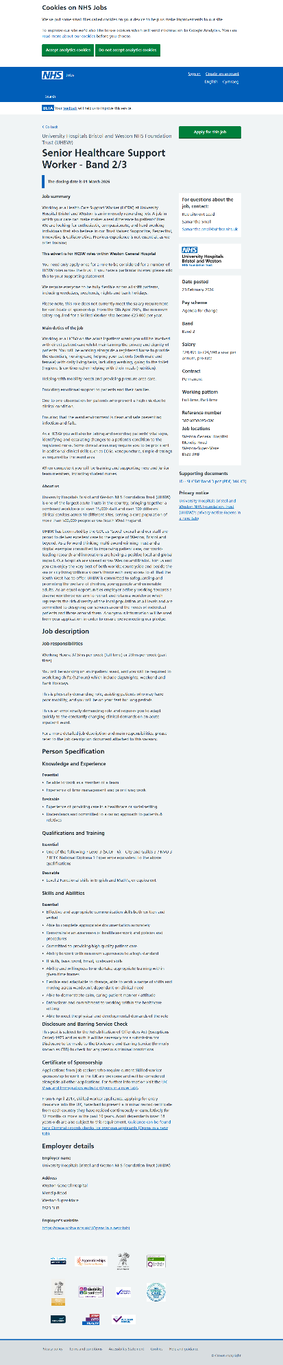
Appendix

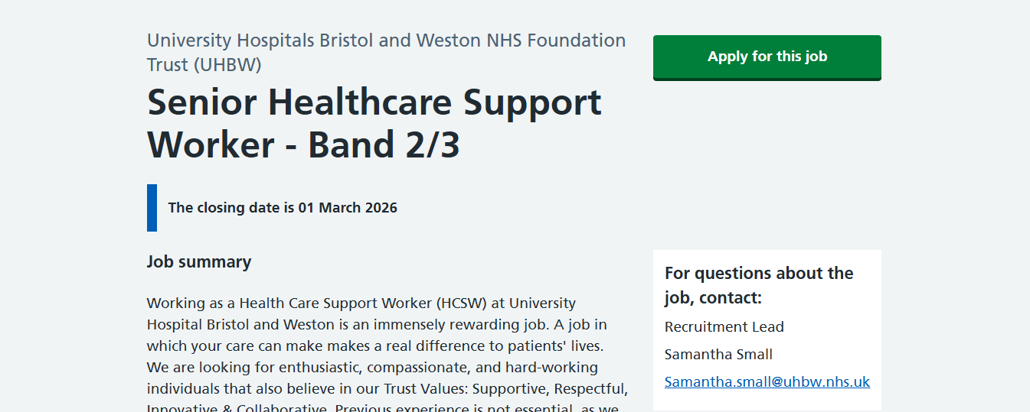
Source: NHS Jobs (2026)


