Knowledge and information management skill for the workplace
Title: analysis of knowledge management
Student name: Shariful Islam Shazal
Student ID: 1711804
Lecturer Name: MD Kalam

Table of Contents
Introduction 3
Concept and Importance of Knowledge Management in Tesco Plc 3
Relationship between Knowledge, Data and Information 4
Relationship of Individual Knowledge and Organisational Knowledge 5
Analysis and Modelling Technique to Identify Knowledge Assets 5
Evaluation of actual and potential knowledge assets 6
Capturing and managing knowledge 7
Important knowledge management processes required for organisational development of Tesco 7
Things required for create, store, apply and integrate knowledge in Tesco 8
Impact of intellectual property rights 9
Framework of establishing knowledge management culture in Tesco 10
Contribution of knowledge management in Tesco 10
Knowledge requirements for Tesco 11
Organisation’s framework for enabling knowledge sharing 11
Recommend improvements to the current framework 12
Conclusion 13
References 14

Introduction
Knowledge management can be defined as a systematic approach of managing organisation knowledge assets in order to create value and meet strategic and tactical requirements. The concept of knowledge management is consisted of the process, initiatives, systems and strategies that will enhance and sustain the storage sharing assessment, refinement and development of knowledge. The system of knowledge management is used in the organisation in order to clarify, disseminate, organise and reuse information and knowledge throughout the every departments of the company. Due to globalisation, the knowledge based economy is a growing in all over the world and knowledge is becoming asset which is in valuable to the companies. For the survival and sustainability of the organisation in the competitive global market, using knowledge has been crucial and effective (Gunjal, 2019). At the same time in order to develop proper decision making, organisational performance enhancement, problem solving and innovation, using knowledge management is required in every multinational organisations nowadays. In fact for the continuous development of the organisation in the competitive world and obtaining competitive advantage, the knowledge management is effective and at the same time it will help the organisation to become flexible for adopting new changes.
In this research the various aspects of knowledge management has been analysed in the context of the multinational organisation Tesco PLC. Tesco is a multinational retail chain dealing in groceries and general merchandise. In terms of revenue, it is the ninth largest retailer in the world. This research will focus on the different aspects of knowledge management that has been utilised in Tesco in order to increase their business performance.

Concept and Importance of Knowledge Management in Tesco Plc
Management of knowledge is one of the most important factors of ensuring business expansion in the global market. Tesco PLC has expanded its business to attain the position of the largest retail chain. It happened mostly due to the explicated concept of battling challenges to manage knowledge and information in an organisation. Tesco developed appropriate management information systems to identify and apply knowledge-transformation-information for a better team building and management of business. Knowledge assets are extremely important for an organisation and key knowledge management processes are widely needed for the development of an organisation. Tesco Plc has adapted to the importance of knowledge management within the organisation- consumer needs, consumer goods, product policies and manufacture are some of the most important information that needs to percolate into the organisation. The managers have taken it up on themselves to collect data, transform the information through analysis and collect an information to be finally communicated to the team and employees. Information has a tangible and an intangible value. The former is inclusive of cost gathering information and leads to an improved control of inventory, increased production, and it reduces the administrative cost. The latter affects the improvement of making decisions and leads to an enhanced customer service and a better image of the organisation. This has been encapsulated within the structure of the organisation. Tesco Plc has become the largest retail chain through improved knowledge management adding on to better consumer service (O’Connor and Kelly, 2017).

Relationship between Knowledge, Data and Information
The relationship between knowledge, data and information has been marked with a subtle and distinctive line. A person’s experience and the information that they possess is combined to form what is known as knowledge.
- Knowledge can be either explicit or tacit knowledge. The former is in a concrete form – stored within documents and diaries- revealing and encapsulating very intricate details. Perceptions, beliefs, intuition and experience characterises what is known as Tacit knowledge. The latter is held unconsciously and it is not very easy to describe or record.
- Data are raw facts – they are recorded from observation and it has to be very formally processed and be passed through a transformation process. Non-random facts, record, symbols, numbers, values in form of chart and statistics are what can be considered to be data. This data when processed to be meaningful is called information. The data generally goes through the process of a transformation which ultimately brims into information.
- To exemplify the same, the latest Tesco Plc sale could include how many frozen food packets have been sold in statistical terms- then the transformation process would include how many sales of frozen food sold last week- and eventually the information would record which is the best seller amidst frozen food items. Classification, rearranging, aggregating, calculating, selections are the types of processing information. The qualitative information that is gathered culminates into what we consider to be knowledge (North and Kumta, 2018).

Relationship of Individual Knowledge and Organisational Knowledge
A person’s knowledge is based on the qualitative properties of their experiences and understanding. Organisational knowledge is the transfer of this individual knowledge. It is a managerial duty to impart and spread organisational knowledge based on the information that they have gathered through qualitative and quantitative data. Information can be passed on through formal and informal communication- former is inclusive of conferences, seminars and the latter can be characterised by casual conversations in the office.
A manager has the duty to forecast, plan, organise, command, coordinate and control according to Henri Fayol and this is universally applicable in the academic and industrial sphere. Decisions transform individual knowledge into Organisational Knowledge. A knowledge worker and a knowledge engineers peeds up the collection of explicit and tacit knowledge which are eventually codified and shared across an organisation (Tesco Plc) optimising business strategies to improve performance of the employees and boost corporate competitive spirit:
- Socialisation in the form of communication
- Internalisation through online learning
- Externalisation through collaboration systems
- Combination through emails and meetings
These four processes ensure a relation between individual and organisational knowledge that is essential for organisational progress (Hislop et al., 2018)

Analysis and Modelling Technique to Identify Knowledge Assets
Identifying knowledge assets is one of the major roles to be played by managers who resort to a specific decision behaviour that identifies cognitive and social factors governing an organisation. The analysis of quantitative information by the analytical manager and reliance on experience by the Intuitive manager can enable identification of knowledge assets. Hard and soft data are collected and subjected to use in structured and unstructured decision making. The annual statistics of Tesco Plc serves as the data to be considered as knowledge assets (Dalkir, 2017).
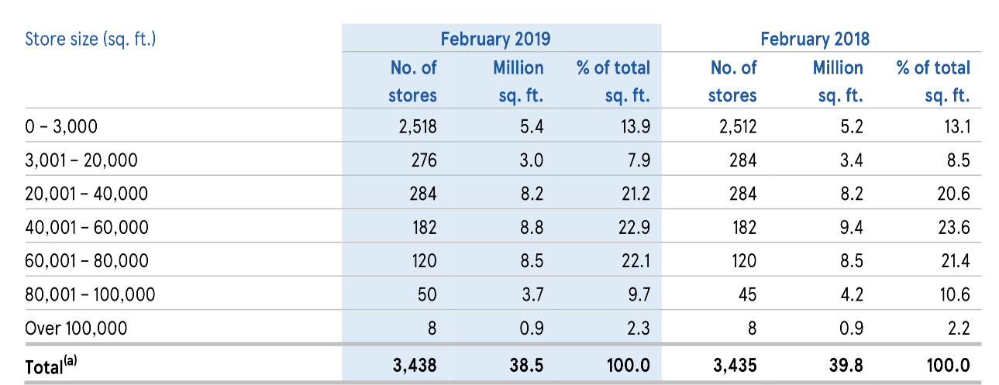
Figure 1: Tesco Revenue 2019
(Source: Wood et al., 2016)

Evaluation of actual and potential knowledge assets
In the present scenario of globalised market environment, the knowledge management is one of the most important components that helps in enhancing the competitive advantage. Tesco has a market share of almost 28 % in food retail industry of United Kingdom. The actual knowledge of Tesco is included in its management cultures and use of innovative technologies like inventory management and tracking of consumer requirement by analysing real time data of consumers. The actual knowledge assets of Tesco include the managers and leaders of the company who have strong resource management and allocation skills. The optimised resource management is done by the Tesco organisation that helps in reduction of the operational cost of the company by almost 1.5 billion Euros. Moreover, technical knowledge is present among the employees that are increased by formulation of capacity building programs in the company.
The potential asset can increase by almost 15 % is optimised through proper communication among the different level of staffs in the organisation (Guo, and Wang, 2019).The inventory management the consumer relationship management and data analytics to know exact consumer buying trends are potential knowledge of the future that can be acquired by the almost 70 % staffs of the company in an efficient way. The potential knowledge can be increased through proper knowledge management process that helps in increasing right decision making of the mangers by analysing complex business conditions. Moreover, the potential knowledge assets lie in the managerial decision making of the company that can be improved by developing the cognitive style of decision making.

Capturing and managing knowledge
Knowledge capture can be defined as a process by which the knowledge can be converted from tacit to explicit form through the processes related to internalization and externalization. The knowledge capture process can be developed in the outside range of organisational boundaries where the external stakeholders like consultants, customers, suppliers and competitors can be found (Oliva and Kotabe, 2019). In order to capture knowledge, things like documents, spreadsheets, presentations, software source, images, records, video and other files that has been used for learning and innovation, can be collected. In the framework of knowledge management process, knowledge capture is one of the important factors that would help to carry out the organisation and processing of knowledge development through obtaining knowledge from different sources.
In case of Tesco, the organisation capture knowledge from the different sources such as their software, website, social media channels and print media channels as well. The management of the captured knowledge is necessary so that the implementation of captured knowledge can be effective and efficiently used for enhancing the employee and organisational performance.

Important knowledge management processes required for organisational development of Tesco
According to the definition of management of Henri Foals he depicted that process as to forecast and analyse situation and plan accordingly by commanding and coordination with the staffs of the organisation. The knowledge management can be done in the same way that helps to enhance the efficiency of the business operations of Tesco plc in this global competitive environment(Wood, Wrigley, and Coe, 2017).The knowledge management process mainly includes the Tacit and explicit knowledge management process. The tacit knowledge management process is important as it helps to grow ability to adapt to situations which are ever changing. For example, Tesco Plc is changing its operational process to technology oriented so Tacit Knowledge management process is required. The tacit process helps in analysing situation and creating the knowledge from the situation and then collaborating with different expert through capacity building program is done to enhance knowledge base. There is another form of knowledge management known as the Explicit Knowledge management. This form of knowledge is documented from the raw data then it is applied in organisational context through the training and teaching process.
The feedback-oriented training is one of the most important knowledge management process in Tesco. In this process of Knowledge management, the Knowledge sharing that includes the managerial plans vision of the organisation and different business strategies and technical knowledge of management software’s are performed. There are several processes of knowledge decimation and knowledge management like socialisation, internalisation, externalisation and combinations (O’Connor, and Kelly, 2017). In case of the Tesco Plc it has been seen that combination process of knowledge management is the most efficient that includes knowledge transfer via meetings, emails, documentation and collaborative training and capacity building programs. The management positions in multinational corporate like Tesco is very much dynamic so the managers need knowledge of technicality, human resource management and information decimation to maintain business operations. So, the combined knowledge management system is very important for the organisation

Things required for create, store, apply and integrate knowledge in Tesco
In order to create knowledge in the organisation, proper data and information are required. In the organisational aspect, knowledge can be created through collaboration, practice, interaction and education as the different types and sources of knowledge are share and converted. Moreover the decision making practice and building blocks can be developed in the organisation through the exchange of relevant information and data (Abubakar et al. 2019). All of these practices can help the multinational organisations like Tesco to create knowledge. As for example the Organisational Management can collaborate with their team members are so that the exchange of different knowledge and skills regarding any specific area can be exchanged with the team members and any problem regarding that area can be reserved easily.
In order to capture or store knowledge in an organisation like Tesco where a number of employees from different culture and communities are employed, the strategies that can be used by the organisation are mentorship program, workplace collaboration, documentation, training, professional and social networks. Knowledge repository such as reports database and documents can be used in order to save the knowledge that has been acquired by the organisation for using in order to resolve any problem in future (Shujahat et al. 2019). Moreover, the specialised software tools have been used by Tesco in order to store the knowledge acquired from different sources.
In order to implement and integrate the company wide knowledge management system in the organisation, organisations like Tesco PLC use specific stages (Wu et al. 2019). Initially the various business issues regarding the business of Tesco need to be identified where the knowledge can be used for dissolving problems. The preparation for transition in the workplace needs to be developed so that the employees cannot be able to resist the changes. Therefore the change adaptation need to be dealt with understanding and patience and the employees need to be provided with proper training and induction session so that they can be aware regarding the implementation of knowledge management system (Dingsøyr, 2019). In the organisations like Tesco, implementation and integration of knowledge is necessary for team building and adopting the continuous change in the Global retail business environment. Therefore the organisation makes it sure that knowledge can be captured and implemented with the help of the proper teamwork so that the business transaction can be developed and business performance can be increased.

Impact of intellectual property rights
The intellectual property rights are very important aspects as it helps to preserve the traditional and unique knowledge of the company so that piracy of the management process can be avoided in an efficient way. It has been seen that intellectual property rights are very important and Tesco has a specified policy for the intellectual property rights. The intellectual property rights in Tesco include the ownership structure right and management of the ownership. This helps in developing a transparency in the legal process of ownership of shares in the Tesco group (Pila, and Torremans, 2019). The brand modification and the brand development are very important aspects those are included in the intellectual property rights. This has a high impact on the business process of the organisation. The promotional campaign and the brand logo those are used by Tesco are patented so that the brand image of the organisation cannot be stole and used by any other company This kind of Knowledge protection is very much important for strengthening the business. Moreover, it has been seen that intellectual property those are developed by employees in Tesco Plc are the property of the employers as well. There is contract made with employees under which the knowledge can be shared with inter departments but cannot be shared with other rival organisations.

Framework of establishing knowledge management culture in Tesco
The cognitive style of knowledge management is one of the most important style that helps the managers of the Tesco organisation to analyse the complex work environment from every perspective. However, it is considered that one of the best Framework to manage the knowledge base is the DIKW framework (Yusofet al.,2018). This consists of four steps and at the base of the framework there is data. There are hard data those are gathered while working and soft data those are gathered from secondary sources. After gathering of data, the cognitive functioning is done by the managers. After the analysis, the data is converted into information this can be accumulated to build the knowledge.
Subsequently after accumulating information the necessary information is stored and analysed to gain knowledge from it. For example, use of the software like inventory management and customer relationship management that enhances the sales of the organisation by almost 15 %. Building up knowledge and then implementing it in the real life helps the managers and employees to develop wisdom This wisdom is used to train the new employees of the company so that they can analyse critical situation and make suitable business decisions.

Contribution of knowledge management in Tesco
The knowledge management plays an important role in the development of the productivity and performance of Tesco PLC. One of the major contributions of knowledge management in the mentioned organisation is to provide the chances for the company to become one of the customer oriented organisations dealing in the Global retail sector. Another major and important contribution of knowledge management in the organisation is to develop the relationship of the customers and the organisation, so that the customer loyalty can be increased in future and better transactions and market share will be exchanged among the stakeholders (Milton and Lambe, 2019). Apart from that, the integration of customer relationship management system with the knowledge management can be seen in the bigger retail organisations like Tesco PLC where the information related to the consumer demand and preferences are integrated and used in innovative way so that the customers can be satisfied and retained for longer time. A proper Framework has been used by the organisation in order to manage the knowledge management, so that the captured knowledge from the different internal and external sources can be used properly for better Innovation and customer satisfaction in an efficient and effective way.

Knowledge requirements for Tesco
In order to deal in the retail sector, the organisations like Tesco need to have the proper knowledge of customer and market dynamics as well as their requirements. In order to communicate with the customers it is necessary for the employees to have solid interpersonal and communication skills, by which they can understand the requirements of the customers and mitigate them effectively and efficiently (Alani et al. 2019). The employees that are appointed in the managerial role for handling the management of Tesco PLC should have specific essential business skills that will help the organisation to understand and mitigate their customers demand and enhance the business performance. One of the major skills that should be there in the employees working in the finance department is to manage the finance related activities in the organisation. A number of accounts related activities can be developed in the organisation and managing them can be critical. However the organisation should hire the employees that have effective skills in managing accounts and Finance, so that any problems can not affect the business. Project management and planning should be developed in the organisation for managing the new product launches and customer demand mitigation in time. Moreover, networking, problem solving and communication, needs to be developed in the organisation so that the knowledge related to the customer handling can be understood by the employees (Dingsøyr, 2019). For better dealing with the customers, it is required to generate better communication skills, and therefore, the companies like Tesco PLC need to develop knowledge regarding the customer communication and proper leadership for motivating the employees for enhancing their business.

Organisation’s framework for enabling knowledge sharing
In order to deal with the knowledge sharing in the organisations like Tesco, it is required that the organisation should follow any specific model. In order to generate knowledge regarding their business, the management of Tesco is using the traditional Framework for knowledge sharing where the internal factors and external factors will be modified and used in the organisational culture. The external factors and informal knowledge of sharing opportunities will be developed in the organisational culture according to the nature and value of the knowledge (Oliva and Kotabe, 2019). In order to ensure the external and internal sources are used for knowledge, the organisation provides awards to the Employees that share knowledge with the team members and other stakeholders. Such actions motivate the employees to increase the teamwork facilities and knowledge sharing within the co-workers. Therefore the organisation can access better customer dealings and teamwork in the company resulting into better development of their business performance.
This value network used in the organisation helps the organisational culture to analyse the nature of share knowledge and examine the opportunities of sharing the knowledge that has been gathered from different internal and external sources. Therefore the organisation has already developed a specific organisational culture using better management facilities.
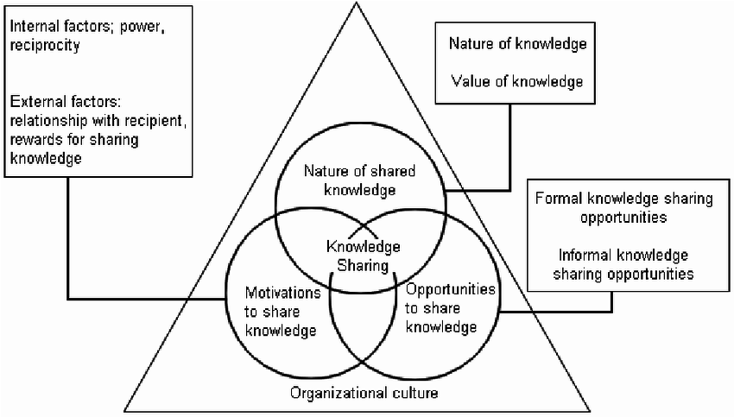
Figure 2: Organisation’s framework of knowledge
(Source: Oliva and Kotabe, 2019)

Recommend improvements to the current framework
In order to improve the current framework of the organisation it is recommended to use specific internal and external stakeholders, from where the required knowledge is collected. Moreover the organisation does not have any specific database that works centrally in order to store the collected data. Therefore, it can be recommended that the organisation should develop a centralised database for every country but they are dealing in the retail sector in order to store the knowledge for utilising it in future transaction with their potential customers.
Understanding the nature and value of the collected and captured data should be developed in a proper way in the organisation. It is recommended that the organisation should develop a proper way of analysing the nature of connected data so that they can be stored according to their nature and value (Milton and Lambe, 2019). The software can be used by the organisation for managing those data. Therefore, finding the data at the time of implementing can be easier for the employees and the knowledge management can be more relevant for the business purpose.

Conclusion
In order to conclude the study, it can be stated that using the proper knowledge management can help the organisations like Tesco PLC in order to manage their customer needs and preferences. The proper use of knowledge management can help the organisation to understand the preferences of the customers and therefore they can develop their strategies accordingly for enhancing the business. The proper relationship of explicit or tacit knowledge, need to be developed in the organisation so that they can use them for the benefit of their business. The organisation needs to consider the internal as well as the external sources of knowledge so that the decision making can be developed properly. In order to enhance the managerial decision making process for better management in Tesco PLC, the right knowledge needs to be captured and stored according to the managerial position holders in the company. Therefore it can be recommended that the organisation should develop a centralised database for their development of knowledge management.

References
Abubakar, A.M., Elrehail, H., Alatailat, M.A. and Elçi, A., 2019. Knowledge management, decision-making style and organizational performance. Journal of Innovation & Knowledge, 4(2), pp.104-114.
Alani, E., Kamarudin, S., Alrubaiee, L. and Tavakoli, R., 2019. A Model of the Relationship Between Strategic Orientation and Product Innovation Under the Mediating Effect of Customer Knowledge Management. Journal of International Studies, 12(3), pp.232-242.
Dalkir, K., 2017. Knowledge management in theory and practice. MIT press.
Dingsøyr, T., 2019. Knowledge management in medium-sized software consulting companies: An investigation of intranet-based knowledge management tools for knowledge cartography and knowledge repositories for learning software organisations. arXiv preprint arXiv:1903.11854.
Gunjal, B., 2019. Knowledge management: why do we need it for corporates. Malaysian Journal of Library & Information Science (ISSN: 1394-6234).
Guo, L. and Wang, Z., 2019. Ratio analysis of J Sainsbury plc financial performance between 2015 and 2018 in comparison with Tesco and Morrisons. American Journal of Industrial and Business Management, 9(2), pp.325-341.
Hislop, D., Bosua, R. and Helms, R., 2018. Knowledge management in organizations: A critical introduction. Oxford University Press.
Milton, N. and Lambe, P., 2019. The knowledge manager's handbook: a step-by-step guide to embedding effective knowledge management in your organization. Kogan Page Publishers.
North, K. and Kumta, G., 2018. Knowledge management: Value creation through organizational learning. Springer.
O’Connor, C. and Kelly, S., 2017. Facilitating knowledge management through filtered big data: SME competitiveness in an agri-food sector. Journal of Knowledge Management.
Oliva, F.L. and Kotabe, M., 2019. Barriers, practices, methods and knowledge management tools in startups. Journal of Knowledge management.
Pila, J. and Torremans, P., 2019. European intellectual property law. Oxford University Press, USA.
Shujahat, M., Sousa, M.J., Hussain, S., Nawaz, F., Wang, M. and Umer, M., 2019. Translating the impact of knowledge management processes into knowledge-based innovation: The neglected and mediating role of knowledge-worker productivity. Journal of Business Research, 94, pp.442-450.
Wood, S., Coe, N.M. and Wrigley, N., 2016. Multi-scalar localization and capability transference: exploring embeddedness in the Asian retail expansion of Tesco. Regional Studies, 50(3), pp.475-495.
Wood, S., Wrigley, N. and Coe, N.M., 2017. Capital discipline and financial market relations in retail globalization: insights from the case of Tesco plc. Journal of Economic Geography, 17(1), pp.31-57.
Wu, K.J., Gao, S., Xia, L., Tseng, M.L., Chiu, A.S. and Zhang, Z., 2019. Enhancing corporate knowledge management and sustainable development: An inter-dependent hierarchical structure under linguistic preferences. Resources, Conservation and Recycling, 146, pp.560-579.
Yusof, W.S.E.Y.W., Zakaria, O., Zainol, Z. and Ananthan, S., 2018. DIKW Application on Knowledge Based Framework with Situational Awareness. International Journal of Academic Research in Business and Social Sciences, 8(6), pp.1110-1120.

