

Software Development
  - ACCB4017

MIRELA-MIHAELA IVAN 1917504
06.05.2021
Lecturer: Renuga Jayakumar

Introduction

Python is an object-oriented, high-level programming dialect with complex semantics that's deciphered. Its high-level data structures, at the side energetic writing and energetic connecting, make it exceptionally engaging for Fast Application Improvement as well as utilize as a scripting or stick dialect to connect existing components together. [1]

A1.
- Variable are utilized to store information that can be referenced and controlled by a computer program. They moreover permit us to check information with expressive names, making our programs less demanding to get it for both the peruser and ourselves. Factors can be thought of as information-holding canisters. They exist exclusively to title and store information in memory.[1]
- In computer program programming, factors are names utilized to hold one or more values. Rather than rehashing these values in different places in your code, the variable holds the comes about of a calculation, database call, comes about of a database query, or other esteem. Rather than different calculations or the stack of different database calls to recover the same information, the variable is put away in computer memory once and utilized wherever it is required in your code.
- width = 10
- As with Lua, Python does not use a prefix like the $ in PHP or explicit line endings like C or PHP.
- Factors are utilized to store values in a program. These may be entire numbers (integrability), decimal numbers or letters. Some programming dialects demand on us announcing the sort of our variable forthright, so the program can distribute memory for it. Typically known as strongly-typed. In Python, be that as it may, this can be not required – in reality there's not a command for announcing a variable in Python. Instep, Python deduces the sort – but there are moreover ways that we are able offer assistance to indicate it.
- Integers - int
- Decimals – float
- Letters – string (str)

A2.

- So, to begin with and first, let us characterize them. An in case else statement may be a sort of check in your code. An in case else contention can be utilized to decide in case a number is equal to 10. In common dialect, it'll be something like this: in the event that this number breaks even with 10, do something; something else (else), do something else.
- An in the event that announcement can be supplemented by an discretionary else if...else explanation, permitting you to test a few conditions with a single if...else statement. There are many things to bear in intellect by utilizing if...else if...else statements: An on the off chance that can have a esteem of zero or one, and it must come after all other ifs. An in the event that will have one or more else uncertainties, which must come some time recently the else.
- The qualification between an On the off chance that articulation and an IF-Then articulation is that the last mentioned has an additional ELSE included to it. In case the articulation interior the test condition assesses to genuine, the In the event that explanation is executed; something else, the explanations interior the ELSE piece are executed. [2]

A3.
- Loops are a essential building square of numerous frameworks. In reality, all programs, but the foremost basic, are likely to have at slightest one circle. Loops can be exceptionally supportive and can spare you, the creator, a noteworthy sum of time.
- Loops are used to replicate the same or identical code a number of times. This number of times could be defined, or it could be determined by the fulfillment of a certain condition. In most programming languages, loops of various sorts are used, such as for loops, while loops, and do....while loops.
- Example:
Display value of i through looping.
for i in range (5):
print(“i”)
The i initiated to 0 and will continue the looping until i becomes 5. The loop will work and i will have the value between 0 and 4.
Output:
0
1
2
3
4

EXERCISES

Exercise 1

# check validation for float
def input1(a1):
while True:
try:
u1 = float(input(a1))
except ValueError:
print("Sorry! Please enter the valid input!")
continue
else:
return u1
# check validation for integer
def input2(a2):
while True:
try:
u2 = int(input(a2))
except ValueError:
print("Sorry! Please enter the valid input!")
continue
else:
return u2
# Validation for checking user input is string
while True:
make_car = input("Brand of Car:- ")
if make_car.isalpha():
break
print("Please enter alphabets only")
while True:
model_car = input("Model of Car:- ")
if model_car.isalpha():
break
print("Please enter alphabets only")
mil = input1("Please Enter Car Mileage:- ")
doors = input2("No. of doors in car:- ")
# Print the result
print("!!!!!!!!!!!!!!!!!!!!!!!!!!!!!!!!!!!!!!!!!!!!!!!")
print("Maker of Car:- ", make_car)
print("Model of a car:- ", model_car)
print("Car mileage:- ", mil)
print("Number of doors in car:- ", doors)

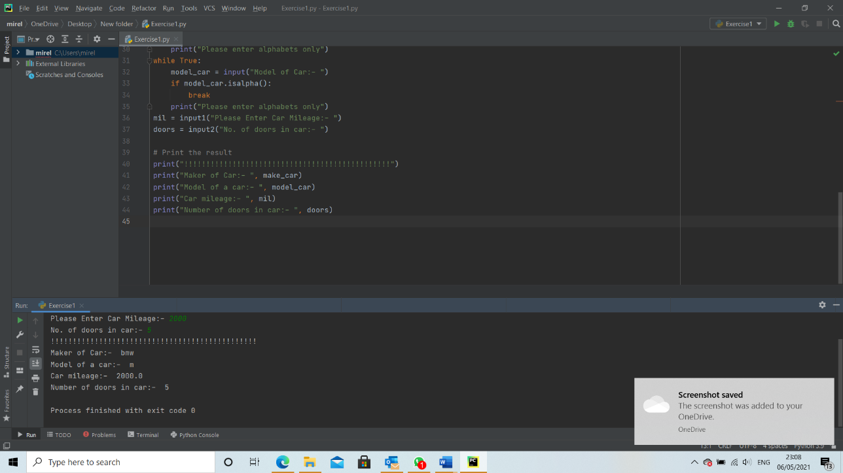
The answer is correct and the program runs in comformity.

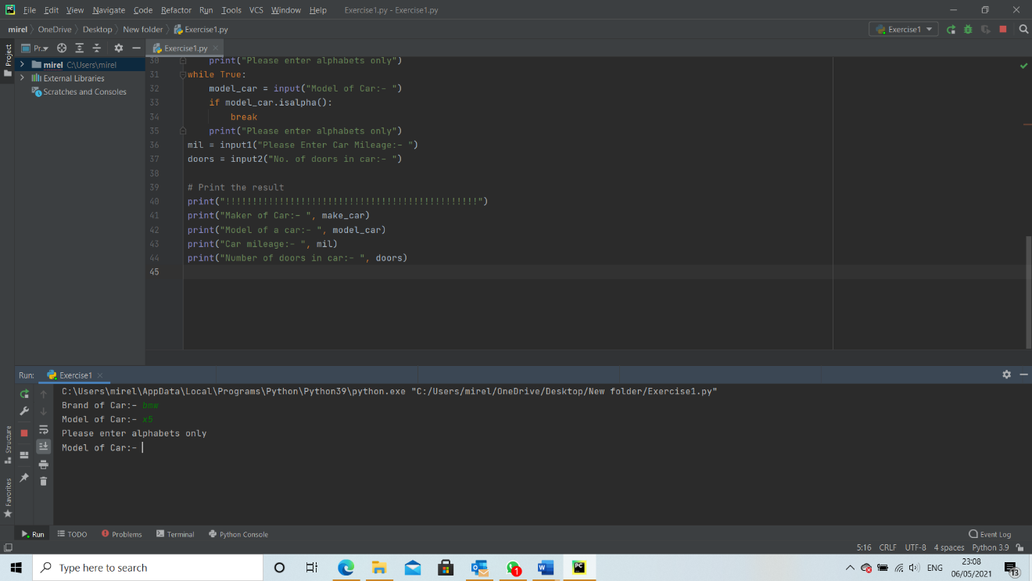
Here the answer is wrong

Exercise 2
#apply proper validation to checkk user input is integer
def user_input(v):
while True:
try:
input1 = int(input(v))
except ValueError:
print("Please Enter Again...It is not an integer!!!")
continue
else:
return input1
#user input
print("----Enter the length & width of vegetable bed----")
length1=user_input("Enter the length of bed:- ")
width1=user_input("Enter the width of bed:- ")
#Calculate the carrot grows
len1=(length1//8)
wid1=(width1//8)
x=min(len1,wid1)
print("Number of carrot grows in vegetable bed:- ",x**2)

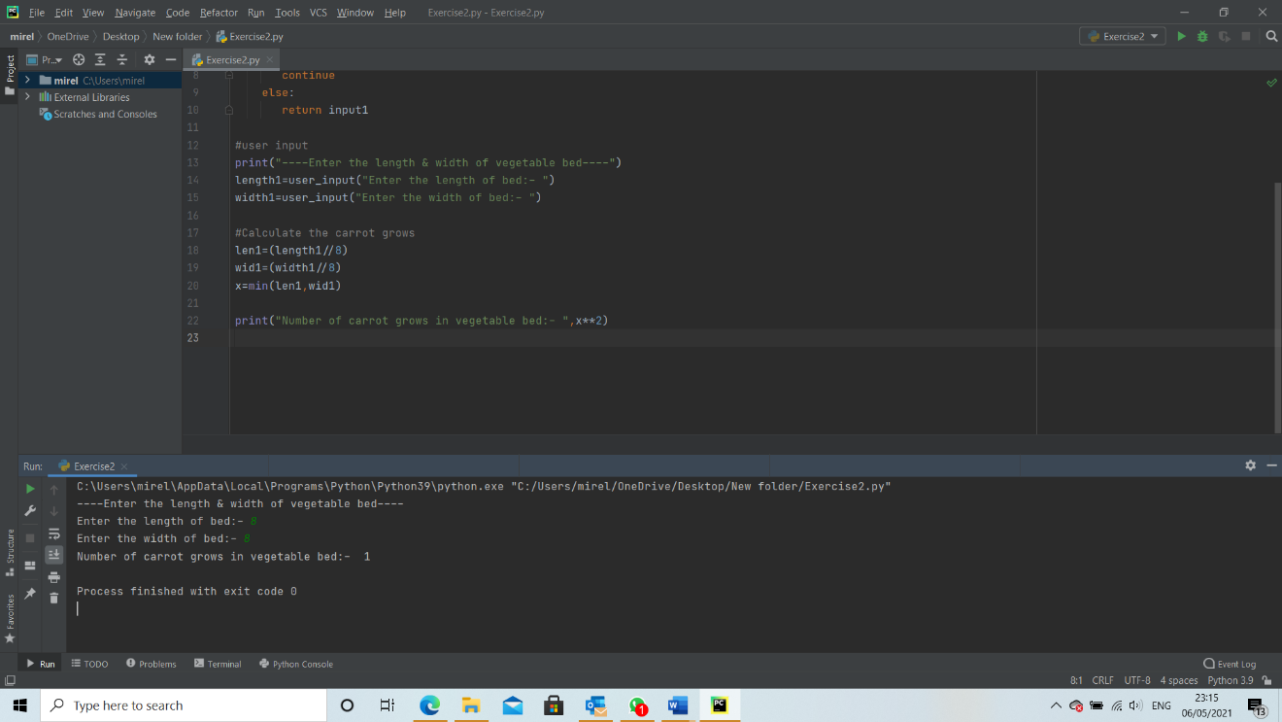
Here the answer is correct and the program runs as expected

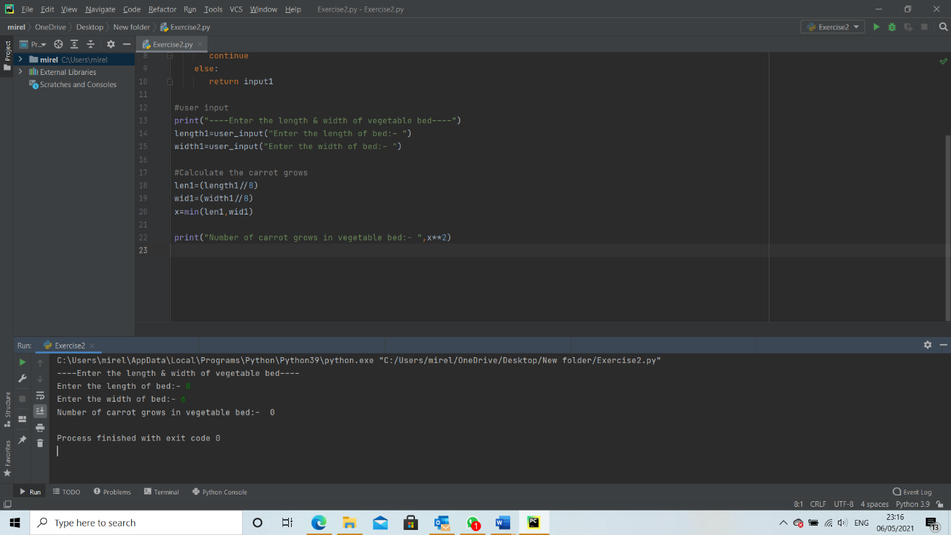

Exercise 3

#apply validation techniques
def chck_input(m):
while True:
try:
us_input = float(input(m))
except ValueError:
print("Please Enter a valid float number...!!!")
continue
else:
return us_input
break
#deine two empty list
list_pro=[]
list_pri=[]
#enter the user input of product and prices
for c in range(1,6):
while True:
print("Enter product",c,":")
prod = input(" ")
if prod.isalpha():
break
print("Sorry!!!...Please enter alphabets")
print("Enter price",c,":")
pri=chck_input(" ")
print("---------------------")
list_pro.append(prod)
list_pri.append(pri)
#calculate the total price
e=sum(list_pri)
print("Product Entered:-")
print()
for c in range(0,len(list_pro)):
print(list_pro[c]," ",list_pri[c])
print("Total Price is: ",e)
#calculate the total price with 15% discount
discount=t-((t*15)/100)
print("Total Price with staff discount:- ",discount)

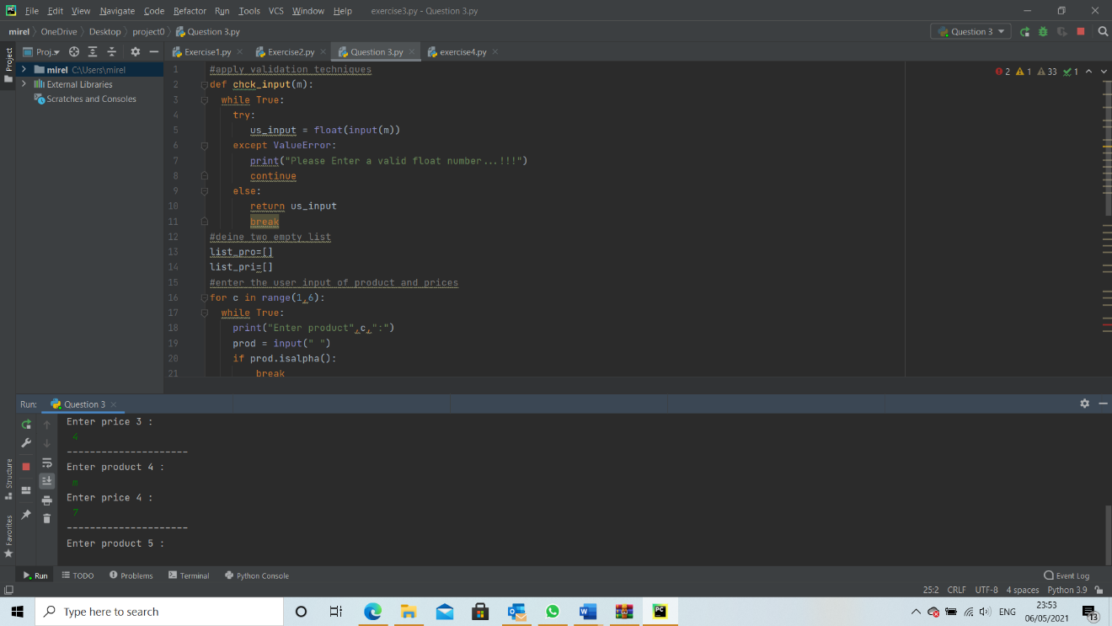

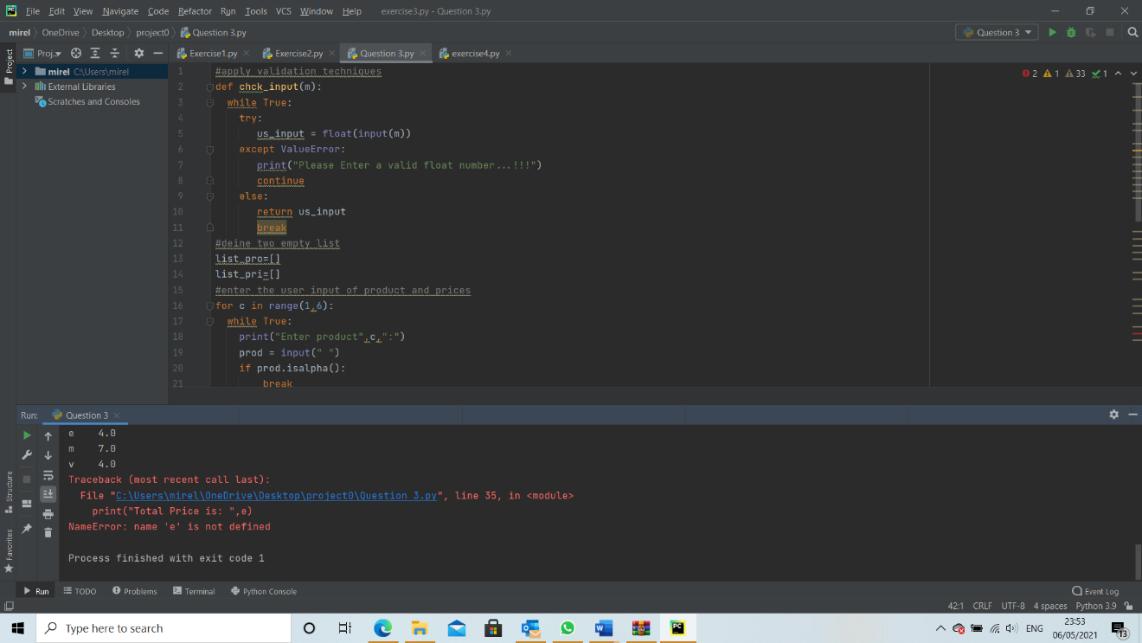

Exercise 4

list1=["0 ","0 ","0 ","0 ","X "]
s=0
while s!=1000:
m1=[]
r1=[]
print("Choose position: (0,15)")
input1: int =int(input())
#Take random library
import random
for i in range(0,4):
x1=random.choice(list1)
x2=random.choice(list1)
x3=random.choice(list1)
x4=random.choice(list1)
r1.append(x1)
r1.append(x2)
r1.append(x3)
r1.append(x4)
k1=[x1,x2,x3,x4]
m1.append(k1)
#check condition
if r1[input1]=="X ":
print("Win! Well done. You took ",s," turns")
break
else:
print("Miss! Unlucky")
print("".join(m1[0]))
print("".join(m1[1]))
print("".join(m1[2]))
print("".join(m1[3]))
s=s+1

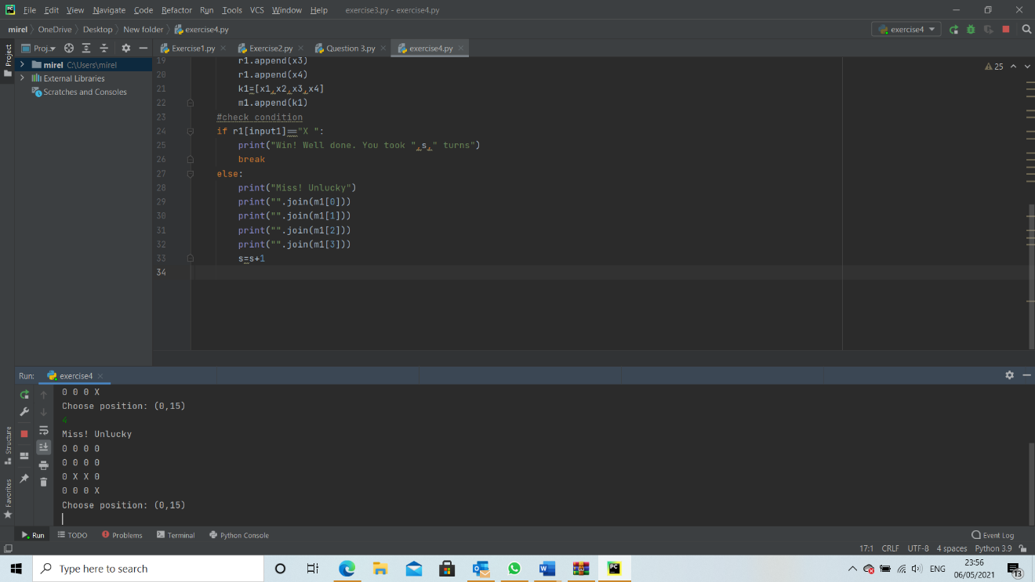

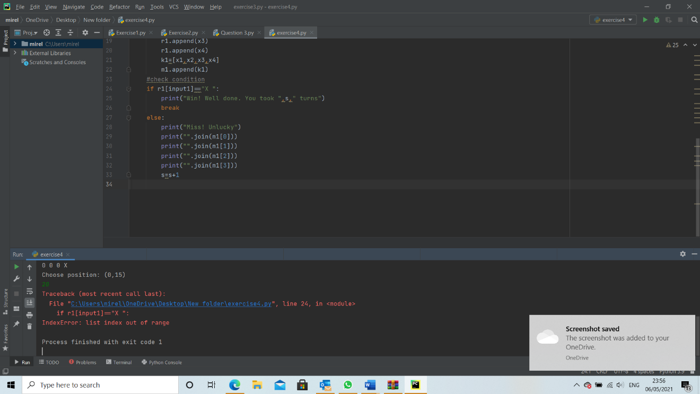

References

[1] | Python, "What is Python?," What is Python? Executive Summary, 2001-2021. [Online]. Available: https://www.python.org/doc/essays/blurb/. [Accessed 02 05 2021].
[2] | Tutorialspoint, "C - if...else statement," 2021. [Online]. Available: https://www.tutorialspoint.com/cprogramming/if_else_statement_in_c.htm. [Accessed 02 05 2021].
[3] | LaunchSchool, "What is a variable in computer programming," Variables, 2021. [Online]. Available: https://launchschool.com/books/ruby/read/variables. [Accessed 02 05 2021].

