Reflective Report



Academic and Employability skills
Janosne Barbara Horvath 2113586
Lecturers name: Sylvia Hoffmann
22.04.2022.

Table of Contents
1. Introduction
2. Gibbs Reflective Model
3. Kolb’s Experiential Learning Cycle
4. Time Management
5. Academic writing
6. Summarizing
7. Presentation and Public Speaking
8. Conclusion
9. References

Introduction
Academic and Employability skills. What defines employability skills? Employability skills make you employable. Employability relates to your knowledge, skills, and attitudes, how you use those assets, and how you present them to employers in today’s context (Kelley, 2021). Examples of employability skills are being a good team member, having effective communication and writing skills, being able to solve problems, being organized, positive, leadership, willing to learn, and having some IT skills.
In this essay, I will discuss time management, academic writing, and summarising. This essay will reflect my experience and my personal feelings about learning academic and employability skills. This essay will follow Gibb’s (1988) reflective cycle framework of reflection. I learned a lot about myself, and what my strengths and weaknesses are. I also learned how to manage my daily life as I am a working mother.
At the age of 46 years old, I always wanted to continue my education as I did not finish it when I was young. Ever since I became a grandmother, I have felt especially old continuing my education. On the first day of university, I looked around the classroom and seeing a lot of young students aged 18-25 made me feel quite stressed. When I met another woman in the class who was a similar age to me, I did not feel that lonely anymore. I doubted myself and questioned why I joined the university as I believed I would fail. The presentation given to us on induction was extremely inspiring. The speech he gave us and his discussion of other people at the university and how they became successful business owners after they finished the course were motivating. He encouraged me quite a lot and made me believe that if they can do it, I can do it too and not give up on myself. This module helped guide me on how to better myself in not only my academic aspects but personally as well.

Gibb’s Reflective Model
Gibbs Reflective Cycle was created (1988) to support experiential learning. The Reflective Cycle is based on six stages. Description, feeling, evaluation, analysis, conclusion, and action plan. The individual need to answer questions to go deeper into the experience and explain in detail with your reflection. The main idea is to systematise reflections and isolate feelings. (Brown .2022)
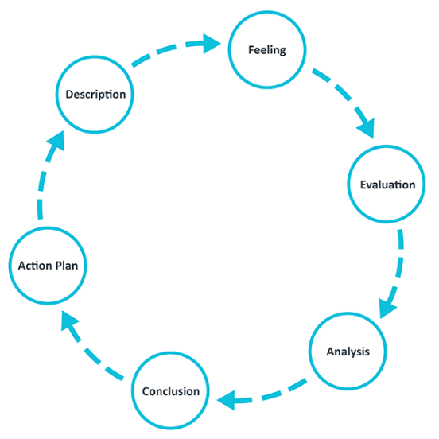
(Source: ed.ac.uk, 2022)
Description
In this section, we had to explain the situation in detail what happened, when, why, and who was involved. Description of the experience set the scene and gives context.
Feelings
In this section, we explain how we felt about the experience. Describe your emotional response to the situation you have experienced.
Evaluation
Describe the key elements, and what went well and what went not so well.
Analysis
Explain the experience, what was positive about it and what was negative. Analyse the experience of why things go well and why did not go well.

Conclusion
This section should explain what you have learned about the experience. How you will apply them in the future.
Action Plan
What actions do you have to take to build your knowledge or skills? What do you need to improve, and what you will do differently in the future?
Kolb’s Experiential Learning Cycle
Kolb’s Experiential Learning Cycle was published in (1984) this learning experience contains four stages: Concrete experience (feeling), Reflective Observation (watching), Abstract Conceptualization (thinking), and Active Experimentation (doing).

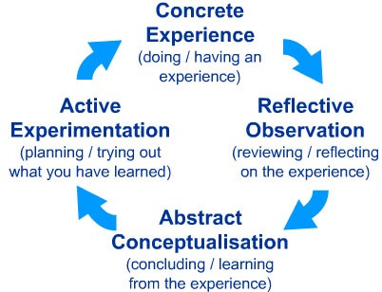(Source: Dsouza, J. 2016)

Kolb states that learning involves the acquisition of abstract concepts that can be applied flexibly in a range of situations. In Kolb’s theory, the impetus for the development of new concepts is provided by new experiences. In his own words, “Learning is the process whereby knowledge is created through the transformation of experience”. (Dsouza 2016)

TIME MANAGEMENT
Time management is learning about how to efficiently prioritize tasks in the time given. It’s important when you get a task to do set up a realistic deadline and stick to it (Kukreja, 2021). Good time management has helped me plan and be in charge of how much time I spend on specific activities, for example, working, learning and being a mother, I need to plan and prioritise my day. Completing more tasks in a shorter period lowers my stress levels and leads to success. I realised I need to take short breaks between self-study sessions to refresh my brain and body then I can focus more, and it will boost my performance and creativity. The three most interesting techniques I learned about in this module were The Eisenhower Method, The Pareto Principles and Eat That Frog. The Eisenhower Method describes splitting tasks into four subsections: what is important and urgent, what is urgent but not important, what is not urgent but important, and what is not urgent and not important. I found this method easy to understand and remember. I have implemented this theory into my learning, for example, the PowerPoint for this module was urgent and important but the reflective report was not urgent but important as one had a closer deadline. On the other hand, The Pareto Principles state that 80% of output is produced by 20% of input. This technique has helped me better understand how to manage a business. For example, I believe that simply being friendly with customers is the 20% input which will attract regular customers creating an 80% effect. This in turn would provide more business in a shop as customers are more likely to come back and purchase items if they feel welcomed by the staff. The Eat That Frog is the last method we learned about that describes putting an extremely important task as the first activity to do in the morning to not waste time. In my opinion, this method seems quite easy to do but I struggled with it quite a lot. Starting my university tasks first thing in the morning is my weakness as it makes me nervous. To work on this weakness, I have started breaking down tasks such as this reflective essay into sections, for example writing 100 words in 2 hours. Breaking down big tasks into small chunks helps me focus on what to do and exactly what is needed in each section. I have found this method of time management to be the most effective in my personal experience.

ACADEMIC WRITING
“The main idea behind academic writing is objective and practical in terms of presentation as it needs to be understood by thousands of readers and not just a single person” (Priya, 2021).
Before this course, I did not understand how to write academically. Learning how to structure and understand each component of an essay was quite a challenge for me as I had not done it previously. English is also not my first language and as I am not fluent, it can be difficult to understand. During the lesson on academic writing, I was quite confused as there was a lot to follow and remember. I evaluated my situation and made a list of the topics I did not understand. The topics that I did not understand at all, for example, the word order in a clause, were at the top of the list. As I found this the hardest to follow, I knew this was the most important topic to work on. To work on my knowledge, I researched how to structure a clause. I used all the resources provided on Moodle in my time. I revisited the PowerPoint slides on academic writing and made detailed notes. I particularly liked how the PowerPoint was structured as it was easier to understand when I was going through them. All the examples with the highlighted words in the sentence made it a lot easier as well as the definitions. I found that watching YouTube videos helped me remember information better as I am a visual learner. I also found it difficult how to learn how to make detailed notes as I had not been in education for a long time. University learning is a big contrast to high school learning as in university, it’s very independent and a lot more time-consuming as there is more research involved. My online learning experience has been very different to what I have experienced in terms of education. Before this course, I had only been taught face to face and never experienced being taught online. I have found it very useful in terms of not travelling to campus and having that extra time to revise and go over my lessons. However, it has created difficulties in terms of my ability to connect with my peers and my teachers and the classroom experience. In my personal experience, this module has been effective in terms of my learning experience.

SUMMARISING
Summarising is condensing key information from a text. Before this course, I did not know how to academically summarise information. I did not understand how to think critically whilst reading a piece of text at a higher education level. I have learned how to explain the main idea in a shortened form. I got a clear explanation and idea from my lecturer about how I can implement it in the future, and how I can use it in my future education and personal life, having these skills helped me with learning how to find the main points and key details, saving me time when I am taking notes from the session. Also, summarising helps me with communication to be more confident and clearer. Furthermore, I will remember better and learn more adequately when I use my own words. My knowledge of summarising has increased sufficiently since taking this module.

PRESENTATION AND PUBLIC SPEAKING
In my Week-9 presentation, I have reflected on my professional and academic skills that actively enhance my academic performance and achievements. On my presentation day, I was so anxious about how I am going to speak in front of people, and how I will deliver my presentation. Before this class, in my teenage years, I was in an acting club in theatre. We played a few costumes pieces and played in my home country in some neighbour villages. I enjoyed that time and was not uncomfortable speaking and playing in front of an audience. However, I loved that time of my life I look back on that time as a great memory. I am an adult now and maybe I have changed over the years, or my memories got faded when I had my first presentation after long years my voice and my hand were shaking. Overall, my presentation did not go well, it was not how I expected. I must work on it, practice in front of a mirror and on my pronunciation which has proven to be an effective way to better presentation skills (Cuncin. 2020). I think it was more difficult for me because English is not my first language, and with practice, I can be better next time and more confident. That assignment was particularly hard for me but in the end, I pushed myself into a scary experience and made mistakes which I learned from.

Conclusion
To conclude, throughout this module I learned how to research information, how to reference, how to think creatively and how to reflect and I also improved my writing skills, listening skills, language skills, and learning skills. Also, I need to practice my presentations in front of the mirror and record my speech so I can hear my pronunciation mistakes and can fix them. The most interesting topic in this module was time management. In this essay, I demonstrated what time management is and what the most popular methods of time management are. Although I found the Eat That Frog method difficult, it is the easiest and most simple way to describe time management. I think if the Eat That Frog method is done efficiently and correctly, it can be an extremely easy and quick way to reduce stress and anxiety about tasks. I personally found it amazingly effective when I did not do well on the task at hand and just did it. My future plan is to continue with my education at a higher level, improve my English by reading more, watching YouTube videos and practise writing, and improving my English by communicating more. This module has taught me how to search for resources and given many examples as to where the resources are. In the future, I am confident I can build a better career for myself. I can now see it is never too late to start education and change your life.

References
Cuncin, A (2022) How to Improve Your Public Speaking Skills Available at: https://www.verywellmind.com/public-speaking-skills-3024308 (Accessed:12.04.2022.)
Doyle, A. (2021) Important Public Speaking Skills for Workplace Success Available at: https://www.thebalancecareers.com/public-speaking-skills-with-examples-2059697 (Accessed:06.04.2022.)
Dr Brown, N (2022) Reflective Model according to Gibbs Available at: https://www.nicole-brown.co.uk/reflective-model-according-to-gibbs/ (Accessed: 04.04.2022)
Dsouza. (2016) David Kolb’s Cycle of Learning Available at: https://medium.com/@johnharrydsouza/david-kolb-s-cycle-of-learning-2777d150d09e (Accessed:06.04.2022.)
Kelley, K. (2021) Why are Employability Skills Important Available at: https://www.simplilearn.com/why-are-employability-skills-important-article (Accessed:18.04.2022.)
Kolb’s Four Stages of Learning Available at: https://citt.ufl.edu/resources/the-learning-process/types-of-learners/kolbs-four-stages-of-learning/ (Accessed: 05.04.2022)
Kukreja, K. (2021) 10 Practical Ways to Improve Time Management Available at: https://www.lifehack.org/articles/productivity/10-ways-improve-your-time-management-skills.html( Accessed:25.03.2022.)
Priya, K. (2021) What is Academic writing-Everything you need to know Available at: https://typeset.io/resources/what-is-academic-writing-everything-you-need-to-know/ (Accessed:03.04.2022.)
Reflection Toolkit Available at: https://www.ed.ac.uk/reflection/reflectors-toolkit/reflecting-on-experience/gibbs-reflective-cycle (Accessed:05.04.2022.)

Appendix

