MA RESEARCH METHODS
CAROLINE JAWAD 2018
LITERATURE REVIEW HANDBOOK

Literature review checklist

- Does your review show a clear understanding of the topic?

- Have all key/landmark studies been cited and most discussed?

- Is there a suitable structure and logical development to the review?

- Does the review state clear conclusions about previous research using appropriate evidence.

- Does the review show the variety of definitions and approaches to the topic area?

- Does the review reach sound recommendations using coherent argument that is based on evidence?

- Is the text written in a clear style, free of spelling and grammatical errors with complete references?

- Does the review show a gap in existing knowledge?

Anticipate reader’s questions, do not leave your work open to questions such as:

- “What is your point here?”
- “What makes you think so?”
- “What is your evidence?”
- “So what?”
A 5 step plan: To create a literature review for your topic, follow this 5 step plan:
Step 1 Define the problem. You need to firstly define the topic of your study and then consider the sub topics within it that you would like to explore. For instance, I might be interested in the impact that giving reward stickers has on children’s performance. I may then wish to look for literature on: rewards and how it links to performance; theories on how children are motivated; and look for definitions of performance and how it is measured. Thinking through these concepts will help you with the next stage
Step 2 Find the research and read critically. You are now ready to start the research. Using the definitions of the problem that you have identified, you could start your search by looking at the library catalogue using some of these key words. Once you have a number of articles, you need to be able to derive from them the information that you need for your literature review. Consider what their key findings are and whether the evidence it offers confirms your view or provides a counter argument. It’s important at this stage that you take clear and effective notes. Carefully note the reference and page numbers, as you will need to refer back to these later
Step 3 Organise and theme. A literature review is not simply a list of all the research you have found but is written in themes. Hopefully, you will have spotted a number of themes as you have been reading and taking notes from your research. These themes can provide headings within your review. In my original example I may for instance notice these emerging themes through my reading. You will need to be able to be selective here and discount some articles that don’t fit into your major themes.
Step 4 Structure. Now you have your main themes for your literature review you will need to decide on your structure. One way to approach this would be to start with the broader themes and move to those that overlap more closely with your study – hence providing evidence for the need for your research.
Step 5 Write up. As with all good writing you need a structure to your literature review. This will include an introduction, main body and conclusion.
Your introduction should explain the broad context of your research area, the main topics that you have chosen to investigate and an idea of how you have structured your review.
The main body: Following from point 4 this would be an analysis of the literature theme by theme showing how your research builds from what has come before. As mentioned, you might like to start on broader themes moving through to those most directly related to your study.
And finally, your conclusion should summarise the state of research in your field, identify any gaps in knowledge and show how your investigation is going to address these gaps.

Example introductions to a literature review

Literature Review Introduction Example 1

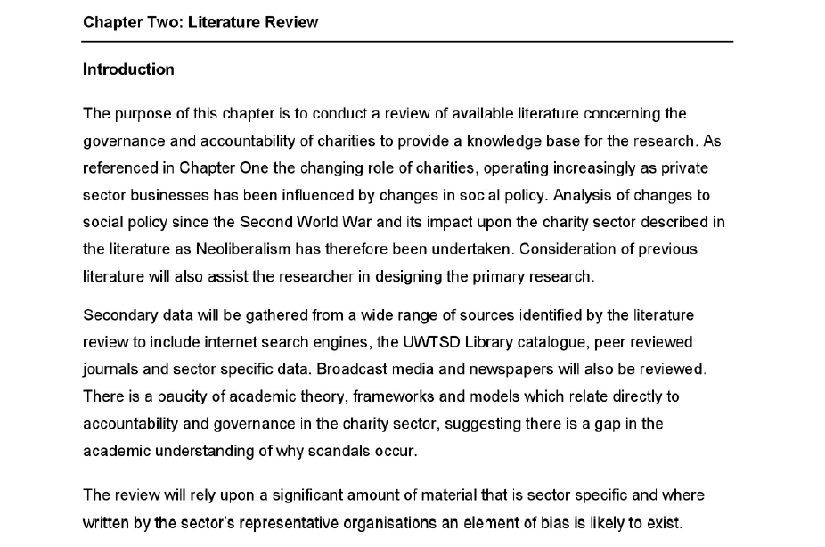

Introduction 2:

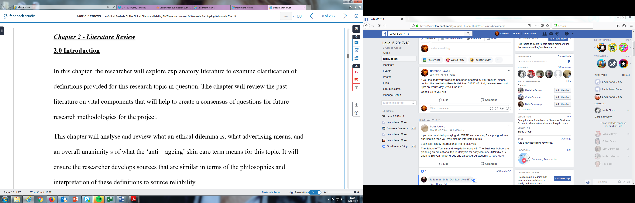

1. Read both introductions
2. In your groups discuss what you think about them. You may want to think about the following:
• Can you tell what the scope of the review will be?
• Can you tell what the structure will be- how the review is organised?
• Can you tell how this relates to the student’s research?
3. Come up with a list of things that you think should be in an introduction.

Literature Review Activity: Extracts from real literature reviews

- Underline: Where the student has commented on the literature they are reviewing (rather than just presenting what the literature has said)

- Circle- Where the writer has used language to avoid a ‘black and white’, right/wrong type of judgement

- Using the list on the Critical writing in a literature review slide decide how the writer has shown criticality by assigning a number 1-8 (can assign more than one number)

Extract 1: MSc dissertation ‘Informing study participants of results of randomised controlled trials: view of researchers and participants’.

Since even summary clinical trial results may have positive or negative implications for the participant, the distinction between providing and offering results is important. According to Cockayne (2005), the fact that not every participant wishes to receive study results emphasises the need for investigators to give patients the choice to ‘opt out’ of the process. Rigby and Fernandez (2005) analysed survey responses from 158 investigators attending an international haematology meeting and found that only 48 (30%) researchers had formal plans for returning results to participants. Of these, most (73%) planned to give participants the choice of receiving the results or not, but the remainder presumably intended disclosing the findings regardless of whether participants wanted them or not. The study by Rigby and Fernandez usefully includes a sample of opinion from researchers across the globe but is limited because it involves investigators of studies other than clinical trials (e.g. cohort, case control, observational, surveys and case reports). However, the authors found that investigators of clinical trials exhibited the highest support rate (73.5%) for the practice of offering study results compared with other investigators, which gives greater credibility to using the data in this context.

Example Literature Review 1

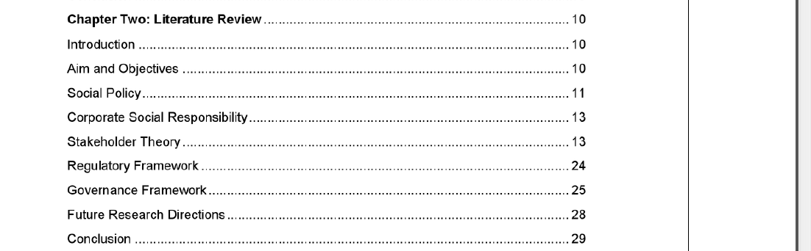

Example Literature Review 2




