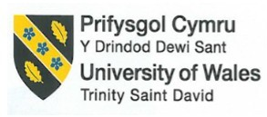

Assignment 1

Feasibility Plan for an International Meeting
Individual Presentation

THE CARDIFF
Winter Sports and Adventure Expo

- Student ID number: 2133909
- Student name: Roxana Ionica Macarie
- The module title: International Meetings Management for the Hotel Industry
- Module code: BMIH6007
- Module Lead: Kathryn Flynn

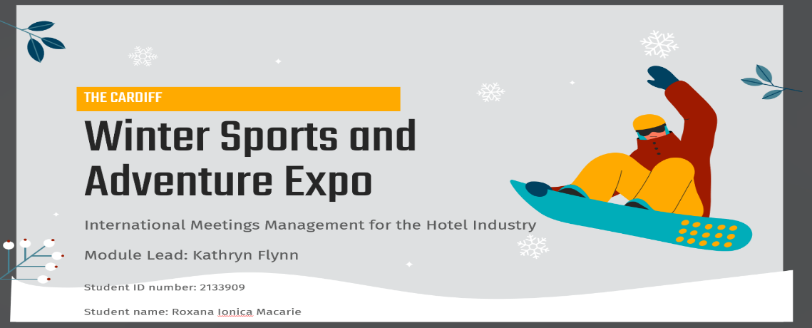
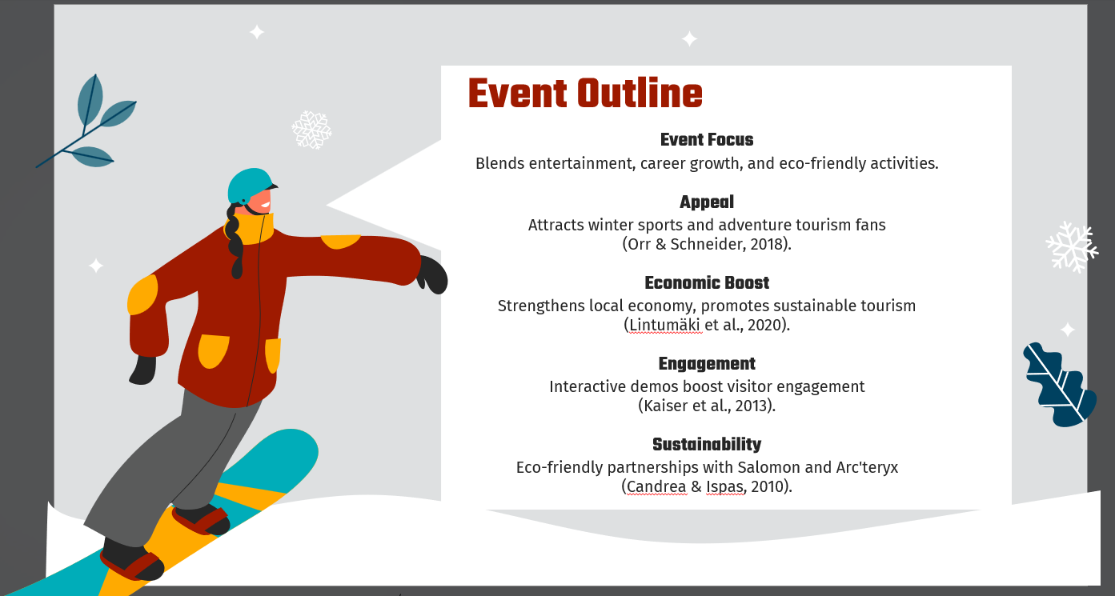

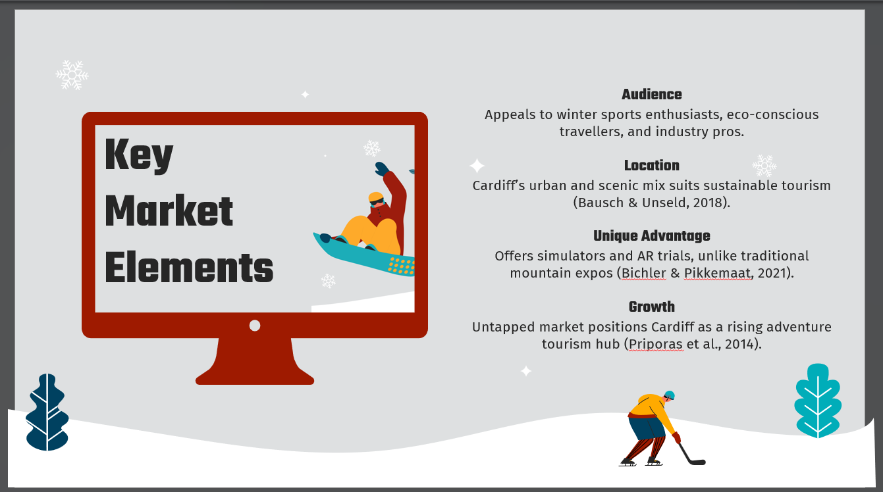

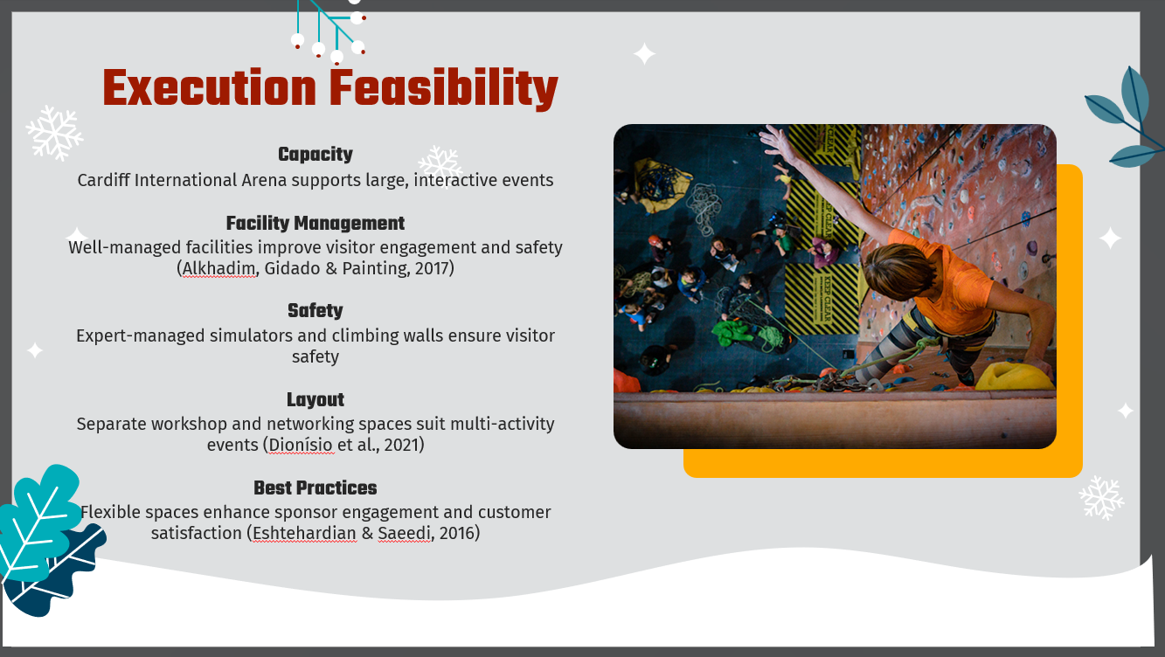

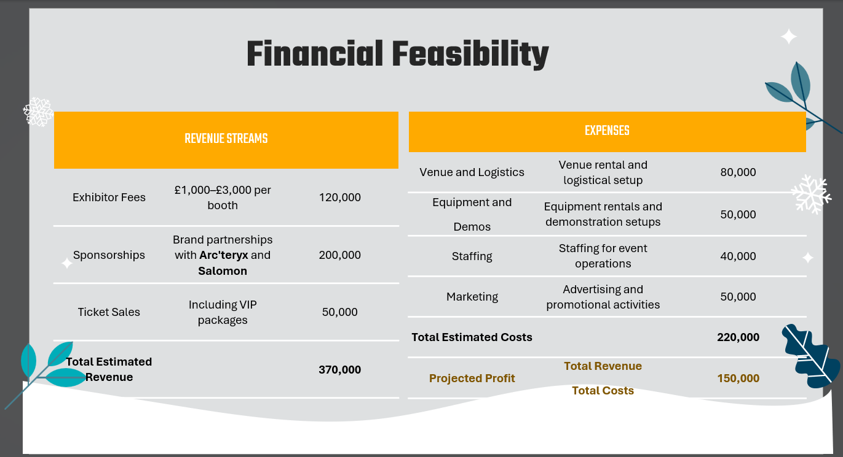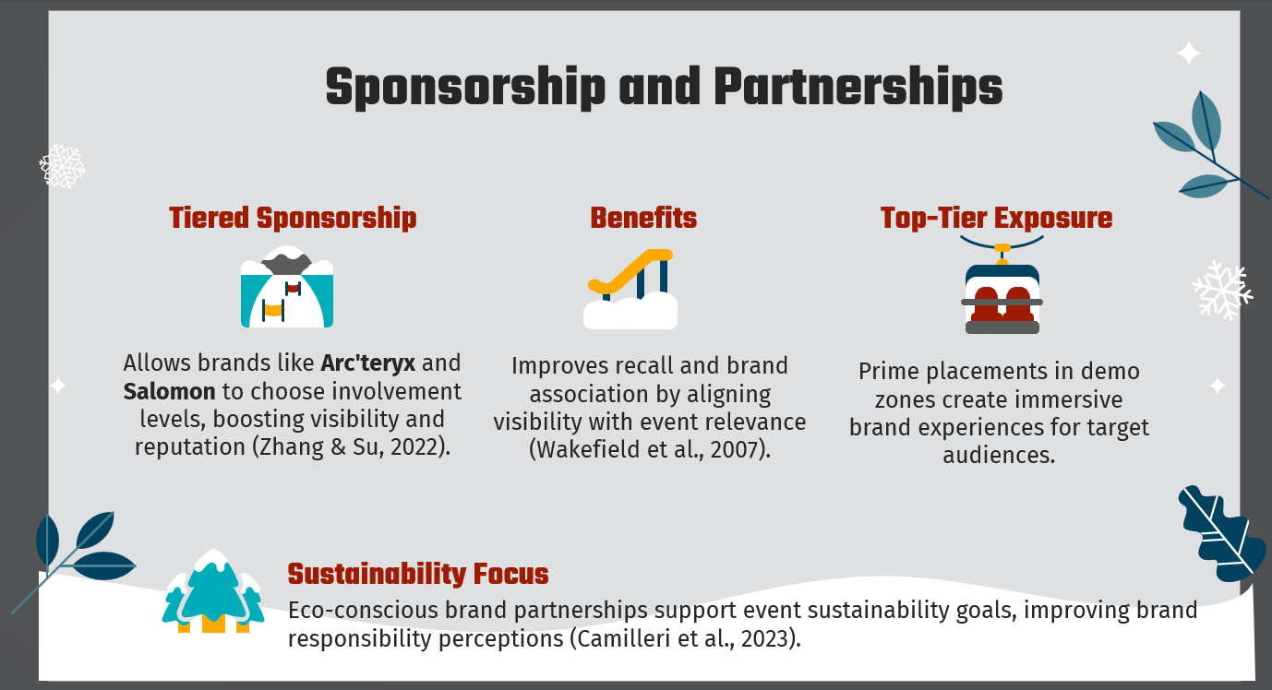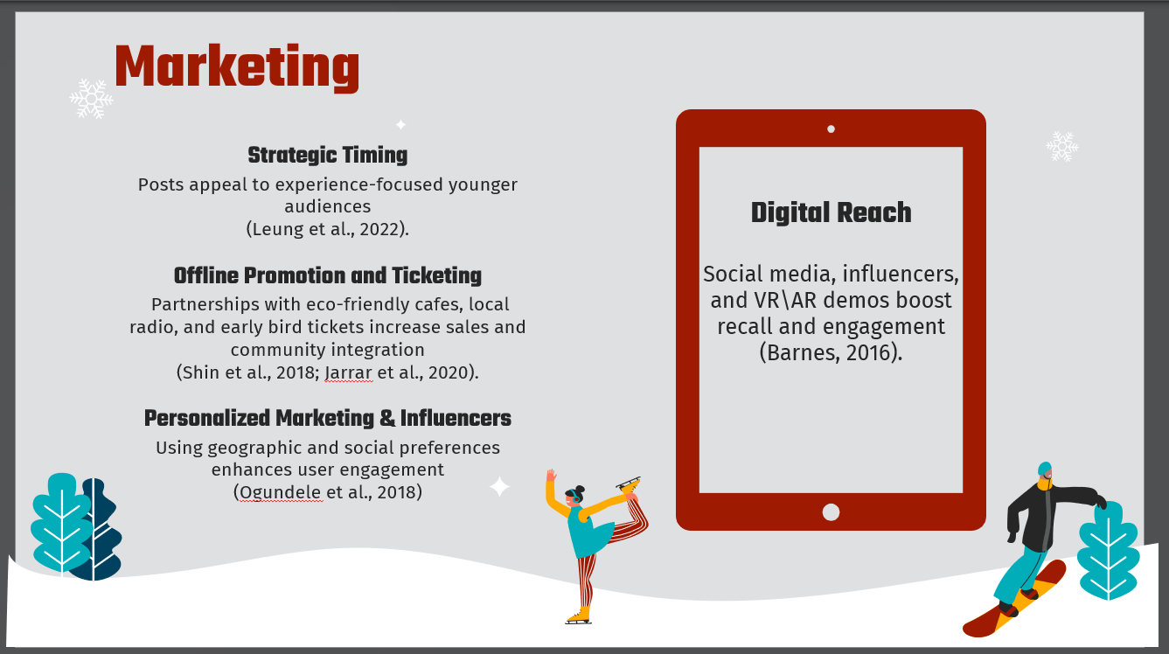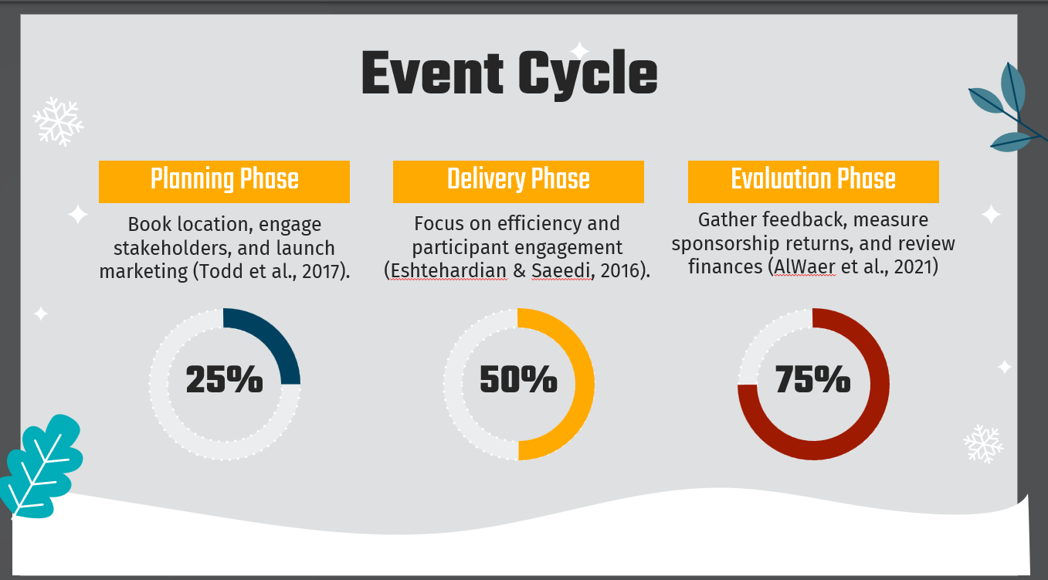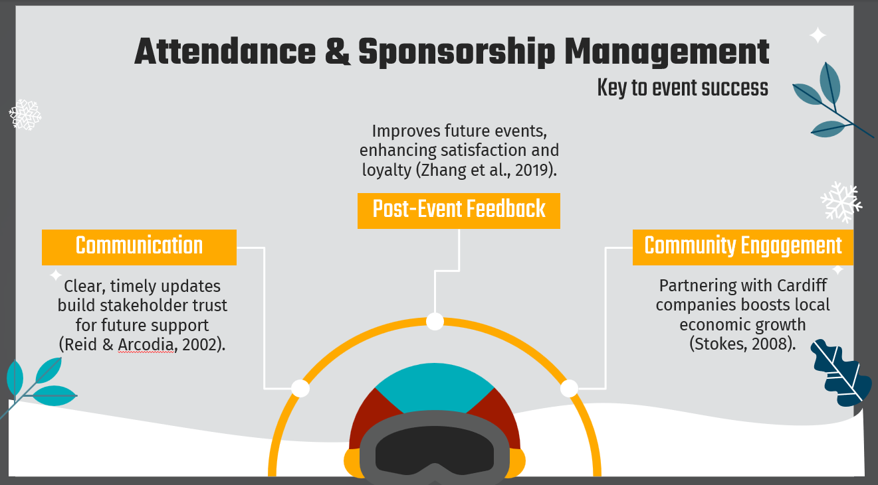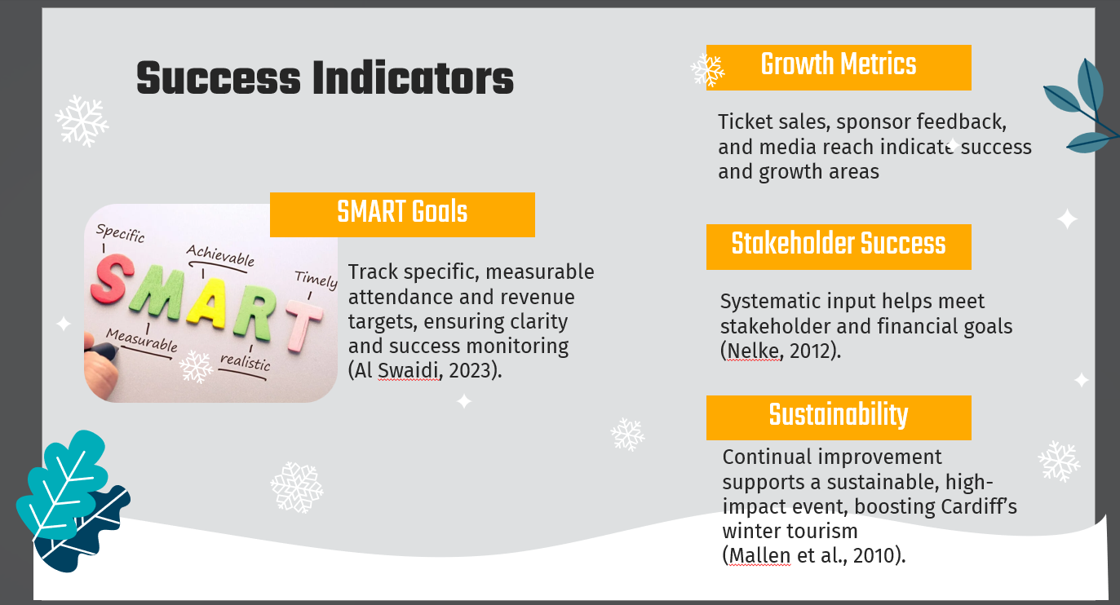

References
- Alkhadim, M., Gidado, K. & Painting, N., 2017. Confirmatory Factor Analysis of Perceived Risk Factors for Crowd Safety in Large Buildings. Springer, pp. 1-13. https://cris.brighton.ac.uk/ws/files/486746/Confirmatory%20factor%20analysis%20of%20perceived%20risk%20(Final).pdf
- AlWaer, H., Rintoul, S., & Cooper, I., 2021. An investigation into decision-making and delivery activities following design-led events in collaborative planning. https://www.researchgate.net/profile/Ian-Cooper-15/publication/354393069_Design-led_events_in_collaborative_planning_improving_post-event_planning_and_delivery/links/61a75f5385c5ea51abc2b127/Design-led-events-in-collaborative-planning-improving-post-event-planning-and-delivery.pdf
- Barnes, S., 2016. Understanding virtual reality in marketing: Nature, implications and potential. Implications and Potential (November 3, 2016).
- Bausch, T., & Unseld, C., 2018. Winter tourism in Germany is much more than skiing! Consumer motives and implications to Alpine destination marketing. Journal of Vacation Marketing, 24, pp. 203 - 217. https://doi.org/10.1177/1356766717691806.
- Bichler, B., & Pikkemaat, B., 2021. Winter sports tourism to urban destinations: Identifying potential and comparing motivational differences across skier groups. Journal of outdoor recreation and tourism, 36, pp. 100420. https://doi.org/10.1016/j.jort.2021.100420.
- Camilleri, M.A., Cricelli, L., Mauriello, R., & Strazzullo, S., 2023. Consumer perceptions of sustainable products: A systematic literature review. Sustainability, 15(11), 8923. https://www.mdpi.com/2071-1050/15/11/8923
- Candrea, A.N. and Ispas, A., 2010. Promoting tourist destinations through sport events. The case of Braşov. Revista de turism-studii si cercetari in turism, (10), pp.61-67. http://www.revistadeturism.ro/rdt/article/download/82/53
- Dionísio, P., Brochado, A., Leal, C., & Bouchet, A., 2021. Stakeholders’ Perspectives on Hosting Large-scale Sports Events. Event Management. https://doi.org/10.3727/152599521x16192004803548.
- Eshtehardian, E., & Saeedi, F., 2016. Developing Improvement Planning Phase in Project Management Maturity Models. Mathematical Models and Methods in Applied Sciences, 10, pp. 1. https://doi.org/10.5539/MAS.V10N9P1.
- Jaimangal-Jones, D., Fry, J.B., & Haven-Tang, C., 2018. Exploring industry priorities regarding customer satisfaction and implications for event evaluation. International Journal of Event and Festival Management, 9(1), pp.51-66 https://www.researchgate.net/publication/322979058_Exploring_industry_priorities_regarding_customer_satisfaction_and_implications_for_event_evaluation
- Jarrar, Y., Awobamise, A., & Aderibigbe, A. (2020). Effectiveness of Influencer Marketing vs Social Media Sponsored Advertising. , 25, 40-54. https://doi.org/10.5281/ZENODO.4280084.
- Kaiser, S., Alfs, C., Beech, J., & Kaspar, R., 2013. Challenges of tourism development in winter sports destinations and for post-event tourism marketing: the cases of the Ramsau Nordic Ski World Championships 1999 and the St Anton Alpine Ski World Championships 2001. Journal of Sport & Tourism, 18, pp. 33 - 48. https://doi.org/10.1080/14775085.2013.799335.
- Lintumäki, P., Winner, H., Scheiber, S., Mederle, A., & Schnitzer, M., 2020. The Economic Impact of Participant Sports Events: A Case Study for the Winter World Masters Games 2020 in Tyrol, Austria. Economies. https://doi.org/10.3390/economies8040094.
- Mainolfi, G., & Marino, V., 2020. Destination beliefs, event satisfaction and post-visit product receptivity in event marketing: Results from a tourism experience. Journal of Business Research, 116, pp.699-710. Available at: https://doi.org/10.1016/j.jbusres.2018.03.001.
- Mallen, C., Stevens, J., Adams, L. and McRoberts, S., 2010. The assessment of the environmental performance of an international multi-sport event. European Sport Management Quarterly, 10(1), pp.97-122. https://doi.org/10.1080/16184740903460488
- Nelke, M., 2012. Strategic goals, measurement and evaluation. , pp. 89-103. https://doi.org/10.1016/B978-1-84334-661-6.50006-1.
- Ogundele, T., Chow, C., & Zhang, J., 2018. SoCaST*: Personalized Event Recommendations for Event-Based Social Networks: A Multi-Criteria Decision Making Approach. IEEE Access, 6, pp. 27579-27592. https://doi.org/10.1109/ACCESS.2018.2832543.
- Orr, M., & Schneider, I., 2018. Substitution interests among active-sport tourists: the case of a cross-country ski event. Journal of Sport & Tourism, 22, pp. 315 - 332. https://doi.org/10.1080/14775085.2018.1545600.
- Priporas, C., Vassiliadis, C., Bellou, V., & Andronikidis, A., 2014. Exploring the Constraint Profile of Winter Sports Resort Tourist Segments. Journal of Travel Research, 54, pp. 659 - 671. https://doi.org/10.1177/0047287514528285.
- Reid, S., & Arcodia, C., 2002. Understanding the role of the stakeholder in event management. Journal of Sport & Tourism, 7, pp. 20 - 22. https://doi.org/10.1080/10295390208718726.
- Shin, H., Lee, H., and Perdue, R.R., 2018. The congruity effects of commercial brand sponsorship in a regional event. Tourism Management, 67, pp.168-179. Available at: https://doi.org/10.1016/j.tourman.2018.01.016
- Stokes, R., 2008. Tourism strategy making: Insights to the events tourism domain. Tourism Management, 29, pp. 252-262. https://doi.org/10.1016/J.TOURMAN.2007.03.014.
- Todd, L., Leask, A. and Ensor, J., 2017. Understanding primary stakeholders' multiple roles in hallmark event tourism management. Tourism management, 59, pp.494-509. https://doi.org/10.1016/j.tourman.2016.09.010
- Wakefield, K., Becker-Olsen, K., & Cornwell, T. (2007). I Spy a Sponsor: The Effects of Sponsorship Level, Prominence, Relatedness, and Cueing on Recall Accuracy. Journal of Advertising, 36, 61 - 74. https://doi.org/10.2753/JOA0091-3367360405.
- Zhang, J.C., Byon, K.K., Xu, K. and Huang, H., 2019. Event impacts associated with residents’ satisfaction and behavioral intentions: a pre-post study of the Nanjing Youth Olympic Games. https://www.researchgate.net/profile/Jingxian-Zhang-5/publication/340701920_Event_impacts_associated_with_residents'_satisfaction_and_behavioral_intentions_a_pre-post_study_of_the_Nanjing_Youth_Olympic_Games/links/5eac27e0a6fdcc70509e1ee4/Event-impacts-associated-with-residents-satisfaction-and-behavioral-intentions-a-pre-post-study-of-the-Nanjing-Youth-Olympic-Games.pdf

