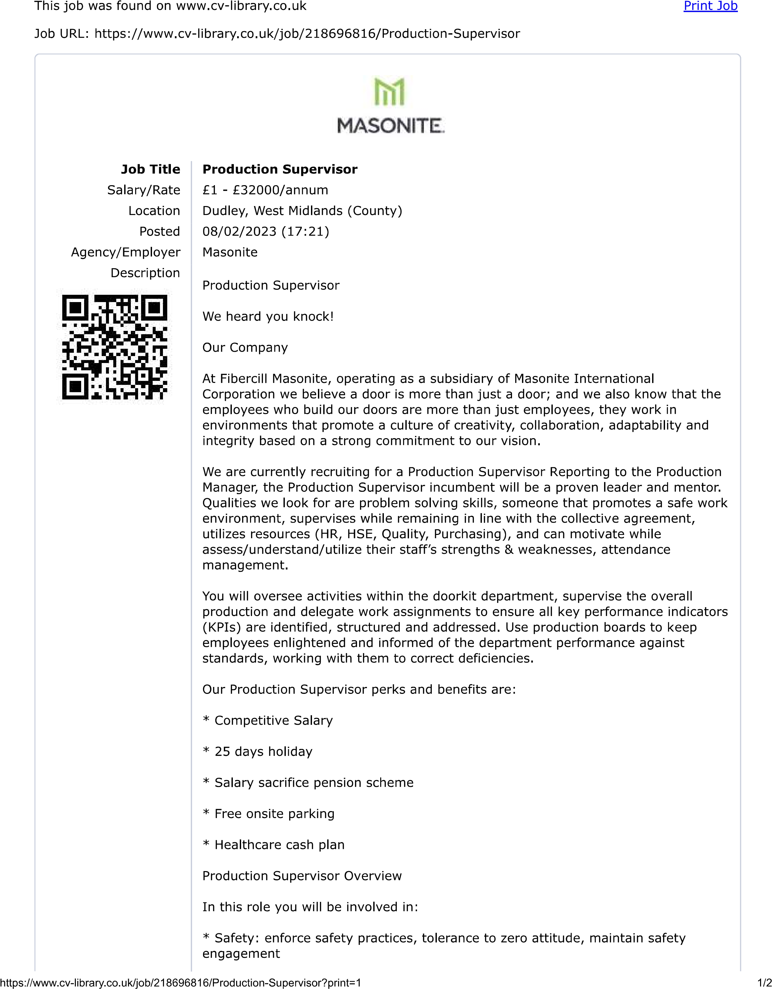
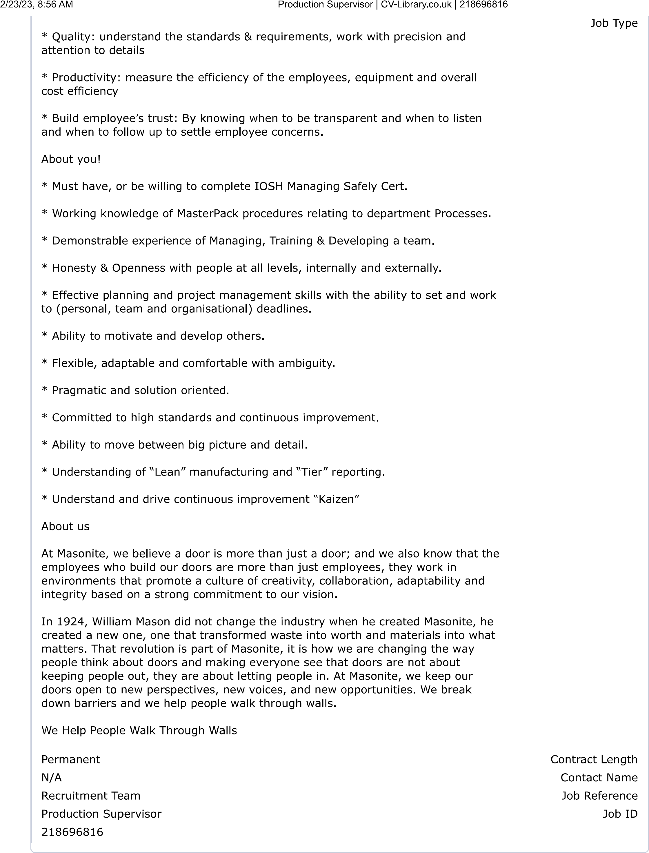

Dear Sir/Madam,

RE: Application for Production Supervisor 21869816.

Please find attached my CV in support of my application for the above position.

I am applying for this role because it is a job I can both excel in and perform to a very high standard. Having researched your organisation in detail, I have been attracted to your strong record of achievement and your company values.

In addition to being an exceptional communicator and collaborator, I am the type of person who understands how important my performance in this role will be to the success of your organisation.

If I am successful, I will constantly seek to add value in my work to help your company maintain its position as a market leader, and ensure you see a positive return from your investment.

I am available for an interview at short notice and can be contacted via any of the details below.
Thank you for considering my application.

Yours Faithfully,
Gabriel-Ciprian Vilcu
07492 247 274
vilcu.gabriel.ciprian@gmail.com

CURRICULUM VITAE

Gabriel Ciprian Vilcu
61 Birch Crescent Tipton B69 1UF
Email: vilcu.gabriel.ciprian@gmail.com Mobile: +447492247274
LinkedIn: linkedin.com/in/vilcu-gabriel-b8754a267

Professional Profile
An experienced and highly positive motivated Production Supervisor with a successful background in the achievement of demanding targets and corporate objectives, with a wealth of transferable skills, including outstanding interpersonal and staff management abilities. A capable organiser, quick to grasp and make good use of new ideas and information, reliable and conscientious in all he takes on. Enjoys being part of successful and productive team, thrives in highly pressurised and challenging working environments.

Career Objective
To enhance new and challenging position, one that will make best use of current skills and experience and enable further personal and development towards the role of Production Supervisor.

Career Summary

November 2020-December 2022

Production/Despatch Supervisor Ricor Ltd
- Leading a team of 25-30 members of staff daily, ensuring their continuous success and progress, making sure daily tasks are completed effectively and on time.
- Ensuring performance targets are achieved in production quality, cost and efficiency whilst striving for continued improvement in these areas (current OEE target of 92.5%)
- Responsibility for the accurate reporting of all performance data, including labour utilisation, quantities of goods and scrapped, downtime and process waste (components, parts), and related reporting.
- Management of training to ensure complete flexibility for job rotation within your area.
- Conducting return to work Interviews, Disciplinary and Investigation Hearings for both absence and conduct related issues.
- Support performance appraisals to encourage staff learning.
November 2017-October 2020 Sertec Springs & WireForms

Production Supervisor
- Leading a team of 27 members of staff to succeed.
- Achieving production requirements as determined by the daily production plan, ensuring machine utilisation, efficiency and quality standards are met and maintained constantly.
- Continuous improvement using Lean Manufacturing and 5’S procedures.
- To ensure that all production information MUST BE input and recorded on the MAPS system.
- Investigate any performance or H&S issues arising within the bay.
- Prioritise workloads ensuring the customer demands are met.
- Monitoring and ensuring daily targets are achieved.
September 2016-November 2017 Sertec Aluminium Structures

Production Supervisor
- Leading the team 15 members of staff to succeed.
- Achieving production requirements as determined by the daily production plan, ensuring machine utilisation, efficiency and quality standards are met and maintained constantly.
- Continuous improvement using Lean Manufacturing and 5’S procedures.
- To ensure that all production information MUST BE input and recorded on the MAPS system.
- Investigate any performance or H&S issues arising within the bay.
- Prioritise workloads ensuring customer demands are met.
- Monitoring and ensuring daily targets are achieved.
May 2015 – September 2016 Sertec Aluminium Structures

Cell Buddy (Line Feeder)/Trainer/Former Operator
- Duties include booking operators onto and off jobs on MAPS system, ordering parts, replenishing parts for robot operators, and training new operators.

2012 – 2015 Irem Servicii (Calais France)

Industrial Mechanic
- Roles involved working closely with other professionals and subcontractors, worked to strict health and safety guidelines in a potentially high dangerous environment, used hand and power tools, worked well as part of a team.

2008 – 2012 Autonet Import (Bucharest Romania)

Team Leader
- Leading a team to pick parts for our customers to meet tight deadlines. Monitoring team’s efficiency hourly to ensure all daily picks are achieved, working closely alongside my manager to make sure correct pick lists are given out. Using Microsoft XL daily to import all data from customer pick lists. Making sure the whole team follows the company’s strict health and safety policy.

2002 – 2008 Elit Spare Car Parts (Bucharest Romania)

Team Leader
- Looking after a team of around 12 people to ensure all daily targets and pick list were achieved while working in a safe and secure manner. Making sure all operatives followed all instructions and procedures to complete all tasks and targets before the deadline.

2000 - 2002 Delta Romania (Bucharest Romania)

Industrial Mechanic
- Working as part of a small team to repair fridge freezers. We had to follow strict health and safety guild lines and wear the correct PPE.

Education

2022 – 2023 Certificate of Higher Education, Skills for Workplace (Birmingham UK)

Skills
- Good Leader, Production Experience, Good written and oral communication skills, Problem-solving abilities, Ability to work and make decisions under pressure, Time management skills, Ability to work as part of a team, Counterbalance license, VNA license, Driving license.

References
- Available upon request.

