
Student Name: Dumitru Breazu
Student Id: 2613974

Assessment 1 – Reading Task Template
PART 1: Upload your photo of your A3 in-class notes here:
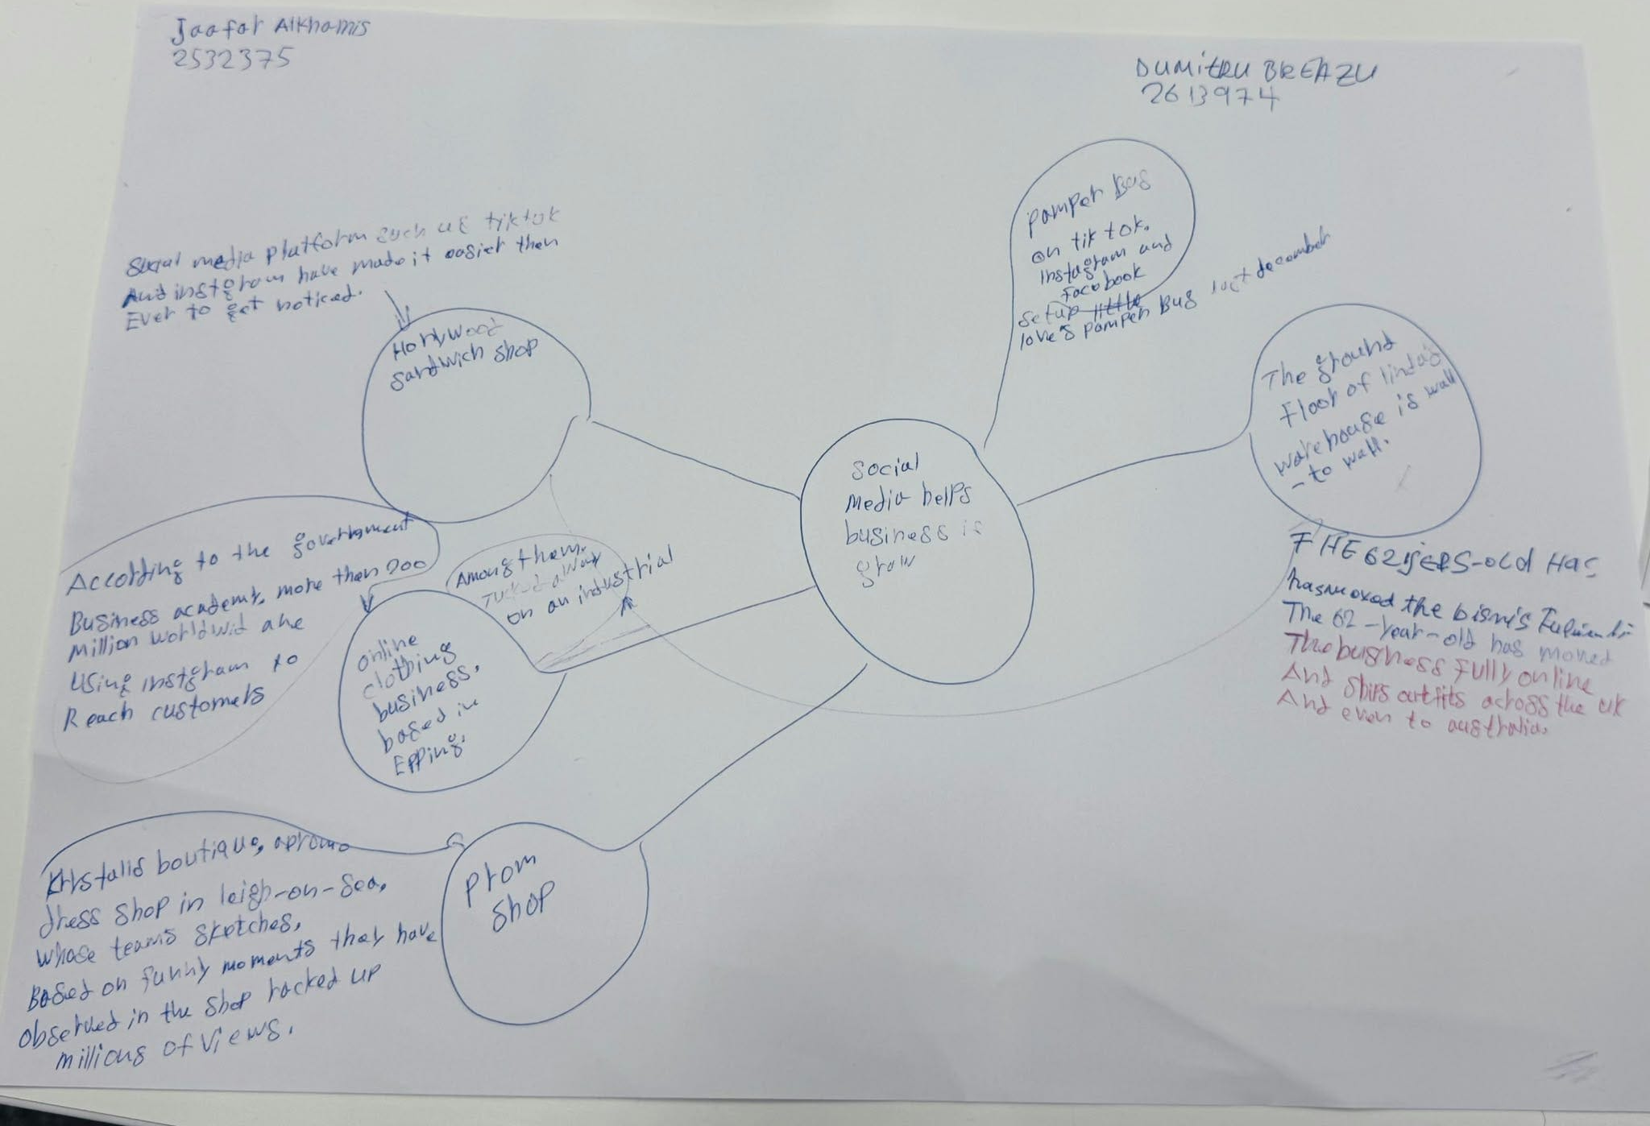

- What is the main idea of the whole text?

The point is that, with the help of social media, small businesses will be able to turn online attention into customer visits, sales and improved recognition. The article highlights how social media helps traders expand beyond local markets. For example, it shows food, clothing, and mobile beauty businesses using TikTok, Instagram, and Facebook to reach wider customers. It also highlights the importance of customer referrals and content that customers can relate to.

- What is one key point that supports the main idea, and which specific example from the text shows this?
These are as follows: Customer-generated content may help in bringing new customers to a business. Customers drove miles to try the chicken burger from Honywood Sandwich Shop after seeing it in customer videos. This example demonstrates that online recommendations are able to impact the purchasing process and attract customers into a physical store (Deady, 2025).

- What is a different key point that supports the main idea, and which specific example from the text shows this?
Another serious aspect is that social media can assist an already established business in adjusting its selling approach and target customers at the global level. With 46 years of experience of selling clothes in the markets, Linda Hunter transformed the Boutique of Lindy Loo to a full online store (Deady, 2025). Her company has already begun to ship clothing to the United Kingdom and even to Australia, and that is why online marketing can be established to promote the further development of new markets that were previously not operated in.

- Which part of the text do you think is most important, and why?
I guess that the final part about relatable marketing is the most important because it explains why the businesses in the examples are successful. Faye Martin believes that individuals are attracted to real-life characters and humorous information, and that is why the humorous sketches of Krystal's boutique are so popular. This section links personal stories and shows how businesses can increase demand by presenting content viewers like.

Reflection:
- What did you find difficult in this task (including in-class components), and why was it difficult?
It was challenging to me to separate the general message and supporting details in the organisation of my notes. There are companies that proved to be so profitable, and therefore I got lost in an illustration and an idea. Another challenge was the inability to choose short pieces of information, as I had to demonstrate the relationship between ideas without copying whole parts of the paper.

- What helped you with this difficulty, and how did it help you?
The example of the business of each section and re-reading each of them and asking what they illustrated assisted me in naming the supporting points. These relationships were further brought to the fore by keeping the mind map on one broad concept and using the branches individually to explain some of the key points and examples. The fact that I was also comparing my notes and questions at the moment contributed to the fact that I was able to minimize repetition and choose the information that is related to each reply.

Reference
Deady, E. (2025) ‘If you post it, they will come: The businesses turning likes into livelihoods’, BBC News, 19 October. Available at: https://www.bbc.com/news/articles/cm2701py5npo

