5/20/2023
Entrepreneurial Innovation (Assignment 2)
[Company name] | [Company address]
Portfolio
Robert Yeo (2000752)
Contents
Business Model Canvas 2
Business Model Canvas Link: 2
Business Model Canvas Citations 2
Business Model Canvas Screenshot 3
PowerPoint Citations 4
Cost Structure Calculations 4
References 5

Business Model Canvas

Business Model Canvas Link:
https://next.canvanizer.com/canvas/rsGd6ny3EE2M5

Business Model Canvas Citations
Revenue Streams:
- (Scrap Local Ltd, 2023)
- (A1 Group, 2020)
- (Zest Recycle Ltd, 2023)
- (Shinsuke Murakami, 2006)
Value Propositions:
- (Samsung, 2023)
Key Activities:
- (Harvard Business School Publishing, 2021)
Customer segments:
- (Joseph D. Blackburn, 2022)
Key Partners:
- (GOV.UK, 2023)

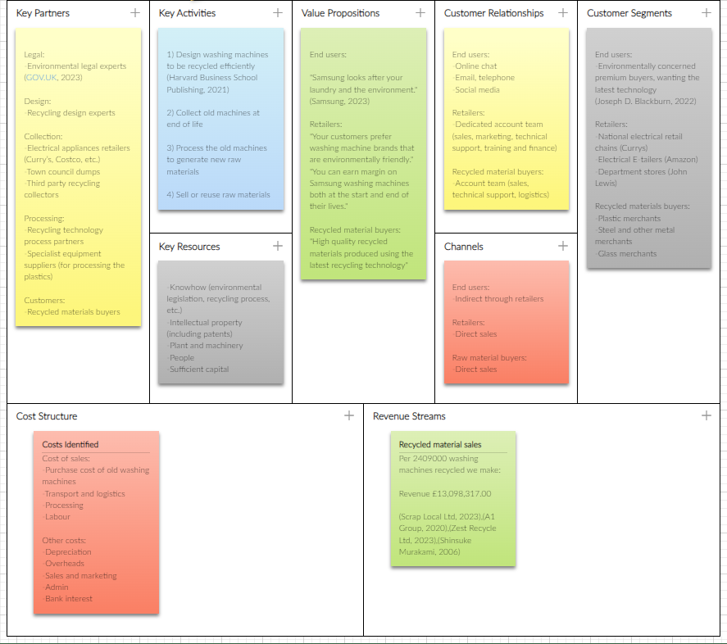
Business Model Canvas Screenshot

PowerPoint Citations
- (European Parliament, 2023)
- (Forbes Media LLC, 2023)
- (Samsung, 2023)
- (Celsa Group, 2020)

Cost Structure Calculations
Material recovered | Tons | Current price/ton | Revenue
Steel | 25061 | £ 160.00 | £ 4,009,760
Copper | 1203 | £ 639.00 | £ 768,717
Mixed metals | 12330 | £ 165.00 | £ 2,034,450
Plastic | 11027 | £ 570.00 | £ 6,285,390
TOTAL |  |  | £ 13,098,317.00

References
A1 Group, 2020. Metal Prices. [Online]
Available at: https://www.a1groupuk.com/waste-management/commercial-services/metal-recycling/metal-prices
[Accessed 20 05 2023].
Celsa Group, 2020. Recycling. [Online]
Available at: https://www.celsagroup.com/en/services/recycling/#:~:text=CELSA%20Group%E2%84%A2%2C%20with%20eight,ferrous%20scrap%20recycler%20in%20Europe.
[Accessed 23 05 2023].
European Parliament, 2023. Circular economy: definition, importance and benefits. [Online]
Available at: https://www.europarl.europa.eu/news/en/headlines/economy/20151201STO05603/circular-economy-definition-importance-and-benefits
[Accessed 22 05 2023].
Forbes Media LLC, 2023. Samsung. [Online]
Available at: https://www.forbes.com/companies/samsung-electronics/?sh=3d2fcc402450
[Accessed 22 05 2023].
GOV.UK, 2023. Electrical waste: retailer and distributor responsibilities. [Online]
Available at: https://www.gov.uk/electricalwaste-producer-supplier-responsibilities
[Accessed 22 05 2023].
Harvard Business School Publishing, 2021. The Circular Business Model. [Online]
Available at: https://hbr.org/2021/07/the-circular-business-model
[Accessed 22 05 2023].
Joseph D. Blackburn, E. A., 2022. Consumer acceptance of circular business models and potential effects on economic performance: The case of washing machines. The Official Journal of the International Society for Industrial Ecology (ISIE), 26(2), pp. 509-521.
Samsung, 2023. Always here to help. [Online]
Available at: https://semiconductor.samsung.com/support/quality-support/customer-service/#:~:text=For%20customer%20satisfaction%2C%20Samsung%20regards,and%20Problem%20and%20Requirement%20Management.
[Accessed 22 05 2023].
Samsung, 2023. Our mission & values. [Online]
Available at: https://www.samsung.com/global/sustainability/planet/circular-economy/
[Accessed 20 05 2023].
Scrap Local Ltd, 2023. Scrap Metal Prices 2023. [Online]
Available at: https://scraplocal.co.uk/scrap-metal-prices
[Accessed 20 05 2023].
Shinsuke Murakami, A. T. N. A. Y. M. H. M., 2006. Material flows of end-of-life home appliances in Japan (Table 2 &7). [Online]
Available at: file:///C:/Users/student/Downloads/Material_flows_of_end-of-life_home_appliances_in_J.pdf
[Accessed 20 05 2023].
Zest Recycle Ltd, 2023. Prices. [Online]
Available at: https://www.zestrecycle.co.uk/prices/
[Accessed 20 05 2023].

