Managing People
Assessment 2

Student: Dimitar Gadov
Student Number: 1913486
Tutor’s Name: Charles Oham
Module: Managing People
Module Number: LCBB5004
2021

Employees are one of the most important assets, which a company may have. The rivalry for the most talented and skilful workers is even more violent than those for the clients. Also the potential to create a strong and stable relationship between the manager and the staff could determine everlasting prosperity and competitive advantage of the organization. Building a sociable and self-progressing environment, increasing employees value and engagement. Employee engagement definition is based on Kahn’s theory of personal engagement and indicating connection to the conceptual perspective. Practically, it could be implemented in different aspects in variety of broad companies. It conducts to growth of the firm’s assets and finances, ingeniousness, adjustability and active learning behaviour. The modern trend is companies to create their HR planning around that concept. (Motyka, 2018)
On the given task we should state a report and ideas that combine effective employee engagement, increasing levels of job satisfaction, relevant activities during the pandemic of Covid-19 and HR strategies for bettering the overall performance the company.
An analysis, by the CIPD, has indicated the correlation between administration of people, workers’ frame of mind and business achievements. Furthermore, staff who is engaged, has bettering their results, beside their colleagues who are not entered into it. Unfortunately, a late research is showing that disengaged workers in UK are significantly more than engaged ones. (Kular & et, 2008)
The working environment is closely related to the people’s personal approach and their engagement to the company. New evaluations state that they should looking for more meaning in their daily working tasks than in personal lives. For that reason, employers have to done the worthwhile and positive working atmosphere in order to satisfy their staff. Moreover, the individual approach, together with emotional welfare should be the key factors of directing how engaged the workers are. Psychological elements are connected to the personal fulfilment, motivation and assurance which they get from the job efforts and being a part of a company’s community. Relations outside the organization, as personal problems or family stress, have given their impact also. However, eventual problems may come from workspace, such as: difficulties with colleagues, social distancing during the Covid-19, organizational issues interfere with communication, lack of diversity. Engaged workers are observed to be notably more positive and are finding meaningfulness in their work live, than other employees, who are not willingly involved. Also other difference is that actively engaged staff are declaring that welfare and healthy environment at the work. (Kular & et, 2008)
Engagement is remarkable foreseer of organizational objectives as: effectiveness, fulfilment, prosperity and customers’ and employees’ retention. For example, Kahn formed a concept of engagement where “in engagement, people employ and express themselves physically, cognitively, and emotionally during role performances”. Relate to those concept, people who are involved, work more passionately and fund themselves extra to develop their expertise and competency. His conceptual is nor permanent state, but it might change in a period of time. That’s why the efforts of the management should not be one time only, but continuously constructive. (Borah & Barua, 2018)
Conceptual scheme of factors, who are related to the employee engagement is looking like this:

Outcomes:
Organizational citizenship behaviour, Intention to quit,
Organizational commitment
Source: A Conceptual Model of Factors Affecting Employee Engagement and Its Outcomes, p.7, (Borah & Barua, 2018)

This framework involves three major elements as drivers of the engagement: personal, job-related and organizational factors. The first feature covers psychological factors, who are personally related to the inner mind of the employee. They are mentality, self-effectiveness and character. Work factors are these who existing in the job itself. They are: work-determination, feedback, availability of sources, role accuracy, implementation of new technologies, a chance for improving. Finally, the organizational elements include management justice and support, authoritative administration, service climate. The results of employee engagement could be citizenship behaviour, organizational dedication and intention to quit. (Borah & Barua, 2018)
In every firm organizational success depends of clear and fare employee engagement and high-level of job satisfaction. In HR sector, the function of the job fulfilment is of significant importance for motivating the staff. However, a lot of firms still are not paying enough attention to that factor. That leads to leaking of talented and competent workers from these firms to another one, which have clear and strong HR policies. When an organization has a positive relationship with the staff, it has notable stabilization of the critical issues: employee retention, prevention of employee turnover, value inclusion, community communication, job welfare. At last, all this leads to remarkable productive connection between employee engagement and job happiness and accomplishment. (Tepayakul & Rinthaisong, 2018)
This could be defined in the following figure.

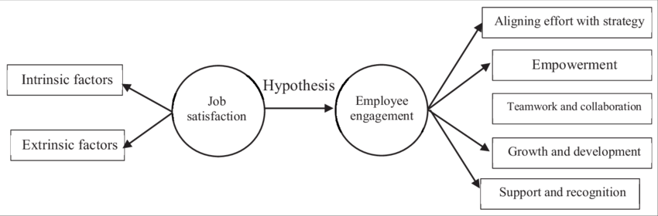
Source: The conceptual model of the relationship between job satisfaction and employee engagement among the HR staff of PHEIs in Thailand, p.81 (Tepayakul & Rinthaisong, 2018)

Levels of employee engagement and job satisfaction can be illustrated with the pyramid of Maslow. This scheme is an excellent opportunity for evaluation of the current situation of a particular company. It shows five different layers of workers’ needs to achieve engagement. People, who are on the bottom level are driven only by the money. The next level there is some strength for the employee, but he/she still doesn’t like the job. Motivation of these two bottom levels is minimal and as a sum we must say that people are not engaged. The next steps of the pyramid could be described as motivators. Staff become much more engaged on each level to the top. In the middle ‘belonging’ layer, people start to have trust of the company and feel part of it. The most censorious level is the ‘importance’. Staff is engaged with the firm and it is feeling much more valued. The top step is ‘high engagement’, where worker’s benefaction is appreciated, he/she has been offered for career development, have top-rated positive relationship with the administration and feel that is working in healthy environment. (Kyhyräinen, 2019) The understanding of the pyramid could help to my boss to estimate the level of engagement during the pandemic and remote working and boost efficiency of the working process.
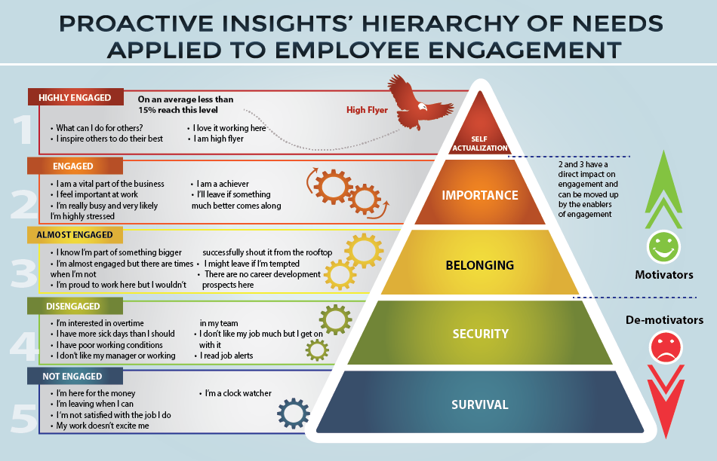
Source: Hierarchy Of Needs Applied To Employee Engagement (Admin, 2020)

Furthermore, digital tools are future of the organizational structure of the companies and their HR policies. The corporations are using digitalization to analyse productiveness, financial effectiveness, clients’ satisfaction, work quality, workspace interactivity on very frequent basis. When it comes to checking the employee engagement, on the other hand, firms are measuring with traditional methods like surveys and no more than once or twice a year. It is recommended to increase frequency of observations and imply digital tools into the HR practices in order to improve satisfaction of the working environment, retention, productiveness of the organization as a whole. (Burnet & Lisk, 2019)
During the pandemic times, firms should distinguish the very best of the workers’ potential, esteem and protect them. Showing solidarity might be one of the most important components to build powerful belief and valuing. (Wulff, 2021)
Nowadays, global situation with Covid-19 pandemic has changed the business fields and dislocate the layers. Countries has applied measurements as public restriction, closure of some businesses, wearing of face covering and etc. A lot of companies started distance working policy and gave to their co-workers some facilities to continue work from home. However, this measure helped for diminishing the spread of the disease, but on the other side, put the employees in a very stressful situation. Remote working increased stress levels as a whole, anxiety among the workers, fear of losing the job or cutting the salaries. These issues caused poor engagement and diminishing of the productivity, because employees were not able to focus on their daily job tasks. In order to deal effectively with these difficulties, the management should have clarity positions and policies and provide welfare working atmosphere. Also good communication, identification of development needs and listening of the labour’s voice are key factors for boosting the employee engagement. Other hints could be: leadership responsibility, keep corporate values, retain motivation high with bonuses and appreciation. (Chanana, 2020) The same issues are implementing at our company as well. The suggestions from my side are strategical and social.
Tactics for higher-level participation are:
- Clear communication- managers should speak straightforwardly with the members of staff, so they could complete the day-to-day tasks successfully;
- Stick to the core values;
- Exceptionally give an encourage to the workers, listen carefully their needs and fears;
- Request frequently the employee feedback- ask for opinion and ideas, strengths and possible opportunities that may help the company;
Useful recommendations for a leader support are:
- Build well-being workplace- motivate workers to create an ergonomically environment at home; provide them all the necessary equipment (relevant computer and accessories, security checks at the system so their personal data will be kept in safe;
- Keep the regime- maintain the working hours and respect the required times for breaks;
- High level of socializing- do video chats, meetings, fun activities with members of the staff online, to keep normality and communication balanced as at the office;
- Maintain welfare procedures- increase engagement and productivity by reducing the absence of the workplace;
- Finance in digitalization- modern digital tools and applications for instant messaging and video-voice platforms could increase the connectivity of the team. Appreciation programmes for acknowledgement are from significant importance for bettering the employees’ feedback to the administration team. (Chanana, 2020)
Further strategy that could be used in order to raise levels of engagement is V5 model. This approach includes five prime factors of employee participation: value, voice, variety, virtue and vision. The elements ‘value’ and ‘voice’ are considered as a topic for members of staff, while other three factors are in the context of the institution.
Value: reviewing the co-workers and their achievements as fundamental capital of the organization. This section includes: the devotion and care of duty, respect at the workplace, good relationship and appreciation. Voice: delivering a chance of choice without any judgement or negative impact. Listening to the labours’ reaction, managers’ sustenance and partnership, implying the effective and clear guidelines are only part of an adequately raise of employees’ voice. Variety: methodologically creating a job that uses different kind of capabilities, expertise and experience to have a better standard of inventiveness and alteration, which increase commitment. It also could diminish the psychological distress. Virtue: meaning ethical mission that brace moral values of the workers, clients, shareholders and society. Normally, firms have morality bunches as trust, equity principles, devotion and compatibility that bettering an environment where members of staff will be high engaged. Vision: a broad transparent aim that an organization endeavour to achieve. Key factors of a good vision are: briefness and clarity, straightforwardness, consistency of accomplishing the set goal, conceptual and innovative thinking. (Kumar, 2021)
Moreover, some other examples that could be implemented in our task as a strategic tool for increasing the work connectivity are top-down and bottom-up approaches. Top-down method incorporate human resources creativities and leadership approaches. Bottom- up techniques include personal programmes that employees could use themselves as self-management, job crafting, strength use and mobilizing ego sources. These proactive methods are helping for the optimization of the work process, job requirements and supplies. They will assist in boosting the self-effectiveness, positivism and stability at the work field. (Bakker, 2017)
To sum all, the good leader should evaluate the co-workers and make everything possible to keep their gratification on high level, pay attention to their needs, give chances for career development. Especially during these hard times, the employees should feel much more engaged to the company’s value system and contribute for its prosperity.

References
Admin. (2020, February 12). Hierarchy Of Needs Applied To Employee Engagement. Retrieved from Proactive Insights: https://www.proactiveinsights.com/blog/hierarchy-of-needs-applied-to-employee-engagement/
Bakker, A. (2017). Strategic and proactive approaches to work engagement. Organizational dynamics, Volume 46, pp. 67-75, http://dx.doi.org/10.1016/j.orgdyn.2017.04.002.
Borah, N., & Barua, M. (2018). Employee Engagement: A Critical Review of Literature. Journal of Organisation & Human Behaviour, 7 (4) ,pp. 22-30.
Burnet, J., & Lisk, T. (2019). The Future of Employee Engagement: Real-Time Monitoring and Digital Tools for Engaging a Workforce. International Studies of Management & Organization , 49 (1), pp.108-119, https://doi.org/10.1080/00208825.2019.1565097.
Chanana, N. (2020). Employee engagement practices during COVID-19 lockdown. Journal of Public Affairs, John Wiley & Sons Ltd, e2508, https://doi.org/10.1002/pa.2508.
Kular, S., & et, a. (2008). Employee Engagement: A Literature Review. Kingston: Kingston Business School, Kingston University, ISBN No. 1-872058-39-6/978-1-872058-39-9/9781872058399.
Kumar, P. (2021). V-5 Model of Employee Engagement During COVID-19 and Post Lockdown. Vision: The Journal of business Perspective, 25 (3), pp.271-274, https://doi.org/10.1177/0972262920980878.
Kyhyräinen, J. (2019). Human resource management as a tool for SME employee engaging. Lahti, Finland: LAHTI UNIVERSITY OF APPLIED SCIENCES.
Motyka, B. (2018). Employee engagement and performance: a systematic literature review. International Journal of Management and Economics, 54(3): pp. 227–244, DOI: https://doi.org/10.2478/ijme-2018-0018.
Tepayakul, R., & Rinthaisong, I. (2018). Job Satisfaction and Employee Engagement among Human Resources Staff of Thai Private Higher Education Institutions . The Journal of Behavioral Scienc, Vol. 13, Issue 2, pp. 68-81.
Wulff, E. (2021). Learning Organization Employee Engagement during COVID-19 and Beyond. Duluth, MN: The College of St. Scholastica, ProQuest Dissertations Publishing.

