Title Page

Name : MUNIRA ZAKARI MOHAMMED
Student ID : 2421787
Module Code : LCHS4007
Module : Digital Skills and Research Methods
Assignment Title : Component 2 - Research Report
Lecturer: Bianca Dodgen

Table of Contents
Introduction 3
Task 1: Selection of a Research Topic 3
1.1 Identifying the Issue 3
1.2 Reflection on Topic Choice 4
Task 2: Evaluating Information Sources 4
Source 1 – Thornicroft et al. (2016), The Lancet 4
Source 2 – Mind (2021), Mental Health Facts and Statistics 5
Source 3 – NHS England (2019), The NHS Long Term Plan 5
Task 3: Research Methodologies 5
3.1 Defining the Three Research Approaches 5
3.2 Chosen Methodology and Justification 6
Task 4: Data Collection 6
4.1 Primary vs. Secondary Data 6
4.2 Chosen Data Collection Method 7
Conclusion 7
References 8

Introduction
The problem of mental health is among the most considerable and expanding issues of the National Health Service (NHS) of the United Kingdom. In the UK, around one out of four individuals will have been affected by a mental issue at any point in a year (Mind, 2021). Although the general population has become more aware of mental health and its stigma, which can be described as negative attitudes, stereotypes and discrimination toward mentally ill people (Thornicroft et al., 2016), they are still a strong hindrance to help-seeking and accessing treatment (Thornicroft et al., 2016). It defines the issue and the target population, evaluates three authoritative sources, explains a proper research method, and analyses how to collect data in the future study of how stigma influences help-seeking behaviour among the UK adult population.

Task 1: Selection of a Research Topic

1.1 Identifying the Issue
Mental health stigma in UK is a problem that targets millions of people of all demographics. According to the latest Adult Psychiatric Morbidity Survey, 16 percent of adults in England satisfied the conditions of at least one of the prevalent mental disorders during a week before the question (NHS Digital, 2016). Nevertheless, one out of several individuals with a diagnosable mental ill issue are treated, and the treatment gap, which consists of over two-thirds of the affected population, is still present (Mind, 2021). The studies always recognize the stigma as the main contributor to this gap.
1 in 4  Adults in the UK who have mental health issues every year (Mind, 2021) | 53%  mention stigma as their key obstacle to seeking help (Mind, 2021) | <33%  of such individuals with mental disorders do not get any form of treatment (Mind, 2021)

Men especially are in danger: statistically, men have a higher risk of suicide by three times, partly because the stigmatization of the gender does not allow them to admit distress (Samaritans, 2022). To care organisations, unaddressed stigma is translated to late presentations, more advanced illness at point of contact, increased hospitalisation rates and greater long-term expenditures of the NHS.
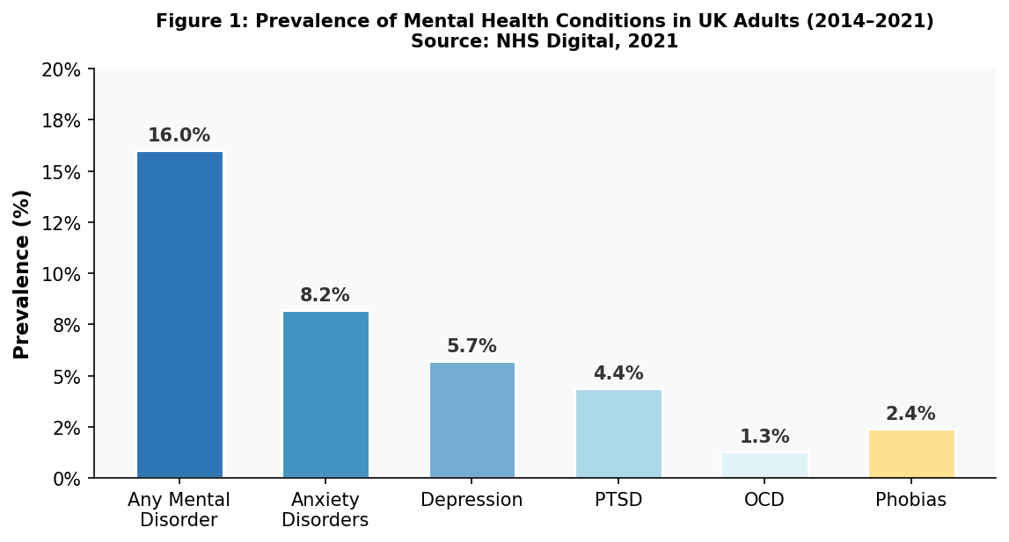
Figure 1: Mental Health Conditions in Adults in the UK

1.2 Reflection on Topic Choice
The topic was chosen due to its direct relation to nursing practice. All nurses must ensure that they encourage equality and oppose any sort of discrimination (NMC, 2018). Stigma is a clinical fact of life: patients miss clinical appointments regularly, conceal symptoms and / or simply stop attending services due to the perceived or perceived threat of being discriminated against. It is also related to professional development because it emphasises the significance of therapeutic communication, anti-stigmatisation advocacy, and culturally sensitive practice.

Task 2: Evaluating Information Sources

Source 1 – Thornicroft et al. (2016), The Lancet
It is a peer-reviewed article that was published in one of the most respected medical journals in the world and conducted a systematic review of anti-stigma measures throughout the world. The data reviewed by the authors consisted of more than 195 studies which makes it methodologically sound and very credible. It is directly pertinent to this study since it measures the effect of stigma and also measures what evidence-based interventions have minimized discriminative attitudes and England Time to Change campaign which was related to a 4-percentage-point change in public attitudes and a six-year follow-up. One of the gaps that the authors recognize is the paucity of evidence on the long-term sustainability of the changes in the attitude, the absence of culturally tailored interventions targeted at ethnic minorities in the UK setting (The Lancet, 387(10023), pp. 1123–1132).

Source 2 – Mind (2021), Mental Health Facts and Statistics
Mind is a UK leading mental health charity. It bases its statistics on NHS Digital data and large-scale population survey, which makes them rather credible as a contextualising source. This report defines the national magnitude of mental health requirement and is necessary to base the research with UK-specific epidemiological information- such as establishing that 75 percent of mental illnesses commence preceding the age of 24. It is however, descriptive and not analytical because it is a document in a charitable sector and not a peer-reviewed article. A gap is the lack of a separation of the role of stigma experience in relation to gender, ethnicity or area that would enhance comprehension of the group at the highest risk (Mind, 2021).

Source 3 – NHS England (2019), The NHS Long Term Plan
It is an official government policy document of the NHS which is an authoritative source. It has made a pledge of more mental health investment of no less than PS2.3 billion annually by 2023-24 and has made a commitment to widen access to psychological therapies. It proves to be helpful in seeing the policy and financial environment that every stigma and access research is conducted in. Another major gap, though, is that although the plan addresses the service capacity, it does not substantively address the stigma as a demand-side barrier, that is, how to motivate individuals to seek the care in the first place. This is a significant loophole that the research project under proposal would aim at filling (NHS England, 2019).
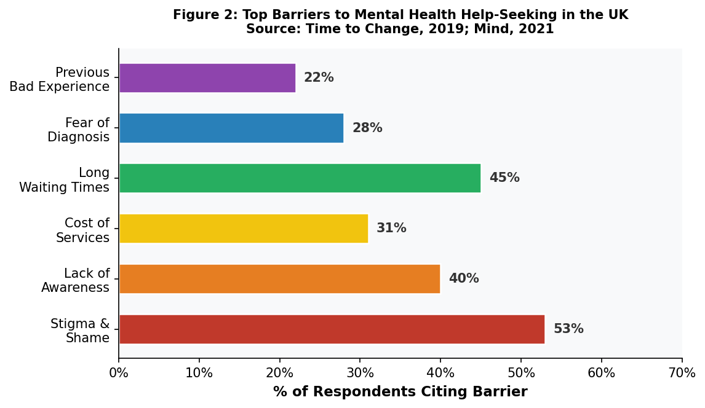
Figure 2: The Barriers to Mental Health Help-Seeking that are on the list of Top in the UK

Task 3: Research Methodologies

3.1 Defining the Three Research Approaches
Quantitative research is a research type that implies the gathering and statistical processing of numbers to discover patterns, relationships, or correlations (Creswell, 2014). The benefit is that it is possible to generalise the results on broader populations, but the drawback is that it is impossible to observe the personal meaning or context of answers using numerical data.
Qualitative research aims to get to know about lived experience, meanings, and perspectives via the use of interviews, focus groups, and observations (Bryman, 2016). It would include an interview, which is semi-structured, of adults who have been stigmatized in accessing NHS services. This is a strong strategy of deep understanding but results cannot be generalised easily.
Mixed methods research is quantitative and qualitative research design in the same study offering a breadth and depth complement. As an example, a quantitative survey of help-seeking delays could be succeeded by a qualitative interview about the causes of such delays. This is a more frequent method of health research (Creswell, 2014).

3.2 Chosen Methodology and Justification
The most suitable methodology in this study is a qualitative one. Mental health stigma is a subjective, situational phenomenon. The number of people being affected can be quantified using statistical methods but not the process of a stigmatization experience, which can be internalized or overcome. Semi-structured interviews (qualitative) would enable the researcher to capture the experiences of the participants in their own words in regards to the subject of stigma. As Bryman (2016) This approach is also compatible with the nursing principle of person-centred care which puts the emphasis on getting to know the personal point of view of the patient.

Task 4: Data Collection

4.1 Primary vs. Secondary Data
Primary data is carried out through in-person collection, in regards to the research study under consideration. This can be interviews, questionnaires and observations. Secondary data is the already compiled data that has been compiled with a different aim (e.g. NHS statistics, government reports, published academic research) (Silverman, 2016). Primary data is precise and highly relevant whereas secondary data is less expensive and is available instantly.

4.2 Chosen Data Collection Method
The data will be collected using the chosen methodology according to the following approach. In this study, semi-structured interview as the method of primary data collection would be utilized. Through GP surgeries and community mental health organisations, a purposive sample of about 15-20 adults in the UK that have sought, or not sought mental health support would be recruited. Interviews would be audio-taped, transcribed, and thematically analysed in order to establish a common pattern in how the participants experience stigma.
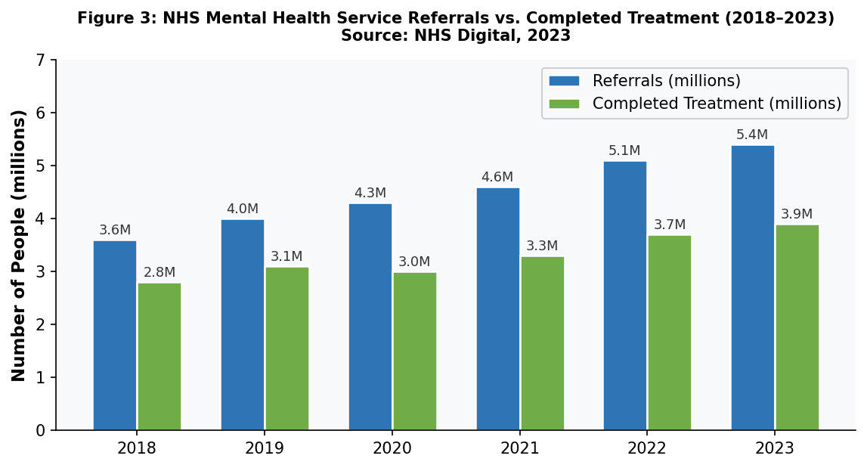
Figure 3: NHS Mental Health Service Referrals vs. Completed Treatment 2018 to 2023
Advantages: The data produced by semi-structured interviews is rich and contains contextually detailed information which answers the research question. They allow the interviewer to dig deep and examine personal accounts by inquiring about unforeseen answers (Silverman, 2016).
Challenges: The approach is time consuming, and it needs a meticulous ethical control because the topic is quite sensitive and the results could not be generalised statistically to the general population of the UK British Psychological Society's ethical guidelines (BPS, 2021).

Conclusion
Mental health stigma has been discussed in this report as an important evidence-based contemporary problem in the UK health and social care. Statistically, it is proven that although one in every four adults has mental health issues every year (Mind, 2021), more than two-thirds are not treated in any way, but the most common obstacle is stigma described by half of the affected individuals. Three plausible sources were assessed and they indicated significant gaps in the literature, especially on the area of culturally sensitive and long-term anti-stigma intervention. The qualitative approach based on semi-structured interviews was selected as a most suitable methodology, and the primary data collection was selected as a tool to provide the depth of information required to comprehend the personal stigma experiences. Addressing mental health stigma is both critical to equitable person-cantered care throughout the UK and should be a priority in policy and practice in nursing.

References
- British Psychological Society (BPS) (2021) Code of Human Research Ethics. Available at: https://www.bps.org.uk/news-and-policy/bps-code-human-research-ethics (Accessed: 10 March 2026).
- Bryman, A. (2016) Social Research Methods. 5th edn. Oxford: Oxford University Press. Available at: https://global.oup.com/ukhe/product/social-research-methods-9780199689453
- Creswell, J.W. (2014) Research Design: Qualitative, Quantitative, and Mixed Methods Approaches. 4th edn. London: SAGE. Available at: https://uk.sagepub.com/en-gb/eur/research-design/book237357
- Mind (2021) Mental Health Facts and Statistics. Available at: https://www.mind.org.uk (Accessed: 10 March 2026).
- NHS Digital (2016) Adult Psychiatric Morbidity Survey: Survey of Mental Health and Wellbeing, England, 2014. Available at: https://digital.nhs.uk (Accessed: 10 March 2026).
- NHS England (2019) The NHS Long Term Plan. Available at: https://www.longtermplan.nhs.uk (Accessed: 10 March 2026).
- Nursing and Midwifery Council (NMC) (2018) The Code: Professional Standards of Practice and Behaviour for Nurses, Midwives and Nursing Associates. London: NMC. Available at: https://www.nmc.org.uk/standards/code/ (Accessed: 10 March 2026).
- Samaritans (2022) Suicide Statistics Report. Available at: https://www.samaritans.org (Accessed: 10 March 2026).
- Silverman, D. (2016) Qualitative Research. 4th edn. London: SAGE. Available at: https://uk.sagepub.com/en-gb/eur/qualitative-research/book242504
- Thornicroft, G., Mehta, N., Clement, S., Evans-Lacko, S., Doherty, M., Rose, D., Koschorke, M., Shidhaye, R., O'Reilly, C. and Henderson, C. (2016) 'Evidence for effective interventions to reduce mental-health-related stigma and discrimination', The Lancet, 387(10023), pp. 1123–1132. Available at: https://doi.org/10.1016/S0140-6736(15)00298-X (Accessed: 10 March 2026).

