Financial Management for the Hotel Industry Comparison of Two Hospitality Organizations.

Module Code: BMIH50074
Lecturer: Dale Clarke

Student: Muhammed Azizur Rahman
ID Number: 2107283

Contents
Introduction 3
Total Revenue 3
Marriott International 3
Hyatt Hotels 4
PESTLE analysis of Marriott International and Hyatt Hotels 5
Political factors 5
Economic factors 6
Social Factors 6
Technological Factors 6
Legal factors 6
Environmental factors 7
Growth potential 7
Marriott International 7
Increased demand in the South Asian Market 7
Hyatt Hotels 8
Increased market size through frequent traveling 8
Financial Commitment to CSR 8
Marriott International – Advance human rights 8
Hyatt Hotels – “Thrive” 8
Recommendations for growth 9
Marriott International 9
Hyatt Hotel 9
Conclusion 10
References 11

Introduction
Marriott International and Hyatt Hotels are two of the giants of the hotels and tourism industry as they cover most of the globe and serve several guests from different countries. The pandemic has impacted the hotel industry as a whole and both Marriott and Hyatt have suffered during the pandemic. This business report will analyse the revenue, current market position, and CSR activities that the hotels have invested in.

Total Revenue

Marriott International
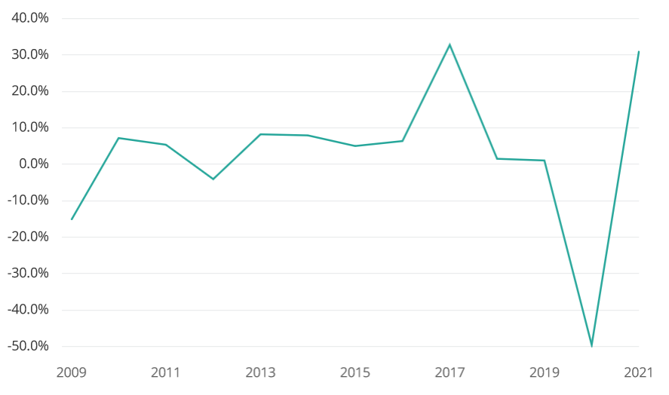
Figure 1 the revenue Growth rate of Marriott International (Wernick and Von Ginlow, 2022)
Losses of $267 million were recorded by a Marriott hotel chain in the year 2020 due to the prohibition of travel and the mandate that residents remain at home due to the pandemic. For 2019, the corporation reported $1.3 billion in net profits, so this is a substantial change (Wernick and Von Ginlow, 2022). In 2021, the company's net income was $1.1 billion, proving that it had recovered and returned to profitability. In 2021, Marriott reported annual sales of $13.9 billion, up 31% over the $10.6 billion reported in 2020 (Wind et al., 2021).
Marriott's network of hotels grew by over 86,000 rooms in 2021, the company said at the time. Towards the end of the year, Marriott acquired more than 3,000 hotels, expanding its room inventory by an estimated 485,000 (Wernick and Von Ginlow, 2022). Corporate executives are keeping a careful check on the development of COVID-19 to guarantee that it is capable of producing as much profit as is humanly feasible while also striving to get the company's income back up to its levels before the recession. The corporation is doing this alongside its efforts to restore pre-recession revenue levels.
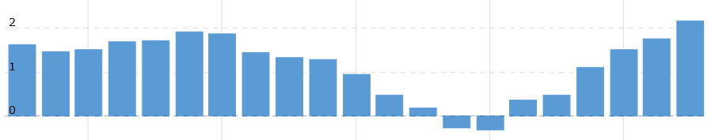
Figure 2 Quarterly revenue of Marriott International from 2017 through 2022 (Lanz et al., 2022)
Marriott's operating income for the second quarter of 2022 was $950 million, a significant increase from the $486 million recorded at the same time in 2021. Net income for the second quarter of 2022 was reported at $678 million, a significant rise over the net income reported for the same time in 2021 ($422 million). This quarter's profits per share (EPS) of $2.06 is up from last year's corresponding figure of $1.28 (Lanz et al., 2022). The adjusted net income for the second quarter of 2022 was $593 million, which is a significant rise from the second quarter of 2021 when it was $260 million. Adjusted and diluted earnings per share during the second quarter of 2022 were $1.80, a significant increase from the $0.79 seen in the second quarter of 2021 (Ramzi and Mohamed, 2022).

Hyatt Hotels
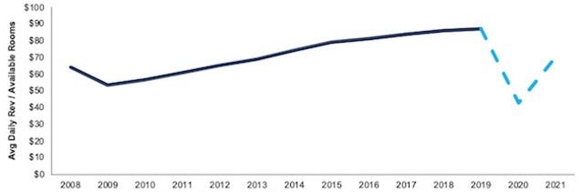
Figure 3 Hyatt Hotel Annual Revenue (Miles et al., 2022)
Hyatt Hotels Corp (H.N) of the United States reported a wider loss for the first quarter on Tuesday because of the COVID-19 epidemic, which caused people to stay inside more frequently. This is because the epidemic hit during the first quarter of the year. But the company said that commercial demand rose throughout the study period, although at a slower clip than consumer demand for leisure pursuits. Although the 2020 pandemic was a major blow for the hospitality industry, hotel owners are hopeful about the next year due to rising vaccination rates and pent-up demand. The hotel industry suffered severely in 2020 due to the pandemic. During the quarter ending March 31st, Hyatt racked up a net loss of $304 million, or $2.99 per share. Last year's loss was $103 million, or $1.02 per share, while this year's loss is expected to be much higher (Law et al., 2020).
A precipitous decline in business and leisure travel led to the extinction of the hotel industry by 2020. Additionally, restrictions on international travel have been implemented to slow the spread of the coronavirus. There has been an increase in the overall number of net bookings made since the start of 2021, and there are signs that occupancy rates throughout the industry may continue to improve. The sector saw a little uptick in occupancy to under 50% in the fourth week of February, from a low of 22% in April of 2021 (Min et al., 2022). After occupancy dropped to a record low of 22% in April of 2021, this occurred. The Chicago-based hotel company Hyatt found that many of these bookings were the result of spring break trips to tropical destinations like the Caribbean and Mexico.

PESTLE analysis of Marriott International and Hyatt Hotels

Political factors
Three of the most important political concerns that might affect Marriott are terrorism, diplomatic difficulties, and the local political atmosphere in hotspots. Terrorist attacks or wars on a worldwide scale that disrupt or hinder international aviation travel pose the greatest risk.
The Hyatt Hotels Corporation operates hotels in over 70 countries across the world (Rai et al., 2022). International trade limitations, tax rules, labor laws, etc. vary in each country and affect Hyatt's profitability and commercial capability. Hyatt Hotels can't succeed internationally without having localized rules.

Economic factors
Instability in the global economy, most notably in China and Europe, would hurt Marriott's bottom line. Due to decreased discretionary income brought on by the fall of the Chinese stock market and the European economic crisis, fewer vacations may be taken than would otherwise be feasible (Sanger et al., 2021).
It is crucial to evaluate the nation's currency rate policy before investing in a country with a significant foreign exchange risk, such as Venezuela. Countries that attract many tourists and whose tourism industry generates a sizable share of GDP may see an uptick in demand and profits for Hyatt.

Social Factors
Good news for Marriott's CSR efforts: the number of individuals expecting to travel throughout the world increased by 13% between 2020 and 2021. From $5,955 in 2020 to $5,136 in 2021, that's a significant rise in the typical vacation budget (Chen et al., 2021). More visits usually mean more money in the bank because of the multiplier effect.
Hyatt Hotels, which employs over 130,000 people in more than 70 countries, is committed to providing a welcoming environment for all of its customers and staff members. Since 2018, Hyatt Hotels' RiseHY initiative has given millions of dollars to areas with low incomes.

Technological Factors
The hotel sector may be significantly impacted by online rental services like Airbnb, which enable individual users to rent rooms or homes directly to visitors, as a consequence of technological developments. More thantechnologicalon people used Airbnb globally in 2021 (Bilgihan et al., 2021). This has impacted the business of both Marriott International and Hyatt Hotels.

Legal factors
The biggest factor that will affect Marriott's bottom line shortly is the legal standing of competing businesses like Airbnb. New York, New Orleans, and Barcelona are just a few of the places that have issued fines against Airbnb and its hosts for breaking zoning rules, falling short of hotel standards, and failing to meet health and safety requirements.
A lawsuit might hurt a business financially and publicly. And if they drive up costs and decrease income, they might hurt the business' bottom line. Hyatt has agreed to pay a sum to put an end to the Biometric Class Action Lawsuit. It is claimed in the lawsuit that Hyatt violated BIPA by using fingerprint scans of workers without their knowledge or consent (Scanlon, 2021).

Environmental factors
For the time being, the cost of gasoline is the most significant external element that might affect Marriott's business strategies. Assuming oil costs remain low, this might mean more people traveling for less money, which would increase the need for hotel rooms (Denton and White, 2022). Marriott would be negatively impacted by an unexpected rise in fuel prices, especially for airplanes.
Hyatt should take into account trash and recycling programs, the installation of renewable energy sources like solar panels, the procurement and consumption of environmentally friendly goods, and the avoidance of resource depletion via actions like rainwater collecting. Aspirations of Hyatt for sustainable development goals in the Year 2030.

Growth potential

Marriott International

Increased demand in the South Asian Market
The hotel sector in the South Asian nations has benefited greatly from the easing of travel restrictions related to the crisis, which has allowed business meetings to restart throughout the world. On-arrival visas in most South Asian Countries have increased business at the region’s five-star hotels, which have held several conferences and seminars since the beginning of 2022 (Pollitt, 2022). While most nations are experiencing ongoing inflationary pressure, the owners of the most luxurious hotels in South Asia have said that this would not hurt their companies. Guests may be certain that health and safety standards are being upheld and service levels are appropriate with the new normal that has evolved in the pandemic-ravaged environment.

Hyatt Hotels

Increased market size through frequent traveling
The worldwide hospitality sector has grown at an astounding rate with the rest of the economy since the conclusion of the financial crisis a decade ago. The World Bank predicts that annual global economic growth will exceed 3% before the worldwide pandemic of 2019–2020 (Kazis, 2022). As a consequence of pent-up demand before the pandemic, the global economy grew by 5.5% in 2021, but growth is predicted to decline to 4.1% in 2022 and 3.2% in 2023, recovering to pre-pandemic levels by 2023. The expansion in international tourism has helped the hospitality and tourism sector by significantly increasing the demand for hotel rooms to accommodate vacationers and business travellers.

Financial Commitment to CSR

Marriott International – Advance human rights
Human rights and cultural diversity are two tenets of Marriott's corporate social responsibility approach. Hotels are actively pushing education in a variety of forms to raise public awareness of human trafficking, forced labour, and exploitation (direct communication, lectures, and posters). During this phase, efforts are made to spot disagreements and managerial blunders and fix them right away (Gunaratna, 2022). Cultural awareness is crucial for many reasons, including the elimination of bias in interpersonal relationships, the promotion of the value of international travel, and the recognition of the unique cultural background of each client and worker. Hotels that make a point of honouring local customs and traditions tend to attract more guests and earn more repeat business.

Hyatt Hotels – “Thrive”
Hyatt Thriver’s four pillars are health and wellness, personal development via learning, economic growth and investment, and environmental protection. This program encourages environmental responsibility among Hyatt staff and guests (Hwang and Chang, 2022). Hyatt is working toward its goal of safeguarding the natural ecosystems and surroundings in the places where its hotels are located by lowering energy and water usage, greenhouse gas emissions, and garbage sent to landfills. As a result of this initiative, Hyatt hotels and the communities they serve will make substantial progress toward environmental sustainability. As part of the Hyatt Earth initiative, local green teams at Hyatt properties around the world are working to protect natural habitats and environments in their communities, track the success of natural resource conservation efforts, and increase operational efficiency by reducing energy and water consumption, greenhouse gas emissions, and waste sent to landfills.

Recommendations for growth

Marriott International
On-going employee training: Marriott International has a very diverse group of employees in their hotels. To ensure that the employees are all on the same page, training is important for everyone. Training is not something that should be done once and forgotten about. Training might take place at any time throughout the day or shift. Training doesn't have to be time-consuming or impede productivity just because it's happening in the hospitality sector (Qadri et al., 2022). Performance support training may be used in place of intensive, multiday training programs to increase employee retention rates and the quality of their new knowledge.

Hyatt Hotel
Personalized customer service: Hyatt Hotels can improve further their customer experience. It may increase the likelihood that a visitor will return if Hyatt treats them as individuals. A good response to each request is guaranteed if Hyatt instils a feeling of urgency among its staff. Although blunders and failures are unavoidable, success may be achieved by going above and beyond. Take back their reactionary treatment of high-profile individuals (Burke et al., 2021). When the bride's bridal party is on the way, it's a nice touch to spruce up the bridal suite and give the bride a welcome basket filled with treats and a congrats card. Careful planning has the potential to turn a one-time visitor into a loyal patron. This can improve Hyatt’s demand in the industry further.

Conclusion
Marriott International has a higher revenue generated in the post-pandemic era, as they have been making more strides towards growth. They are entering the more lucrative South Asian market so that they can ensure that their business returns to record highs. Marriott is also being very vocal about the human rights stakes. On the other hand, Hyatt has been slow to address the post-pandemic needs but after the slow start, they are now planning to grow with CSR activities and opening new hotels.

References
- Bilgihan, A., Okumus, F., “Khal” Nusair, K. and Joon‐Wuk Kwun, D., 2021. Information technology applications and competitive advantage in hotel companies. Journal of Hospitality and Tourism Technology, 2(2), pp.139-153.
- Burke, B., McBride, J. and Kimble, K., 2022. Development of an Enterprise-wide Energy Information and Utility Monitoring System in a Major Hotel Chain: The Hyatt Hotels Corporation Experience.
- Chen, W. and Tabari, S., 2021. A study of negative customer online reviews and managerial responses on social media—a case study of the Marriott hotel group in Beijing. Journal of Marketing and Consumer Research, 41, pp.53-64.
- Denton, G.A. and White, B., 2022. Implementing a balanced-scorecard approach to managing hotel operations: the case of white lodging services. Cornell Hotel and Restaurant Administration Quarterly, 41(1), pp.94-107.
- Gunaratna, R., 2022. The Islamabad Marriott in Flames: The Attack on the World's Most Protected Hotel. Journal of Policing, Intelligence and Counter Terrorism, 3(2), pp.99-116.
- Hwang, S.N. and Chang, T.Y., 2022. Using data envelopment analysis to measure hotel managerial efficiency change in Taiwan. Tourism Management, 24(4), pp.357-369.
- Kazis, N., 2022. Challenges and Opportunities for Hotel-to-Housing Conversions in NYC.
- Lanz, L.E.O.R.A., Fischhof, B.A.R.B.A.R.A. and Lee, R.E.B.E.C.C.A., 2022. How are hotels embracing social media in 2022? Examples of how to start engaging. New York: HVS Sales and Marketing Services.
- Law, R., Sun, S. and Chan, I.C.C., 2020. Hotel technology: A perspective article. Tourism Review, 75(1), pp.286-289.
- Miles, M.S., Demi, A.S. and Mostyn-Aker, P., 2022. Rescue workers' reactions following the Hyatt Hotel disaster. Death Education, 8(5-6), pp.315-331.
- Min, H., Min, H. and Chung, K., 2022. Dynamic benchmarking of hotel service quality. Journal of Services Marketing.
- Pollitt, D., 2022. Marriott hotels stress the spirit to serve. Human Resource Management International Digest, 16(5), p.26.
- Qadri, M.A., Ahsan, K.D.L. and Hashmi, S., 2022. A Study of Cross-Cultural Communication Strategy: Case of Marriott Hotels & Resorts. environment, 19.
- Rai, S.K., Rana, P. and Kashif, M., 2022. Hotel Personnel Retention In Uttar Pradesh: A Study of HYATT Hotels. International Journal of New Practices in Management and Engineering, 11(01), pp.47-52.
- Ramzi, M. and Mohamed, B., 2022. Customer loyalty and the impacts of service quality: The case of five-star hotels in Jordan. International Journal of Economics and Management Engineering, 4(7), pp.1702-1708.
- Sanger, D.E., Perlroth, N., Thrush, G. and Rappeport, A., 20. Marriott Data Breach Traced to Chinese Hackers. The New York Times, pp.A1-L.
- Scanlon, N.L., 2021. An analysis and assessment of environmental operating practices in hotel and resort properties. International Journal of Hospitality Management, 26(3), pp.711-723.
- Wernick, D.A. and Von Glinow, M.A., 2022. Reflections on the evolving terrorist threat to luxury hotels: A case study on Marriott International. Thunderbird International Business Review, 54(5), pp.729-746.
- Wind, J., Green, P.E., Shifflet, D. and Scarbrough, M., 2021. Courtyard by Marriott: Designing a hotel facility with consumer-based marketing models. Interfaces, 19(1), pp.25-47.

