Contributing to Coaching and Mentoring

Word Count:2929
Sian Govier

Contents page

- Investigation Notes

- The Impact on Coaching and Mentoring within an organisation.

- Recommendations on Further developments for Coaching and
Mentoring.

- Supporting the implementation of Coaching and Mentoring within an organisation.

Investigation Notes

I have discussed Coaching and Mentoring with my manager, we regularly use the OSCAR model in Perthyn, when it comes to training managerial employees about Coaching and Mentoring. The feedback gained through the learning and Development feedback logs has been positive. I will provide a blank copy of the questions asked. The questions that I feel are important within the learning log is, did the employee enjoy the course? what the employee learnt from the course? And what changes could be made to the course.
The above questions allow the employees who attended the course to give feedback, and for the trainers to equally learn from the course attendees on what part of the course delivered was good and what could be added or improved on the course.

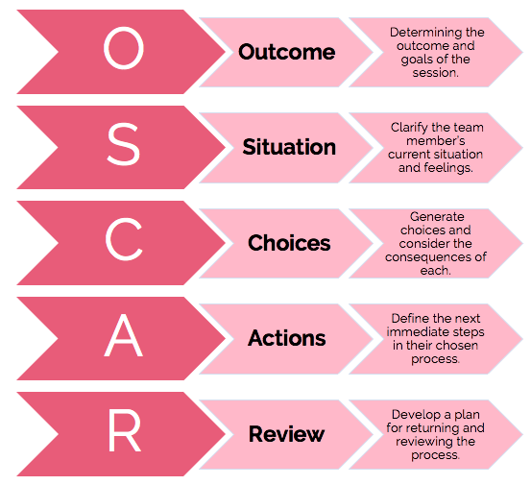

Throughout the Pandemic, I have experienced Coaching with my Manager Gareth Morgan, the coaching was based around adapting to a change in my working environment, working from home and taking on new tasks. I found this beneficial and helpful, particularly as working from home can make a person feel isolated. I was also coached to learn how to use Zoom and Teams meeting, which involved sending out meeting invites to existing employees, potential employees, or external agencies. I also took part and still participate in teams’ meetings on a regular basis and to ensure and maintain the growth of knowledge, training has been provided via team’s meetings, such as mental health first aid and the use of Microsoft software courses.

I have been a Coach for newly appointed managers and existing managers to assist with employee Annual Leave, supporting the managers with annual leave bookings and to monitor and update the annual leave planners. I also run annual leave reports and have explained to managers how annual leave dates can be changed; these are changed using the Request to change annual leave form.
The model used was OSCAR along with the GROW model.

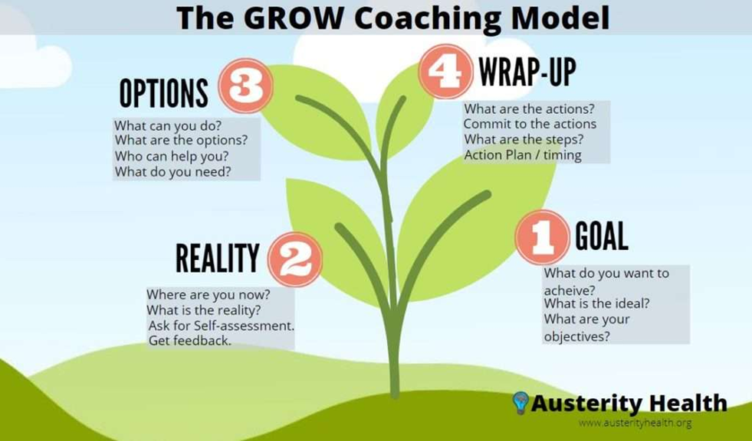

Meeting sessions with the managers are often set out by what the manger intends to gain.
The outcome, usually it is to ensure the understanding of how annual leave is processed and dealt with and how to use the relevant documents to ensure the employee does not over or undertake their annual leave allowance.
Situation is where the whole staff team are, or a certain employee, what annual leave has been booked, needs to be booked or possibly cancelled. Where the manager is and what they need to learn around the annual leave protocol.
Choices and Consequence is based on the documents and tools used for annual leave bookings, annual leave reports being sent to the manager, individual or for the full service, including the managers annual leave.
The consequences of over or under booking annual is explained clearly, such as if the employee over takes their annual leave then at the end of the financial year they may need to repay the hours, as they were not entitled to take them or if an employee does not take their annual leave this could result in the employee becoming distressed and feeling over worked due to not having a suitable amount of rest time.
Actions of the meeting usually involves the manager making notes and going away from the meeting to discuss any annual leave discrepancies with the employee directly. The manager will then update me via teams, email or telephone using the relevant documents where necessary.
Review, I will regularly meet with a manger to continue with areas of support and to ensure that all records correspond, and the line manger has gained the knowledge and Skills they need around the topic and procedures of annual leave. All the above is also based and underpinned from the grow model, to ensure the growth of the managers expertise in a particular area such as annual leave.
The topic of annual leave will continue through mentoring, allowing the manager to contact me should they need updates, discussions or reports sent to them in relation with annual leave. This has proved to be a positive outcome for managers as they feel they have support from HR to manage annual leave which in general can be difficult, especially in a health and social care environment, where employees work around the clock and on shifts such as nights, sleep ins, mornings, and afternoons. Annual Leave is booked by the employee at the start of the financial year, they will book their full years entitlement, therefore I receive regular annual leave change requests. There are many reasons for the annual leave change requests, such as:
- Cancelling annual leave due to supporting the service when staffing levels are low.
- Changing due to family or personal issues.
- Changing due to holiday cancellations, which has been, frequent during the COVID-19 pandemic.
- Changes for trips out or just to ensure leave is used and many more.
On times this can be a challenge to managers as they are only able to authorise a specific number of staff annual leave, due to managers ensuring there are safe working levels at the service.
Continuous mentoring has also allowed the managers to develop professionally and enhance on their knowledge while feeling enlightened that they have a point of contact, resulting in an inviting open culture and improving productivity through a happy, skilled workforce.

The Impact on Coaching and Mentoring within an organisation.
Employees can gain feedback and give feedback during professional reviews and Development discussions; effective coaching processes will ensure the employee is sufficiently supported and challenged throughout. It is also vital that the Reviewer, the Coach or Mentor has the relevant training, allowing them to provide suitable support and challenges to the employee. They should be familiar with the principles around this area to encourage deeper thinking and reflection which can avoid a sense of unease or threat and gain a positive working relationship and culture. Coaching and mentoring can be an effective programme in the development of employees, they have both grown in popularity. With many organisations using them to enhance their employees, skills, knowledge, and performance of their people based on specific skills and goals.
There are many aims of providing coaching and mentoring in an organisation, such as:
- Assisting performance management.
- Preparing and supporting people through change.
- Supporting self-directed learning and development.
- Sharing curating resources.
Although coaching and mentoring programmes are widespread within organisations, there can be challenges about how best to manager and deliver them. When delivering coaching and mentoring there can often be confusion around, what is the best way to deliver or who is the best person to deliver, how best to manage the stakeholders in the process and on occasions the way an organisation can work effectively with a complex external coaching industry. Some businesses tend to hire eternal courses to train senior managers or those who are in a leadership position, although this can be a more expensive option than internal training. Perthyn will use external trainers on occasions, who will train the trainers, regional managers, or directors of the organisation, this is then passed on to other employees such as community support managers, behaviour specialists, through organised training days.
According to the Deloitte Research Brief (2012) retention is 25% higher for employees who have engaged in company mentoring. Mentoring can promote mutual learning to challenge and stimulate employees at all levels within the organisation. According to PricewaterhouseCoopers Global Survey on Coaching (2011), Coaching will help the employee to achieve their best performance, the return of investment for companies, who invest in coaching is 7x the initial investment. Coaching and mentoring models are not new, they have been around for many years, these models have supported businesses over the years to develop and retain talent. However traditionally these programs have only been offered to a minimal amount of staff, this can be due to cost of the programmes. However, these days companies have more resources and ROI research and experts and have more opportunities to employ and support these programs, not only to the senior leaders but across the organisation. This will result in a positive for employee’s careers, growth, engagement, and retention at all levels. The value of developing L&D skills leads to the enhancement of employee skills and has an impact of improving the organisation, the employees will undertake their roles more efficiently, effectively, and creatively. Although some organisations may worry about dedicating time and resources to learning, if people professionals have the correct approach, then the organisation as well as the employees will benefit. People professionals should correspond with the support leaders and show that there is a more effective way to achieve the organisations core purpose resulting in the organisations objectives being met.
There are many different coaching and mentoring tools to consider in an organisation as well as other learning strategies that can be considered:
- The coaching tool- the 5-minute pre-session check in, this allows the clients or employees to complete a questionnaire before each session, this will help both parties to understand and recognise the progress and success since the previous session. It will also allow them to establish if there are any obstacles.
- Smart goal setting technique in coaching, this stands for Specific, Measurable, Attainable, Relevant, and Time based. It brings a clear structure in to goals; each goal or Milestone will come with clear and verifiable elements instead of vague resolutions.
- Effective coaching technique – Let employees write down and share the gold nuggets after each session, encourage employees to share with the coach, it will leave them with a picture of how much value in return of investment they achieved from coaching.
- Ask open ended questions, Open ended questions will allow the employee to include more information, including feelings and the understanding of the subject allowing the coach to communicate more effectively.
- Coaching technique – use the power of writing, writing plans and goals is the first step to making them a reality and will commit the employee to take action in order to receive their end goal.
- Be fully present and focused, it is important that coach takes time for themselves to allow them to effectively deliver the session. They will need to avoid distractions and show genuine interest and care to the employee.
- Follow up with the client/employee – Use ongoing feedback for invaluable information, this can be achieved by checking in with regular questionnaires, allowing for the employee to share their thoughts, experience, progress, success or any challenges that have been present.
- One of the best techniques for coaching and mentoring – the coaching journal of progress, A regular journal will support the employee to develop and gai self-awareness. This will help the employee to focus on themselves without feeling pressured or distracted. They can also reread and recap prior entries at a later stage.
- Effective coaching technique- homework assignment to strengthen accountability, regardless of the name, homework, worksheet, questionnaire or action item, they will all support the work within a coaching session.
- A shared to do list, employees will commit to steps and plans and can note the to-dos with their coach to enable the existence of the goal.
Through investment in CPD, L&D practitioners have the capability to influence the wider success of the company as the CIPD Skills Pulse Survey demonstrates a significant impact on organisational growth, productivity, and performance. This could be why 90% of high performing businesses who have a focus on learning, ensure they give their L&D professionals opportunities to develop and grow. Maturity’s health check (2018) found that those companies allowing for growth had the biggest positive impact because of learning.

Coaching and Mentoring activities can be developed to benefit an organisation, there are many recommendations of how this can be achieved such as:
- Choosing the most relevant Coaching and Mentoring model that will work well for the industry.
- External or internal coaches and mentors can be used.
- Team coaching.
- Sponsorship.
The evidence for externally resourced professionals, is generally short term and shows short term performance improvement, although the behavioural change can be strong. The evidence for longer deeper change is weaker, this is because it can be more difficult to measure over a longer period of time or because the quality of the coach can be highly variable. Therefore it is vital to have a well-founded process for assessing any external coach hires, the trend has currently moved away from external experts, internal HR professionals tend to take on the coaching and Mentoring role, this will build on internal assessment capability and ensure that people, who understand the corporate culture make the assessments.
Many internal experts will have similar qualifications and coaching hours to their external counterparts, they also know the culture. I feel that internal coaches and mentors will be more beneficial for the organisation, being more cost effective and the internal professional will know the organisations, objectives, goals and culture.
HR have been deemed as champions for coaching and mentoring, this is because there is a wide variation of understanding the nature of coaching and mentoring across the HR community. Although in business partner structures, time has pressed HR professionals, they may not have the capacity to focus on championing coaching and mentoring. Taking this into consideration, I feel that an organisation would still benefit from employing a designated coaching and mentoring employee, they could deliver internal training and encourage many other aspects around staff teams such as employee engagement and relations. External professionals can be a costly method over a long period of time. Employees will be aware that there is an internal people profession they can speak to around this topic. I feel it is important for an organisation to progress towards a coaching and mentoring culture, deliver a high standard of coaching and mentoring.
As expenditure on coaching and mentoring increase, it becomes more important to ensure that an organisation delivers its training with Value for Money, this will involve bringing experts with more capabilities in house, Coaching and mentoring has become high on the agenda of HR in recent years.
Supporting and implementing Coaching and/or Mentoring programs within an organisation

While there are many benefits of Coaching and Mentoring in an organisation, there can also be barriers and obstacles to consider, it is important to understand and address them, to increase the likelihood of success for any coaching and mentoring strategy or localised implementation. The barriers can be as followed:
- The organisations culture.
- Lack of understanding of the values of coaching.
- Not seen as a priority for the business.
- Resistance from senior management.
- Low levels of skills and experience within the organisation.
- Lack of time and resources.
Enrich and Hansford, (1999) identify a number of barriers to coaching and mentoring, these are:
- Incorrect matching of mentors/coaches and learners.
- Lack of top-down support.
- Resentment felt by those not involved in the scheme or the perception of favouritism.
- Creation of false promotional expectations.
- Over dependence of the mentor/mentee.
- Gender issues.
- The burring of role and boundaries.
It is paramount to understand and address any obstacles or barriers when developing coaching and mentoring in the organisation. Communication is key.
One of Perthyns barriers for training courses such as coaching and mentoring was the Covid-19 pandemic, all employees had to adapt to many changes to adhere to government guidelines. The delivery of coaching and mentoring was put on hold for a short period of time, to allow for compulsory learning to in able employees to work effectively and efficiently for the support needs of the individuals at their homes. However, this was soon adapted, with delivering less compulsory training via Microsoft teams. As mentioned in my investigation notes, I was grateful to experience an element of coaching and mentoring from my manager as well as delivering coaching and mentoring to manager’s around annual leave.
There is support for mentors and coaches to enable them to deliver their knowledge, skills and wisdom effectively, it can be through using models such as the GROW model, which was established in the 1980’s by Graham Alexander, Alan Fine and Sir John Whitmore, a good way to think about the GROW model is by recognising where you are now and how you plan your journey.
Another successful model to use is GIBBs reflective model.

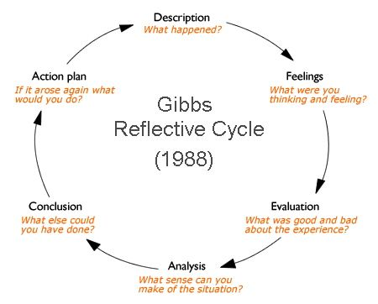

The managerial coaching and mentoring support, I provided proved successful in order for the employees to take their correct annual leave allowance and for the managers to maintain and monitor any annual leave changes. A successful tool which was formed was the new starter annual leave booking form, which can be utilised for new employees, throughout the year. By coaching managers to work on the service annual leave planers, they were able to make sufficient changes immediately using their newly learnt skills, this would include, taking leaver staff off the planner, adding new employees, and making annual leave changes on request, they therefore had a clear tracker of their direct employees’ annual leave.
The barriers faced during this was if a manager had to cancel a session due to lack of staff or the possible difficulty with software and time to ensure all the correct documentation is completed around the annual leave processes

References Accipio (no date) Barriers to coaching and mentoring. Available at: https://www.accipio.com/eleadership/mod/wiki/view.php?id=1795 (Accessed 04/12/21). CIPD (2021) Coaching and Mentoring. Available at: https://www.cipd.co.uk/knowledge/fundamentals/people/development/coaching-mentoring-factsheet (Accessed 03/12/21). Clevermemo (no date) 14 effective coaching techniques and tools every coach should know. Available at: https://clevermemo.com/blog/en/effective-coaching-techniques/ (Accessed 04/12/21). Clutterbuck, D (2014) ‘What every HR director should know about coaching and mentoring strategy’ BMPD5014: Contributing to Coaching and mentoring in the organisation Available at: https://davidclutterbuckpartnership.com/what-every-hr-director-should-know-about-coaching-and-mentoring-strategy/ (Accessed 04/12/21). CIPD (2019) ‘Professionalising learning and development’ BMPD5014: The CIPD’S new Profession Map and Key L&D development needs. Available at: https://moodle.uwtsd.ac.uk/pluginfile.php/334899/mod_resource/content/1/CIPD%20professionalising-learning-development-report19_tcm18-53783.pdf (Accessed 04/12/21). Mindtools (no date) The GROW Model of Coaching and Mentoring. Available at: https://www.mindtools.com/pages/article/newLDR_89.htm (Accessed 04/12/21) The general teaching council for Scotland (no date) Coaching and Mentoring. Available at: https://www.gtcs.org.uk/professional-update/coaching-and-mentoring/ (Accessed 03/12/21). White paper (no date) How coaching & mentoring can drive success in your organization. Available at https://www.opm.gov/wiki/uploads/docs/Wiki/OPM/training/Mentoring/How%20Coaching%20%20Mentoring%20Can%20Drive%20Success%20in%20Your%20Organization508.pdf (Accessed 04/12/21). Quiver management (2017) Coaching for organisational objectives – the missed opportunity. Available at: https://www.quivermanagement.com/2017/01/12/coaching-for-organisational-objectives-the-missed-opportunity/ (Accessed 04/12/21).

