Writing Module: Effective Team Working and Communication
Student Name: Renaldo Jose Juman
Student ID: 2114362
Module Code: BMSW 4002
Tutor: Mr Dale Clarke
Assignment Title: Effective Teamworking for Team Success.

Table of Contents
Introduction 3
Developing an effective team. 4
Types of effective team roles. 5
Type of impact can effective teamworking have. 6
(Tuckman, 1965) 7
Barriers to effective teamworking. 8
References 11

Introduction

The assignment I am about to write is a report about effective team working for team success. Let take a moment and explain what effective team working is first before explaining what team success is.
In an organisation effective team working is very important which can increase motivation in employees’ attitude and initiative, regardless of they are physically present or not, which helps develop success in that company. In effective team building one of the most important skills is communication, which help process wonderful outcomes. Apart from communication other attributes to effective team working are openness (willing to know other team members), respect (to have constructive feedback and mutual respect for others’ opinion), trust (team members are comfortable with each other to share ideas and feelings).
(Leadership Management Australia Pty Ltd, n.d.)
With team success the focus on goals and results which comes from good leadership, they offer each other support by having fun and communicate well with each other. Team members do achievement diverse.
Effective team work can have a positive and negative impact and staff and even on a leader. Some team leaders must show that they are willing to go beyond and above their duties to provide integrity to their team, which comes with successful team leadership. Having the abilities to solve problems, motivate the team, care for the health, safety and well being for his team.

Developing an effective team.

The objective of team work is defined by “as a cooperative process that allows ordinary people to achieve extraordinary results” (Scarnati, 2001). Harris & Harries also explain that a team has a common goal or purpose where team members can develop effective, mutual relationships to achieve team goals. Team work replies upon individuals working together in a cooperative environment to achieve common team goals through sharing knowledge and skills. The literature consistently highlights that one of the essential elements of a team is its focus toward a common goal and a clear purpose (Harries, 1996). Teams are an integral part of many organizations and should be incorporated as part of the delivery of tertiary units. Successful teamwork relies upon synergism existing between all team members creating an environment where they are all willing to contribute and participate in order to promote and nurture a positive, effective team environment. Team members must be flexible enough to adapt to cooperative working environments where goals are achieved through collaboration and social interdependence rather than individualised, competitive goals (Luca, 2001).

Types of effective team roles.

In doing this research there are numbers of attributes required for successful teamwork.
- Open Communication and positive feedback – Listening to other team members, sharing information, ability to give real time and frequent feedback across all directions is a positive sign of open communication between peers, co-workers.
- Interdependence - Refers to team members rely on each other for the functioning of their teams. During team meetings and planning sessions, which highlights group’s interdependence.
- Commitment to team processes, leadership & accountability - Each team members need to be accountable for their actions and contribution to the project. Being aware of the team progress, ideas and practice. Effective leadership in a team help with making great decision and solving problems.
- Commitment to team success and shared goals – Commitment to team success helps support the team decisions and recommendations which focus on achieving team purpose over and above their individual objectives.
- Interpersonal skills - In a team there is a lot of different personalities, which might have a lot of problems in different ways. mainly how there verbal or non-verbal communication skills are, or their decision making or problem solving impacts in the team. Sometimes their interpersonal skills can show consideration for others, even respect and support in difficult times.

Type of impact can effective teamworking have.

- Reinforce a shared purpose - Each team members are connecting to the mission, which help effective leaders to build a collective sense of shared purpose and connect everyone to the mission of a larger team.
- Providing role clarity - Ensure each a team member knows their roles and understand each other positions and parts played in the project and what areas they need to focus on. Even providing necessary instructions in how to do the task.
- Team working matters – Some teammates learn from each other which motivate them to work even harder and faster, which strengths working relationships such communications skills, strengths, habits, talents and even weakness.
- Be aware of emotional security – Having the idea of feeling safety in a team is relieving, which helps, with building confidence to take risks and feel challenged and excited to try new things which obtaining a freedom of apprehension.

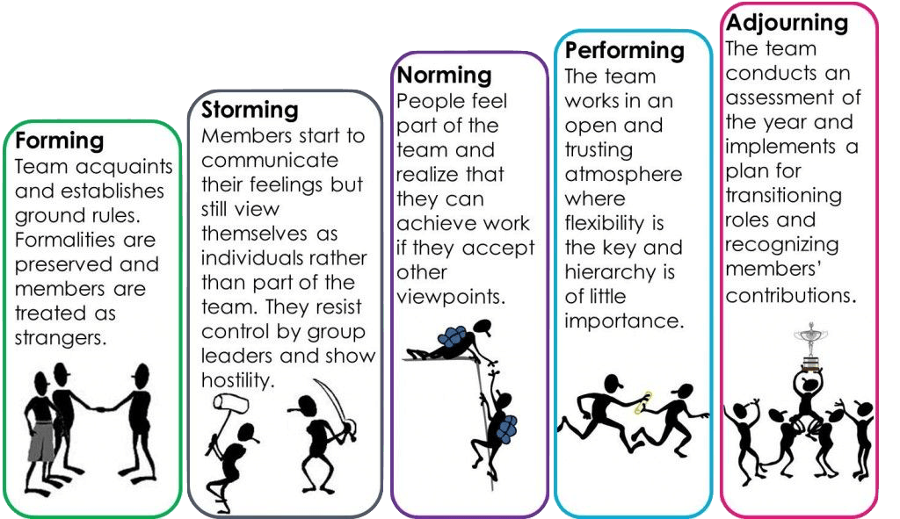

(Tuckman, 1965)

Bruce Tuckman explains in the model that team members come together to reach a place of stability where they can perform to the best of their abilities.
Would explain it in the way simpler

- Forming - Accepting a leader’s guidance and authority would maintain a relationship without disagreements.
- Storming - Trying to battle with feelings and wondering who will support or undermine them and proving the leader their value to the team.
- Norming - This when you feel part of the team. One unity, working together for one course, trying to achieve every goal possible.
- Performing - The leader and team members would recognise their contributions of one other and ensure that credit is awarded where it is needed.
- Adjourning - When it comes to a stage where team members have a sense of closure, knowing the team successfully finish their project, and for team members to look back to the beginning and notice how far they come as a team.
Barriers to effective teamworking.

"Much of the work that has been written about teams and team work focus on the assumption that some teams are more effective than others. While team effectiveness can be judged by measuring the productive output of the team", For teams to work together successful they often need to overcome several barriers. The basic benefit of team is many minds and bodies working together to accomplish a common goal. Truly successful teams take advantage of the unique strengths and perspectives of the individuals that make up the group. However, often the differences themselves preclude effective communication and connection to get to the very advantage that is sought. The following is a quick list of barriers that teams must overcome to function together successful and some notes how to overcome the barrier. (Tahir Nadeem, 2015)
- Lack of connection between team members and team leader, which can strongly damage decisions making.
- Some team members wouldn’t be able to take in other team members because they are saying or thinking something different.
- Members for the team might not finish project because luck of knowledge of the tasks or when is the deadline.
- The common goal is not clearly defined or bought into by all team members. Some people enjoy the social interaction of team so naturally adjust well to working in a team, others however would prefer to be individual contributors. If individuals do not understand the common goal, they are less likely to stretch themselves to work together as a team to accomplish. Ensure the group understand the goal they are trying to achieve as a team and the benefits of working together as a team. (Tahir Nadeem, 2015)
- Some teams are bought into the common goal and not clear what to do.
- Teams can experience challenges if they don’t understand the fundamental of their work that is given to them.
- Having a communication gap can be a problem in some groups. With out communication explaining their perspectives can be challenging and pointless.
- Having face with accountability issues can be challenging for a team, where no one once to take responsibility for not meeting deadlines or finishing projects.
- Working remotely on terms, whatsapp, skype can also happen a team performs as they are not faced to face with each other, communication can be complex and complicated.
- Some professionals find it is easier to work for an incentive, if there are lack of incentive teams does not work well together because there is no purpose.

Conclusion

As a team leader there is a lot of ups and down, hard decisions making which mostly happens to be the team leader fault, not other members of the team. Some would be upset, some would want to leave, some would not want to listen and even some would not want to contribute. Sometimes evaluating your team’s effectiveness from the beginning, can help by keep barriers and chaos from truly holding back your team.
Even taking step to correct some issues can help a team achieve these goals.
Teamwork is becoming increasingly important in contemporary organisations, and as long as teams are formed, managed and implemented effectively, can provide a source of competitive advantage in terms of increased employee satisfaction, creativity and innovation. However, if teams are assigned to inappropriate tasks, are managed ineffectively or not provided with adequate support, resources and autonomy to carry out their tasks then the effect of teamwork can be counterproductive. Teams are formal groups assigned by management that have shared goals. There is a difference between teams and groups; groups can exist without teams, but teams cannot exist without groups. Therefore, the impact of group behaviour and group dynamics will have a significant impact on the overall performance of the team. Therefore, management must be awareness of the presence of groups that create their own norms and personal goals, which may deviate from the objectives of the team. Therefore, teamwork can be is a complex management area, yet if carried out effectively, the results can be very rewarding. (UKEssays, 2018)

References

Harries, P. H. &. K., 1996. Managing Effectively Through Teams. An International Journal , 2(3), pp. 23-36.
Leadership Management Australia Pty Ltd, n.d. Leadership & Performance Development. [Online]
Available at: https://leadershipmanagement.com.au/effective-teamwork-the-key-to-success/
Luca, P. T. &. J., 2001. Does Emotional Intelligence Affect Successful Teamwork?. roceedings of the 18th Annual Conference of the Australasian Society for Computers in Learning in Tertiary Education at the ASCILITE, pp. 367-376.
Scarnati, J. T., 2001. Team Performance Management. An International Journal, 1 Feburary , 7(1/2), pp. 5-10.
Tahir Nadeem, 2015. Linkedin. [Online]
Available at: https://www.linkedin.com/pulse/top-5-barriers-effective-teamwork-tahir-nadeem
[Accessed 20 June 2015].
Tahir Nadeem, 2015. Linkedin. [Online]
Available at: https://www.linkedin.com/pulse/top-5-barriers-effective-teamwork-tahir-nadeem
[Accessed 20 June 2015].
Tuckman, B., 1965. 8 model of team effectives. [Online]
Available at: https://medium.com/@RiterApp/8-models-of-team-effectiveness-3a3b84efb3ae
UKEssays, 2018. The Importance Of Team Work Management Essay. [Online]
Available at: https://www.ukessays.com/essays/management/the-importance-of-team-work-management-essay.php#citethis
[Accessed 1st January 2015].

