Professional Skills and Health & Safety in Construction
Keaton Lewis Davies
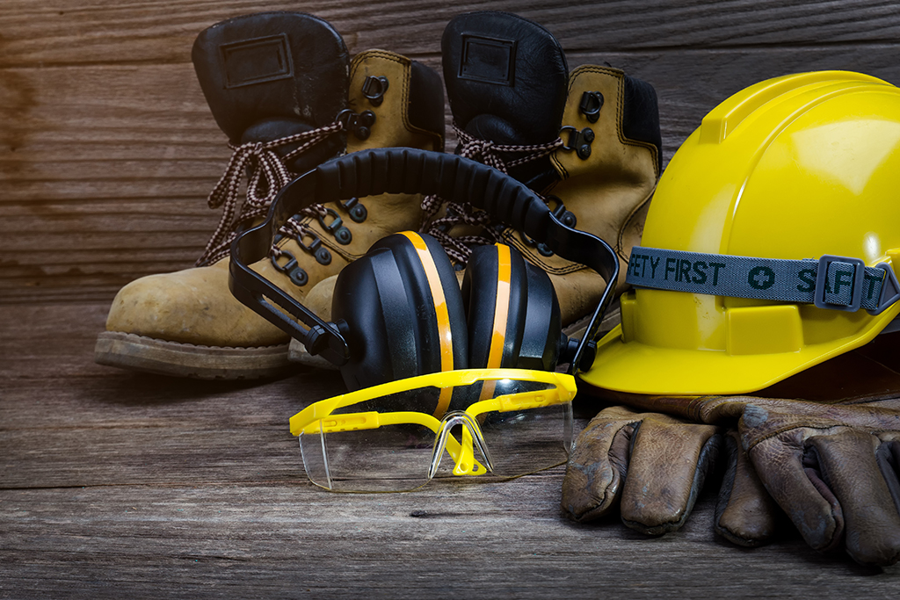
ACBB4003
Word count: (1,043 excluding references.)

(www.lawdonut.co.uk, n.d.)

Table of Contents
Introduction 3
Have we been measuring safety all wrong? 3
How can technology help Safety within the construction industry? 4
What’s different between Safety I and Safety II? 4
Conclusion 4
References 5

Introduction
In this assignment, we look at the efficiency and accuracy of the health and safety measurement techniques currently used by the construction industry. While accident rates and other standard measures have long been important components of safety assessments, there is growing concern that these methods may not adequately capture the complex aspects of health and safety on construction sites. We examine the flaws of current approaches, look at possible issues with gauging mental and emotional health, and weigh the effects of technology breakthroughs. The purpose of this investigation is to encourage a more proactive and comprehensive approach to safeguarding the safety of workers in the construction industry, as well as to force a revaluation of present procedures.

Have we been measuring safety all wrong?
While construction sites are very dangerous, the construction industry has long been known for its emphasis on safety. However, a thorough study of safety measures and processes raises the possibility that the sector has been assessing safety in a way that leaves out important dangers and areas for improvement. Usually, indicators including injury rates, accident frequency, and adherence to regulations have been used to measure safety in the construction industry. Although these measurements offer insightful information, it's possible that they don't fully capture all of the many variables affecting employee safety on construction sites.
The effective morality of traditional safety measurements is one of the downsides. Accident frequencies and injury rates are usually calculated after the fact, offering a reactive rather than a proactive approach to safety. The industry's capacity to recognise such hazards and take appropriate action before they cause harm may be limited by this prospective focus. A construction workplace that puts employee well-being first requires an organisational change towards a more proactive, predictive, and preventative safety environment.
In addition, the focus on trailing indicators like injury rates may unintentionally encourage event underreporting. Due to the worry about the consequences or possible delays in project completion, construction workers could be reluctant to disclose near misses or minor injuries. Underreporting hides important information on occurrences that may be early indicators of more serious accidents, it has the potential to change the real picture of safety.
Warning signs should be taken into consideration by the construction industry as it strives for a more thorough safety measuring strategy. Proactive measures known as leading indicators give information about the effectiveness of safety programmes before events happen. These might involve putting safety training programmes into place, conducting frequent safety audits, monitoring employees' well-being with technology that is worn, and reviewing near-miss incidents. Through the utilisation of leading indicators, the construction industry may promptly recognise and manage possible risks, avoiding disasters and nurturing an environment of ongoing enhancement.
It is also important to take into account the cultural and psychological aspects of safety. Construction workers' mental and emotional health is just as important as their physical safety, despite the fact that standard measures mostly concentrate on the physical measures. Long work hours, unstable employment, and high-stress work situations can all lead to mental health issues for construction workers. Ignoring these things might cause you to become less focused, make more mistakes, and be less satisfied with your work in general. Consequently, a comprehensive approach to safety assessment should take into account both mental and physical health, realising that a safe and effective workforce is one that is in good physical condition.

How can technology help Safety within the construction industry?
The construction industry has to evaluate how technology is used to quantify safety as well. Modern technologies have the power to completely change safety procedures. Examples include sensors, artificial intelligence, and data analytics. Wearable technology can track physiological markers to provide real-time information on employees' levels of stress, exhaustion, and general wellness. Drones with cameras and sensors built in may check sites to find any risks and make sure safety procedures are being followed. These technologies improve accuracy and encourage a proactive approach to risk mitigation when integrated into safety measuring techniques.

What’s different between Safety I and Safety II?
A fundamental change in safety measurement is provided by the idea of a Safety-II method as opposed to a conventional Safety-I approach. Safety-I emphasises the avoidance of unfavourable consequences and the reduction of accidents and injuries. On the other hand, Safety-II recognises that complex systems are inherently variable and adaptive. It places a strong emphasis on realising the elements that lead to success, comprehending how things work well, and applying this understanding to improve safety performance. Using a Safety-II approach promotes a broader understanding of how complex and dynamic construction projects are, and how resilience and adaptation are essential for maintaining safety in a constantly changing environment.
On top of that, establishing a collaborative and communicative culture is essential to efficient safety measurement. Numerous parties are involved in construction projects, including employees, owners, contractors, and subcontractors. Enhancements to the industry as a whole may be encouraged by making sure that safety information is openly shared and that lessons from one project are applied to others. A more uniform and thorough approach to safety measurement throughout the construction industry may be made possible by collaborative efforts to standardise safety measures and best practices.

Conclusion
In conclusion, it's possible that the construction industry has been measuring safety in a method that misses out on a variety of dangers and chances for development. Although useful, traditional measurements could only provide a portion of the picture when it comes to safety performance. It is vital to make an approach shift that includes integrating the most recent findings, emphasising mental and emotional health, integrating modern technology, and moving towards a Safety-II strategy that places an emphasis on adaptation and resilience. The construction industry can guarantee the health and well-being of its employees as well as the success of its projects through using a more proactive and thorough approach to safety measurement. This will also make the workplace safer, healthier, and more productive.

References
www.lawdonut.co.uk. (n.d.). Health and safety FAQs. [online] Available at: https://www.lawdonut.co.uk/business/health-and-safety/managing-health-and-safety/health-and-safety-faqs (Accessed 4 Jan. 2024).
Staff, C.M. (2023). Have we been measuring safety all wrong? [online] Construction Management. Available at: https://constructionmanagement.co.uk/have-we-been-measuring-safety-all-wrong/.
Martins, J.B., Carim, G., Saurin, T.A. and Costella, M.F. (2022). Integrating Safety-I and Safety-II: Learning from failure and success in construction sites. Safety Science, 148, p.105672.: https://doi.org/10.1016/j.ssci.2022.105672.
Xu, J., Cheung, C., Manu, P., Ejohwomu, O. and Too, J. (2023). Implementing safety leading indicators in construction: Toward a proactive approach to safety management. Safety Science, 157, p.105929. : https://doi.org/10.1016/j.ssci.2022.105929
Emily (2023). Implementing technology to improve safety on construction sites. [online] Open Access Government. Available at: https://www.openaccessgovernment.org/implementing-technology-to-improve-safety-on-construction-sites/149285/
Kolosky, C. (2023). Pioneering Protection: How Technology is Revolutionizing Construction Safety. [online] Online Database Software: Use Knack For Custom Online Databases & Systems. Available at: https://www.knack.com/blog/construction-technology-safe/

‌

‌

‌

‌

