Student Name:
Student Number:
Module Code: Managing Projects in The Organisation
Module Title: BMSK5004
Assignment Title:
Module Lecturer’s Name:

Table of Contents
Introduction: Defining project and overview of Company 3
Identification of a project in my work: Project Title and Clear deliverables 4
About the project Plan: Timing of project, Project manager and other participants 4
Body 5
Sponsors, Stakeholders & Scope of the project 5
Tools & techniques of project management 6
Communication methods for the proposed project 8
Benefits of managing this project 9
Characteristics of project managers 10
Supportive organisational structure for the project 10
Discussion about different types of project and project objectives 12
Different phases of Project life cycle 13
Division of project through the method of PRINCE2 14
Analysing the project through different Risk management techniques 14
Impact of soft skills for better project management 16
Analysing critical issues of stakeholders in the project 17
Feedback from Critique about the project 17
Evaluation of the project 17
Reflection: Evaluating my ability to manage a project 18
SWOT of myself as a project manager 18
Personal development plan (PDP) for improving my ability in this project 19
Conclusion 20
References 21

Introduction: Defining project and overview of Company
To solve problems or to grab different types of opportunities; a new idea, or innovative solution which are called project management is very important for every organisation. This report has been made on complex situation of BBC case study and ways to solve this difficult situation as a project manager by myself.
Definition: Project can be defined as a group of activities which is planned before actual operation of the project with specific deadlines assigned for each activity for the purpose of achieving specific objectives out of the resources applied in the project (Reiss, 2015). Whereas project management refers to the team which undertakes a project, works collaboratively solving the problems out of the ways of project action and targeting a specific goal.
Overview of the selected company facing a complex situation: BBC World News formerly known as BBC World has been selected for completing this report (Home - BBC News, 2020). It is an international media channel owned by the British Government and launched in 1995 as a pubic media company. It had been positioning on top in the largest market share (31.57%) in UK and had a strong number of listeners worldwide as well by 2017. BBC has 15 sister channels as a part of attracting audiences on this media taking and taking different projects.
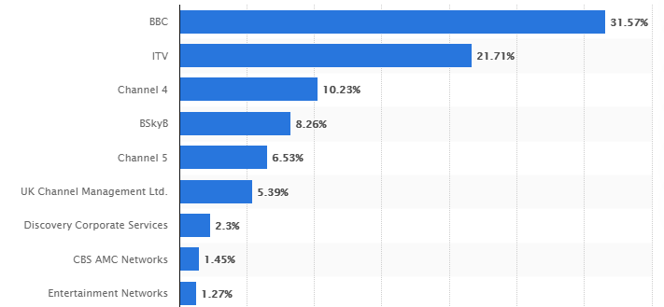
Figure: Market of share of BBC by audience
(UK: TV broadcasters market share 2017 | Statista, 2020)

Identification of a project in my work: Project Title and Clear deliverables
The problem with BBC World is they could not increase audience base because of changing pattern in consumers’ preference for content and being an entertainment, news media and public relation company, BBC needs to change content as per how audiences prefer to listen to and watch. Being part of a distinguished media company in UK I have found that the company is facing sever gap between its employees and the goals the company wants to achieve (Maylor, 2005). This gap has led employees to have a sense of separation among themselves and this divergence has become the biggest barrier for BBC to innovate good content and to achieve better financial performance as well (Home - BBC News, 2020). So, to reduce this gap a project has been undertaken titled as-
“Developing a better workplace culture for achieving desired goals of BBC World”
Beyond these results this project has been aimed to deliver project results through application of organisational motivational techniques to increase engagement of employees so that they find the goal of employees very relevant to their personal goals.

About the project Plan: Timing of project, Project manager and other participants
This project will be run for 1-year period and from starting to finish of the project, each activity of the project will be divided to be accomplished within a certain time period. But within this 1-year time period there will be result checking after every 3 months period beyond 6 months of application purpose. This project will have two important authority for showing output of project; one is WEx which is the executive team of BBC and another one is GLT of BBC which is composed of senior officers (Müller and Turner, 2010). In this project these two group will be included I will be assumed to take the role of a project managers.

Body

Sponsors, Stakeholders & Scope of the project
When a project is undertaken, its sponsors, stakeholders and scope in terms of relevant areas to go through have to be analysed to make the project successful. Because without knowing these project managers will not understand who are part of the project and thereby need to be prioritised who are not.
Sponsors of Project: The owners, idea generator of this project who do not get involved in the day to day operations of the project and still they are very important part of the project as they work for the project as one step level up of the project leader. They help the project to run by giving resources, strengthening capabilities of the team member, providing funds, inspiration and valuable suggestions (Müller and Turner, 2010). The independent directors, non-executive directors of board can become sponsor of the project.
Stakeholders of the project: Stakeholders of BBC project are every people who will be affected by the outcome of this project.

Figure: Project stakeholders for changing employees’ way of thinking
Source: (Made by Author)
Two types of stakeholders are there; internal stakeholders and external stakeholders. Internal stakeholders are the part of this project who will directly control the operations or take part in the project for example- the project team will undertake the organisational motivation tools and techniques as per the work breakdown structure (Kerzner, 2017). The internal stakeholders will both run the project and enjoy the benefits of the project on the other hand, the external stakeholders will be affected by the outcome of this project for example the shareholders who will not participate in this project rather will get the benefit in term of increased return on investment as the efficiency and audience of BBC will rise for this project.
Scope of the project: This project has a very widespread scope in perspective of BBC World because it covers all the employees, overall workplace pattern, organisational structure etc. and most important this project will change the attitude of employees towards the meaning of BBC (Maylor, 2005). Thus, this project includes the behavioural, motivational, communicative tools and techniques through which employees will be convinced that BBC cares for its staff (Reiss, 2015). This project will clearly articulate its goal to all the employees of BBC that the company want very meaningful content with the best presentation ways to audiences. As this project is about improving the workplace of an organisation, it has a very long lasting and impactful scope.

Tools & techniques of project management
There are different tools and techniques for project management and the appropriate of those techniques depends on the objective or type of project. One project might give better result with one technique but it does not mean that technique will be useful universally. So, before selecting a technique the appropriateness of the technique being used should be determined. Some of the relevant techniques for this project are:
Waterfall techniques: This is a classical technique for project management where every task is completed following a sequence. After successfully finishing one step the nest step is undertaken so that the whole project is checked, reviewed at every step for moving forward with a new one which is similar to the concept of waterfall (Heerkens, 2015). This technique will give better result for workplace culture maintenance of BBC if the project team addresses the challenges that staff faces in the company and thereby selecting which one to solve first and which one to solve later. Designing what motivational, behavioural strategies would change the environment will be implemented and verified and maintained with support sequentially.
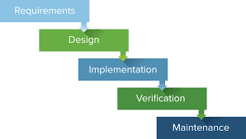
Figure: Steps of Waterfall technique (Leach, 2004)
Gantt Chart: Gantt chart is also a useful technique as it helps the project manager in tracking, controlling the activities of the project underlining the percentage of completed task and what new task are there to be completed (Kerzner, 2017). It makes the project management activities more visible, transparent because members in a team can quickly track their activities and can be more accountable for their tasks as each series of activity shows who is responsible for what and how much is done with starting and finished dates of the project.
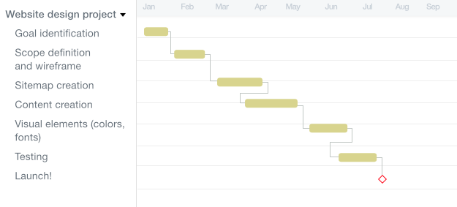
Figure: Gantt Chart showing different series of activities with progress
Source: (Maylor, 2005).
Work Break Down Structure technique for project management: This technique helps the project tasks to be broken down or distributed among different teams of the project (Meredith & Mantel, 2009). From initiation of a project to final completion, lot of tasks need to be completed and without proper assignment of the tasks to be done the project leader will not be able to finally coordinate all the broken-down tasks and make accountable of specific department’s job.
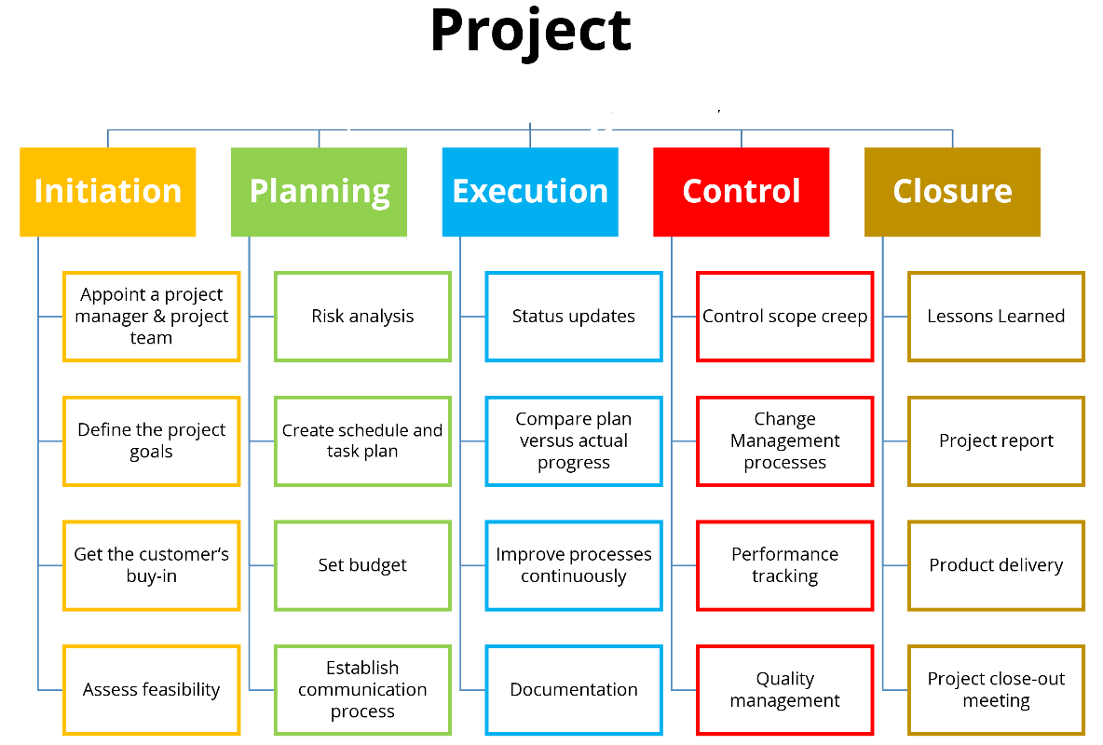
Figure: Work Breakdown Structure (WBS) for Project management (Reiss, 2015)

Communication methods for the proposed project
There are several ways to communicate a project with the participants and other related ones such as- interactive communication methods, push methods and pull methods. For this project interactive communication methods are most important and most useful as changing workplace environment, changing attitudes of employees require a very cooperative and coordinated workplace (Berkun S,2008). In some cases, push and pull methods are also useful where communication objective is not complete understanding of the whole issue and further understanding can be provided. Use of different methods have been mentioned below-

Figure: Communication methods of workplace changing project in BBC World
Source: Made by Author

Benefits of managing this project
Project management can have so many benefits and most of them are generally the results of objectives primarily set when the project was undertaken. Some of the benefits of managing project have been explained below-
Achieving desired results: By managing project carefully, it can be assured that desired results will be achieved and without managing project, all the resources may end up being used showing no outputs (Kerzner, 2017). For example- this project of BBC World will help to achieve its desired results like-
- To achieve financial stability with excellent return for investors and the company as well
- To establish a strong position and reputation for the brand BBC World
- To expand the outreach of the company to be a famous world class media company
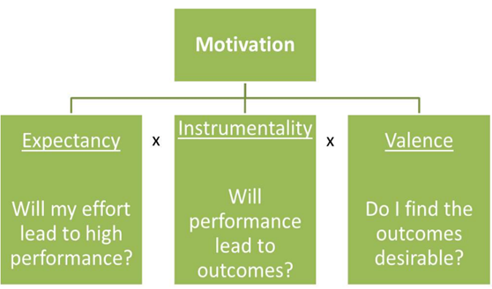
Figure: Motivating employees to work for the organisation (Berkun S,2008)
Efficient use of business resources: Project management ensure efficient usage of organisational resources with the help of techniques it uses such as- Work Break-down Structure and OBS ensures which department will do what task and it increase responsibility of employees (Meredith & Mantel, 2009).
Proper use of budget: Every company announces a yearly budget every year and without proper project management for every action, the costs as per budget will not be possible to maintain.
Increased motivation, productivity and effectiveness: OBS, Gantt Chart techniques used in project management ensures that overall organisation will fall under a set structure which will raise certainty of assigned job, monitoring, better review and thus will increase motivation and productivity of employees.

Characteristics of project managers
Every project manager should own certain characteristics for leading the project team for successful completion till achieving end results. These are-
- A project manager should have strong sense of responsibility feeling an owner himself/herself for the completion of whole project
- Project manager should not react to the project team members rather he should be proactive with suggestions that can correct a mistake (Reiss, 2015)
- Project leader should own the quality of meaningful and constant communication
- Project manager should be authoritative which means to be strict with rules, and guidelines of the project but softly not being hard to project participants (Heerkens, 2015)
- He/she should be able to properly distribute the project’s every activity understanding the ability and scope of every task.
- Project leader should be a good decision maker and very diplomatic in delegation of tasks

Supportive organisational structure for the project
Any project management is part of the overall organisation or sometimes it can be just a small part of the overall project but considering a project separately out of the organisation no matter what is its impact in general can lead the project to be very unsuccessful. So, any project is part of the whole organisation and thus have great influence in overall output of its activities if it becomes successful in terms of achieving desired results (Cakmakci, 2019). The overall organisational structure should be very supportive towards any project taken because successful project will have significant potential return (Maylor, 2005). If the organisational structure creates barrier for the project, it will not get the necessary resources for efficient running. BBC workplace improvement project requires to change attitudes of employees so that they get a clear idea what the company wants from them. This support can be ensured through the use of OBS explained below-
Organisational Breakdown Structure (OBS): This technique is especially important for making departments of the organisation responsible and collaborative so that each department can know who will report to whom. For example- in the selected project of this report, the project manager will jointly work together with HR department and Quality manager.
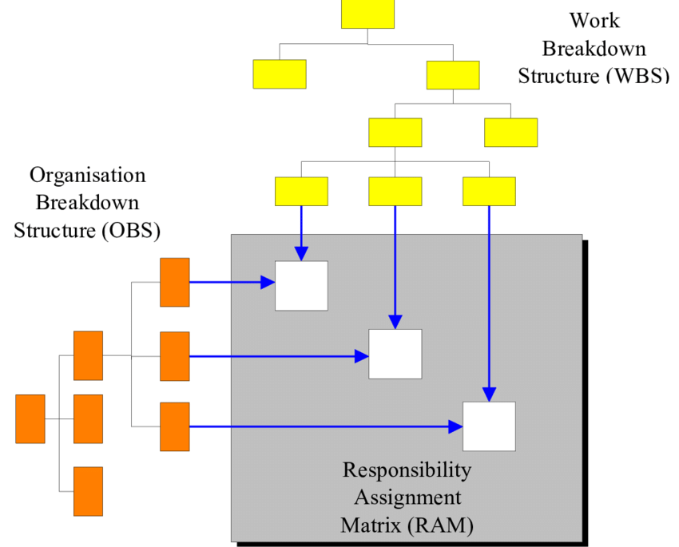
Figure: Combined support of WBS and OBS for making project successful (Pedersen, 2013)
Because changing employees’ attitude is important for getting innovative, quality content from their heads and thought about the company. As employees are there in every department and BBC wants to achieve excellent return for shareholders, both HR and Quality department and all other functional divisions of BBC need to come forward so that whole organisation can work very closely.

Discussion about different types of project and project objectives
There can be different types of projects arising out of different opportunities or problems for example- manufacturing projects, management projects, construction and research projects. Each of these types of projects are different based on the objectives for which the project has been made (Meredith & Mantel, 2009). For example- manufacturing projects are undertaken for production of new products, construction projects are for building new offices, shops etc., research projects are taken for discovering some idea, theory, or for scientific, statistical, and data-related jobs. Management projects are the main concern of this report because the case study of BBC is about management where employees need to be managed.
Objectives of this project are:
- To stop the practice of not sharing information within different departments of the organisation so that employees find the workplace very open and inclusive to them
- Build strong collaboration of work among different regions and the headquarter office
- To grow the sense of accountability within each staff of BBC (Heerkens, 2015)
- As the CEO is trying to be One BBC, the meaning of this statement should be reached to every employee working in BBC regardless of region serving
- To increase motivation among employees
- As the media world has been changing, simplicity is highly important and should be targeted by every staff
- Trust & respect of employees for BBC should be increased with the establishment of new ways of working
- Both team and success of individual employees should be appreciated and rewarded immediately
- Being a company in public relation, its staff should focus in creative content

Different phases of Project life cycle
Every project follows a sequence of certain phases from initiation to completion until it becomes a successful step. In each of the step, the project manager and team members have to do certain activities to move forward for the next phase which have been explained below-
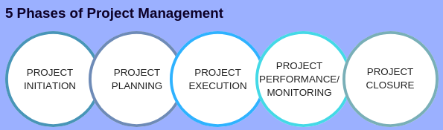
Figure: Five stages of project life cycle (Maylor, 2005).
Project initiation: First of all, an idea, a problem or an opportunity is identified and after analysing the future potentiality of the opportunity, future disruptions of the problem the responsible organisation takes decision whether to undertake necessary actions to get over of those ideas, or opportunities or not (Berkun S,2008).
Project planning: Then project is planned determining what will be the benefits of this project, what techniques will be used in this project, the time-frame for each sub tasks etc. Delegation of each task, dividing each department’s’ responsibility are also planned here.
Execution: After executing all the activities as per planned project gets one step further. This phase deals with the actual functions of the project where every responsible team has to finish their assigned jobs here.
Performance evaluation/ monitoring: Project performance is evaluated after execution to compare the planned results with the actual results (Cakmakci, 2019). If the expected results are not met, corrective actions are taken for further improvements.
Closure: When the corrective measures are done and the project shows actual result such as- final development of target product or service, expected results of any management problem etc, the project is announced to be closed.

Division of project through the method of PRINCE2
PRINCE2 refers to managing and controlling of projects in a controlled environment where each of the task follows a specific guideline and set principles which help the project for successful completion (Heerkens, 2015). It is a certification about the quality of a project which ensures the project sponsor and overall team that the project complies with certain principles and phases. These are-
- The project will be considered as A continuous process of justification where every stage of the process will ensure to go for next step
- The team members, project manager will thrive to learn from each activity of project operations even if the project fails or gains success
- Every team member should have definite and individually assigned task roles so that they can be accountable and feel enriched of their activities
- Every task will be completed sequentially; completing each step before moving on to another stage of this project.
- When the project fails to meet certain deadlines, it will follow the principle of management by exception setting extra time than scheduled one
- This project will focus on the end results for which the project was undertaken for example- the quality, engagement of human resource management of BBC is the ultimate focus here (Leach, 2004)
- The principles of PRINCE2 method will be modified according to the needs, complexity, size and challenges arising out of the project to make the management more and more flexible. As this project in BBC is mainly management related, this principle is more important for me to ensure two-way communicative workplace culture in BBC World.

Analysing the project through different Risk management techniques
Brainstorming: This technique refers to discussion, open-talk of a group of people where every member in the group has privilege to give any random idea or solution to an existing or potential problem (Meredith & Mantel, 2009). I will use this technique in general so that employees can think freely and thus be more engaged in the workplace of BBC.
Delphi technique: It is like brainstorming but different in the way that it ensures the talk, meeting of group of people be more systematic and structured especially for forecasting, future projections and taken more formally as face-to-face communication.
Risk breakdown structure: this technique allows the project to be designed as per the risky areas where there is future potentiality to have unexpected result. The risks of BBC World project will be broken down surrounding different departments it will be affected or have influence. This technique will help me to separately identify or plan expected preventive actions under each department.
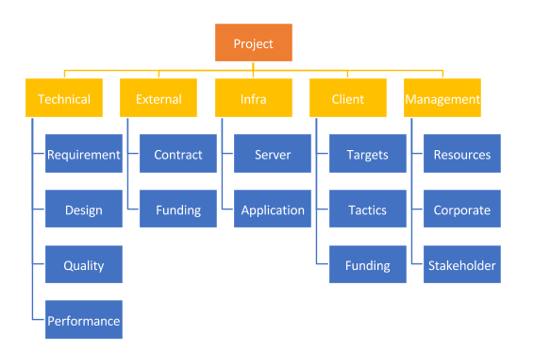
Figure: Risk breakdown structure
Source: (Meredith & Mantel, 2009).
Probability and Impact Matrix: This technique identifies different uncertain, challenging activities with two different criteria; one is probability of unexpected event occurring and second is impact of that event on this project (Cakmakci, 2019). If the probability of event occurring and impact both are high, I will focus on every possible way to prevent that even from occurring whereas if both are moderate and one moderate, another high or vice versa, that risk will be ignored. If any of the category is moderate, the event will be considered unacceptable and thereby needs preventive actions early
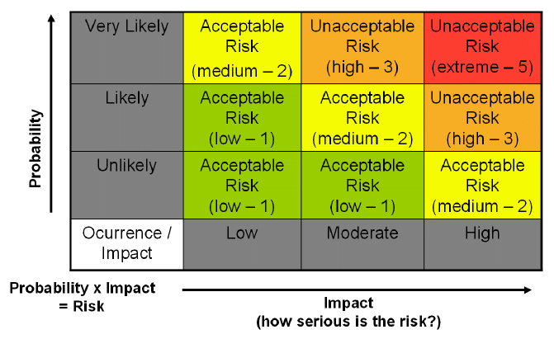
Figure: probability and impact matrix for managing project risk (Leach, 2004)

Impact of soft skills for better project management
Softs skills refer to emotional, personal attributes, attitude, behaviour and necessary social qualities of project leader which help him/her to be a great leader to successfully lead and motivate followers for doing a task (Home - BBC News, 2020). Without these people skills I will not be able to modify particular HR of BBC Project towards the ultimate goal
- Leadership
- Communication
- Critical thinking
- Analytical ability
- Motivation
- Quick decision-making
- Managing conflict
- Building trust, confidence and self-assurance
- Quality of better organising
- Negotiation
- Influencing and coaching team members of the project
As a project leader in BBC’s project I will try to develop these soft skills within the team members and also within myself so that I can ensure sufficient soft skills to influence, modify the behaviour of related employees and convince them the goal of BBC’s One World.

Analysing critical issues of stakeholders in the project
Stakeholder analysis is one of the most important factors in project planning because every stages and end results of the project will affect stakeholders and also will be affected by actions of stakeholders. I will try to ensure the protection of interests and objectives of both internal and external stakeholders as they are the most important parties of an organisation for which BBC World exists.
One of the most common jargon in business world is Fair-trade which refers to exchange of something for something to be done fairly. In BBC Project, I will ensure this fair trade by motivating, engaging employees, making them empowered in workplace environment with a fair trade of increasing shareholders’ return on investment and raising audiences of BBC which will help the company to take care of employees’ personal goals as well (Leach, 2004). The green agenda concept will be highly maintained in this project ensuring that no activities of this project will be harmful for the environment, the community people.

Feedback from Critique about the project
This is a management project and thereby will follow all sorts of organisational, motivational, Huma Resource Management theories and concepts so that the project is sound and gain objectives without any criticism (Cakmakci, 2019). The positive impact of this project will be huge and long lusting as it will make BBC more sustainable. So, this project will surely have very less criticism as it is targeted to do good for all stakeholders of the company but there might be negative impact on employees who will not want to cooperate with project’s recommended practices, tools and technologies which will be a criticism then that few employees might find this difficult and leave the company.

Evaluation of the project
Evaluating project performance maintaining a certain frequency is very important for getting sustainable desired results from the project (Hughes, 2012). For evaluating this project, I need to be even more careful than other projects beyond Management projects because production, construction projects’ evaluation is more straightforward giving solid outcome of the project. For this, after the project completion which means after 6 months, I will ask employees some questions which will prove whether employees have become engaged in achieving BBC’s overall goals or not. The questions will be-
- Do you think BBC’s workplace environment recognises your effort?
- Do you feel engaged and enrichment in the workplace?
- Does the workplace also seem to be practiced in silo working concept or do the information dissemination is equally transparent to everyone?
- Do you properly understand the meaning of ‘One BBC’?
- Can you relate the organisational goals set for you with your personal goals?

Reflection: Evaluating my ability to manage a project

SWOT of myself as a project manager
- My biggest strengths as a project manager are my soft skills like- being socially interactive, ability to negotiate in most convincing ways, to motivate, to manage employees etc. Another most important strength is my learning and knowledge on courses of managing projects successfully where I have learned many techniques, tools and strategies for successfully leading a project (Meredith & Mantel, 2009).
- There are some weaknesses of mine such as- my experience is not so well so I may not find some stages in this project well known to me and those handlings might be challenging for me. But I can recover these weaknesses over time.
- There are some opportunities for me arising externally which I can aim to convert into my advantage for example- the CEO of BBC is very supportive and also the employees of BBC already understand that they are not engaged in the company and they do not find the workplace motivating. Their cooperative attitude will help me a lot (Heerkens, 2015).
- Threats may come from the competitors of BBC such as they may take stronger workplace actions which may increase their audiences even more thereby minimising the impact of this project a bit. Some employees may not agree with the project’s approaches posing threat.

Personal development plan (PDP) for improving my ability in this project
What are my development objectives? | Priority | What activities do I need to undertake to achieve my objectives? | What support/ resources do I need to achieve my objectives | Dates for achieving my objectives
 |  |  |  | Target date | Actual date
Create a questionnaire for asking employees why they are not satisfied, why they do not feel engaged with BBC | Relevance of each question asked | I need to design each question in such a way so that the objectives are met | I need support from HRM team | 15-06-2020
Find answers of problems that employees have mentioned within Workplace of BBC | Suitability of each solution with problems mentioned | I need to learn all the motivational theories, organisational, leadership technologies for finding best solution | HRM, leadership and change team | 06-07-2020
Implement the solutions by changing workplace culture, motivational tools, reward system etc. | To ensure the quality, openness of workplace culture | I need to ensure the application of organisational, motivational theories | Organisational behaviour, HRM practices | 07-08-2020
Review Date: |  |  |  | 01-12-2020

Conclusion
Every organisation faces different types of challenges or difficulties everyday arising out of the operations in running the employees, production, delivery of products or services, financial performance, etc. This project mainly focuses on giving its staff a better workplace and make feel that they can altogether re-organise BBC’ reputation. This project is to give employees that kind of workplace environment, let them know that Content development is not a separate form of task rather it is coordinated effort. Key ideas are-
- Managing projects successfully is very important for every organisation
- A clear output stating that audiences have developed their attachment and regained trust in BBC World’s content
- Making BBC a world-class company by clearly explaining what BBC means, rise of accountability and coordinated working culture etc.
- Employees of BBC will be considered as participants of the project, and in overall portfolio of BBC

References
Berkun, S (2008) Making Things Happen: Mastering Project Management (Theory in Practice) O'Reilly
Buttrick, R. (2009). The Project Workout: The Ultimate Handbook of Project and Programme Management. 4th ed. Harlow, England: Financial Times/Prentice Hall
Field, M. & Keller, L. Project Management, London: Open University / Thomson Learning, 1998.
Heerkens, G. (2015). Project management (A briefcase book). New York: McGraw-Hill.
Hughes, B. (2012). Project management for IT-related projects (2nd ed.). Swindon: BCS.
Leach, L. (2004). Critical chain project management [ebook] (2nd ed., Artech House effective project management series). Boston, Mass. ; London: Artech House.
Maylor, H. (2005). Project Management. 3rd ed. Harlow, England: FT Prentice Hall.
Meredith, J. & Mantel, S. (2009) Project Management: A Managerial Approach, Asia: John Wiley & Sons
Reiss, G. (2015). Project management demystified London: Routledge.
Kerzner, H., 2017. Project management: a systems approach to planning, scheduling, and controlling. John Wiley & Sons.
Meredith, J.R., Mantel Jr, S.J. and Shafer, S.M., 2017. Project management: a managerial approach. John Wiley & Sons.
Cakmakci, M., 2019. Interaction in Project Management Approach Within Industry 4.0. In Advances in Manufacturing II (pp. 176-189). Springer, Cham.
Charvat, J., 2003. Project management methodologies: selecting, implementing, and supporting methodologies and processes for projects. John Wiley & Sons.
Labuschagne, C. and Brent, A.C., 2004. Sustainable Project Life Cycle Management: Aligning project management methodologies with the principles of sustainable development.
Pedersen, M., 2013. A quantitative examination of critical success factors comparing agile and waterfall project management methodologies (Doctoral dissertation, Capella University).
Pinto, J.K. and Slevin, D.P., 1987. Critical factors in successful project implementation. IEEE transactions on engineering management, (1), pp.22-27.
Gido, J. and Clements, J.P., 2003. Successful project management. Thomson/South-Western.
Rosenau, M.D. and Githens, G.D., 2011. Successful project management: a step-by-step approach with practical examples. John Wiley & Sons.
Müller, R. and Turner, R., 2010. Leadership competency profiles of successful project managers. International Journal of project management, 28(5), pp.437-448.
Statista. 2020. UK: TV Broadcasters Market Share 2017 | Statista. [online] Available at: <https://www.statista.com/statistics/269983/leading-tv-broadcasters-in-the-uk-by-audience-share/> [Accessed 16 April 2020].
Inloox.it. 2020. What Is A Work Breakdown Structure?. [online] Available at: <https://www.inloox.it/project-management-glossary/work-breakdown-structure/> [Accessed 16 April 2020].
BBC News. 2020. Home - BBC News. [online] Available at: <https://www.bbc.com/news> [Accessed 20 April 2020].
Project Smart. 2020. SWOT Analysis In Project Management. [online] Available at: <https://www.projectsmart.co.uk/swot-analysis-in-project-management.php> [Accessed 20 April 2020].
Teamgantt.com. 2020. Work Breakdown Structure (WBS) In Project Management | Teamgantt. [online] Available at: <https://www.teamgantt.com/blog/how-to-estimate-projects-accurately-using-a-work-breakdown-structure> [Accessed 20 April 2020].

