Module Name: LCLM6005 Independent Project

Element 1: Independent Project

Research Topic: The impact of AI-driven tools and technologies in managing supply chain disruption and customer experience: A case study of Ocado Group and the Retail Industry.

Student Name: Cristina Morariu
Student ID: 2227087
Supervisor Name: Roopa Aruvanahalli Nagaraju

11/2025

Acknowledgement
I would like to convey my gratitude to my tutors, as without their guidance and supervision, I could not have completed the dissertation properly. I would also like to acknowledge the role of my institute in providing me with the opportunity to work on this research. Moreover, I would also like to thank my parents, as they have contributed to my success and supported me in the ups and downs. Acknowledging all of my classmates, especially the close ones, I would also like to thank my seniors, as all of them have pushed me for conducting this research.

Abstract
In the research introduction, the researcher has set the base for the overall study, providing research background, research rationale, aim and objectives. The literature review has been based on the aims and objectives of the research. To fulfil them in an appropriate way, resources relevant to the use of artificial intelligence to improve customer experience and reduce supply chain disruptions have been evaluated. Furthermore, the chapter identifies the literature gaps to highlight the scope for further research. Whereas a research methodology section has also been included in this research for the analysis to be systematic. Integration of Saunders’ research onion has been included in this aspect. A thematic analysis has also been conducted here with the use of analysing relevant secondary sources. Here, it has been detected that Ocado Group utilises the Ocado Smart Platform in order to optimise its overall operations, including its supply chain. Additionally, the retail sector, along with the firm, faces a lot of challenges, including data quality issues and the complexity of the technology. For overcoming them, setting protocols and using training programmes could be beneficial. In terms of finding quantitative data, the statistical analysis has been conducted, for which information, as well as relevant data, has been gathered from different secondary resources. Discussing the findings from both of these analyses, they have been critically analysed before comparing them and highlighting their limitations. A conclusion section has been added in this research, for the final evaluation of the information included in this research alongside recommendations and limitations.

Glossary
Algorithm: An algorithm is a set of instructions which is followed by an AI tool in order to accomplish tasks in an appropriate way.
Data quality: Data quality could be depicted as the characteristics of any information related to its accuracy, consistency, and relevance.
Supply chain disruption: Supply chain disruption, in simple terms, could be depicted as the interruption in the overall flow of production, along with any disturbances in the distribution.
NLP: Natural language processing (NLP) refers to the technology which allows computers to interpret, manipulate, and analyse the human language.
Predictive Analysis: Predictive analysis in AI uses historical data, statistical algorithms, and machine learning to forecast future events and trends.
Market Size: This is defined as the net number of buyers for any product or service, as well as the sum of revenue those sales might generate within a particular market over any pre-assumed time.
Data Security: The procedure of taking protection of any digital information from unauthorised access, theft, loss or corruption throughout the lifecycle if called data security.

Table of Contents
Chapter 1: Introduction 7
1.1 Chapter Introduction 7
1.2 Research Background 7
1.3 Research Aims and Objectives 7
1.4 Research Questions 8
1.5 Research Rationale 8
1.6 Brief Idea of Methodology 9
1.7 Structure of the Dissertation 9
1.8 Chapter Summary 9
Chapter 2: Literature Review 10
2.1 Chapter Introduction 10
2.2 Conceptual Framework 10
2.3. Review of literature 10
2.4 Literature Gap 14
2.5. Chapter Summary 14
Chapter 3: Research Methodology 15
3.1 Chapter Introduction 15
3.2 Research Onion 15
3.3 Research Philosophy 15
3.4 Research Approach 15
3.5 Research Design 16
3.6 Research Strategy 16
3.7 Research Methods 16
3.8 Research Data Collection and Analysis Techniques 16
3.9 Time Horizon 17
3.10 Ethical Considerations 17
3.11 Gantt Chart 18
3.12 Chapter Summary 18
Chapter 4: Results and Discussion 19
4.1 Chapter Introduction 19
4.2 Results and Findings 19
4.2.1 Thematics Analysis 19
4.2 Results and Findings 25
4.2.2 Statistical Analysis 25
4.3 Discussion 28
Critical review of the findings 28
Comparing and contrasting the two findings 29
Implications or Significance of the findings 29
Explanation of Limitations 30
4.4 Conclusion 30
Chapter 5: Recommendations, Conclusion and Limitations of the research 31
5.1 Introduction 31
5.2 Achievement of Research Objectives 31
5.3 Conclusion 31
5.4 Recommendation 32
5.5 Limitations 32
5.6 Future Research Directions 32
5.7 Chapter Summary 32
References 33

Chapter 1: Introduction

1.1 Chapter Introduction
The introduction chapter will allow establishing the foundation of the research in terms of guiding the reader and providing context, stating the research problem as well as the objectives. It will also help outline the study's scope and significance in the study to create a base and capture the interest of the readers. With the integration of this chapter, the researcher aimed to justify the research while serving as a road map for the entire paper to review. Other than that, it also allowed the information to preview what is to come further in the investigation.

1.2 Research Background
Within recent years, supply chains have become significantly more challenging in order to manage. The rising complexity of product portfolios can be seen with longer and increasingly interlinked which causes disruptions in the operations. After the COVID-19 pandemic, market volatility has seen to elevate the need for flexibility and agility. As a result, companies as well as stakeholders these days are now more focused on enhancing their supply chain to be more resilient. Supply chain management proves to be a potent instrument in terms of organisations to tackle the challenges. AI is already something that is touching most created experiences, while creating a smooth shopping experience, which customers love. Hence, when it comes to integrating AI technology, it has been anticipated that the growth can range from 11.83 billion to 54.92 billion dollars by the year 2033 (sap, 2024). Other than that, AI technology, such as NLP and ML, is also progressively being used within organisations behind innovative stopping features that delight the customers while engaging them. Therefore, in this research, the investigator is aiming to understand the evolution that AI have formed in decision making along with its supply chain management. According to research made by SAP Value Lifecycle Manager, with improved product availability resulting in up to 30% less revenue due to stockouts and inventory costs up to 25% by avoiding over-stocking (sap, 2024). According to the latest McKinsey Global Institute report, the global AI in logistics market is expected to reach around 20.8 billion dollars in the year 2025, which is a staggering CAGR of 45.6% from the year 2020 (Hana, 2025). The revolution has re-shaped how goods now move across various industries around the globe, with 78% of the supplier leaders supporting the same, stating that operational improvements have been seen as evident due to the implementation of AI-powered logistics solutions (Hana, 2025).

1.3 Research Aims and Objectives
Research Aim
To understand the impact of AI-driven tools and technologies in managing supply chain disruption and customer experience at Ocado Group
Research Objectives
To recognise the AI-based tools and technologies followed by Ocado Group to improve customer experience and manage supply chain disruption.
To assess the challenges that Ocado Group has faced while incorporating AI-powered practices in its supply chain operations.
To evaluate some appropriate strategies that Ocado Group may implement to manage their AI-related issues, to manage supply chain disruption and customer experience.

1.4 Research Questions
What is the AI-based tools and technologies followed by Ocado Group to improve customer experience and manage supply chain disruption?
What are the challenges that Ocado Group has faced while incorporating AI-powered practices in its supply chain operations?
What are some appropriate strategies that Ocado Group may implement to manage their AI- related issues to manage supply chain disruption and customer experience?

1.5 Research Rationale
Coming year, 95% of data-driven decisions are expected to be made by companies that at least partially want to automate the same (gartner, 2025). However, even though the percentile seems to be high, only 10% of the CEO say that their businesses are using artificial intelligence within their operation in a strategic manner. In contrast to it, even fewer technology leaders, who are 9% state that their business is clearly defining their vision statement with AI (gartner, 2025). According to a recent study, it has been discovered that many companies that are mature in artificial intelligence usage are more likely to define their performance metrics within the early ideation phase of AI use cases. Apart from that, the survey also states that around 25% of KPI reporting will be powered by GenAI models by the year 2028 (gartner, 2025). Therefore, this comprehensive research has been executed in terms of exploring how AI is revolutionising the supply chain landscape by the year 2025. Especially, within companies that are forward-thinking and leveraging these technologies in terms of having within the global complex marketplace. The same can be understood with the example of Maersk’s AI-driven Maritime logistics, which has decreased its vessel downtime by a percent of 30 via predictive maintenance (Hana, 2025). Thus, this has allowed them to save over 300 million annually and reduce 1.5 million tons of carbon emissions. Moreover, their AI systems also analyse over 2 billion data points daily from more than 700 vessels and predict failures in 3 weeks advance with an accuracy level of 85% (Hana, 2025). This showcases how AI within supply chain and logistics has been evolving, influencing the companies to implement it more and more concerning potential operation transformation. In this study, the researcher has tried to evaluate the way companies can utilise algorithms in AI to automate their operation. Other than that, research will also focus on forming an insightful understanding of challenges, solutions, and the identification of AI usage operations.

1.6 Brief Idea of Methodology
In this research, the research methodology using mixed secondary sources has been involved in terms of identifying, evaluating, and integrating both existing qualitative and quantitative data to answer the questions (Mishra and Alok, 2022). In this research, the key steps to define the questions while selecting a mixed method design to determine how the integration of different types of data during the analysis phase has justified the approach combining the sources.

1.7 Structure of the Dissertation
In this dissertation, several chapters have been included which start from the introduction and end with the conclusion and recommendations. In the very first chapter of the introduction, the researcher has tried to integrate information which allowed this research to create a base. Afterwards, the literature review has been integrated in the study, which provided the study with the reviews of different scholars who provided insights for topic development. Chapter 3 consists of research methodology, which allows this research to be more defined and systematic with the integration of a framework called the research onion. Later on, findings and analysis chapters have been included where the main research work has been evaluated, gathering different sources and information for further analysis in the discussion section. Lastly, the conclusion and recommendation chapters have been included, which provide actionable recommendations on the basis of the overall study.

1.8 Chapter Summary
In this introductory chapter, several elements have been provided that allowed the research to be executed with information that is fundamental to creating this research. The introduction chapter allowed setting the attention of the readers concerning why this research has been conducted by the investigator. Other than that, this chapter has also included research background and Research rationale, which formed an understanding related to the conclusions to draw out.

Chapter 2: Literature Review

2.1 Chapter Introduction
The chapter of the literature review will evaluate the relevant resources that support the aims and objectives of the study. Furthermore, the gaps in this section are also mentioned in a proper way.

2.2 Conceptual Framework

Figure: Conceptual Framework
Source: (Author)
The conceptual framework is completely based on the aims as well as the objectives of the study. As per this framework, virtual assistants, chatbots, personalised recommendation engines, machine learning algorithms, digital twins and predictive analysis are the AI technologies used to improve customer experience and to reduce supply chain disruptions. Additionally, there are plenty of challenges that come on the path of retail companies while implementing the AI technologies, and these challenges are improper integration with legacy systems, data quality and availability-related issues. The lack of human interaction is also a major issue that needs to be mentioned here. To overcome the challenges properly, strategies such as investment in scalable and compatible infrastructure, data governance, and quality management can be efficient enough.

2.3. Review of literature
The AI-based tools and technologies are used by retail companies to improve customer experience and manage supply chain disruption
Use of AI-based tools and technologies to improve customer experience
As per the views of Kacar (2023), the implementation of artificial intelligence technologies has increased rapidly in recent years. The survey reports further unfold that there er 79% of German companies that consider AI as one of the crucial factors to achieve success in business in a sustainable way. Furthermore, it is evident that the retail industry is subject to strict regulations, and there is a need to tackle customer data in a proper way.
AI Chatbots and virtual assistants: One of the tools of artificial intelligence that improves customer engagement is AI Chatbots and virtual assistants. According to Nguyen et al. (2022), artificial intelligence has been gradually increasing in different sectors. However, research on customer attitudes as well as behaviour towards the use of AI is still an under-researched topic. Through the use of artificial intelligence chatbots and virtual assistants, retail companies such as Ocado Group have been able to offer 24/7 customer service facilities. It is considered to be an excellent way for customer identification and customer advocacy. However, there is a need to consider that there are many customers who develop a sense of frustration due to continuous interaction with AI chatbots. On the other hand, the acceptance among audiences regarding the AI tools is also a matter of debate.
Personalised recommendation Engines: According to the views of Hoyer et al. (2020), technologies such as Internet of Things, augmented reality, virtual reality, and chatbots and robots contribute to transforming the entire customer experience. Within the retail sector, these technologies shape each stage of the customer shopping journey. The journey states are pre-transaction, transaction and post–transaction. In this way, the retail companies get the opportunity to develop a new conceptualisation to manage the new technologies along with the dimensions of customer experience. The views of Inavolu (2024), reflect that the role of customer experience is vital to determine the success of a business, and this affects customer loyalty, satisfaction and brand perception. Using personalised recommendation engines, the retail companies biome able to provide personalised recommendations to customers as per their expectations and preferences and enhance their satisfaction.
Use of AI-based tools and technologies for supply chain disruption management
Digital Twins: As per the views of Hendriksen (2023), the technology of artificial intelligence has developed dramatically in recent years. Furthermore, the implementation of AI technologies in supply chain management is not only a technical process; however, it is a social process as well. The entire process is inspired by human sensemaking and interpretation. Through the use of digital twins technology in the supply chain, the retail companies are able to get real-time visibility and manage the disruptions in a proper way. However, mentioning the views of Daios (2025), it can be stated that it becomes complicated for the supply chain managers to make decisions depending on the AI data.
Machine Learning algorithms: According to the views of Hendriksen (2023), the use of artificial intelligence is supported by the newest generation of large language models launched in early 2023. Furthermore, there are many researchers who have evaluated the chance of increasing supply chain efficiency with digitalisation and the use of AI. It is evident that many different AI systems have revolved around machine learning and big data analytics in order to achieve efficiency and quality improvement within the supply chain. In this way, it becomes easier to get an overview of the disruptions that may happen with the supply chain. However, often the retail organisations face difficulties in making decisions due to the poor quality of data regarding the supply chain.
Predictive Analysis: Here, the name of predictive analysis can also be mentioned, as it is an available AI tool that supports supply chain management. Through this, the retail business is able to get an overview of the potential risks. The views of Kuźnar and Lorenc (2023), reflect that the prediction regarding undesirable damage and damage contribute to increasing the reliability of the entire supply chain. However, as per the views of Nguyen et al. (2022), it becomes difficult to completely overcome the risks through the use of predictive analysis.
The challenges that retail companies have faced while incorporating AI-powered
practices in their supply chain operations
While implementing the AI technologies within the supply chain disruptions and proper customer management, the retail companies are seen to face several challenges. The views of Chen et al. (2021), reflect that the use of artificial intelligence has the potential to improve work efficiency, customer experience and contribute to reducing the entire service cost to a great extent. However, the entire process is under development to date, and it is the reason why the companies encounter plenty of challenges in implementing AI technologies in a proper way.
Data availability and quality issues: The lack of availability of high-quality and reliable data can be considered one of the issues in this aspect. Considering this issue, the higher authority of the organisations faces difficulties in making decisions regarding the supply chain disruptions as well as customer management. As per the views of Heins (2023), though there are many significant benefits of artificial intelligence in the business areas, there is a need for high-quality and dependable data. Getting this kind of data, AI algorithms can work properly and can contribute to reducing supply chain disruptions and improving customer experience.
Integration with legacy systems: Another challenge that comes on the path of AI integration is the integration with legacy systems. As stated earlier, there are many strict regulations for retail companies, and in such circumstances, they have the requirement to pay attention to the ethical issues and maintain the legal requirements. It is clearly reflected in the views of Adanyin (2024), that maintenance of customer privacy and fairness is one of the requirements of AI integration. The adaptation of artificial intelligence has transformed the retail industry and has enabled to offer of more personalised services as well as efficient operations. However, the rapid use of AI technologies raises plenty of ethical concerns, such as customer privacy and fairness. In order to overcome the issue, it is important to take initiative and maintain ethics throughout the process.
Gap for human interaction: It is evident that the use of artificial intelligence in different business areas is increasing at a rapid rate. Along with this implementation, the issue of a lack of human interaction is also increasing. Completing the customer management and supply chain tasks, the companies do not engage their employees in these processes. It is evident that there are many complex customer management issues that AI chatbots can not resolve properly. Here, the engagement of suitable employees is highly essential to improve the processes and tackle the issues in a proper way. Mentioning the views of Yrjölä et al. (2025), it can be stated that, along with the development and implementation of technical devices, it is also important to keep a human touch. Furthermore, excessive dependency on AI technologies may cause plenty of other difficulties for companies in the UK retail sector.
The appropriate strategies that retail companies may implement to manage their AI-related issues, to manage supply chain disruption and customer experience
There is a need for companies in the UK retail sector to overcome the AI-related issues in order to manage the supply chain disruption and improve the overall customer experience. As per the views of Ifekanandu et al. (2023), the use of artificial intelligence has a vital influence on customer loyalty and customer experience. Furthermore, the benefits of personalisation help to improve the overall relationship with customers to a great extent. On the other hand, the views of Beta et al. (2025), reflect that the supply chains within the retail sector are facing plenty of difficulties due to the changing situations, such as COVID-19. The use of artificial intelligence improves the demand and supply forecasts and contributes to effective problem-solving. To gain the benefits and implement them to achieve proper success, it is highly important to overcome the issues in a proper way and ensure proper efficiency.
Investment in Scalable and Compatible infrastructure: One of the valuable strategies that can improve the process of AI implementation is the strategy for retail companies to invest in compatible and scalable infrastructure for AI technologies. According to the views of Okeke et al. (2024), improving customer experience with the help of AI technologies is a vital part of businesses’ digital strategies. Through this, the companies can be able to ensure a consistent and smooth flow of data. It is highly essential that businesses keep investing in this aspect and improve access to data, and implement AI to boost real-time responsiveness within the supply chain activities. In addition to this, the use of developed infrastructure will enable the companies to improve the customer experience with AI technologies to a great extent.
Data governance: Data governance is another strategy to overcome the ethical issues that companies face while using AI technologies to improve customer experience and reduce supply chain disruptions. As per the views of Van Hoek and Lacity (2023), it is important that retail companies maintain the policies, roles and responsibilities that are highly related to the use of AI to reduce the chance of any kind of ethical or legal complexity. Furthermore, there is a need to set data regarding polices and implement them within the workplace to ensure proper use of data, maintaining ethics. In a similar way, there is a need to ensure that companies use the data related to supply chain and customers in a responsible way and secure them properly.
Quality management: Considering the AI implementation challenges, the strategy of quality management can be highly valuable for companies in the retail sector. As per the views of Uzozie et al. (2023), real-time quality control in the data collection and analysis process is essential. This initiative can help the higher authority of the organisations to depend on the collected data and make decisions based on it.

2.4 Literature Gap
The section of the literature review has a consistent discussion of the valuable resources that perfectly match the research aims and objectives. Despite this efficiency, there is a presence of outdated, and due to this, the efficiency of the outcome gets reduced to a great extent and reduces their resilience. Therefore, it is important to conduct further secondary research to fill this gap and improve the process of using AI technology and tools to improve customer experience and reduce supply chain disruptions.

2.5. Chapter Summary
The use of artificial intelligence enables the companies of the UK retail sector to improve the overall experience of customers and reduce the disruptions within the supply chain. To overcome the challenges on the path, suitable strategies play a vital role and contribute to ensuring overall efficiency to a great extent.

Chapter 3: Research Methodology

3.1 Chapter Introduction
The research methodology chapter plays a crucial role in terms of providing a transparent and detailed account of the process by which the study will ensure its reliability and validity (Zou and Xu, 2023). The chapter acts as a blueprint which justifies all the methods to be used as well as demonstrates how the researcher will utilise their expertise, including replication of the study (Williams, 2021). Additionally, this chapter will be utilising the how-to of the research project while explaining how exactly the questions of a research project will be answered from the collection of data, moving towards analysis. In this chapter, a clear explanation of the methods using a framework to evaluate credibility and reliability is provided (Coe et al., 2025). Other than that, a structure is provided within this chapter for the entire research guide, where one can define objectives and choose a proper design to collect data.

3.2 Research Onion
The ‘Research Onion' framework can be crucial in terms of structuring a systematic design for the project by ensuring that all the components are logically connected and coherent. This will allow a high-level philosophical choice in terms of specifying collection techniques (Armour and Williams, 2022). Nevertheless, this aspect has been utilised in the research to enhance the quality, credibility, and reliability of the research outcomes while helping researchers to make appropriate choices.

3.3 Research Philosophy
Research philosophy allows the development of a foundational guide while influencing different aspect of a study, from the research question to the interpretation of the findings. Nevertheless, with the execution of research philosophy, the researcher is able to clarify their belief regarding reality and the knowledge alongside assumptions. This, in turn, allows researchers to dictate their research strategy and methodology, ensuring the approach is coherent and suitable. For this investigation, the researcher has utilised a pragmatism research philosophy, as it has been beneficial for this study, providing the flexibility it needs. This has also allowed the researcher to use a mixed-method approach for both quantitative and qualitative data, answering the questions. It has also been useful for focusing on practical application and the usefulness of findings while fostering a problem-solving mindset, which focuses on ‘what works best’ in terms of finding solutions.

3.4 Research Approach
The research approach allows the necessary framework to be structured with clear guidelines in terms of ensuring the study's validity, credibility, and reliability in a systematic manner (Taherdoost, 2022). In other words, research approach ensures that data collection and analysis are executed properly and minimise any bias in the study (Olmsted, 2024). For the context of this study, an abductive research approach has been utilised in terms of creating alignment with the study philosophy. Nevertheless, the researcher was able to align their overall study for data collection of both quantitative and qualitative methods with its utilisation.

3.5 Research Design
Research design allows the structuring or blueprinting of the plan for a research study. It allows the investigator to ensure maintenance of a systematic, effective and credible research structure (Huntington-Klein, 2021). For this particular dissertation, the research design provided focus on guiding the entire process from data collection to analysis while diminishing any kind of error. This enables that the results are well attained with accuracy and consistency. In this investigation, the researcher has chosen an exploratory research design which allowed them gather secondary quantitative and qualitative information through the utilisation of both data types. Furthermore, with its employ, the researcher was able to gather knowledge for topic analysis, even when there was limited data available (Gamage, 2025).

3.6 Research Strategy
According to the research onion model, the concept of research strategy is vital in creating a systematic framework. This aspect ensures all the decisions to be made are justified, interconnected and consistent. Moreover, it also ensures that the research method chosen for the data collection and the analysis is well aligned with the philosophy and approach leading towards a more reliable and rigorous study (Johannesson and Perjons, 2021). This research study has utilised a case study strategy in its research to find real-time information in real situations, finding complex issues and gathering rich qualitative information.

3.7 Research Methods
Research methods are considered to be the backbone of the study, as per the research onion model (Ghanad, 2023). This term can be crucial in terms of providing a layer model which helps the researcher to make coherent and consistent choices from philosophical assumptions. Apart from that, it also allows creating as well as gathering logically connected designs (Denny and Weckesser, 2022). Therefore, for the context of this study, the investigator has selected a mixed approach in terms of selecting board qualitative and quantitative information for cross-validation of the knowledge (Meeker et al., 2021).

3.8 Research Data Collection and Analysis Techniques
Research data collection and analysis are crucial when it comes to analysing and collecting the data (Petropoulos et al., 2024). Hence, as per the research onion model, emphasising data collection and analysis techniques could be the practical core of the project. Nevertheless, in this research context, the researcher has selected secondary sources for quantitative and qualitative information (Clark et al., 2021). Thus, the investigator has utilised books, journals, industry reports, Google Scholar and company information websites from the Google search engine (Enders, 2022). Moreover, for the analysis, the researcher has chosen both thematic as well as statistical analysis approaches to embrace the theme-based assessment and numeric-based assessment for the topic (Ortloff et al., 2023).

3.9 Time Horizon
Time Horizon is known to refer to the period over which the research study or the project is conducted for further analysis. In this investigation time horizon has been chosen to be a cross-sectional time (Maier et al., 2023). The allowed the investigation to be completed within a specific period of time rather than following a continuous process to collect a snapshot of information.

3.10 Ethical Considerations
The researcher in any research project needs to ensure its reliability and credibility by fostering ethical considerations (Vu, 2021). Hence, the investigator of this research study has integrated a number of considerations which allowed them to protect the reliability with proper citation and referencing. Apart from that, they have also maintained that this research was devoid of any plagiarism issues and that the privacy of the information was maintained (Ovádek, 2021).

3.11 Gantt Chart
Features | 1st week | 2nd week | 3rd week | 4th week | 5th week | 6th week | 7th week | 8th week | 9th week | 10th week | 11th week | 12th week
Choosing a research topic
Picking the aim
Objectives
Literature Review
Methodology
Findings and Analysis
Discussion
Conclusion and Recommendations
Submission

3.12 Chapter Summary

In this chapter, several elements regarding research methodology as a process for detailed accounts have been provided to ensure its reliability and validity. The chapter has introduced the elements over which the research investigator has demonstrated this overall study, with the utilisation of the research onion framework.

Chapter 4: Results and Discussion

4.1 Chapter Introduction
This chapter will provide insights into the way AI technologies impact management supply chain disruption, along with the customer experience. A focus will be given on Ocado Group and the retail industry within the United Kingdom. Here, a thematic analysis as well as a statistical analysis will be provided, followed by a critical discussion of the findings.

4.2 Results and Findings

4.2.1 Thematics Analysis
Presentation of Data
Theme 1:
Author | Published | Title | Findings
Zhuang | 2025 | ‘AI-Driven Supply Chain Adaptation: A Cross-Cultural Analysis of COVID-19 Impacts on Online Supermarkets in China and the UK.’ | Ocado Smart Platform
Zakaria et al. | 2024 | ‘Use of AI in the UK Food System.’ | Demand Forecasting
Savushkin | 2024 | ‘Warehouse automation in logistics: Case study of Amazon and Ocado.’ | Route optimisation and warehouse automation
Theme 2:
Author | Published | Title | Findings
Visser | 2021 | ‘Strategy and Business Models.’ | Reducing waiting time
Shi et al. | 2024 | ‘Smart supply chain management in business education: Reflection on the pandemics. | Improving risk management
Khare et al. | 2022 | Artificial Intelligence as an Enabler of Sustainability.’ | Reduce human error

Theme 3:
Author | Published | Title | Findings
Oosthuizen et al. | 2021 | ‘Artificial intelligence in retail: The AI-enabled value chain.’ | Data quality issues
Brau et al. | 2024 | ‘Utilizing people, analytics, and AI for decision making in the digitalized retail supply chain.’ | Staff resistance
Kollia et al. | 2021 | ‘Ai-enabled efficient and safe food supply chain.’ | Complex technology
Theme 4:
Author | Published | Title | Findings
Hong et al. | 2023 | ‘Statistical perspectives on reliability of artificial intelligence systems’ | Unreliable outputs
Cao | 2021 | ‘Artificial intelligence in retail: applications and value creation logics.’ | Faulty decision-making
Anica-Popa et al. | 2021 | ‘The integration of artificial intelligence in retail: benefits, challenges and a dedicated conceptual framework.’ | Scalability issues

Theme 5:
Author | Published | Title | Findings
Wamba et al. | 2023 | ‘Are both generative AI and ChatGPT game changers for 21st-Century operations and supply chain excellence?.’ | Implementing protocol
Pereira et al. | 2022 | ‘Customer models for artificial intelligence-based decision support in fashion online retail supply chains.’ | Transparent process
Joel et al. | 2024 | ‘Leveraging artificial intelligence for enhanced supply chain optimization: a comprehensive review of current practices and future potentials.’ | Training employees
Eyo-Udo | 2024 | ‘Leveraging artificial intelligence for enhanced supply chain optimization.’ | Human oversight
Interpretation of Data
Theme 1: AI-based tools and technologies
Within the overall operations of Ocado Group, AI tools are being thoroughly integrated, and this is being done in order to ensure that the supply chain can be made more efficient. Specifically, the Ocado Smart Platform is a major technology that is owned by the Ocado Group and is powered by Artificial Intelligence (Zhuang, 2025). This specific tool is being designed by the firm to ensure that the various kinds of activities in the supply chains are done in a more streamlined manner. Apart from this, the technology also helps the firm to guarantee that almost all the tasks can be properly executed without any kind of human errors.
Demand Forecasting
A major technology that is being used by Ocado Group, as well as plenty of other retail firms in their own supply chain, is simply the use of demand forecasting. Here, tools like the Ocado Smart Platform simply help to provide the necessary data for proper forecasting of future demands. Most of the time, the demand and supply in the retail industry could fluctuate due to several reasons (Zakaria et al., 2024). As such, with the help of Artificial Intelligence, the various kinds of data relevant to demand are being gathered and thereafter, properly analysed. This crucially enabled the firm to make proper predictions about the various fluctuations in consumer demand regarding the product. In case the consumer demand increases, the company could simply make better preparations.
Route optimisation and warehouse automation
With the help of AI technology, the companies in the retail sector are also optimising their own route for the supply chain, and automating plenty of aspects in the warehouse. Specifically, using the route optimisation technologies, the company are simply able to ensure that the most suitable routes are being selected for the transportation of the products. This enables the firm to save a lot of capital as well as time, and this helps to enhance the supply chain management. Additionally, the company becomes able to provide the products to the consumers at a faster pace, along with justified prices (Savushkin, 2024). Besides this, warehousing is also another crucial aspect in the supply chain, and in this regard, the company simply uses AI for increasing automation. This also helps to save a lot of time and store more product, thus improving the overall supply chain management.
Theme 2: Improving customer experience and managing supply chain disruption through AI
With the proper incorporation of AI tools and technologies, retail companies like the Ocado Group could benefit in numerous ways. Here, the tools and technologies could simply guarantee that the customer experience could be thoroughly enhanced while also managing supply chain disruptions.
Reducing waiting time
One of the most noteworthy ways through which AI technologies could improve the customer experience is simply by reducing the overall time (Visser, 2021). Simply put, nowadays, most customers simply want their products as promptly as possible. This has also given rise to quick deliveries as well as fast retail. In order to ensure that Ocado Group can remain competitive in the changing markets, the firm is simply using technologies, including AI, for tracking the time of transportation of goods. Here, the company uses its own Ocado Smart Platforms to ensure that the various products can be properly distributed across its various facilities. This way, the consumers could also easily access the products without any kind of major hassle. This ultimately boosts the overarching experience of the consumers, giving Ocado Group a major competitive advantage.
Improving risk management
Within the overall supply chain of any kind of retail business, plenty of risks could be in place, and they could ultimately delay the overall process (Shi et al., 2024). Apart from this, the risks related to supply chain disruptions could also result in higher costs of operations for the company. As such, with the help of the AI tools and technologies, a lot of the risks could be mitigated. Simply put, it becomes easier for companies to prepare for any kind of challenging situation with the help of the predictive capabilities of the AI tools. Here, the firm could also ensure that proper automation is being done, which can reduce the chance of human errors, therefore, reduce the risks associated with supply chain management (Khare et al., 2022). Overall, Ocado Group is able to ensure that any kind of supply chain disruption is being minimised with the proper use of AI tools and technologies.
Theme 3: Challenges faced during AI implementation
There are plenty of challenging situations that the retail firms have to encounter while integrating AI within their own operations. Here, the challenges could ultimately cause a lot of problems for the firms and delay the entire process of implementation.
Data quality issues
There is plenty of data that is being used by AI technologies, and it is essential for companies to ensure that the AI is able to access proper data. However, this could be rather challenging for the companies, as collecting the data could be rather difficult (Oosthuizen et al. 2021). Simply put, a lot of the data that is being used for training the Artificial Intelligence could be rather outdated, and might not contain recent industry trends. Apart from this, there could also be plenty of duplication of the data as well, and as such, the data being used might not be completely reliable. Sometimes, acquiring the most accurate data could also be rather time-consuming, and as such, this could also result in various kinds of challenges in the proper implementation of AI within the supply chain.
Complex technology
Artificial Intelligence is a major technology, and can be very complicated for people to understand (Kollia et al., 2021). While there are plenty of AI tools that could be used for simple tasks, performing complicated tasks using AI could become rather difficult. Here, the staff members might not have the proper knowledge regarding the use of the most recent AI tools that are being introduced by Ocado Group. As such, they might find it rather difficult to use the tools in the most efficient manner. Apart from this, due to the complicated nature of the technology, certain employees might also resist adopting the technology altogether (Brau et al., 2024). As such, retail businesses like Ocado Group simply have to identify solutions in order to mitigate such problems.
Theme 4: Impact of the AI implementation challenges
Ocado Group can be severely impacted due to the presence of numerous challenges associated with the integration of Artificial Intelligence within its operations. Specifically, in the context of supply chain management, the firm could be impacted a lot, and this could cause a lot of problems for the firm.
Unreliable outputs
Due to the challenge related to data quality, the retail firm could ultimately be impacted by unreliable outputs (Hong et al, 2023). Essentially, the AI tools could provide information that might not reflect the current scenario. Specifically, there could be a lot of mistakes in the predictive analysis, and as such, this would ultimately fail the demand forecasting. There could be a lot of misinformation in the output generated by the AI tools, therefore could create problems for the company related to decision-making. The firm would have to make a lot of decisions; however, due to the data quality issue, a lot of them might not be totally sound, causing further disruption in the supply chain. The reliability of the entire process could be undermined, while, instead of improving the supply chain optimisation, the use of the technology could delay the procedures (Cao, 2021).
Scalability issues
Scalability issues are also another major impact that could be caused due to the challenge of the complexity of the technology associated with AI tools. Specifically, in order for any company to properly scale up any kind of new technology, they have to be properly adopted by the staff members. Apart from this, proper infrastructure has to be present as well in order to almost guarantee that the staff members can properly adopt the new technologies without major hindrances (Anica-Popa et al., 2021). Nevertheless, due to the complicated nature of Artificial Intelligence and a lack of consistency in this new technology, it could be very difficult for Ocado Group to properly scale up its usage. As a direct result of this, even in recent times, the company has been able to use the new technology only in a limited capacity, and its full potential has not been fully reached.
Theme 5: Strategies to improve AI integration and mitigate AI-related issues
There is a need for proper integration of AI technology within the overall operations of Ocado Group, and for this, plenty of strategies have to be adhered to. The strategies could eventually help the firm to mitigate the key issues related to AI technology and ensure that it can be optimally utilised.
Implementing protocol
While integrating AI within the operations, and specifically in the supply chain management, Ocado Group needs to ensure that it is utilising following proper protocol (Wamba et al., 2023). For this, the company have to ensure that it is able to properly formulate the protocol regarding data collection. As such, it could properly use suitable data for training the AI tools and ensure that they provide more accurate results. Apart from this, the protocols could also be set regarding the exact manner in which the AI output could be used within the various aspects of the decision-making process. This could help to make the entire process more transparent for the staff members. Additionally, the presence of protocols could also help in ensuring that the staff members thoroughly understand the various things that they need to adhere to. This could make the implementation of AI within the operations less complicated (Pereira et al., 2022).
Training employees
Training the staff members is also another major aspect that could be used by the retail firms to ensure that the AI technology can be implemented in a smooth manner, without major issues (Joel et al., 2024). Here, the staff members could be made aware of the exact manner in which the new technologies related to AI could be used. Specifically, in which areas of operations they need to be used can be properly conveyed. Apart from this, the various steps regarding the use of AI could also be properly communicated, and this training could help in the better implementation of the numerous technologies. Besides, giving proper training could also help to ensure that proper human oversight is also maintained. Plenty of times, AI could give faulty outputs, and with proper knowledge regarding AI, the staff members could detect them rather swiftly (Eyo-Udo, 2024).

4.2 Results and Findings

4.2.2 Statistical Analysis
Size of AI tools and technologies in the retail market all over the world
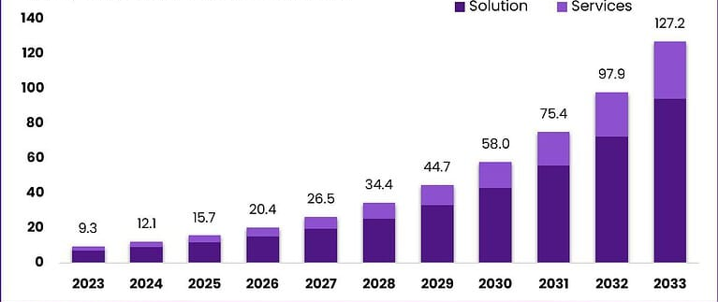
Figure: Global market size of AI tools and technologies
Source: (market.us, 2024)
Artificial intelligence is considered to be one of the leading business trends within the market, not only in any specific country but within the whole world. Taking that into consideration, this can be clearly stated that every industry seems to get benefited from the tools as well as technologies based on artificial intelligence. Therefore, nearly all business sectors focus on making use of these technologies as well as tools. As the above graph is showcasing, the market size of the AI tools as well as technologies seems to increase by a significant amount by the year 2033. It is anticipated to be worth almost 120.26 billion British Pounds by the year 2033, which would be risen from the value of 6.93 billion British Pounds in 2023. A clear CAGR of at least 29.9 percent can be seen during the forecast period, starting from 2024 to the end of 2033 (market.us, 2024).
Size of AI tools and technologies in the UK retail market
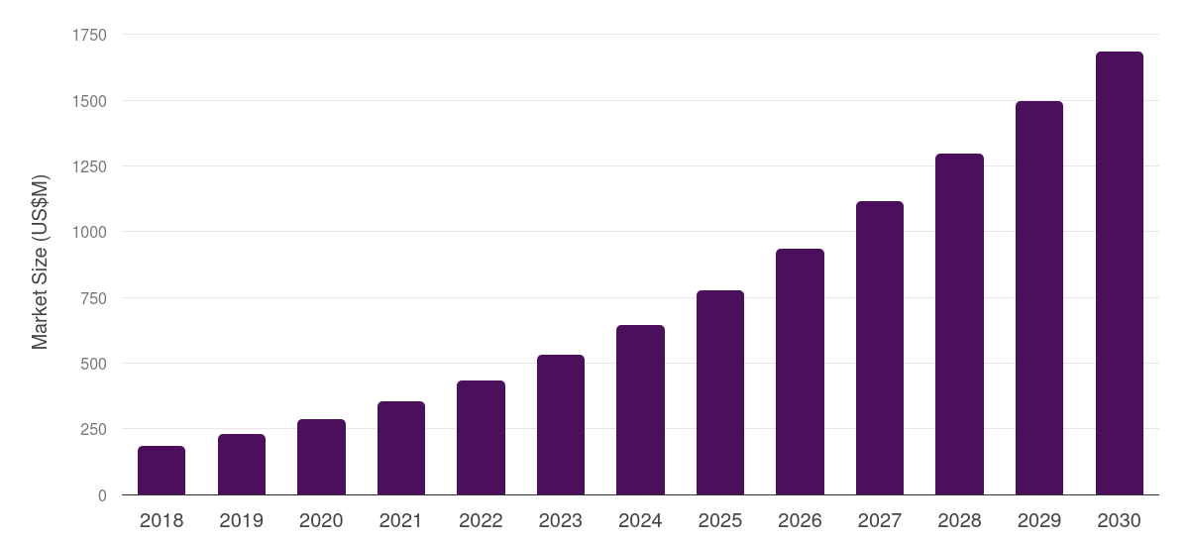
Figure: Marketing size of AI tools and technologies in the UK
Source: (grandviewresearch, 2025)
A significant number of business organisations from different industries have been making use of artificial intelligence tools as well as technologies in terms of obtaining a range of beneficial factors. According to the above graphical representation, this can be clearly seen that the use of AI tools as well as technologies has been rising in the retail sector within the United Kingdom. As per the forecast, the revenue generated from the retail market is expected to grow by nearly 1.2 million British pounds at the end of the year, 2030. In 2024, the revenue of the retail market in the United Kingdom was almost 480.08 British Pounds. Starting from 2025, the CAGR seems to be expected of increasing 18.7% by the year 2030 (grandviewresearch, 2025). Retail sector as well, here, seems to be one of the most lucrative component segments by acknowledging the fastest development as well as growth.
Common areas os using AI tools and technologies by retail firms in the United Kingdom
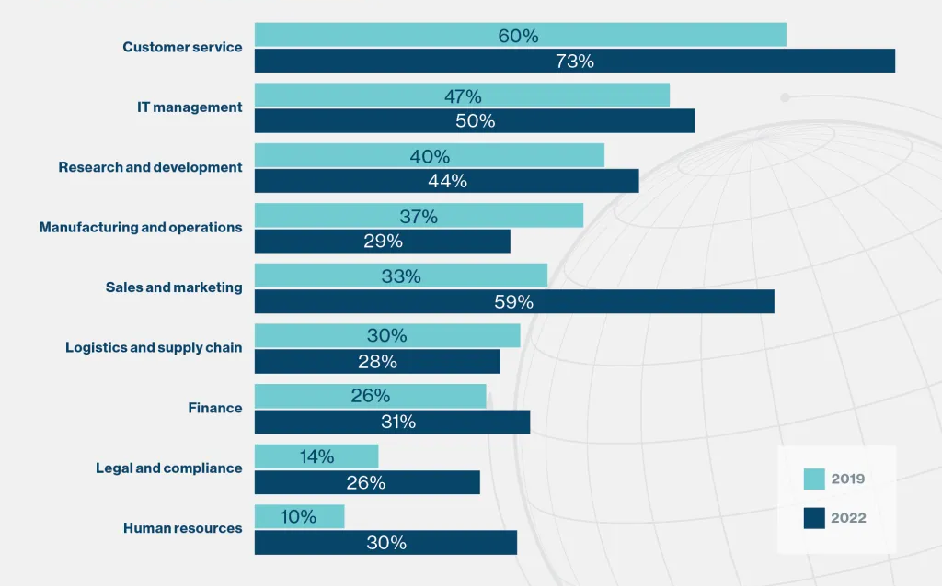
Figure: Areas in which AI tools and technologies are used mostly
Source: (technologyreview, 2020)
There are multiple areas present where the tools, as well as technologies based on artificial intelligence, can be made use of within the workplace of all business organisations, including business firms in the retail sector. Business organisations tend to utilise these kinds of tools as well as technologies based on the artificial intelligence in the area of providing consumer service mostly. A survey clarified that almost 60 percent of those respondents had made use of AI tools in the customer service area in 2019, which has further increased to 73 percent at the end of 2022. While the percentage of using AI tools (47 percent) was quite high in the IT management, ranking in 2nd position, it did not show much significant growth in the use by 2022. Surprisingly, the use of AI in sales and marketing was quite low in 2019 at 33 percent, and that has increased to 59 percent by the end of the year of 2022. Research and development, manufacturing or operations, logistics or supply chain, finance, as well as human resources are considered to be other key areas where AI tools as well as technologies can be efficiently used.
Potential challenges faced by retail companies during the integration of AI tools and technologies

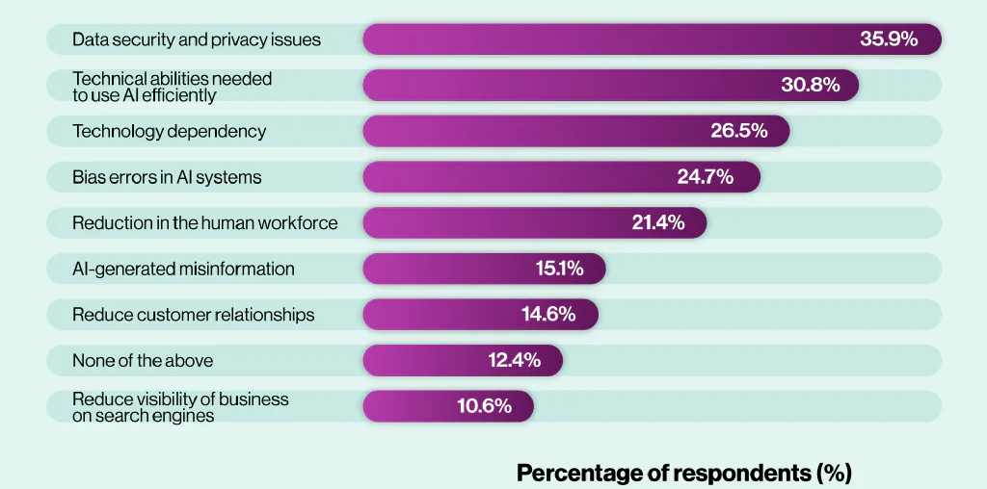
Figure: Common issues faced by retail businesses during AI tool integration
Source: (aiprm, 2024)
The application of artificial intelligence oriented tools as well as technologies involves a huge range of beneficial factors, due to which, such a major segment of business organisations tend to incorporate them. However, there are still certain drawbacks present which make a business organisation encounter potential challenging factors. The issue of data security, as well as privacy, is considered to be one of the most crucial problematic factors, as almost 35.9 percent of companies face this, leading to serious hampering of business practices (aiprm, 2024). In this case, it is also quite crucial to have technical ability, using which employees of an organisation can enhance the overall business performance or else it delivers another critical issue. There is a high chance of a technology reliability issue, while bias error in these systems based on AI can be another vital issue. Similar other issues are also present, which can make the business practices weak as presented in the graph.
Key benefits of incorporating AI tools and technologies within retail businesses
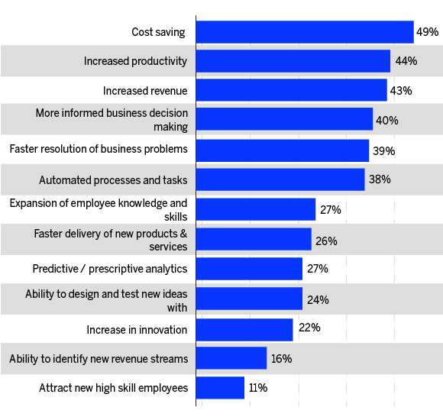
Figure: Benefits of using AI tools and technologies in retail firms
Source: (appventurez, 2024)
An effective implementation of artificial intelligence based tools as well as technologies within the workforce of any retail business organisation, such as the Ocado Group, tends to have certain potential beneficial factors. According to the above graphical representation, a few key beneficial factors of integrating AI tools or technologies are cost saving, higher productivity, more business revenue, better informed decision making and similar others. Automating tasks or methods, expanding staff knowledge or skills, faster delivery, predictive analysis, and enhancing innovation, as well as attracting new high skill staff members, also come under its benefits. Among all these beneficial factors, the major segment of companies in the retail sector tends to encounter the benefit of cost-efficiency more. Taking that into consideration, the companies can make sure to overcome the potential barriers faced by them while integrating these AI-based tools as well as technologies. Their investments would have been anticipated to reach almost 7.3 billion British Pounds by 2020, and that has been met splendidly as well.

4.3 Discussion

Critical review of the findings
Two types of analyses have been conducted in the above section, which are thematic analysis as well as statistical analysis. Both of these analyses primarily revolve around the way tools, as well as technologies based on the artificial intelligence, are useful for managing the supply chain disruption as well as consumer experience in the United Kingdom. Five themes have been developed from the gathered findings, which can be effective in answering to all three research questions. The first theme focuses on identifying the tools as well as technologies related to the artificial intelligence that business organisations in the retail industry mostly use. From the first theme, different smart platforms utilised by Ocado can be learned, such as demand forecasting, as well as route or warehouse optimisation tools. The way these tools, based on AI, can be beneficial for the improvement of consumer experience, as well as supply chain management through AI, has been analysed in the second theme. In this theme, two factors, such as reducing the waiting time period as well as enhancing risk management, have been described. Third theme focuses on finding out critical challenging factors that a business organisation, such as Ocado, tends to face, which are data quality issues as well as complicated technological aspects. Unreliable outputs, as well as scalability issues, are considered to be the potential impacts of the challenges faced during the implementation of artificial intelligence, which have been addressed in the fourth theme. The fifth and last theme has been in regard to the strategies of mitigating those challenges while enhancing the integration process of AI tools or technologies. The statistical analysis has covered the size of the huge application of AI tools as well as technologies in the retail market within the United Kingdom. Along with that, its application all over the world in the global market has been highlighted as well. It also has highlighted certain potential challenges as well as beneficial factors to get a clear picture of this aspect.

Comparing and contrasting the two findings
Both of these analyses have critically analysed all three research objectives, and while both of these findings have been effective in their own ways, certain information has been lacking still. On the one hand, the thematic analysis has been thoroughly focused on describing the information, where, instead of quantity, the quality of the findings has been prioritised more clearly. On the other hand, the statistical analysis has been more attentive towards the quantitative information by highlighting the percentage factors. While only two benefits or two challenges of using AI tools as well as technologies have been explored in the thematic analysis, multiple factors of these similar criteria have been explained in the statistical analysis. However, the impact of those challenges, as well as the significance of implementing such AI tools as well as technologies, has been included in the thematic analysis. The statistical analysis has lacked this kind of information, failing to acknowledge the depth of the challenging factors, as well as the significance of these beneficial factors. It clearly showcases the way both of these findings have failed to meet certain criteria while revolving around the same concepts. While both the findings meet at certain points, there are still some points of difference present, which might be covered further.

Implications or Significance of the findings
The thematic analysis has clearly described the way a retail business organisation in the United Kingdom, such as Ocado, makes use of different tools as well as technologies based on the artificial intelligence through its smart platforms. By addressing the way these tools improve consumer experience, as well as manage supply chain management practices through artificial intelligence, a clear understanding of the importance of integrating them can be acknowledged. Similarly, finding out the crucial challenging factors makes interested people learn about the impact of those challenges and how this is highly important to overcome those issues. The impacts have been highlighted as well, while potential strategies which can be utilised for overcoming those issues can be acknowledged along with them. In a similar manner, the statistical analysis has included different beneficial factors as well as challenging aspects that companies generally face in the real sector, which has clarified their significance. The wide range of the applications of AI tools, as well as technologies, in the huge retail market within the United Kingdom has been highlighted, making people aware of the breadth of its market. Thus, the whole findings as well as analysis has been quite insightful in terms of obtaining a huge amount of information as well as data regarding the impact of incorporating AI tools or technologies on customer experience and supply chain disruption.

Explanation of Limitations
Certain limitations are still present within the findings as well as the analysis of this discussion. The number of tools, their benefits, challenges, impacts, as well as overcoming strategies are discussed in a limited number in the thematic analysis. This puts a limitation on the number of factors described by focusing on the impact of AI tools or technologies. On the other hand, the statistical analysis has been described in regard to any challenges and benefits; however, it still has failed to acknowledge their effectiveness. It also has not included the overcoming strategies, unlike the thematic one.

4.4 Conclusion
The above section of results and discussion has focused on conducting two types of analyses with the help of secondary resources. Here, both thematic as well as statistical analyses have been conducted, for which data from books, articles, websites or journals have been gathered. Analysing those findings, they have been compared, while their limitations have been explored as well.

Chapter 5: Recommendations, Conclusion and Limitations of the research

5.1 Introduction
The conclusion chapter plays a crucial role in terms of providing a final synthesis of the research while summarising key findings and explaining the significance and implications of the study. It offers a final opportunity which allows leaving a lasting impression on the readers about why this research topic matters and highlights new knowledge, suggesting areas for future studies.

5.2 Achievement of Research Objectives
Within this research study, the researcher has tried to achieve the research objectives by analysing information found in the literature review section and the findings and analysis section. An argument regarding that has been formed, which states that the implementation of AI technology has been rapid in recent years. Additionally, the study has also focused on how human interpretation and sense are entirely essential when it comes to integrating automation within these operational elements. Lastly, information on proper ways to maintain supply chain efficiency concerning the environment of Big Data analytics has been gathered in the literature review section, which provided essential information related to how making predictions in this function is important. All this information has allowed this research to be conducted and analysed in alignment with the research objective and questions.

5.3 Conclusion
The research has shed light on how, in recent years, the supply chain has significantly changed, with more challenges arising to manage. In the study, challenges related to product portfolios with longer and increasingly interlinked relationships have been seen to create disruptions, has been included. Information related to how AI is already touching the most created experience among the customers' shopping criteria has been mentioned. AI technology is expected to be anticipated with a rate of 11.83 billion to 54.93 billion dollars by the year 2033. Moreover, studies from different authoritative reports have also been drawn out in terms of finding how the logistics market is seen to implement AI within its operations. A McKinsey Global Institute report says that the AI in logistics market is expected to reach around 20.8 billion in the year 2025, and this is a stark increase from 2020, with a CAGR of 45.6 per cent. Additionally, 78% of supply chain leaders who support the same have also been analysed within this research with the implementation of AI-powered logistics solutions. The research has provided several insights concerning how AI-algorithms working properly can contribute towards reducing any kind of supply chain disruption and improving the experience customers face.

5.4 Recommendation
Customer experience enhancement
The organisation can utilise AI to analyse the customer data and provide still product suggestions both online and in-store. Apart from that, they can also employ an AI-powered chatbot within their operations to handle customer enquiries and provide store navigation assistance to them. Furthermore, Ocado Group, by identifying the risk in the supply chain and then utilise several strategies to mitigate them (Quinones et al., 2023).
Predictive analytics and demand forecasting
Predictive analytics powered by AI and demand forecasting with the utilisation of historical data can help businesses to optimise the inventory level while preventing stockouts and over-stocking (Falatouri et al., 2022). The organisation can analyse datasets with machine learning algorithms, which will allow them to spot patterns and external influences such as competitor activities, seasonality, and economic uncertainty to produce a more precise forecast than the traditional methods.

5.5 Limitations
Utilisation of secondary methods has been integrated in this research study, and this has caused various limitations related to finding real-time and updated information. Although the researcher has used both qualitative and quantitative information in this study. However, none of them being primary has caused this research to find hindrances related to real-time information.

5.6 Future Research Directions
In future, the research can move toward focusing on developing new theoretical models that can integrate AI into the traditional supply chain theories while evaluating long-term adaptability and theoretical implications of AI technology. Additionally, future research can also move towards assessing the impact of AI on customer behaviour and only channel strategies while fostering collaboration between industry and academia to share practices.

5.7 Chapter Summary
This chapter will also provide a synthesis of the main points and findings while giving the readers a crucial message regarding the topic and directly addressing the question stated in the introduction section. This section has included recommendations related to AI-powered logistics solutions in the Ocado Group, with integration of AI and analysis of the long-term impacts.

References
Adanyin, A., (2024). Ethical AI in retail: Consumer privacy and fairness. arXiv preprint arXiv:2410.15369.
aiprm, (2024). AI Statistics 2024. [Online] Available at: https://www.aiprm.com/ai-statistics/ [Accessed 4 October 2025].
Anica-Popa, I., Anica-Popa, L., Rădulescu, C. and Vrîncianu, M., (2021). The integration of artificial intelligence in retail: benefits, challenges and a dedicated conceptual framework. Amfiteatru Economic, 23(56), pp.120-136.
appventurez, (2024). Role of Artificial Intelligence in Retail Industry. [Online] Available at: https://www.appventurez.com/blog/artificial-intelligence-in-retail-industry [Accessed 4 October 2025].
Armour, R. and Williams, B., (2022). Reliability and validity in quantitative and qualitative research. Introducing, designing and conducting research for Paramedics, pp.69-72.
Beta, K., Nagaraj, S.S. and Weerasinghe, T.D., (2025). The role of artificial intelligence on supply chain resilience. Journal of Enterprise Information Management, 38(3), pp.950-973.
Brau, R.I., Sanders, N.R., Aloysius, J. and Williams, D., (2024). Utilizing people, analytics, and AI for decision making in the digitalized retail supply chain. Journal of Business Logistics, 45(1), p.e12355.
Cao, L., (2021). Artificial intelligence in retail: applications and value creation logics. International Journal of Retail & Distribution Management, 49(7), pp.958-976.
Chen, T., Guo, W., Gao, X. and Liang, Z., (2021). AI-based self-service technology in public service delivery: User experience and influencing factors. Government Information Quarterly, 38(4), p.101520.
Clark, T., Foster, L., Bryman, A. and Sloan, L., (2021). Bryman's social research methods. Oxford university press.
Coe, R., Waring, M., Hedges, L.V. and Ashley, L.D. eds., (2025). Research methods and methodologies in education. SAGE Publications Limited.
Daios, A., Kladovasilakis, N., Kelemis, A. and Kostavelis, I., (2025). AI applications in supply chain Daios, A., Kladovasilakis, N., Kelemis, A. and Kostavelis, I., 2025. AI applications in supply chain management: A survey. Applied Sciences, 15(5), p.2775.management: A survey. Applied Sciences, 15(5), p.2775.
Denny, E. and Weckesser, A., (2022). How to do qualitative research? Qualitative Research Methods. Bjog, 129(7), p.1166.
Enders, C.K., (2022). Applied missing data analysis. Guilford Publications.
Eyo-Udo, N., (2024). Leveraging artificial intelligence for enhanced supply chain optimization. Open Access Research Journal of Multidisciplinary Studies, 7(2), pp.001-015.
Falatouri, T., Darbanian, F., Brandtner, P. and Udokwu, C., (2022). Predictive analytics for demand forecasting–a comparison of SARIMA and LSTM in retail SCM. Procedia Computer Science, 200, pp.993-1003.
Fu, H.P., Chang, T.H., Lin, S.W., Teng, Y.H. and Huang, Y.Z., (2023). Evaluation and adoption of artificial intelligence in the retail industry. International Journal of Retail & Distribution Management, 51(6), pp.773-790.
Gamage, A.N.K.K., (2025). Research design, philosophy, and quantitative approaches in scientific research methodology. Sch J Eng Tech, 2, pp.91-103.
gartner, (2025). How AI Is Transforming Supply Chain Management. [Online] Available at: https://www.gartner.com/en/supply-chain/topics/supply-chain-ai [Accessed 6 October 2025].
Ghanad, A., (2023). An overview of quantitative research methods. International journal of multidisciplinary research and analysis, 6(08), pp.3794-3803.
grandviewresearch, (2025). UK Artificial Intelligence In Retail Market Size & Outlook. [Online] Available at: https://www.grandviewresearch.com/horizon/outlook/artificial-intelligence-in-retail-market/uk [Accessed 4 October 2025].
Hana, (2025). How AI is Changing Logistics & Supply Chain in 2025?. [Online] Available at: https://docshipper.com/logistics/ai-changing-logistics-supply-chain-2025/ [Accessed 4 October 2025].
Heins, C., (2023). Artificial intelligence in retail–a systematic literature review. foresight, 25(2), pp.264-286.
Hendriksen, C., (2023). Artificial intelligence for supply chain management: Disruptive innovation or innovative disruption? Journal of Supply Chain Management, 59(3), pp.65-76.
Hong, Y., Lian, J., Xu, L., Min, J., Wang, Y., Freeman, L.J. and Deng, X., (2023). Statistical perspectives on reliability of artificial intelligence systems. Quality Engineering, 35(1), pp.56-78.
Hoyer, W.D., Kroschke, M., Schmitt, B., Kraume, K. and Shankar, V., (2020). Transforming the customer experience through new technologies. Journal of interactive marketing, 51(1), pp.57-71.
Huntington-Klein, N., (2021). The effect: An introduction to research design and causality. Chapman and Hall/CRC.
Ifekanandu, C.C., Anene, J.N., Iloka, C.B. and Ewuzie, C.O., (2023). Influence of artificial intelligence (AI) on customer experience and loyalty: Mediating role of personalization. Journal of Data Acquisition and Processing, 38(3), p.1936.
Inavolu, S.M., (2024). Exploring AI-driven customer service: Evolution, architectures, opportunities, challenges and future directions. International Journal of Engineering and Advanced Technology, 13(3), pp.156-163.
Joel, O.S., Oyewole, A.T., Odunaiya, O.G. and Soyombo, O.T., (2024). Leveraging artificial intelligence for enhanced supply chain optimization: a comprehensive review of current practices and future potentials. International Journal of Management & Entrepreneurship Research, 6(3), pp.707-721.
Johannesson, P. and Perjons, E., (2021). Research strategies and methods. In An introduction to design science (pp. 41-75). Cham: Springer International Publishing.
Kacar, M., (2023). Application of AI in customer experience management. In Marketing and Sales Automation: Basics, Implementation, and Applications (pp. 409-430). Cham: Springer International Publishing.
Khare, V., Orduz, A.G. and Gonzalez, O.C., (2022). Artificial Intelligence as an Enabler of Sustainability. In ISPIM Conference Proceedings (pp. 1-9). The International Society for Professional Innovation Management (ISPIM).
Kollia, I., Stevenson, J. and Kollias, S., (2021). Ai-enabled efficient and safe food supply chain. Electronics, 10(11), p.1223.
Kuźnar, M. and Lorenc, A., (2023). A hybrid method for technical condition prediction based on AI as an element for reducing supply chain disruptions. Applied Sciences, 13(22), p.12439.
Maier, C., Thatcher, J.B., Grover, V. and Dwivedi, Y.K., (2023). Cross-sectional research: A critical perspective, use cases, and recommendations for IS research. International Journal of Information Management, 70, p.102625.
market.us, (2024). Global AI in Retail Market By Component. [Online] Available at: https://market.us/report/ai-in-retail-market/ [Accessed 4 Octoer 2025].
Meeker, W.Q., Escobar, L.A. and Pascual, F.G., (2021). Statistical methods for reliability data. John Wiley & Sons.
Mishra, S.B. and Alok, S., (2022). Handbook of research methodology. Educreation publishing.
Nguyen, T.M., Quach, S. and Thaichon, P., (2022). The effect of AI quality on customer experience and brand relationship. Journal of Consumer Behaviour, 21(3), pp.481-493.
Okeke, N.I., Alabi, O.A., Igwe, A.N., Ofodile, O.C. and Ewim, C.P.M., (2024). AI in customer feedback integration: A data-driven framework for enhancing business strategy. World J. Advanced Res. Reviews, 24(1), pp.3207-3220.
Olmsted, J., (2024). Research Reliability and Validity: Why do they matter?. American Dental Hygienists' Association, 98(6), pp.53-57.
Oosthuizen, K., Botha, E., Robertson, J. and Montecchi, M., (2021). Artificial intelligence in retail: The AI-enabled value chain. Australasian Marketing Journal, 29(3), pp.264-273.
Ortloff, A.M., Fassl, M., Ponticello, A., Martius, F., Mertens, A., Krombholz, K. and Smith, M., (2023), April. Different researchers, different results? analyzing the influence of researcher experience and data type during qualitative analysis of an interview and survey study on security advice. In Proceedings of the 2023 CHI Conference on Human Factors in Computing Systems (pp. 1-21).
Ovádek, M., (2021). Facilitating access to data on European Union laws. Political Research Exchange, 3(1), p.1870150.
Pereira, A.M., Moura, J.A.B., Costa, E.D.B., Vieira, T., Landim, A.R., Bazaki, E. and Wanick, V., (2022). Customer models for artificial intelligence-based decision support in fashion online retail supply chains. Decision Support Systems, 158, p.113795.
Petropoulos, F., Laporte, G., Aktas, E., Alumur, S.A., Archetti, C., Ayhan, H., Battarra, M., Bennell, J.A., Bourjolly, J.M., Boylan, J.E. and Breton, M., (2024). Operational Research: methods and applications. Journal of the Operational Research Society, 75(3), pp.423-617.
Quinones, M., Díaz-Martín, A.M. and Gómez-Suárez, M., (2023). Retail technologies that enhance the customer experience: a practitioner-centred approach. Humanities and social sciences communications, 10(1), pp.1-8.
sap, (2024). What is AI in retail? [Online] Available at: https://www.sap.com/resources/ai-in-retail#:~:text=By%20forecasting%20demand%20more%20accurately,sales%20and%20increasing%20sales%20revenues. [Accessed 2 October 2025].
Savushkin, N., (2024). Warehouse automation in logistics: Case study of Amazon and Ocado.
Shi, T., Lee, S.J. and Li, Q., (2024). Smart supply chain management in business education: Reflection on the pandemics. Decision Sciences Journal of Innovative Education, 22(1), pp.19-32.
Taherdoost, H., (2022). What are different research approaches? Comprehensive review of qualitative, quantitative, and mixed method research, their applications, types, and limitations. Journal of Management Science & Engineering Research, 5(1), pp.53-63.
technologyreview, (2020). How AI is changing the customer experience. [Online] Available at: https://www.technologyreview.com/2020/04/28/1000675/how-ai-is-changing-the-customer-experience/ [Accessed 4 October 2025].
Uzozie, O.T., Onaghinor, O., Esan, O.J., Osho, G.O. and Olatunde, J., (2023). AI-Driven Supply Chain Resilience: A Framework for Predictive Analytics and Risk Mitigation in Emerging Markets.
Van Hoek, R. and Lacity, M., (2023). How global companies use AI to prevent supply chain disruptions. Harvard Business Review, pp.11-33.
Visser, M., (2021). Strategy and Business Models. In Digital Marketing Fundamentals (pp. 30-66). Routledge.
Vu, T.T.N., (2021). Understanding validity and reliability from qualitative and quantitative research traditions. VNU Journal of Foreign Studies, 37(3).
Wamba, S.F., Queiroz, M.M., Jabbour, C.J.C. and Shi, C.V., (2023). Are both generative AI and ChatGPT game changers for 21st-Century operations and supply chain excellence? International journal of production economics, 265, p.109015.
Williams, H., (2021). The meaning of “Phenomenology”: Qualitative and philosophical phenomenological research methods. The Qualitative Report, 26(2), pp.366-385.
Yrjölä, M., Hautamäki, P. and Ranta, R., (2025). Value propositions of artificial intelligence in retailing. The International Review of Retail, Distribution and Consumer Research, 35(4), pp.355-382.
Zakaria, S., Bradford, M., Hutton, E. and Besse, J., (2024). Use of AI in the UK Food System. FSA Research and Evidence.
Zhuang, Z., (2025), April. AI-Driven Supply Chain Adaptation: A Cross-Cultural Analysis of COVID-19 Impacts on Online Supermarkets in China and the UK. In Proceedings of the 2025 International Conference on Digital Economy and Information Systems (pp. 109-114).
Zou, P.X. and Xu, X., (2023). Research methodology and strategy: theory and practice. John Wiley & Sons.

