Ten Years in the Making
  - Production diary

Ash Edwards 1704521 CAMF6007

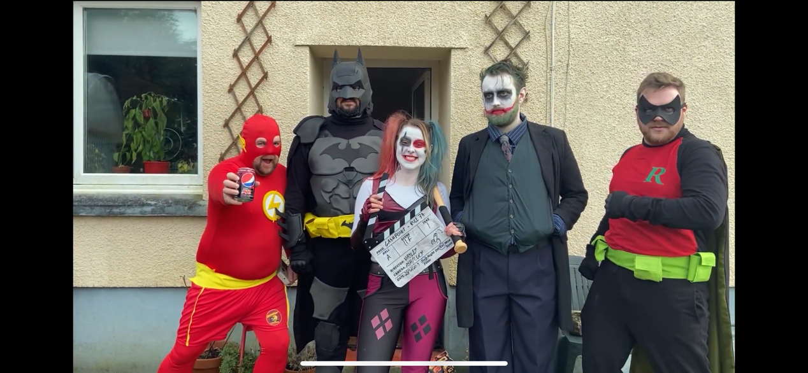

Synopsis:

The initial aim of my documentary was to both tell the origin story of Team Larsy as well as chronicle the production of their new project. As for the documentary I had reunited them to create another video after a ten-year hiatus. However, the final product I will be submitting is more akin to the first chapter in a greater series or feature length documentary, the reasons being that of time. In the final cut I was close to 40 mins before leaving the early stages of production for Project Mango (Team Larsy’s latest venture) as an estimate; with two days of filming still to go I would say the final cut could be around an hour and a half. This was obviously far too long for a 12 minute requirement, but I also didn’t want to compromise in telling my friends’ story. Therefore, I decided to do two cuts, one short submission cut, the aforementioned ‘chapter’ that will focus solely on the origin of Team Larsy. The second cut will be feature length and I have been working on it alongside the shorter cut. I will also be screening it in in Crosshands Cinema alongside their newest production for all cast, crew and family.

In lieu of a preproduction folder I will be submitting this brief journal as there was very little pre-production aside from the attached risk assessments and some minor scheduling documentation screenshots. Due to organizing up to 15 people to be in the same place at the same time most shoots tended to be on the hoof or organized solely in WhatsApp chats and in person. The Interviews were done in a single day and shot over an eight-hour period, as it was one of few opportunities I had when all persons required were available. As far as what questions to ask, they were pretty self-explanatory, I wanted to get into the origin, their favorite memories of working on it as well as their own personal experiences of on set shenanigans, though questions did alter dependent on person. But pictured below is am example of both the questions as well as the method in which most of the organization occurred.

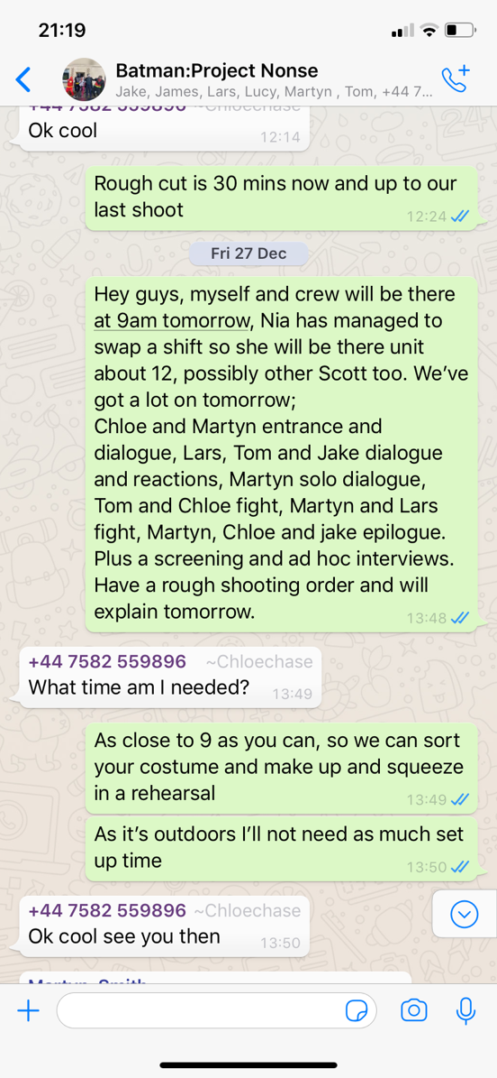
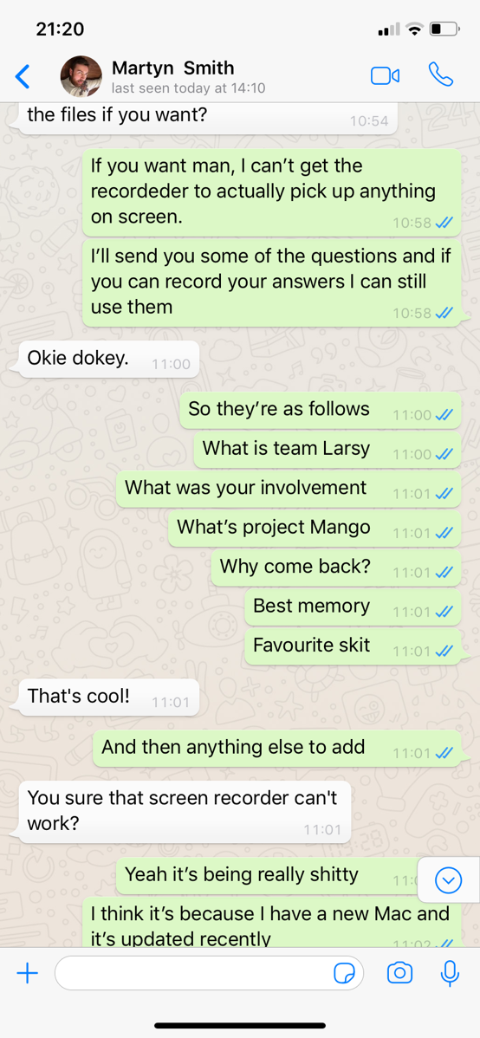

As far as production went, it was relatively smooth. Apart from the occasional changing in schedule, filming two productions in tandem and fluctuating availability. I kept crew small, down to an occasional skeleton crew as we were often shooting in a house so both out of respect and logistics a smaller crew worked best for the situation. I primarily took on a producer and director role over anything technical as organisation was a job in itself, at one point the project was known in house as Herding Cats. The interview shoot was pretty straight forward, two angles both shot on iPhone 11’s for convenience sake, simple light set up and a H6N with a shotgun mic. Then a sofa and uniform background for the set, with all of Lars’ personal nick knacks as framing as seen in images below.
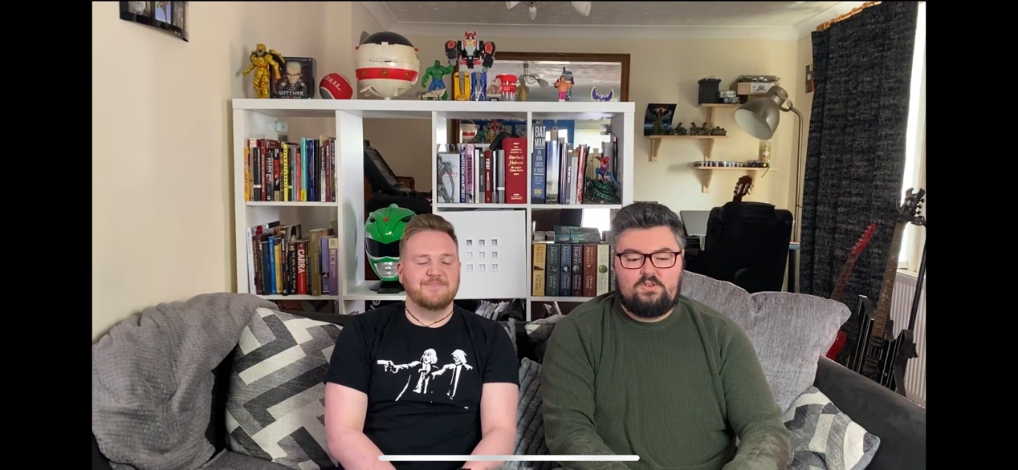
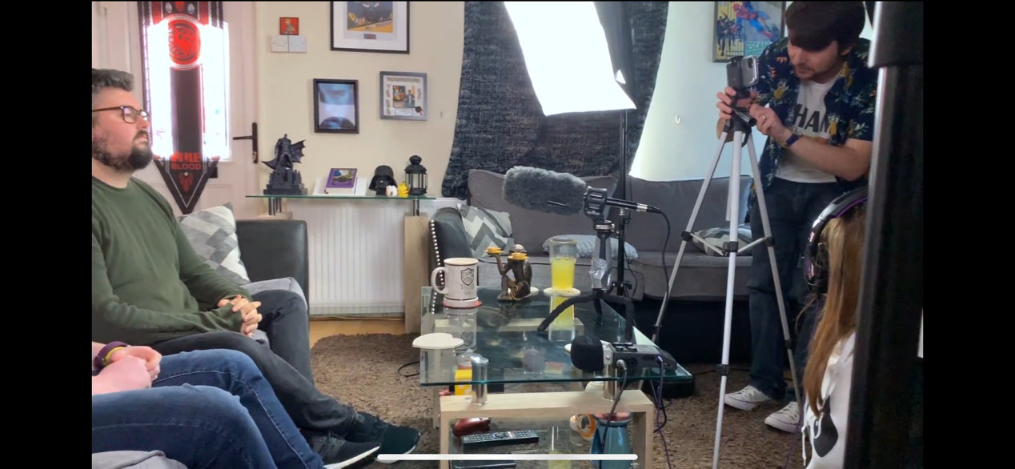
Aside from the one day of interviews I was assisting with shooting and planning Project Mango and was at the whim of a Team Larsy schedule. After several shooting sessions I acclimatized to their way of working and understood that on the hoof and ad hoc was what made them work best. Therefore, planning and following a standard pre-production documentation procedure became increasingly difficult. Towards the end and at time of writing, I am more than anything along for the ride. I was having so much fun that until reading the brief once again I forgot completely about release forms. Normally I’m such a stickler for those. I have attached a blank example one and will get them to complete it in time but will not be able to before submission, as I said. Herding Cats.

On the post stage of production aside from a few minor technical errors it was relatively stress free, the footage was good, the story was interesting, and the only downside was that twelve minutes wasn’t enough time to do the story justice. I used Adobe Premiere, After Effects, Audition and Photoshop as they are what I’m familiar with and what I have access to.

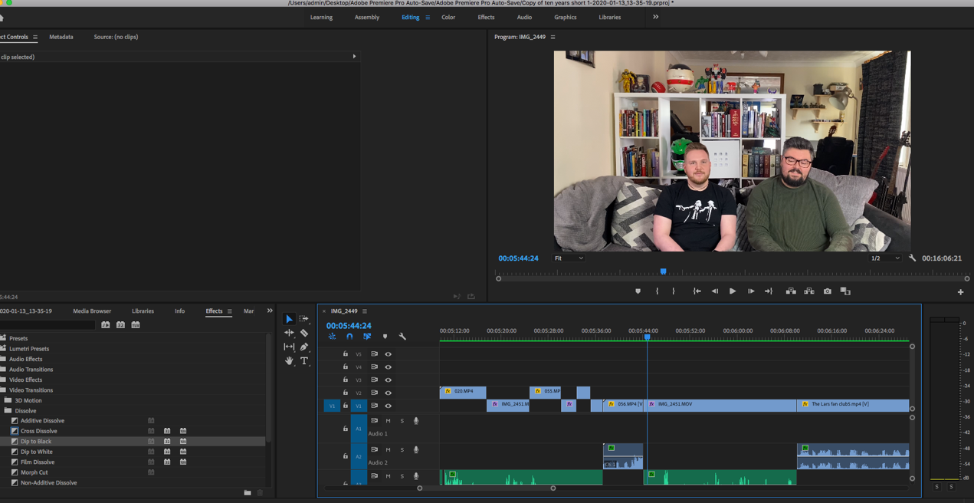

In summary I have truly enjoyed my time making this documentary and aim to make more in the future. Working with my friends has been incredibly enjoyable as well as occasionally frustrating, though I have been made an honorary member of Team Larsy and the documentary has rekindled their love of filmmaking and they plan to shoot a Samurai Cop (Shervan, 1991) parody in the summer. A that has made the entire experience worthwhile, to get my friends back together to do what they do best. And yes, I will be shooting it for them.

The Pre-Production Part
The following items are preproduction material that I managed to maintain throughout the process.
Risk Assesment Lars’
Release form example
Kit list

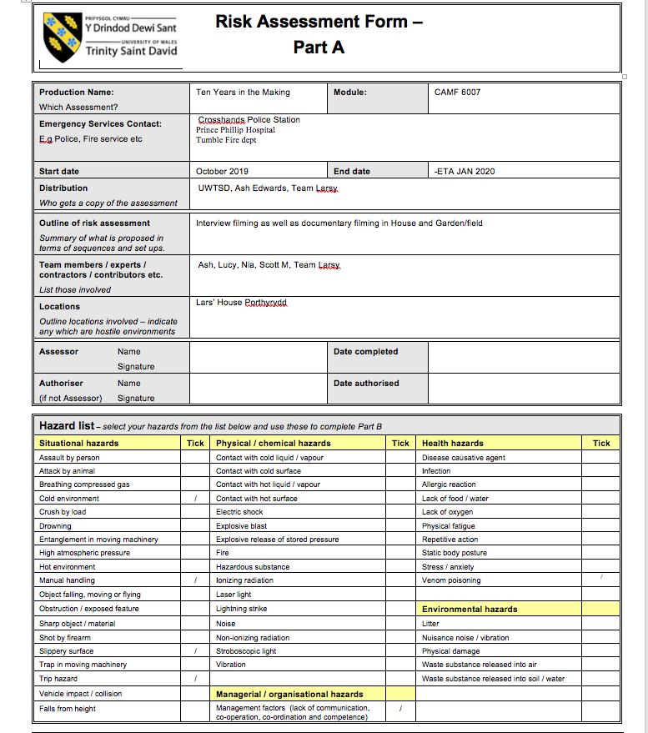

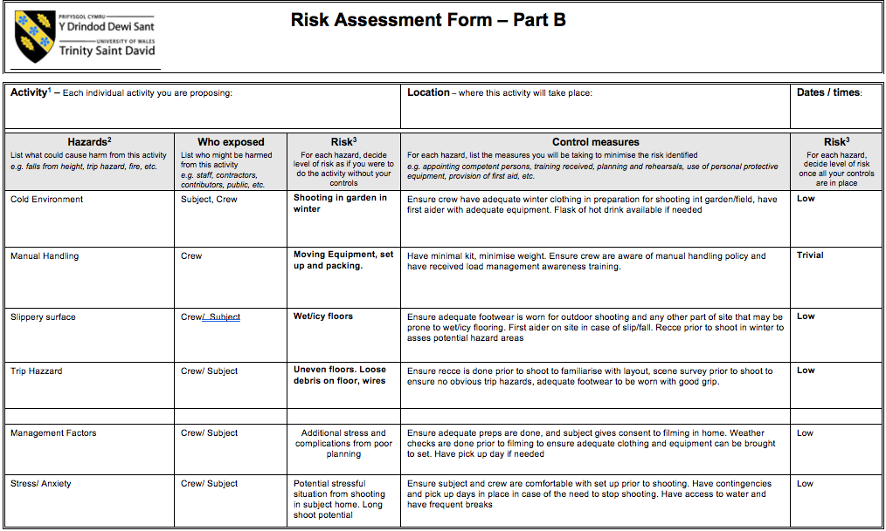

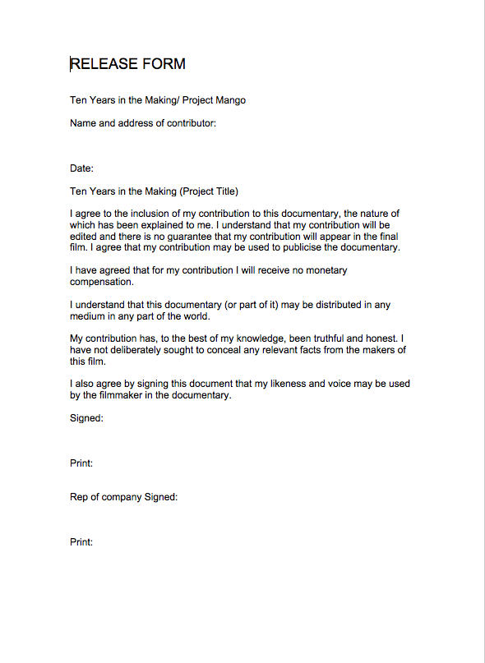

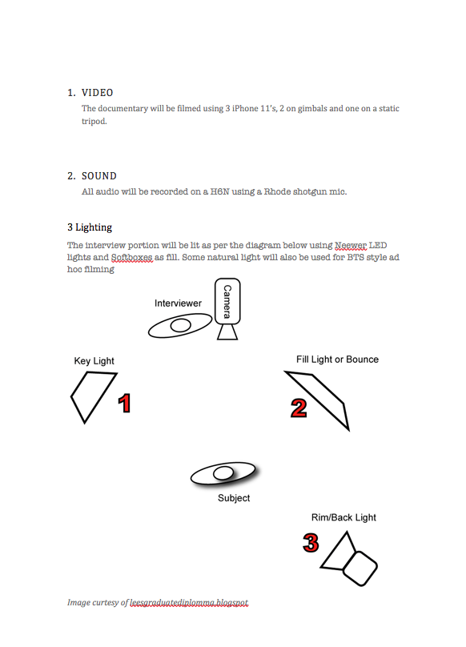

The Documentary
And finally, here’s the link to the final draft of the Chapter Cut of Ten Years in the Making.
https://drive.google.com/open?id=1HSWeBwkUCwI21zVEucaGTlsJpNghE8Y6

