

BSc (Hons) Professional Police Practice

LEVEL 5 - 40 Credits

Workbook title: Competency Based Workbook 3 (PCDA)

(SOUTH WALES POLICE, GWENT POLICE AND UWTSD)

Learner name: Jessica Swain
Learner’s University Registration Number: 1922419

FACULTY OF BUSINESS AND MANAGEMENT
PUBLIC SERVICE PROGRAMME

Module title: Professional Police Practice 2 (PCDA) BMPP5000D

Workbook Guidance

Please read these notes carefully; they provide essential information.

What is the workbook for?

The purpose of this workbook is to enable learners to demonstrate and provide evidence of how they meet the learning outcomes set by the College of Policing, for the BSc programme. Essentially, you are being asked to outline your experiential learning based upon your theoretical understanding in a range of operational situations.

- Wellbeing and Resilience
- Decision-making and Discretion
- Vulnerability and Risk
- Public Protection
- Maintaining Professional Standards
- Leadership and Team-working
- Policing the roads
- Information and intelligence
- Conducting Investigations

You may wish to use the same incidents as you’ve outlined in the Occupational Competence Portfolio.

How should the workbook be presented?

Blank electronic copies can be found on Moodle of this workbook. You must submit this document electronically therefore it is important that you save your work regularly and upload the final typed version through Turnitin on Moodle.

Word count policy can be found in chapter 7 of the Academic Quality under section 7.7 (this applies to presenting work above and under the specified word count).
(https://www.uwtsd.ac.uk/media/uwtsd-website/content-assets/documents/academic-office/aqh-chapters/chapters---en/Chapter_07_Assessment_Taught_Programmes_Pages_72-79-UPDATED-05-11-2019.pdf)

Reflective practice is a core aspect for your workbooks and although there is a variety of useful resources on Moodle, there is one particular book, that is specifically based on reflective practice in policing, here is a link to one chapter from Selina Copley’s Reflective Practice for Policing Students:
https://moodle.uwtsd.ac.uk/pluginfile.php/298870/mod_resource/content/1/Reflective%20Practice%20for%20Policing%20Students%20-%20Selina%20Copley%20Chapter5.pdf

How is the workbook assessed?

Advice and support about the completion of this workbook will be provided by university staff as part of your initial training day. Your tutor constable and in-force training staff will not be involved in assessing or marking your workbook after it has been submitted.

Dates of workbook submission will be made available during the initial training day and posted on Moodle.

Once submitted your workbook will be assessed and marked independently.

Confidentiality

It is important that no individual can be identified either directly or indirectly from the information in the workbook. Therefore, you must:

- adhere to guidance in the Student Handbook about unfair practice and plagiarism.
- not identify individuals including witnesses, victims or offenders by name.
- not write information that enables any individual to be identified indirectly through the description you provide. This includes references to names, colleagues, places (including hospitals, schools, town, villages, streets) specific incidents which were high profile and could be identified due to past publicity, other professionals or any other personal information including medical or other conditions.
- take personal responsibility for adhering to confidentiality rules.
- not include any dates of any incidents or anything that specifically identifies an actual incident.

NOTE

Your workbook will be submitted electronically via Turnitin on Moodle. Guidance on this is in the Student Handbook.

Remember that the workbook is YOUR responsibility you must not rely on the assessor or anyone else to pick up any confidentiality breaches as this is your work and you must accept full responsibility for confidentiality. Meeting all the confidentiality requirements is very important.

Dyslexia and other special circumstances

If you have any condition that you feel may affect your ability to deal with any part of the programme, please see the Student Handbook for further guidance. The University has a Student Services Unit that may be able to help but it is the learner’s individual responsibility to contact them.

Guidance:

- Your workbook must contain the items specified in the table below (clearly identified and in the order given);
- You should use this particular document to insert your text / answer within each section of this workbook;
- You should upload your completed document as a saved pdf file of this workbook; if this is not possible then a Worddoc file is acceptable. Do not send a scanned file from a photocopier, an apple.dot file or a Microsoft publisher file as Turnitin will not be able to assess them, despite you being able to upload them.

Contents

Workbook | Area of Professional Practice | Word count
Task 1 | Wellbeing and Resilience | 1250
Task 2 | Decision-making and Discretion  Vulnerability and Risk  Public Protection | 1750
Task 3 | Maintaining Professional Standards  Leadership and Team-working | 1750
Task 4 | Policing the roads  Information and intelligence  Conducting investigations | 1750
Task 5 | Individual Learning Plan | 1500 equivalent
 | Total | 8000
 | Bibliography

Task 1

Relevant areas of the National Policing Curriculum:
Wellbeing and Resilience

Having achieved Independent Patrol Status, reflect on the impact of organisation culture within policing on your wellbeing and resilience (organisation change, retaining personal values in a wider organisational culture).

Consider the risks of conforming to organisational culture.

Illustrate your strategies for maintaining wellbeing and resilience.

1250 words (+/- 10%: include your actual word count at the end of each section)

ANSWER:

In this essay, I will be reflecting on the impact that organisational culture within policing has had on my wellbeing and resilience. I will also be outlining the risks of conforming to organisational culture and identify my strategies for maintaining my wellbeing and resilience. These strategies include exercising, resistance training and maintaining a good sleep pattern.

According to Reiner (2000), police cultures can be defined as “a kind of shared values, beliefs, norms, working practices and informal rules”. He stated police officers will use these cultures to “justify their works in the world”. This is often referred to as “cop culture”. “Organisational culture of a police department affects the behaviour of the officers” (Reiner, 2020). Police culture is often viewed negatively, and the ‘blue wall of silence’ has resulted in police officers not being held accountable for misconduct (Frye, 2006). The ‘blue wall of silence’ is supposedly an unwritten rule between police officers whereby they are encouraged not to testify against each other. Traits such as loyalty and ‘brotherhood’ are closely associated with the ‘blue wall of silence’ (Kleinig, 2001). However, organisational culture can also have a positive effect on police officers and can reduce anxiety and uncertainty in human relationships and communicate the ideology that defines what the organisation is all about (Champoux, 2006).

Therefore, the establishment of a professional, moral, ethical culture in a police organisation can control, prevent, and punish misconduct and corruption.

On the other hand, ‘cop culture’ allows officers to express their emotions as they have already suffered from high pressure on their daily work (Waddington, 2004). Organisational culture in the police increases cohesion between officers which in turn enhances officers working attitudes (Waddington, 2004).

Police officers have to adapt and over time develop coping mechanisms in order to deal with the high number of stressors that they are faced with every day. Police officers help, guide and support each other and this is how relationships within the job are built. Characteristics such as “protective instincts, shared attitudes and views of the world” are also linked to officers’ relationships, this often results in a ‘blue wall of silence’ or a ‘closed police society’ (Inciardi, 1990). The creation of the ‘blue fraternity’ begins at the police academy however is an “on-going process throughout an officer’s career” (Inciardi, 1990).

Every police officer is influenced by the organisational culture during training, during tutorship and once they have reached independent status.

The definition of stress is “pressure or worry caused by the problems in somebody’s life” (Oxford Dictionary, n.d). When an individual is stressed their thought processes can change and due to their adrenaline increasing, they can often forget things or rationalise things differently to how they would if they were not stressed, this can sometimes lead to wrong decisions being made.

For instance, police officers have to be aware of this as they are often placed in stressful situations however, they still have to be able to make the necessary decisions whilst also managing their adrenaline, as it can affect their thought processes

Stress management is a key part of being a police officer which is still something that I am working on. The release of the stress hormone, cortisol is part of the human body’s response to stress which also has an effect on the development of long term sickness (Oxford Dictionary, n.d). Therefore, it is important that individuals are able to manage their stress, this is something I personally have learnt and am continuing to learn.

Stress and resilience are not the same thing, although some people believe that they are. Resilience is “the ability of people or things to recover quickly after something unpleasant such as shock” (Oxford Dictionary, n.d). Charles Darwin (n.d) highlighted that “it is not the strongest of the species that survive nor the most intelligent that survives, it is the one that is the most adaptable to change”. This means that the more resilient individual is most likely to “survive” as they are able to deal with the ever-changing stressors that they are faced with, much like police officers. “

Another strategy that I used to aid in my wellbeing and assist in my resilience developing is physical exercise. Throughout tutorship, I created an exercise plan where I would guarantee that I spent at least one hour a day participating in some sort of physical activity. Whether I went swimming, attended a local fitness class or even if I just went for a run; I ensured that I made time for exercising in order to have all the benefits. Having achieved independent patrol, I continued to stick to this plan as I could see the benefits it was having on my mental health, such as reducing my stress levels. Not only did it become part of my daily routine, but I actually look forward to exercising everyday now as I know that I always feel better after it and less stressed. Due to work pressures and shift changes I have had to adapt my exercise plan on some days however this has not prevented me from continuing to complete my daily exercise plan.

Exercise assists an individual in being able to deal with the stress so that it doesn’t negatively impact them. This is supported by Kelly McGonigal (2020) who stated “On days when people exercise stressful things take less of a toll on their well-being. Not only that, but regular exercise also changes your brain over time and maintains brain health”. McGonigal’s research shows that “individuals are more resilient because of how movement makes them feel about themselves and their capacity to handle challenges”. She also stated that “there are changes in the systems of the brain that help regulate emotions and keep stress in check”, so participating in regular activity over time can result in your resilience increasing.

Further research into exercise improving individuals’ wellbeing and resilience has been conducted by Childs and De Wit (2014) whereby they compared psychophysiological responses to an acute psychological stressor between individuals who did, or did not, report regular physical exercise. They measured every participant’s heart rate, blood pressure, cortisol levels and self-reported mood before and after each individual took place in either a Trier Social Stress test (TSST) or a non-stressful control task. Their findings support claims that “regular exercise protects against the negative emotional consequences of stress” (Childs and De Wits, 2014) and suggests that exercise has beneficial effects in healthy individuals.

Another way in which exercise promotes health is by increasing an individual’s resilience to stress, since “stress exposure and chronic stress burden has been associated with physical and mental illness” (McEwen, 2007). Police work involves stressful demands such as dealing with human misery, abused children and instantaneous life or death decisions. Sources of stress in policing may be classified into two general categories (Shane, 2010): those arising from “job content” which include “work schedules, long-work hours, overtime, traumatic events and threats to physical and psychological health”. The second category is referred to as “job context” which refers to characteristics of the organisation and behaviour of the people that produce “stress such as bureaucracy and co-worker relations” (US National Library of Medicine, 2017).

A study conducted by Massachusetts General Hospital, examining brain scans for 293 patients found higher activity levels in the brain’s stress centre, the amygdala were associated with arterial inflammation – a high predictor of heart attack stroke (Le, Nowell & Kim-Fuchs, 2016). According to studies cited by the National Alliance on Mental health (NAMI) “between seven and nineteen percent of police officers experience symptoms of Post-Traumatic Stress Disorder, compared to three and a half percent of the general population”. This is due to the traumatic situations that officers have to deal with. Strategies such as exercising, resilience training and a regular sleeping routine were all strategies I have used to help manage my stress and develop my resilience.

As police officers it is important that we are resilient as we are constantly faced with different or changing circumstances that we must be able to adapt to quickly in order to effectively deal with the situation. Another model that I used to increase my resilience is Seligman’s 3P’s model (Seligman, 1990). This a positive psychology framework that includes three emotional reactions (Moore, 2019).

- Personalization – During this stage the individual has to understand that the problem is not them (Seligman, 1990). Individuals have to come to the realisation that other factors could have caused the negative outcome. I found this stage difficult as I often blame and critique myself when sometimes my actions had no effect on the outcome of the situation.

- Pervasiveness - During this stage the individual is required to come to the realisation that negative feelings do not impact all aspects of your everyday life (Seligman, 1990). For instance, if something negative occurs in work, this does not mean that every aspect of the individual’s life is now negative. For example, having a bad day at work whereby I have had to deal with a difficult situation does not mean every day is going to be like that or that every aspect of my day outside of work is going to be negative.

- Permanence - During this stage, the individual has to understand that bad experiences might happen but that they shouldn’t hold onto it. The individual has to understand that the bad experiences and feelings do not last forever (Seligman, 1990). For example, If I have had a stressful shift in work, I am now able to understand that not all days are like this and that the bad feelings and experiences are just temporary.

This theory allows individuals to view negative experiences from different perspectives. This theory helped me understand how my thoughts, mindset and beliefs effect my experiences (Moore, 2019). It also allowed me to realise that I can adapt and bounce back from the challenges that I am faced with. This model has helped mem to become more resilient and will continue to use it not only as a police officer but in my life outside of the police.

Another strategy that I used was prioritising sleep. I ensured that I maintained a regular sleep pattern throughout tutorship, and I have continued this since becoming independent. Prior to joining the police, I had never worked shifts before, and it took me a while to get used to it. According to Bond and Baughman (2013, 2014) “rotating shifts often lead to inadequate sleep for officers which lowers physiological resistance to stress”. I ensured that I had 8 hours sleep every night as this is what is recommended for a twenty-year-old (National Health Service, 2020).

In conclusion, since achieving independent patrol status I have had to particate in strategies that develop my resilience due to the ever-changing circumstances that police officers are constantly faced with. I have also had to prioritise my wellbeing as reaching independence comes with a lot of new stressors and added pressure, which you have to be able to deal with effectively in order to prevent it from negatively effecting you. The skills that I have learnt since reaching independent patrol status, such as developing my resilience and ensuring my wellbeing is not being compromised are skills that I can use in the future as I progress my career in the police.

WORDCOUNT: 1375

Task 2

Relevant areas of the National Policing Curriculum:
Decision-making and Discretion, Vulnerability and Risk, Public Protection.

You must choose an incident, for example a domestic related incident, and reflect on how you made decisions in complex and unpredictable circumstances using dynamic risk assessment.

Give a brief description of the problem including social and legislative contexts and any relevant cultural, ethnicity and language issues.

Evaluate decisions made during the incident and your use (or otherwise) of the National Decision Model. Explain the rationale behind your decisions and your considerations when recording details of the incident. Consider your ethical approach to the decision. Outline the consequences of your decision making.

1750 words (+/- 10%: include your actual word count at the end of each section)

ANSWER:

In this essay, I will be outlining a domestic related incident and reflect on how I made decisions in complex and unpredictable circumstances using a dynamic risk assessment model. I will also be evaluating the decisions I made during the incident and my use of the national decision model. I will be explaining my rationale behind my decisions and considerations throughout this essay and will be using Borton’s reflective model (Borton,1970) to do this.

South Wales Police define domestic abuse as being “any incident of controlling, coercive or threatening behaviour, violence or abuse between those aged 16 or over who are or who have been intimate partners or family members, regardless of their gender or sexuality”. This includes physical, sexual, psychological or financial abuse (South Wales Police, n.d)

For the year ending March 2020, the Crime Survey for England and Wales showed that an “estimated 2.3 million adults aged 16 to 74 years experienced domestic abuse in the last year. This equates to a prevalence rate of approximately 5 in 100 adults” (Office for National statistics, 2020). Domestic abuse is a hidden crime and not everyone reports the incidents, therefore it is predicted that these statistics are much higher however only recorded incidents can be included. The below diagram shows a higher percentage of adults were victims of partner abuse than family abuse:

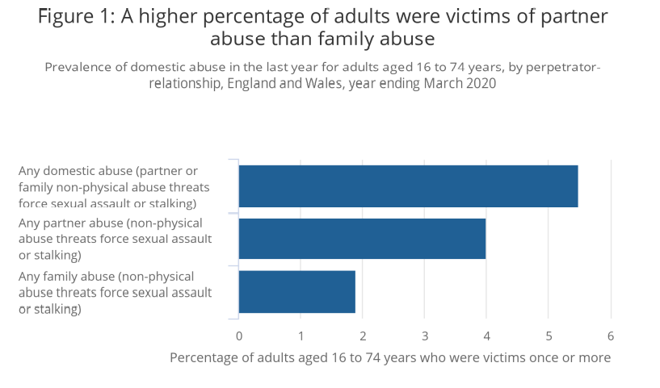

Source: Office for National statistics – Crime Survey for England and Wales

Police officers have the ability to make effective decisions quickly based on the information they have available to them at the time, the National Decision Model (NDM) is used to assist police officers with this. The NDM consists of five elements, each element provides the decision maker with an area for focus and consideration. The NDM includes the code of ethics – this is what separates the NDM from other decision making models (College of Policing, 2013). Below is a diagram outing the different stages of the NDM:

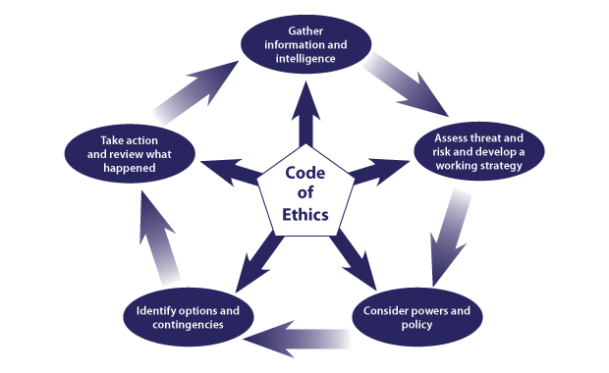

The first stage of the NDM is gathering information and intelligence. This is where the decision maker has to obtain information in order to be able to make effective decisions (College of Policing, 2013). For example, when I was instructed to attend this incident, the only information provided by the control room was that the call ended after a male could be heard requesting police. Police officers are often provided with little information when attending incidents. Whilst on route to this incident, I requested more information such as who lives at the address; including any children, whether any weapons had been seen, did anyone have any injuries and any warning markers. Warning markers are used to provide officers with an individual’s history which would allow officers to conduct a risk assessment and make a decision based on this information. For this incident, the individual’s identities were not disclosed therefore, we were unable to check warning markers.

During this incident, the identity of the caller was unknown however, we were able to identify where the call was made from and I therefore conducted a check on the address. Warning markers can also be placed on an address to inform police of previous incidents, whether there are any critical markers which can affect the police’s response to the incident. Conducting a check on the address allowed me to identify that the address had markers for previous domestics at the location. It also allowed me to identify that there were two children linked to the address.

Stage two of the NDM is assessing threat and risk and developing a working strategy. In order to do this, the parties involved should be separated. Therefore, I spoke to a male in the kitchen whilst my colleague spoke to the female. The female did not want us to talk to the male without her present however due to the nature of the call, separating them was necessary to ascertain what had happened. Once inside the kitchen, I saw a male who had clear facial injuries however the male would not disclose anything to me on how he sustained his injuries. I had conferred with my colleague who had informed me that the female stated that the male must have fallen over because he was intoxicated.

The next stage is considering powers and policies. This stage involves considering what powers, policies and legislation could be applied to a particular situation (College of Policing, 2013). When dealing with this incident, I considered all possible options and needed to identify the most suitable one. First, I needed to establish if any criminal offences had been committed and if so, how to deal with these offences, such as make an arrest or using an out of court disposal (OOCD). These are responses to crime that the police can administer locally without having to take the matter to court. Some examples of OOCDs are cautions, penalty notice for disorder and community resolutions such as Restorative Justice or women’s pathfinder (HM Government, 2014).

The next stage is to identify options and contingencies. South Wales Police’s policies state that “positive action must be taken when dealing with domestic abuse incidents”. Positive action doesn’t always mean making an arrest however, officers must be able to justify their decision, whether that be why they did or did not arrest someone. In some situations for example, when the behaviour does not amount to criminal conduct another approach may be taken, such as the ones mentioned in the stage above.

In this incident I was able to ascertain what had happened and as a result I was able to identify the options and contingencies that were relevant to the current situation. However, when using the NDM as more information is gathered, sometimes other options become available or sometimes your preferred option is no longer applicable. For instance, to utilise restorative justice as an out of court disposal for an offence, the subject must take responsibility for the offence committed. This means that officers must continuously reassess their decisions as they gain more information. Whilst at an incident, an officer could go through the stages of the NDM multiple times due to ever-changing scenarios.

The final stage of the NDM is ‘Take action and review what happened’. An example of this is when an officer makes an arrest which has required the officer to consider all of their options, powers, polices, legislation and decide which the most suitable option is. In the incident I dealt with, an arrest was the most suitable outcome as the male eventually disclosed to me that his wife had punched him in the face and then slapped him across his face however he did not want us to arrest his wife. Sometimes officers attend incidents where individuals have requested police in order to stop them from being hurt however then do not want any action taken. As police officers, it is our job to protect life and limb even if sometimes it is not what the individual wants.

It is an offence for any person to unlawfully assault another. An “assault” is any act, which intentionally or recklessly, causes another person to apprehend immediate and unlawful personal violence (Crown Prosecution Service, 2020). Examples of injuries sustained from common assault includes grazes, minor bruising and reddening to skin. Due to what the victim had disclosed to me during this incident and my understanding as to what category his injuries would be classed as, I arrested his wife for common assault under Section 39 of the Criminal Justice Act 1988 (legislation.gov.uk, 2018).

Although, this is not what the victim wanted, due to what he had disclosed I had to take positive action and safeguard him and his children – which I did by arresting her.

Considering the consequences of your actions is another way to assist in your decision making. For example, domestic incident’s where an individual has hit their partner but they both state that they are fine now. If you were an officer attending this incident, you have to consider the consequences of your actions, such as what could happen if you leave them both there. One being, there could be further violence once you have left, the victim could be too scared to say anything in front of their partner or you could leave and everything could be fine. However, if everything is not fine, further violence could occur due to the decision you made.

For example, if you attend a domestic and decided to leave both parties at the same address, there could be a further disturbance after you have left. Also, by leaving both parties together, safeguarding has not been addressed.

Between March 2018 and March 2020, “362 domestic homicides were recorded by the police” (Officer for National statistics, 2021). This represents “19% of all homicides where the victim was aged sixteen years over during this period” (Officer for National statistics, 2021). Of the 362 homicides, 214 (59%) were female victims who were killed by a partner or ex-partner. In contrast, 33 (9%) were male victims were killed by a partner or ex-partner (Office for national statistics, 2021). South Wales Police’s policy when attending domestics is to “always take positive action” to safeguard the victim, and in this case the appropriate outcome was to make an arrest (South Wales Police, n.d).

Safety and support for victims is paramount. The definition of safeguarding is “protecting an adult’s right to live in safety, free from abuse and neglect” (Department of health, 2014). There are numerous organisations and charities that offer support and guidance for victims. One organisation that offers support to victims is called “LIVE-FEAR-FREE”. This is a helpline service for sexual violence and domestic abuse victims in Wales. Live fear free can provide help and advice to:
- Anyone experiencing domestic abuse
- Anyone who knows someone who needs help, such as a friend, family member or colleague
- Practitioners seeking professional help (Gov.Wales, n.d)

There also campaigns that were designed to raise awareness such as the ‘Make yourself heard’ campaign. This is a national campaign that raises awareness about a system called ‘Silent Solution’. This system was created in 2002 and “enables a 999 caller who is unable to make a noise or speak to press 55 when prompted – to inform police they are in a genuine emergency” (Belfast Area, 2019). Assistant Chief Constable, Alan Todd of the police service of Northern Ireland stated that this method “allows people who are unable to speak to contact police while filtering out huge volumes of accidental calls made every day”. This campaign is supported by the family of Kerry Power, who was killed by her ex-partner in 2013. Power made a silent 999 call but did not respond to the operator and did not press 55. This led to the call being terminated and Devon and Cornwall Police were not notified of Power’s call (Belfast Area Domestic Violence Partnership, 2019).

Police officers safeguard victims by liaising with different agencies, such as social services, local education authority and mental health services. This is due to the identification that “police information was not known to other agencies which resulted in a lack of multiagency risk identification, assessment and action planning” (Detective Superintendent Fiona Grant, 2019). Police use an information sharing document called Public Protection Notification (PPN) reports to do this (South Wales Police, 2008), where officers can record safeguarding concerns when they have been identified. It is important to acknowledge the General Data Protection Regulation (GDPR), Data Protection Act (DPA) 2018 and Human Rights legislation are in existence to provide a framework to ensure that personal information about individuals is shared appropriately. There are four different categories: child concern, honour-based abuse, adult at risk and domestic abuse/stalking & harassment (DASH). In this incident, I had to complete a domestic abuse PPN, whereby DASH questions had to be completed. I then submitted this to our SWP Public Protection Unit who share it with the relevant agencies.

In conclusion, the NDM is a useful tool that was created to assist when making decisions efficiently. Police officers have to make decisions quickly and effectively, even when the circumstances are actively changing and quite often, very little information is available. Police officers have to be able to take whatever information they have and make an effective decision whilst considering their powers, legislation and safeguarding. I am confident that I effectively used the NDM and made the correct decision by arresting the female. When I later reviewed the situation, I identified that a consequence of not arresting the female could have led to the victim being subjected to further violence. It is important that officers are aware of the consequences of their actions as these assists when making the decision.

Wordcount: 1925

Task 3

Relevant areas of the National Policing Curriculum:
Maintaining Professional Standards, Leadership and Team-working

Evaluate theories of team dynamics as a means of developing team cohesion (reasons why some teams cannot function, theories and models relating to team dynamics, ways to improve team cohesion).

Consider why inter-personal conflict can occur within a team and outline what strategies can be adopted to enhance individual and team performance.

Consider how team dynamics within the police service can result in failing to comply with professional standards requirements (Code of Ethics, policies, procedures, protocols or legislation).

1750 words (+/- 10%: include your actual word count at the end of each section)

ANSWER:

In this essay, I will be evaluating the theories of team dynamics as a means of developing team cohesion. I am also going to be discussing why inter-personal conflict can occur within a team and outlining what strategies can be adopted to enhance individual and team performance. Additionally, I am going to be examining how team dynamics within the police service can result in failing to comply with professional standards requirements, including the code of ethics, policies, procedures, protocols, and legislation.

An early definition of team cohesion is “the total field of forces which act on members to remain in the group” (Festinger, Schacter & Back, 1950). “A team differs from a group in that team members are required to complete a task or project” (Towler, 2019) for example a team of employees working towards an organisations goal.

In a Harvard business review article in 2011, team cohesion was shown as occurring when the members engage in collective work and demonstrate mutual commitment to challenging goals in order to reach an overarching purpose. The authors state that “collective work produces more innovative and productive outcomes that exceed the simple sum of individual efforts” (Hill & Lineback, 2011).

According to Bruce Tuckman (1965), there are four stages in team development that can be used to assess a team’s cohesiveness. Tuckman’s model outlines how to build an effective team. He initially described four stages that he believes every team goes through in order to become ‘cohesive task-focussed teams’ (Tuckman, 1965).

The four stages of Tuckman’s model are; Forming, Storming, Norming and Performing. Tuckman stated that by understanding these stages, individuals would be able to understand why certain behaviours are happening and make informed changes.

The first stage of Tuckman’s model is ‘forming’. This stage occurs at the beginning so when a new team forms, individuals will be unsure of the team’s purpose, how they fit in, and whether they’ll work well with one another. Teams have high expectations and are eager of what is to come (Miller, 2014). When I joined my current police response team, it took a while for me to find my feet. Not only was I still trying to comprehend the job of a constable, but I was also trying to create positive relationships with a team that was already well-established. When a new member is added, it disrupts the dynamics of the team. Relationships within the team must be built for the disruption to end, this happens over time (Paquet, 2020).

The second stage of Tuckman’s Model is ‘storming’. During this stage, conflict can occur between individuals. As an individuals preferred way of working becomes established, disagreements between team members or supervisors can occur. Another factor that can cause team disagreements is leadership styles. My supervisor has a democratic leadership style which consists of decisions being made collectively as a team and gives individuals the opportunity to express their opinions should they want to. This type of leadership encourages team involvement, encouragement and participation, which ultimately increases the cohesion within a team (Jakhar, 2017).

Approximately, six months into working with my current police team, I entered the next stage in Tuckman’s team development model, which is ‘Norming’. At this stage I was more comfortable around my team and started to feel like a valued member of the team. As a trusted member of the team, this is when I started to gain more responsibility. For instance, being assigned more incidents to deal with myself and attending more complex incidents.

The next stage is ‘performing’, this is where I realised how much I had progressed since joining my current team. I am now more confident in my decisions and my rationales. I am able to deal with complex incidents effectively, and without the direct supervision from my sergeant. Although I have gained experience since joining the police, I understand that I am still inexperienced in relation to some colleagues who have had over twenty years’ service in the police. I am going to utilise these colleagues and supervisors in order to help me progress and further my development.

An advantage of this model is that it helps us understand that teams evolve and also allows us to consider how they may encounter different problems at different stages of their development (Happy manager blog, 2021). However, a limitation is that the model makes team building appear too linear and sequential (Happy manager blog, 2021) Some teams may revisit certain stages whilst they are in development, but this is not outlined in the model. Below is a diagram of Tuckman’s model:

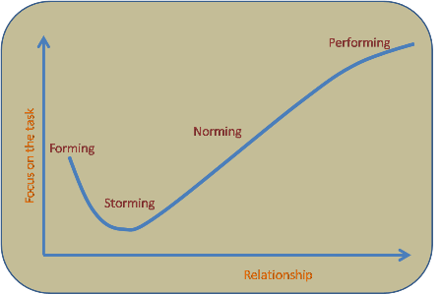

One strategy that can assist in individual and team performance is the DISC model. This model was developed by Dr. Marston in 1928. The model is used for conflict management as it predicts behaviours based on four key personality traits, which he originally described as Dominance, Inducement, Submission and Compliance (Marsten, 1928). The DISC model is often used in professional contexts because having some insight into individual’s personality traits can help when trying to resolve conflicts with a team. Below is a diagram of the DISC model, and it outlines some of the characteristic that are associated with each section of the DISC model:
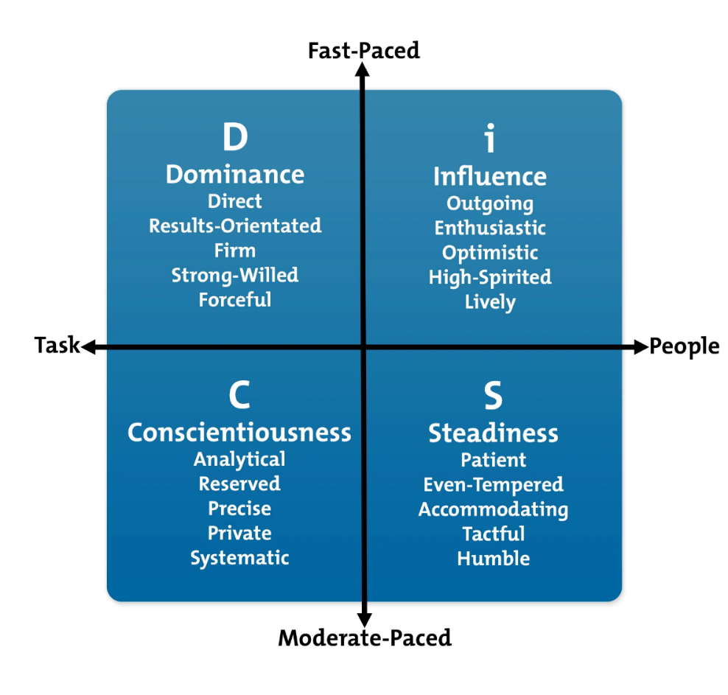

The DISC model allows individuals to analyse their own preferred behavioural style and those of their team members. Also, by sharing DISC profiles with other individuals on a team, it helps them to understand their differences so they can work more effectively together. This model can be used to increase team building as it allows individuals to understand that everyone has different preferences and that individuals are able to “improve their interpersonal relationships and manage team members in a way that plays to their strength” (Mindtools.com, 2019).

An advantage of this model is that it allows individuals to analyse their own preferred behavioural style and those of their team members (MindTools, 2019). However, this is a simplified model and individuals are complex and sophisticated therefore this model is not always the most suitable model.

Another model that facilitates team progression is Belbin’s model of Team Role. Dr Belbin’s research identified that there are nine clusters of behavioural attributes which are effective for team development (Belbin, 2021). The nine Belbin team roles can be broken down and defined as:

- Resource investigator – where the individual is extrovert, enthusiastic and communicative.

- Team worker – where the individual is mild, perceptive, diplomatic, listens and averts friction.

- Co-ordinator – where the individual takes a mature approach to situations, is confident and delegates well.

- Plant – where the individual is creative, imaginative, unconventional, introverted and a problem-solver.

- Monitor Evaluator – where the individual is astute, sees all options and points of views whilst judging accurately.

- Specialist – whereby the individual has in-depth knowledge of a key area.

- Shaper – the individual is dynamic, thrives on pressure, has the drive and ability to overcome obstacles.

- Implementer – whereby the individual is reliable, efficient and can turn ideas into practical actions.

- Completer Finisher – where the individual is conscientious, anxious, searches out errors and omissions, whilst being a perfectionist. (Belbin, 2021).

Belbin stated “The types of behaviour in which people engage are infinite. But the range of useful behaviours, which make an effective contribution to team performance is finite. These behaviours are grouped into a set number of related clusters, to which the term ‘Team Role’ is applied” (Belbin, 1981). Belbin’s research indicated that the most successful teams were made up of a diverse mix of behaviours. This does not mean that every team needs to consist of nine individuals to be effective, instead some individuals will have more than one preferred team role so will often occupy more than one beneficial trait in their team. Belbin created a psychometric test called the “Belbin Team Inventory test” to establish the ideal team roles for individuals to possess within a team. Participants must evaluate their own behaviours, receive feedback from observers and compare the two.

An advantage of this model is that it reflects how individuals like to work and their preferred ways of working. However, there are also limitations to this model, such as individuals who use this model needing to understand that their identified strengths are not fixed for life. Behaviours change and people adapt therefore it is possible for individuals to achieve a different ‘preferred role’ if completing the test again in the future.

A contradiction of Belbin’s model is Honey’s team roles, whereby Honey’s research exhibits five team roles that are essential for an effective team.
- The leader – whereby an individual ensures that the team understand their aims and objectives whilst ensuring involvement and commitment stays high. In the police force an Inspector would be associated with this role.
- The challenger – whereby the individual questions the effectiveness of the task, the team etc and asks to implement improvement. In the police force this role could be associated with a sergeant. This role is important as it is crucial that time isn’t wasted, and productivity is high.
- The doer – whereby the individual attempts to get the team to contribute to the task at hand and plays a practical part of all tasks.
- The thinker – whereby the individual comes to the team with well-thought ideas and attempts to improve ideas of other team members.
- The supporter – whereby the individual tries to keep team cohesion and harmony. They try to ease all the tension and ensure good teamwork. Again, in the police force this role can be associated with a sergeant (Honey, 2001).

Interpersonal conflict can occur on any team, even the ones with the best performance. Patrick Lencioni outlines five common problems team experience that impact their effectiveness in his book called “The five dysfunctions of a team” (2005). Lencioni stated that the five dysfunctions are Lack of trust, fear of conflict, lack of commitment, avoidance of accountability and inattention to results. These are all displayed in the diagram below:

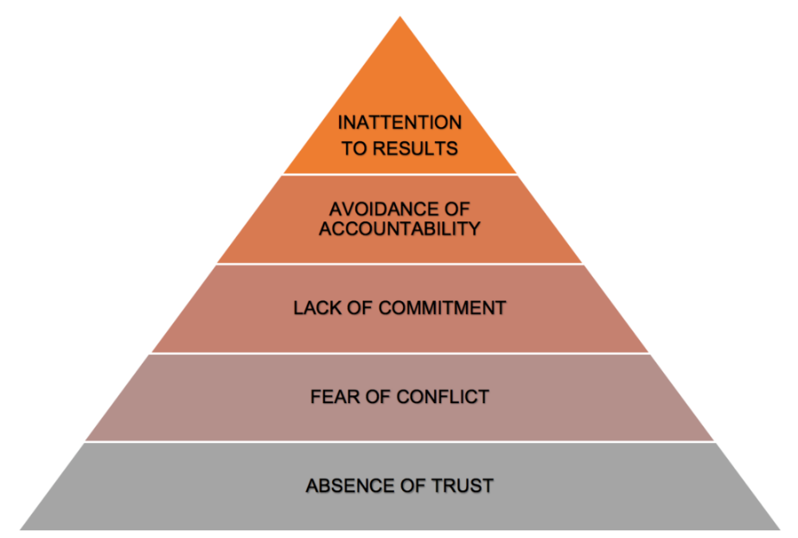

Lencioni created this diagram and advised when tackling each dysfunction that individuals start from the bottom and work their way up. He believes that “establishing trust is a crucial first step to being able to manage conflict, achieve commitment, create accountability and focus on results”. Although all teams face some sort of interpersonal conflict, multiple methods have been created in order to assist with team cohesion and team development that include dealing with interpersonal conflict.

Although team cohesion is needed for an effective team, there can be times where individuals take it too far and forget that they must adhere to specific standards such as the professional standards of policing, which includes the code of ethics, policies, procedures, and legislation. This can often lead to a misconduct hearing for the officers involved and can even result in their dismissal from the job, an example of this would be Deniz Jaffer and Jamie Lewis. Both Jaffer and Lewis were Metropolitan police officers who were both sentenced to two years and nine months after they took photos of two murder victims whilst they were meant to be guarding the scene in London 2020 (Dodd, 2021). The two officers took photos of the bodies and shared them in Whatsapp groups, one of which contained 41 other officers. Their actions amounted to a gross breach of trust and even helped the defence of the murderer, Danyal Hussein as his defence team tried to claim possible contamination by the two officers entering the crime scene to take photos. Both officers had to leave their post and enter the crime scene to take the photos that were found on their phones as these could not have been taken from the post that they were assigned to (Dodd, 2021).

As police officers there are certain expectations and standards that we have to live up to and both Jaffer and Lewis abandoned these. Within the code of ethics, there are ten standards of professional behaviour. These are:
- Honesty and integrity
- Authority, respect and courtesy
- Equality and diversity
- Use of force
- Orders and instructions
- Duties and responsibilities
- Confidentiality
- Fitness for work
- Conduct
- Challenging and reporting improper behaviour (College of Policing, 2014,

Jaffer and Lewis breached a multiple amount of these standards as they did not act with integrity, they compromised and abused their position by accessing the crime scene. Also, they did not abide with police regulations as they left their post. Moreover, they did not follow the reasonable order which was to stay at their post. Adding to that, they breached confidentiality by not treating the victims/victim’s family with respect. They accessed and disclosed information/photographs which were not in proper course of their duties. Lastly, they brought discredit to the police service and undermined public confidence in policing.

In Conclusion, multiple theories of team dynamics such as Tuckerman’s, Belbin’s and Honey’s have been created as a means of developing team cohesion. All of these theories have benefits and limitations however some contradict each other, such as Belbin’s and Honey’s. Nonetheless, all of these theories were created as a means of making a team more effective and increasing cohesion within a team.

Moreover, there are many reasons why interpersonal conflict can occur and models like Lencioni’s outlines five common problems that teams experience which impacts their effectiveness. Lencioni’s model breaks down the five areas and he suggest that trust should be targeted first when trying to reduce interpersonal conflict.

Throughout this essay, I have explained how team dynamics within the police force can result in failing to comply with professional standards. I have considered reasons for this such as failing to uphold the standards of professional behaviours and bringing discredit to the police service. Police officers are held to higher standards, whether they are on or off duty. Lastly, Police officers should not have to be reminded of this as they should constantly considering the code of ethics whilst they are carrying out their role.

Wordcount: 1925

Task 4
Relevant areas of the National Policing Curriculum:
Policing the roads, information and intelligence and conducting investigations.

Explain how information and intelligence can be used in the disruption of the more prevalent criminal activity (e.g. drug smuggling, human trafficking, child sexual exploitation, counterfeit goods, organised crime groups and ‘county lines’) by effective policing of the roads.

Outline how ANPR can be used as investigative resource when disrupting criminal activity.

1750 words (+/- 10%: include your actual word count at the end of each section)

ANSWER:

In this essay, I am going to be defining information and intelligence whilst explaining how they can be used in the disruption of criminal activity by effective policing of the roads. Moreover, this essay will also include the benefits of automatic number plate recognition cameras (ANPR) and how it is used as an investigative resource when disrupting criminal activity.

Information can be defined as “a message that contains meaning, implication or input for decision and/or action” (Liew, 2007). Information can be used to assist in decision making or solving problems (Liew, 2007). Intelligence consists of information that has been obtained and analysed (Innes and Sheptycki, 2004). For instance, police officers receive information from members of the public, which then gets analysed, and becomes intelligence. Intelligence is a vital component of police operations and also assists in decisions made by police forces, such as South Wales Police.

Intelligence-led policing (LIP) was introduced in the UK in the 1990s as a new model of policing. Within this policing model, intelligence from several agencies is pooled with the explicit intention to “disrupt, disable or undermine criminal behaviour” (Newburn & Neyroud, 2008). The concept of intelligence-led policing underpins all aspects of policing including the investigation of serious and organised crime and terrorism (Thornton, 2007). The Mantra of the LIP became to “target the criminal and not just the crime” (Audit Commission, 1993) and this led to a much greater emphasis on intelligence gathering, by using the 5x5x5 model and the use of intelligence analysis.

LIP allows police forces to create strategies and tactics that aim to disrupt criminality (Innes and Sheptycki, 2004). LIP allows police forces to prevent a crime from occurring as it focusses on future crimes that could be committed rather than focussing on the detection of crimes that have already been committed. This allows police objectives to become more pragmatic and enables them to be able to disable criminal networks and markets (Innes and Sheptycki, 2004).

South Wales Police have a specialised unit called the ‘Roads Policing Unit’ which consists of them patrolling the roads day and night to both prevent and detect offences. The ‘Roads Policing unit’ also targets organised criminals and proactively denies them the use of the road network (South Wales Police, n.d).

Organised crime is “planned and co-ordinated criminal behaviour and conducted by individuals working together on a continuing basis, often for financial gain” (Crown Prosecution Service, 2019). There are approximately “4,500 identified organised crime groups currently operating in the United Kingdom (National Audit Office, 2019). Organised crime groups use vehicles to assist in committing crimes such as county lines, human trafficking, drug smuggling, child sexual exploitation (gov.uk, 2017). Organised crime groups use a variety of techniques such as hiring vehicles, obscuring number plates, stolen vehicles, cloning number plates as well as obscuring their faces when travelling past cameras (Disrupting serious and organised criminals, n.d). Organised Crime groups often participate in activities such as drug smuggling, human trafficking, child sexual exploitation and county lines.

County lines is where illegal drugs are transported from one area to another by vehicles including cars, vans, trains, buses etc. Another criminal activity conducted by OCG members that utilises vehicles is human trafficking. Human trafficking is the “movement of people for exploitation by the use of threat, force, fraud or the abuse of vulnerability” (gov.uk, 2017). It starts with recruitment of vulnerable people, followed by them being transported to a destination and then exploitered. OCG members use vehicles to transport their victims.

In order to disrupt organised crime groups, it is necessary to obtain as much information about that group and their criminal activities as possible. Exchanging intelligence with partnering agencies allows a vast amount of intelligence to be obtained. The Government Agency Intelligence Network (GAIN) is one way of doing this. The GAIN consists of 20 national bodies including the police and it enables valuable information about organised criminals to be accessed whilst helping partner agencies to understand the threat from serious and organised crime (Regional organised crimes unit, 2015).

South Wales Police regularly submits referrals to the GAIN co-ordinator when they are considering action against an organised crime group or when they believe a new organised crime group member has been identified. From March 2014 to March 2015, South Wales Police submitted approximately 60 requests to access GAIN’s intelligence. An example of how information and intelligence can be used to disrupt crime is ‘Operation Orange Gobi’, whereby the South Wales Police Organised Crime Unit and Force Intelligence department conducted an investigation that focussed on ‘suspected criminal activities of an organised crime group’ that were engaged in facilitating the transfer, storage and supply of large quantities of the class A controlled drug, cocaine (Sedgwick Chudleigh Mckenna Law, n.d). Whilst conducting the investigation, it was discovered that the OCG hired vehicles in an attempt to evade police attention and intervention however through the use of ANPR cameras, officers were able to track the vehicles. The total amount of cocaine recovered during the operation would have had a “street value of almost £500,000 (Sedgwick Chudleigh McKenna Law, n.d). This is just one example of how information and intelligence is used to disrupt criminality.

By obtaining intelligence, it then allows operations to be created to intercept these criminals whilst they are on the roads and potentially before the crime has been committed.

Technology has the ability to transform how police forces tackle criminality on the roads. One source of technology available to police forces is automatic number plate recognition cameras (ANPR). ANPR cameras are used to help “detect, deter and disrupt criminality” at all levels (Police.uk, 2021). This includes tracking travelling criminals, such as organised crime groups.

ANPR cameras read a vehicle’s registration number as it passes the camera. It then checks the registration number against a database which contains vehicles of interest. ANPR cameras have the ability to store every vehicle’s registration number once it has passed the camera, including vehicles that are not known to be of interest at the time of passing the camera. Police officers, including those on the Roads Policing Unit are then able to use the data received from ANPR cameras to gain an insight into the vehicle’s day to day movements, allowing them to identify if there is a pattern emerging. This also allows officers to intercept and stop vehicles, check the vehicle for evidence and where necessary, make arrests (Police.uk, n.d)

Another benefit of ANPR cameras is that it allows police officers attention to be drawn to offending vehicles whilst allowing law abiding drivers to go about their business unhindered (Police.uk, n.d). Adding to that, ANPR cameras can be used as an alarm. Specific markers can be placed on vehicles which are then registered on the Police National Database (PND). These markers can be used nationally to identify a vehicle that requires intervention. A Police National Database marker can be placed on a vehicle so that any time a check is conducted on that vehicle, the marker will appear. For example, if a vehicle is stolen in the Swansea but is then driven to Cardiff and a check is completed on the car for an irrelevant reason, such as excelling the speed limit, the officer will be able to see that a marker has been placed on the vehicle to say that it has been stolen and can intervene. Other markers include, ‘ACT’ markers which sends a notification to the relevant police force every time that vehicle passes an ANPR camera. This alerts police to the vehicles movements so that they can intervene.

Adding to that, ANPR cameras can also be used to identify vehicles that are travelling in convey. For instance, Local police forces were assisted by ANPR cameras in identifying a male who was co-ordinating armed robberies. The vehicles used to commit the armed robberies had false number plates therefore ANPR was not able to track the vehicles. However, through using ANPR police forces were able to identify a common vehicle which was travelling in convoy. This vehicle was owned and registered to an OCG member and led to him being arrested and convicted (Disrupting serious and organised criminals, n.d).

Section 163 of the Road Traffic Act 1988 is a police power which “requires a person driving a mechanically propelled vehicle on a road to stop the vehicle on being required to do so by a constable in uniform” (Legislation.gov.uk, 2020). Despite this power, there are circumstances when drivers chose to ignore this and will continue to drive. This could be because they are participating in criminal activities or because they could have contraband in the vehicle which they do not want the officer to seize. If a vehicle is failing to stop for an officer, police can utilise ANPR cameras to track the direction of travel of the vehicle so that they can intercept it at a further point.

Although ANPR cameras have many benefits, one limitation is that they do not cover all roads. OCG members are aware of this, and they often try to avoid overt CCTV cameras and ANPR camera locations by taking an alternative route. Police have had to adapt to this and have increased visibility on the roads in an attempt to influence the type of roads used by OCG members. By having an increased police presence on rural roads used by OCG members it encourages them to use alternative routes, which may place them directly into police contact. This can lead to more vehicle stops, which amounts to more intelligence being created, that police can then use to create strategies and tactics to intervene (Disrupting serious and organised criminals, n.d).

In conclusion, information and intelligence is greatly beneficial and utilised by all police forces across the UK. Intelligence-led policing has allowed police to determine where or what crimes are going to occur before they have been committed. Intelligence gathering has also allowed all partnering agencies to be aware of specific individuals, groups, or vehicles as they are all sharing their information and intelligence so that officers are better equipped when dealing with said individual, group or vehicle. Also, by sharing intelligence, more than one police force will have access to this information where a vehicle may be involved in crimes such as County lines related offences or human trafficking. As the intelligence is available to other forces, there is a higher chance of the vehicle being intercepted and the driver/occupants being brought to justice for committing any offences.
Lastly, the use of ANPR cameras has had a drastic effect in disrupting criminal activity on road networks. Police forces are now able to track vehicles, identify convoy vehicles, identify an individual’s identity and most of all provides the opportunity for police forces to intervene prior to the crime being committed. ANPR cameras have led to numerous convictions of multiple OCG members throughout the years that without the assistance of ANPR cameras, would have been difficult to locate. The benefits of ANPR cameras truly outweigh the limitations and by using ANPR cameras as an investigative resource policing has developed and become more efficient.

Wordcount: 1844

Task 5
Individual Learning Plan

The second learning outcome identified in the accompanying module descriptor (BMPP 5000D) asks that you create an individual learning plan to meet your identified needs through reflection upon your continuing practice. This shows confidence in your ability to manage your own learning in response to evolving circumstances in the workplace.

This task differs from the PDPs that you have completed in your previous workbooks in that this learning plan allows you to assess what level you believe you are in key knowledge, skills and experience against where you believe you (and the force) consider you should be – now and in the coming 6 to 12 months of your placement. This should then be used to target future development need.

1500 words equivalent. Please note that this is not the actual number of words used in completing the table, the count reflects the thought and research behind it.

It will count towards the overall equivalent word count of 8000 words expected from this module.

ANSWER:

Knowledge, Skills and Experience Assessment

 | REQUIRED |  |  | RATING |  |  | DEVELOPMENT NEED
KNOWLEDGE | Low  1-4  4 | Med  5-7 | High  8-10 | Low  1-4  4 | Med  5-7 | High  8-10 | As a front-line response officer, I have been faced with many different situations and circumstances, although I have not been in the police force for a long period of time, I feel that my experience is at four. At the end of my tutorship, I would have graded myself a two however since being independent my knowledge has increased, hence why I would now grade myself a four  I will also be able to further my knowledge when I complete the necessary attachments. For example, as a response officer, I have not dealt with many Road traffic collisions (RTC) as South Wales Police have their own specialised traffic unit that attends all the Road Traffic Collisions. I have an attachment booked with the traffic unit for February whereby I will stay with a traffic officer for a few shifts and observe how they deal with incidents. This will further my knowledge and they will be teaching me new things regarding traffic in general. I have also booked other attachments to assist in developing my knowledge such as the Public Protection Unit, Custody, The Hub which is where all interviews take place and Crime investigation detectives.
SKILLS | Low  1-4  5 | Med  5-7 | High  8-10 | Low  1-4  5 | Med  5-7 | High  8-10 | In relation to my skills, I would grade myself a five as although my skills have developed since I have achieved independent status, I know that I still must further develop them in order to become a skilled officer. I plan on ensuring that I take the correct steps to further develop.  I know that throughout my career, I will be able to progress and develop my skills. One way of me being able to do this is by going on police attachments. I plan on completing an attachment with the Public protection unit – this will allow me to develop my victim and safeguarding skills. I will also complete my interviewing and CID attachment to develop my investigative skills.  In addition to this, I will be using my Blackstone’s policing book to further my skills by making myself aware of certain techniques and alternatives ways to conduct policing policies. This will result in me being a well-rounded police officer in the future which I intend to be.
EXPERIENCE | Low  1-4  3 | Med  5-7 | High  8-10 | Low  1-4  3 | Med  5-7 | High  8-10 | In relation to my experience of the job, although I have successfully completed by 6 months theory-based training, I have only been independent for approximately eighteen months. In terms of having a full career in the police, which is thirty-five years, my knowledge is little compared to what it will be in the future when I have been in the job for a longer period.  I plan to develop my experience by completing different attachments such as CID, Public protection unit, the interviewing unit, traffic unit etc. these will allow me to develop skills in those specialised departments that I can then use whilst on response.

Bibliography
The bibliography should only include sources referenced within the workbook using the Harvard referencing system. Information about referencing in written assignments and how to avoid plagiarism can be found on Moodle. It is important that you are aware of the importance of ensuring that the work submitted is your original work.
References:

- BBC News (2019) Silent 999 calls: Press 55 to confirm emergency. Available at: https://www.bbc.co.uk/news/uk-47847735 (Accessed on 20.12.21)

- Belfast area domestic violence partnership (2019) Make yourself heard campaign. Available at: https://belfastdvp.co.uk/make-yourself-heard-campaign/#:~:text=Make%20Yourself%20Heard%20Campaign%20%E2%80%98Make%20Yourself%20Heard%E2%80%99%20campaign,are%20in%20imminent%20danger%20but%20unable%20to%20speak. (Accessed on 20.12.21)

- Belbin (2021) Belbin team roles. Available at: https://www.belbin.com/about/belbin-team-roles (Accessed on 01.02.22)

- Belbin Associates (n.d) The nine Belbin team roles. Available at: https://www.belbin.com/about/belbin-team-roles (Accessed on 31.12.21)

- Bond et al & Baughman et al (2013, 2014) Available at https://www.ncbi.nlm.nih.gov/pmc/articles/PMC6400077/ (Accessed on 25.12.21)

- Borton (1970) Model of reflection. Available at: https://essaywritingserviceuk.co.uk/advice-and-guidance/bortons-model-of-reflection (Accessed on 29.12.21)

- Childs, C & De Wit, H (2014) Regular exercise is associated with emotional resilience to acute stress in healthy adults. Available at: https://www.ncbi.nlm.nih.gov/pmc/articles/PMC4013452/ (Accessed on 29/11/2021)

- College of Policing (2015) Arrest and other positive approaches. Available at: https://www.app.college.police.uk/app-content/major-investigation-and-public-protection/domestic-abuse/arrest-and-other-positive-approaches/ (Accessed on 22/07/2021)

- College of policing (2014) Code of Ethics. Available at: https://assets.college.police.uk/s3fs-public/2021-02/code_of_ethics.pdf (Accessed on 31.12.21)

- College of Policing (2013) National Decision Model. Available at: https://www.app.college.police.uk/app-content/national-decision-model/the-national-decision-model/#the-model (Accessed on 01/08/2021)

- Crown Prosecution Service (2020) offences against the person incorporating the charging standard. Available at: https://www.cps.gov.uk/legal-guidance/offences-against-person-incorporating-charging-standard (Accessed on 29.12.21)

- Crown Prosecution Service (2019) Organised crime – Strategy. Available at: https://www.cps.gov.uk/organised-crime-strategy (Accessed on 03.02.22)

- Culture in the Police Force (2018) UKEssays. Available at: https://www.ukessays.com/essays/cultural-studies/culture-as-the-way-of-life-cultural-studies-essay.php?vref=1 (Accessed on 09.12.21)

- Department of Health (2014) Definition of safeguarding. Available at: https://www.gov.uk/ government/uploads/system/uploads/attachment_data/file/366104/43380_23902777_Care_Act_Book.pdf (Accessed on 20.12.21)

- Dodd, V (2021) Two Met police officers jailed over photos of murdered sisters. The Guardian. Available at: https://www.theguardian.com/uk-news/2021/dec/06/two-met-police-officers-jailed-photos-murdered-sisters-deniz-jaffer-jamie-lewis-nicole-smallman-bibaa-henry (Accessed on 31.12.21)

- Disrupting serious and organised criminals (n.d) Menu of tactics. Available at: https://whatworks.college.police.uk/Research/Documents/Menu_of_tactics.pdf (Accessed on 03.02.2022)

- Festinger. L, Schacter. S & Back, K (1950) – Social pressures in informal groups: a study of human factors in housing. Available at: https://www.collectionbooks.net/pdf/social-pressures-in-informal-groups-a-study-of-human-factors-in-housing-by-leon-festinger-stanley-schachter-and-kurt-back – page 164 (Accessed on 02/09/21)

- Gov.uk (2017) Human Trafficking: migrant health guide. Available at: https://www.gov.uk/guidance/human-trafficking-migrant-health-guide (Accessed at 31.12.21)

- Gov.Wales (n.d) Live Fear Free. Available at: https://gov.wales/live-fear-free/domestic-abuse-wales#:~:text=Live%20Fear%20Free%20can%20provide%20help%20and%20advice,member%20or%20colleague%203%20practitioners%20seeking%20professional%20advice. (Accessed on 01/11/2021)

- Hill, L & Lineback, K (2011) – Article titled Turn your group into a true team. Available at: https://hbr.org/2011/06/turn-your-group-into-a-true-te.html (Accessed on 02/09//21)

- HM Government (2014) Out of Court Disposals. Available at: https://consult.justice.gov.uk/digital-communications/out-of-court-disposals/results/out-of-court-disposals-response.pdf (Accessed on 9.12.21)

- Honey, P (2001) Team roles theory. Available at https://studyhub.fxplus.ac.uk/study-guides/teams-groupwork/activities/team-roles (Accessed on 31.12.21)

- Indeed Editorial Team (2021) The nine Belbin team Roles. Available at:https://www.indeed.com/career-advice/career-development/belbin-team-roles#:~:text=Meredith%20Belbin%20devised%20the%20Belbin%20Team%20Inventory%20test,receive%20feedback%20from%20observers%20and%20compare%20the%20two. (Accessed on 31.12.21)

- Innes & Sheptycki (2004) From detection to disruption. Available at: https://journals.sagepub.com/doi/abs/10.1 (Accessed on 31.12.21)

- Jakhar, S (2017) Why and how democratic leadership style is on of the most effective management styles. Available at: https://www.linkedin.com/pulse/why-how-democratic-leadership-style-one-most-effective-jakhar (Accessed on 01.02.22)

- Kleinig, J (2001) The blue wall of silence, an ethical analysis. Available at: International Journal of applied Philosophy, Volume 15, pages 1-23 (Accessed on 31.01.22)

- Last, S (2019) Five models of understanding Team Dynamics. Available at: https://pressbooks.bccampus.ca/technicalwriting/chapter/understandingteamdynamics/#return-footnote-1135-8 (Accessed on 03/08/2021)

- Le, C, Nowell, C, Kim-Fuchs, C (2016) Chronic stress in mice remodels lymph vasculature to promote tumour cell dissemination. Available at https://doi.org/10.1038/ncomms10634 (Accessed on 25/12/21)

- Legislation.gov.uk (2018) Criminal Justice Act 1988. Available at: https://www.legislation.gov.uk/ukpga/1988/33/section/39 (Accessed on 25.12.21)

- Legislation.gov.uk (2020) Road Traffic Act 1988. Available at: https://www.legislation.gov.uk/ukpga/1988/52/section/163 (Accessed on 04.02.22)

- Liew (2007) Data, information, Intelligence, Wisdom and their interrelationships. Available at: https://www.researchgate.net/profile/Anthony-Liew-2/publication/236870996_DIKIW_Data_Information_Knowledge_Intelligence_Wisdom_and_their_Interrelationships/links/0deec519c0cac9afca000000/DIKIW-Data-Information-Knowledge-Intelligence-Wisdom-and-their-Interrelationships.pdf (Accessed on 31.12.21)

- Lencioni, P – The five Dysfunctions of a Team (2005) Available at: https://www.academia.edu/39178542/The_Five_Dysfunctions_of_aTeam_Patrick_Lencioni (Accessed on 03/08/2021)

- McGonigal, K (2020) Available at: https://www.shape.com/fitness/tips/exercise-mental-resilience-stress#:~:text=%22On%20days%20when%20people%20exercise%2C%20stressful%20things%20take,your%20brain%20over%20time%20and%20maintains%20brain%20health. (Accessed on 13/11/2021)

- Marsten, W (1928) – Emotions of Normal people. Keegan Paul Trench Trubner and Co. Ltd: republished London: Routledge (2002) Available at: https://archive.org/details/emotionsofnormal032195mbp (Accessed on 03/08/2021)

- Miller, T (2014) When four worlds collide. Available at: Training journal, pages 22-27 https://www.thecampuscommon.com/library/ezproxy/ticketdemocs.asp?sch=suo&turl=https://search-ebscohost-com.southuniversity.libproxy.edmc.edu/login.aspx?direct=true&db=bth&AN=95880476&site=eds-live (Accessed on 29.12.21)

- MindTools (2019) The DISC MODEL. Available at: https://www.mindtools.com/pages/article/newCDV_92.htm (Accessed at 31.12.21)

- Moore, C (2019) Resilience Theory: What research articles in psychology teach us. Available at: https://positivepsychology.com/resilience-theory/ (Accessed on 04.02.2022)

- National Alliance on mental Health (2018) why high rates of PTSD in police officers. Available at: https://nationalpolicesupportfund.com/police-officers-experience-high-rates-of-ptsd/#:~:text=That%20issue%20is%20Post%20Traumatic%20Stress%20Disorder.%20New,and%20large%2C%20police%20officers%20suffer%20from%20cumulative%20PTSD. (Accessed on 25.12.21)

- National Audit Office (2019) Tackling serious and organised crime. Available at: https://www.nao.org.uk/wp-content/uploads/2019/03/Tackling-serious-and-organised-crime-Summary.pdf#:~:text=The%20challenges%20in%20tackling%20serious%20and%20organised%20crime,treatments%2C%20and%20a%20cost%C2%A0of%20%C2%A38%C2%A0billion%20from%20economic%20crime. (Accessed on 04.02.22)

- National Health Service (2020) How much sleep do children and adults need? Available at: https://www.nhs.uk/live-well/sleep-and-tiredness/how-much-sleep-do-kids-need/ (Accessed on 25.12.21)

- Newburn, T and Neyroud, P (2008) Available at: Dictionary of Policing, Page 146. (Accessed on 15/09/2021)

- Office for National Statistics (2021) Domestic abuse prevalence and trends, England and Wales: year ending March 2021 Available at: https://www.ons.gov.uk/peoplepopulationandcommunity/crimeandjustice/articles/domesticabuseprevalenceandtrendsenglandandwales/yearendingmarch2020 (Accessed on 22/07/2021)

- Oxford Dictionary (n.d) Definition of Resilience. Available at: https://www.oxfordlearnersdictionaries.com/definition/english/resilience?q=resilience (Accessed on 09.12.21)

- Paquet, J (2020) Tuckerman Model: Team cohesion. Available at: https://www.myagilepartner.com/blog/index.php/2020/07/30/tuckman-model/ (Accessed on 16/12/21)

- Police.uk – Automatic Number Plate Recognition (ANPR) (2021) Available at: https://www.police.uk/pu/advice-crime-prevention/automatic-number-plate-recognition-anpr/ (Accessed on 18/07/2021)

- Regional organised crime unit (2015) A review of capability and effectiveness. Available at: regional-organised-crime-units.pdf (justiceinspectorates.gov.uk) (Accessed on 03.02.22)

- Reiner, R (2000) Crime and Control in Britain. Available at: https://journals.sagepub.com/doi/10.1177/S0038038500000067 (Accessed on 09/12/21)

- US National Library of Medicine (PMC) (2017) Police stressors and health: A state of the art review. Available at: https://www.ncbi.nlm.nih.gov/pmc/articles/PMC6400077/ (Accessed on 20.12.21)

- Seligman, M (1990) The 3P’s model. Available at: Helplessness: on depression, development, and death. (Accessed on 04.02.2022)

- Shane, J (2010) Organisational stressors and police performance. Available at: Journal of criminal Justice, Volume. 38, No. 4, pp. 807 – 818 (Accessed on 25/12/21)

- South Wales Police (n.d) Road smart. Available at: https://beta.south-wales.police.uk/police-forces/south-wales-police/areas/campaigns/campaigns/road-smart/#:~:text=At%20South%20Wales%20Police%20we%20have%20specialist%20teams,proactively%20denying%20them%20use%20of%20the%20road%20network. (Accessed on 02.02.22)
- South Wales Police (n.d) What is domestic abuse? Available at: https://www.south-wales.police.uk/advice/advice-and-information/daa/domestic-abuse/what-is-domestic-abuse/ (Accessed on 22/07/2021)

- Team cohesion in the workplace (n.d) – Russell Tobin Available at: https://www.russelltobin.com/culture/team-cohesion-in-the-workplace/ (Accessed on 16/12/21)

- The happy manager (2021) Teamwork theory. Available at: https://the-happy-manager.com/article/teamwork-theory/ (Accessed on 31.12.21)

- Thornton, S (2007) Available at: Introduction in ACPO practice : introduction to Intelligence-led policing, ACPO centrex, Page 3 (Accessed on 15/09/2021)

- Towler, A (2019) – Article titled The importance of team cohesion for team effectiveness. Available at: https://www.ckju.net/en/dossier/importance-team-cohesion-team-effectiveness (Accessed on 02/09/21)

- Tuckman, B (1965) – Developmental sequence in small groups. Available at: http://web.mit.edu/curhan/www/docs/Articles/15341_Readings/Group_Dynamics/Tuckman_1965_Developmental_sequence_in_small_groups.pdf (Accessed on 16/12/21)

- Waddington, P (2004) British Journal of Criminality. Available at: https://www.researchgate.net/publication/249284138_Police_canteen_sub-culture Accessed on 09.12.21)

