Evan Davies

1802833

Music Technology

Word Count- 1517

Ryan L. Moule

Rob Jones

Musical Extremism

I have decided to organise a concert for this essay. The theme is musical and performance extremism. I thought this would be an interesting topic to cover and to get a hypothetical gig consisting of some of the most extreme acts of the late 20th century and early 21st century. I have chosen two acts in particular. Nine Inch Nails, Marilyn Manson and. I feel these two bands are thematically tied, yet different enough to substantiate the potential pairing of the three on a bill. Nine Inch Nails represent a technological extremism within their shows and Marilyn Manson offers a theatrical almost film like performance.

The venue I have selected is the Newport Centre. This was the location of the first and so far only gig I have attended (Marilyn Manson 8/12/17), so am basing my knowledge slightly off of personal experience. It was a great location for the gig. It was relatively small and provided a great view of the stage for every attendee. There isn’t much to say about the acoustics of the Newport Centre. It’s brick walls and concrete, laminated floors reflect sound well, resulting in a rather cacophonous sound.

Nine Inch Nails is the moniker used by Trent Reznor. In preparation for performances, Reznor enlists a band of four other musicians to execute the songs. Nine Inch Nails became a duo in 2016, with Atticus Ross joining Reznor.
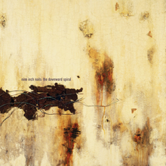
The band begun in 1988, in Cleveland, Ohio. The music initially created was synthpop, with Reznor’s vocals creating a harsh contrast to the melodic and catchy music. During the 90’s his musical output became more aggressive and guitar driven resulting in the Broken EP (1992) which was a precursor to the bleak sound found on NIN’s most popular and successful album The Downward Spiral(1994). On this album in particular Reznor used numerous samples from other media including films such as THX188(1975). The scene in which the titular character watches a man being beaten is used as the intro to the opening song on the album Mr. Self-Destruct. At the beginning of the track The Becoming, there are screams, lifted from the film Robot Jox (1990). In the song Reptile, there is a voice during it’s quiet interlude saying “Kirk, help”, which is from Texas Chainsaw Massacre (1974). The tour, named Self Destruct, is where Reznor realised his theatrical live shows. The Downward Spiral (1994)
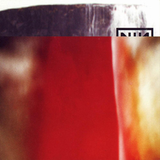
The most noteworthy part was the screen that would come down in front of the band during three slower songs in the middle of the set. On the screen would be different video clips of war and violence as well as decomposing animals. This created an interesting effect of placing the band within the same destructive setting as the images. During this time Reznor became addicted to cocaine and heroin. The next release was a double album named The Fragile (1999). This album showcased a sound design driven style, with more emphasis on soundscapes and musical collage within a
popular music structure, and still retaining Reznor’s honest and emotional lyrics and vocals. The Fragile (1999)
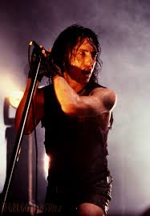
After the tour for the album, Reznor took a sabbatical from music to deal with his cocaine and heroin addiction, but in 2005, 6 years after The Fragile, returned with the album With Teeth (2005). A more stripped back album musically, relying more on live instruments like guitars and drums instead of the highly sequenced and programmed previous albums. The live show was also less theatrical, with more of an emphasis on technology and particular lighting. For the next album, Year Zero (2007) the technology was even more prevalent in the /music than before. The initial tour was even more stripped back as they mostly played small clubs, with only the lighting being much of a visual attraction other than the band. I believe that Nine Inch Nails would work
well in the exhibition due to the innovative technological and musical advances they’ve made and would provide an interesting and unique alternative to the other bands on the bill. The piece I would have them perform would be “Closer” off the album The Downward Spiral. This is arguably they’re most well-known song. It also contrasts well to the the other bands due to its reliance on a dance rhythm and minimal guitar. Trent Reznor (1994)

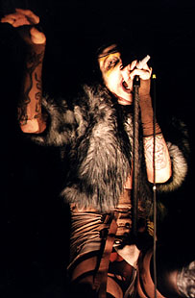
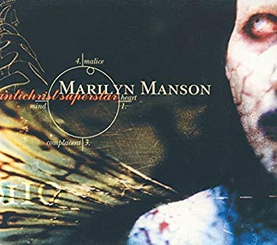
Marilyn Manson are an Industrial rock band from Canton, Ohio. The band formed by Marilyn Manson and Daisy Berkowitz, started as a psychedelic hard rock band in 1989, releasing Portrait of an American Family in 1994. However, with the arrival of Twiggy Ramirez and Madonna Wayne Gacy in 1994 and 1991 respectively, the band took a darker root for their second album Antichrist Superstar (1996), resulting in the departure of Berkowitz in the recording stage. Manson live shows have always been extreme and based in the realm of performance art, making their shows very visual and unique. Manson himself would often become a Willy Wonka type figure during the band’s early days, but on the Dead to the World tour became
a much darker persona with more violent and self-destructive tendencies. It became about more than just music with the art of the show being the main attraction, with the music becoming a backing to the apocalypse that was occurring on stage.

Marilyn Manson (1997)

A massive musical change occurred by the next album Mechanical Animals (1998). They abandoned the grim and bleak image and music, for a satirical, sexual and hedonistic glam rock, inspired by David Bowie and T-Rex. The tour had more of an emphasis on drugs and sex compared to before with Manson simulating sex during the song User Friendly, and a large, bright sign saying DRUGS, for the song I Don’t like the Drugs (But the Drugs like Me).
Another musical metamorphosis occurred prior to the next album Holy Wood (In the Shadow of the Valley of Death (1999). Drawing on a mix of the arrogance of glam from Mechanical Animals and the darkness and nihilism of Antichrist Superstar to create the sound for this record. It also saw Manson become a lot more messianic. He drew parallels between himself and Jesus Christ, John Lennon and John F. Kennedy. With one of the main themes of this album being his huge animosity towards the media after they scapegoated him for the Columbine Massacre. The album is extremely layered and detailed, with many different instruments being used such as mellotron (Valentine’s Day), slide guitar (A Place in the Dirt) and distorted flute (In the Shadow of the Valley of Death). Live performances also went up a level with Manson donning different costumes. For opening song Irresponsible Hate Anthem, he would be brought out on a chariot being carried by two naked women, whilst he would be wearing a gladiator-eques outfit. For The Love Song and Valentine’s Day he would wear a bishop outfit and during Cruci-fiction in Space he would wear a conical skirt which would rise in the air during the song.
The song I would have Manson perform would be the title track to his 1997 album Antichrist Superstar. This would be the perfect encapsulation of everything Marilyn Manson was trying to achieve both lyrically and musically. The Lyrics themselves represent the point on the album where the character annihilates the world and is written in a way that is sardonic of dictators and world leaders. Musically the song is in drop B tuning, consisting of 27 rhythm guitar tracks and 5 lead guitar tracks resulting in a massive oppressive sound. There are also a lot of electronic flourishes, such as organ sounds as well as a keyboard part that sounds like a malfunctioning sound system. During performance of this song Manson would front a podium that was designed to replicate the Nuremburg rallies of the late 30’s and early 40’s. Banners with the era’s logo would appear on the backdrop as well as on the podium itself. He would often tear pages out of a bible and fling it into the crowd whilst making exaggerated movements meant to mimic and make fun of the dictator’s and world leaders. Manson would wear an outfit similar to a minister, whilst the band members would wear army helmets whilst remaining motionless and emotionless during the song, just playing their instruments. A lot of onlookers believe this to be a declaration of Manson’s political beliefs and that he wanted to popularize fascism, however Manson himself stated “I'm satirising the fascism of politics, of religion, and most importantly the fascism of rock N roll. Whether people are realising that, or simply buzzing off the spectacle, isn't my concern. I'm thoroughly entertained by it as a massive piece of performance art because it has so many dimensions, because we're the polar opposite of Nazism, would be the first to be destroyed by it, and we're using that imagery against itself ... Words and symbolism are only as powerful as you make them. Just looking at fascist imagery doesn't make it hateful ... All there is, is making people think for themselves. That's it. No answers. You make your choice.”

Bibliography-

http://www.newport.gov.uk/en/Business/Conference-venues/Newport-Centre-conference.aspx

http://www.mansonwiki.com/wiki/Interview:1996/09_Guitar_World

