ORGANISATIONAL CONSULTANCY

CONSULTANCY REPORT

La Fenice Hotel Italy



12.11.2024

- Name: MARIANA MURESAN
- Student ID:2210334
- Module Title: ORGANISATIONAL CONSULTANCY
- Module code: BMIH6005
- Modulel lead: Jaliya De-Silva
- Word count: 5583

I acknowledge the use of Grammarly App and Microsoft Word Editor on 13th November 2024 to check my grammar, syntax and misspellings.

I confirm that I have not presented any Al generated text as my own work. I confirm I have copies of my drafts, notes, and other resources I used before, and after the use of Al tools which I may be asked to provide in evidence.

Executive Summary

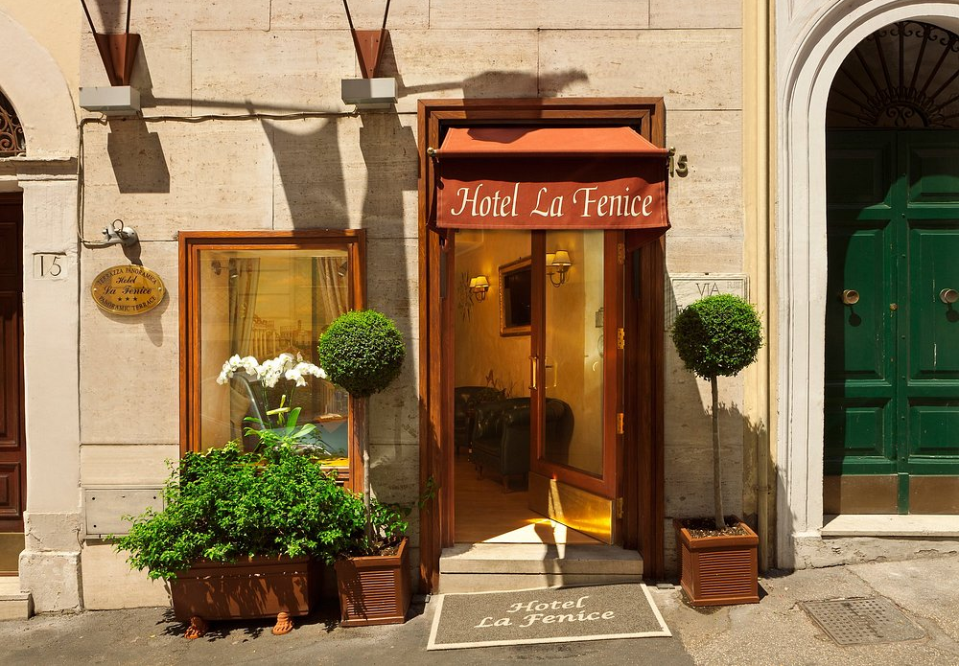Hotel La Fenice, a centrally situated mid-range hotel in Rome, experienced considerable operational difficulties, adversely affecting guest satisfaction and its market reputation. The hotel's closeness to popular attractions such as the Trevi Fountain and the Spanish Steps provides a competitive edge; however, persistent problems with room quality, cleanliness, and customer service have resulted in weakened guest satisfaction, as evidenced by numerous unfavourable reviews on TripAdvisor and Booking.com (TripAdvisor, 2024; Booking.com, 2024). This executive summary provides a concise overview of the principal issues identified, analyses performed, and actionable recommendations designed to improve guest experiences and operational efficiency.

Key Issues Identified
- Room Conditions and Cleanliness Guest comments often highlight inferior conditions, including mould, offensive odours, and outdated furnishings. Mould and ventilation problems signify fundamental maintenance issues, especially regarding air quality and climate regulation (Asadi et al., 2011). Research indicates that air quality is crucial for guest comfort and health, and substandard indoor conditions can substantially reduce satisfaction levels (Kim et al., 2022). The hotel's deficient cleaning and maintenance practices have resulted in an environment that fails to meet guest expectations (Park et al., 2019).
- Misleading Advertising: A significant concern is the disparity between the hotel's online promotional images and the actual state of the rooms. Numerous guests have indicated that online images must accurately represent the outdated and poorly maintained rooms they experience, undermining the hotel's credibility and reducing trust (Pailose and Shakeel, 2021). Deceptive advertising results in discontent and promotes adverse online reviews that further undermine the hotel's reputation (Kuo et al., 2015; Zemke et al., 2015).
- Operational Inefficiencies: Operational inefficiencies at Hotel La Fenice, including the off-site check-in arrangement with Hotel La Fenice, frustrate customers who anticipate convenient, on-site assistance (Kim et al., 2012). Research in the hospitality industry highlights the significance of an efficient check-in procedure for creating a favourable atmosphere for the overall guest experience (Lim et al., 2018). Moreover, maintenance problems, such as defective air conditioning and improper bathroom drainage, signify insufficient routine maintenance, further intensifying unpleasant guest perceptions (TripAdvisor, 2023).
- Competitive Pressure and Customer Bargaining Power: Hotel La Fenice faces significant competition from similarly priced nearby hotels, such as Hotel Nazionale, Hotel Condotti, and Hotel delle Nazioni, all of which provide comparable locations and amenities (Booking.com, 2024). In an environment where guests hold significant bargaining power, partly due to online review platforms such as TripAdvisor, upholding rigorous standards in cleanliness and customer service is essential for preserving market share (Kim and Kim, 2022). Moreover, competition from alternative accommodations such as Airbnb provides guests with increased options, especially for those pursuing economical and flexible lodging solutions.

Summary of Analysis

The evaluation used four frameworks to analyse the challenges faced by Hotel La Fenice. The SWOT Analysis identified the prime location as a strength while noting deficiencies in cleanliness and service. Opportunities for the hotel relate to improvements in service quality, while threats include competition and reputational risk. The PESTEL Analysis evaluated external factors, identifying limitations imposed by local government regulations on historic properties and opportunities to engage eco-conscious guests through sustainable practices. The TOWS Analysis produced feasible strategies, such as improving hygiene protocols to mitigate cleanliness complaints and utilising location to attract tourists. Ultimately, Porter’s Five Forces analysis highlighted intense competition and significant customer power, necessitating changes in service to differentiate the hotel.

Recommendations Overview
To address these issues, the following recommendations are proposed:
- Cleaning Protocols: Adopt regular deep cleaning and mold-focused training for housekeeping staff.
- Transparent Marketing: Update online photos and descriptions to reflect room conditions accurately.
- Dedicated Reception: Implement a standalone reception and self-check-in option for greater efficiency.
- Facility Upgrades: Upgrade ventilation and air conditioning to improve guest comfort, particularly in hot months.
- Feedback Systems: Use in-room surveys and post-stay feedback and actively monitor online reviews to stay responsive.
Cost Overview
The proposed upgrades will necessitate investments, especially for facility renovations and reception reorganisation. Projected initial expenditures are approximately €44,000, supplemented by ongoing maintenance and staff training costs, to maximise guest retention and satisfaction.
Potential Consequences of Inaction
Not considering resolving these issues may result in persistent negative reviews, reduced guest loyalty, and eventual loss of market share to competitors, ultimately compromising the hotel's profitability and long-term sustainability.
Conclusion

In conclusion, implementing these targeted improvements will enable Hotel La Fenice to address critical operational challenges, enhance guest satisfaction, and strengthen its competitive position. By investing in cleanliness, transparency, and facility upgrades, the hotel can rebuild trust and establish itself as a preferred choice for travellers in Rome’s competitive hospitality market.
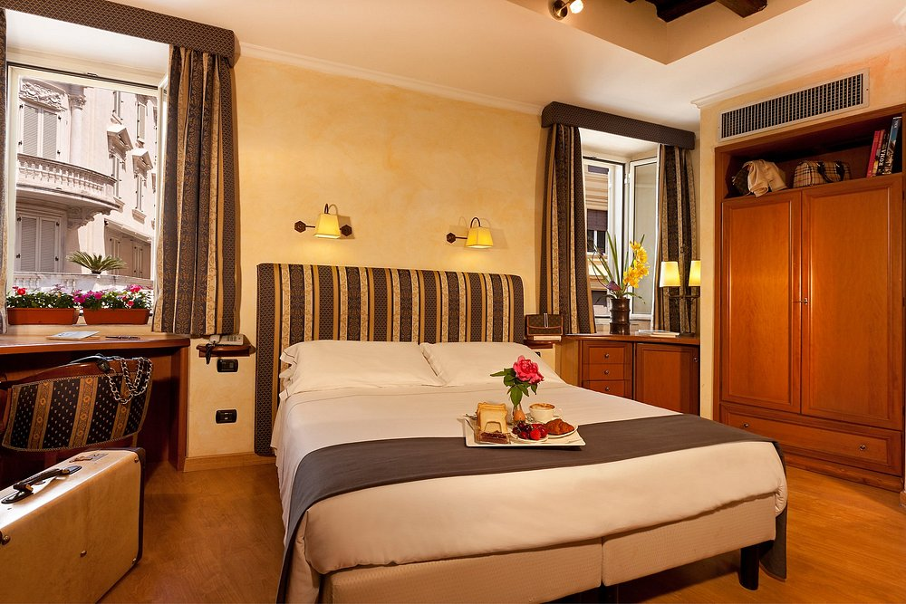

1. Introduction
Hotel La Fenice, located in the centre of Rome, Italy, provides guests with a prime location within walking distance of the city's most renowned landmarks, such as the Trevi Fountain and the Spanish Steps. The hotel is positioned as a mid-range accommodation to attract international tourists and business travellers who prioritise convenience and accessibility to Rome's historical sites. The property offers various room options to accommodate diverse travellers, yet recent guest reviews indicate a discrepancy between expectations and actual experiences. The hotel's marketing promotes comfort and affordability as primary selling points; however, problems with cleanliness, maintenance, and deceptive advertising have resulted in guest dissatisfaction (TripAdvisor, 2024; Booking.com, 2024). Given the intense competition in Rome's tourism sector, Hotel La Fenice must improve its guest experience and correct operational deficiencies to maintain competitiveness and strengthen its reputation among visitors.
PrimeStay Strategy Group is a consultancy firm focused on the hospitality industry, providing strategic solutions to improve operational efficiency, guest satisfaction, and hotel profitability. PrimeStay Strategy Group leverages extensive experience in the hospitality industry, using detailed market analysis and analytical frameworks to provide customised recommendations that address specific operational challenges within the sector. Utilising industry expertise, PrimeStay partners with hotel management teams to execute sustainable improvements that promote enduring success and reputation improvement. Collaborating with Hotel La Fenice helps PrimeStay implement its hospitality expertise in Rome's competitive tourism sector.
The main aim of this report is to examine and solve the factors leading to Hotel La Fenice's decreasing guest satisfaction and reputational issues. This report defines fundamental problems affecting guest experiences, such as cleanliness, operational inefficiencies, and marketing strategies. Through analysing these domains, PrimeStay Strategy Group intends to deliver practical recommendations that improve the hotel's service quality and synchronise its operations with guest expectations. This consultancy report aims to assist Hotel La Fenice in enhancing its competitiveness in Rome's hospitality sector by cultivating a favourable reputation and strengthening guest loyalty through operational and strategic modifications.
The report utilises various analytical frameworks, such as PESTEL, SWOT, TOWS, and Porter’s Five Forces, to thoroughly evaluate the internal and external challenges confronting Hotel La Fenice. The PESTEL analysis considers the political, economic, social, technological, environmental, and legal influences on the hotel's operations, while the SWOT analysis delineates principal strengths, weaknesses, opportunities, and threats. The TOWS analysis offers strategic insights for transforming weaknesses and threats into viable opportunities. Finally, Porter’s Five Forces analysis assesses the competitive environment by examining industry rivalry and customer bargaining power. This comprehensive approach guarantees a complete evaluation, directing pragmatic and evidence-based suggestions.

2. Analysis
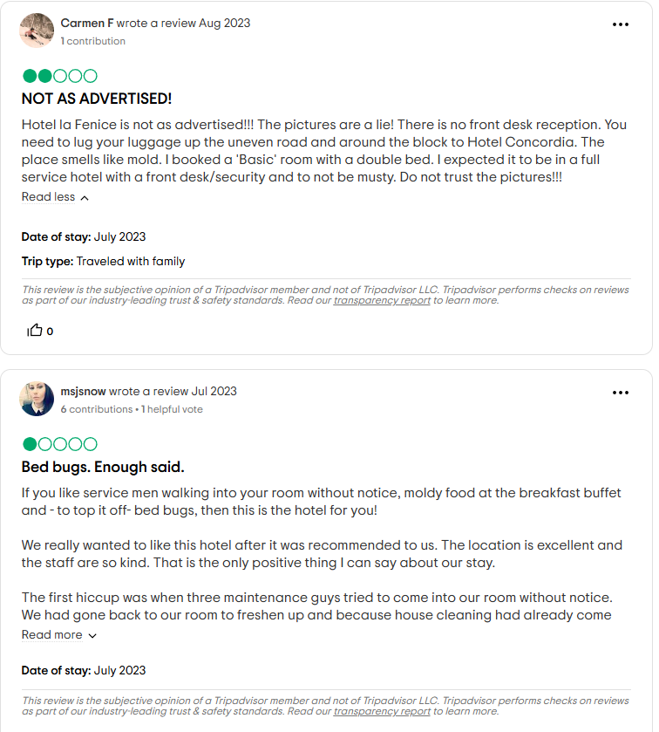
2.1 Issue Identification
Guest Complaints
Guest complaints regarding Hotel La Fenice highlight significant issues in cleanliness, room condition, and misleading advertising. Many reviews across platforms like TripAdvisor and Booking.com report unpleasant odours, particularly the smell of mould in rooms, which indicates poor ventilation and possible water damage. Mould is a common issue in older hotels, especially in historic buildings. Still, the impact on guest satisfaction can be severe, as poor indoor air quality is linked to respiratory problems and discomfort (Asadi, 2011). The presence of mould, reported by multiple guests, suggests that the hotel’s cleaning and maintenance practices are insufficient, as these problems should be regularly addressed to maintain acceptable living conditions (TripAdvisor, 2024; Booking.com, 2024).
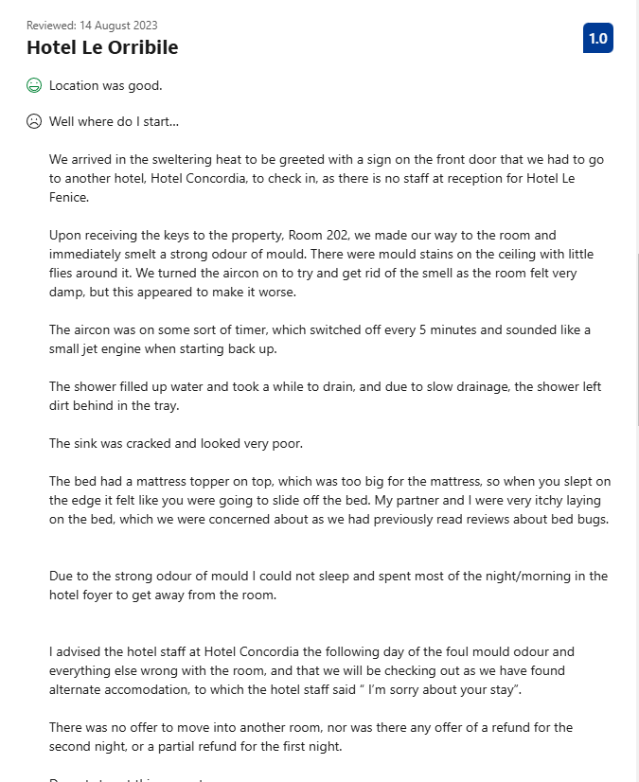
Another frequent complaint is the lack of reliable air conditioning. Rome experiences high temperatures in summer, making functional air conditioning essential for guest comfort. Research shows that temperature control significantly affects guests' perceptions of comfort and overall satisfaction, particularly in regions with hot climates (Kim et al., 2022). Guests at Hotel La Fenice reported that air conditioning units either did not work consistently or operated on short-timers, which likely disrupted sleep and daily comfort (Booking.com, 2024). Inadequate climate control can lead to negative reviews and diminished repeat business, as guests expect a minimum standard of comfort aligned with the hotel’s advertised amenities (TripAdvisor, 2024).
Misleading advertising also emerged as a core issue. Guests frequently noted discrepancies between the hotel’s online photos and the actual condition of rooms, which were often described as outdated and poorly maintained. Misleading advertising in the hospitality industry can severely damage brand trust, as customers perceive discrepancies between expectations and reality as a breach of trust (Kuo et al., 2015). The effects are compounded by the power of online reviews, where misrepresentation can lead to a loss of potential clients who might otherwise consider the hotel.

Operational Inefficiencies
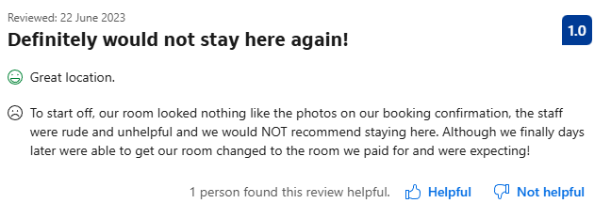
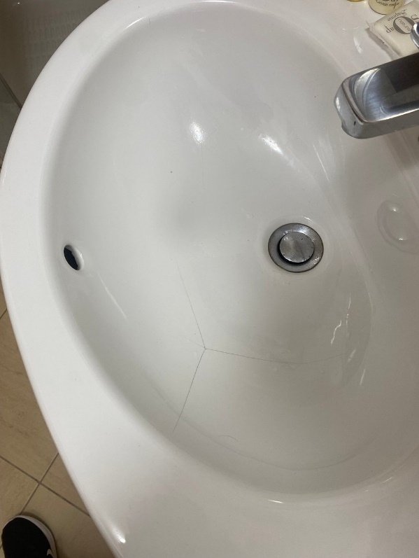
The operational inefficiencies of Hotel La Fenice constitute a significant issue. The reception services are shared with the nearby Hotel Concordia, inconveniencing guests who must check in and receive assistance off-site. This configuration indicates insufficient resources to sustain an independent front desk or inappropriate operational design, undermining service quality. Research in hospitality customer service suggests that initial impressions, particularly during check-in, are essential for guest satisfaction (Kim et al., 2012). Guests anticipate prompt, on-site assistance and off-site reception arrangements have resulted in dissatisfaction, mainly when problems such as room access or service concerns occur outside of Hotel La Fenice's operational hours (TripAdvisor, 2023).
Furthermore, reports of maintenance problems, including defective showers, fractured sinks, and inadequate drainage, suggest a deficiency in regular maintenance. Regular maintenance is crucial in hospitality to maintain facilities' functionality and appearance, as poor maintenance directly impacts guest experiences and diminishes the probability of favourable reviews (Lai and Yik, 2012).
2.2 SWOT and TOWS Analysis
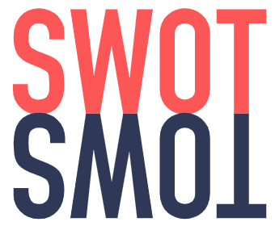
Strengths
The central location of Hotel La Fenice in Rome is its primary advantage. The hotel is conveniently located within walking distance of prominent tourist attractions, including the Trevi Fountain and Spanish Steps, which improves its attractiveness to international visitors seeking quick access. Guests highly value proximity to these landmarks, as it helps them to optimise their sightseeing experience without requiring extensive transportation (TripAdvisor, 2023). Location is a vital asset in the hospitality sector, as research demonstrates that hotels located near prominent attractions typically experience increased occupancy rates and better guest satisfaction (Latinopoulos, 2020). This strategic positioning confers a competitive advantage, facilitating the attraction of tourists to Rome's historic districts.
Weaknesses
However, considerable flaws compromise the hotel's advantages. Guests have consistently reported issues with cleanliness, including mould, unpleasant odours, and inadequate room maintenance, raising significant concerns regarding hygiene standards (Booking.com, 2024). Cleanliness is fundamental to guest satisfaction, as improper sanitation is associated with lowered satisfaction and unfavourable reviews (Kim et al., 2020). Moreover, operational inefficiencies—such as depending on a nearby hotel for check-in services—irritate guests, who expect seamless, on-site assistance. These deficiencies weaken the hotel’s overall reputation and could discourage repeat business, as evidenced by research correlating cleanliness and operational efficiency with guest loyalty (Manolitzas et al., 2021).

Opportunities
Considering these opportunities, the hotel confronts challenges from strong rivals and reputational concerns. The intense competition in Rome's central district provides guests numerous options, resulting in less tolerance for substandard services (Anagnostopoulou et al., 2019). Moreover, enduring negative reviews on platforms like TripAdvisor undermine the hotel's credibility, as prospective guests frequently depend on peer evaluations when selecting accommodations (Kim and Kim, 2022).
Threats
In light of these opportunities, the hotel faces challenges from formidable competitors and issues related to its reputation. The fierce competition in Rome's central district offers guests many choices, leading to diminished tolerance for inferior experiences (Anagnostopoulou et al., 2019). Furthermore, persistent negative reviews on platforms like TripAdvisor damage the hotel's credibility, as potential guests often rely on reviews from other travellers when choosing accommodations (Kim and Kim, 2022).
TOWS Analysis table
Factor | Strengths | Weaknesses
Opportunities | Leverage Location for Partnerships: Partner with local attractions (Trevi Fountain, Spanish Steps) to provide packages that attract tourists, therefore increasing the hotel's attractiveness despite its operational deficiencies. Studies demonstrate that location-based collaborations may improve a hotel’s occupancy and revenue. (Zahrah et al., 2022).  Implement Digital Check-In: Collaborate with local landmarks (Trevi Fountain, Spanish Steps) to offer packages that attract tourists, thus improving the hotel's appeal despite its operational shortcomings. Research indicates that location-based partnerships may increase a hotel's occupancy and revenue. | Strengthen Hygiene and Maintenance Protocols: Cleanliness issues, including mould and insufficient room maintenance, must be rectified to improve guest satisfaction (TripAdvisor, 2023). Implementing stricter protocols might mitigate these vulnerabilities, positively affecting the guest experience and online evaluations.  (Jiang and Wen, 2020).  Transparent Marketing: Synchronising promotional materials with the hotel's actual room quality may help manage guest expectations while improving customer trust. Studies indicate that transparent marketing reduces negative online feedback and improves brand perception (Kuo et al., 2015).
Threats | Enhance Service with Location-Based Strategies: Due to the intense competition in Rome's central district, promoting location-specific advantages can help maintain market share (Slivar, 2018). Providing walking tours or personalised Rome city guides might differentiate Hotel La Fenice from its competitors (Silvar, 2018). | Address Online Review Criticisms Promptly: The widespread nature of online reviews and the risk of reputational harm necessitate swift responses to adverse feedback. Neglecting to respond to criticisms regarding cleanliness and service may lead to additional reputational damage, directing potential customers towards competitors (Proserpio and Zervas, 2015; Wang and Chaudhry, 2018).
2.3 PESTEL Analysis
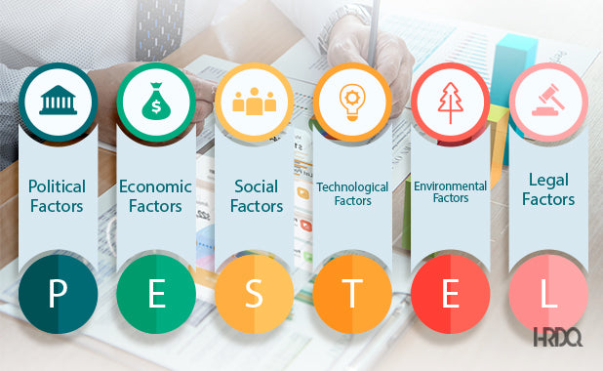Political
The political landscape in Italy significantly influences hotel operations, as the government implements regulations to guarantee safety, cultural preservation, and environmental sustainability in historic regions such as central Rome. Local rules, including zoning laws and noise ordinances, directly impact Hotel La Fenice, constraining its capacity for renovations and operational adaptability (Micelli and Pellegrini, 2018). The Italian government has raised taxes on accommodations to improve tourism infrastructure, imposing financial pressure on hotels, which may influence room rates and occupancy (Garo, 2024; Swenson, 2021).
Economic
The post-pandemic economic environment poses challenges for the hotel sector, with considerable pressures on revenue stemming from variable demand and increased operational expenses. Although Italy's tourism industry has slowly recovered, the uncertain global economic landscape and inflationary pressures have influenced consumer spending, reducing disposable travel budgets (Anguera-Torrell, 2020). Hotel La Fenice, similar to other businesses, struggles with competition for a decreasing pool of budget-conscious travellers, which could damage profitability. Furthermore, rising energy, cleaning supplies, and labour expenses increase operational costs, demanding hotels improve resource utilisation and possibly limit amenities or services to control expenses (Xiao, 2023).
Social
Social trends highlight the importance of cleanliness, transparency, and health standards in guest expectations. The COVID-19 pandemic intensified guests' awareness and expectations regarding hygiene, as demonstrated by the unfavourable reviews mentioning mould and cleanliness concerns at Hotel La Fenice (Booking.com, 2024). Research indicates that cleanliness is a crucial determinant of guest satisfaction, with numerous guests increasingly expecting visible hygiene protocols as a norm (Sharma and Kausik, 2021). Furthermore, transparency regarding amenities and room conditions is essential, as inconsistencies may damage customer trust, a fundamental factor in fostering brand loyalty within the hospitality sector (Kuo et al., 2015).
Technological
Technological innovations in customer service are becoming more critical in the hospitality industry. Hotels globally implement digital solutions to optimise operations and improve guest experiences, including mobile check-in, digital room keys, and automated customer service (Buhalis and Moldaska, 2022). Hotel La Fenice has faced criticism for its dependence on off-site check-in procedures, which may inconvenience guests and cause frustration. Investing in digital improvements, such as an autonomous digital check-in system, could improve operational efficiency and fulfil contemporary guest expectations (Sykmite, 2023).
Environmental
Environmental sustainability is a developing priority in the hospitality sector, as numerous travellers increasingly prefer eco-friendly lodgings. Guests are becoming more aware of the ecological consequences of their accommodations and favour hotels that implement sustainable practices, including energy-efficient lighting, waste minimisation programs, and water conservation measures. Hotel La Fenice can distinguish itself by adopting sustainable practices, eventually attracting environmentally conscious customers while improving its brand image through global trends in responsible tourism (Shanti and Joshi, 2021).
Legal

Adherence to health and safety regulations is essential in the hospitality sector, especially concerning fire safety, sanitation, and guest security. Noncompliance with these regulations may result in penalties, operational limitations, and harm to reputation (Segbedzi et al., 2023). The persistent cleanliness and maintenance problems at Hotel La Fenice indicate a necessity for greater attention to hygiene and safety standards. Compliance with these standards would reduce legal risks and improve guest satisfaction, as cleanliness and safety are essential to the overall guest experience (Zagrade and Tyagi, 2017).

2.4 Porter’s Five Forces Analysis

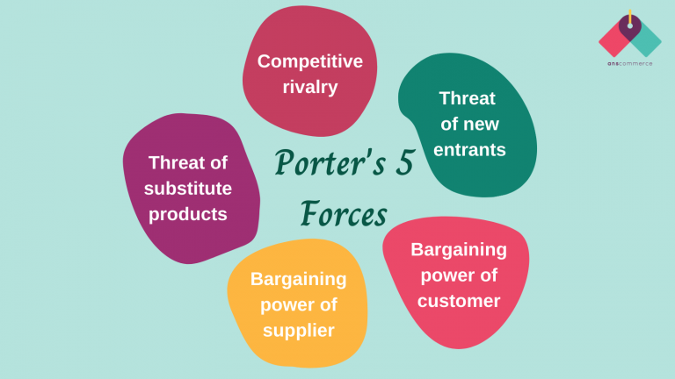
Threat of New Entrants

The risk of new entrants in Rome's hospitality industry is moderate, mainly due to significant entry barriers such as rigorous regulations, considerable financial obligations, and the city's well-established tourism market. The Italian government implements strict zoning laws and preservation regulations in historic districts, limiting the construction of new buildings and renovating existing structures (Micelli and Pellegrini, 2018). Consequently, entering the central Rome hotel market necessitates substantial capital, mainly due to the increased expenses linked to buying or leasing properties near prominent attractions such as the Trevi Fountain and Spanish Steps. The increased cost landscape complicates the ability of small or independent hotel operators to gain a presence without significant financial support (Ahmad, 2015). Nevertheless, major hotel brands possessing the financial resources and operational expertise to navigate these constraints, such as Marriott and Hilton, may still penetrate the market through partnerships or purchases. Consequently, it is placing pressure on independent operators like Hotel La Fenice.

Bargaining Power of Suppliers

In the hospitality sector, the bargaining power of suppliers could be more moderate owing to the multitude of vendors providing comparable products and services. Hotels can procure essential supplies such as cleaning products, linens, and maintenance services from various suppliers, allowing them to negotiate advantageous terms (Yilmaz and Bititci, 2006). Nonetheless, for hotels dependent on particular, high-calibre suppliers, the bargaining power may experience a modest increase. Hotel La Fenice's dependence on local suppliers for cleaning and maintenance offers an opportunity to renegotiate long-term contracts to improve service quality and cost efficiency, particularly in light of ongoing guest complaints regarding cleanliness and maintenance (TripAdvisor, 2023). By forming alliances with reliable vendors, Hotel La Fenice might improve service consistency and reduce recurring maintenance-related criticisms, positively influencing guest satisfaction.

Bargaining Power of Customers

Clients in the hospitality sector, especially in renowned tourist locales such as Rome, have considerable bargaining power. The development of online review platforms like TripAdvisor and Booking.com has granted customers considerable power, as unfavourable reviews may discourage potential clients. Research indicates that online reviews significantly influence booking choices, as travellers frequently depend on peer evaluations to assess a hotel's quality and dependability (Kim and Kim, 2022). Guests at Hotel La Fenice have consistently voiced discontent regarding cleanliness, antiquated amenities, and customer service, compromising the hotel's reputation (Booking.com, 2024). Furthermore, with rival hotels nearby—such as Hotel Nazionale, Hotel Condotti, and Hotel Delle Nazioni—guests can readily choose alternative lodgings if their expectations are not fulfilled. To make up for this power inequality, Hotel La Fenice must proactively address client complaints while improving service quality, as research demonstrates that hotels with responsive management generally excel in customer retention and loyalty (Vermeulen and Seegers, 2009).

Threat of Substitutes

The threat of substitutes in Rome's accommodation market is significant, chiefly due to the increasing number of short-term rental platforms like Airbnb. These platforms offer economical and adaptable accommodation alternatives, frequently attracting budget-minded travellers and individuals desiring a more authentic experience (Guttentag, 2015). Airbnb accommodations feature amenities such as kitchens and more expansive living spaces, which especially appeal to long-term guests seeking to minimise costs. Hotels like La Fenice face considerable challenges from this trend, as guests may regard Airbnb as providing superior value. To compete effectively, Hotel La Fenice might consider diversifying its offerings by delivering distinctive services or curated experiences that attract guests seeking convenience and local appeal (Guttentag and Smith, 2017).

Industry Rivalry

The competition in Rome's central hotel sector is fierce, fuelled by a high concentration of hotels competing for a restricted number of tourists, particularly during off-peak periods. Hotel La Fenice faces direct competition from nearby competitors, including Hotel De Petris, Hotel Marisa, and Hotel Relais Dei Papi, all of which provide similar proximity to Rome's principal attractions. Hotels in this region frequently participate in price competition or provide special promotions during off-peak periods to sustain occupancy rates (Boogink, 2024; Balaguer and Perinas, 2013). The intensified competition necessitates that Hotel La Fenice distinguishes itself through pricing and rectifying significant service shortcomings, especially in cleanliness and customer service, which have been consistently highlighted in guest feedback (TripAdvisor, 2023). Improving service quality and exploiting its prime location will allow Hotel La Fenice to maintain market share despite intense competition.

3. Recommendations and Change Management

3.1 Recommendations for Improvement

Cleaning Protocols

To resolve persistent cleanliness issues, including mould and unpleasant odours reported by guests, Hotel La Fenice must establish improved cleaning protocols that comply with higher hygiene standards. Mould, often mentioned in guest reviews, signifies a requirement for both prompt remediation and preventive strategies (Sun et al., 2021). Consistent deep-cleaning protocols, including mould assessments and ventilation improvements, are essential for sustaining a sanitary environment (Islam et al., 2023). Research indicates that adopting an integrated strategy with specialised cleaning services for routine deep cleaning, such as those offered by local vendors on Europages, may effectively address mould problems while improving air quality (Park et al., 2021; Europages, 2023). Instructing housekeeping staff on revised cleaning protocols and performing routine quality assessments would guarantee the consistent compliance to these standards. Research demonstrates that increased cleanliness standards not only boost guest satisfaction but also strengthen brand loyalty, particularly when they are visible and consistent (Jiang and Wen, 2020).

Accurate Marketing

Deceptive advertising has resulted in guest dissatisfaction, as discrepancies between online descriptions and actual room conditions undermine trust (Amoako et al., 2019). Guests have consistently indicated that online images do not accurately reflect the condition of outdated or badly maintained rooms (Booking.com, 2024). Precise and transparent marketing is crucial for effectively managing guest expectations. To make sure that marketing content correctly portrays room conditions, Hotel La Fenice should perform a full review of its existing promotional materials (Rather, 2019). This involves updating images and descriptions across all booking platforms to make sure they accurately represent room quality, amenities, and decor (Kuo et al., 2015). The hotel needs to invest in high-quality photography that accurately depicts the rooms, highlighting both advantages and existing limitations. This transparent strategy builds trust and reduces the likelihood of guest dissatisfaction, as demonstrated by research correlating truthful marketing practices with heightened guest satisfaction (Paulose and Shakeel, 2021).

Independent Reception Operations

The dependence on Hotel La Fenice for check-in services has resulted in operational inefficiencies and unhappy customers due to the lack of on-site assistance. Implementing a separate reception at Hotel La Fenice would improve guest experiences by offering uninterrupted, on-site assistance (Gundersen et al., 1996). The initial impression of the check-in process is essential in the hospitality sector, as it influences the guest's overall perception of their stay (Kim et al., 2012). Having a dedicated front desk at Hotel La Fenice, operated by trained personnel available all day, could mitigate the inconveniences associated with off-site check-ins (Nalley and Bufquin 2020). An independent reception area would optimise guest interactions and allow staff to address questions and service requests quickly, which would improve overall service quality. Moreover, the introduction of a digital self-check-in feature, as utilised by numerous modern hotels, would improve the efficiency of the process for technologically adept guests (Cheong et al., 2021; Sykmte, 2023).

Facility Upgrades: Ventilation and Air Conditioning

Upgrading the hotel's ventilation and air conditioning systems is essential for ensuring guest comfort, especially during the hot summer months in Rome. Persistent guest complaints regarding insufficient air conditioning and inadequate room ventilation suggest that the existing systems are unsatisfactory (TripAdvisor, 2023). Research shows the significance of indoor climate regulation for maintaining guest comfort and satisfaction, particularly in areas with extreme seasonal temperatures (Kim et al., 2022). Hotel La Fenice should contemplate upgrading to more efficient air conditioning units and improving the ventilation system to reduce mould proliferation and improve air quality. Investing in energy-efficient HVAC systems can improve comfort while promoting environmental sustainability, attracting eco-conscious guests (Shanti and Joshi, 2021). Although initial installation expenses may be considerable, these improvements could diminish long-term maintenance costs while increasing guest retention through providing a consistently comfortable atmosphere.

3.2 Change Management Strategy

Employee Training

To achieve sustainable improvements at Hotel La Fenice, a specialised training program for housekeeping and front desk staff is essential. Housekeeping training should prioritise compliance with current cleanliness standards, including mould control, improved sanitation procedures, and quality assessments following each cleaning session. By collaborating with professional cleaning services, such as those featured on Europages, the hotel can organise regular expert-led workshops to make sure staff are properly prepared to address cleanliness challenges effectively (Europages, 2023). Studies demonstrate that consistent and high-quality housekeeping training is directly associated with improved guest satisfaction, as cleaner environments are more likely to fulfil guests' expectations (Wu et al., 2018).

Front desk staff training has to include fundamental customer service skills, conflict resolution techniques, and streamlined check-in procedures to reduce any remaining dissatisfaction from previous off-site check-in experiences. Positive initial impressions are essential in hospitality, as they frequently shape guests' overall perceptions of their experience. Front desk operators must be trained in the utilisation of new digital tools, such as self-check-in kiosks, to guarantee seamless service for guests desiring quick and effective access (Spektor et al., 2023). This proactive strategy would allow Hotel La Fenice to develop a consistently favourable guest experience, which would boost service quality (Waqanimaravu and Arasanmi, 2020).

Guest Communication

Clear communication with guests is essential for restoring trust and managing expectations, particularly during ongoing developments. Guests must be informed of the precise measures Hotel La Fenice is implementing to rectify previously reported concerns, such as cleanliness and older amenities, which can be specified through welcome letters, room notices, and digital displays in the hotel’s common areas. Studies indicate that transparent communication regarding changes, such as cleanliness protocols, increases guest trust and positively affects satisfaction (Kim and Kim, 2017).

The hotel’s website and booking platform listings must be revised to accurately represent ongoing changes, assuring guests receive precise information regarding current conditions. Moreover, front-desk staff should be asked to share any recent upgrades during check-in, highlighting improved cleaning protocols and newly upgraded amenities. This proactive communication strategy assures guests that their concerns are addressed and exemplifies the hotel’s dedication to excellence. Consistent updates on the hotel’s social media channels and review platforms can expand audience reach and improve the hotel’s online reputation by directly responding to previous criticisms (Anagnostopoulus et al., 2019).

Monitoring & Feedback

To guarantee that changes adequately fulfil guest expectations, Hotel La Fenice ought to implement rigorous monitoring and feedback mechanisms. The process may commence with routine internal audits evaluating cleanliness standards, facility maintenance, and overall service quality. Employees must be trained to conduct quality assessments and promptly report any issues, ensuring that problems are resolved before affecting the guest experience. Research indicates that internal performance monitoring aids in sustaining service quality consistency and can proactively detect issues that may result in adverse feedback (Llach et al., 2016).

Furthermore, guest feedback needs to be methodically gathered through both direct and digital channels. In-room feedback cards, post-stay surveys, and follow-up emails may encourage guests to communicate their experiences. Incorporating feedback channels with online review platforms such as TripAdvisor and Booking.com would allow the hotel to promptly resolve any issues identified, showcasing responsiveness to guest concerns (Vermeulen and Seegers, 2009). Management should consistently evaluate this feedback, utilising the acquired insights to modify service strategies accordingly. By promptly addressing reviews and demonstrating how guest feedback informs improvements, Hotel La Fenice may strengthen guest loyalty and cultivate a favourable reputation, both essential for maintaining competitiveness in Rome's saturated hospitality sector.
In order to improve this strategy, Hotel La Fenice could adopt a Net Promoter Score (NPS) system, a metric frequently utilised in the hospitality industry to assess guest satisfaction and loyalty. Through the analysis of NPS results, the hotel can discern areas necessitating improvement and monitor advancements over time. This feedback-oriented system will allow Hotel La Fenice to implement data-informed modifications, creating a dynamic strategy for continual growth and strengthening its long-term reputation management plan (Kristensen and Eskildsen, 2011).

3.4 Success Metrics
To evaluate the impact of the proposed improvements, Hotel La Fenice must develop key performance indicators (KPIs) focused on guest satisfaction, online reputation, and operational efficiency. Guest satisfaction metrics can be obtained through post-stay surveys, Net Promoter Score (NPS) tests, and in-room feedback cards, allowing the hotel to assess alterations in guest perceptions regarding cleanliness, service quality, and overall experience. Research indicates that consistent improvements in guest satisfaction are strongly correlated with increased loyalty and repeat customers (Kristensen and Eskildsen, 2011).
Online review ratings on platforms like TripAdvisor and Booking.com are essential indicators, as they directly influence the hotel's public image and impact prospective guests. Studies demonstrate that responding to guest feedback on these platforms signifies the hotel's commitment to issue resolution, which can favourably influence prospective customers' booking decisions (Vermeulen and Seegers, 2009).
Occupancy rates serve as an operational KPI, reflecting the hotel's effectiveness in attracting and retaining guests. Hotel La Fenice may evaluate the direct impact of the proposed modifications on its market appeal by analysing occupancy rates prior to and after to their execution. Studies suggest that heightened occupancy rates, along with positive guest reviews, often indicate that a hotel’s improvements to service are successfully meeting guest expectations and strengthening competitive advantage (Pardinha et al., 2023).
4. Action Plan (350 words)
Issue | Recommended Solution | Desired Outcome | Timeline | Estimated Budget
Cleanliness and Mold in Rooms | Implement developed cleaning protocols and partner with specialised services (e.g., Europages vendors) for deep cleaning and mould management (Park et al., 2021; Europages, 2023). | Improved hygiene and air quality; increased guest satisfaction as research shows cleanliness is essential for positive guest perceptions (Sharma and Kaushik, 2021). | 3 months | £6,880
Inaccurate Online Marketing | Update online images and descriptions to reflect actual room conditions with professional photography and realistic representations (Balomenou and Garrod, 2019). | Improved guest trust and reduced complaints about room conditions, as transparency in advertising, aligns expectations with reality and builds trust (Kuo, et al., 2015). | 2 months | £2,580
Off-Site Reception | Establish an independent reception desk at Hotel La Fenice and offer digital self-check-in options for convenience. | Enhanced guest experience through on-site support and streamlined check-in, both of which contribute positively to overall guest satisfaction (Spektor et al., 2023; Waqanimaravu and Arasanmi, 2020). | 4 months | £12,900
Ventilation and Air Conditioning Issues | Upgrade the HVAC system to energy-efficient units and enhance room ventilation to reduce mould and improve air quality. | Improved room comfort and air quality are essential for guest comfort, especially in climates with extreme seasonal temperatures (Kim et al., 2022). | 6 months | £17,200
Staff Training for Service Quality | Conduct workshops for housekeeping and front desk staff, focusing on updated cleaning standards and customer service excellence (Kim et al., 2022). | Enhanced service consistency and guest satisfaction, as well-trained staff reduce operational issues and negative reviews (Kim et al., 2021). | 1 month (initial), ongoing every 6 months | £4,300 initial; £2,580 annually
Monitoring and Guest Feedback | Establish feedback collection systems (in-room cards, post-stay surveys) and track KPIs such as satisfaction scores and online reviews. | Continuous improvement driven by guest feedback supports reputation and loyalty, as active responsiveness to feedback is essential for guest retention (Christou, 2003). | Immediate and ongoing | £1,290 annually
This action plan offers Hotel La Fenice a systematic framework for addressing operational and guest experience challenges. Each initiative includes a definitive timeline and budget, ensuring realistic improvements that elevate service quality and guest satisfaction while conforming to industry best practices.

5. Conclusion
This consultancy report has identified several fundamental issues affecting guest satisfaction at Hotel La Fenice, primarily related to cleanliness, operational inefficiencies, and deceptive marketing practices. An detailed examination of guest feedback, operational metrics, and industry standards reveals that resolving these issues is crucial for improving the hotel's reputation, guest loyalty, and overall profitability.
Significant findings reinforce the necessity of instituting improved cleaning protocols to reduce ongoing mould and odour problems. Collaborating with respected cleaning services, such as those listed on Europages, and conducting regular staff training on current hygiene protocols will guarantee that the hotel fulfils guest expectations for cleanliness. Furthermore, upgrading ventilation and air conditioning systems will facilitate the maintenance of comfortable room conditions, addressing a prevalent concern noted in guest reviews.
Operational recommendations entail creating an independent reception to optimise the check-in process and alleviate guest frustrations, as well as improving marketing strategies to accurately depict room conditions and amenities. Effective marketing, backed by high-quality visuals and clear descriptions, will promote trust and stick to industry best practices for sustaining a favourable brand image.
To facilitate ongoing improvement, Hotel La Fenice ought to develop complete feedback systems, monitor key performance indicators (KPIs) including guest satisfaction metrics and online review ratings, and consistently modify strategies in response to guest feedback. These KPIs, together with occupancy rates, will function as effective metrics to evaluate the success of implemented changes and maintain a constant dedication to quality.
In summary, these proposed modifications offer a definitive strategy for Hotel La Fenice to improve guest satisfaction, optimise operational efficiency, and strengthen its market standing.

Appendix
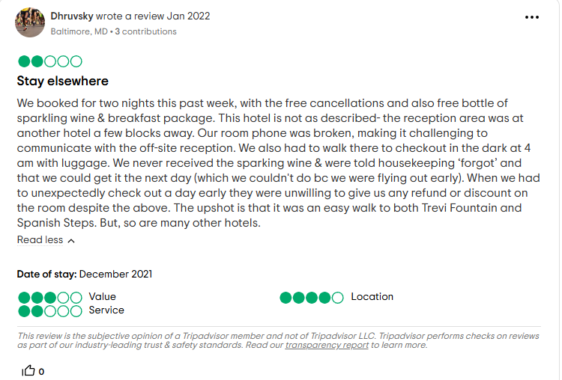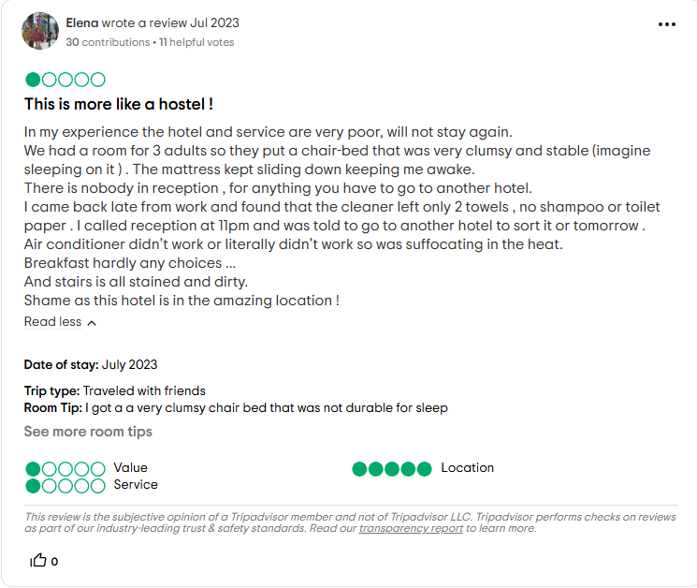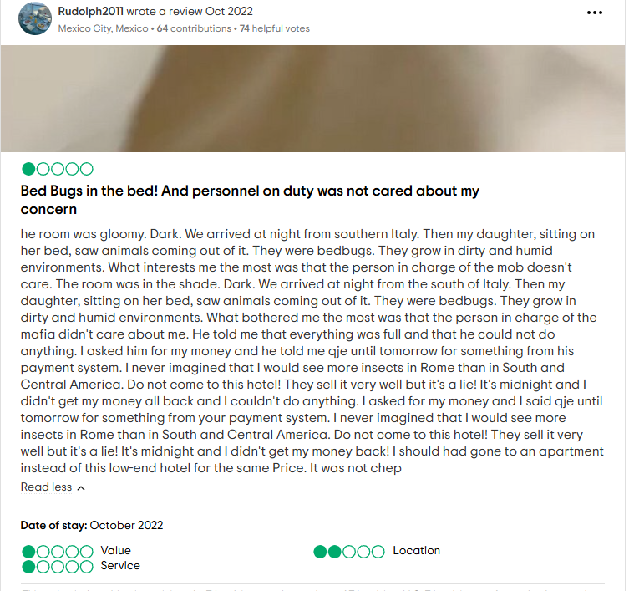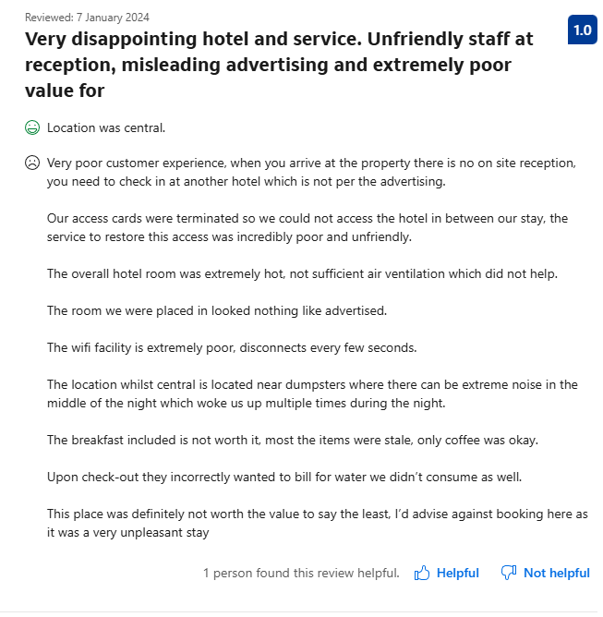

Reference List
- Ahmad, S., 2015. Entrepreneurship in the small and medium-sized hotel sector. Current Issues in Tourism, 18, pp. 328 - 349. https://doi.org/10.1080/13683500.2014.934211.
- Airbnb. (2023). "Rome rental prices on Airbnb." https://www.airbnb.com
- Amoako, G., Neequaye, E., Kutu-Adu, S., Caesar, L., and Ofori, K., 2019. Relationship marketing and customer satisfaction in the Ghanaian hospitality industry. Journal of Hospitality and Tourism Insights. https://www.proquest.com/scholarly-journals/relationship-marketing-customer-satisfaction/docview/2447267341/se-2?accountid=130472
- Anagnostopoulou, S., Buhalis, D., Kountouri, I., Manousakis, E., and Tsekrekos, A., 2019. The Impact of Online Reputation on Hotel Profitability. Other Financial Economics eJournal. https://www.proquest.com/scholarly-journals/impact-online-reputation-on-hotel-profitability/docview/2336176781/se-2?accountid=130472
- Anguera-Torrell, O., Aznar-Alarcón, J., and Vives-Perez, J., 2020. COVID-19: hotel industry response to the pandemic evolution and to the public sector economic measures. Tourism Recreation Research, 46, pp. 148 - 157. https://doi.org/10.1080/02508281.2020.1826225.
- Asadi, E., Costa, J., and Silva, M., 2011. Indoor air quality audit implementation in a hotel building in Portugal. Building and Environment, 46, pp. 1617 - 1623. https://doi.org/10.1016/j.buildenv.2011.01.027.
- Balomenou, N. and Garrod, B., 2019. Photographs in tourism research: Prejudice, power, performance and participant-generated images. Tourism Management, 70, pp.201-217. https://doi.org/10.1016/j.tourman.2018.08.014
- Booking, 2024. Central Hotels in Rome. https://bit.ly/4fp0UAB
- Booking.com, 2024. Hotel La Fenice Rome Reviews. https://shorturl.at/80EgM
- Buhalis, D., and Moldavska, I., 2021. Voice assistants in hospitality: using artificial intelligence for customer service. Journal of Hospitality and Tourism Technology. https://www.proquest.com/scholarly-journals/voice-assistants-hospitality-using-artificial/docview/2674008237/se-2?accountid=130472
- Bux, C., and Amicarelli, V., 2022. Circular economy and sustainable strategies in the hospitality industry: Current trends and empirical implications. Tourism and Hospitality Research, 23, pp. 624 - 636. https://doi.org/10.1177/14673584221119581.
- Cheong, S., Ling, H., and Teh, P., 2021. Encrypted Steganography Quick Response Scheme for Unified Hotel Access Control System. 2021 IEEE 11th International Conference on System Engineering and Technology (ICSET), pp. 303-308. https://doi.org/10.1109/ICSET53708.2021.9612533.
- Christou, E., 2003. Guest Loyalty Likelihood in Relation to Hotels' Corporate Image and Reputation: A Study of Three Countries in Europe. Journal of Hospitality & Leisure Marketing, 10, pp. 85 - 99. https://doi.org/10.1300/J150v10n03_05.
- Espino-Rodríguez, T. F., and Ramírez-Fierro, J. C. (2018). "Outsourcing Performance in Hotels: Evaluating Partnership Quality." Sustainability. https://doi.org/10.3390/su10082766
- Europages, 2023. Cleaning services in Rome and Lazio, Italy. https://www.europages.co.uk/companies/italy/cleaning%20services.html
- Garro, J., 2024. Italy’s Tourist Taxes Are Going Up-Here’s What You’ll Pay in 2025.PASSING THRU. https://passingthru.com/how-much-will-tourist-taxes-in-italy-cost-you-in-summer-2025/
- Gundersen, M., Heide, M., and Olsson, U., 1996. Hotel Guest Satisfaction among Business Travelers. Cornell Hotel and Restaurant Administration Quarterly, 37, pp. 72 - 81. https://doi.org/10.1177/001088049603700222.
- Guttentag, D., 2015. Airbnb: disruptive innovation and the rise of an informal tourism accommodation sector. Current Issues in Tourism, 18, pp. 1192 - 1217. https://doi.org/10.1080/13683500.2013.827159.
- Guttentag, D.A. and Smith, S.L., 2017. Assessing Airbnb as a disruptive innovation relative to hotels: Substitution and comparative performance expectations. International Journal of Hospitality Management, 64, pp.1-10. https://doi.org/10.1016/j.ijhm.2017.02.003
- Immobiliare, 2024. Property price trend in the zone Cetro Storico. https://www.immobiliare.it/en/mercato-immobiliare/lazio/roma/centro-storico/
- Islam, M., Pandey, U., Sinha, S., and Hussin, S. (2023). How does a hotel’s hygiene protocol quality trigger guests’ revisit intention during the pandemic? Evidence from Chinese guests. International Journal of Tourism Cities. https://www.proquest.com/scholarly-journals/how-does-hotel-s-hygiene-protocol-quality-trigger/docview/3060949344/se-2?accountid=130472
- Jiang, Y., and Wen, J., 2020. Effects of COVID-19 on hotel marketing and management: a perspective article. International Journal of Contemporary Hospitality Management, 32, pp. 2563-2573. https://doi.org/10.1108/ijchm-03-2020-0237.
- Kim, J. W., Kim, L. H., and Kim, S. Y. (2020). "Impact of hotel cleanliness on guest satisfaction and loyalty." International Journal of Hospitality Management, 89, 102594. https://doi.org/10.1016/j.ijhm.2020.102594
- Kim, J., Christodoulidou, N., and Brewer, 2012. Impact of Individual Differences and Consumers’ Readiness on Likelihood of Using Self-Service Technologies at Hospitality Settings. Journal of Hospitality & Tourism Research, 36, 114-85. https://doi.org/10.1177/1096348011407311.
- Kim, M., Lee, E., Kim, S., Cha, J., and Cichy, R., 2022. Impact of Indoor Environmental Quality on Hotel Guests’ Behaviors. International Journal of Hospitality & Tourism Administration, 24, pp. 288 - 313. https://doi.org/10.1080/15256480.2021.1981188.
- Kim, S., and Kim, D., 2017. Antecedents of Corporate Reputation in the Hotel Industry: The Moderating Role of Transparency. Sustainability, 9, pp. 951. https://doi.org/10.3390/SU9060951.
- Kim, Y., and Kim, H., 2022. The Impact of Hotel Customer Experience on Customer Satisfaction through Online Reviews. Sustainability. https://doi.org/10.3390/su14020848.
- Kristensen, K., and Eskildsen, J., 2011. Is the Net Promoter Score a reliable performance measure?. 2011 IEEE International Conference on Quality and Reliability, pp. 249-253. https://doi.org/10.1109/ICQR.2011.6031719.
- Kuo, P., Zhang, L., and Cranage, D., 2015. What you get is not what you saw: exploring the impacts of misleading hotel website photos.. International Journal of Contemporary Hospitality Management, 27, pp. 1301-1319 https://www.proquest.com/scholarly-journals/what-you-get-is-not-saw-exploring-impacts/docview/2105050303/se-2?accountid=130472
- Lai, J., and Yik, F., 2012. Hotel engineering facilities: A case study of maintenance performance. International Journal of Hospitality Management, 31, pp. 229-235. https://doi.org/10.1016/J.IJHM.2011.05.002.
- Latinopoulos, D., 2020. Analysing the role of urban hotel location in guests’ satisfaction. Anatolia, 31, pp. 636 - 650. https://doi.org/10.1080/13032917.2020.1808489.
- Lim, W., Teh, P., Ahmed, P., Cheong, S., Ling, H., and Yap, W., 2018. Going keyless for a seamless experience: Insights from a unified hotel access control system. International Journal of Hospitality Management. https://doi.org/10.1016/J.IJHM.2018.03.014.
- Llach, J., Alonso‐Almeida, M., Martí, J., and Rocafort, A., 2016. Effects of quality management on hospitality performance in different contexts. Ind. Manag. Data Syst., 116, pp. 1005-1023. https://www.proquest.com/scholarly-journals/effects-quality-management-on-hospitality/docview/2093329440/se-2?accountid=130472
- Manolitzas, P., Glaveli, N., Palamas, S., Talias, M., and Grigoroudis, E., 2021. Hotel guests’ demanding level and importance of attribute satisfaction ratings: an application of MUltiplecriteria Satisfaction Analysis on TripAdvisor’s hotel guests ratings. Current Issues in Tourism, 25, pp. 1203 - 1208. https://doi.org/10.1080/13683500.2021.1915253.
- Mattila, A., and O’Neill, J., 2003. Relationships between Hotel Room Pricing, Occupancy, and Guest Satisfaction: A Longitudinal Case of a Midscale Hotel in the United States. Journal of Hospitality & Tourism Research, 27, pp. 328 - 341. https://doi.org/10.1177/1096348003252361.
- Micelli, E., and Pellegrini, P., 2018. Wasting heritage. The slow abandonment of the Italian Historic Centers. Journal of Cultural Heritage, 31, pp. 180-188. https://doi.org/10.1016/J.CULHER.2017.11.011.
- Nalley, M., and Bufquin, D., 2020. Lines at the Hotel Front Desk: A Case for Effective Capacity Management. Journal of Hospitality & Tourism Cases, 8, pp. 22 - 27. https://doi.org/10.1177/216499872000800404.
- Pardinha, J., Mota, J., and Costa, R., 2023. Key performance indicators in short-term rental accommodation. International Journal of Tourism Cities. https://www.proquest.com/scholarly-journals/key-performance-indicators-short-term-rental/docview/2886231570/se-2?accountid=130472
- Park, H., Kline, S.F., Kim, J., Almanza, B. and Ma, J., 2019. Does hotel cleanliness correlate with surfaces guests contact?. International Journal of Contemporary Hospitality Management, 31(7), pp.2933-2950. https://www.proquest.com/scholarly-journals/does-hotel-cleanliness-correlate-with-surfaces/docview/2283793829/se-2?accountid=130472
- Park, J., Yoo, J., and Yu, J., 2021. Effect of Hotel Air Quality Management on Guests’ Cognitive and Affective Images and Revisit Intentions. International Journal of Environmental Research and Public Health, 18. https://doi.org/10.3390/ijerph18179346.
- Paulose, D. and Shakeel, A., 2021. Perceived Experience, Perceived Value, and Customer Satisfaction as Antecedents to Loyalty among Hotel Guests. Journal of Quality Assurance in Hospitality & Tourism, 23(4), 447-481. https://doi.org/10.1080/1528008X.2021.1884930.
- Rather, R., 2019. Consequences of Consumer Engagement in Service Marketing: An Empirical Exploration. Journal of Global Marketing, 32, pp. 116 - 135. https://doi.org/10.1080/08911762.2018.1454995.
- Segbedzi, C., Ansah, E., and Apaak, D., 2023. Compliance to food safety standards - Determining the barriers within the hotel industry. . https://doi.org/10.1101/2023.12.13.23299917.
- Shanti, J., and Joshi, G., 2021. Examining the impact of environmentally sustainable practices on hotel brand equity: a case of Bangalore hotels. Environment, Development and Sustainability. https://doi.org/10.1007/s10668-021-01682-9.
- Sharma, S., and Kaushik, T., 2021. Aesthetically clean to clinically clean – A study on new housekeeping practices in Delhi hotels beyond COVID-19 pandemic. Worldwide Hospitality and Tourism Themes. https://doi.org/10.1108/WHATT-05-2021-0069.
- Slivar, I., 2018. MARKETING COMMUNICATION IN THE VISIT PHASE THROUGH GUEST.NET - AN INDESTINATION, LOCATION-BASED SYSTEM AT MAISTRA HOTEL CHAIN IN CROATIA. Review of Innovation and Competitiveness. https://doi.org/10.32728/RIC.2018.43/3.
- Spektor, F., Fox, S., Awumey, E., Begleiter, B., Kulkarni, C., Stringam, B., Riordan, C., Rho, H., Akridge, H., and Forlizzi, J., 2023. Charting the Automation of Hospitality: An Interdisciplinary Literature Review Examining the Evolution of Frontline Service work in the Face of Algorithmic Management. Proceedings of the ACM on Human-Computer Interaction, 7, pp. 1 - 20. https://doi.org/10.1145/3579466.
- Sun, B., Liu, L., Chan, W., Zhang, C., and Chen, X., 2021. Signals of Hotel Effort on Enhancing IAQ and Booking Intention: Effect of Customer’s Body Mass Index Associated with Sustainable Marketing in Tourism. Sustainability. https://doi.org/10.3390/SU13031279.
- Swenson, C., 2021. Empirical Evidence on the Economic Impacts of Hotel Taxes. Economic Development Quarterly, 36, pp. 33 - 42. https://doi.org/10.1177/08912424211046172.
- Sykimte, C., 2023. Evaluating Self-Service Kiosks in Hotel Check-in Processes. International Journal of Advanced Research in Science, Communication and Technology. https://doi.org/10.48175/ijarsct-12356.
- TripAdvisor.com, 2024. Hotel La Fenice Reviwes. https://www.tripadvisor.com/Hotel_Review-g187791-d518424-Reviews-Hotel_La_Fenice-Rome_Lazio.html
- Vermeulen, I. E., and Seegers, D., 2009. Tried and tested: The impact of online hotel reviews on consumer consideration. Tourism Management, 30(1), 123-127. https://doi.org/10.1016/j.tourman.2008.04.008
- Wang, Y., and Chaudhry, A., 2018. When and how Managers' Responses to Online Reviews Affect Subsequent Reviews. Journal of Marketing Research, 55, pp. 163 - 177. https://doi.org/10.1509/jmr.15.0511.
- Waqanimaravu, M., and Arasanmi, C., 2020. Employee training and service quality in the hospitality industry. Journal of Foodservice Business Research, 23, pp. 216 - 227. https://doi.org/10.1080/15378020.2020.1724850.
- Wu, H., Ng, T., Wong, J., and Lai, K. (2018). Environmental Sustainability and Mold Hygiene in Buildings. International Journal of Environmental Research and Public Health, 15. https://doi.org/10.3390/ijerph15040681.
- Xiao, K., 2023. Research on Cost Management and Control in China's Budget Hotels. Tourism Management and Technology Economy. https://doi.org/10.23977/tmte.2023.060410.
- Yilmaz, C., and Bititci, U. S. (2006). "Performance measurement in supply chains: A case study." International Journal of Logistics Management, 17(1), 48-66. https://doi.org/10.1108/09574090610663419
- Zahrah, H., Rahayu, A., and Dirgantari, P., 2022. The Effect of Partnership Strategy on Business Success (Case Study on Hospitality in West Java). Journal of Accounting and Finance Management. https://doi.org/10.38035/jafm.v3i5.153.
- Zemke, D., Neal, J., Shoemaker, S., and Kirsch, K., 2015. Hotel cleanliness: will guests pay for enhanced disinfection?. International Journal of Contemporary Hospitality Management, 27, pp. 690-710. https://www.proquest.com/scholarly-journals/hotel-cleanliness-will-guests-pay-enhanced/docview/2105050499/se-2?accountid=130472
- Zhang, J., 2022. Research on Impact of Economy Hotel Service Quality on Customer Satisfaction and Customer Loyalty. International Journal of Business Studies and Innovation. https://doi.org/10.35745/ijbsi2022v02.01.0003.

