University of Wales Trinity Saint David
LCLM4001
Reflective report Task 3
Elvis Gjini
2234008
Akash Puranik

Table of Contents
1. Introduction 3
The purpose of the report 3
The experiences in learning journey 3
2. Description of Experiences 4
The specific experiences or activities from the module. 4
The key classroom events that had a significant impact on learning. 4
3. Analysis and Personal Reflection 5
Evaluate experiences 5
Analyse the experiences described and discuss what have learned from them. 5
How these experiences contributed to understanding of the module content. 5
The strengths and areas for improvement in this module. 6
Reflect on personal growth and development as a student of this program. 6
4. Conclusion 7
Summarise the key points 7
Reflect on the overall impact 7
5. References 8

1. Introduction

The purpose of the report
Academic skills are the abilities, strategies, and habits to help learners succeed in an educational setting. The study in this article focusses specifically on critical thinking, research techniques, and digital competency, all of which have been very important to my educational journey. Throughout my academic career, I have encountered both beneficial and negative experiences that have impacted my learning process.

The experiences in learning journey
The experiences in my learning journey, I will be able to describe my learning significance in helping me to improve my ability. I will be able to apply all of these talents in both academic and professional settings as I continue to study. Putting these abilities into practice has helped me prepare for the next job while also improving my subjects' performance.

2. Description of Experiences

The specific experiences or activities from the module.
A number of activities that I worked on required me to gather information, evaluate it, and draw conclusions from it. Improving my ability to do research and analyse data was one of the most important learning exercises I completed in this session. Working on the research-related activity gave me the opportunity to practise using databases, evaluating sources critically, and properly structuring arguments. My approach to academic research has improved since resolving the first challenge of material identification (Magalhães et al., 2023).

The key classroom events that had a significant impact on learning.
During one of my critical thinking classes, I learnt the value and need of soliciting feedback and getting input from others before drawing conclusions. Participating in them helped me understand the value of teamwork and how much I could learn about topics that are hard to understand without engaging in a debate.
Participating in class discussions was a crucial learning experience that I used as one of my learning characteristics. Via team meetings and other gatherings, I was able to share my expertise and develop my interpersonal communication skills via discussions and arguments (Lamberti et al, 2023).
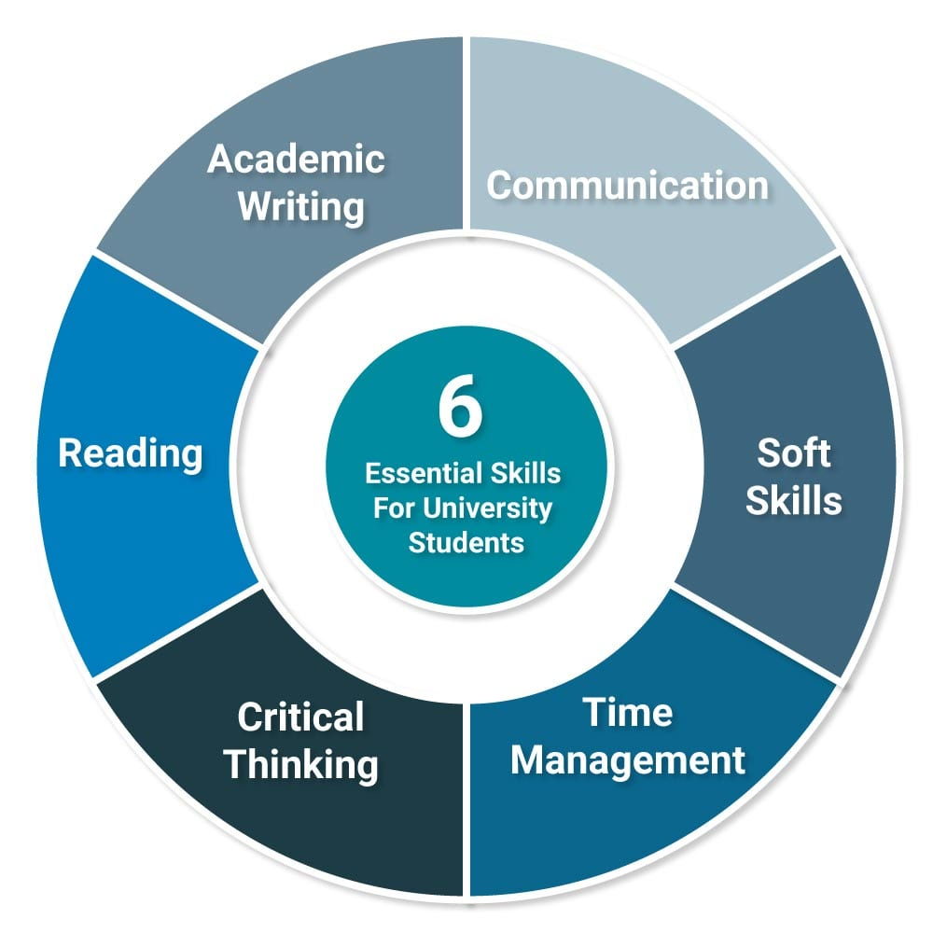
Figure: Academic Skills (Galster et al, 2023).

3. Analysis and Personal Reflection

Evaluate experiences
While organising the knowledge I had acquired and determining which facts were most important, I ran across various obstacles. Last but not least, readers found it difficult to follow my main arguments at times due to the abundance of material I employed. The ability to do research and analyse data is another crucial talent that I was able to acquire over my educational journey (Franco-Ángel et al, 2023). In this regard, I was able to locate and examine the data from scholarly sources in order to develop the elements of a stronger case. With the aid of feedback, I was also able to choose the most significant sources more effectively and structure the knowledge I had acquired over time.

Analyse the experiences described and discuss what have learned from them.
I valued the chance to voice my thoughts, as well as the chance to get or share information about topics I may not be familiar with and to think critically. Although my writing style in Task 1 and discussion forums may show that this is one of my shortcomings, I also believe that it is one of my main strengths. Being an active participant in a group and conducting group discussions were two other things that I found beneficial. I lack the courage to challenge other viewpoints. Participating in these conversations has been a beneficial approach to developing the critical thinking and communication skills required for both the academic and professional spheres (Fletcher et al., 2023).

How these experiences contributed to understanding of the module content.
This is due to the fact that academic achievement involves a critical thinking approach in which students examine, evaluate, and draw well-founded conclusions rather of just repeating what they have been taught by their instructors or read in books (Ferreira et al., 2023). Because of these instances, I realised that being an active learner is beneficial. In my situation, going beyond just reading the textbooks to do research and participate in the conversations allowed me to have a better understanding of the subject matter. Additionally, I realised how crucial time management is to completing projects and research as well as participating in class to get the most out of the experience.

The strengths and areas for improvement in this module.
I still believe, however, that I could use some more confidence when it comes to refining my areas of interest and engaging in debate with others. Thus, by improving my note-taking, organising, and formulation abilities, as well as my summarisation and memorisation techniques, I should be able to avoid similar challenges in further academic endeavours.
My capacity for continuous improvement was my strongest suit in the module. I also paid attention to the criticism, learnt from it, and made sure to apply it to my work. My ability to explain and dispute, which the critical thinking training helped me develop, was another emphasised quality (Ellah et al, 2023).

Reflect on personal growth and development as a student of this program.
My analytical abilities have grown as a consequence of the course, and I will make sure that they continue to improve and that I actively seek out chances that allow me to put them to use in real-world situations. There have been noteworthy advancements in my critical thinking, communication, and analytical abilities during this curriculum (Doherty et al, 2023). This subject has been excellent and has laid a strong foundation for a number of my academic and professional goals.
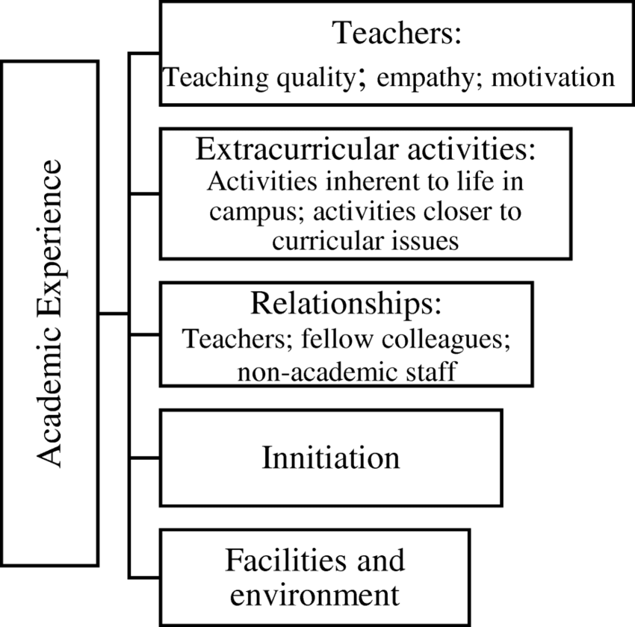
Figure: Experiences (Deswarta et al, 2023).

4. Conclusion

Summarise the key points
So, it can be concluded that this report gave me a better understanding of how my research, analytical, and communication abilities have developed over the majority of the assignments and class discussions. One of my strengths is that I was able to identify my critical thinking skills; on the other hand, I need to improve on defining the study issue and stating my position.

Reflect on the overall impact
I have learnt that these abilities will continue to shape me for future difficulties and for further academic growth. Overall, I have learnt that this module has impacted every aspect of my learning process as it gave me the opportunity to broaden my knowledge and hone my critical thinking abilities while handling material.

5. References
Deswarta, D., Mardianty, D., & Bowo, B. (2023). Pengaruh Soft Skill, Hard Skill Dan Motivasi Kerja Terhadap Kesiapan Kerja Mahasiswa Fakultas Ekonomi Dan Bisnis Universitas Islam Riau Dimasa Endemi Covid 19. Management Studies and Entrepreneurship Journal (MSEJ), 4(1), 364-372.
Doherty, O., & Stephens, S. (2023). Hard and soft skill needs: higher education and the Fintech sector. Journal of Education and Work, 36(3), 186-201.
Ellah, H. R., & Azmi, N. (2023). High School Students’ Perception and Development of Soft skills. International Journal of Language and Literary Studies, 5(2), 192-208. MU
Ferreira, C., Robertson, J., & Pitt, L. (2023). Business (un) usual: Critical skills for the next normal. Thunderbird International Business Review, 65(1), 39-47.
Fletcher, S., & Thornton, K. R. (2023). The top 10 soft skills in business today compared to 2012. Business and Professional Communication Quarterly, 86(4), 411-426.
Franco-Ángel, M., Carabali, J., & Velasco, M. I. (2023). The internship performance of undergraduate students: Are hard or soft skills more important?. Industry and Higher Education, 37(3), 384-396.
Galster, M., Mitrovic, A., Malinen, S., Holland, J., & Peiris, P. (2023). Soft skills required from software professionals in New Zealand. Information and Software Technology, 160, 107232.
Lamberti, G., Tomas, A. B., & Laura, T. (2023). University image, hard skills or soft skills: Which matters most for which graduate students?. Quality & Quantity, 57(Suppl 4), 553-574.
Lamri, J., & Lubart, T. (2023). Reconciling hard skills and soft skills in a common framework: the generic skills component approach. Journal of Intelligence, 11(6), 107.
Magalhães, C., Araújo, A., & Andrés Marques, I. (2023). Hotel workers’ perceptions on soft and hard skills in Porto, Portugal. Journal of Human Resources in Hospitality & Tourism, 22(1), 49-70.

