ACADEMIC AND EMPLOYABILITY SKILLS

Name of the Student: Constantin Daniel Mihai
Student’s ID: 1907369
Name of the University: University of Wales
Trinity Saint David London
Lecturer: Peter Allen

Table of Contents
Introduction 3
Main Body 4
Conclusion 9
References 10
Appendix 12

Introduction
Academic Skills are the expertises that approached to apply in developing the learning process. These are critically useful for getting success in universities for acquiring good grades in the academic session. These skills are important for learning throughout the life of a person. Employability skills on the other hand help in making a graduate ready for joining the professional life. This kind of readiness and its implication cannot be looked down. This report will look into the academic and employability skills and analyse them in context to own areas. Importance of these skills in later life will be looked with the ways of development.

Main Body
Academic Skills
I try my level best to develop academic skills as it helps me to gain a good score and that this development helps me to develop learning skills for the rest. In this section, I will discuss some of the academic skills on which I have assessed that I am good but at time, these skills became my weakest part.
- Academic Integrity and Honesty
I do not copy anything direct from the internet sites and try to figure the meaning and then rephrase them according to need. Most of my works are given good grades as the assessor found it the best work provided among the others. I did the work according to the principles provided by my college and the ethical principles in which the academic session develops on. Still I found that most of my works when conducted for plagiarism comes with heavy percentage. Mainly in the works of project management and in the scientific words issues of plagiarism is compulsory which is not resistible (Marsh and Campion, 2018).
- Note Making
I have a tendency of writing all the things that are given lectures by the assessors. I am not able to make the notes and that consumes most of my time. I, therefore, could not cope up with all the notes that are provided in class. I have to depend on the notes taken by my fellow mates and that many times does not get appropriately with the topic that assessor have provided. There is always a contradiction for understanding the lectures, which affects the level of understanding (Dohaney et al. 2015). One thing that helps me is that I can remember the material and the piece on which lecture has been provided. I can organise the ideas and then make connections, which help me in structuring and plan the assignment that has been provided. I can review the assignments that are provided and that helps me to revise before the starting of examinations.
- Report Writing
I can write the report as assignment provided by the lecturer. Most of my writings have been appreciated and that in times I help my fellow mates to develop the structure and write report based on that. Based on the curriculum topics writing the topics is not a tough one and that I have an expertise on this field. Without searching most of the internet sites, I have a flow on writing reports by constructing a well pattern structure and with the references needed. Still, this has not been my strong part as I am weak in grammar. My writings are not well proofed and for that reason, I could not attain the percentages like other. I did my level best to lessen this part by using different software. Problems of grammatical mistake impacts on my academics as well as it lower the percentage needed for passing examinations. Topics for writings reports outside curriculum is difficult as getting ideas at the earliest and implementing it in writing is impossible (Weldy et al. 2014).
- Time Management
My capabilities in managing time are poor. I do not complete my projects in time, as there were issues of getting the right kind of information that are needed for developing the project. Issues of writing fillers are there and that takes most of my time in completing the project in time. I am nervous to do the critical paths and in doing power point presentations, I am not clear of the ideas. Another thing that takes time is referencing and that searching the references with the keywords become tough one (Cagliyan et al., 2017).
- Searching the information
In this section, I am weak as I do not have thorough knowledge of using the keywords and place them properly. I go through the sections, and according to the questions, I used to search information. Taking help of search engines I go through all the sections comes after searching the questions. This takes most of my time and that I am not able to start the project on time. On the other side it has, some advantages as it helps me to go through all the sections and read requirements based on which the project will develop. Gaining knowledge from all these sites help me to do the research thoroughly and write projects accordingly.
- Paraphrasing
I am well acquainted with this and that it takes less time to complete the task. If I get the required material I will do paraphrase at the earliest without any flaws. I used to read many books, which directly coordinates with the subject I am studying. This helps me to get an idea of what needs to write and which part I need to avoid. Having a strong base in English I do not have to face any kind of issues regarding words and their meanings.
- Group Work
I am a good leader in dividing the works among my fellow mates. I use to look for the word count that every individual get the right proportion of work and that submission of the work within the time. According to the topic and the team selected by the professors, I do not have any kind of problem in doing the work. I have found that most people studying in the same class have appreciated this skill. Only thing that distracts me from developing this as my strongest point is that I could not coordinate with the way they develop the work, as my way of doing work is entirely different from those working as a group.
Employability Skills
Completion of my academic skills helps me to develop the skills based on which I will get employment. During my academic session, I have gained a thorough knowledge on how to improve the skills, which are my strongest part, but at time, I lag because of not monitoring those skills. I have developed specialised skill to get job of my requirement but also stress on the general skills that are looked by the recruiting members. Having these, skills help in getting establishing a special impression in front of the board of directors (Jackson, 2015). I will discuss some of the skills that help me a lot in achieving employment but at times became my greatest threat factor.
- Communication
I am a good communicator and before that, I am a good listener. I know that before developing communication listening to colleagues is important as it helps in developing the point that I want to mean. I made it sure that none of my colleagues felt that their point of view is not understood and that they are not able to hear my point of view. Stress on the non-verbal way of communication is of need as it helps in identifying what is actually the need and what needs are fulfilled (Bharathi, 2016). Still this part found not as developed as I think of it. I have found that I am compatible to communicate with my fellow colleagues and that when people from outside team want to communicate I do not respond them. I lack the confidence of communication and fail to project my views.
- Team work
I have developed my skills of doing works in team and that I have found that according to the professional standards it helps me to achieve goals set by organisation. I use to look after the team given for developing work and get along with them so that within time it can be completed. I use to look for the ways through which the work can be done with perfection, not compromising quality and at the earliest. Communication with fellow mates is important and that it helps in structurally designing the entire work (McKinlay and Pullon, 2014).
- Problem Solving
This skill is really lacking in me, as I do not have the knowledge of how to solve problems right from the beginning. I do not look at the work right the beginning and that assess the problems that can come at any point. Senior people use to look for the problems that have arrived and that ways are directed in which the problem can be solved (Shokri and Nabhani, 2015). I do not do research regarding the possible problems that may arise and I use to stress more on the ways through which work can be completed in time.
- Planning and organisation
I am very good at achieving what has been needed and by which means it has to be done. I made it clear that I have to do this and for that reason, I will develop research on that. I use to not down all the things that are required for developing the project and organise them accordingly. My planning part in this way appreciated by most of the people and that I am selected for giving instruction to others regarding my developed skill of planning and organisation. Still problem come when I have to make other commitments and that hampers the work (De Bruecker et al., 2015)
- Self-management
I use to do my own job and that I do not need any help from other as my skills and the way I work does not need any other member constantly follow my job. I use to finish the work before the deadline and submit it, which gives me a confidence in doing other works, and assisted others. Still this has become one of my weak points as taking other responsibilities with the work being done again takes time, which reflects that I am doing any proof reading. Schedule at this time really becomes tough to follow (Makki et al., 2015).
- Learning
I am a good learner and I always look into the new possibilities of learning new things in the workplace. I try to pick the new things that I have learnt at the earliest so that I can adapt to the changes and establish myself as potential and effective employee. According to the new developments, it is worth to do a short course online and develop efficacy (Manuti et al. 2015). Still I have found that developing the skills takes time and that I am not efficient doing this practically.
- Technology
I am technically sound and I know much of the software on which companies use to work. I have flair knowledge of MS Excel, MS Word and that I can do the Gantt chart required. I am competent in doing the spreadsheets and that I have a good knowledge about DTP. Only thing that I am lacking is of short hardware and software problems that can be developed without taking any help from IT people. This technological deficient scrutinised mostly by the senior level managers (Jang, 2016).

Conclusion
In conclusion, it can be stressed that time management needs to be looked at so that works can be done effectively and in time. Strong points that are highlighted found not to give any kind of support as these are comparatively lacked by the small flaws that hamper both the skills of academic and employability. Having knowledge is of great worth but this needs to e used accordingly so that weakness cannot bring in forth. Taking this in knowledge helps in developing skills that are required for employability. This also helps in gaining good scores in the academics that help in future to attain good marks.

References
Bharathi, A.V., 2016. Communication Skills-Core of Employability Skills: Issues and Concerns. Higher Learning Research Communications, 6(4), p.n4.
Cagliyan, V., Zerenler, M. and Isiklar, Z.E., 2017. Evaluation on time management skills of university students. Economic and Social Development: Book of Proceedings, pp.215-223.
De Bruecker, P., Van den Bergh, J., Beliën, J. and Demeulemeester, E., 2015. Workforce planning incorporating skills: State of the art. European Journal of Operational Research, 243(1), pp.1-16.
Dohaney, J., Brogt, E. and Kennedy, B., 2015. Strategies and perceptions of students' field note-taking skills: Insights from a geothermal field lesson. Journal of Geoscience Education, 63(3), pp.233-249.
Jackson, D., 2015. Employability skill development in work-integrated learning: Barriers and best practice. Studies in Higher Education, 40(2), pp.350-367.
Jang, H., 2016. Identifying 21st century STEM competencies using workplace data. Journal of Science Education and Technology, 25(2), pp.284-301.
Makki, B.I., Salleh, R., Memon, M.A. and Harun, H., 2015. The relationship between work readiness skills, career self-efficacy and career exploration among engineering graduates: A proposed framework. Research Journal of Applied Sciences, Engineering and Technology, 10(9), pp.1007-1011.
Manuti, A., Pastore, S., Scardigno, A.F., Giancaspro, M.L. and Morciano, D., 2015. Formal and informal learning in the workplace: a research review. International journal of training and development, 19(1), pp.1-17.
Marsh, J.D. and Campion, J., 2018. Academic integrity and referencing: Whose responsibility is it?. Journal of Academic Language and Learning, 12(1), pp.A213-A226.
McKinlay, E. and Pullon, S., 2014. Back to Back: Having interprofessional education during the undergraduate years is essential for building teamwork skills in general practice: Yes. Journal of primary health care, 6(4), pp.331-333.
Shokri, A. and Nabhani, F., 2015. LSS, a problem solving skill for graduates and SMEs: case study of investigation in a UK business school curriculum. International Journal of Lean Six Sigma, 6(2), pp.176-202.
Weldy, T., Maes, J. and Harris, J., 2014. Process and practice: Improving writing ability, confidence in writing, and awareness of writing skills' importance. Journal of Innovative Education Strategies, 3(1), pp.12-26.

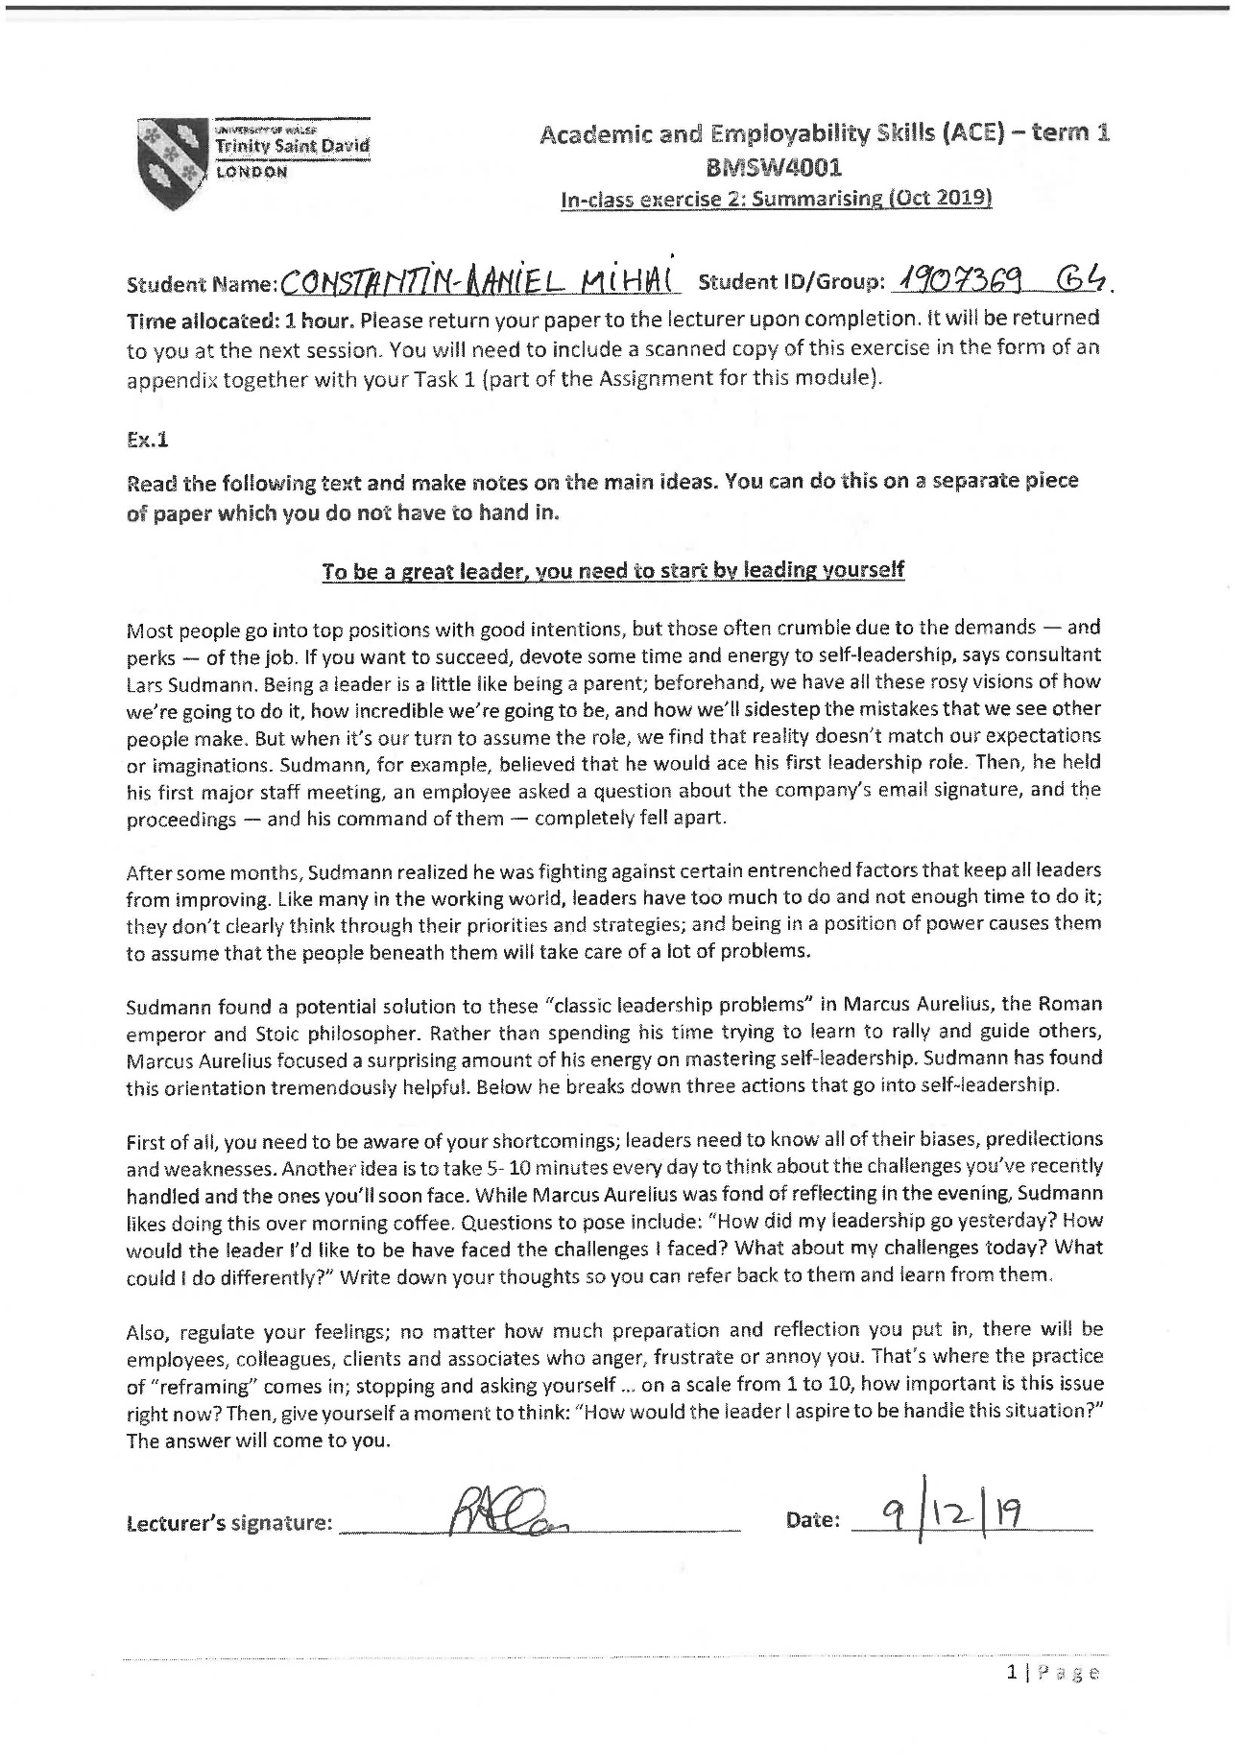
Appendix


