Running Head: ASSIGNMENT

Introduction to Web and Database Concepts
[Ahmed yasir ibrahim abdelgadir]
[16/11/2025]
[student ID: 2438780]

Table of Contents
1. Introduction 3
2. Scenario Explanation 3
3. Task 1: Database Implementation 4
3.1 Scenario Analysis 4
3.2 Entity–Relationship Diagram (ERD) 5
3.3 Data Structure Development 5
3.4 Normalisation and 3NF Compliance 6
3.5 Sample Data Population 7
3.6 Query Development 7
3.7 Validation and Testing 8
4. Task 2: Coursework Written Elements 9
4.1 Design Decisions 9
4.2 Reflection on Challenges and Future Improvements 9
5. Conclusion 10
6. References 12
7. Appendices 14
SQL TABLE CREATION 14
SAMPLE DATA POPULATION 14

Introduction to Web and Database Concepts

1. Introduction
According to the Bai and Bhalla (2022), trying to achieve the mission of green transportation accessibility to parks, university campuses, train stations, and other public areas, EcoRide electric bike rental scheme is a new project that aims to offer green transportation to a wide audience. With increasing scale of the service, lack of organised digital information system has posed a number of operational challenges. The use of manual paperwork and spreadsheet has complicated the use of the staff to effectively monitor the riders, bikes and rentals as well as maintenance operations (Rockoff 2021). In order to address these shortcomings, this report outlines the design and implementation of an organised relational database system that will help in the efficient management of the operations of EcoRide. The report will consist of two activities, the first one will deal with the technical development of the database and the second one will provide the written analysis, design justification, and reflection.

2. Scenario Explanation
EcoRide now offers electric bikes where its customers scan on station with the ID, and drop off the bike at any EcoRide docking spot. The service remains largely reliant on manual documentation even though its popularity is increasing (Kaufmann and Meier 2023). Consequently, employees cannot effortlessly determine the existence of bikes, maintenance times, and the activity of riders. Another challenge facing the system is the inability to monitor unreturned bikes and avoid instances of long bookings. This assignment is thus aimed at coming up with a database system that can handle the riders, Bikes, Rental transactions, and maintenance in a well-organised and secure way. The system will assist the EcoRide to record the correct data, become more transparent on operations undertaken and enhance planning of the services.

3. Task 1: Database Implementation

3.1 Scenario Analysis
Critical examination of the situation indicates that the operations of EcoRide need four major actors to be managed. The first one is the Rider, which entails people registering under the service. Their information involves name, contact details and ID numbers which are required in the authentication of rentals (DeBarros 2022). The second one is the Bike with such information as its unique ID, type, condition, current location, and status. The bikes can be shared by more than one person and can have many waste check-ups in the course of its existence. The third entity is the Rental, which logs every occasion when a rider takes out a bike. The major data involves rental time, return time, duration and cost. The rentals are connected to only one rider and bike. The fourth one is the Maintenance Record where activities done by staff members are recorded. The identity of the staff and the kind of service provided is taken to ensure that the history on the maintenance of each bike is at hand (Muppala 2025).
Relationships that arise out of these entities are not complicated but significant. A rider may possess a large number of rentals, a bike may also possess a large number of rentals and each rider is connected to one bike (Muppala 2025). Moreover, every bike could also receive a number of different check-ups, and each check is performed by an employee. Such relationships contribute to the picture of the whole operation, and they will make sure that the system will encompass all the necessary processes without repetition (Dora, Hluchý and Nemoga 2023).

3.2 Entity–Relationship Diagram (ERD)
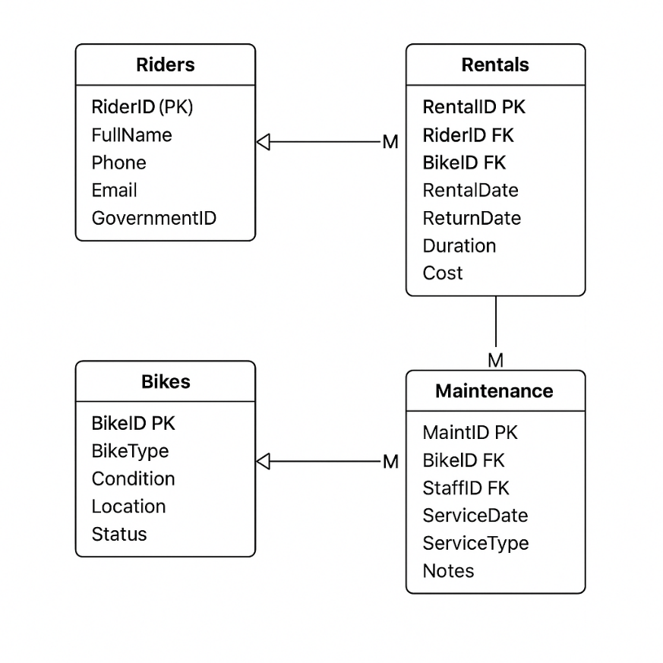
The ERD developed for EcoRide’s operations shows the following main entities and relationships:
- A Rider has a one-to-many relationship with Rental.
- A Bike has a one-to-many relationship with Rental.
- A Bike also has a one-to-many relationship with Maintenance Record.
- Staff have a one-to-many relationship with Maintenance Record.
Primary and foreign keys are clearly labelled. This model supports referential integrity and defines the logical structure for implementation.

3.3 Data Structure Development
With the help of the ERD, it was possible to draw relational tables that perfectly represent the entities and relations. RiderID, FullName, Phone, Email, and GovernmentID are just some of the fields that are in the Riders table. The Bikes table contains the values of BikeID, BikeType, ConditionStatus, Current Location, and OperationalStatus. Rentals Table has RentalID, RiderID, BikeID, RentalDate, ReturnDate, Duration and Cost. The Maintenance table holds the value of the MaintenanceID, BikeID, StaffID, ServiceDate, ServiceType, Notes, and MaintenanceStatus. Lastly, there is Staff table which contains StaffID, StaffName, Role and ContactDetails.
The implementation of primary keys was in the form of auto-increment integer IDs that provided uniqueness (Dora, Hluchý and Nemoga 2023). The Rentals and Maintenance tables had foreign key constraints so as to associate the records with Riders, Bikes and Staff. These limitations do not allow deleting referenced records unless child records are corrected or they removed (Kini et al. 2022). Types of data were chosen in order to be accurate and efficient. To provide some examples, dates are identified as DATE or DATETIME, costs are identified as DECIMAL, and textual descriptions are identified as VARCHAR with adequate length restrictions.

3.4 Normalisation and 3NF Compliance
The system has all the tables that have the requirements of Third Normal Form. At the First Normed Form (1NF) level, atomic, indivisible values are non-repeating groups, and this is represented in a table. As an illustration, the rider contact information will be stored on separate phone and email fields instead of concatenated strings. On the Second normal form (2NF) level, no non-key attribute is dependent on a subset of the key since all the composite keys were substituted with surrogate primary keys. In the Third level of normalisation (3NF) all the non-key attributes of the table are independent of the non-key attributes, a table today can only be part of the cost of a rental, but not on the rider or a bike (Bai 2022). It is guaranteed by the rigid distinction of entities like Riders, Bikes, Rentals, and Staff that promote minimisation of redundancy, enhances data integrity, and effective updating (Kareem et al. 2021).

3.5 Sample Data Population
Sample data was entered into both tables in order to illustrate the usability of the system by using realistic sample data that represents the EcoRide operations. Five riders were developed with different ID numbers and contacts. In the same manner, five bikes were introduced with different conditions i.e. excellent, needs service and good and with different locations e.g. Central Park Station and University Dock A. Sample rentals were added to indicate real utilisation patterns, such as short-daily rentals and more than short-daily usage (Bai 2022). There were some other entries of maintenance as well, and one of these is the battery check, replacement of tyres, and routine check. Such examples are used to confirm important relationships, so that every rental should be able to refer to a rider and a bike properly, and the maintenance logs should be able to associate personnel record and bike records appropriately.

3.6 Query Development
A series of SQL queries were developed to illustrate the common tasks that could be done in the EcoRide staff. A query for example where all the bikes that are out on a rental check are being searched by the appropriate date to retrieve and the bike has a null date. The other query is used to locate bikes that are in need of maintenance, based on their Needs Service or their last maintenance records (DeBarros 2022). Another search query is to get a list of rentals an individual rider made, and this is useful when the staff needs to study the activity of the users.
Also, frequency analysis queries were created in order to find out the most common bikes to rent, which would be useful during the planning of repairing them or upgrading. Bike availability queries enable the staff to know in realtime the position of bikes that are available anywhere. These questions demonstrate how the system enhances visibility, minimization of ambiguity as well as offering actionable information that could not have been realised before with the use of paper-based recording (Kaufmann and Meier 2023).

3.7 Validation and Testing
The testing was done as a comparison between what was discussed in a scenario and what the developed database was able to do. The initial one was that it can register the riders and save the necessary information. This feature was effective to the extent that it enabled insertion of records in the Riders table without duplication of records of the government ID. Accurate storage and tracking of bike information was the second requirement (Dora, Hluchý and Nemoga 2023). This was tested when the test data were inserted and querying live bike status was performed. The third one was the need to have an accent of service of recording rental transactions that was confirmed by connecting rentings with the riders and the bikes using foreign keys. The fourth need was maintenance tracking, which was also demonstrated successfully with the help of the insertion of the service entries and the retrieval of full maintenance history concerning each bike (Kini et al. 2022).
Also, referential integrity testing was conducted by trying to utilise activities that do not comply with foreign key restraints. Using the example of deleting a bike that has already been described in a rental record, the blocking was made correctly too. Boundary testing was used to ensure that the NULL values on the required fields had not been permitted. In general, the system is fully consistent with the operational requirements outlined by the scenario and is much more precise and reliable than manual operations.

4. Task 2: Coursework Written Elements

4.1 Design Decisions
There are a number of issues that affected the choice made when designing the database system. It was one of the significant choices to retain entities on their own and distinct instead of consolidating data into fewer tables. This strategy increases the clarity, normalisation and scalability of the future. As an illustration, though technically one may perform maintenance tasks directly and create a maintenance table in the Bikes table, it is more convenient to separate them into a Table of Maintenance where one could get a historical log and avoid redundancy. Another related design was aimed at Rentals whose best place is to be on the side of Riders and Bikes so that each entity can participate in a variety of rental activities (Bai and Bhalla 2022).
The other significant choice is that of using surrogate primary keys as opposed to the natural keys, which include government ID and bike serial number. Surrogate keys make relationships to be simple, minimise the number of user errors, and offers some form of consistency (Kaufmann and Meier 2023). The choice of relationships was also taken care of. All relationship designs were geared towards realistic operating patterns e.g. rental only has one rider and one bike at the same time. Such decisions help in having the clean and logical structure by which the database could be maintained easily.

4.2 Reflection on Challenges and Future Improvements
There were a number of pitfalls encountered in the development. It was one of the first challenges to establish the extent of the details of the bike and maintenance record required in the case of the simplified assignment. The practical bike rental systems are associated with many technical requirements, tracking devices, and autonomous status changes (DeBarros 2022). The challenge was, however, to have sufficient detail to be used meaningfully without too complex structures since only a simplified one was required in the assignment. This balance was needed through the continuous review of attributes and relationships.
The other issue was related to normalisation. The entities were not complex, but all attributes needed to be considered with respect to 3NF. An example would be that the original thoughts of storing the calculation of rental costs directly into the Rentals table would have to be revisited to ensure cost was not dependent on rider or bike attributes (Dora, Hluchý and Nemoga 2023).
One needed to be creative in the creation of meaningful test queries as well. Inquiries had to represent realistic, practical requirements as opposed to strictly technical displays. This demanded some thought in the minds of ecoRide staff that require the details of the availability of bikes, how they are used as well as when they need to be serviced.

5. Conclusion
EcoRide database system will be a stable efficient and reliable solution to the challenges identified during the scenario. The system can guarantee precision in the monitoring of riders, bikes, rentals and service of maintenance activities because of the utilization of the normalised, relational database in the place of paper-based procedures. This is evident in the ERD, table structures, sample data and queries, which depict a full implementation of all functional requirements. The system is useful in understanding the daily operations as well as gives information which can assist the eco ride team in planning the expansion and resource management. All in all, the project is used to demonstrate that database design is significant in enhancing service delivery, data management, and organisational decision making.

6. References

Bai, Y. and Bhalla, S., 2022. Introduction to databases. In Oracle Database Programming with Java (pp. 9-66). Auerbach Publications.
Bai, Y., 2022. SQL Server Database Programming with Java (pp. 71-96).
DeBarros, A., 2022. Practical SQL: A Beginner's Guide to Storytelling with Data. no starch Press.
Dora, J.R., Hluchý, L. and Nemoga, K., 2023. Ontology for blind SQL injection. Computing and Informatics, 42(2), pp.480-500.
Kareem, F.Q., Ameen, S.Y., Salih, A.A., Ahmed, D.M., Kak, S.F., Yasin, H.M., Ibrahim, I.M., Ahmed, A.M., Rashid, Z.N. and Omar, N., 2021. SQL injection attacks prevention system technology. Asian Journal of Research in Computer Science, 6(15), pp.13-32.
Kaufmann, M. and Meier, A., 2023. SQL and NoSQL Databases. Switzerland: Springer. doi, 10, pp.978-3.
Kini, S., Patil, A.P., Pooja, M. and Balasubramanyam, A., 2022, May. SQL injection detection and prevention using Aho-Corasick pattern matching algorithm. In 2022 3rd International Conference for Emerging Technology (INCET) (pp. 1-6). IEEE.
Muppala, M., 2025. SQL Database Mastery: Relational Architectures, Optimization Techniques, and Cloud-Based Applications. Deep Science Publishing.
Rockoff, L., 2021. The language of SQL. Addison-Wesley Professional.

7. Appendices

SQL TABLE CREATION
CREATE TABLE Riders (
RiderID INT PRIMARY KEY AUTO_INCREMENT,
FullName VARCHAR(100),
Phone VARCHAR(20),
Email VARCHAR(100),
GovernmentID VARCHAR(50) UNIQUE
);

CREATE TABLE Staff (
StaffID INT PRIMARY KEY AUTO_INCREMENT,
StaffName VARCHAR(100),
Role VARCHAR(50),
Contact VARCHAR(50)
);

CREATE TABLE Bikes (
BikeID INT PRIMARY KEY AUTO_INCREMENT,
BikeType VARCHAR(50),
ConditionStatus VARCHAR(50),
CurrentLocation VARCHAR(100),
OperationalStatus VARCHAR(50)
);

CREATE TABLE Rentals (
RentalID INT PRIMARY KEY AUTO_INCREMENT,
RiderID INT,
BikeID INT,
RentalDate DATETIME,
ReturnDate DATETIME,
Duration INT,
Cost DECIMAL(6,2),
FOREIGN KEY (RiderID) REFERENCES Riders(RiderID),
FOREIGN KEY (BikeID) REFERENCES Bikes(BikeID)
);

CREATE TABLE Maintenance (
MaintID INT PRIMARY KEY AUTO_INCREMENT,
BikeID INT,
StaffID INT,
ServiceDate DATE,
ServiceType VARCHAR(100),
Notes VARCHAR(255),
MaintenanceStatus VARCHAR(50),
FOREIGN KEY (BikeID) REFERENCES Bikes(BikeID),
FOREIGN KEY (StaffID) REFERENCES Staff(StaffID)
);

SAMPLE DATA POPULATION
INSERT INTO Riders (FullName, Phone, Email, GovernmentID) VALUES
('Ali Raza', '03001234567', 'ali@example.com', 'CNIC1234'),
('Sara Malik', '03006543210', 'sara@example.com', 'CNIC2234'),
('John Smith', '03009998877', 'john@example.com', 'CNIC3234'),
('Fatima Khan', '03001112233', 'fatima@example.com', 'CNIC4234'),
('Ahmed Noor', '03007775544', 'ahmed@example.com', 'CNIC5234');

INSERT INTO Staff (StaffName, Role, Contact) VALUES
('Umar Hussain', 'Technician', '03111222334'),
('Rachel Green', 'Mechanic', '03223334455'),
('Bilal Siddiqui', 'Inspector', '03334445566'),
('Maria Gomez', 'Technician', '03445556677'),
('Emily Stone', 'Supervisor', '03556667788');

INSERT INTO Bikes (BikeType, ConditionStatus, CurrentLocation, OperationalStatus) VALUES
('Electric A1', 'Excellent', 'Park Station A', 'Available'),
('Electric B2', 'Good', 'Campus Dock 3', 'Available'),
('Electric C3', 'Needs Service', 'Repair Centre', 'Unavailable'),
('Electric A1', 'Good', 'Train Station South', 'Available'),
('Electric B2', 'Fair', 'Campus Dock 1', 'Available');

INSERT INTO Rentals (RiderID, BikeID, RentalDate, ReturnDate, Duration, Cost) VALUES
(1, 1, '2025-11-01 09:00', '2025-11-01 10:00', 60, 2.99),
(2, 2, '2025-11-02 14:00', NULL, NULL, NULL),
(3, 4, '2025-11-03 08:30', '2025-11-03 08:50', 20, 1.25),
(4, 5, '2025-11-04 11:15', NULL, NULL, NULL),
(5, 1, '2025-11-05 17:00', '2025-11-05 17:45', 45, 2.30);

INSERT INTO Maintenance (BikeID, StaffID, ServiceDate, ServiceType, Notes, MaintenanceStatus) VALUES
(3, 1, '2025-10-20', 'Battery Check', 'Battery health low', 'Pending'),
(3, 2, '2025-10-22', 'Tyre Replacement', 'Front tyre replaced', 'Completed'),
(5, 3, '2025-10-25', 'Inspection', 'General check done', 'Completed'),
(2, 4, '2025-11-01', 'Brake Adjustment', 'Brake pads worn', 'Pending'),
(4, 5, '2025-11-03', 'Software Update', 'System updated', 'Completed');

Bikes currently out on rental
SELECT Bikes.BikeID, BikeType, CurrentLocation
FROM Bikes
JOIN Rentals ON Rentals.BikeID = Bikes.BikeID
WHERE Rentals.ReturnDate IS NULL;

Bikes needing service
SELECT * FROM Bikes
WHERE ConditionStatus = 'Needs Service';

Total rentals per rider
SELECT Riders.FullName, COUNT(Rentals.RentalID) AS TotalRentals
FROM Riders
LEFT JOIN Rentals ON Riders.RiderID = Rentals.RiderID
GROUP BY Riders.FullName;

Most frequently rented bikes
SELECT BikeID, COUNT(*) AS RentedTimes
FROM Rentals
GROUP BY BikeID
ORDER BY RentedTimes DESC;

Maintenance history of a bike
SELECT Bikes.BikeID, ServiceType, ServiceDate, StaffName, MaintenanceStatus
FROM Maintenance
JOIN Bikes ON Bikes.BikeID = Maintenance.BikeID
JOIN Staff ON Staff.StaffID = Maintenance.StaffID
WHERE Bikes.BikeID = 3;

