Assignment 2: Future Developments in the Field of Marketing
(Individual Report)
Marriott International : Data Breach 2018

Module : BMMB7012 Marketing Management​

Lecturer : Chris Wilkins​

By Deborah Jenkins

Contents page
Executive summary
Introduction
Findings
Task 1: Provide a critical evaluation of your chosen organisation’s marketing activities
The Impact of Data Breaches on Marketing Efforts
Marketing and Reputation management
Reputation and Loyalty as part of marketing programmes
Brand personality concept in marketing
Customer relationship management systems (CRM) and Social Responsibility
Marketing strategy and frameworks

Task 2
Task 3
Conclusions
References
Appendices

Recommendations

Executive Summary

This report critically evaluates the role and activities of the marketing department within the Marriott International Hotel group for the Marriott brand outlining future developments and future marketing planning to address the challenges identified during the Data Breach on the takeover of the Starwood . There are three tasks as part of the report, with the first task analysing the marketing activities by identifying, evaluating and justifying these. Task 2 will provide a conclusion to those marketing activities and address any shortcoming s in the marketing strategy by the Marriott brand and the third task will provide recommendations on improvements to the marketing strategy for future realistic sustainable marketing.

Introduction
This Report will critically analyse the data breach in the takeover of the Starwood portfolio by Marriott International Hotel Group in 2018. Critical evaluation of The Impact of Data Breaches on their Marketing Efforts will identify challenges in managing the crisis, discuss frameworks that can be followed as part of marketing strategy and the impact on brand reputation and the costly legal issues with the negative publicity impacting brand reputation and significant financial losses (Suter,n.d). Analysis of marketing activities will be considered on how the brand’s marketing activities were used to manage the crisis, the marketing strategy of the future developments within frameworks and models such as the 4p’s of marketing mix, AIDA, 4 C’s and the 4 E’s, the 5 C’s ,the Edelman trust barometer, the brand personality, the SWOT analysis, perceptual mapping, CRM systems, SOSTAC, RACE models are all considered.
When Marriott acquired Starwood in 2016, the company inherited a compromised reservation system where hackers had accessed 500 million guests personal data since 2014 that resulted in lawsuits and reputational damage after the breach was announced in 2018. This resulted in class action lawsuits in the US as well as GDPR infringement fine by the ICO in the UK this regulation came into effect in May 2018 as standardises rules and regulations across Europe, with a clear rule that ‘ companies must notify and communicate all high risk breaches to users immediately for measures to be taken’ (Fahy and Jobber, 2019) .
The report will give rise to the questions whether the management of the crisis handled correctly by the Marriott as there was mixed reviews. The Marriott inherited problem that was not managed sufficiently, as human error 2 years previously was to blame , with 82% of data breaches against businesses which involved a human element, through issues like error and social engineering this risk was realised in the merger (Suter, n.d).
According to Oxford English Dictionary a data breach crisis is defined as ‘A time of severe difficulty or danger. A time when a difficult decision must be made’. Statistics show 45% of the world population use the internet, an estimated of 3.4 billion individuals (Suter,n.d) making Cybercrime increase of 125% a global threat to business and individuals (AAG - cybercrime statics 2023).

Task 1: Provide a critical evaluation of your chosen organisation’s marketing activities
The concept and importance of marketing is understanding the needs of the customer by delivering processes that identifies and anticipates them to provide value, and prices, and promotes well ( Kotler et al, 2020) and according to Peter Drucker, ‘the aim of the marketing mix is a set of tools that work together to engage, satisfy needs and build relationships’. According to Marriott's annual report, Marriott invests significant resources in marketing to achieve these goals, spending $422 million on marketing and sales expenses in 2020, including advertising, promotions, and loyalty program expenses. Marriott's marketing strategies include a mix of traditional advertising, as well as digital marketing, such as email marketing, social media marketing, and search engine advertising.
The Marriott during the crisis used the promotions element to the 4 P’s of the marketing mix, the promotions marketing mix, blends advertising, public relations, personal selling, sales promotion and direct marketing as tactics that companies use to communicate with and persuade customers to buy their products or services (Kotler et al 2020).Based on evidence Marriott did not take proactive measures to respond quickly and effectively to the data breach. There was limited marketing effort on social media and the only PR information offered was in the following year. This was found to not have protected affected customers vulnerable to identity fraud. This is not an ethical or transparent way to communicate with customers. Majority of conversation (93.41%) surrounding the breach took place on Twitter with Marriott International (@MarriottIntl) tweet using general response only (Jobber and Ellis-Chadwick, 2016).

The Impact of Data Breaches on Marketing Efforts
Marriott engaged leading security experts , third parties to determine the situation and notified authorities and law enforcement this meant a longer period of time before results, during this time the customers were not informed of the situation which was a reason of social media negativity. (Appendix 8). Marriott management were waiting for guidance and facts from experts however, one of the laws of GDPR legislation in the UK is an immediate reaction is needed, this resulted in a fine by the ICO for the Marriott in 2018.
The Marriott did not take proactive measures to respond quickly 12 weeks, with limited marketing effort on social media and PR information offered not protecting affected customers vulnerable to identity fraud. A website was made available with a tab to a dedicated Website area and call centre open 7 days a week in multiple languages but was criticised for being inaccessible , email notification sent to affected guests in the Starwood guest reservation database took months and the Free Web Watcher enrolment free of charge was only for one year. This poor communication meant customers felt communication was confusing and lacked transparency. For example, some customers received multiple notifications with different information about the breach (Marriott,2018).
The developments in technology as part of modern business means that it needs to be closely monitored , A1 is identified in the support of innovation while providing a framework to ensure risks are identified and addressed (Donelan, 2023).Data breaches and misuse of data have become major concerns for legislators and in 2018 General Data Protection Regulation (GDPR ) legislation came into effect across Europe .The fine by the ICO was £18.4 million for GDPR infringement further damaging the reputation the brand.

Marketing and Reputation management and how the data breach crisis affected this
Data breaches can have a significant impact on a company's marketing efforts to mitigate reputational damage that diminish customer trust, and increasing costs associated with regulatory compliance and remediation efforts (Shaikh, 2022). Competitive advantage was lost after the 2018 data breach crisis with Marriott suffered a financial impact equating to $1 billion or a 7% drop from the customer base. (Wadsworth, 2018). The significance of financial losses and legal consequences bring long-term reputational damages which marketing departments must work to minimise (Fahey and Jobber,2009). The Marriot brand depends on the quality and reputation, deterioration and negative publicity can impact the brand perception by the customer. Reputational value is based on perceptions across social platforms influence perceptions negatively and positively as was seen in 2018 (appendix 8) (Capuano ,2022).
Reputational loss is catastrophic and expensive and it’s difficult to win back trust and loyalty. When dealing with negative reputation, Warren Buffett famously said, “It takes 20 years to build a reputation and five minutes to ruin it.” The advances of online, mobile and social media marketing has created complex social responsibility and ethical issues with negative consequences to brand reputation (Kotler et al, 2019).This has been seen in the aftermath of the social media on Twitter in 2018 as well as on Facebook (Appendix 18) for the Marriott. Responding the marketing team immediately launched the new Bonvoy loyalty programme, a retooled loyalty program resulting in RevPAR growth up to 3% and rooms growth 5.5% as was reported in 2019 first quarter report.(Marriott,2019).
With travellers interacting with these programmes public relations used encouragement from Arne Sorenson who promised to “promote the programme for interaction and value for the travellers ”( Fahy and Jobber, 2019). In the hospitality industry emotional hospitality is delivering the emotional values linking to the Maslow Hierarchy of Needs and the sense of belonging, emotional intelligence is therefore key for a brand to managing relationships. Considering the AIDA framework suggests the desirable qualities of a good message (Kotler et al 2020).

Reputation and Loyalty as part of marketing programmes
The Marriott SWOT analysis shows loyalty as a strength with ineffective data protection an internal weakness (Business Strategy Hub, 2023). This would still means that since 2018 this needs further marketing support. According to Edelman 202 Trust Barometer (Appendix 1) that measures public trust, misinformation remains a significant concern highlighting the importance of building and maintaining trust with stakeholders, particularly during times of crisis and uncertainty. People are increasingly concerned about the spread of misinformation and fake news, ethical values link to the brand personality of sincerity, competency and customer loyalty (The Edelman Trust Barometer , 2022).
Brand personality concept in marketing and how the data breach crisis made changes to this.
According to Aaker (1997) brand personality connects to human characteristics highlighting 5 distinct personalities. By identifying the core dimensions of brand personality, this framework shows how consumers perceive and relate to different brands. By cultivating a unique and authentic brand personality, a stronger emotional connection is formed with the target audience and differentiate their brand from competitors in the marketplace such as sincerity, excitement, competence, sophistication and ruggedness.
These personalities emerge through marketing efforts and the Marriott brand personality is competence because of technical advertising unique digital ways to new markets and sincerity because of the family traditions that is sincere and real shown in their marketing campaigns. A Brand personality attributed to a brand (Appendix 3) gives a viable solution to establishing distinctiveness and trust and what the customer thinks and feels about that brand so the Marriott brand is associated with sincerity (Kotler et al, 2019).
​Implementing a strong brand personality is a strategy companies use to accomplish loyalty.​The data breach in 2018 damaged the brand reputation and brand image, with ethics and competence being questioned support Sigmund Freud’s theory of human motivation where brand personality of the Superego – morality is relevant, whilst Maslow’s theory supports basic needs as motivating factors of safety, security and belonging this was not supported during the data breach crisis (Kotler et al, 2019).

​
Customer relationship management systems (CRM) and Social Responsibility in marketing and how the data breach crisis affected this
Customer relationship management (CRM) begins by understanding the value, attitudes and behaviour of various customers forming a part of relationship strategy (Jobber and Ellis-Chadwick, 2016). Social media analytics data shows majority of conversation (93.41%) surrounding the breach took place on Twitter with Marriott International (@MarriottIntl) tweet using general response only (Jobber and Ellis-Chadwick, 2016) . During the data breach a letter (appendix 5) went to all customers involved but the relationship strategy was compromised because of the mistakes. Corporate social responsibility fallout can have harmful consequences to organisations (Jobber and Ellis-Chadwick, 2016). In 2018, CEO Arne Sorenson admitted that the company had let the customer down because of the time it took to announce the situation (Forbes ,2019).
Carroll’s CSR pyramid (appendix 2) on social responsibility is a useful tool widely used in corporate social responsibility. The first level of economic responsibility to make a profit and create economic value for shareholders (Jobber and Ellis- Chadwick, 2016) . After the data breach in 2018, economic responsibility dropped for the brand as there was a significant drop in share price (Appendix 7 ) , it can be argued through the reaction of Marriott customers that the ethical values of the company were questioned as well as the legalities rendering Carroll’s CSR pyramid still relevant not outdated even with the advancement of digital technology. A study found 65% data breach victims lost trust in an organisation that did not consider ethical issues.

Marketing strategy and frameworks that are used
The concept and importance of marketing is understanding the needs of the customer by delivering processes that identifies and anticipates them to provide value, and prices, and promotes well ( Kotler et al, 2020) and according to Peter Drucker, ‘the aim of the marketing mix is a set of tools that work together to engage, satisfy needs and build relationships’.
Marketing ethics is the systematic study of how moral standards are applied to marketing decisions, behaviours and reputation strategy as part of a corporate marketing mix with respect to ethical issues generates brand loyalty. The primary aim of the issue is not to focus on the reputation of the business but the ethical decision making for addressing the issue. (Lee and Jin, 2029).As Arne Sorensen, on his blog, “What social media is allowing us to do is not draw attention to ourselves, but to see our guests in their own spotlight”.
Ethical reasons responding to external pressures, means that visibility needs open communication, ethical responsibility for mistakes needs transparency ‘although this is often criticized for being glossy public relations statements..’ (Crane et al, 2008).

Proactivity in marketing campaigns and training of employees with additional security measures to prevent significant incidents in the future (Capuano ,2022) is supported by research FTI Consulting (2020) revealed 9% drop in global turnover as a result of a data privacy crisis responsiveness with an action plan, and training to detect the most probable and destructive scenarios (data privacy manager , 2020).
Learning from the 2018 crisis, Marriott’s robust digital integrated marketing approach since now follows these principles and has successfully launched new innovative ideas to target the brand’s market segments across integrated platforms. According to the Marriott 2020 Annual Report the digital channels generated more than 27% of room bookings with 3.8 million followers on Instagram and 2.5 million on Twitter and over 11 million on Facebook (Marriott, 2020).
Essential to their marketing mix is an integrated marketing communications strategy focusing on promotions through digital mediums with is successfully aligning with the reputation strategy, effective engagement and value propositions (Jobber and Ellis-Chadwick,2019). The Marriott’s robust digital integrated marketing approach since 2018 follows these principles and has successfully launched new innovative ideas to target the brand’s market segments as seen across platforms engagement.

Promotion Strategy of Marriott International Marriott International has been in the hospitality industry for almost a decade now and the name “Marriott” speaks for itself. It is one of the positive beneficiaries of “word of mouth” promotion. Two of the Marriott primary value propositions visibility and brand/status was not supported at the time of the data breach in 2018. The failure to communicate to the customers organically led to panic and dissatisfaction. This negative spin could have been avoided as was shown in the example of British Airways data breach in the same year where a full page apology was printed in the newspapers by the PR team and this was viewed favourably by the customer with no negative social media backlash for the company (Appendix 10 & 11) .

The 5 C’s analysis is a marketing framework that can be used to analyse the environment in which a company operates. In this case the digital environment for marketing the Marriott brand providing vision for success in line with the core values and risk exposure to technological factors which could be addressed using the PEST framework accessing the macro environment of the company (corporate Finance Institute, 2022) .
The Marriott brand collaborators of online digital media would be the customers using these platforms . On the merger of the Starwood portfolio different customers across the 10 brands from luxury to mid-scale were affected so different demographics needed considering and the Marriott brand online marketing strategy lacked clear communication as different marketing approaches would have to be considered. This gave rise to a less than acceptable media presence and the lack of communication for those customers (Starwood acquisition, 2016.)
Marriott invests significant resources in marketing to achieve these goals. According to Marriott's annual report, the company spent $422 million on marketing and sales expenses in 2020, including advertising, promotions, and loyalty program expenses. Marriott's marketing strategies include a mix of traditional advertising, such as print and TV ads, as well as digital marketing, such as email marketing, social media marketing, and search engine advertising.

The RACE model developed by Dave Chaffey, 2010 is a tool enhancing elements to plan, manage, and optimise digital marketing. With a robust digital marketing strategy this should be followed. In 2018 the Marriotts digital marketing response was poor reaching the customers took too much time. With no further interaction after the initial post (Chaffey, 2010).
Task 2: Provide a conclusion addressing the shortcomings of your chosen organisation’s marketing strategy

Marriott was criticised over social media (appendix 6) about the 12 weeks time to announce the breach and further criticism about the ethical values of the management in the way in which the news was delivered. When CEO Arne Sorenson admitted to these failings there was further backlash (Forbes,2019).

This negative backlash damaged brand reputation in which a marketing department must address. Transparency about the breach and proactive communication with customers, as in the case of British Airways where they apologised with full page adverts in newspapers which was viewed favourably by the customer with little social media negative backlash (Appendix 10) and immediately announced on Twitter an apology (Appendix 11) This open approach and quick reaction, helped control the damage and reassure customers the data breach was highest priority, this would have been a better approach for the Marriott and is key to a proactive integrated marketing communication approach (Gibbs, 2018).
Three essential elements to consider are Time, Information and Thoroughness when notifying customers. Clear and concise communication to include what happened, what the company is doing to address the issue, and what customers and the company can do to protect in future. Free compensation to affected customers will rebuild trust (Heaslip,2020).
New opportunities of connection with customers on social media platforms brings new chances of conversations with the customer however, control over what is said is lessened (Gula,2021).Brand behaviours through marketing channels would match the brand marketing strategy of honesty and transparency . ​Considering Coleman’s 2022 Five key principles, would be a good option for the continued guidance to communicate as organisations slow to react can be seen negatively or as incompetent when handling crisis.​
In the UK the Independent Commissioners Office have a comprehensive GDPR guide for business clearly showing the 5 principles for the use of personal data . However, the Marriott must maintain a level of trust with the customers by showing that employees receive regular security training, and best practices that stay current with the evolving cyber threat landscape (Heaslip,2020).
They have now created a webpage with further resources, as shown in Appendix 4,5,6,7 and there is more communication across more digital platforms.

Barton (2001) document that organisations with clear crisis management planning handle crisis more effectively with a trained designated crisis management team that practice testing the plans and marketing templates are available with crisis messages that align with brand behaviour.
Marriott's social media strategy focuses on reminding their customers that they are a company that cares about people. Innovation with The M Live team, operates 24/7, scrutinizing over 300,000 guests posts from Marriott properties around the world, listening to their customers through Twitter feeds and Facebook posts in an effort to join the social conversation and be in tune with the latest trends. The team connects with customers about travel and engage with them organically this increases hotel bookings (Golden and Caruso-Cabera, 2016).

PR Smith’s strategy process framework SOSTAC® planning model is the process of creating and executing a marketing plan into future situational analysis that stands objectives, strategy, tactics , actions and controls, this can be followed by the Marriott after the crisis in 2018 as logical and highly effective planning methodology framework to address negative reputation .
A customer analysis, a competitor analysis using perceptual mapping, a SWOT analysis to highlight strengths weaknesses and opportunities and threats with a PEST analysis to look at technological support for cybercrime and legal requirements, the objectives can be linked to the core values of the common and the Marcomm objectives of the state of mind of the customer after the crisis using AIDA framework in communication.

The strategy clarifies positioning the objectives to rebuilding customer loyalty and trust with engagement relationship building and processes. The marketing mix and communication mix would be used effectively from automated personalised customer journeys to intelligent 1-2-1 conversations with customers (Sostac Official Site, Nd. )

Both communicating and delivering to customers presents new challenges as marketers fight to get customers’ attention, interest, the Marriott Bonvoy membership and campaigns as mentioned maintains this.
With internal marketing tactics to motivate immediate transparent communication an effective social media policy is import for effective planning, clear aims and objectives of the purpose of the policy, and well-trained staff are crucial to ensuring control over online communication and interaction . In addition, companies must consider the reputation of their brand and its impact on customer trust and loyalty. (Kenan,J,2023).
To achieve these goals the Marriott must establish clear guidelines and protocols in social media management , email communication and data security, provide ongoing training and education to employees to ensure they understand the risks and responsibilities associated with online communication and data security, and how to prevent and respond to data breaches with clear marketing communication of brand values and reputation.

Task 3: Based on the conclusions drawn in Task 2, provide recommendations as to how your chosen organisation’s marketing strategy could be improved
A data breach will not only affect the level of trust with your current customer base but also create a way you are publicly perceived by customers, impact on operations, affect brand value and costs of a data breach (data privacy manager,2020).
In order for the Marriott to be fully transparent providing a self-service privacy portal for customers, in order for them to manage their privacy preferences and get information about how the Company is processing their data means being in a “State of Connected Customer“ to increase the level of trust 92% of customers stated that they would be more willing to trust a company with their personal information if they would have control over what information is collected about them and 91% would appreciate transparency about how their information is used .(Data Privacy manager, 2020).
A visible crisis management team on the website will provide customers with a feeling of security a basic need according to Maslow, according to research 91% of customers surveyed said that they would like to see a commitment by the company to protect their personal information with 90% supporting a strong privacy policy.(Data Privacy manager, 2020).
A privacy policy on the website shows further commitment from the company to respecting data privacy explaining to the customer why data is collected, how it will be used and who is going to process it. This is in line with the California Privacy Policy as well as GDPR regulations in Europe , resolving customer requests and enable customers to exercise their GDPR rights show them how the collected data is going to provide useful information for a better customer experience with clear information showing ‘Unfortunately, no data transmission or storage system can be guaranteed to be 100% secure. If you have reason to believe that your interaction with us is no longer secure please immediately notify us in accordance with the “Contact Us” section, below’ .(Marriott,2023)
When mistakes occur service strategy recovery should be a main priority designed to solve the problem and restore customer trust in the brand. One strategy is to set up tracking systems and monitor closely with staff trained to respond quickly with open communication across membership platforms. Timeous resolution encourage and satisfy the customer to remain loyal to the brand. Second strategy is to train and empower all staff on cyber security issues and technology changes (Jobber and Fahey 2009).
Customers today have high expectations to feel heard, appreciated, and valued when it comes to the quality of products and services they receive, and they expect companies to take prompt action to address any issues that arise especially on social media platforms (Sellers,2021).
When companies fail to meet these expectations, it can lead to dissatisfaction, negative reviews, and a loss of trust among customers as was the case in 2018. Quick action and effective resolution is needed addressing customer concerns or complaints, will build a positive brand personality and reputation which is why more effort now is needed with an online portal dedicated to this . A self-service online portal for guests, a more proactive approach in response to the breaches for further improvements have now been considered and should be continued such as enhancing monitoring and threat detection capabilities, implementing additional security protocols, and increasing employee training on cybersecurity awareness. Corporate social responsibility fallout can have harmful consequences to organisations (Jobber and Ellis-Chadwick, 2016). Customers are more likely to view these companies as caring, responsible, and trustworthy, which can result in increased loyalty and positive word-of-mouth referrals the Marriott utilise all the marketing activities across a variety of platforms launching its in-house ad network called ‘Marriott Media Network’ (Marriott news Centre , 2022).
A further recommendation would be to have an in house crisis management team consisting of IT and data forensics experts so as not to have outside time delays when a crisis occurs, pr team ensure your public relations communications are positive and immediate following examples from other companies. Having a crisis management plan to include a spokesperson that can handle media response to a data breach crisis, and ongoing up to date training frequently so staff are versed on being compassionate and empathetic to the customers affected, minimising liability is important showing sincerity and care will go along way to maintaining trust. (Effective Crisis communication, 2022).
Taking accountability as a management team by being ‘seen’ to be communicating across marketing platforms in a truthful and honest upfront way was shows transparency and ethical values. The quick connection through social media means careful monitoring by skilled trained staff to respond in a crisis with speed and professionalism and in line with the brand personality as has been seen on many occasions by the CEO of the Marriott focusing on solving the crisis response by aligning with the long-term vision and goals of the organisation (Heaslip,2020).
Cybersecurity marketing is a future recommendation involving a variety of ways to communicate with customers through content marketing with educational content in blog posts, and webinars to raise awareness about cybersecurity threats and offer advice on how to protect against them. Effective cybersecurity marketing requires a deep understanding of the target audience, their pain points, and help reach and engage potential customers across various channels and touchpoints, building brand awareness and trust over time (Chinn et al. 2019) .

Conclusion
Research has shown that consumers do care about ethics and brand purpose, if a customer cannot trust the ethical values of the brand they will not buy from that brand (Schaverian,2018). According to the Marriott’s Business Conduct Guide J.W.Marriott says “Our business relies on good judgement and integrity ‘ with further enforcement to Marriott’s reputation for being a global hospitality leader commitment to service and business integrity with high standards. The business conduct guide and policies has been developed to provide all members of the Marriott Group to follow in order to continue to maintain the brand personality and reputation (Business Conduct Guide, 2022).

For the marketing team it is important to remember ethics is a priority, customer trust is important but fragile, for the Marriott. Back in 2018 had the Marriott acted differently they would not have had the backlash they experienced, since then the brand has maintained a more robust sense of marketing communications constantly enforcing the brand personality of sincerity and the core values.​ In conclusion, the use of digital marketing has become essential for businesses to reach and engage with customers in today's highly competitive market. However, as the Marriott data breach demonstrates, companies must also be aware of the potential ethical and social responsibility issues that can arise from their marketing strategies to include Cyber security marketing as a critical role in raising awareness about the importance of digital security and promoting solutions that can help individuals and organizations stay protected in an increasingly complex and evolving technical threatened landscape.

It has been found within this report that the failures to marketing correctly and effectively in 2018 has made the Marriott look to improving the marketing strategy with the continued online presence across the digital platforms and that as a hotel they will still be responsible for collecting data.
​

References
Aaker DA (1996) Measuring brand equity across products and markets. Calif Manag Rev 38(3):103

Aaker, J. L. (1997). Dimensions of Brand Personality. Journal of Marketing Research, 34(3), 347–356. https://doi.org/10.1177/002224379703400304
Allnut,H., and Hunt,S., (2023): The Cyber & Data Risk Horizon.https://www.dacbeachcroft.com/
Armstrong, G., Kotler, P. (2017). Marketing: An Introduction. United Kingdom: Pearson.
Barton. L., (2000). Crisis in Organizations II 2nd Edition. Cengage Learning.
Boyd D, Crawford K (2012) Critical questions for big data: provocations for a cultural, technological, and scholarly phenomenon. Inf Commun Soc 15(5):662–679
Business Conduct Guide, (2022). Our commitment to integrity https://ir.marriottvacationsworldwide.com Accessed 1 May 2023
Consumers Do Care About Retailers' Ethics And Brand Purpose, Accenture Research Finds. https://www.forbes.com. (Accessed 1 May 2023)
Capuano G. A. (2022) Investor Relations | Marriott International available at https://marriott.gcs-web.com/static-files/0ca47c6d-46df-486c-b6c2-0a84ff19c927
Chaffey, D. (2010) RACE Marketing Tool. Dave Chaffey. Available at: https://www.davechaffey.com/digital-marketing-glossary/race-marketing-planning-model/ (Accessed 2 May 2023)​
Chinn, D., Kaplan,J. and Poppensieker, T. (2019) Perspectives on transforming cybersecurity. https://www.mckinsey.com/
Coleman, A. (2022). Everyday Communication Strategies: Manage Common Issues to Prevent a Crisis and Protect Your Brand. United Kingdom: Kogan Page.
Core Values & Heritage. https://www.marriott.com/culture-and-values/core-values.mi (Accessed 5 May 2023)
Crane,A., Matten,D. and Spence. L.J. (2008) Corporate Social Responsibility. Readings and cases in a global context. Routledge
Data privacy manager, (n.d.,).Privacy, Data Breach and Reputation Management. https://dataprivacymanager.net/data-breach-and-reputation-management. (Accessed 1 May 2023)
The Edelman Trust Barometer (2022). The Cycle of Distrust . https://www.edelman.com/trust/2022-trust-barometer
Engage,(n.d) The 5 Stages of Customer Loyalty and Retention: What You Should Know https://engage.link/post/the-5-stages-of-customer-loyalty-and-retention-what-you-should-know
Fahy, J., Jobber, D. (2009). Foundations of Marketing. United Kingdom: McGraw-Hill Higher Education.
Effective crisis communication starts with this. Blog. (2022) https://firstup.io/uk/blog/effective-crisis-communication
Forbes (2019) . Marriott CEO Reveals New Details About Mega Breach. Available at https://www.forbes.com/sites/kateoflahertyuk/2019/03/11/marriott-ceo-reveals-new-details-about-mega-breach (Accessed 10 March 2023).
Furr, N. and Shipolov, A. (2019) Digital Doesn’t Have to Be Disruptive. https://hbr.org/2019/07/digital-doesnt-have-to-be-disruptive
Gibbs,S.,(2018). How did hackers manage to lift the details of BA customers? https://www.theguardian.com. (Accessed 29 April 2023)
Golden.J and Caruso-Cabera,M.,(2016). Why Marriott is so interested in your social media. https://www.cnbc.com. (Accessed 2 May 2023)
Griffin, A . (2008) Reputation Management. Gaining control of issues, crisis and corporate social responsibility. United Kingdom.
Gula, D., (2021). How To Overcome Reputation Challenges with Brand Marketing https://www.trustsignals.com/blog/how-to-overcome-reputation-challenges-with-brand-marketing (Accessed 1 May 2023)
Headline Cyber Crime Statistics. https://aag-it.com/the-latest-cyber-crime-statistics. (Accessed 3 May 2023).
Heaslip, E., (2020) How to Communicate a Data Breach to Customers. https://www.uschamber.com. (Accessed 1 May 2023).
Jobber, D., Ellis-Chadwick, F. (2016). Principles and Practice of Marketing. United Kingdom: McGraw-Hill Education
Jobber, D., Ellis-Chadwick, F. (2019). EBOOK: Principles and Practice of Marketing, 9e. Spain: McGraw-Hill Education.
Karwczyk, M. and Xiang, Z., (2016). Perceptual mapping of hotel brands using online reviews: a text analytics approach. https://link.springer.com/article. ( Accessed 2 May 2023)
Kelly,C. (2022)Marriott launches hospitality industry’s first media network https://www.marketingdive.com/news/marriott-hospitality-media-network-digital-ads
Kenan, J (2023) Social media policy: A guide for your organization. https://sproutsocial.com/insights/social-media-policy
Kotler, P., Armstrong. G, Lloyd, H, Hongwei, HE, (2019) Principles of Marketing. Pearson. United Kingdom.
Lee. J, and Jin. C, (2019). The Role of Ethical Marketing Issues in Consumer-Brand Relationship. Sustainability. 11(23) 6536.
Marker, A.,(2020 . The Most Useful Crisis Management Examples: The Good, Bad, and Ugly. https://www.smartsheet.com/content/crisis-management-examples
Marriott news centre (2018) Marriott Announces Starwood Guest Reservation Database Security Incidenthttps://news.marriott.com/news/2018/11/30/marriott-announces-starwood-guest-reservation-database-security-incident.
Marriott News Centre (2021).Marriott Bonvoy Proclaims the Transformative Power of Travel. https://news.marriott.com/news/2021/06/23/marriott-bonvoy-proclaims-the-transformative-power-of-travel.
Mayer-Schönberger V, Cukier K (2013) Big data: a revolution that will transform how we live, work, and think. Houghton Mifflin Harcourt.
Mest, E ( 2019). Marriott ends 2018 ahead despite data breach, strikeshttps://www.hotelmanagement.net/financing/marriott-comes-out-2018-ahead-despite-breaches-strikes-and-more. (Accessed 2 May 2023)
P.R. Smith Marketing Success, (nd) . SOSTAC® Official Site (Accessed 4 May 2023)

Privacy Centre, (2023). MARRIOTT GROUP GLOBAL PRIVACY STATEMENT.https://www.marriott.com/about/privacy.mi (Accessed 2 May 2023)
Sellers, A.,(2021).The Top Customer Service Expectations and How to Exceed Them [New Data] https://blog.hubspot.com/service/customer-service-expectations. (Accessed 1 May 2023).
Shaikh,H. (2022) The Impact of Data Breaches on Marketing Efforts. https://martechlive.com/the-impact-of-data-breaches-on-marketing-efforts. (Accessed 3 May 2023).
Shastri, A ( 2023) The Art of Marketing Hotels: Strategy of Marriott – A Case Study. https://iide.co/case-studies/marketing-strategy-marriott-international
Starwood Acquisition & Historical Information (2016). https://marriott.gcs-web.com/starwood(*Accessed 2 May 2023)
Chaffey, D. (2010)The RACE planning Framework. https://www.smartinsights.com/digital-marketing-strategy/race-a-practical-framework-to-improve-your-digital-marketing/
C. Good Business Is Ethical Business. https://www.prnewswire.com/news-releases/marriott-good-business-is-ethical-business
Suter, E. (n.d). Cybersecurity :A Modern Hospitality Challenge https://hospitalityinsights.ehl.edu/cybersecurity-hospitality-challenge (accessed 30 April
Marketing Skills Academy. The 5 E's of Content Marketing. https://www.marketingskillsacademy.co.uk/blog. (Accessed 2 May 2023)
The Five Principles of Ethical Leaders. https://harperfoxpartners.com/principles-of-ethical-leaders. (Accessed 2 May 2023)
The Rt Hon Michelle Donelan MP, Secretary of State for Science, Innovation and Technology (2023) A policy paper. A pro-innovation approach to AI regulation. https://www.gov.uk/government/publications/ai-regulation-a-pro-innovation-approach/white-paper. (Accessed 3 May 2023)
Business Strategy Hub ( 2023) . Marriott SWOT analysis. https://bstrategyhub.com/marriot-swot-analysis. (Accessed 3 May 2023).
Understanding industrial crises[1] Paul Shrivastava, Ian I. Mitroff, Danny Miller, Anil Miclani Pages: 285-303 First Published: July 1988
Wadsworth. S, ( 2018) Counting the reputational cost of data breach – Marriott’s global data disaster.(Accessed 4 May 2023).
(2023) What Is a Brand Personality? Here's How to Develop One. https://www.entrepreneur.com/growing-a-business/what-is-a-brand-personality-heres-how-to-develop-one. (Accessed 5 May 2023)
(2018).Counting the reputational cost of data breach – Marriott’s global data disaster https://www.igniyte.co.uk/blog/counting-reputational-cost-data-breach-marriotts-global-data-disaster/
Vallee-Smith, L. ( 2020). The rise of apology marketing: How brands can say sorry like they mean it. https://hub.airfoilgroup.com/blog/the-rise-of-apology-marketing-how-brands-can-say-sorry-like-they-mean-it
The Cyber & Data Risk Horizon (2023) . https://www.dacbeachcroft.com. (Accessed 3 May 2023)

Appendices

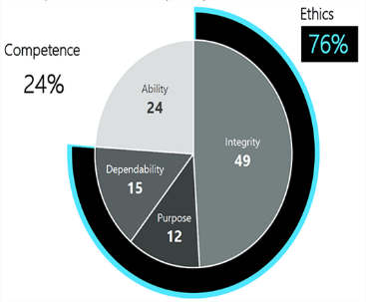
Appendix 1 Edelman (2023) Trust Barometer

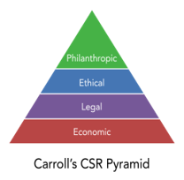Appendix 2
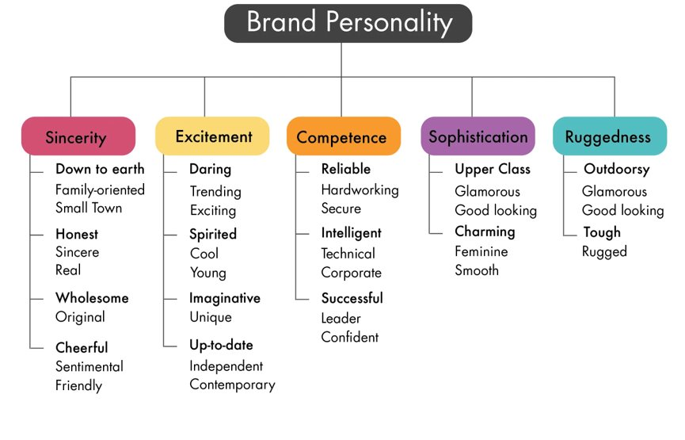Appendix 3
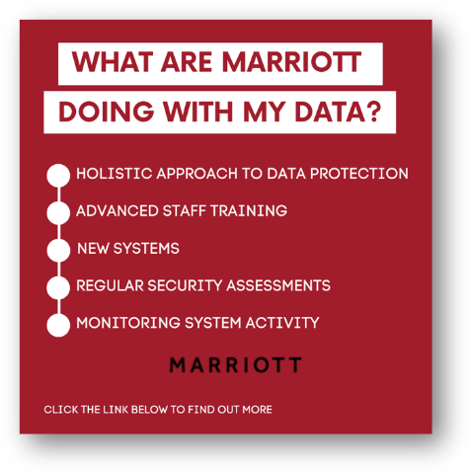 Appendix 4
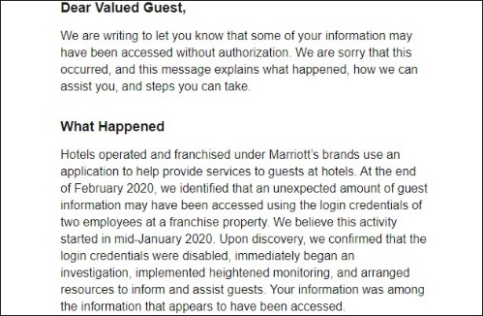Appendix 5
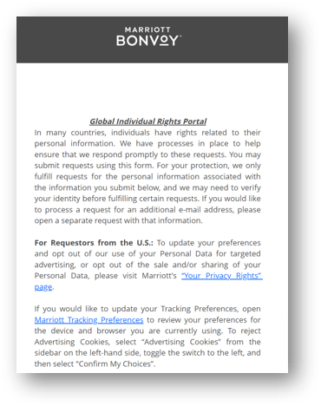Appendix 5
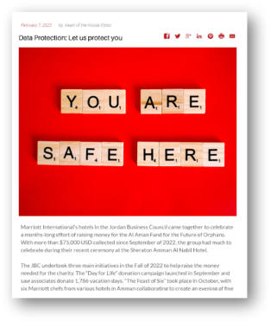Appendix 6
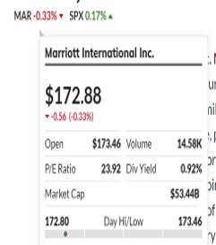 Appendix 7
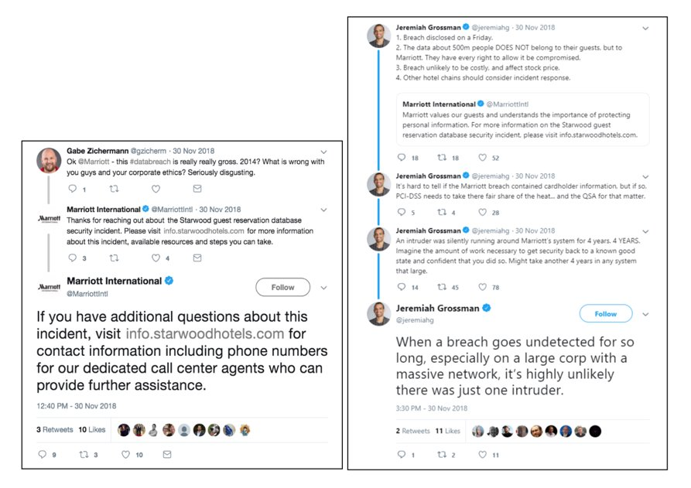Appendix 8
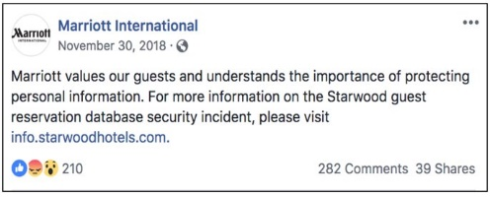Appendix 9
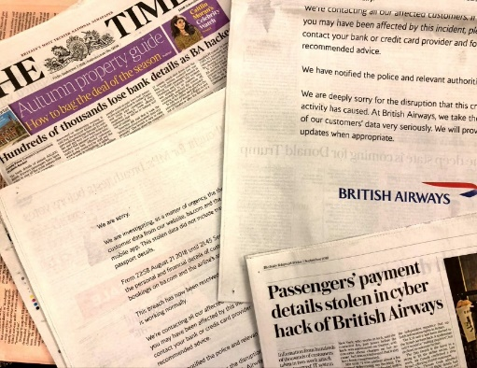Appendix 10
A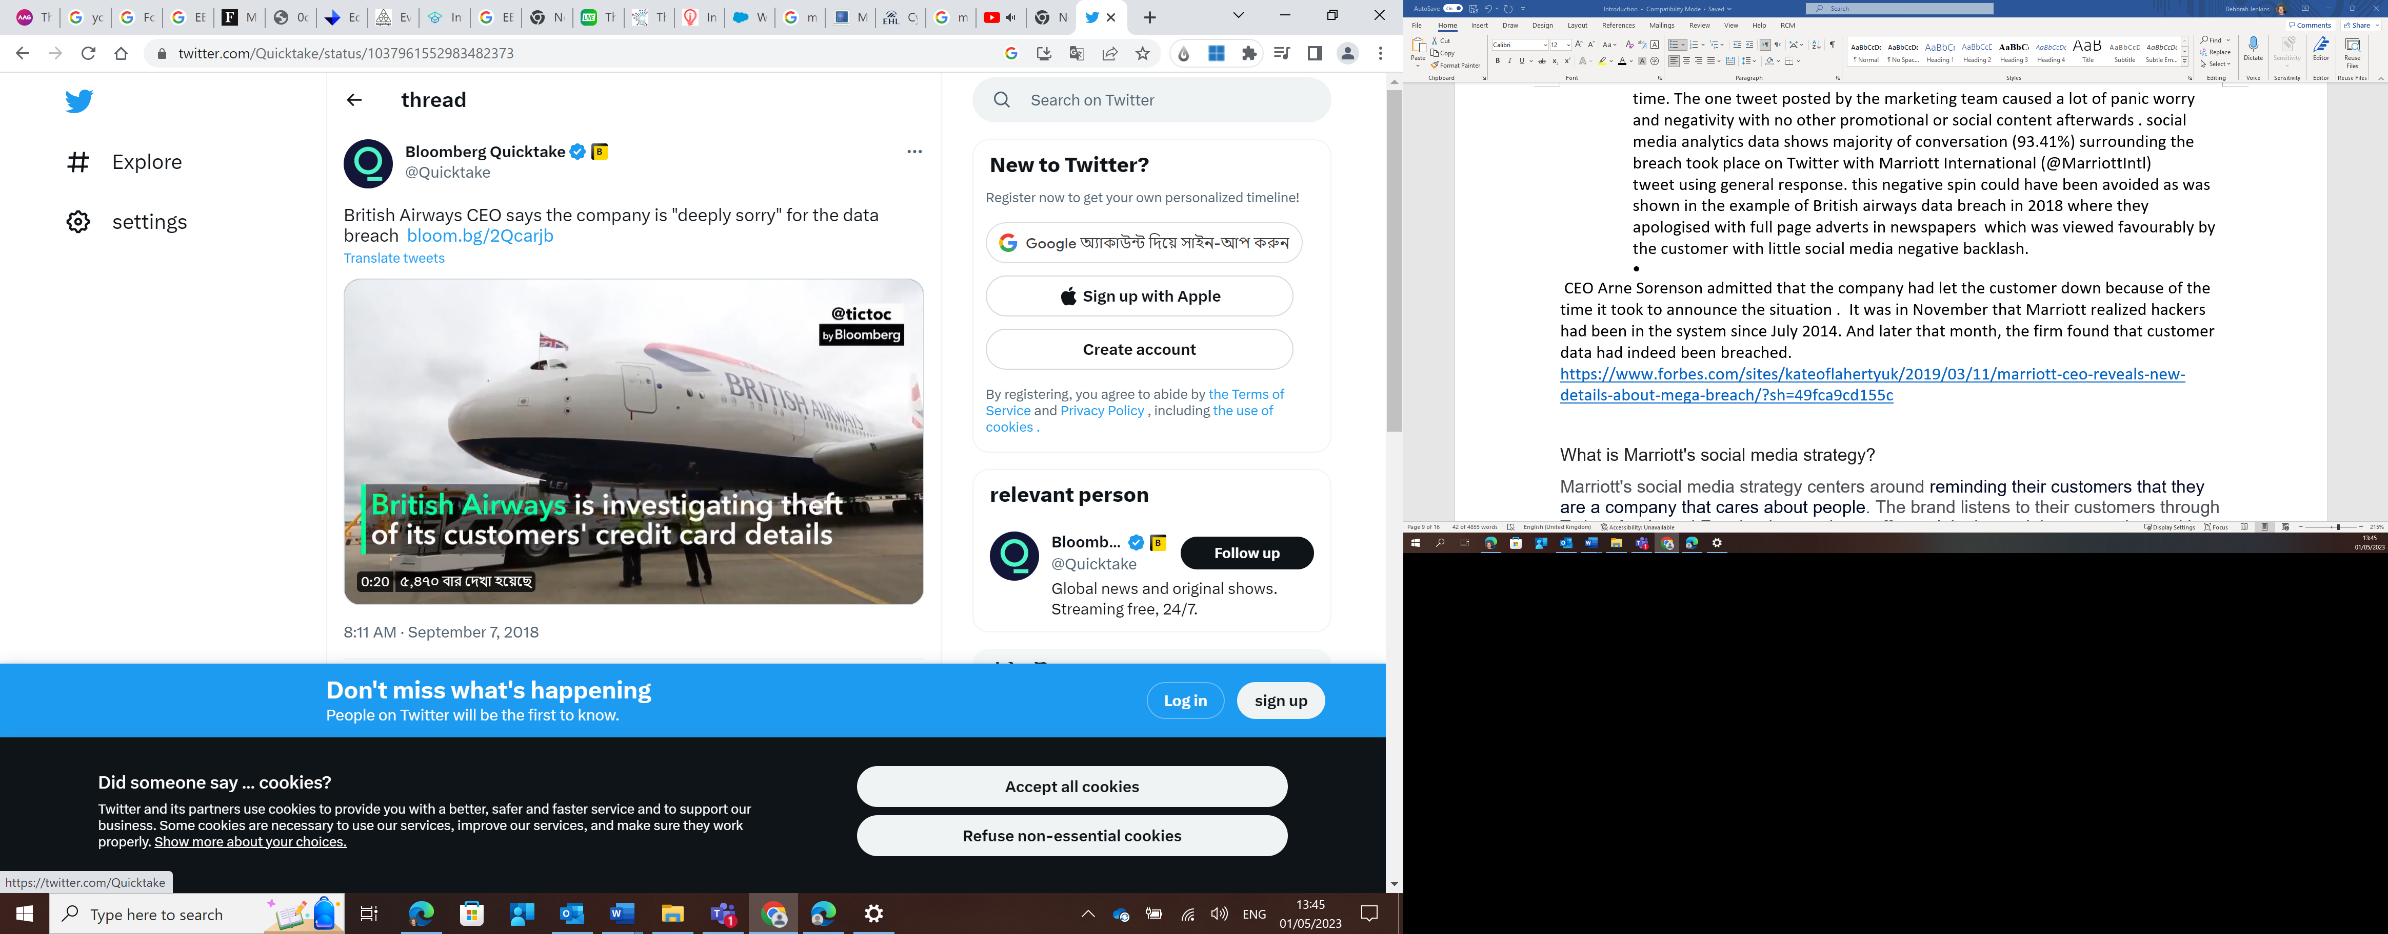Appendix 11
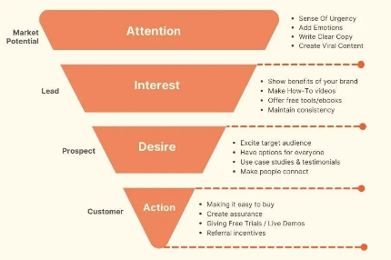Appendix 12
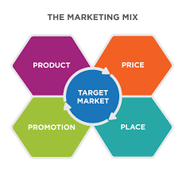Appendix 13
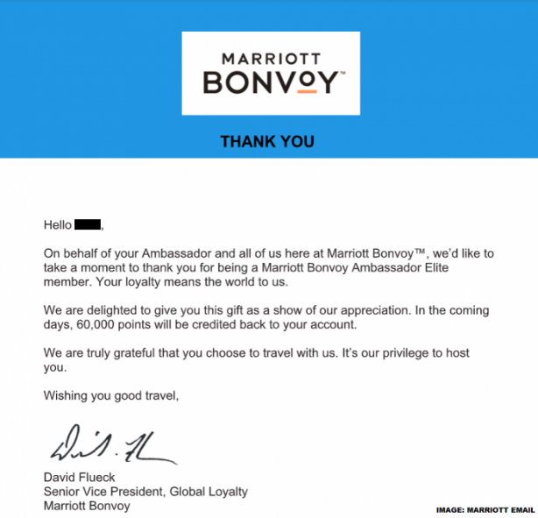 Appendix 14
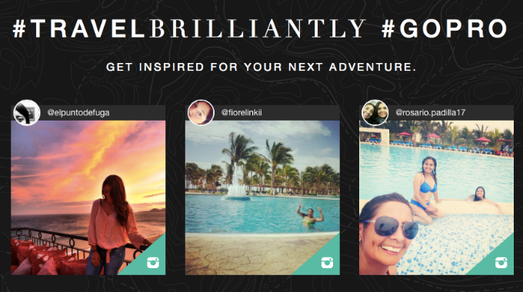 Appendix 15
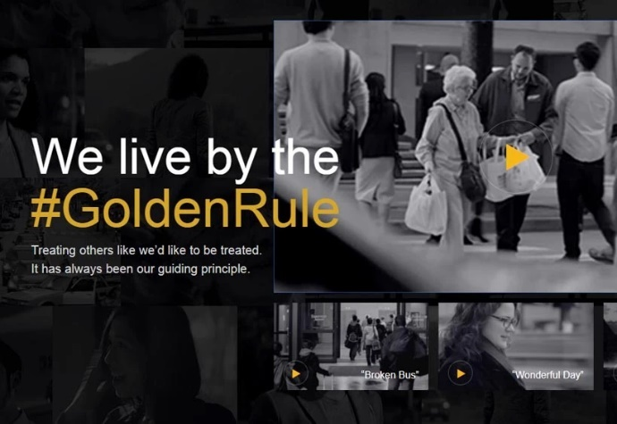 Appendix 16
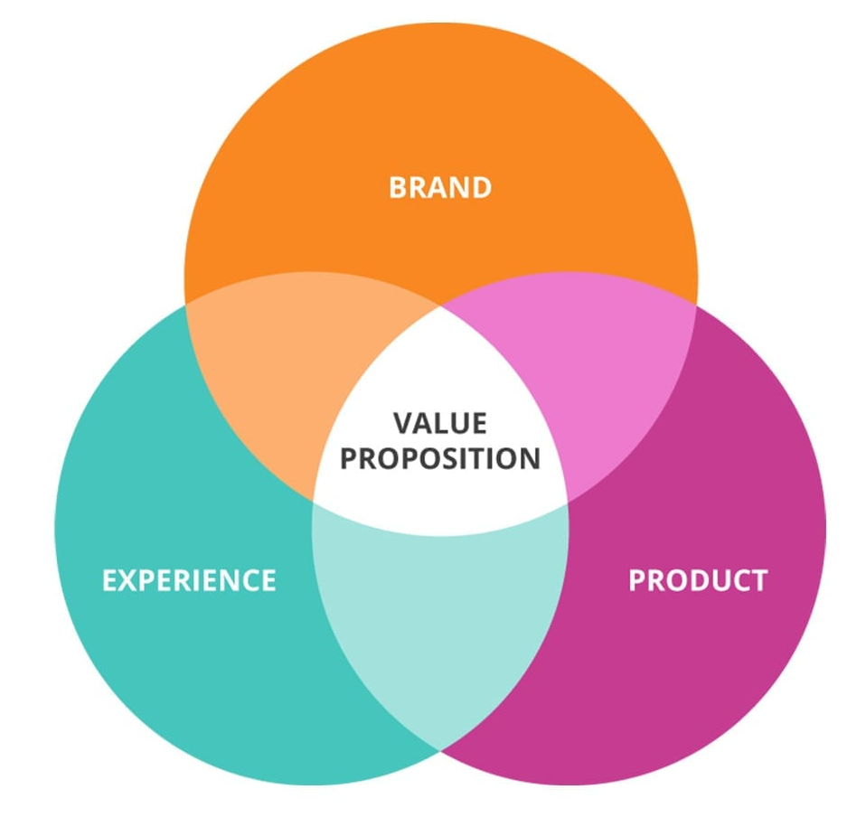Appendix 17
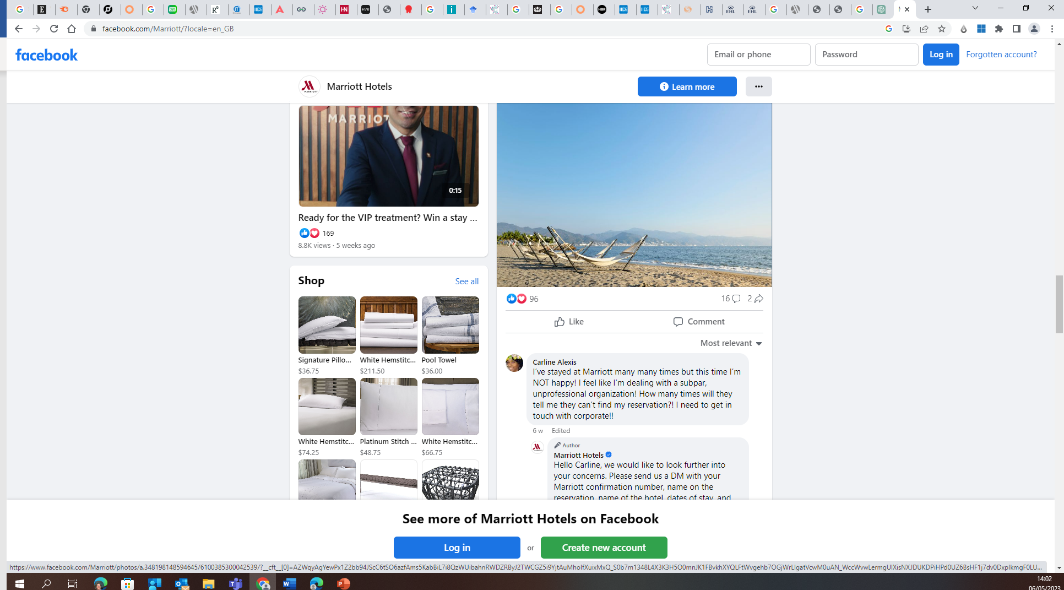 Appendix 18
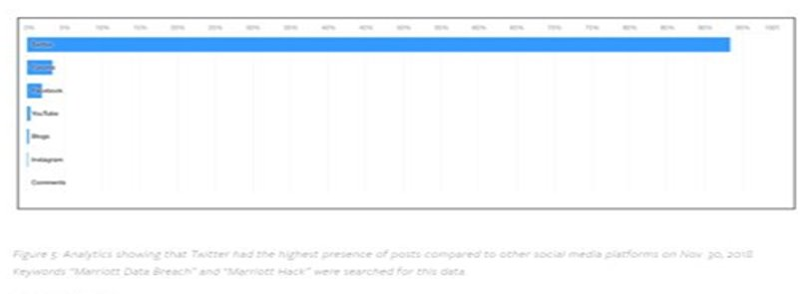Appendix 19
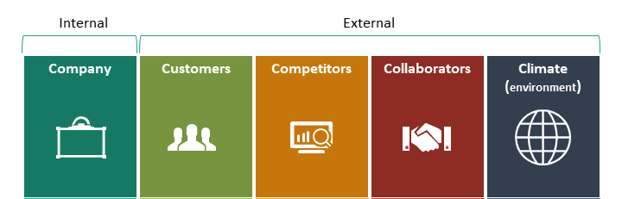Appendix 20
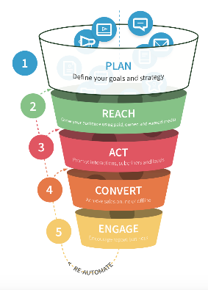Appendix 21
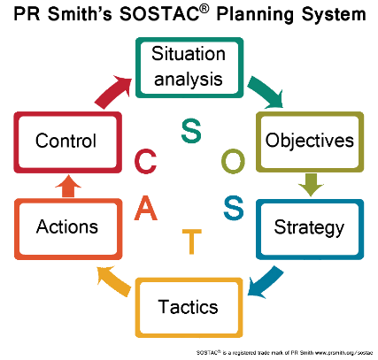 Appendix 22

