

Evaluating the importance of early intervention programmes regarding the prevention of crime- with a focus on their use in South Wales.

Caoimhe Alanna Darcy Ulyett
1800588

Dissertation submitted as part of the requirements for the award BSc (Hons) Policing and Criminology

University of Wales Trinity of St David
Module code: BMPS6012
Independent Study (Dissertation)

Impact of Covid-19
In light of the continuing impact of the global pandemic, it is important to include a statement at the start of my dissertation which outlines the effects that COVID-19 has had on the research that I have undertaken towards my undergraduate degree.

The University of Wales Trinity Saint David recognises that the COVID-19 pandemic, and consequent closures of our campus (18th March 2020) and national and international lockdowns, has directly or indirectly impacted the work of many of our undergraduate researchers. Although the campus had periods of re-opening in 2020 and 2021, some research will have been disrupted and some personal circumstances difficult to manage. Teaching was arranged via suitable meeting software and documents shared electronically. All research data collection was designed to utilise digital data collection.

The inclusion of this statement is to facilitate the reader’s awareness, both now and in the future, that the pandemic may have had an effect on the scope, direction and presentation of the research.

The academic standards and quality threshold for the award remains unchanged. I wish to reassure readers that this statement is not evidencing a lack of original research or quality.

Acknowledgments

I would like to offer my thanks to the staff at University of Wales Trinity St David for their continuous support during my time studying there.
I would also like to extend my thanks to each participant who volunteered to take part in this study, as your time and efforts are greatly appreciated.
I am grateful for the continuous support from my family and friends who have endlessly encouraged me to reach my full potential throughout my studies.

Abstract

The following study investigated whether early intervention programmes are resulting in positive outcomes and aimed to calculate their importance and value within society as well as within the criminal justice system in South Wales. The study comprised of both primary and secondary research and all participants voluntarily offered me invaluable information to help develop this study.

Table of Contents
1.0 Introduction 7
2.0 Literature Review 7
2.1. The need for ‘early intervention’ 7
2.2. Crime 8
2.3. Wales 9
2.4. Adverse Childhood Experiences (ACE’s) 11
2.5. Case Study 12
3. Research Methodology 13
3.1. Rationale 13
3.2. Research ‘Onion’: Research Approaches 14
3.3. Research Strategy 14
3.4. Ethical Considerations 15
3.5. Limitations of Research 16
3.6. Data Analysis 16
4. Analysis of Results- Findings 17
4.1. Data 17
4.2. General Public Questionnaire 17
4.2.1. Public Understanding of Early Intervention 17
4.2.2. Crime Prevention 18
4.2.3 Focus of early intervention 19
4.3. Expert Survey 20
4.3.1. When should we intervene? 20
4.3.2. What is the main purpose of early intervention? 21
4.3.3. Are these services used widely enough? 22
4.3.4 Crime Prevention 23
4.4. Expert interviews 24
Q.1. 25
Q.2. 25
Q.3. 26
Q.4. 26
Q.5. 26
Q.6. 27
Q.7. 27
5. Discussion and Recommendations 28
6. Conclusion 30
Reference List: 32
Appendices 39
Appendix A: General Public Survey 39
Appendix B- Expert Survey 41
Appendix C- Expert Interview Questions 43

Introduction

Parkin et al. (2019) describes early intervention as a public policy approach which has been introduced to identify individuals or families that are deemed to need support, to ultimately prevent problems occurring later in their lives, such as poor mental health, involvement in criminal and anti-social behaviour and a lack of involvement in education. Wilson et al. (2020) states that early intervention also focuses on targeting problems as they arise before they escalate to more extreme issues, such as serious criminal behaviour.

Literature Review

The purpose of this chapter is to review published academic literature regarding the use of early intervention programmes with the aim of preventing crime, this will complete the first objective of this dissertation.

2.1. The need for ‘early intervention’

Olds (2008) highlights that the early years of a child’s life is an opportune time to prevent unfavourable outcomes later in their life, especially a child’s development of criminal behaviour. The use of early intervention is not a revolutionary idea and has been developed considerably over time, the effectiveness and usefulness of early intervention programmes continue to be critically analysed by academics.
There are numerous types of early intervention programmes being developed and utilized. Farrington and Welsh (2006, P.3), two leading experts in the field of crime prevention, believe that “prevention is better than cure”, much like it is with medical issues and argue that national strategies for crime prevention should be developed and introduced. Farrington and Welsh (2006) attempt to define the term ‘early intervention’ by focusing on three defining features. The first defining feature includes measurements that are implemented in the very early years of a child’s life, or even prior to a child’s birth. Secondly, early intervention can be provided to whole communities to discourage delinquency before the acts are carried out. Lastly, early intervention can focus on preventing certain individual’s criminal potential, or by improving social conditions, such as poverty, that ultimately influence offending.
UK Government (2020) published Youth Justice statistics from the year April 2018 to March 2019 across England and Wales. It should be considered that children under the age of 10 cannot legally commit a crime due to the age of criminal responsibility in the UK, so these statistics only consider those persons aged 10 to 17. Though the publication proves there has been decreases in factors such as the number of children being cautioned or sentenced within the UK criminal justice system, these numbers are still considerably high, thus supporting the argument that there is a significant need for the use of early intervention programmes across the UK. Between April 2018 and March 2019, 21,700 children were cautioned or sentenced with a crime across England and Wales, and 38.4% of children and young people reoffended.

2.2. Crime

Reiss (1986) describes ‘crime’ as an event, or a sequence of events, that violate a criminal law. Arguably, to effectively prevent crime it is important to first understand the causes of it, who is committing the offences and on what scale it is occurring. Sutherland et al. (1992, P.3.8) defines the study of criminology as “a body of knowledge regarding crime and delinquency”, this could suggest that criminologists would be the most equipped to develop programmes that will prevent criminal behaviour by first identifying the factors that can influence criminality.
Ministry of Justice (2012) explain how crime rates are measured within the UK, it is stated that both police recorded crime and the British Crime Survey are both considered when calculating the levels of crime in England and Wales. Though it is evident that crime rates are continuously decreasing across England and Wales from previous years, it should be considered that the levels are still considerably high in comparison to other countries.
Ministry of Justice (2012) statistics identify that England and Wales have a crime rate that is considerably higher than average for the 42 Council of Europe countries, this highlights the need for increased crime prevention efforts, which can be delivered in the form of early intervention.
Farrington and Hawkins (1991) believe that identifying factors that contribute directly to the initiation of criminal behaviour can ultimately help to inform delinquency prevention efforts, thus then potentially resulting in reducing later offending.

2.3. Wales

The Welsh Government (2017) have emphasised their commitment to ensuring every child in Wales, regardless of the circumstances they were born into, gets the chance to achieve their full potential.
The Wellbeing of Future Generations Act (2015) and the Social Services and Wellbeing Act (2014) have placed responsibility on local authorities, and those in partnership with them, to develop concepts such as early intervention and prevention across the whole of Wales.
Bellis et al. (2015) developed a report which sought to identify how Adverse Childhood Experiences are affecting the lives of the Welsh adult population. The report states that 47% of all adults in Wales have experienced and suffered from at least one of the identified ACE’s during their childhood. Evidence, also provided by Bellis et al. (2015), proves that those persons who have experienced 4 or more adverse childhood experiences are 15 times more likely to have committed violence against another person and 20 times more likely to have been incarcerated in their lifetime, compared to those who have never suffered from any of these experiences.
Wales has several early intervention/prevention services in place, ‘children looked after’, ‘flying start’ and ‘families first’ are just some of the programmes being utilized.
Families First has been described as an innovation programme that emphasises the need for prevention and early intervention for families, mainly those families who are living in poverty, according to the Welsh Government (2011). Early intervention programmes such as Families First do not specify that they focus directly on preventing crime, however they focus on achieving objectives such as supporting low-income families to obtain a good level of education with the hopes of progressing towards secure employment.
Feinstein (2015) explains that initiatives in Wales such as Families First and Flying Start should have substantial long-term benefits, however Feinstein also recognizes that there is the potential of Welsh services not having all the financial benefits possible if it is not invested in correctly.
The Howard League for Penal Reform (2009) stated that most of the children in custody in Wales had extremely challenging behaviour, and that most of the young people share the history of chaotic family life, as well as experiencing neglect and abuse. One in three girls in custody had reportedly been victims of sexual abuse, and one in 20 boys also reportedly experienced this. 81% of boys and 76% of girls were said to have been excluded from school in the past and were not engaged with the education system. At the time of this publishment, there was said to be an average of 1 social worker to every 171 children in police custody, in some prisons it was said to be higher, at 1 social worker for every 200 children. Some prisons also reported not having any social workers.
BBC (2018) published that cuts to youth clubs and the growing problem of county lines are being blamed for the increasing level of knife crime within Wales, which is said to have increased by 25% over the period July 2017 to June 2018. The publication states that a teenager from Cardiff reported that she had seen children as young as 12 carrying knives. South Wales Police, which covers the Cardiff area, said to have seen the largest rise in knife crime, with an increase of 43%.

2.4. Adverse Childhood Experiences (ACE’s)

Academics often identify Adverse Childhood Experiences as a leading cause for troubled behaviour in young people. UK Government (2018) state that there is no universally agreed definition of adverse childhood experience, however many studies and academics have identified similar experiences such as the following:
- Verbal/ physical/ sexual abuse
- Physical/ emotional neglect
- Parental separation
- Mental illness within the household
- Domestic violence within the household
- Alcohol abuse within the household
- Drug abuse within the household
- Incarceration of a household member.
Wolff and Baglivio (2016, P.1) supports the theory that youths who have been exposed to “adverse parenting practices” are more likely to offend and reoffend throughout their lifetime than those who have not been exposed.

2.5. Case Study

Worldwide studies regarding the effectiveness of early intervention, as well as the general monitoring of these services have been carried out and analysed for many years. Dodge et.al (2015) carried out a trial to test the efficiency of early intervention to prevent psychopathology in adulthood and improving the well-being of children who are considered to have developed early conduct problems. The aim of the intervention was to focus on developing children’s social competence skills by focusing on social-skills training, parental behaviour-managing, peer coaching and reading tutoring. This study was carried out over a 10-year period and then reviewed when the participants were aged 25, in conclusion there were several positive outcomes of the early intervention they received, such as lower violent and drug related crime scores in comparison to those who did not take part in the intervention trial.
Evaluating case studies of previous early intervention trials can set a basis for identifying what works and what does not work in practice, though it should be considered that what works for one family/individual might not work for another, this highlights the need for flexibility.

3. Research Methodology

3.1. Rationale

The most appropriate approach for this research was combining both qualitative and quantitative research as this allows both written words and meanings to be explored in depth, as well as collecting data numerically, on a larger scale. Qualitative research aims to obtain deeper understanding of responses collected during research, as supported by Alharahsheh and Pius (2019).
Ryan (2018) identifies two common research paradigms that are used widely for both methods and analysis of research: positivism and interpretivism. Interpretivism can arguably be seen as less reliable as those participants in research have their own personal perceptions based on their experiences in life, thus meaning that their understanding of certain meanings for example, can alter from another person’s based off what they have experienced and how they socially interact with others. Ritchie and Lewis (2003) support Ryan’s interpretation of interpretivism, suggesting that opinions alter since there is not one shared reality.
Ryan (2018) explains positivism as a more reliable and scientific form of research as it removes all bias from individuals’ beliefs by focusing on what is scientific and information that can be proven.

3.2. Research ‘Onion’: Research Approaches
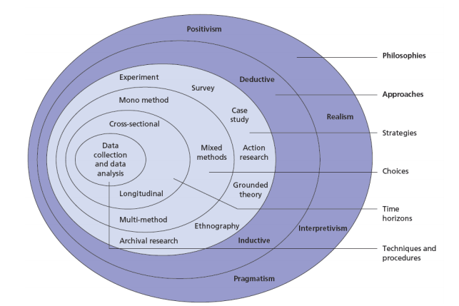
The Research ‘Onion’, developed by Saunders et. al (2009) consists of six main layers and supports researchers to organise research and develop research designs, according to Melnikovas (2018). The two main approaches identified are deductive and inductive, the inductive approach focuses on interviewing experts who have experience in the field. The deductive theory is referred to as the ‘testing theory’ by Saunders et al. (2009; P.124) and is said to be a development of theory that is then subject to rigorous testing. This study will focus on the use of the inductive approach to gather opinions from a large number of people, rather than a scientific study.

3.3. Research Strategy

Bolderston (2012) highlights how valuable interviews can be during research studies and identifies how they can be used for qualitative research. Interviews can be conducted either face-to-face or remotely, and to gather useful data it is important to choose suitable interviewees, develop useful interview questions and ensure ethical issues are considered and protected, such as their privacy.
The usefulness of interviews was taken into consideration during this research, and due to their crucial role in obtaining data they will be used to help complete this study. Participants of the expert interviews will be selected from professionals who have valuable experience working for or alongside early intervention programmes in South Wales. A short survey will also be developed and shared with professionals, this allows people to take part in this study quickly and anonymously, as it must be considered that not all people would agree to face-to-face interviews. For context, the word ‘expert’ refers to those people who have a high insight into specialist knowledge, a person who has the responsibility of implementing policies and persons who has privileged access to delicate information, as supported by Audenhove (2007).
In addition to the expert interviews there will be a survey for the public which will be shared on social media for all persons aged 18 of over to answer if they choose to. The survey will be developed with the intention of gathering public opinions regarding their knowledge of early intervention and crime, as well as understanding their personal opinions surrounding the use of early intervention programmes. Jones et al. (2013) states that questionnaires and surveys are incredibly useful as they allow researchers to assess large numbers of responses relatively easily.

3.4. Ethical Considerations

Prior to this study an Ethics Form was completed which identified ethical factors that needed to be considered throughout the study. Firstly, each participant in this study will be informed of their role in the research and have an acceptable knowledge of how their responses are being used. Each participant will be reassured that their responses are anonymous due to potential private information being shared, this allows for full participation without fear of embarrassment or being identified. Each participant will also be informed that they can withdraw their responses at any time and has no obligation to take part in this study.

3.5. Limitations of Research

The coronavirus pandemic has caused a significant limitation for research. National lockdown and social distancing measures have had an impact on those attempting to carry out primary research, as face-to-face meeting has been banned for some time. Due to the restrictions in place, interviews must be carried out online, over phone calls or on video calls, this process can lead to responses being delayed and it can be more difficult to gather participants willing to take part in research due to changes in schedules and the use of technology, such as waiting for responses over email.
Secondly, measuring the success of early interventions can be difficult as these programmes and trials are often monitored over a long period of time, rather than several months, which is the time limit on this research.

3.6. Data Analysis

To ensure all government guidelines are being adhered to, data for this study will be collected online using Google Forms for the surveys, and video calls over Microsoft Teams for the more in-depth expert interviews. Data will then be analysed both manually, by identifying key points in interviews, and will also be analysed through the Google Forms programme.

4. Analysis of Results- Findings

4.1. Data

A total of 75 people voluntarily took part in this study as respondents. 66 members of the public took part in the first survey that was shared across social media. 7 experts, who work for or alongside early intervention programmes responded to the second survey and 2 experts took part in a more in-depth interview. Respondents had the option to skip any question within the surveys or interviews if they so wished, this meaning that not every person answered every question.

4.2. General Public Questionnaire

4.2.1. Public Understanding of Early Intervention

A brief description of early intervention was given at the start of the survey provided to the public; however, it is important to understand how many of the respondents had prior knowledge, to gain an understanding of how early intervention is perceived and understood by members of society who do not have a professional link to early intervention programmes. 42 of the 66 (63.6%) respondents stated that they had some form of knowledge regarding early intervention before answering the survey, this forms a strong basis to start the research as it is important to identify how widely these early intervention services are used. Though 63.6% of the respondents had a previous understanding of what early intervention is, only 10 out of the 65 respondents who answered that question had experienced, or knew someone who had experience early intervention, thus potentially meaning only 15.4% of the respondents have a deeper, or personal understanding of how these systems work.
Graph 1:
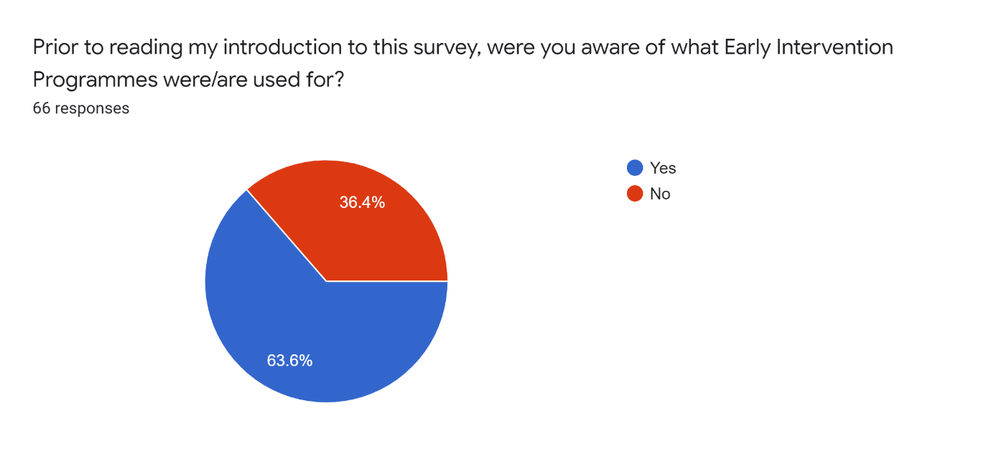

4.2.2. Crime Prevention

When the public were asked if they believe crime prevention is possible a large percentage of the respondents agreed that it was possible, and when asked what they believe the best ways to prevent crime are their most common answers include the following:
- Encouraging every child obtains a good level of education and providing extra support for those children who are disengaged with the education system.
- Reducing poverty, deal with societal imbalances.
- Support for external services such as schools, social services etc.
- Increased work/job opportunities.
- Improve relationships with the police force.
- Healthy parenting.
Many of the factors identified by the public correspond with the aims and objectives of many early intervention programmes and services, such as Families First, who aim to build relationships between services such as schools, healthcare services, housing services, police, and youth offending teams (Welsh Government, 2017). It is clear from these responses that the public have a general shared opinion about what works in society regarding crime prevention, and most people agree that with increased early intervention efforts, crime can be prevented.

4.2.3 Focus of early intervention

Many of the respondents stated that they believe early intervention programmes should focus most on protecting those people who are vulnerable in society. It is important to understand what the public want these programmes to focus on to ensue their needs are being adhered to. The least common response was the focus on supporting children from pre-birth to school ages, this suggests it is a common belief that early intervention should not be used that early in life but should target children when they are slightly older.
The second most common answer to this question was focusing on preventing anti-social behaviour and the ever-increasing chances of gang involvement. UK Government (2010) have developed safeguarding guidance for children and young people who may be affected by gang activity within England and Wales. It is stated that gang-prevention is a multi-agency issue, and that partnership working, and effective communication is vital in successfully preventing gang involvement.

Graph 2:
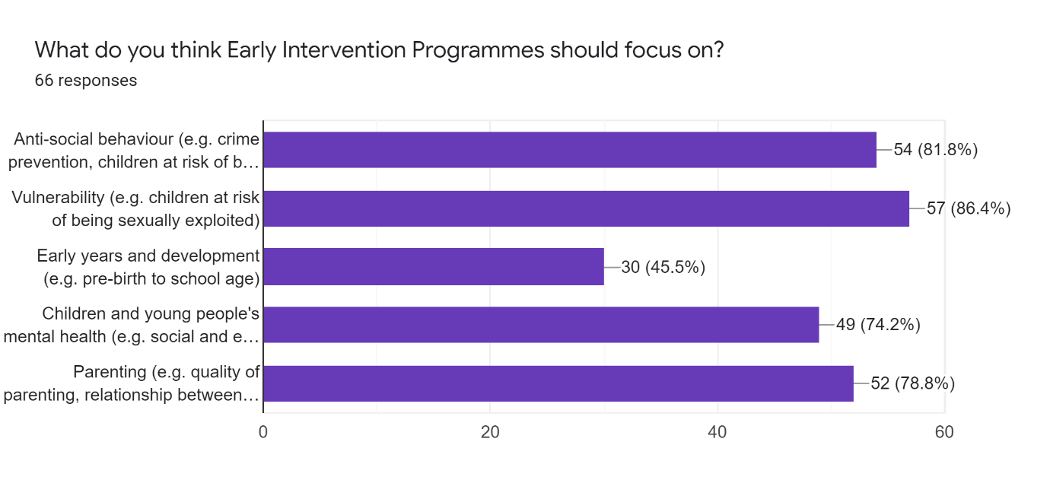

4.3. Expert Survey

The following results are from a survey that was developed for individuals whose profession interacts with early intervention programmes, youth justice or youth offending services within South Wales.

4.3.1. When should we intervene?

In comparison to the responses received by the public, there is a common theme that suggests it is not in the best interest to intervene in a young person’s life at an extremely young age. Though the responses are suggesting it is not best to intervene pre-birth or at a very young age, pre-birth involvement can protect unborn babies from possible future risks, Critchely (2018) argues that pre-birth work is under-researched and under-theorised but can play a vital role in encouraging positive outcomes when implemented effectively.
Graph 3:
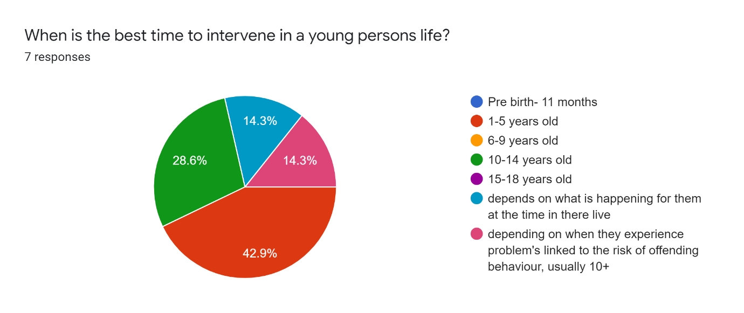

4.3.2. What is the main purpose of early intervention?

Understanding the intentions of staff who work for, or in partnership with early intervention programmes is incredibly important as these are the people who are delivering the services to the public.
Keeping families and individuals out of the criminal justice system, as well as offering these people opportunities to develop were identified by the experts to be the most important purpose of early intervention programmes.
Graph 4: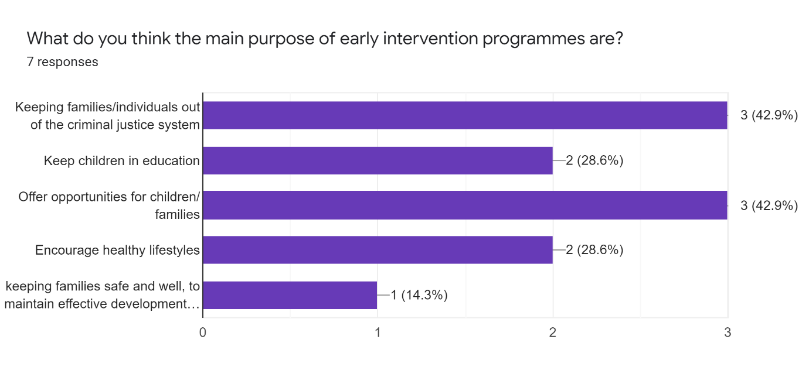

4.3.3. Are these services used widely enough?

6 out of 7 people agreed that early intervention programmes and services are not being used widely enough across South Wales, the reasons for this are as following:
- “There are different types of interventions - maybe sometimes the whole ‘menu’ of opportunities isn’t on offer so families don’t always have access to things that would benefit them eg youth work support”
- “More targeted but some families on the cusp need support too but slip through the net”.
- “I don't think they are used widely enough as people don't know what's out there for them.”
- “Conversely, there are a cohort of families who fall under the radar due to them not knowing support networks”.
- “Due to funding of services, lack of resources, resistance by families, Covid pandemic, lack of suitable education provision outside of school setting for young people.”
- “It’s always too little too late.”
- “Intervention is more reactive than proactive. Usually due to lack of funding and resources.”
Graph 5: 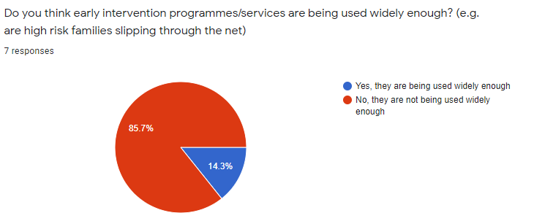

4.3.4 Crime Prevention

6 out of the 7 respondents stated that they do not believe enough is being done to prevent crime, and when asked what else could be implemented to help prevent crime, their responses are as follows:
- “Investment in youth work services”
- “Youth worker being involved to offer support, and bridging the gap with policing”.
- “Whilst the young people are in school, they should be taught the outcome of crime is.”
- “I feel lack of funding for community projects/youth projects leaves limitations to constructive use of time in some areas.”
- “Earlier intervention by taking a multi-agency approach, this happens now but can always be improved/strengthened. very comes down to people and how we work together as services to improve outcomes for the child/young person and prevent offending /and or re-offending ask children and young people in their communities what they want.”
- “Getting to the root of the individuals’ problems and helping in that way.”
- “Focus on consequences for perpetrators and victims”.
Graph 6: 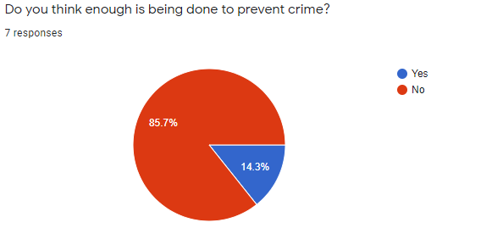

4.4. Expert interviews

The experts who took part in this section of the study have experience working in Cardiff, Aberystwyth, and Carmarthen. Their several years of experience within the field of early intervention means the following information they have provided me with is vital in evaluating the efficiency of early intervention programmes in South Wales.
Both interviewees were asked the same questions but had the opportunity to expand on any answer and provide details that they wished to share. Though there were several similarities between their responses, there are distinct differences between some of their opinions and experiences.
For reference, the first person interviewed, who worked within the Cardiff area will be referred to as ‘Interviewee A’. ‘Interviewee B’ will be used to refer to the second person interviewed who had experience working within Aberystwyth and Carmarthen.
Q.1. What do you think the main purpose of early intervention programmes are?
Interviewee A believes that the main purpose of early intervention is to divert people away from the criminal justice system, whereas interviewee B believes the main purpose should be engaging individuals and families and then building on their education and getting them involved in employment opportunities. Interviewee B also emphasised that the safety and well-being of individuals and families should be prioritised first are foremost.
Q.2. Do you think these services are used widely enough? (Are high risk families/individuals slipping through the net?)
Interviewee A identified that early intervention programmes are far more widely publicised than they used to be, this making them more accessible. Interviewee A also states that there is a focus on multi-agency work in the hope that referrals can be identified and dealt with efficiently, however they did also state that it is common for individuals/families to “miss out”. Interviewee B was confident that the current services being offered are excellent, and that it is often more difficult to get people to engage with the services rather than it being difficult to offer them the service. Interviewee B states that as a member of staff working for these services, they often experienced an underlying fear that funding for these services could be cut by the Welsh Government at any point and that there was a fear of losing these benefits since these are not always statutory services.

Q.3. When do you think it is the best time to intervene in someone’s life? Have you found from personal experience that it is better to do this younger or slightly older?
When asked about the best age to intervene in a child’s life, interviewee A believes that the best time to intervene is between the ages of 10 and 18 but states that it can often happen too late after referrals from police for example. Interviewee B stated that the best time to intervene is between the ages of 11 and 13 as children’s bodies and minds are changing and developing, the interviewee suggests that after the age of 13 children can start to form bad habits as they are interacting with different types of people, in school for example.
Q.4. Do you think there can be negative effects of targeting families/individuals? (e.g., Creating stigmas)
Regarding the negative effects of early intervention, Interviewee A states that the services they work for are voluntary, therefore they do not believe that there can be negative effects such as creating a stigma for the family/individual as they are choosing to use the service and have the right to withdraw from it at any point, which is said to happen regularly.
In opposition, Interviewee B states that there can be negative effects of targeting individuals and families, and often these people do not trust the service providers and staff. Interviewee B suggests there is a serious need to find similarities with these individuals to build trust and form a relationship.
Q.5. How would you measure the success of these early intervention programmes? Do you think it is hard to do?

Measuring success is a difficult process due to personal opinions, Interviewee A simply measures the success of the programmes by identifying if the individual/family leaves the programme in a better state than when they arrived, but also identifies success by measuring how likely these people are to re-offend, if the risk is lower then the programme has been successful.
Interviewee B states that regarding youth justice, they measure success by the young person not re-offending and going on to be successful in education/work. Regarding youth offending and prevention services, success was measured by the young person not offending at all and keeping them engaged in education, so they gain qualifications.
Q.6. How often do you experience success in intervention?

Interviewee A states that those who continue to use the services do engage most of the time, however there will never be a 100% success rate. Interviewee B states that the majority of those involved experience some sort of success, however states that it is too hard to measure success fully. Interviewee B suggests that the greatest success of these programmes is when it results in the young person engaging and not getting involved in criminal activity, though success could also be considered as these people gaining their basic GCSE qualifications for example.
Q.7. Do you think enough is being done to prevent crime?

When asked if they believe enough is being done to prevent crime both interviewees agreed strongly that there was there was a lot of room for improvement regarding crime prevention efforts.
Interviewee A identified the issue of an ever-changing society, in which the threats of crime are always changing. In the modern-day society, risks such as asylum-seeking children and the increased number of children coming out of care are all factors that influence the crime rates, and Interviewee A believes that children are becoming more at risk as time goes on. Interviewee A states that there is a serious need for more of a focus co-ordinated response within the early intervention programmes and partnering services, the interviewee provided the example of the Violence Prevention Service not using their funding efficiently.
Interviewee B also agrees that the face of crime is changing, with gang culture and county lines becoming an increasing threat within South Wales. Interviewee B highlights the need to support parents and families to encourage healthy relationships and lifestyles. Providing better services for young people, such as services for leisure time (youth clubs) and placing more youth workers within schools will arguably help to prevent crime according to Interviewee B.

5. Discussion and Recommendations

It is evident from both primary and secondary research that there is a need for early intervention to be implemented in society and to be continuously monitored and developed to fit the changing face of crime.
Crime within the UK is a significant problem, and it is evident that there is a major concern for the safety of children within South Wales since crime is changing and becoming more serious over time. There is a clear need for early intervention services, as well as partnering services, to be more well-equipped to deal with the threats that children are facing. To ensure these services can provide the best support there should be a safety-net to ensure they are receiving adequate funding from the Welsh Government, and it could also be considered that these services should become ‘statutory services’ to protect them from serious budget cuts in the future.
Though the topic of parenting can be considered extremely personal it should be considered that more should be done to ensure children are getting a greater level of support from their families, focusing, and developing the use of pre-birth intervention could be considered as a potential mechanism in dealing with this problem. Research suggests that Adverse Childhood Experiences are often a leading factor in criminal behaviour, so great importance should be placed on ensuring children are not suffering from these experiences in their early years of life.
Both primary and secondary research proves how widely these programmes are used, with interviewees stating that the programmes are usually at full capacity. The possibility of increasing funding and offering more services should be considered, but arguably this is not always prioritised within South Wales.
Though evidence proves Early Intervention can have several positive outcomes, it should also be considered that there is a wide-spread belief that it can also cause negative effects. Expert opinions suggest that it can often create a stigma and prejudice within society, it could be recommended that there is a need for reform of society, for example, if members of society are not willing to invest and prioritise vulnerable people it can be difficult to make long-term positive changes. Interviewee A supports this argument as they believe it is “everyone’s responsibility” to be preventing crime and encouraging healthy lifestyles, not just the work of these services.
Altering the education system to ensure young people are more informed about the effects of ACE’s and potential consequences of their criminal behaviour can potentially help to prevent young people’s involvement in crime.
Expert opinions should be considered when suggesting recommendations, some suggestions provided by the respondents of the expert survey state that:
- Programmes should “use strength-based approaches, suitable to the needs of the child /family, services adopting a more inclusive approach, empowering parents to adopt skills needed to address the issues themselves.”
- Programmes should “better diversionary opportunities in our most deprived communities, and actually ask children and young people what they wish for/want in their local communities. what would work for them that is realistic and achievable e.g could be just free wifi hotspot access”.
- Programmes should “highlight consequences with hard hitting reality.”
- “Interventions need to be put in place sooner, there needs to be somewhere that they feel that they can go to or a person that they can speak to in confidence.”

6. Conclusion

To conclude, evidence strongly suggests that Early Intervention can result in positive outcomes and can benefit the criminal justice system greatly if implemented correctly. Staff who work for these services are very confident that their efforts are having long-lasting positive outcomes for young people but do recognise the need for services to continuously develop.
Evidence also suggests that crime rates within England and Wales and continuously decreasing which implies that crime prevention efforts are becoming more successful.

Reference List:

Alharahsheh, H. Pius, A. (2019). ‘A Review of key paradigms: positivism VS interpretivism’. P.40. Available at: file:///C:/Users/Home/Downloads/GAJHSS_23_39-43.pdf (Accessed: 21 April 2021).

Audenhove, L. (2007). ‘Expert Interviews and Interview Techniques for Policy Analysis.’ P.6. Available at: https://www.ies.be/files/060313%20Interviews_VanAudenhove.pdf (Accessed: 5 May 2021).

BBC. (2018). ‘County lines and youth cuts blamed as knife crime rises’. Available at: https://www.bbc.co.uk/news/uk-wales-46359798 (Accessed: 5 May 2021).

Bellis, M. Ashton, K. Hughes, K. Ford, K. Bishop, J. Paranjothy, S. (2015). ‘Welsh Adverse Childhood Experiences (ACE) Study’. Public Health Wales. P.2-5. Available at: http://www2.nphs.wales.nhs.uk:8080/PRIDDocs.nsf/7c21215d6d0c613e80256f490030c05a/d488a3852491bc1d80257f370038919e/$FILE/ACE%20Report%20FINAL%20(E).pdf (Accessed: 23 April 2021).

Bolderston, A. (2012). ‘Conducting a Research Interview’. Journal of Medical Imaging and Radiation Sciences. Edition 43. Available at: https://www.jmirs.org/article/S1939-8654(11)00132-9/pdf (Accessed: 23 April 2021).
Critchley, A. (2018). ‘Pre-birth child protection’. Iriss. Available at: https://www.iriss.org.uk/resources/insights/pre-birth-child-protection (Accessed: 3 May 2021).

Dodge, K. Bierman, K. Coie, G. Greenberg, M. Lochman, J.McMahon, R. Pinderhughes, E. (2015). ‘Impact of Early Intervention on Psychopathology, Crime, and Well-Being at Age 25’. P.1. American Journal of Psychiatry. Vol.172 Iss.1. Available at: file:///C:/Users/Home/Downloads/appi.ajp.2014.13060786.pdf (Accessed: 3 May 2021).

Farrington, D, P. Welsh, B, C. (2006). ‘Saving Children from a Life of Crime: Early Risk Factors and Effective Interventions’. Oxford University Press. P.7. Available at: file:///C:/Users/Home/Downloads/Saving%20Children%20from%20a%20Life%20of%20Crime%20Early%20Risk%20Factors%20and%20Effective%20Interventions%20(Studies%20in%20Crime%20and%20Public%20Policy)%20by%20David%20P.%20Farrington,%20Brandon%20C.%20Welsh%20(z-lib.org).pdf (Accessed: 26 January 2021).

Farrington, D. Hawkins, J. (1991). P.2. ‘Predicting participation, early onset and later persistence in officially recorded offending’. Criminal Behaviour and Mental Health. Vol.1. Available at: file:///C:/Users/Home/Downloads/cbm.1991.1.1.1.pdf (Accessed: 23 April 2021).

Feinstein, L. (2015). ‘Quantifying the Benefits of Early Intervention in Wales: a Feasibility Study’. Public Policy Institute for Wales. Available at: http://ppiw.org.uk/files/2014/10/PPIW-Report-Quantifying-the-benefits-of-early-intervention.pdf (Accessed: 3 May 2021).

Jones, T. Baxter, M. Khanduja, V. (2013). ‘A quick guide to survey research’. Ann R Coll Surg Engl. Edition: 95(1). Available at: https://www.ncbi.nlm.nih.gov/pmc/articles/PMC3964639/ (Accessed: 2 May 2021).

Melnikovas, A. (2018). ‘Towards an Explicit Research Methodology: Adapting Research Onion Model for Futures Studies’.P.33. Journal of Future Studies. Edition 23(2). Available at: https://jfsdigital.org/wp-content/uploads/2019/01/03-Melnikovas-Onion-Research-Model.pdf (Accessed: 23 April 2021).

Ministry of Justice. (2012). ‘Comparing international criminal justice systems.’ P.14. Available at: https://www.nao.org.uk/wp-content/uploads/2012/03/NAO_Briefing_Comparing_International_Criminal_Justice.pdf (Accessed: 21 April 2021).

Olds, D, L. (2008). ‘Preventing Child Maltreatment and Crime with Prenatal and Infancy Support of Parents: The Nurse Family Partnership’. Journal of Scandinavian Studies in Criminology and Crime Prevention. Vol.12. Iss.9. Available at: https://booksc.org/book/42471529/879c1e (Accessed: 26 January 2021).

Parkin, E. O’Donnell, M. Bolton, P. Long, R. Barber, S. Kennedy, S. Jarrett, T, Powell, T. (2019). ‘Early Intervention’. UK Parliament. Available at: https://commonslibrary.parliament.uk/research-briefings/cbp-7647/ (Accessed: 17 April 2021).

Riess, A, J. (1986). ‘Why Are Communities Important in Understanding Crime’. Vol.8. P1. Available at: file:///C:/Users/Home/Downloads/1147423.pdf (Accessed: 26 January 2021).

Ritchie J, Lewis J. (2003) ‘Qualitative Research Practice: A Guide for Social Science Students and Researchers’. Sage Publications, London. Edition 2.
Ryan, G. (2018). ‘Introduction to positivism, interpretivism and critical theory’. Nurse Researcher, 25(4) p. 14-17. Available at: http://oro.open.ac.uk/49591/ (Accessed: 21 April 2021).

Saunders, M. Lewis, P. Thornhill, A. (2009). ‘Research Methods for Business Students’. P.108. Fifth Edition. Pearson Education Limited. Available at: file:///C:/Users/Home/Downloads/Research%20methods%20for%20business%20students%20by%20Mark%20Saunders%20Philip%20Lewis%20Adrian%20Thornhill%20(z-lib.org).pdf (Accessed: 23 April 2021).
Social Services and Well-being (Wales) Act 2014. Available at: https://www.legislation.gov.uk/anaw/2014/4/contents (Accessed: 23 April 2021).

Sutherland, E, H. Cressey, D, R. Luckenbill, D, F. (1992, P.3). ‘Principles of Criminology’. Eleventh Edition. Rowman & Littlefield. Available at: https://books.google.co.uk/books?hl=en&lr=&id=JVB3AAAAQBAJ&oi=fnd&pg=PP1&dq=study+of+criminology&ots=mOImpcIMG4&sig=tylmnzJbh3-VVdUTYAYWDDFhrAQ&redir_esc=y#v=onepage&q&f=false (Accessed: 26 January 2021).

The Howard League for Penal Reform. (2009). ‘Youth Justice in Wales: Thinking beyond the prison bars’. P.5. Available at: file:///C:/Users/Home/Downloads/Youth-justice-in-wales-thinking-beyond-the-prison-bars%20(1).pdf (Accessed: 5 May 2021).

UK Government (2018). ‘The evidence behind early intervention’. Available at: https://publications.parliament.uk/pa/cm201719/cmselect/cmsctech/506/50605.htm (Accessed 20 April 2021).
UK Government. (2010). ‘Safeguarding children and young people who may be affected by gang activity’. P.1. Available at: https://assets.publishing.service.gov.uk/government/uploads/system/uploads/attachment_data/file/189392/DCSF-00064-2010.pdf.pdf (Accessed: 3 May 2021).

UK Government. (2020). ‘Youth Justice Statistics 2018/19’. P.2. Available at: https://assets.publishing.service.gov.uk/government/uploads/system/uploads/attachment_data/file/862078/youth-justice-statistics-bulletin-march-2019.pdf (Accessed: 17 April 2021).
Well-being of Future Generations (Wales) Act 2015. Available at: https://www.legislation.gov.uk/anaw/2015/2/contents/enacted (Accessed: 23 April 2021).

Welsh Government (2017). ‘Families first: Programme Guidance’. P.1. Available at: https://gov.wales/sites/default/files/publications/2019-07/families-first-guidance-for-local-authorities_0.pdf (Accessed: 23 April 2021).

Welsh Government. (2011). ‘Families First: Programme Guidance’. P.3. Available at: https://core.ac.uk/download/pdf/4159682.pdf (Accessed: 23 April 2021).

Welsh Government. (2017). ‘Families First’. P.6. Available at: https://gov.wales/sites/default/files/publications/2019-07/families-first-guidance-for-local-authorities_0.pdf (Accessed: 3 May 2021).

Wilson, H. Asmussen, K. McBride, T. (2020). ‘Developing a good theory of change’. Early Intervention Foundation. Available at: https://www.eif.org.uk/resource/developing-a-good-theory-of-change (Accessed 21 April 2021).

Wolff, K. Baglivio, M. (2016). P.1. ‘Adverse Childhood Experiences, Negative Emotionality, and Pathways to Juvenile Recidivism’. Crime and Delinquency. Available at: file:///C:/Users/Home/Downloads/0011128715627469%20(1).pdf (Accessed: 21 April 2021).

Appendices

Appendix A: General Public Survey
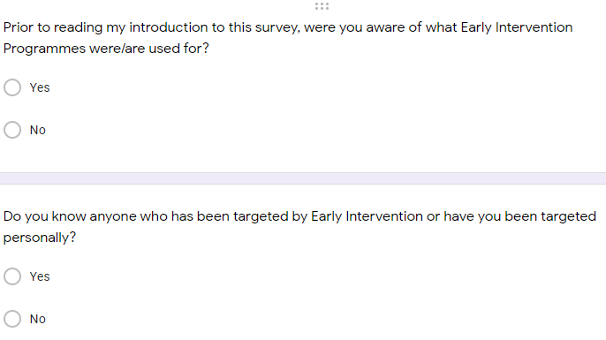
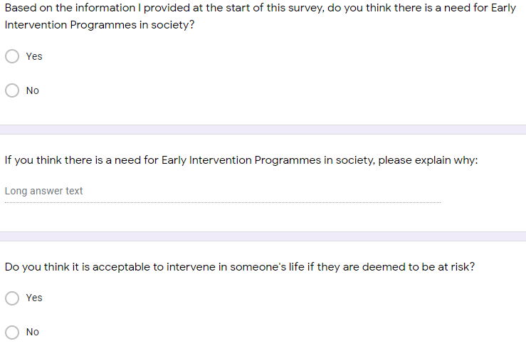
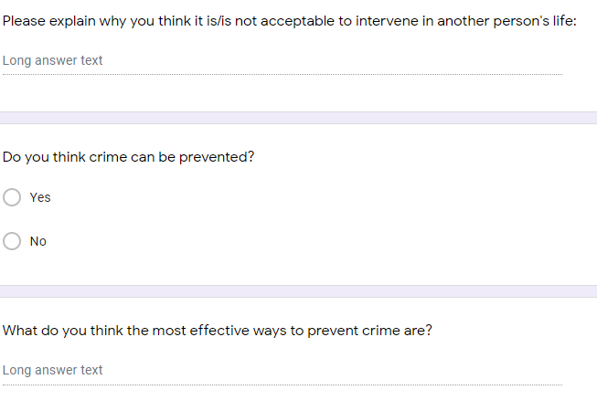
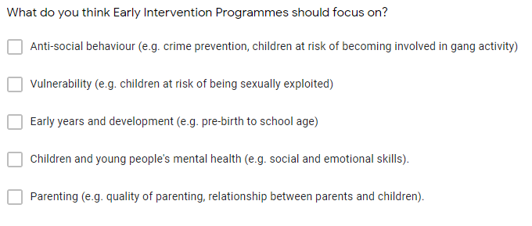

Appendix B- Expert Survey
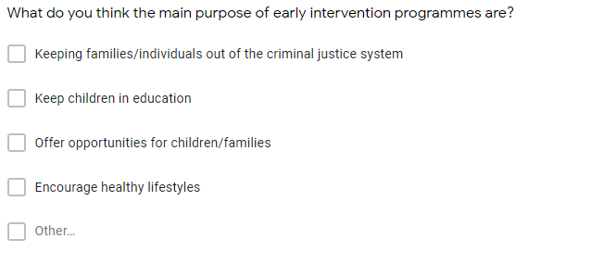
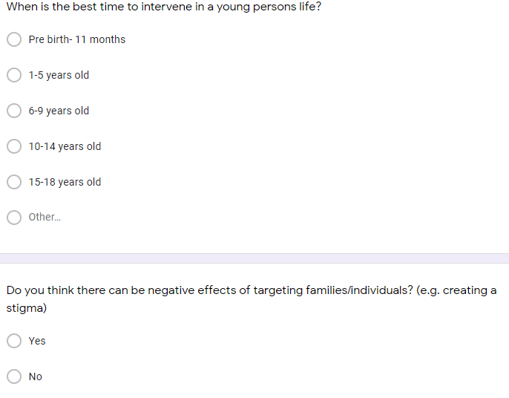
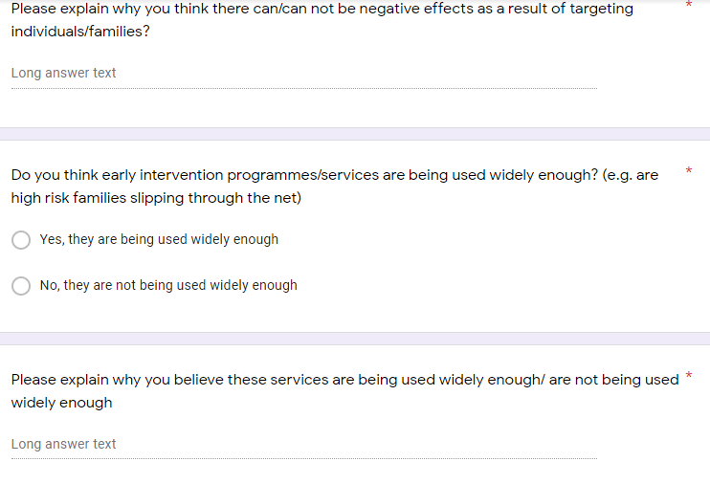
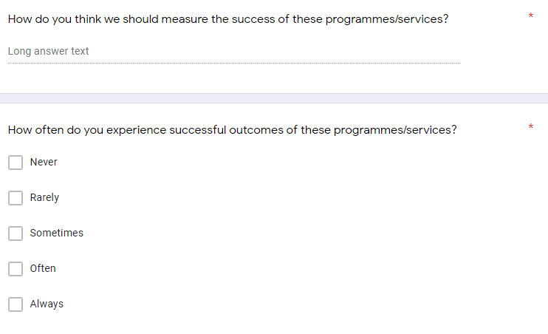
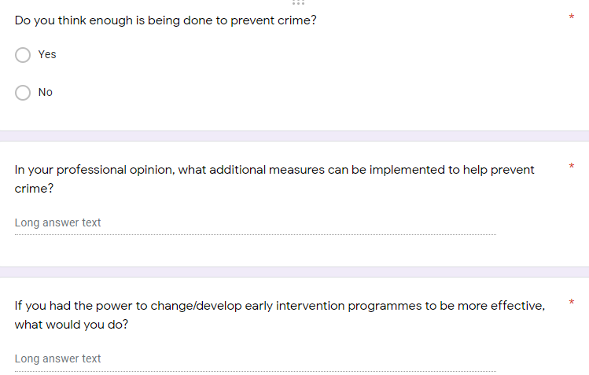

Appendix C- Expert Interview Questions

- What do you think the main purpose of early intervention programmes are?
- Do you think these services are used widely enough? (Are high risk families/individuals slipping through the net?)
- When do you think it is the best time to intervene in someone’s life? Have you found from personal experience that it is better to do this younger or slightly older?
- Do you think there can be negative effects of targeting families/individuals? (e.g., Creating stigmas)
- How would you measure the success of these early intervention programmes? Do you think it is hard to do?
- How often do you experience success in intervention?
- Do you think enough is being done to prevent crime?
- If you had the power to change/develop early intervention programmes to be more effective, what would you do?

