Robert McIntyre
P149064
Software Engineering Principals
Group Software Development
Gordon Dickers

Team Members
Jonathan Evans
Naomi Jones
Introduction
Contents
Introduction 3
Here are the colour codes 3
Key stakeholders identified 3
Team members/structure and responsibilities 3
Functional and Non Function Requirements 4
Use cases derived from scenario 6
Identified requirements for 1st iteration 10
Plan for requirements for 2nd iteration 10
Legislation and related ethical and sustainability issues. 10
Static Design 11
Class design (UML) 11
Collaboration and Responsibilities 12
Dynamic Design 14
Sequence Diagrams – UML 14
User Interface Design Prototypes 15
Code Implementation (1st Iteration) 17
Testing 17
Version Control 17
Individual contribution and team working discussion 17
Design to Requirements matrix 18
References 20
Appendices 20
Meeting 1/11/17 22
Roadmap 23
Preparation 23
Initiation 23
Design 23
Development 23
Testing 23
Documentation 24

Introduction
The document is how the project designs the mobile application for the

Here are the colour codes
Purple  Jonathan | Blue  Robbie | Red  Naomi | Black  Anything in black is work done together on one computer. Also, in black are the unanimous decisions made after our discussions.  There were many tasks that were hard to divide, such as class diagrams (We needed to know how the classes relate to one another). These were done together.

Key stakeholders identified
There are two stakeholders who are Gordon Dickers and Andrew Baker who commissioned making the application. Other stakeholders would be the heritage sites that are included in the app and their customers.
- Client
  - Andrew Baker
  - Gordon Dickers
- Organisations
  - Heritage sites (Museums, Historic monuments and Walks.)
  - University
- Customer
  - Tourists
- Developers
  - Robbie
  - Jonathan
  - Naomi

Team members/structure and responsibilities
There was equal status between all of us. We had shared roles.
Developers
- Jonathan Evans
- Robbie McIntyre
- Naomi Jones
In the group work, was divided at every stage. During the meeting we all discussed what work had been done and the work going forward. Planning the project consisted of having regular meetings to discuss and plan each stage.

Functional and Non-Function Requirements
The system was designed in one of the group meetings where we each designed our own system requirements. The following week we all then discussed what the system should have.
The system requirements below were agreed in our group meeting. Each of us brought to the meeting a list of system requirements which was then discussed to produce a final version that we all agreed on.
System Requirements
MUST
Allow a staff user to input information about a location
- Basic layout of the location (Floor plan of a museum/cathedral, etc.)
  - Identify and catalogue places of interest within a location
- Artefacts/items of interest
- Specific parts of the location, e.g. room, part of a building.
- Allow a staff user to create an ideal tour route
  - Create a suggested order of seeing points of interest
- Have an intuitive user interface
  - Be accessible for visitors with visual/auditory disabilities
  - Have at least three buttons
- Begin audio
- Further descriptions
- Move on
- Query, scan item button?
SHOULD
- Select the correct visitor information for a location from GPS data
- Be able to work on many different systems
  - e.g. Windows tablets/phones, apple products, android devices
- Allow a visitor to access information about an artefact or place of interest by scanning a QR code or similar.
- Implement an augmented reality overlay
- Allow an option to enforce headphones only for audio playback at certain locations
COULD
- Generate a suggested route based on a location layout and points of interest.
- Have an “Offline location” feature where a visitor can pre-download information about more rural locations that may not have internet access.
WON’T
- Cater for very young children
- Be able to use GPS in replacement of barcodes, due to insufficient degree of accuracy with working out where a user is within several meters
- Future Development
- Using near field communications instead of using barcodes

Use cases derived from scenario
Use Case | Scanning a point of interest
Context | The user will scan a point of interest to gain information about the object
Location:
- Object to scan
User will have:
- Barcode or Aztec code to scan
- Portable device such as a phone or tablet
- High enough quality camera to scan the barcodes.
Success condition | The application will successfully scan the object and retrieve the information from the database.
Failed Conditions | The application will eventually time out
Primary and Secondary Actors | Primary  - Users and Staff  Secondary  - Database  - Mobile permissions
Trigger | Device will scan QR/Aztec codes using the camera.
Description | Step | Action
 | 1 | User will download the application to their device
 | 2 | Application will use the camera to detect the QR/Aztec codes.
 | 3 | Information will be gathered from the database that is stored on the database. The database will include Description, Audio and other attributes.
 | 4 | Information will display appropriate information on device.
Extensions |  | There may be no information shown on the device if the system cannot find the scanned QR/Aztec code. This is either based on the
 | 2a | The system might not be able to find the relavant information from the database due to services and user error.
Sub-variation | No | Branching action
 | 1 | - The user will either have android, ios or a windows phone.  - The user may decide not to enable their GPS locations.  - The user may not have access to mobile data.  - The user might not have headphones.
This is the section that we all came up with ideas for the use case. We stuck with three primary use cases that we had discussed within our meeting adding a location of the item, scanning point of interest and update add templates.

Priority | High
Performance | - The performance is dependant on the speed of the device finding the location  - This should take a reasonable amount of time to guide to tour.
Frequency | - The amount of device the application is downloaded to.  - The number of tours per group
Channel actors | - Database to store all information for each site.
Open issues | - What should people do if they do not have a device to run the application.  - Unable to find object in database.  - A large database might have a take longer to retrieve the information from the database.  - What type of system will we target?
Due date | - When Application is finished and released

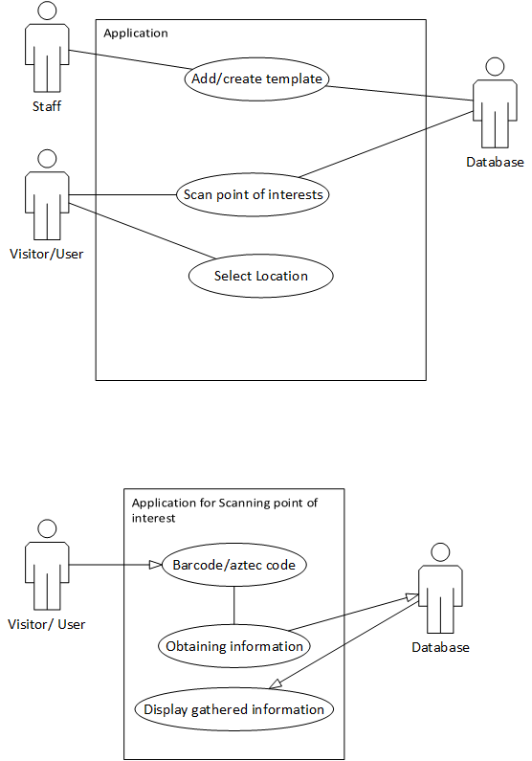

Selecting a location
Use case: | Selecting a location
Context: | A user’s location is transmitted to the mobile application using GPS
Scope: | - User & Curator
Preconditions: | - User has:  - A smartphone with a working camera  - Downloaded the application  - Already scanned a QR code and has begun their tour
On Success: | The application will detect the user’s location and display information relevant to the site they are at.
On Failure: | The application will prompt the user that their location cannot be found.
Actors: | Primary:  - User, curator, and mobile application  Secondary:  - Tour institution - museum, etc  - Mobile ecosystem - Devices, operating systems, app stores  - Location services – GPS
Trigger: | Application detects user location through GPS
Description | Step | Action
 | #1 | Mobile application detects GPS coordinates are within the radius of a point of interest
 | #2 | Information pertaining to the point of interested is retrieved from the back end database – Narration (Both subtitles and audio), AR (Augmented Reality) sequences, etc.
 | #3 | Information is presented to the user accordingly
Extensions | Step | Branching action | Proposed solution
 | #2.1 | No information available as a result of neglecting to add the information, service failure, user mistakes, or any other reason. | Display a message to the user, informing them of service failure, prompting them to notify the curator of the issue. From this point, the curator can troubleshoot the issue.
Sub-variations | No | Branching Action
 | #1.1 | User may have:  - Android OS, iOS, or other operating systems.  - Hardware capabilities – phone may not have GPS.  - User may not have a mobile device
 | #3.1 | - Phone resolutions will vary  - User may not have headphones
Priority: | Top
Performance: | Information will have to be downloaded onto to a given number of mobile devices. This process should not take longer than a minute as this would delay the tour.
Frequency: | On a per-tour basis
Issues: | - Which operating systems should we target?  - How do we cater for users whose hardware is incapable of running the application? (Slow hardware, lack of components such as GPS, etc.)  - How do we deal with users without a smart phone or headphones?  - What can we do in case of downtime?
Due: | First stable release

Adding Location
USE CASE 1 | Add Location
Goal in Context | Allows a Curator to add a new location to the app.
Scope & Level
Preconditions | Curator is logged in.  The program is open.  The location has a floor plan/outline
Success End Condition | The new template location is added to the app
Failed End Condition | An error occurs, and the new template is not added to the app
Primary, Secondary Actors | Curator, Database
Trigger | Curator selects “Add new location”
Description | Step | Action
 | 1 | The name of the location is entered.
 | 2 | The type of the location is entered e.g. Museum, Cathedral etc.
 | 3 | An outline of the location is added e.g. blueprint.
 | 4 | The user places a marker on the approximate location of points of interest (Including artefacts)
 | 5 | The GPS coordinates to the entrance of the location are added
 | 6 | A route between the point of interest is added, either by entering the data manually or by dragging and dropping lines between points of interest.
 | 7 | An overview of the data is given for confirmation of accuracy.
 | 8 | Confirmation is given
 | 9 | Information is added into the database

Identified requirements for 1st iteration
The First iteration contains a skeleton of all the objects and classes and show how the systems are implemented. This was agreed in a meeting.
We decided to use the following classes for the 1st iteration.
Objects and Functionalities
- Mobile application
  - Draw interface
- Scanner
  - Gets an item
  - Checks to see if it is valid
- DbPointOfInterest
- This will be a database table that is represented in the program as an object.
- The will store:
  - PlaceId
  - VenueId
  - ShowingDate
  - QRCode
  - Description
  - Is the audio narration available?
  - If text narration exists
- DbNarration
  - Duration
  - Title
- Web Application
  - This will be used for the admin user to change the data within the application. This will be implemented at a later stage.
- Editor
  - This allows the admin to edit the data. This will be implemented at a later stage.
- Player
  - This will manage and play the audio and text version. Not necessary in the first iteration could be introduced in the further iterations.

Plan for requirements for 2nd iteration
There are additional features that we discussed and are going to include in the final version of the code. The additional features were QR Code Recognition, audio file player and there were also discussions to include QT as this is a cross platform language. This is because once it is coded for one device type such as android it can be transferred into other device types.

Legislation and related ethical and sustainability issues.
The confidentiality of data is important to all users. [1] If the GPS was used this would require permission from the user to use their location. The use of GPS may require third party software. This may need a licence as this is covered by copyright. After Brexit, all software licences need to be examined to check the usage clauses as they may need to be updated. [2] In the Long term the GPS might be affected as the UK may not have access to the EU GPS project. [3]
When distributing the software to the client and the user, there need to be GNU licencing so that it is open source and any one can use and modify the software if necessary. The software will need to acknowledge that open source has been used as is covered by GNU licence.[4] Using bitbucket as a way of publishing the software means that any mention of it will need to be acknowledged.
The software need to be maintained to ensure that the performance does not deteriorate over time otherwise the software will become unusable. [5]

Static Design

Class design (UML)
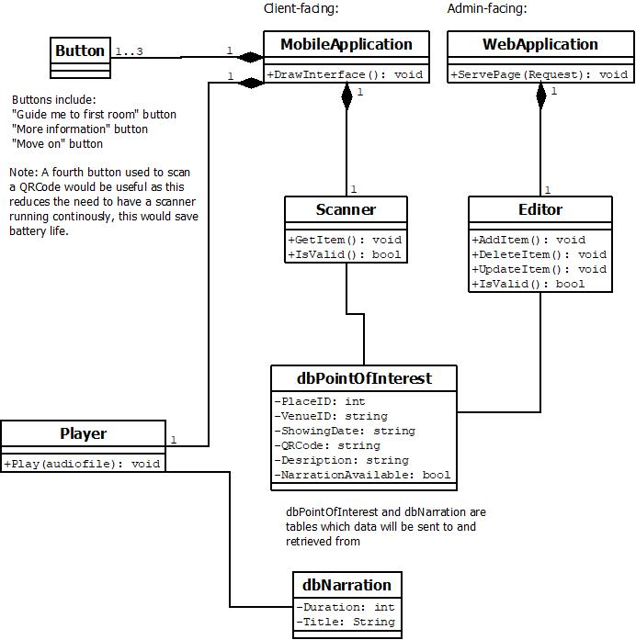

Figurer 1: Class Diagram

Collaboration and Responsibilities
These are the hand-written objects and classes showing the different relationships between collaborators .
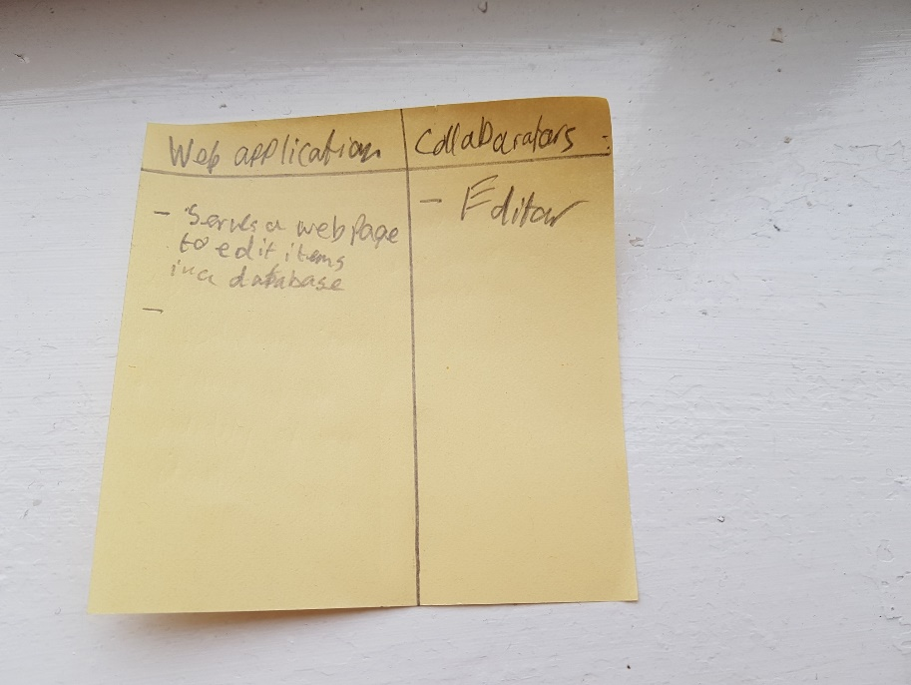

Figure 2: Web Application responsibilities
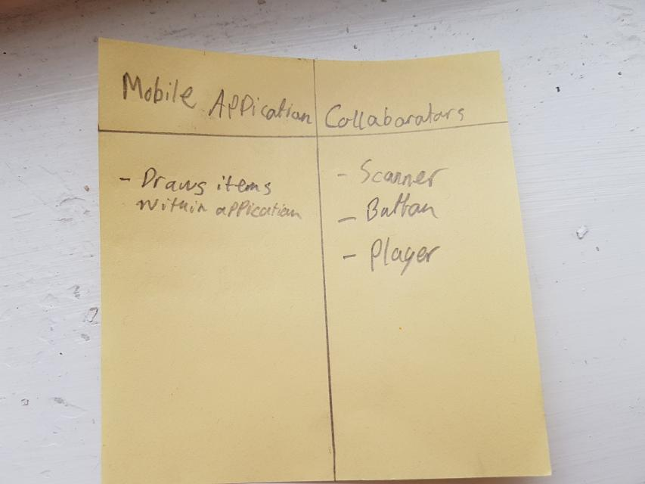

Figure 3: Mobile Application responsibilities

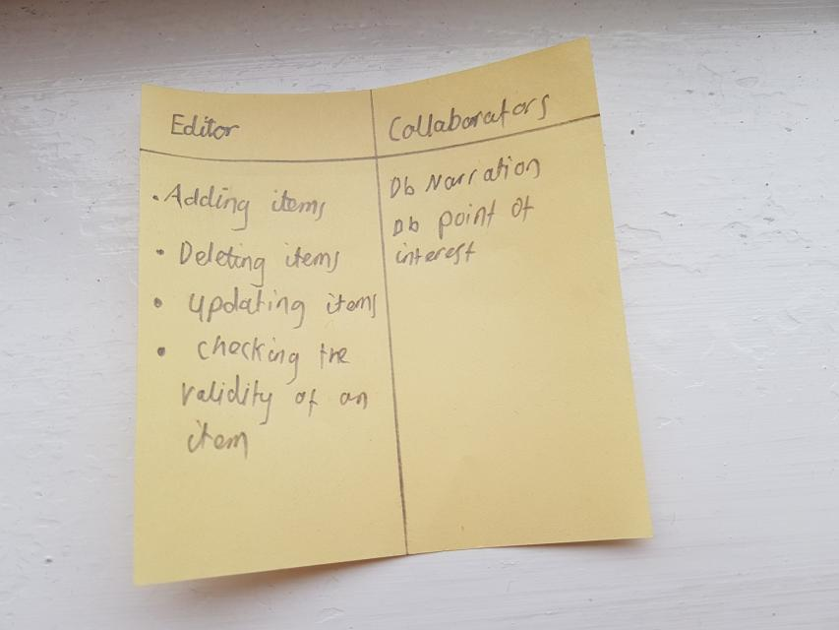

Figure 4: Editor responsibilities

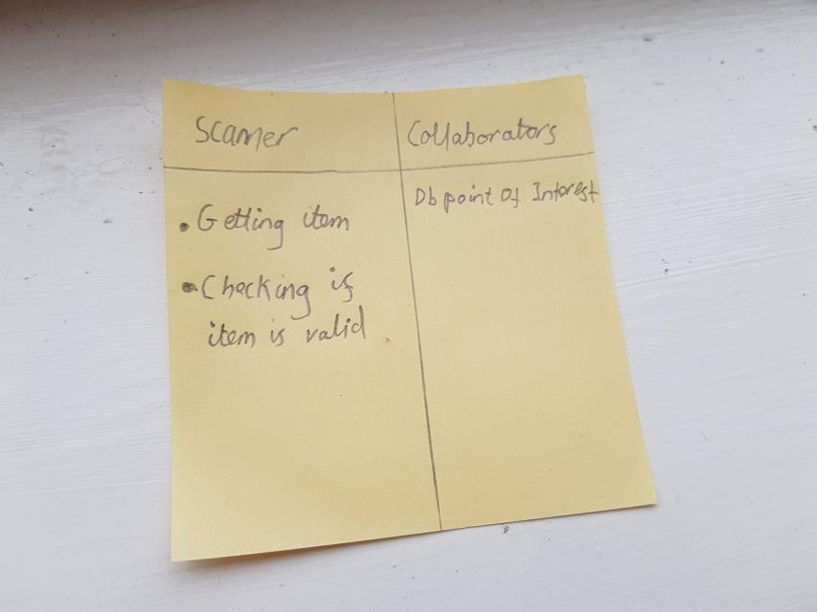

Figure 5: Scanner responsibilities

Dynamic Design

Sequence Diagrams – UML
This is the sequence diagram for how the system is going to work.

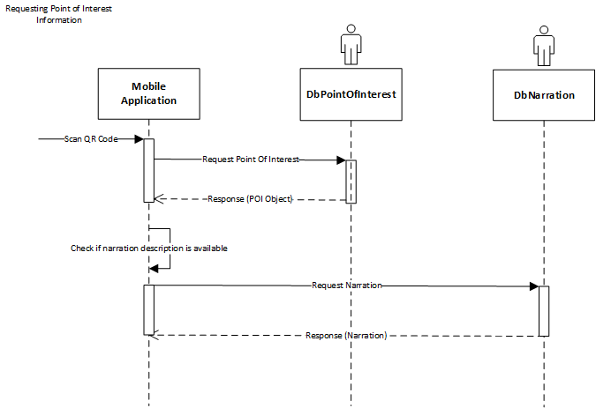
Figure 6: Requesting Point of Interest Information
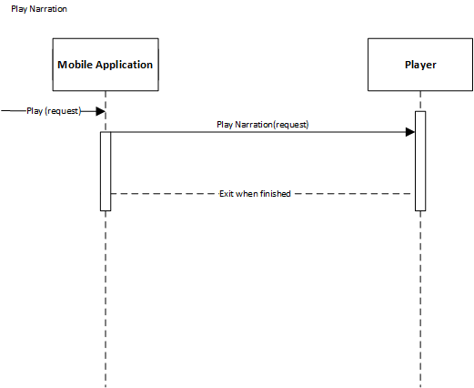
Figure 7: Play Narration

User Interface Design Prototypes
The user interface where designed in two ways in
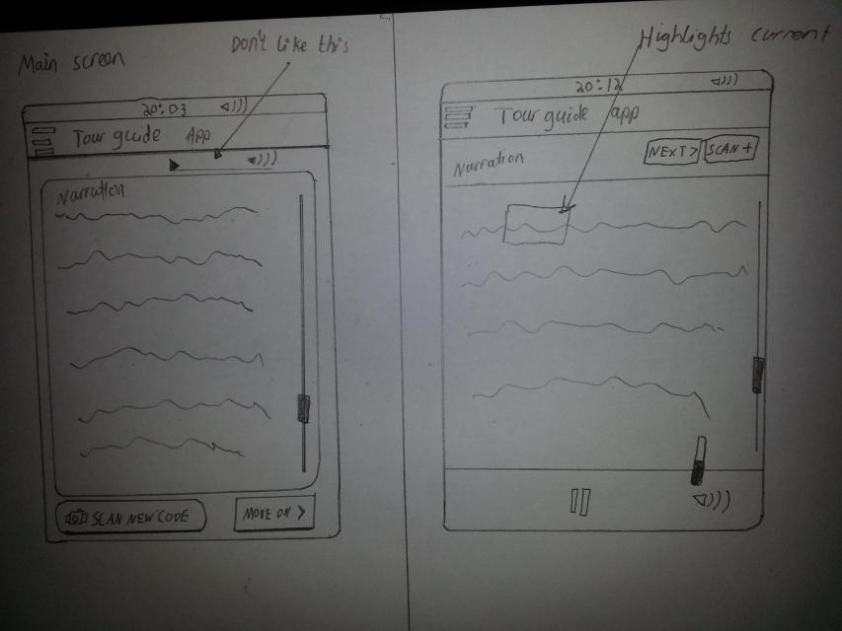

Figure 8: Prototype 1 of system
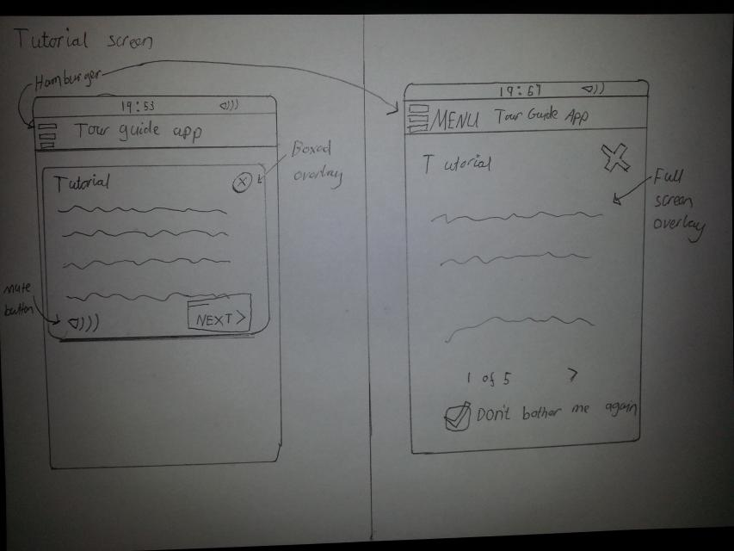

Figure 9: Prototype 2 of system

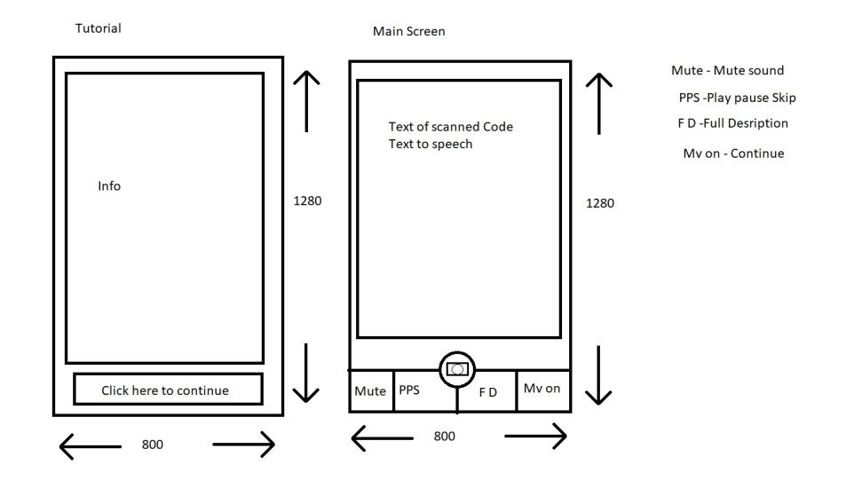
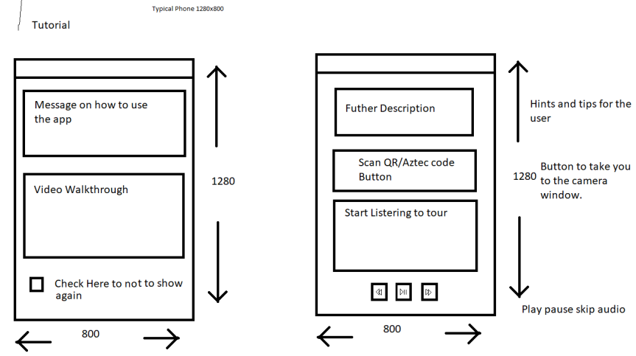
Figure 10: Prototype 3 of system
Figure 11: Prototype 4 of system

There are Four different designs that Jonathan and I have created. We thought of having a tutorial screen and a main page.
We have agreed as a group on which designs we like best. From Jonathan’s example we like the tutorial screen from prototype 2. This is the screen on the left side. For the main screen we all like the prototype 4 screen on the right side as that is the most elegant.

Code Implementation (1st Iteration)

Testing
We have tested some of the features that were programmed. Testing the narration and text
We have given some people the compiled version of the release executable to test on their computer to see if it works. They were given the task of testing to see if they could find any bugs in the system.
Below is their feedback
Ruaidhri Cook – There are no bugs. Runs fine.
Keltan Xavier – There are no bugs that I can see.

Version Control
Bit bucket is the version control we have used as a group. It includes information about the version control. We all used bitbucket to manage our codes. There are steps that are needed to upload and edit the files. Such as cloning the repository “git clone https://Robspierre987@bitbucket.org/sepassignment/teamrocket-ar-program.git” which will down load the repository that we have created. Once downloaded then can be edited. We all created branches so that we did not change the master branch if a mistake is made.
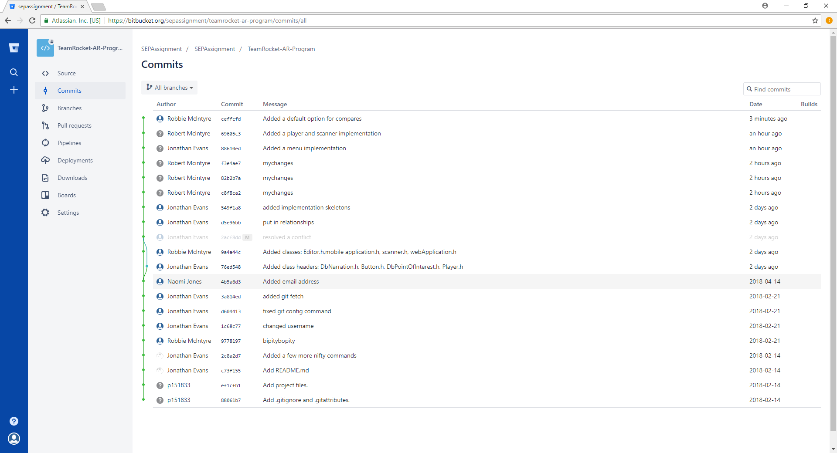
Figure 12: Commits made to the repository

Individual contribution and team working discussion
We have work well as a team. We could have met more often. The meetings we had as a team were very productive sessions. We have all contributed towards the project. I feel I have contributed a lot to the team as I produced a list of requirements to discussed with the team. I have produced a use case for the scanning a point of interest which was one of the primary use cases. I helped to produce the requirements for the first iteration. The static design was created together with the team members in one of our meetings. I created the responsibilities for the web application and the mobile application. Together with other team members we created the sequence class diagram. I produce two prototypes for the mobile application. I programmed part of the skeleton code including the basic functions. I have coded the Scanner and the Player part of the application. I collated all the meeting dates.

Design to Requirements matrix

 | Requirement | Allow staff to input location information | Allow staff to create ideal tour route | Have intuitive user interface | Select correct visitor information from GPS data | Allow a visitor to access information on an artefact of place of Interest | Enforce headphones only at certain location
Design
Class Diagram |  | X |  |  |  | X
CRC #1 |  | X
CRC #2 |  |  |  |  |  | X
CRC #3
CRC #4 |  | X
Sequence Diagram #1 |  |  |  |  |  | X
Sequence Diagram #2 |  |  |  |  |  | X
UI Design #1 |  |  |  | X
UI Design #2 |  |  |  | X |  | X

References
[1] “British Computer Society Code of Conduct | Confidentiality | Profession.” [Online]. Available: https://www.scribd.com/document/103550733/British-Computer-Society-Code-of-Conduct. [Accessed: 09-May-2018].
[2] “Impact of Brexit on software license contracts – Forensic Diaries: A Fraud Investigation &amp; Dispute Services Blog.” [Online]. Available: https://forensicdiariesblog.ey.com/2016/11/30/impact-of-brexit-on-software-license-contracts/. [Accessed: 09-May-2018].
[3] “UK might have to build a new satellite system after Brexit, government says | The Independent.” [Online]. Available: https://www.independent.co.uk/life-style/gadgets-and-tech/news/brexit-galileo-uk-government-europe-eu-gps-satellite-navigation-a8322026.html. [Accessed: 09-May-2018].
[4] “GNU General Public License version 2 | Open Source Initiative.” [Online]. Available: https://opensource.org/licenses/GPL-2.0. [Accessed: 09-May-2018].
[5] “The 3 Keys to Preventing Code Rot | Base36.” [Online]. Available: http://www.base36.com/2013/07/the-3-keys-to-preventing-code-rot/. [Accessed: 09-May-2018].

Appendices
Meetings table also on bit bucket.
Meeting Number | Meeting Date | Meeting Time | Meeting Finished | Type of Meeting | Who was there
No. Meeting | Date | Time – Starts | Time – Ends | How we met | Jon, Naomi, Robbie
1 | 1 Nov 2017 | 11:00 | 1:30 | In Person | Jon, Naomi, Robbie
2 | 8 Nov 2017 | 11:00 | 1:30 | In Person | Jon, Naomi, Robbie
3 | 15 Nov 2017 | 11:00 | 1:00 | In person | Jon, Naomi, Robbie
4 | 10 Jan 2018 | 10:30 | 11:00 | In Person- met Gordon | Jon, Naomi, Robbie
5 | 14 Feb 2018 | 13:00 | 16:00 | Talked over Discord | Jon, Naomi, Robbie
6 | 21 Feb 2018 | 13:00 | 15:00 | Talked Over Discord | Jon, Robbie
7 | 6 March 2018 | 13:00 | 13:00 | Emailing Gordon | Jon, Naomi, Robbie
8 | 7 March 2018 | 11:00 | 12:00 | In Person | Jon, Naomi, Robbie
9 | 25 April 2018 | 9:00 | 11:00 | In person | Jon, Naomi, Robbie
10 | 7 May 2018 | 10:00 | 14:00 | Discord | Jon, Robbie
11 | 8 May 2018 | 9:00 | 15:00 | In person | Jon, Robbie

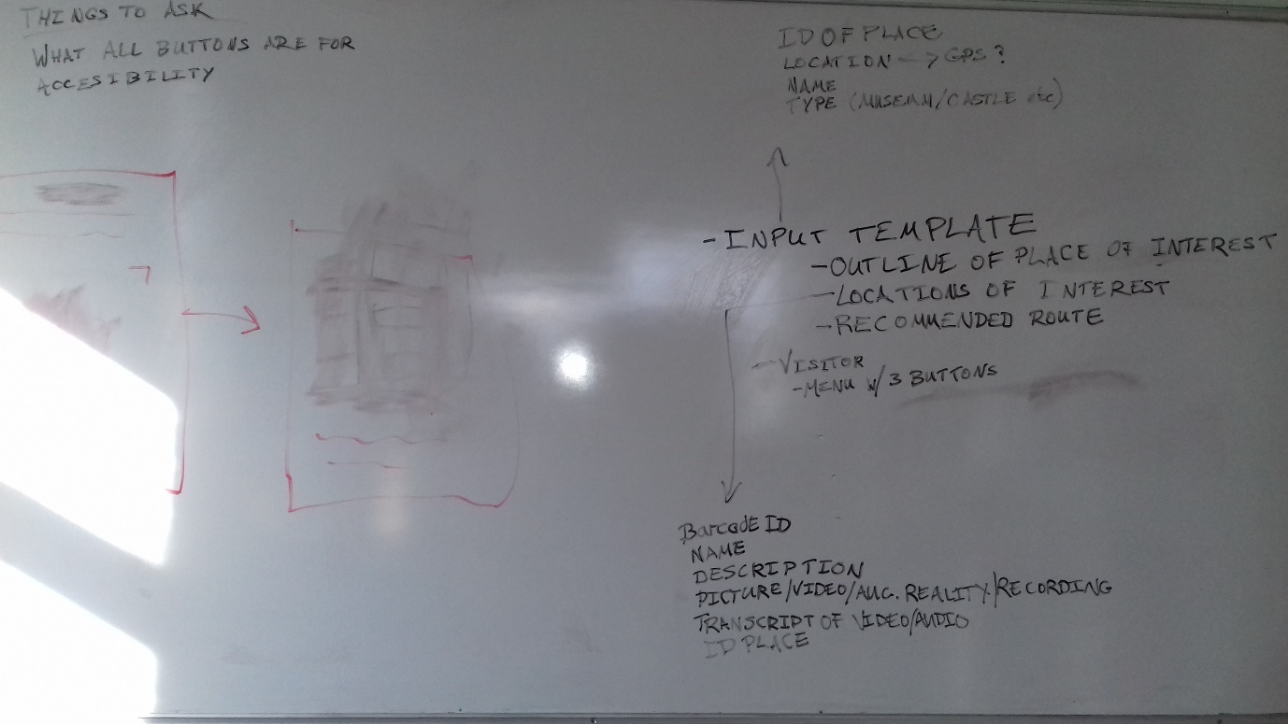
First Meeting discussions
Figure 13: Meeting notes on whiteboard

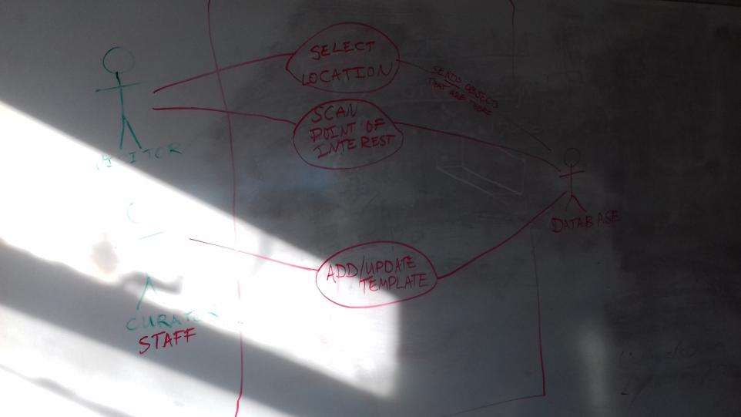
Figure 14: More meeting notes on white board.

Meeting 1/11/17

Attendees:
- Naomi
- Robbie
- Jonathan
Agenda:
- Requirements identification
  - Outline - Augmented reality mobile application
  - Targeted OS: Android
  - Introduction screen with 3 buttons – Discuss with customer.
  - Bar code scanner (GPS could be included later)
    - Linked with the
  - Template for multiple purposes, i.e: museum artefacts, castles
    - Outline place of interest
    - Location of interest
      - BarcodeID
      - Name
      - Description
      - Media
  - Administrative backend
  - Targeted audience: Adults (~18-50)
  - Narrator
    - Subtitles for accessibility option
  - ID of Place

Chairperson: Everybody
Minute taker: Everybody
Things to ask about:
- What each button should be for
- Accessibility options
Course of action for next week
- Talk to Gordon and Andrew
- Outline of how the app will work (Upload to discord)
- Separate plans uploaded on Sunday of all the plans.

Meeting 3 – Road Map

Roadmap
This is derived from the detailed requirements documents and use cases.

Preparation
Requirements detailed | ✔
Use cases | ✔
Class diagrams
Sequence diagrams
Database diagrams (ERD)

Initiation
- Set up git repositories (all agreed on GitLab due to the convenience of unlimited private repositories and good CI, continuous integration support)
  - Work environments setup
    - Setup code linting (Code checking)
      - Clang-Tidy??
  - Git repositories:
    - Application itself
    - Design files
    - Documentation (Getting started document, etc.)
  - Decide on release numbering
    - ? 0.0.1 (in order: release . beta . alpha)

Design
- Wireframe designs
  - Low fidelity designs
  - High fidelity (detailed) designs

Development
- Creation of interface – using QT
  - Other suggestions:
    - Java ☹
    - .NET

Testing
- Alpha (in-house) – Test system internals
  - Writing unit tests for use with continuous integration on GitLab
  - Test runs
- Beta (user testing) – Test system itself
  - Get user to trial the software and report on any bugs

Documentation
- Write user guide

