University of Wales Trinity Saint David
Wales Institute of Science & Art



School of Engineering Portfolio
Automotive Chassis Systems
ACHA5013

Oliver Nayler
1901161
04/01/2022
Table of Contents
- Introduction……………………………………………………………………Page 3
- Vehicle Structures…………………………………………...………….Page 4-6
- Vehicle Structures and their use of composite material.Page 7-8
- Question 3………………………………………………..……………….Page 9-10
- Question 4…………………………………………………………………….Page 10
References………………………………………………………………Page 11-12

1.0- Introduction
This technical report will explore and evaluate the development of vehicle structures and materials, whilst exploring their crash worthiness and safety. A case study of a van will also be used to assess the structure of the vehicle using the simple structural surfaces (SSS) method, which will allow for the shear load and torsional load on each panel to be discovered.

2.0- Vehicle Structures
Working motor vehicles have been around since 1885 and have seen many changes since, due to development and modern technology. These changes include the structure of the vehicle, since there have been many different vehicle structure types which is explored below.

2.1- Body on Chassis
The first type of vehicle structures to emerge were ‘body on chassis,’ they used a leaf spring suspension system and a ladder frame chassis. These structures allowed for manufacturing flexibility as different bodies could fit onto the same chassis. When this structure was first created torsion was not considered and they had extremely low stiffness. They were made to be able to only carry its own weight, passengers, and a payload (C. Brown, et al, 2001). Initial fabric on wood bodies were soon replaced by pressed steel which allowed for mass production. This change caused unwanted load transfer between the body and the chassis causing squeaking and rattling. To improve this more springs in series were introduced and the chassis was stiffened. To stiffen the chassis cruciform bracing was introduced. This is where two pieces of steel are used to form a cross attaching to both side member and fill part of the open sections of the chassis. Another method of stiffening up the chassis was ladder frames; this is where multiple cross members are added to stiffen the chassis. Ladder frame chassis are still used today in vehicles such as SUV’s and commercial vehicles (C. Brown, et al, 2001).

2.2- Backbone Structure
Backbone structures were first introduced in 1904 by Rover with their 8hp model. The backbone chassis is like the Ladder frame chassis in the way that the body and other mechanical components are bolted onto it. This type of chassis was then developed and can be found on specialist sports cars such as the Lotus Elan and Europa and the TVR S Series (SJW, 2018).
The backbone structure is a large tube with the walls in shear, the body is often glass reinforced plastic. Backbone structures can also be made up of a triangulated tube structure (C. Brown, et al, 2001).

2.3- Triangulated Tube Structure
One of the main manufacturers to use the triangulated tube structure is Caterham and lotus. Lotus used this structure to create their Lotus seven which was in production from 1957- 1960 (Nick D,2021). Following this Caterham then bought the right to produce their own version of the Lotus seven and created their own Caterham seven in 1973 (Branch, 2021). Triangulated tube structures surround the outside of the body, meaning the coachwork can connect directly to the chassis requiring no structure. This type of vehicle structure is suited to low volume production vehicles as it takes a long time to produce meaning its labour intensive. This type of chassis also allowed for the incorporation of a roll cage into the structure which increases the torsional stiffness of the chassis (C. Brown, et al, 2001).

2.4-Pure Monocoque / Monocoque
The monocoque chassis was first used for motorsport purposes with Lotus using it in their 1962 Lotus 25 formula 1 car. The monocoque chassis was then developed further by Mclaren as they were the first team to use carbon fibre reinforced polymers to construct the monocoque of the 1981 Mclaren MP4/1. The monocoque was introduced into production cars in 1990, when Jaguar released their XJR-15 (Ford, 2021). Monocoques are a very weight efficient chassis and are used for motorsport applications, this is because they require a totally closed tube and the shell requires reinforcements to help prevent buckling and out of plane loads (C. Brown, et al, 2001). An example of a pure monocoque is a typical formula 1 car, these chassis are made of a carbon fibre composite and has a torsional stiffness of 30,000 Nm/deg (C. Brown, et al, 2001).

2.5- Punt or Platform structure
An example of a punt chassis can be seen in the Lotus Elise which was released in 1969. A punt/platform chassis usually consists of sheet metal construction, where floor members are of large, closed sections with joints between members. This type of structure has a grillage structure of members meaning it has high torsion and bending properties (C. Brown, et al, 2001).

2.6- Space Frame
Space frames have been used in automotive industry since the 1930’s. They can be compared to monocoque chassis as they both function as the body and frame simultaneously (WhyHighEnd,2021). Space frames use small section tubular members which are built into stiff jointed ring beam bays and are welded together at joints or nodes. The ring beams within this structure are effective at carrying local in plane shear. However, to achieve this the edge members of each ring frame must be stiff locally in bending (C. Brown, et al, 2001).

2.7- Integral or Unitary Body Structure
The integral or unitary structure is the most common structure used in modern vehicles as it is well suited to mass production. This structure is made up of pressed sheet metal, which is spot welded together. This type of structure is much stiffer than other vehicle structures as it can carry high torsion, bending and other loads. The typical values of torsional stiffness for this structure can range from 8000-10000 Nm/deg for everyday vehicles and 12000- 15000 Nm/deg for luxury vehicles (C. Brown, et al, 2001). An example of one of the first Integral/ Unitary body structure is the Citroen 11CV which was produced between 1934-1956 (C. Brown, et al, 2001).

2.8- How are composites used in modern vehicles?
One composite used in modern vehicles is carbon fibre reinforced polymers (CFRP). CFRP is currently used in production of modern high-performance vehicles and tend to be some sort of monocoque chassis (WhyHighEnd b, 2021). There are many benefits to using CFRP’s which include high stiffness and strength, lightweight, corrosion resistant and low coefficient of thermal expansion (Clearwater, 2021). There are also many disadvantages to CFRP’s such as they have a lack of flexibility, this means that if the chassis were to take a large enough impact it could crack or bend and repairing the structure would not be possible like a metallic structure (WhyHighEnd b, 2021). As modern cars are evolving into EV, more space is required to house batteries to run the vehicle and the chassis structure will need to be amended to accommodate the extra space needed for the batteries. CFRP’s are being used within this development to produce battery enclosures for the developing structures. The batteries in these vehicles need to be stored in a safe and stable space as damaged and exposed batteries can become extremely dangerous. CFRP also provides the benefits over aluminium battery enclosures, these benefits include that CFRP casings are 40-50% lighter. They also provide the benefit of being stiffer and providing approximately 200 times lower thermal conductivity which shields the battery from heat and cold. Finally, another benefit is that CFRP is noncorrosive meaning the casing will prevent water and gas leakage compared to aluminium which corrodes (Moore,2019).

3.0- Vehicle Structures and their use of composite materials

3.1- Crash Requirements
Each vehicle that is produced is required to go through some sort of testing before it can be deemed road legal or safe to be on the road. One of these tests is the Euro NCAP testing. This testing was introduced in 1997 and approximately 90% of all cars sold in Europe are tested (EuroNCAP, 2022). Euro NCAP carry out multiple crash tests to see how they affect adult occupants, child occupants, Vulnerable roads users whilst also testing the vehicles safety assists.
As an example, a crash report on a BMW i3 which uses a full CFRP chassis can be found on the Euro NCAP website. The BMW i3 was the first BMW to use a CFRP chassis and it was the cheapest car on the market to use a full carbon tub (DeMattia, 2020). The BMW i3 was given an overall 4/5-star rating by Euro NCAP in 2013. The BMW i3 scored 86% in the adult occupant section of testing with the main risk being chest protection when carrying out more severe side pole impact testing. The child occupant testing scored 81% with the only risk to the child occupant being that the information provided to the driver regarding the status of the passenger airbag is not sufficiently clear. In the pedestrian test the vehicle scored 57% with the front edge of the bonnet scoring no points and poor results were recorded at the base of the windscreen along with the stiff windscreen pillars. Finally, the i3 scored 55% on safety assist with its built-in electronic stability control (ESC) and seatbelt reminders (Euro NCAP b, 2022).

3.2- Developments in Manufacturing Technology
Over time the development in manufacturing technology to produce vehicles and the production of materials for vehicles has increased significantly. The main aim for this development is to reduce labour and material costs whilst also increasing productivity, efficiency, and component quality (Aladmin, 2008). One big change in the automotive manufacturing sector is the use of automation, automation/ robotics are used in multiple different sections of the production line of a vehicle in areas such as chassis spot welding, painting and many other areas. However, using automation in the automotive industry has also had backlash as these automotive companies required less staff meaning unemployment levels would rise (Aladmin, 2008). Another development in manufacturing included the use of computer aided design (CAD), this software allows for manufacturers to produce and mock up parts before they are produced saving on materials and making the design process a lot more efficient. Alongside the use of CAD there has also been a development that allows for parts to be scanned with a 3D laser scanner, this scanner can quickly capture warping and variations in shape of an entire part (Aladmin, 2008). Manufacturing technology has also improved in a way that allows for the production of electric and autonomous vehicles. An example of the development of electric and autonomous vehicles is Tesla. Tesla have been producing electric road cars since 2012 and have managed to develop their technology significantly since, with developments on a ‘million-mile battery’ which would help the sustainability of electric vehicles as fewer precious metals would need to be mined to produce batteries. Current Eclectic Vehicle (EV) batteries can last up to 1000 full charges or around 8 years and 150000 miles (Mitchell, 2020). Tesa vehicles also have the technology and development to be able to be fully autonomous, this technology allows for the vehicle to drive without a human behind the wheel however due to laws around the world this technology is yet to be used due to safety concerns. However, in some areas of the world these vehicles are allowed to run at conditional automation. This is the third level of automation for a vehicle, at this level the vehicle is at 75% automation, at this level the vehicle can perform safety critical functions such as accelerating, breaking and steering. It can complete these actions using many different sensors and cameras that monitor the surrounding environment and judging the distance between itself and other vehicles (Mbaabu, 2020).

3.3- Developments in Materials
Since the first automobile was made the development in materials has increased significantly, benefitting the performance and cost of producing the vehicle. One material that has started to be used in the automotive industry and is slowly replacing aluminium is carbon reinforced polymers (CFRP). CFRP are a composite material which relies on the carbon fibre to provide strength and stiffness while the polymer provides a cohesive matrix to protect and hold the fibres together (Fekete et al, 2017). This material is currently mainly found in high end sports vehicles such as the Mclaren 720’s, and the Lamborghini Aventador. However, as mentioned previously they can also be found in cheaper road vehicles such as the BMW i3. The development of this material has become popular in the automotive industry as the material is extremely lightweight and can achieve mass reductions unachievable by the metals currently being used in the industry (Fekete et al, 2017). Another benefit of CFRP is that as they are artificially composited materials their properties can be tailored to different applications. This is done through varying the strength, length, direction and number of reinforced fibres in the selection of polymer matrix (Fekete et al, 2017). There are some downsides to CFRP especially in the cost of producing the fibres and the low throughput rates at which components can be produced. However, as CFRP is becoming more desirable new technology is being produced reducing the cost of fibres and panel processing (Fekete et al, 2017).


4.0- Question 3

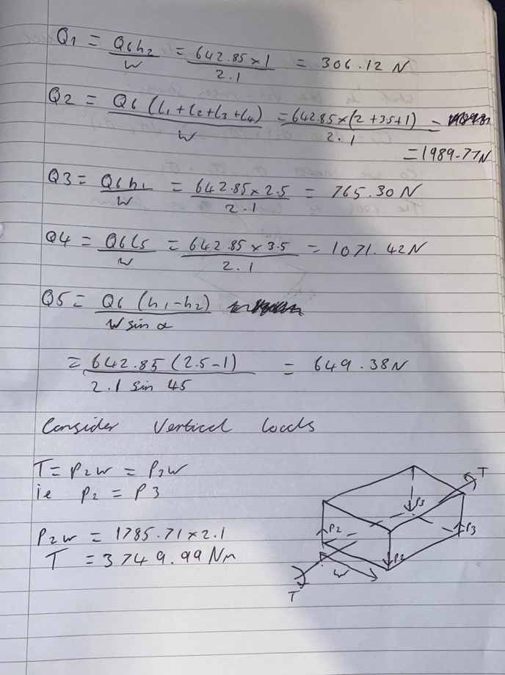



5.0- Question 4
If this vehicle were to be made of CFRP and there was a faulty batch of adhesive then panels 5 and 8 would significantly reduce in the amount of shear load each panel could carry. This is because if the join is compromised then the two panels will not be secure meaning they may end up counteracting each other, putting more stress on each panel until they eventually break. This may also cause further stress on panel 6,7 and 10 and it will also affect the join between these panels if one were to break.

References

Aladmin, 2008, New Methods for Manufacturing, [online], Accessed 3/1/22, https://www.automotivemanufacturingsolutions.com/new-methods-for-manufacturing/6623.article

Clearwater Composites, 2021, Advantages of Carbon fibre, [online], Accessed 2/1/22, https://www.clearwatercomposites.com/resources/advantages-of-carbon-fiber/

Euro NCAP b, 2022, BMW i3, [online], Accessed 3/1/22, https://www.euroncap.com/en/results/bmw/i3/8863

Euro NCAP, 2022, Timeline, [online], Accessed 3/1/22, Euro NCAP | Timeline

J.R. Fekete, J.N. Hall, 2017, Design of auto body, Automotive steels, Elsevier Ltd

Jason C. Brown, A. John Robertson, Stan T. Serpento, 2001, Motor Vehicle Structures, Elsevier Ltd

Joe Ford, 2021, What are the types of chassis?, [online], Accessed 1/1/22, https://answerstoall.com/common-questions/what-are-the-types-of-chassis/

Jon Branch, 2021, A Brief History From The Lotus 7 To The Caterham 7, [online], Accessed 31/12/21, https://silodrome.com/lotus-7-caterham-7-history/

Nick D, 2021, Lotus 7-Ultimate guide, [online], Accessed 31/12/21, https://www.supercars.net/blog/1957→1960-lotus-7/

Nico DeMattia, 2022, Is the BMW i3 One of the Best BMWs of All Time?, [online], Accessed 3/1/22, https://www.bmwblog.com/2020/11/29/bmw-i3-best-bmw/

Onesmus Mbaabu, 2020, Conditional Automation in Driving, [online], Accessed 3/1/22, https://www.section.io/engineering-education/conditional-automation-in-driving/

Russ Mitchell, 2020, Elon Musk’s million-mile battery: what it really means, [online], accessed 3/1/22, https://www.latimes.com/business/story/2020-09-21/the-million-mile-car-battery-what-is-known

SJW, 2018, Backbone Chassis, [online], Accessed 31/12/21, https://www.motoringweekly.com.au/2018/07/02/backbone-chassis/

Stephen Moore, 2019, CFRP battery enclosures deliver multiple benefits in EV’s, [online], accessed 2/1/22, https://www.plasticstoday.com/automotive-and-mobility/cfrp-battery-enclosures-deliver-multiple-benefits-evs

WhyHighEnd b, 2021, Carbon Fibre Chassis, [online], Accessed 2/1/22, http://www.whyhighend.com/carbon-fiber-chassis.html

WhyHighEnd, 2021, Spaceframe Explained, [online], Accessed 1/1/22, http://www.whyhighend.com/spaceframe.html

