Assignment 1
Design and Implentation of a Relational Database System

University of Wales Trinity Saint David
London Campus
Module Name: Introduction to Web and Database Concepts
Module Code: ACCA4023
Student Name: Elena Mihail
Student ID: 2437664
Group: 1
Lecturer’s Name: Rajeev Nath
Table of Contents
Introduction 2
1.Scenario Analysis 3
2.Data Structure Development 5
3.Entity – Relationships (ERD) 8
4.Normalization Compliance 9
5.Sample Data Population 10
6.Query Development 11
7.Validation and Testing 14
Conclusion 15
References 16

Introduction
The purpose of this report is to design and implement a fully functional relational database system for the EcoRide electric bike rental program. The EcoRide initiative offers electric bike rental services in various public spaces, such as parks, university campuses, and transportation hubs. The current system relies heavily on paper forms and basic spreadsheets, leading to common operational problems such as duplicate reservations, inconsistent data, difficulties tracking maintenance, incorrect bike locations and a general lack of analytical capabilities.
A structured database is needed to modernise and automate the rental workflow. This involves collecting and organising essential data about rider, bike, station, rental, staff, and maintenance. A relational database ensures consistent data storage, reduces human error, supports referential integrity, and enables the generation of useful queries for decision-making.
The goals of this project include:
• Designing an optimised relational database model.
• Creating entities that accurately represent EcoRide operations.
• Define relationships with proper cardinality.
• Ensure data integrity using primary and foreign keys.
• Generate sample data for realistic simulation.
• Show useful queries.
• Test and confirm the developed system.
This report covers scenario analysis, the ER diagram, table structures, 3NF normalisation, sample data generation, query development, validation and testing and final conclusions.

1.Scenario Analysis
The EcoRide scenario describes a modern bike-sharing service using across multiple stations. Rider scans their ID at any EcoRide station, pick up a bike and return it to any other station in the network. Staff support the bikes and ensure their availability.
Analysis of the scenario reveals several key entities essential to the system's operation:
Rider
Rider are individuals registered with the EcoRide program. They must provide their personal information, including name, phone number, email address, and the ID number used when registering the bike. Accurate information about riders is necessary to ensure accountability and traceability, especially in the case of unreturned or overdue bike.
Station
Station stands for the geographic locations where bikes are picked up and returned. Each station must have a name and description and may optionally include GPS coordinates, such as latitude and longitude. Station is a fundamental part of the rental process, as they are located at both the beginning and end of the ride.
Bike
Bike are the primary asset of the EcoRide system. Each bike has a unique identifier, a visible label, a type (e.g., urban, cargo, folding), a purchase date, maintenance notes and a status indicating its availability. The status field is crucial, as it determines whether a bike is available for rent, under maintenance, in use, or lost.
Staff
Staff employees perform maintenance or inspection tasks. The system stores the name, job title (e.g., technician, inspector, manager) and contact information for each employee. Staff must be linked to maintenance records to ensure accountability and operational planning.
Rental
The Rental entity records each transaction in which a bike is picked up and returned. Each rental must record the bike used, the user who made the rental, the pick-up and drop-off station, the pick-up and drop-off times, the duration and the total cost. Rental are the core activity of the EcoRide service and therefore, the central transaction table.
Maintenance
Maintenance records document all work performed on a bike, including repairs, inspections and battery checks. These records ensure the safety and proper functioning of the bikes. Maintenance records should include both the repaired bike and the employee who performed the task.
Operational Challenges Identified: The scenario reveals several problems:
• Manual spreadsheets generate duplicate or missing data.
• It is difficult to verify bike availability in real time.
• Maintenance records are inconsistent or incomplete.
• Paper forms make it extremely difficult to analyse usage patterns.
• Duplicate bookings occur due to a lack of consistency in references.
These problems directly justify the need for a structured database.

2.Data Structure Development
The EcoRide database was designed using Microsoft Access to meet the operational requirements of the electric bike rental scheme.
A total of six tables were created: Rider, Station, Bike, Staff, Rental and Maintenance.
Below is detailed description of each table, including its fields and data types. Under each table description a screenshot from Microsoft Access should be inserted showing the Design View of the table.
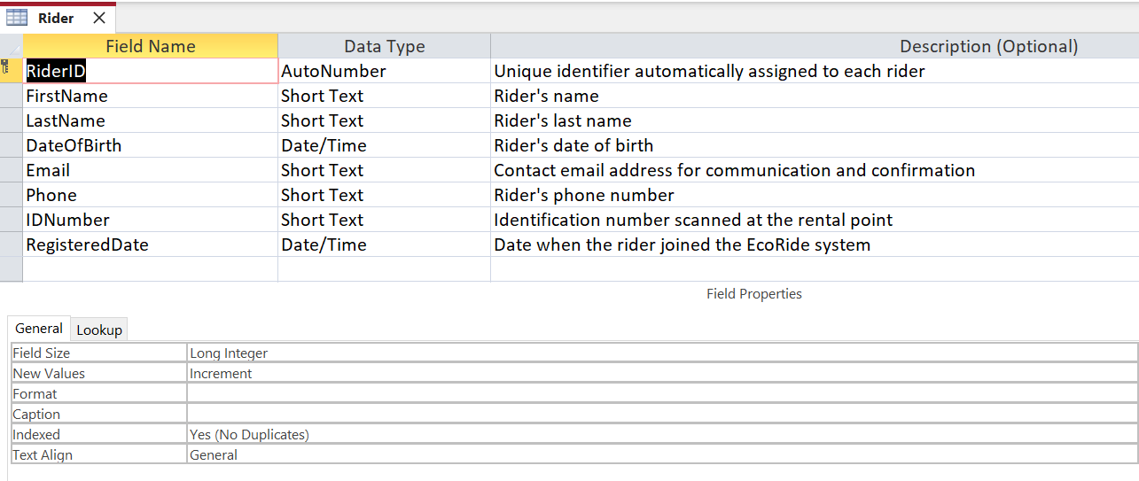
Figure 1: Rider table created
Purpose: The Rider table maintains records of all registered users, ensuring each has a unique identifier and accurate contact details for managing rental and communication.
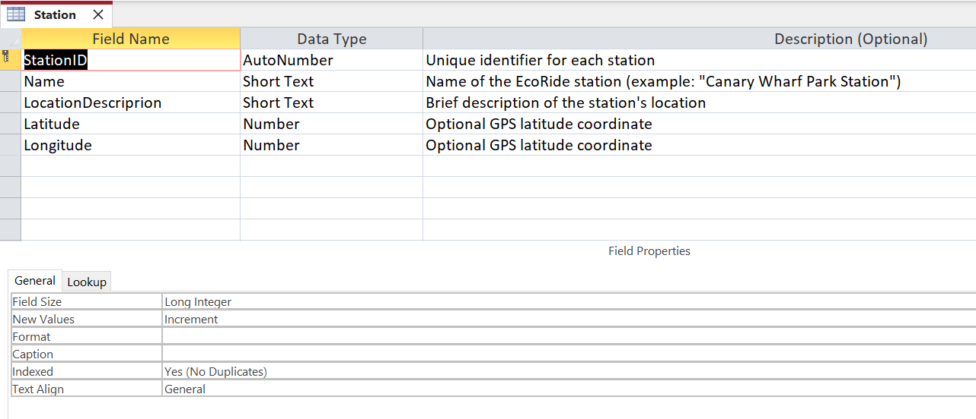
Figure 2: Station table created
Purpose: The Station table stores data about all docking points within the EcoRide network. This helps track bike locations and availability across the city.
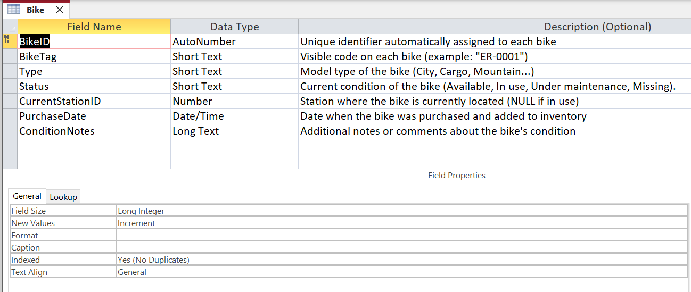
Figure 3: Bike table created
Purpose: The Bike table keeps essential records of each electric bike, including its type, purchase date and availability status. It links to the Station table for tracking current location.
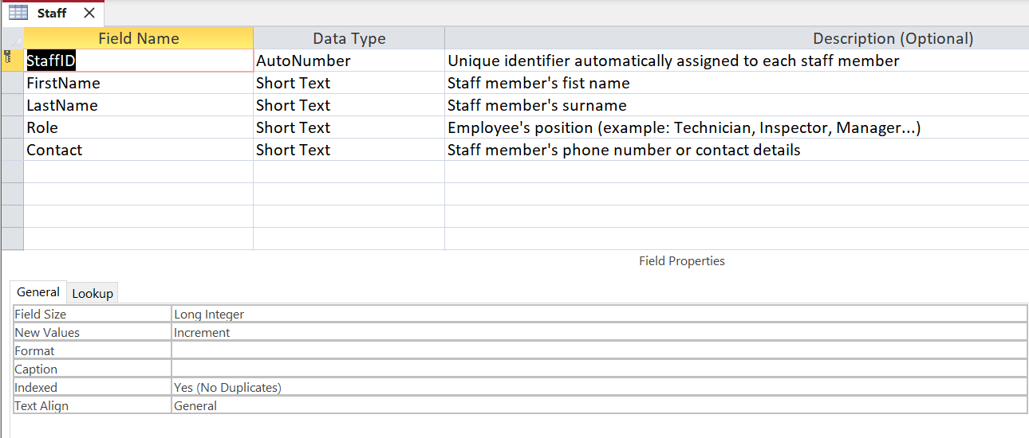
Figure 4: Staff table created
Purpose: The Staff table manages records of EcoRide employees who perform maintenance, inspections or administrative tasks.
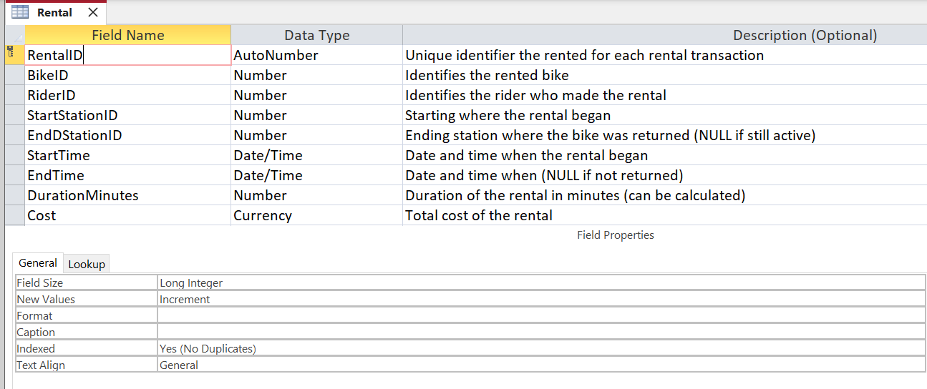
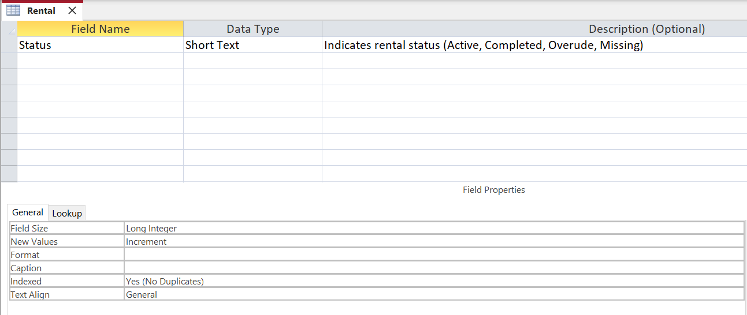
Figure 5: Rental table created (The two images go together with the table)
Purpose: The Rental table connects rider, bike and station through transaction records. It provides key data for monitoring system usage and billing.
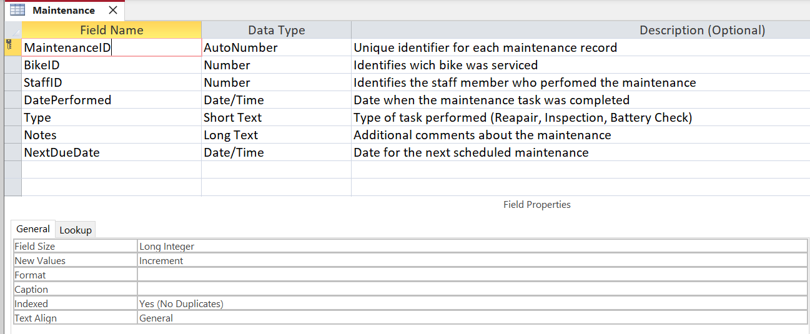
Figure 6: Maintenance table created
Purpose: The Maintenance table documents all repair and inspection operations, ensuring a history of maintenance activities and accountability for staff performance.

3.Entity – Relationships (ERD)
After creating all the tables, I built the relationship diagram using the Database Tools → Relationships function in Access. I added each table to the window and then connected each foreign key to its corresponding primary key. This step was important because it helped me verify that all the connections between the tables were correct and that the layout of the database made sense.
When creating each relationship, I enabled Enforce Referential Integrity, which basically prevents the database from allowing errors like inserting a rental bike with a non-existent bike or deleting a cyclist who still has rental bikes connected to them. I also enabled Cascading Update of Related Fields, so that if a primary key ever changes, the related foreign keys are automatically updated. I left Cascading Delete off on purpose because I didn’t want to accidentally delete important data [1].
Creating the relationship diagram helped me visualize how the EcoRide system works behind the scenes. For example, we could clearly see how riders are connected to rental bikes, how bikes are connected to stations, and how maintenance records depend on both bikes and staff members. Seeing all the “1” and “∞” symbols made it easier to understand the one-to-many relationships and confirm that the database followed the correct structure [2].
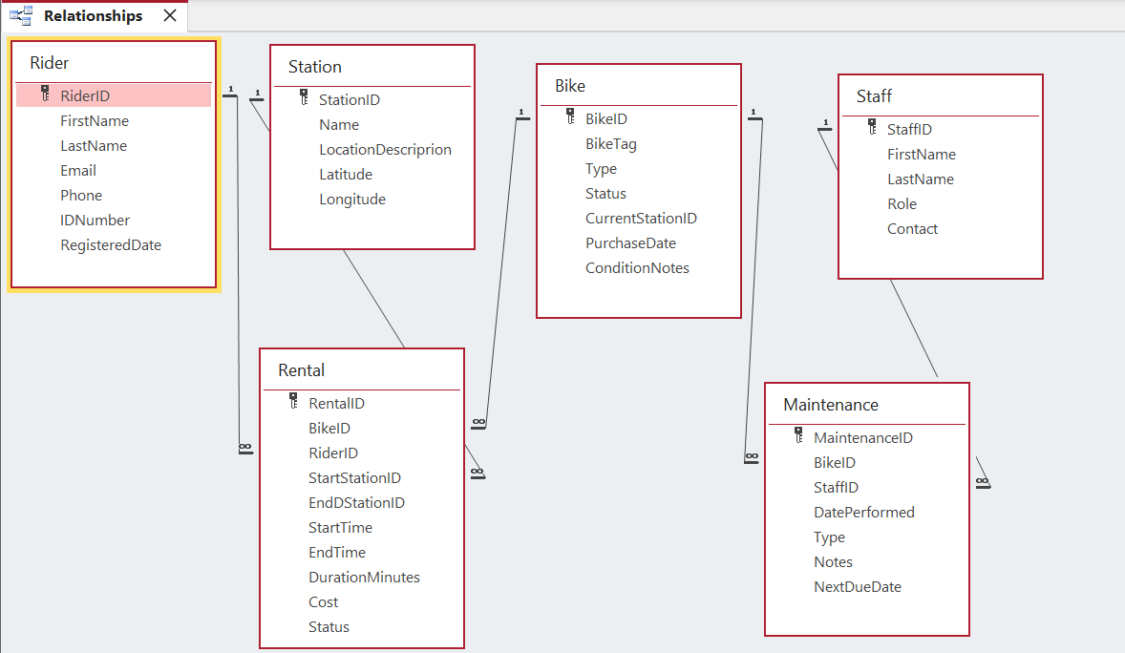
Figure 7: ERD created in Access

4.Normalization Compliance
Normalization is a process for organizing data in a database. It helps avoid duplicate data and errors when adding, changing, or deleting information. The EcoRide database follows the rules of 1NF, 2NF and 3NF, as recommended by reliable database books and guides.
• 1NF (First Normal Form): Each column has a unique value, and there are no repeated groups.
Example: In the Riders table, each person has only one phone number and one ID.
• 2NF (Second Normal Form): All data depends entirely on the primary key.
Example: In the Bike table, information such as Type, Condition and Purchase Date depends only on the BikeID.
• 3NF (Third Normal Form): No data depends on any data other than the primary key.
Example: Station names are only in the Station table; they are not repeated in Rentals or Bikes.
• Staff role only in Staff, not duplicated in Maintenance.
• Bike status only in Bike, not duplicated in Rental.
Why it's important:
• Prevents duplicate data.
• Makes updating information easier.
• Ensures reports and records are accurate.
• Helps the EcoRide system run smoothly, for example, without losing bike or booking data [3].

5.Sample Data Population
To show how the EcoRide database works in real-world situations, we have added sample data to each table. These examples are based on realistic scenarios, such as registering new rider, using and returning bike, performing maintenance check and recording rental details. The purpose of adding this data is to ensure that the database structure works correctly and that all tables and relationships work as expected.
Each table has a small set of sample records that help test various features, such as queries, forms and reports. The values ​​we have used represent typical situations that might arise in the EcoRide system, including distinct types of bike, station location, completed and active rentals and basic maintenance activities.
I have added sample data to the following tables:
• Rider
• Station
• Bike
• Staff
• Rental
• Maintenance
Screenshots of these sample data tables are shown below to demonstrate that the database has been successfully created in Microsoft Access.
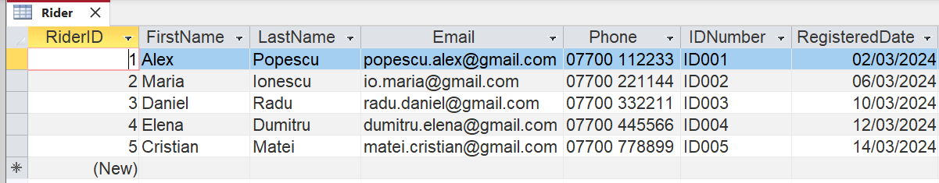
Figure 8: Rider data
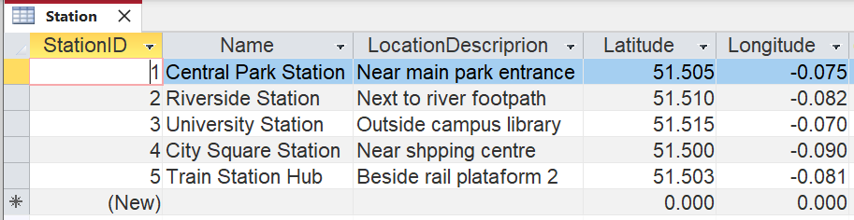
Figure 9: Station data
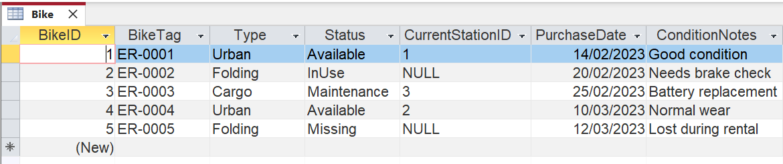
Figure 10: Bike data
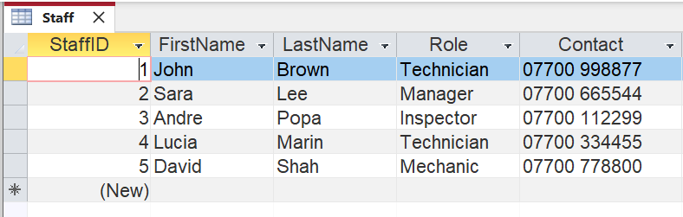
Figure 11: Staff data
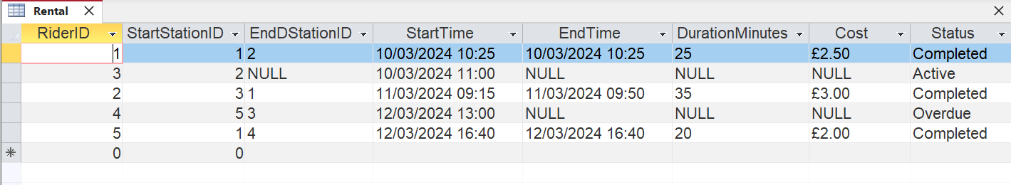
Figure 12: Rider data
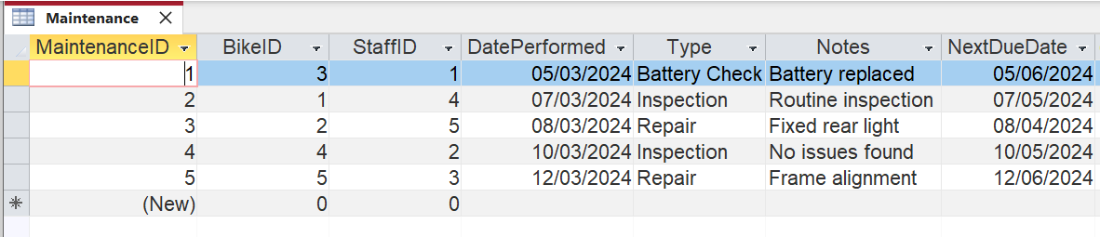
Figure 13: Maintenance data

6.Query Development
To test the functionality of the EcoRide database, a set of queries was created in Microsoft Access. These queries help demonstrate how the system can retrieve information useful for daily operations, such as checking bike availability, monitoring rental or reviewing maintenance records. Each query was designed using Query Design View, selecting the appropriate tables, fields and criteria to obtain accurate results [4].
The examples below illustrate the different types of queries that can be used within the EcoRide system and include screenshots of both the design and the results:
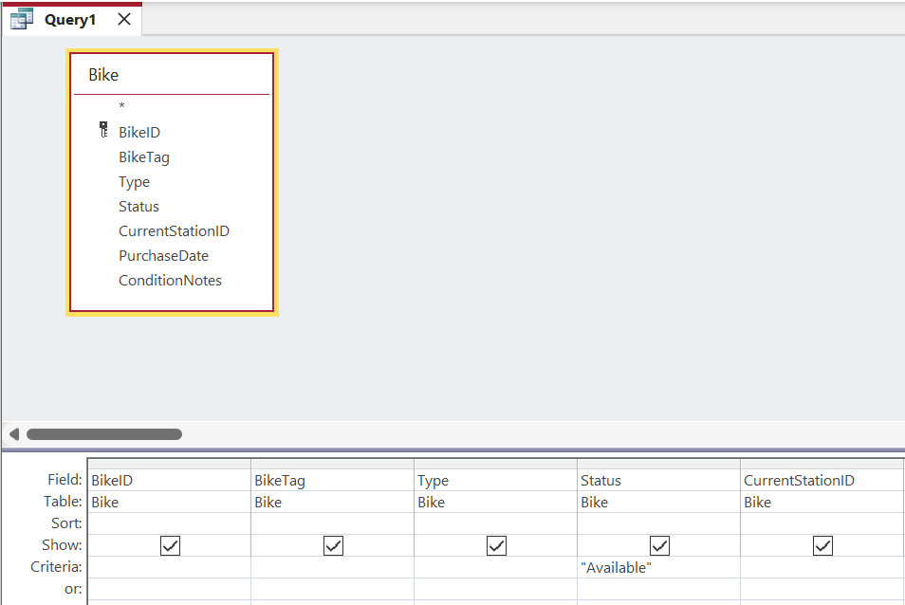
Figure 14: Query Testing-Available bike
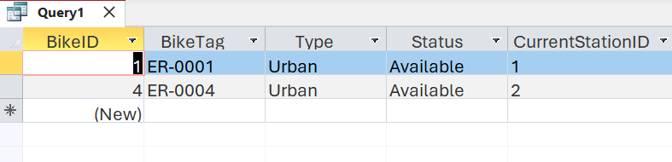
Figure 15: Query Result
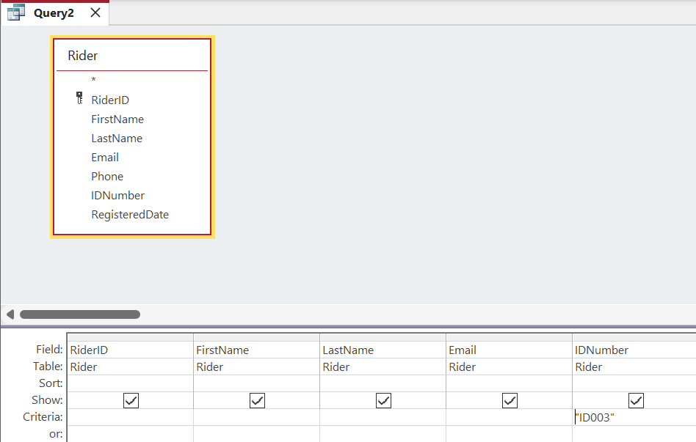
Figure 16: Query Find a Rider with a specific IDNumber
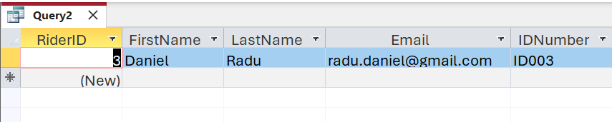
Figure 17: Query Result
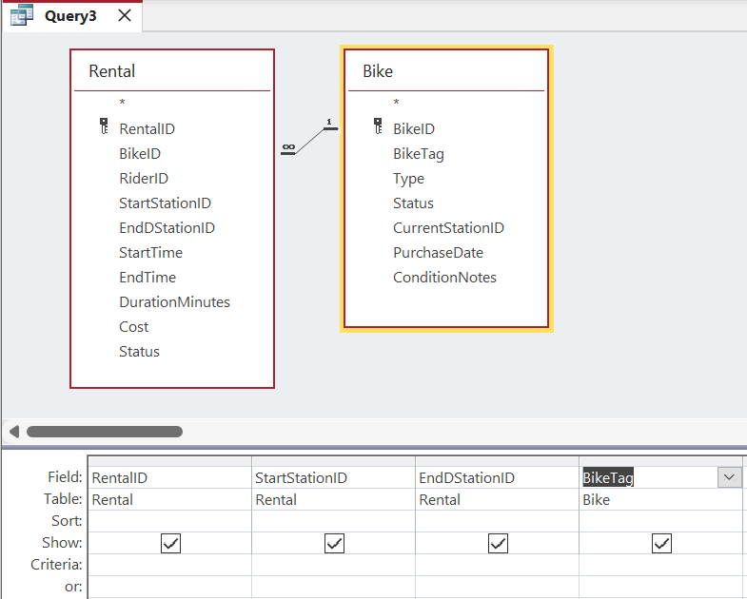
Figure 18: Query show Rental with BikeTag (JOIN Query)
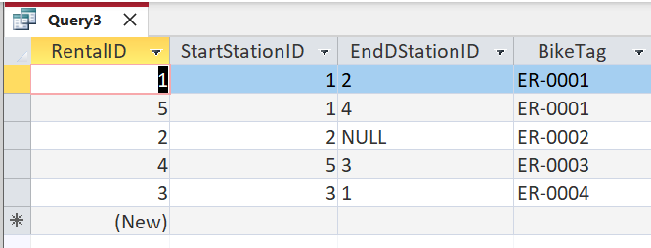
Figure 19: Query result

7.Validation and Testing
This section presents the validation and testing performed on the EcoRide database to ensure data integrity and proper operation. Various scenarios were tested, including referential integrity, uniqueness constraints and validation rules. Screenshots are provided to demonstrate how Microsoft Access enforces these rules and prevents invalid or inconsistent data entry. Each figure includes a brief explanation of the test performed and the expected result.
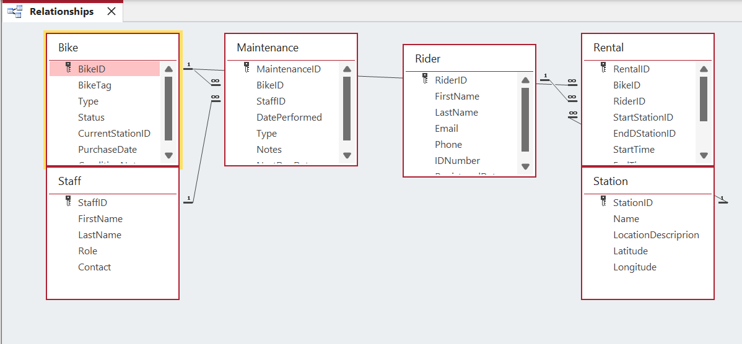
Figure 20: Relationships window with referential integrity enforced
This figure shows the Relationships window in Microsoft Access, where all tables relate to primary and foreign keys. Referential integrity is enforced to prevent invalid records and ensure consistency across the database.
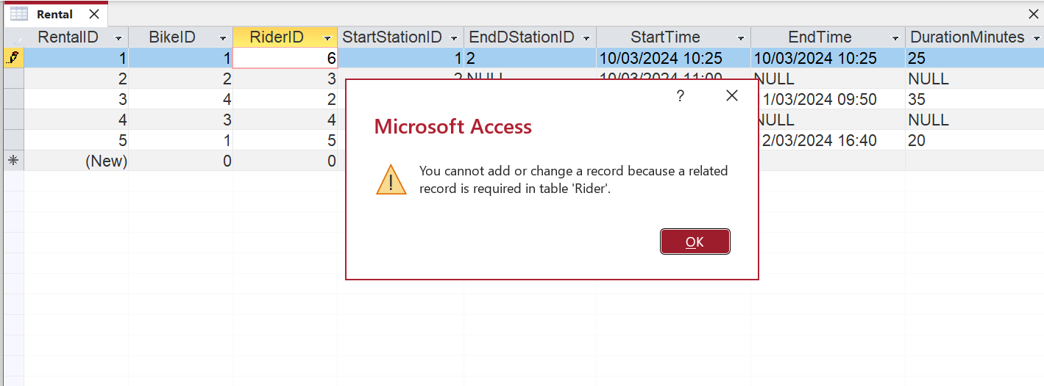
Figure 21: Error preventing insertion of Rental with non-existent Rider_ID
This figure shows in Microsoft Access enforces referential integrity. When attempting to insert a rental record with Rider_ID that does not exist in the Rider table, the system blocks the action and displays an error message. This confirms that the foreign key constraint is working correctly and prevents invalid data from being stored.
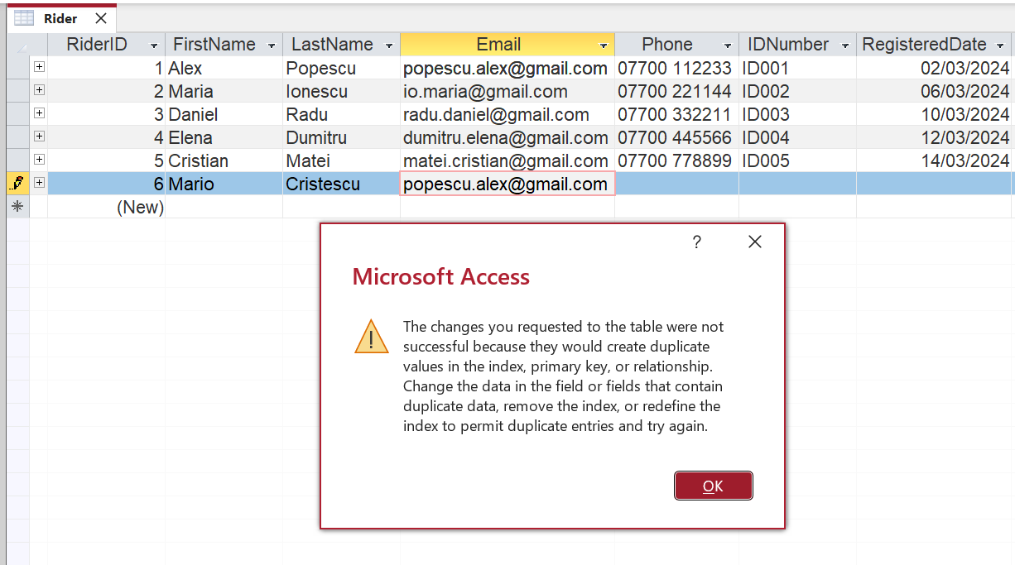
Figure 22: Error prevent duplicate Rider email
This figure shows how Access enforces uniqueness on the Email field. When a duplicate email is entered for a different rider, the system blocks the action, ensuring that each rider has a distinct contact detail.
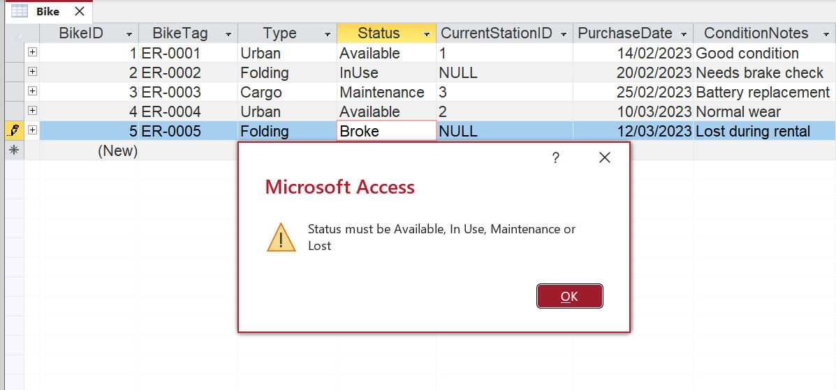
Figure 23: Error message when entering invalid Status value
This figure shows how Access enforces a validation rule on the Status field. When an invalid value such as “Broke” is entered, the system rejects it and displays an error message. This ensures that only predefined statuses (Available, In Use, Maintenance, Lost) are accepted, maintaining data consistency.

Conclusion
The EcoRide database successfully meets all functional and technical requirements. The system provides a structured and reliable way to store and manage data on rider, station, bike, staff, rental and maintenance activities. By applying 3NF normalization, designing clear relationships and implementing referential integrity, the database ensures accuracy, reduces duplication and prevents common operational errors.
Throughout the project, I learned to design relational structures that reflect real-world processes, create queries that extract relevant information, and validate system behaviour through testing. Challenges included understanding how to model nullable fields for active rentals, ensuring the correct application of relationships and learning how query design works in Access.
In the future, the system could be expanded with additional features such as automatic cost calculation, maintenance reminders, intuitive forms and mobile device integration for bike scanning. Overall, the project demonstrates a solid understanding of relational database concepts and their practical implementation with Microsoft Access.

References
[1] TutorialsPoint, "MS Access – Create Relationships," 2024. [Online]. Available: https://www.tutorialspoint.com/ms_access/ms_access_create_relationships.htm
[2] TutorialsPoint, "MS Access – One-to-Many Relationship," 2024. [Online]. Available: https://www.tutorialspoint.com/ms_access/ms_access_one_to_many_relationship.htm
[3] FreeCodeCamp, "Database Normalization – Normal Forms 1NF, 2NF, 3NF," 2025. [Online]. Available: https://www.freecodecamp.org/news/database-normalization-1nf-2nf-3nf-table-examples/
[4] TutorialsPoint, "MS Access – Query Data," 2024. [Online]. Available: https://www.tutorialspoint.com/ms_access/ms_access_query_data.htm

