  Component One:  What are the key skills required when working in the housekeeping team? 750 words (+/- 10%)  Contribution to Overall Module Assessment: 25% | Student No: | 2210756
 | Module Title: | Hotel Placement – Operating Hotel Facilities
 | Module Code: | BMIH4006
 | Lecturer: | Lisa-Marie Bassler
The capacity to work well with others is the most important quality a hotel housekeeper can have. The greater the resort or hotel, the bigger the crew (George and Hancer, 2008). There may be various housekeeping teams, with the least experienced at the bottom and the most seasoned at the top. An excellent housekeeper should work well with others. Therefore, this is an important talent to have. Being reliable is a must-have quality for a hotel housekeeper (Jones and Siag, 2009). One of the most important skills to have as a hotel housekeeper is the ability to multitask. It is not about racing. Because it is easy to make mistakes or overlook important details when you're in a hurry, I can accomplish more if I am on a team by working together effectively. By delegating responsibilities, I can ensure that everything gets done efficiently. Knowledge of cleaning procedures, supplies, and equipment is essential. Housekeepers must pay special attention to detail to ensure everything is cleaned thoroughly and nothing is overlooked. Since many tasks typically need to be completed simultaneously, housekeeping requires strong time management abilities. For projects to be finished on time, it is essential to have the capacity to prioritise tasks, manage time effectively, and work quickly (Nimri et al., 2020). Constant standing, walking, bending, and lifting are among the physical demands of housekeeping. It is necessary to be able to lift big objects repeatedly if you want to succeed in this position.
As a housekeeping staff member at the Crew Hall Hotel and Spa, I was responsible for various tasks. The hotel's guest rooms, common areas, and speciality areas like the spa facilities all benefit from my expertise in cleaning and sanitation. I took great care to ensure that every room was pristine, the beds were made perfectly, the supplies were restocked, and the surfaces were clear of debris. Time management was another ability I honed while working as a member of the housekeeping staff at the Crew Hall Hotel and Spa. To ensure that everything ran smoothly, I got my work done in the allotted time, cleaned up after myself according to the timetable, and communicated with my coworkers. I helped the hotel's housekeeping staff run more smoothly by organising her time more efficiently. My ability to keep things in order was essential to her success. I had to manage my time wisely, assign rooms, keep track of cleaning supplies, and equip the common areas with the necessary amenities. By maintaining order, I helped streamline processes, reduced the number of mistakes made, and ensured that guests had a pleasant stay.
Cleaning methods, sanitation procedures, safety procedures, and compliance with industrial standards are all part of the theoretical knowledge that makes up housekeeping. Cleaning a hotel effectively and efficiently requires familiarity with the finest methods for cleaning various surfaces, materials, and rooms (Brody, 2019). With this information, hosts can keep their establishments spotless and safe for visitors. Housekeeping employees who are well-versed in properly using various cleaning chemicals, tools, and equipment are better equipped to do their duties successfully. This guarantees efficient cleaning and protects fixtures and furnishings from being harmed. The well-being of visitors and employees may be ensured by following established safety procedures (Sharma and Kaushik, 2021). As a result, accidents are reduced, the workplace is kept safe, and health codes are followed.
There are several reasons why housekeeping is so important in the hotel sector. Hotel customers often expect the hotel to be clean and well-kept. Cleanliness and upkeep are important in creating a welcoming and relaxing atmosphere for guests. The quality of housekeeping directly affects guests' overall satisfaction with their stay and their propensity to return or suggest the hotel to others (Anthonisz, 2014). To keep guests healthy and safe, hotels must practise good sanitation practices. A hotel's guests will be healthier and more comfortable if proper housekeeping measures are taken to eliminate the transmission of germs, allergies, and other impurities. A hotel's efficiency depends on a well-oiled housekeeping machine. Housekeeping helps the hotel run smoothly by sticking to cleaning schedules, keeping track of supplies and inventory, and working with other departments (Nimri et al., 2020). Hotels must adhere to all local health and safety laws. Guest satisfaction, fines, legal trouble, and bad press may all be avoided by adhering to cleaning and sanitation regulations. Therefore, a theoretical understanding of housekeeping is essential for ensuring efficient cleaning procedures, compliance with safety requirements, guest happiness, brand reputation, and operational effectiveness in the hospitality business (Bhatnagar and Dheeraj, 2019). A hotel's ability to attract and retain repeat visitors depends on its reputation for cleanliness and comfort.

Word Count | 770

Component Two:
Contribution to Overall Module Assessment: 25%
In this scenario – You have just been promoted to team leader for a floor within the hotel. A guest complained that on their arrival, their room had not been properly cleaned. Create an action plan and answer the following questions.

Problem | Why did it happen? | What are you going to do? | How will you prevent this from happening in the future? | What measures would you introduce to improve team effectiveness?
 | The room was not cleaned because of a misunderstanding between the front desk and the housekeeping staff. | I will apologise for this visitor's trouble, and I promise I'll do my best to fix it as soon as possible. | I would meet with the housekeeping workers to go through their routine, stressing the need to pay close attention to detail and be meticulous. Any deficiencies in knowledge or ability can be remedied with extra training sessions or refresher courses. | I would set high standards of performance for the group. Standards of cleanliness, effective time management, and high levels of customer service are all part of this.
 | Time restrictions, such as high check-ins and check-outs, may have forced the housekeeping staff to speed through cleaning operations or overlook details. | I will personally inspect the room to ensure the claim made by the visitor is accurate, and I'll clean it immediately after that. Make the necessary preparations if an emergency cleaning or room change is needed. | To reduce the possibility of misunderstandings, I would work to improve the cleaning team's internal lines of communication. Cleaning rooms consistently and without error may be achieved through the use of standardised checklists and the provision of clear instructions. | The team's knowledge and productivity may improve through ongoing training and education. I will try to introduce workshops on cleaning methods, customer service, and group dynamics are all possible examples.
 | The housekeeper who serviced the room was not properly briefed on the hotel's expectations for cleanliness. | I offer the visitor options, such as moving them to a different, cleaned room or arranging for a full cleaning of their existing space, depending on the nature of the problem. Any other demands or monetary demands would be taken into account. | Rooms should be inspected, and quality checked frequently. Dedicated personnel or random spot checks are two options for ensuring quality control. | The total efficiency of a team may be raised by encouraging its members to speak freely to one another, develop a mutually supportive team culture, and work together. Hence, I will communicate effectively. Problems, solutions, and opinions may all be discussed and shared during regularly scheduled team meetings.
 | Due to a hiccup in operations, the cleaning staff may have been unable to get to the room and ready it on time. | I will try my best to keep the visitor informed about the progress of the issue's resolution and, if required, make apologies with appropriate payment or goodwill gestures, such as a complimentary lunch or an upgrade. | I want to create a culture where everyone on the team feels free to speak out and take initiative. For me to immediately respond and provide support, I will set up a procedure wherein workers may report any problems they may be anonymously experiencing at work. | As part of my commitment to maintaining a high standard of cleanliness, I plan to perform routine inspections and quality checks of cleaned rooms. Delegate staff members or managers to conduct random spot checks, report to the team and address any issues as soon as possible.
 | The housekeeping staff may miss anything or leave certain areas uncleaned despite their best efforts. | Following the resolution of their first issue, I would contact them again to ensure their future experience is up to par. This shows that you care about your customers' happiness and is a step towards regaining their confidence. | I will address the deficiencies quickly, and the team can use the results as a springboard for further development. | It is crucial for motivation and keeping strong morale to acknowledge and appreciate the team's efforts and accomplishments. I will put in my efforts for a well-implemented system of rewards and recognition because it boosts morale and productivity in the workplace.

Component Three:
Contribution to Overall Module Assessment: 50%
Your task is to create and prepare a presentation following the detailed scenario provided below.

As the floor housekeeping manager and given the recent guest complaints you need to put together a basic training presentation for your colleagues within the housekeeping team to get the best out of them, ensure that brand standard is being achieved and that Health and Safety procedures are also being followed.

Training Notes:
Introduction
Housekeeping is the maintenance of a hygienic, hospitable, secure, and aesthetically beautiful home. Housekeeping duties include cleaning, fixing, and maintaining the hotel's guest rooms, common spaces, back hallways, and outside grounds (Sharma and Kaushik, 2021).
Welcome to the Trinity Hotel’s housekeeping department’s training session!
We aim to run the hotel successfully by offering impeccable services and accommodations through promoting, motivating, and educating team members.
Training Notes:
The Role of Housekeeping
Housekeeping plays an important role in the presentation and reputation of a hotel. The entire hotel must be pristine, which falls to the housekeeping staff. Housekeeping not only makes sure that guest rooms are ready and cleaned promptly but also cleans and maintains the entire hotel to keep it looking as nice as the day it originally opened (Indeed, 2022). The visitor's experience with the hotel is directly impacted by the housekeeping's efforts to give a comfortable room. Hotels often have a bigger cleaning workforce compared to other service areas.
Training Notes:
Significance of brand standards
In the hotel sector of the hospitality business, brand standards are very important. They help hotels maintain uniformity in their procedures, offerings, and overall client satisfaction. They guarantee that clients of different hotels under the same brand will have similar experiences. Hotel customers have come to anticipate a particular standard of service, facilities, and general quality regardless of where they are staying. Customers are more likely to stick with a brand they know what to anticipate. The hotel's reputation can be better safeguarded if brand standards are strictly adhered to (Yang et al., 2015). Guests are more inclined to spread the word about a hotel's excellent service and recommend it to others if they believe the company always delivers on its promises. This praise may do wonders for the company's image and bring in a steady stream of new customers. You need to know your brand standards. What are the current in-room standards for the hotel?
Closet setups
Towel set up.
Amenity tray
Coffee and ice bucket station
Laundry cart setups.
Guest requirements
It is all in the presentation! Everything must be ordered and straight. Fluff up the cushions and furniture. Straight lamp shades are preferred. Everything from turndown service to elegant towel folding is appreciated.
Training Notes:
Health and safety at the hotel
The health and safety of hotel guests and employees is paramount. Protocols and rules are in place at most hotels to ensure guests' well-being. Using the proper disinfectants regularly during cleaning are essential for keeping public spaces, guest rooms, and other high-traffic areas in tip-top shape (Rosemberg, 2020). Keeping abreast of the ever-evolving health condition and the most recent local health legislation is crucial. To ensure the greatest possible levels of safety and health, they adjust their procedures as needed. A thorough cleaning should be performed every three months.
Each property should have binders and a checklist.
Never permit someone to enter a room for the protection of our visitors. Visitors must register at the front desk.
Why is this crucial?
What further safety concerns do you have?
Training Notes:

Cleaning and sanitation
The cleaning staff at the hotel play a crucial role in ensuring visitors are provided with a clean and sanitary environment. Housekeeping staff are responsible for maintaining a spotless and orderly environment throughout the hotel. Use only cleaning supplies and disinfectants tested and shown to be effective against the germs of concern (Gupta et al., 2022). They adhere to the health department's and the hotel's specified cleaning processes and requirement to maintain proper sanitations.
Pathogens (germs) must be eliminated using a chemical agent and heat.
Washing surfaces with a sanitising solution is one method of disinfecting them.
Daily disinfection of the telephone and television remote is also required.
Carpet and drapery vacuuming, furniture dusting, desk wiping, and mildew (an odour-causing fungus) prevention
Mildew develops on wet materials, including window sills, flooring, and shower curtains.
Training Notes:
Engagement model
The Aon Hewitt Employee Engagement Model is a well-known tool for gauging and boosting morale in the workplace (Padhi et al., 2015). This framework identifies the top four causes of employee engagement and offers recommendations on how businesses may improve each.
Leadership: Employee engagement is greatly aided by strong leadership. Leaders must motivate their staff by painting a compelling picture of the future. In addition, they should encourage open lines of communication, praise people for their contributions, and help them advance in their careers.
Performance: This motivator centres on ensuring workers know what is expected of them and giving them access to the tools, training, and resources they need to do their tasks well (Bhuvanaiah and Raya, 2014). Employees may only get insight into their performance and be guided towards improvement with the help of regular feedback and performance talks.
Culture: When the atmosphere at work is upbeat, people are more likely to help one another out and feel like they belong there. Improving the hospitality industry's culture may entail encouraging workers to go above and beyond to satisfy guests.
Reward and recognition: Employee motivation and engagement may be greatly improved by publicly acknowledging and recognising good work. Bonuses, promotions, public acknowledgement, and possibilities for professional growth are all examples of such incentives.
Training Notes:
Example
Only Marriott International has achieved this double honour (Best Global Employer 2017 and be. Over 800,000 people at 6,400 global firms are the focus of research conducted by Aon plc, a global workforce, retirement, and health solutions organisation (Bureau, 2017). Marriott has always emphasized fostering its culture of cooperation, achievement, and charitable giving. Marriott's commitment to its employees and the importance it places on their well-being are reflected in how the firm operate. The Aon Best Employers programme evaluates businesses too single out those that emphasise their employees as a strategic asset. The high levels of employee engagement, engaging employer brand, effective leadership, and high-performance culture of Marriott International in India were evaluated. Marriott, as a market leader, is committed to ensuring the vision is maintained by being an improvement driver and committing to the finest employee practices in the industry.
Training Notes:
Additional responsibilities
Beyond basic upkeep like dusting and mopping, the housekeeping staff is responsible for various duties that contribute to the hotel's pleasant environment for guests. Your work helps make the hotel a warm and inviting place where guests may relax. Cleaning standards can be enforced by routine inspections of guest rooms, common areas, and individual workplaces (Sadhale, 2021). They routinely inspect the product for flaws, fix problems, and do extensive quality assurance checks. You will need to do everything you can to keep the hotel secure. If the crew notices anything unusual, they must notify the hotel management or local authorities immediately. Also, ensure there is a way out in an emergency and the proper procedures are followed.
Maintains a record of who has stayed in each room and when.
Controls all pass keys used by Room Attendants.
Distributes cleaning materials.
Maintains and files Room Attendant Worksheets.
Inspects a Sample of Rooms Declared Clean by Room Inspectors
Projects including dusting high shelves, cleaning air conditioning ducts, scrubbing out rust from toilet bowls, shampooing carpets, and vacuuming drapes should be scheduled and assigned regularly.
Training Notes:
Conclusion
This training provided you with an analysis of the important strategies and procedures you must ensure while working at the hotel. The significance of adhering to brand standards and health and safety regulations has been made clear during this training. You can use these tactics to create a welcoming environment for your fellow employees and our visitors.
We appreciate your commitment to giving our customers excellent service.

References

Almanza, B.A., Kirsch, K., Kline, S.F., Sirsat, S., Stroia, O., Choi, J.K. and Neal, J., (2015). How clean are hotel rooms? Part II: examining the concept of cleanliness standards. Journal of environmental health, 78(1), pp.14-19.
Anthonisz, A., (2014). Assessing the future of housekeeping operations in Dubai’s five-star hotel industry–room for innovation?. Worldwide hospitality and tourism themes.
Bhatnagar, E. and Dheeraj, N., (2019). Impact of housekeeping services and practices on customer satisfaction and repeat business. Prabandhan: Indian Journal of Management, 12(8), pp.46-57.
Bhuvanaiah, T. and Raya, R.P., (2014). Employee engagement: Key to organizational success. SCMS journal of Indian Management, 11(4), p.61.
Brody, D., (2019). Housekeeping by design: Hotels and labor. University of Chicago Press.
Bureau, O. (2017) Aon Hewitt recognises Marriott International as best employer in India & Best Global Employer 2017, BW Hotelier. Available at: https://bwhotelier.businessworld.in/article/AON-Hewitt-Recognises-Marriott-International-as-Best-Employer-in-India-Best-Global-Employer-2017/12-05-2017-118067/ (Accessed: 12 June 2023).
Choi, J., (2019). Is cleanliness really a reason for consumers to revisit a hotel?. Journal of Environmental Health, 82(5), pp.16-22.
George, R.T. and Hancer, M., (2008). Housekeeping managers and the administration of housekeeping service. International journal of hospitality & tourism administration, 9(4), pp.365-383.
Gupta, V., Roy, H., Chhabra, M., Sanchez‐Canizares, S.M. and Sahu, G., (2022). How the sanitation dimensions impacts consumer perceptions and emotions in five-star hotels due to COVID-19 pandemic?. International Journal of Tourism Cities.
Indeed (2022) What does a hotel housekeeper do | indeed.com. Available at: https://www.indeed.com/career/hotel-housekeeper (Accessed: 12 June 2023).
Jones, P. and Siag, A., (2009). A re-examination of the factors that influence productivity in hotels: A study of the housekeeping function. Tourism and Hospitality Research, 9(3), pp.224-234.
Lucy (2020) Top skills of a great hotel housekeeper, Polo & Tweed. Available at: https://poloandtweed.com/blog/top-skills-of-a-great-hotel-housekeeper (Accessed: 12 June 2023).
Mohanty, A. and Mohanty, S., (2018). The impact of communication and group dynamics on teamwork effectiveness: The case of service sector organisations. Academy of Strategic Management Journal, 17(4), pp.1-14.
Nimri, R., Kensbock, S., Bailey, J., Jennings, G. and Patiar, A., (2020). Realizing dignity in housekeeping work: Evidence of five star hotels. Journal of Human Resources in Hospitality & Tourism, 19(3), pp.368-387.
Padhi, B. and Panda, D.A.K., (2015). A study on employee engagement models for sustainability of organisation. Padhi, B. and Panda, AK (2015)." A Study on Employee Engagement Models for Sustainability of Organisation". International Journal of Research and Development-A Management Review (IJRDMR), 4(4), pp.79-85.
Park, H., Kline, S.F., Kim, J., Almanza, B. and Ma, J., (2019). Does hotel cleanliness correlate with surfaces guests contact?. International Journal of Contemporary Hospitality Management.
Rosemberg, M.A.S., (2020). Health and safety considerations for hotel cleaners during Covid-19. Occupational Medicine, 70(5), pp.382-383.
Sadhale, M., (2021). The Changing Role of Housekeeping Department in Hotels Post COVID-19 Pandemic. Eureka Publications.
Sharma, S. and Kaushik, T., (2021). Aesthetically clean to clinically clean–A study on new housekeeping practices in Delhi hotels beyond COVID-19 pandemic. Worldwide Hospitality and Tourism Themes, 13(5), pp.646-659.
Sharma, S. and Kaushik, T., (2021). Aesthetically clean to clinically clean–A study on new housekeeping practices in Delhi hotels beyond COVID-19 pandemic. Worldwide Hospitality and Tourism Themes, 13(5), pp.646-659.
Yang, J.T., Wan, C.S. and Wu, C.W., (2015). Effect of internal branding on employee brand commitment and behavior in hospitality. Tourism and Hospitality Research, 15(4), pp.267-280.
Zemke, D.M.V., Neal, J., Shoemaker, S. and Kirsch, K., (2015). Hotel cleanliness: will guests pay for enhanced disinfection?. International Journal of Contemporary Hospitality Management, 27(4), pp.690-710.

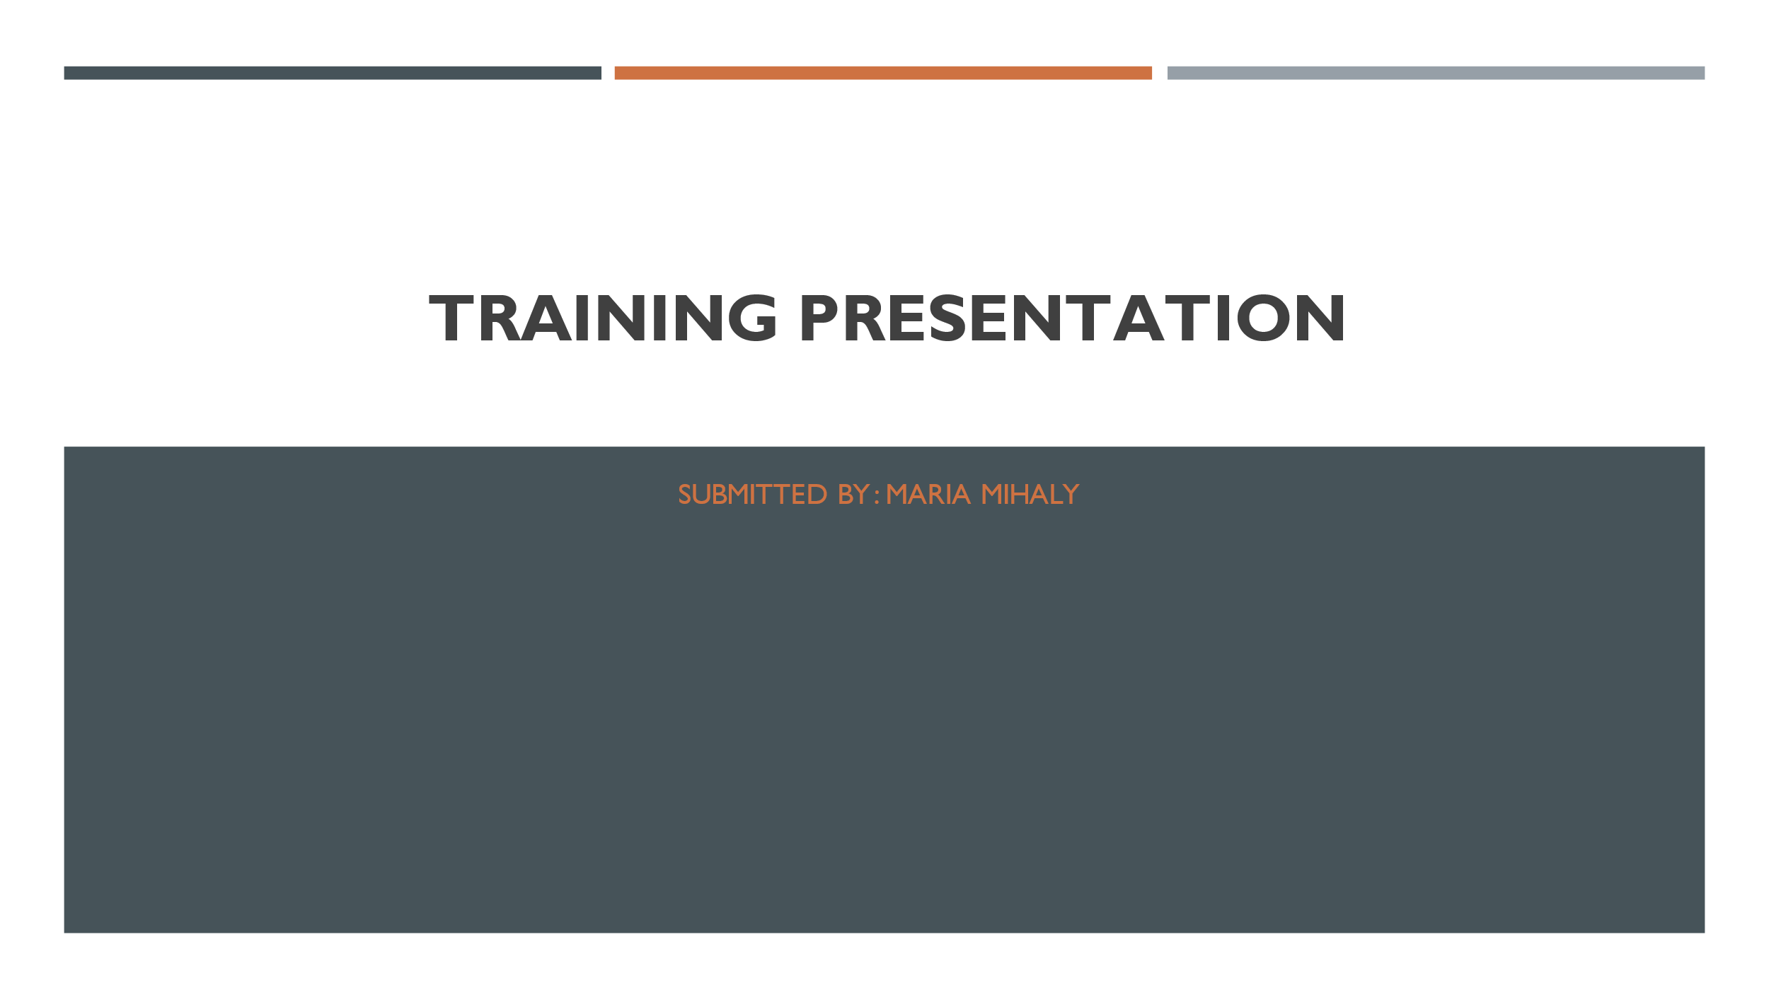
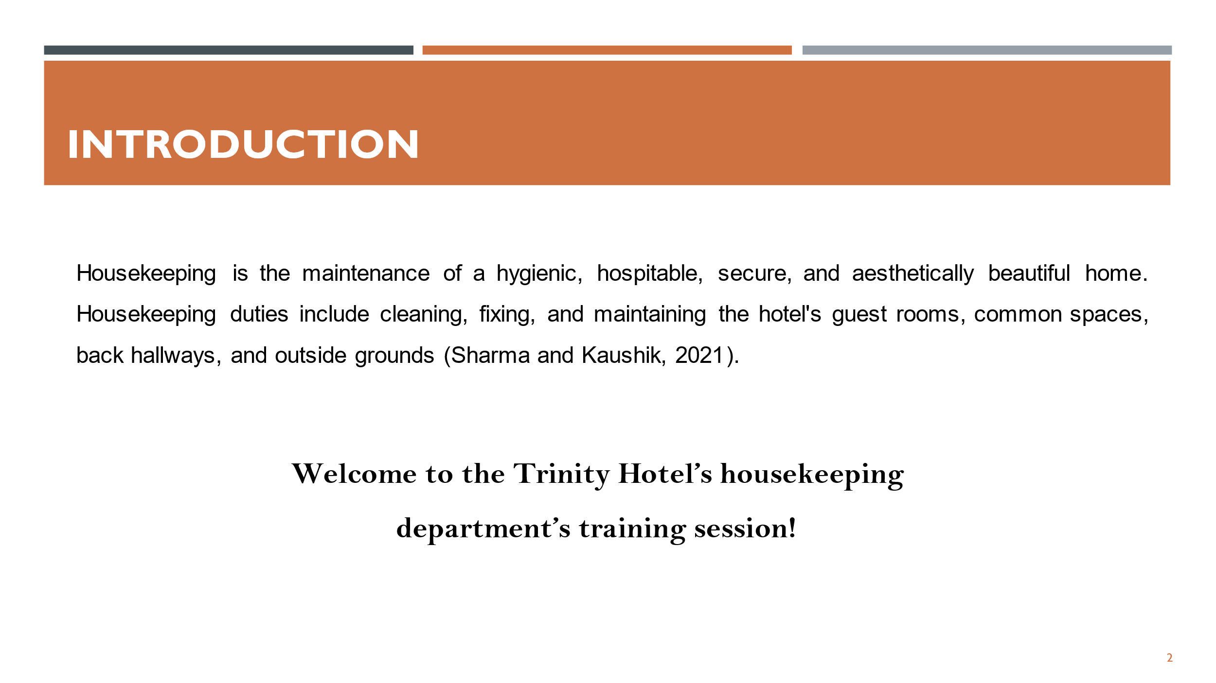
We aim to run the hotel successfully by offering impeccable services and accommodations through promoting, motivating, and educating team members.
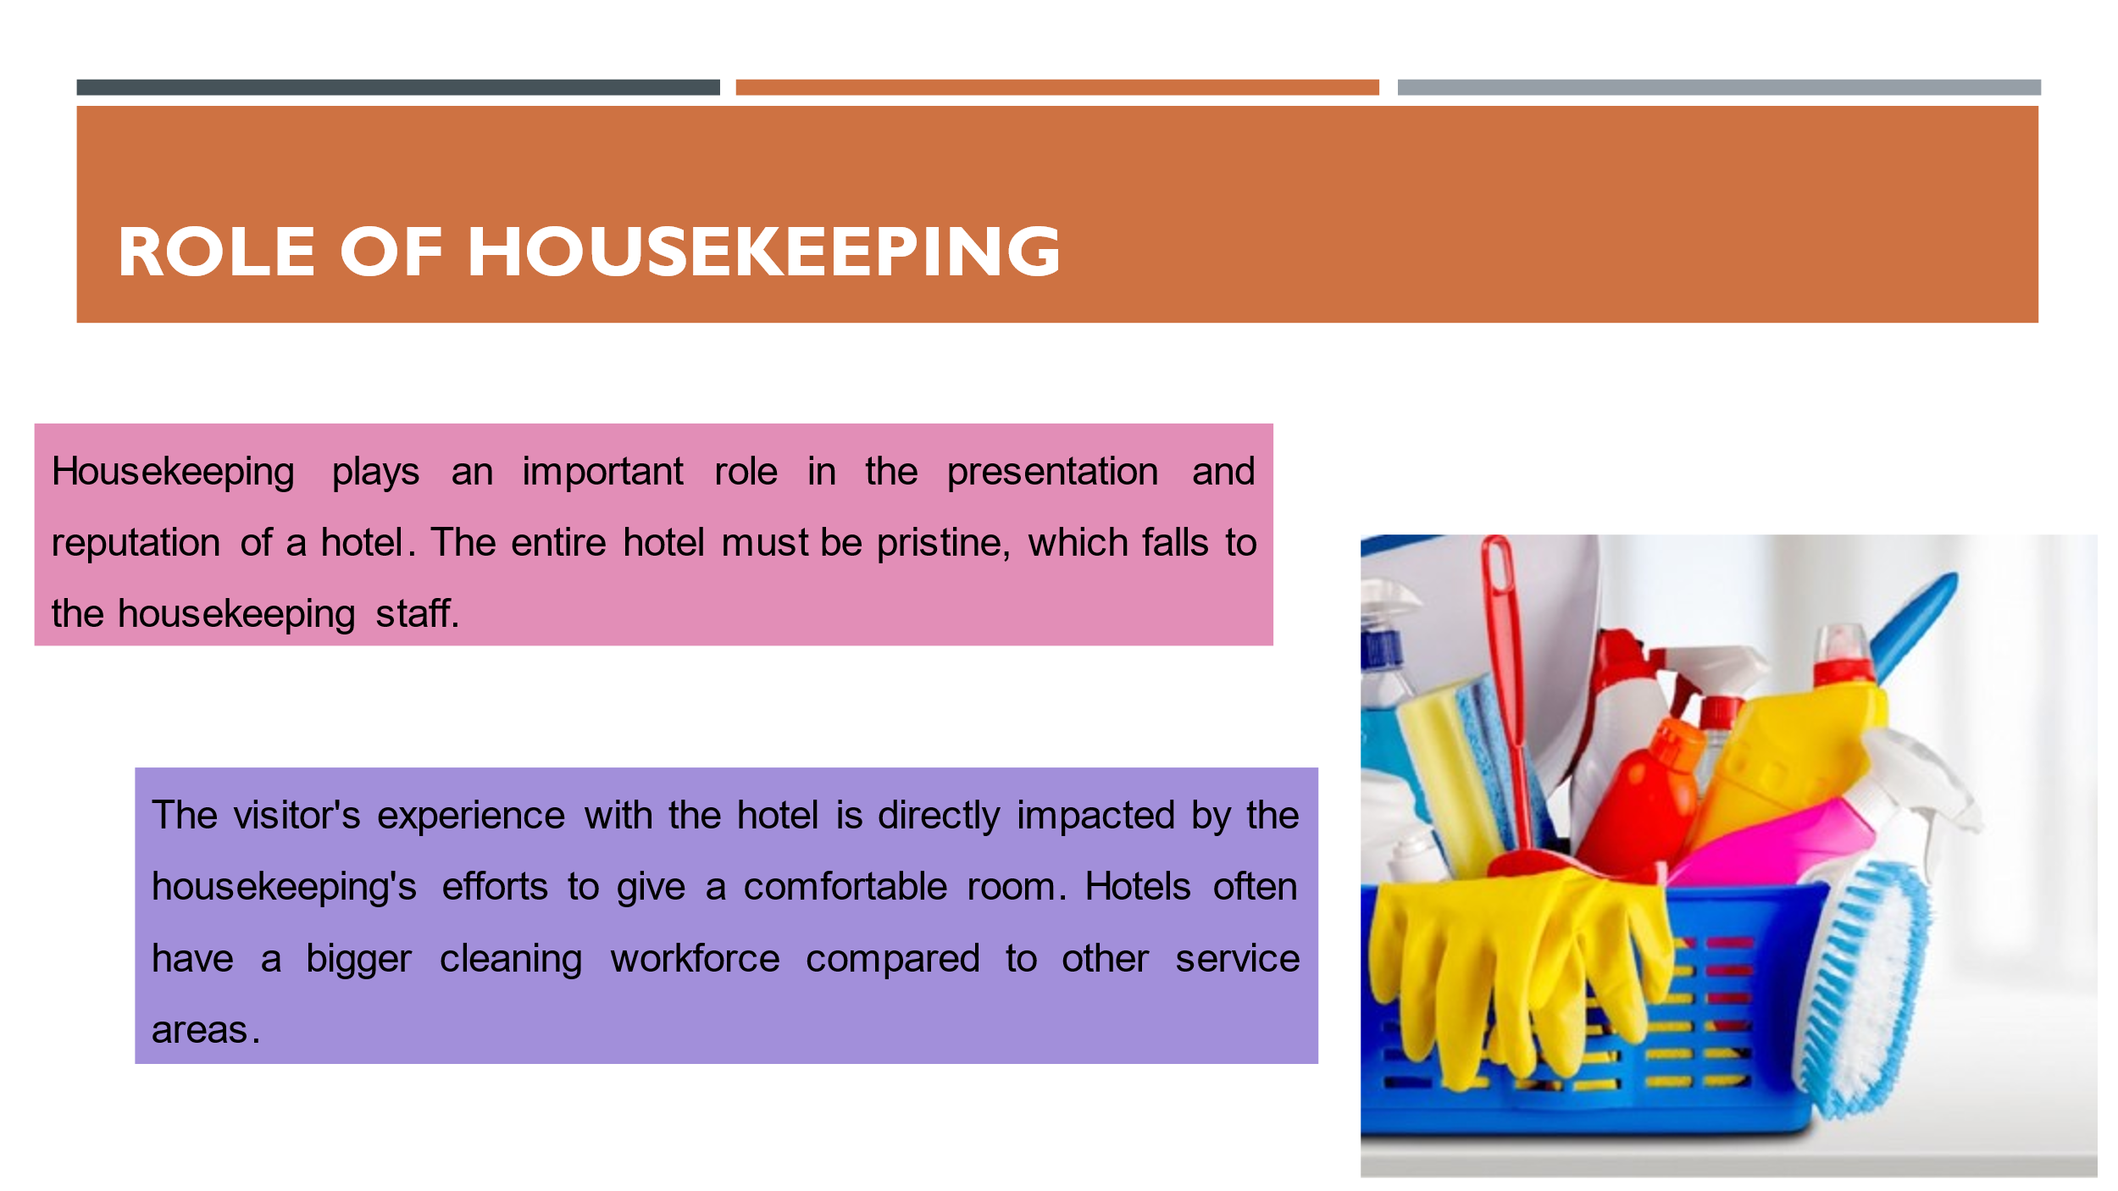
Housekeeping not only makes sure that guest rooms are ready and cleaned promptly but also cleans and maintains the entire hotel to keep it looking as nice as the day it originally opened (Indeed, 2022).
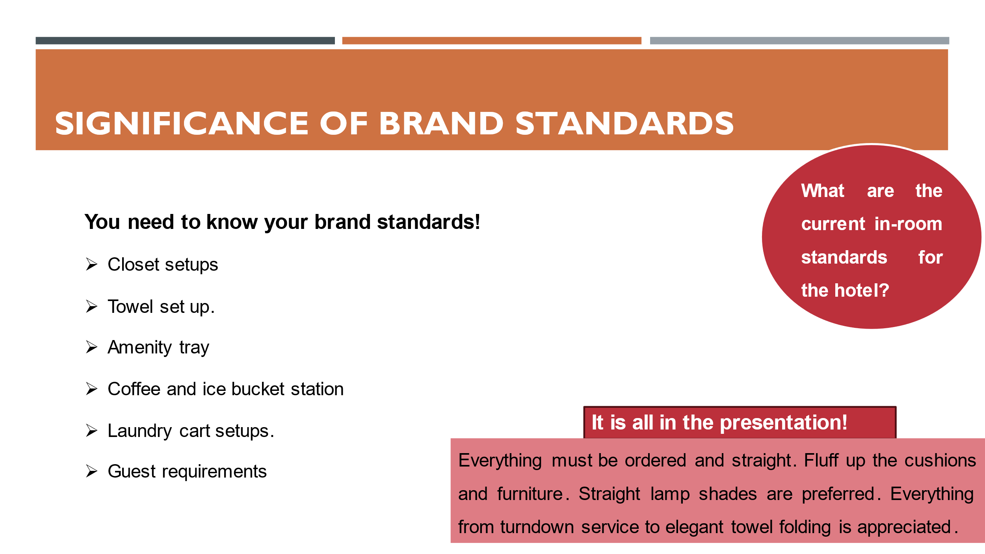
In the hotel sector of the hospitality business, brand standards are very important. They help hotels maintain uniformity in their procedures, offerings, and overall client satisfaction. They guarantee that clients of different hotels under the same brand will have similar experiences. Hotel customers have come to anticipate a particular standard of service, facilities, and general quality regardless of where they are staying. Customers are more likely to stick with a brand they know what to anticipate. The hotel's reputation can be better safeguarded if brand standards are strictly adhered to (Yang et al., 2015). Guests are more inclined to spread the word about a hotel's excellent service and recommend it to others if they believe the company always delivers on its promises. This praise may do wonders for the company's image and bring in a steady stream of new customers.
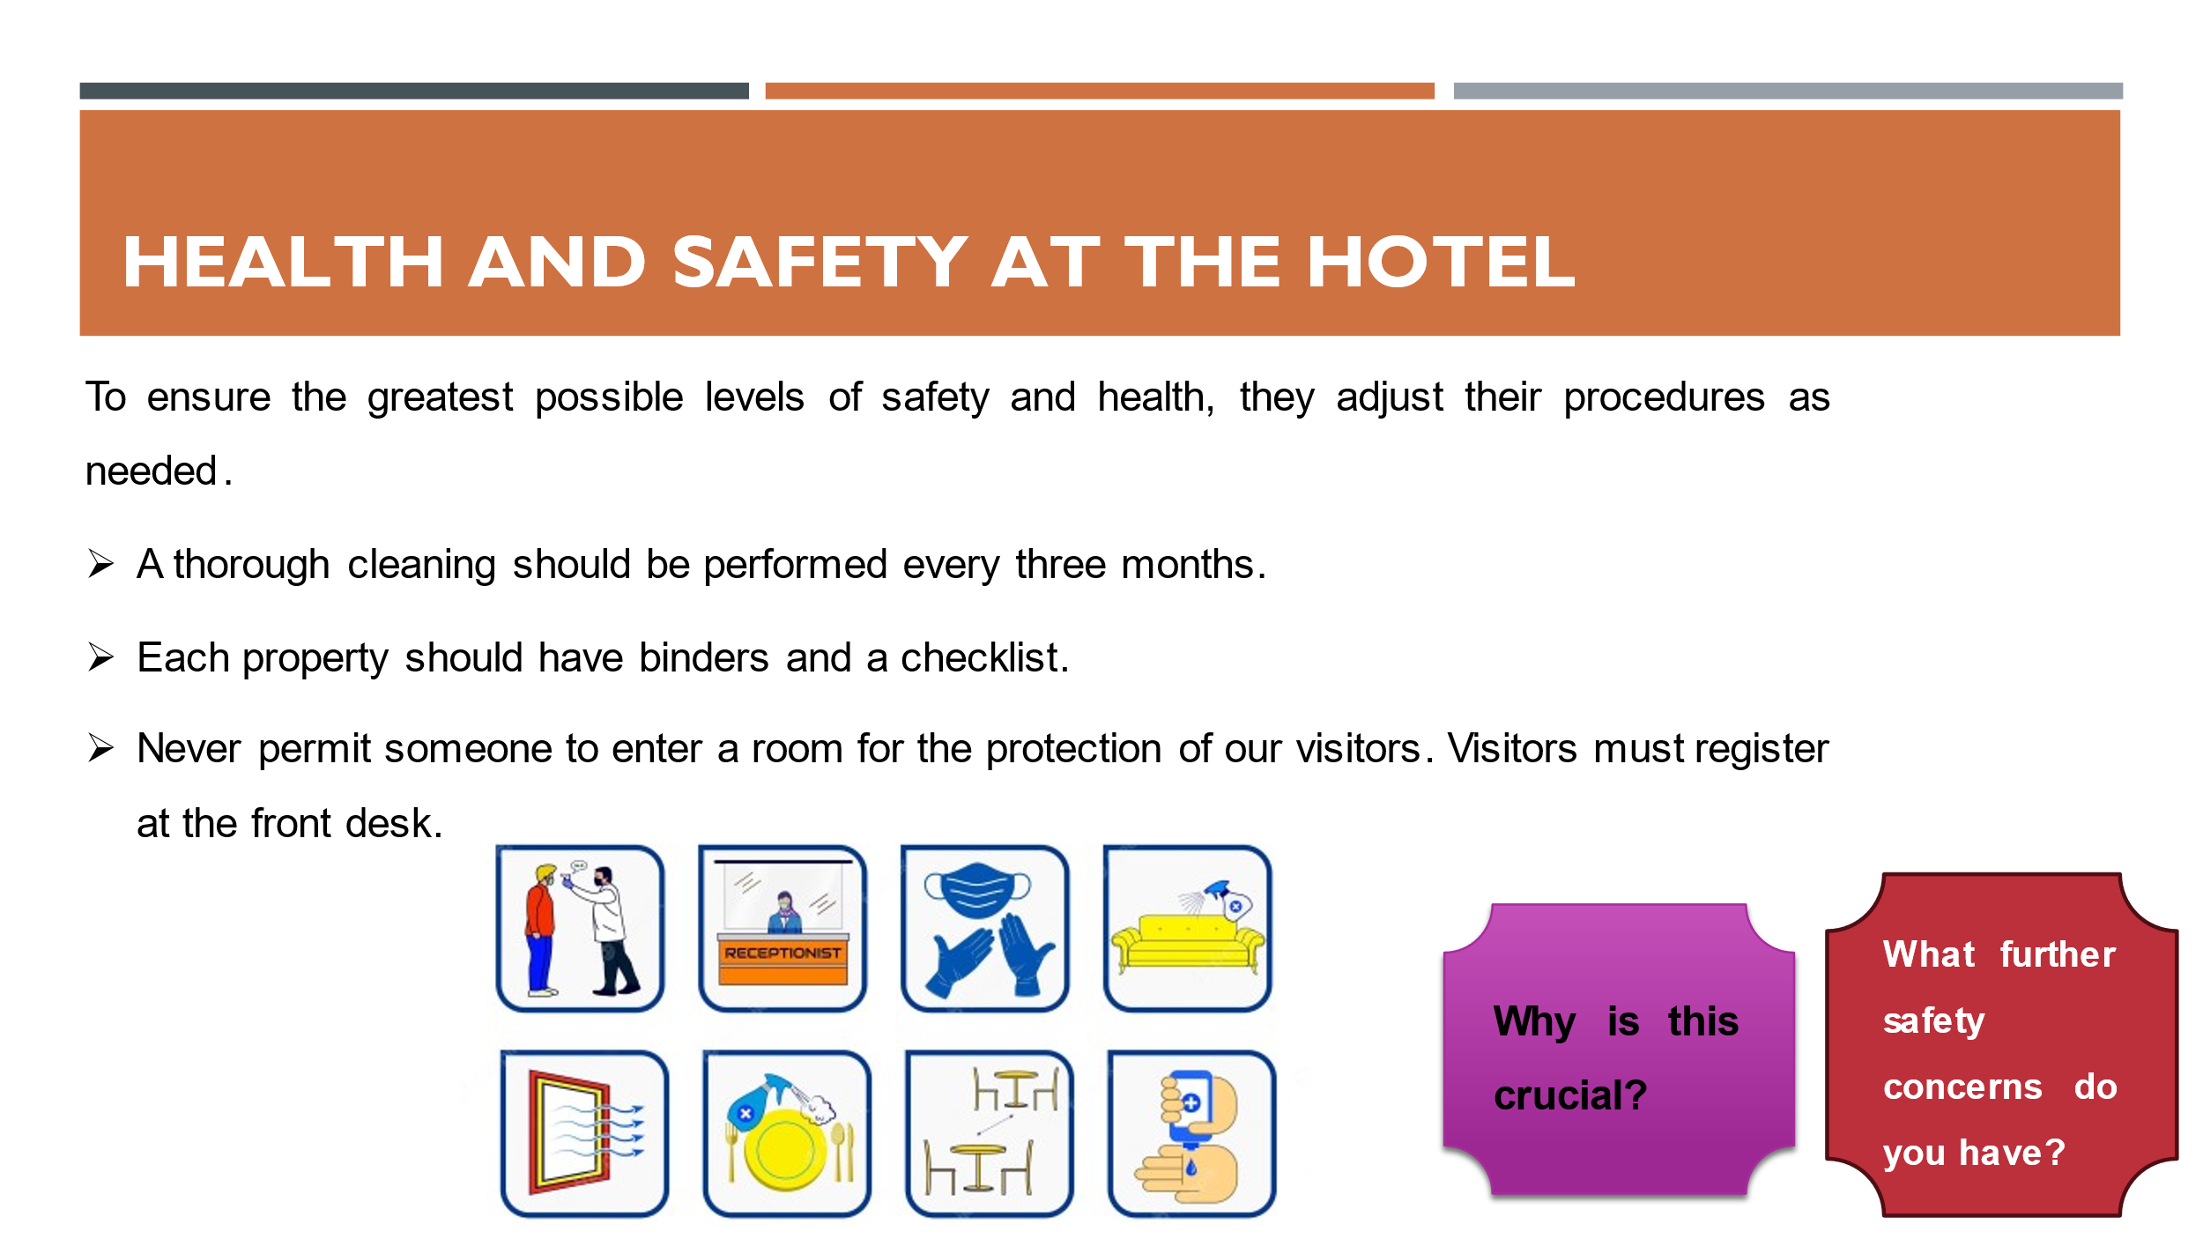
The health and safety of hotel guests and employees is paramount. Protocols and rules are in place at most hotels to ensure guests' well-being. Using the proper disinfectants regularly during cleaning are essential for keeping public spaces, guest rooms, and other high-traffic areas in tip-top shape (Rosemberg, 2020). Keeping abreast of the ever-evolving health condition and the most recent local health legislation is crucial.
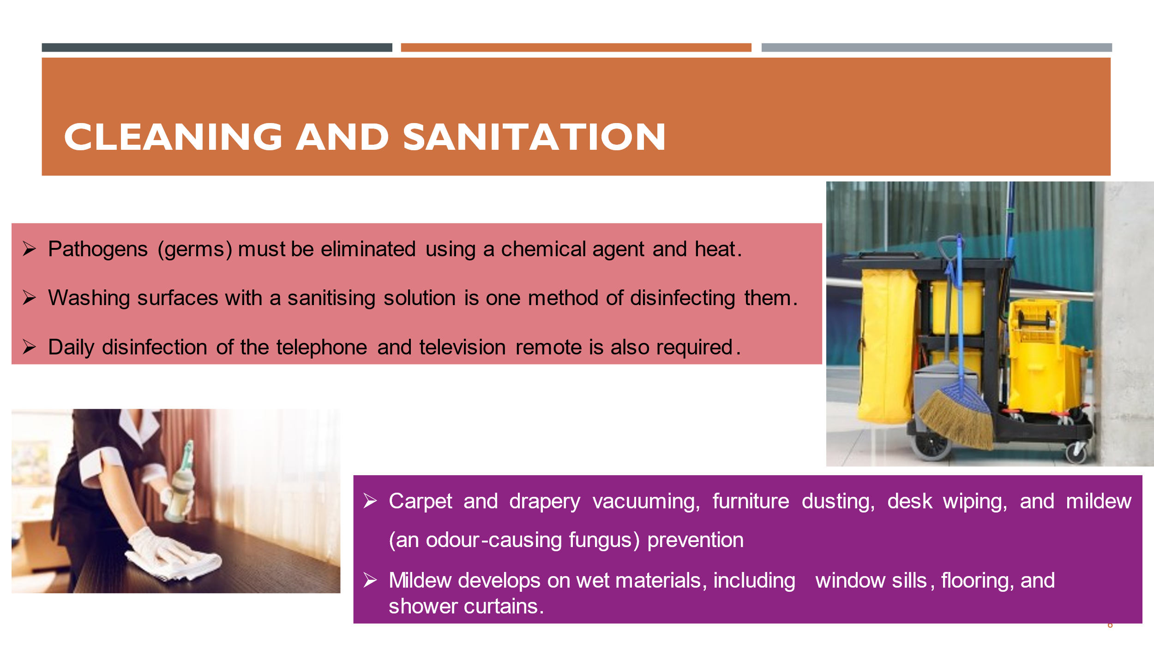
The cleaning staff at the hotel play a crucial role in ensuring visitors are provided with a clean and sanitary environment. Housekeeping staff are responsible for maintaining a spotless and orderly environment throughout the hotel. Use only cleaning supplies and disinfectants tested and shown to be effective against the germs of concern (Gupta et al., 2022). They adhere to the health department's and the hotel's specified cleaning processes and requirement to maintain proper sanitations.
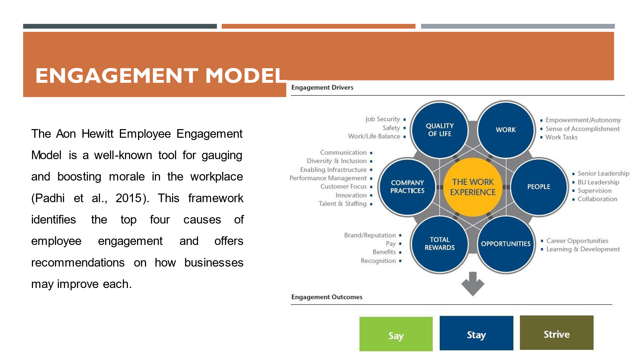
Leadership: Employee engagement is greatly aided by strong leadership. Leaders must motivate their staff by painting a compelling picture of the future. In addition, they should encourage open lines of communication, praise people for their contributions, and help them advance in their careers.
Performance: This motivator centres on ensuring workers know what is expected of them and giving them access to the tools, training, and resources they need to do their tasks well (Bhuvanaiah and Raya, 2014). Employees may only get insight into their performance and be guided towards improvement with the help of regular feedback and performance talks.
Culture: When the atmosphere at work is upbeat, people are more likely to help one another out and feel like they belong there. Improving the hospitality industry's culture may entail encouraging workers to go above and beyond to satisfy guests.
Reward and recognition: Employee motivation and engagement may be greatly improved by publicly acknowledging and recognising good work. Bonuses, promotions, public acknowledgement, and possibilities for professional growth are all examples of such incentives.
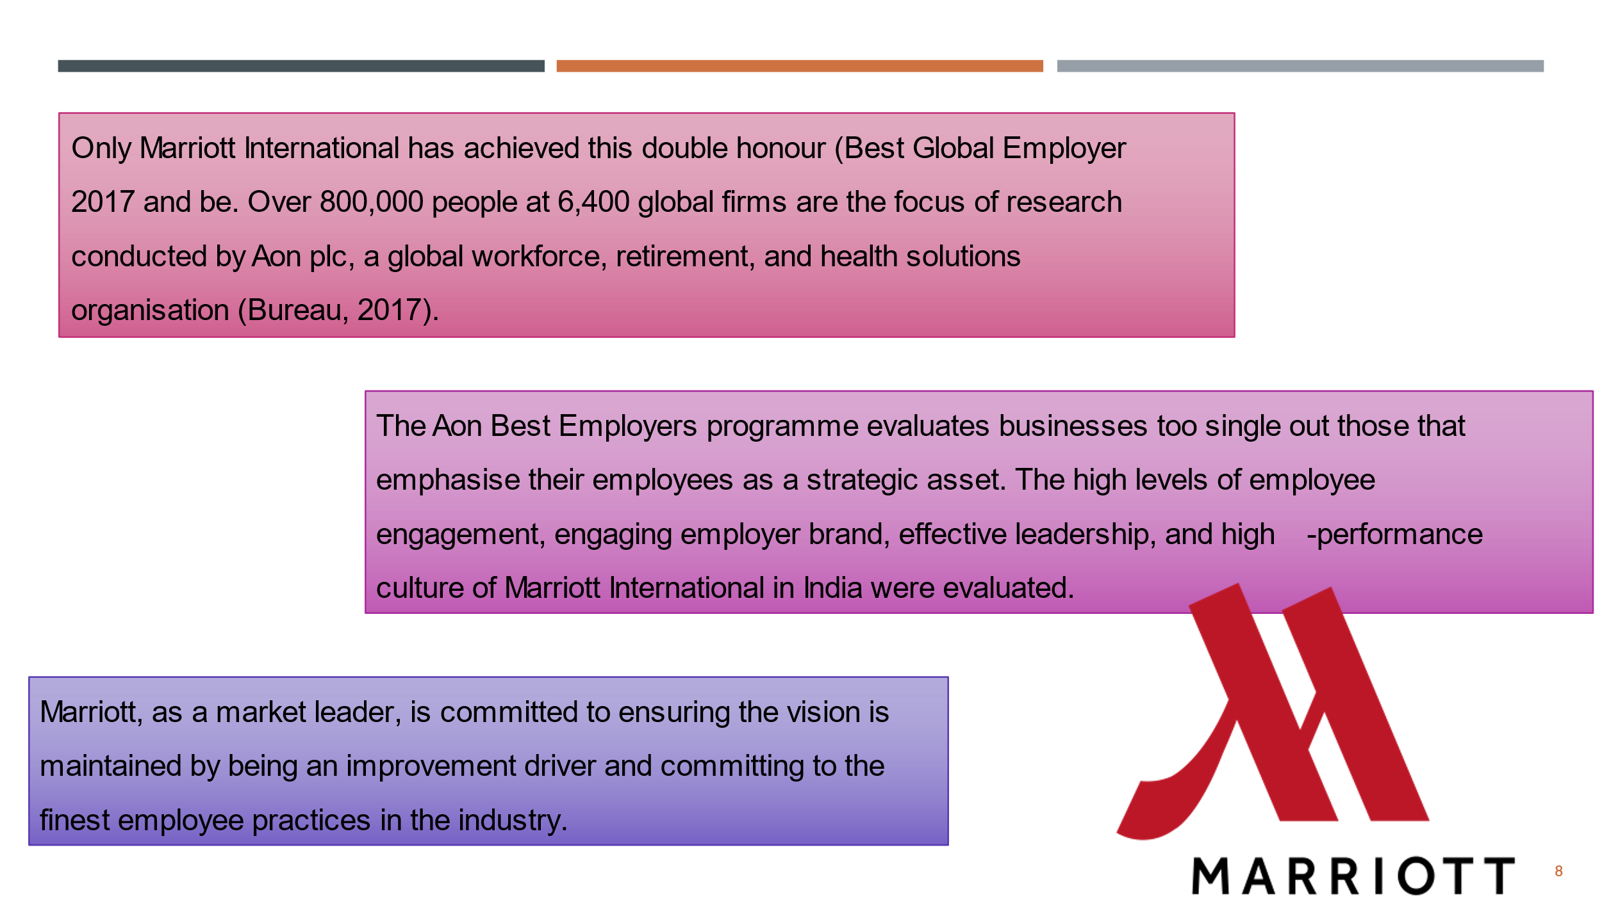
Marriott has always emphasized fostering its culture of cooperation, achievement, and charitable giving. Marriott's commitment to its employees and the importance it places on their well-being are reflected in how the firm operate.
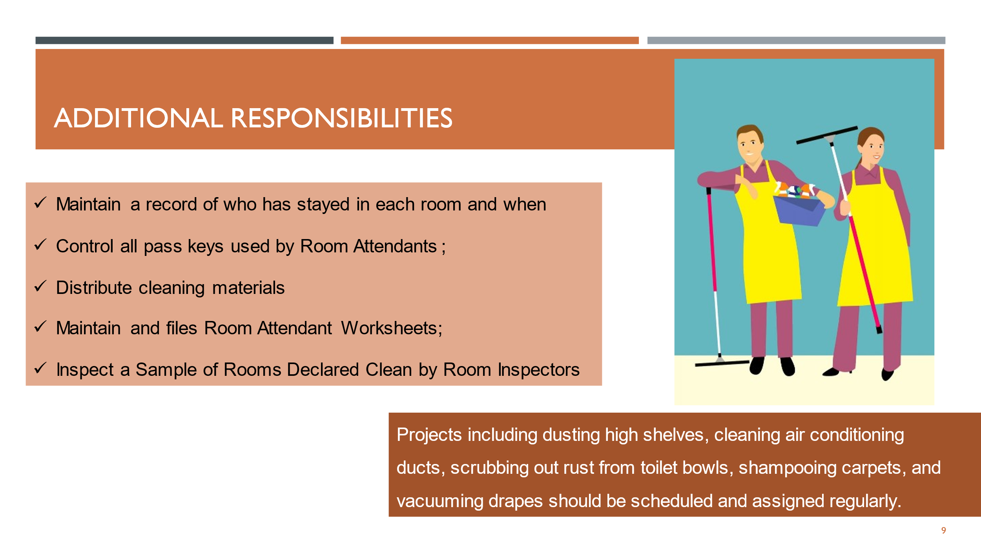
Beyond basic upkeep like dusting and mopping, the housekeeping staff is responsible for various duties that contribute to the hotel's pleasant environment for guests. Your work helps make the hotel a warm and inviting place where guests may relax. Cleaning standards can be enforced by routine inspections of guest rooms, common areas, and individual workplaces (Sadhale, 2021). They routinely inspect the product for flaws, fix problems, and do extensive quality assurance checks. You will need to do everything you can to keep the hotel secure. If the crew notices anything unusual, they must notify the hotel management or local authorities immediately. Also, ensure there is a way out in an emergency and the proper procedures are followed.



