Module: Management Economics
Module code: LCBB5003
Assignment Title: Assessment 1

Student name: Ivan Todorov Todorov
Student ID: 2023561

Table of Contents
Introduction 3
Unilever and Its Main Products 4
Factors Influencing Demand 5
Demand and Market Equilibrium 5
Factors Influencing the Price Elasticity of Demand 9
Price Elasticity of Demand 9
Substitution Effect 10
Income effect 11
The pricing policy Unilever should Employ 11
Conclusion 13
References 14

List of Figures
Figure 1: Demand and Market Equilibrium 5
Figure 2: Effect of substitute price in demand 6
Figure 3: Effect of complement price in demand 7
Figure 4: Income effect on normal and Inferior Goods 8
Figure 5: Price Elasticity of Demand 10

List of Tables
Table 1: Financial data of Unilever 4

Introduction
Unilever is the chosen company which is the largest manufacturer of soaps and other items. Here one product is selected for the research as focusing on a single product will be less complicated. Otherwise, it will be tough to go through with the huge range of products that are produced by Unilever. In the beginning, the demand and market equilibrium will be explained in this report. There are some factors that can influence the demands of a specific product depending on the situation. The factors and how they can indicate the demand increasing or decreasing will be discussed thoroughly. The demand can be more elastic or more inelastic and the way factors indicate the elasticity is also a concern of this report. All this along with government policy can change the managerial decisions of an organization.

Unilever and Its Main Products
Unilever is one of the biggest companies in the world that belongs to the first-moving consumer goods industry. There is a huge range of products that are served to customers in almost 190 countries (Ons.gov.uk, 2022). It is a British multinational company which has been founded in 1929. The headquarters are situated in London, England and also the company has been listed on London Stock Exchange. Foods and Refreshments, Home Care, and Beauty & Personal Care are three sub-categories of Unilever. It owns 400 brands that together concentrate on ensuring a worthwhile living for the consumers (Unilever, 2022). In recent years, Unilever is focusing to be carbon neutral so that it can be more environmentally friendly. The popular products of Unilever are soaps, shampoo, detergent, shower gel, conditioner, body lotion, toothpaste, ice cream, beverage, desserts and so on. Appropriate business models, organizational structure and perfect strategies that match the current situation are their main strengths to reach the highest ranking position and compete with their rivalry (Salvatore, 2018). Here the main product is the soap that is selected to analyze the demand and market equilibrium. Soap is the main produced item of Unilever so choosing soap will uphold an understanding of the factors that affect the demand for soap and these factors will perfectly identify whether the demand for the product is more elastic or more inelastic. In the below table, the financial data are in € (Millions).
Particulars | 2021 | 2020 | 2019 | 2018 | 2017
Sales | 52444 | 50724 | 51980 | 50982 | 53715
Share Capital | 17,107 | 15,266 | 420 | 464 | 484
Profit | 6,621 | 6,073 | 6,026 | 9,788 | 6,486
Employees | 148,044 | 148,949 | 149,867 | 154,848 | 161,000
Table 1: Financial data of Unilever
Source: (Statista, 2022)

Factors Influencing Demand

Demand and Market Equilibrium
At the equilibrium point, demand and supply of any particular product get balanced and prices reach a stable position (Salvatore, 2018). When demand increases, the price goes up until it reaches the equilibrium point. Similarly, when the demand decrease, the price goes down at that time people get that product at a relatively lower cost. In the below graph, the equilibrium point is where the demand and supply curves intersect with each other (Starr, 2017). As more people demand the product but the amount of supply is limited, it affects the company in which it is produced. Here the main product is the soap that is manufactured by the biggest company Unilever. The demand for the soap fluctuates frequently. There are several factors that influence demand and even the factors indicate whether demand is increasing or not (Cubbin, 2013).

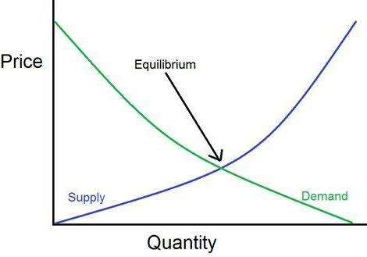
Figure 1: Demand and Market Equilibrium
Source: (Starr, 2017)
Price of Substitute: Substitute refers to a product or service that can be replaced by another product or service, but the satisfaction level still remains the same whether from a price perspective or quality perspective (Salvatore, 2018). When any substitute of a necessary product can be found at a lower price, Consumers can switch their products for cost-minimizing. There are some substitutes for Unilever soap that are produced by different companies in which they include new ingredients and they are more consumer-friendly in their pricing structure (Liu, 2013). When any new product is launched, consumers want to try the new products. Johnson & Johnson and Procter & Gamble also have a good range of soap bars and customers are quite satisfied with them. They are also trying to reduce their expenses by making different plans. As the competitors are focusing more on innovating new substitutes and keeping the price lower, this can affect the demand for soaps (Salvatore, 2018). Even these companies are producing alternatives to soaps such as body wash or shower gel. People who prefer very gentle products can switch to other companies if they get a similar kind of service at a lower price (Cubbin, 2013).

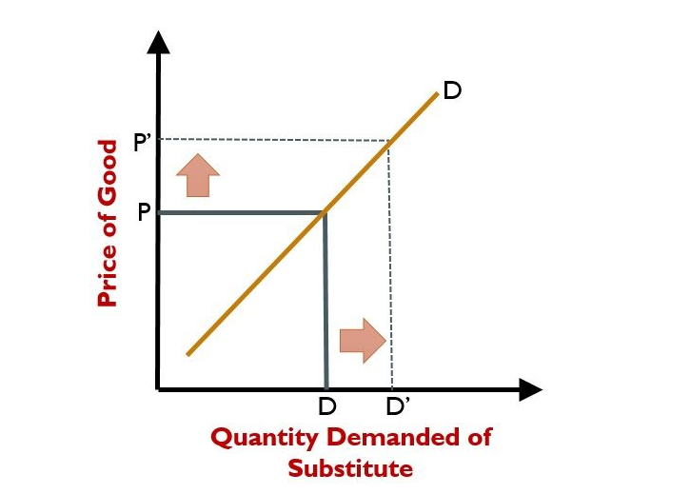
Figure 2: Effect of substitute price in demand
Source: (Spiegel, Benzion and Shavit, 2018)
Price of Complements: When a product changes the value of another product, this is called complements. The existing product becomes more worthy when something adds value to it. For getting more facilities in the form of complementary products, consumers agree to pay more. A specific product is strongly related to its complementary product that cannot be used without each other (Spiegel, Benzion and Shavit, 2018). There is an inverse relationship between them. When the price of complement increases, demand for the main product decreases. That means this factor can influence the demand for that main product. Here soap of Unilever is considered as the main product and the complements can be soap dishes or soap dispensers and vice-verses. That means they are interdependent and can affect the demand. For example, if the prices of soap dishes and soap dispensers increase, people may stop using soaps and switch to other body wash or shower gel that can be easily used without purchasing any soap dish. As they cannot use soaps without soap dishes, a price hike in soap dishes can reduce the demand for soaps (Unilever, 2022). The price of soap dishes and dispensers is increasing day by day so consumers prefer alternative options. Hence Unilever should focus on this factor.
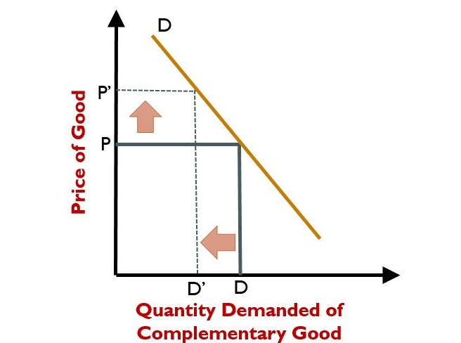
Figure 3: Effect of complement price in demand
Source: (Spiegel, Benzion and Shavit, 2018)
Consumer Income: Consumers must have enough money to purchase their necessary items. Consumers’ income affects the demand for products and services. People purchase more when their income increases. But the demand for all products does not move in the same direction when income increases. Some people can decide to purchase an upgrade version at a higher price when they get a higher salary (Lee, 2019). Income is directly related to demand in the case of normal goods such as technology products or leisure items. But income is inversely related to the demand for necessary items that are called inferior goods. Even a specific product can be normal or inferior good depending on the situation (Salvatore, 2018). A product that was once a luxury item can now become a necessity with the increase in income. Soap is a necessary item for many people and is considered an inferior product so the demand for soaps can be lower with higher salaries as consumers will move to more luxury alternatives. But those who cannot afford soaps and imagine them as luxury products; for them it is a normal good. So the demand will increase when their income increases.
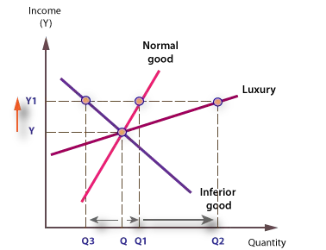
Figure 4: Income effect on normal and Inferior Goods
Source: (Salvatore, 2018)
Consumer tastes & preferences: Consumers’ tastes and preferences are important factors that can influence the demand for different products. When the taste or preference changes, consumers do not want to continue with their prior product but rather want to try new ones. If consumers do not want to use the soaps anymore, the demand will decrease. Tastes cannot remain the same for a long time and they prefer to try the variations that can serve them even better. So the company has to analyze consumers’ tastes and preferences critically so that they can upgrade their existing products. Unilever can introduce more varieties of soaps and even products that can work as an alternative to soaps such as shower gel, essential oils and so on (Murphy and Murphy, 2018).
Consumer expectations of price: Buyers’ expectations can change the demand for any product. When consumers expect that the price may decrease soon, they will not purchase right now thinking they can get the same product at a lower price if they wait for it (Lee, 2019). This holding off buying will reduce the demand and thus force the price to increase. Similarly, when consumers expect the price to rise, they will purchase more for stock of the product and demand will go up. For example, if buyers expect that Unilever will increase the soap price, demand will automatically go up as today the consumers will purchase more than the regular quantity.
Demographics: This factor is very important for a company to analyze the demand for the product. Before launching a new product, a company observes its target market so that it can identify the consumers’ behaviour and preferences (Bodhankar, 2020). Otherwise randomly introducing any product in any market will make the business worse. Purchasing power, age, geographical region and family status are common variables of demographics (Lee, 2019). If the business intends to sell budget-friendly items, it should go for people with lower income as people with high income will prefer luxury items. The product will be attractive or not also depend on the consumer’s family status. But this factor does not affect the demand for soap that much as people of all ages and genders use soap daily (Bodhankar, 2020). Even Unilever produce soaps in price range so this factor hardly influences the demand for soaps.

Factors Influencing the Price Elasticity of Demand

Price Elasticity of Demand
Price elasticity refers to the calculation of change in demand and supply of a product and service because of its price fluctuation (Goodwin et al., 2018). When this measurement is calculated only for the demand of a product this is called price elasticity of demand. The demand and price are related to each other. If the demand keeps changing continuously even with a minimal price variation, the product is called perfectly elastic and thus price elasticity is not finite at all (Starr, 2017). It is not necessary that all the products and services will be elastic, it can be inelastic too. The product is considered elastic when the price elasticity is more than 1. Inversely product is considered inelastic when the price elasticity is less the 1 which means despite of change in price, demand does not change significantly (Lucke, Schröder and Schumacher, 2018). There are different factors that affect the price elasticity of demand.
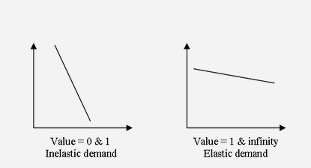
Figure 5: Price Elasticity of Demand
Source: (Lucke, Schröder and Schumacher, 2018)

Substitution Effect
The demand for a product or service is more elastic or more inelastic depending on the substitute (Spiegel, Benzion and Shavit, 2018). Every product or service does not have a suitable substitute by which consumers can be properly satisfied. The price elasticity of demand will be more elastic if consumers can reach to the substitute that can fulfil their demand even with alternatives. But there will be inelastic demand if the consumers fail to identify a substitute. So this substitute factor can properly indicate whether the demand is more elastic or more inelastic (Lucke, Schröder and Schumacher, 2018). The demand for soaps can be elastic from the perspective of brands as there are huge numbers of substitute brands available. The consumer can easily switch to other brands when they are not satisfied with the regular one. The main competitors of Unilever are Procter & Gamble, Johnson & Johnson and some other brands (Ons.gov.uk, 2022). They also produce soaps with different fragrances and ingredients. If Unilever increases the price of soaps so much, demand will change significantly in fact decrease and consumers will move to other brands. Even there are many substitutes for soaps such as shower gel and other natural cleansers that can be replaced by soaps (Unilever, 2022). But it is also true that the consumption of soaps will not be changed that much even if the price goes high as this is considered a necessary item. Consumers may switch brands but hardly use any substitute of soaps as they can find them at a lower price than shower gel. So it can be said that the demand for soap is relatively inelastic. Soaps are not luxurious products so even if the price increases a little bit, people continue using them (Murphy and Murphy, 2018).

Income effect
Income can also influence the price elasticity of demand. When people spend a small amount on a product or service, a change in income will not affect that much ((Bodhankar, 2020). They will still purchase it whether their income increases or decreases. Then the demand for the product will be considered relatively inelastic as the demand does not change in relation to the change in price. Here the main product is the soap of Unilever and they produce soaps in different price ranges. So the consumer can choose the price at which they fit in. The purchase of soaps represents a small portion of an individual’s income. So there is no significant impact of consumer’s income on the demand for soap and thus the demand for soap is inelastic though the demand can change slightly (Goodwin et al., 2018). But if the consumer is spending a large amount on any product, the demand for that product will be highly elastic. As any change in income tend to lower or higher the demand. So the price elasticity depends on the consumer’s family status. For those who have a high income, the price will not affect them as they are not bothered about whether the price is increasing or decreasing (Smith, 2019). But the price change has a great impact on people with relatively lower income. So this factor can influence the price elasticity of demand.

The pricing policy Unilever should Employ
There are different pricing policies that are used by businesses. A company analyzes all the factors to reach a conclusion and fix a price at which it agrees to sell the product and services (Cubbin, 2013). Choosing the perfect pricing structure is very crucial as many things depend on it. If the pricing policy is not appropriate, the company will not be able to survive in the long run. Pricing is the first and most important factor to attract the target customers (Smith, 2019). Different pricing structures are taken into consideration to fix the product price such as value-based pricing or cost-based pricing. A perfect pricing policy will help to build the trust of customers. The price of the product should not be so high or low because the customers may think of a cheap product is not so effective. Unilever serves a large number of customers from different categories and a competitive pricing strategy is followed by them (Unilever, 2022). They offer both low and high price products. Those who want premium quality products can easily reach Unilever and take the service. The economic condition should also be considered as the world is recovering slowly after the pandemic and other problems (Ons.gov.uk, 2022). So the pricing policy should consider the issue.

Conclusion
A specific product of Unilever has been chosen for conducting the analysis. The soap of Unilever is a very popular product that is distributed in different price ranges to satisfy all the customers. The demand for soap is not always the same as it is influenced by many factors. The demand for soap is relatively inelastic as the demand does not change with the price. It is a necessary product so people purchase it even if their income changes or they find any substitute. Unilever should focus on the pricing structure to attract more people.

References
Bodhankar, A., 2020. The New FMCG Consumer (Challenge for FMCG Sector). Journal of Advanced Research in Dynamical and Control Systems, 12(SP8), pp.582-587.
Cubbin, J., 2013. Market Structure and Performance. Hoboken: Taylor and Francis.
Goodwin, N., Harris, J., Nelson, J., Rajkarnikar, P., Roach, B. and Torras, M., 2018. Microeconomics in Context. Milton: Routledge.
Lee, R., 2019. Macroeconomic implications of demographic changes. Tokyo: Inst. for Monetary and Economic Studies, Bank of Japan.
Liu, B., 2013. Coordination of pricing, sourcing and product design decisions in a supply chain. [Tuscaloosa, Ala.]: [University of Alabama Libraries].
Lucke, D., Schröder, P. and Schumacher, D., 2018. R&D and price elasticity of demand. New York.
Murphy, P.E. and Murphy, C.E., 2018. Sustainable living: unilever. In Progressive Business Models (pp. 263-286). Palgrave Macmillan, Cham.
Ons.gov.uk. 2022. Economy - Office for National Statistics. [online] Available at: <https://www.ons.gov.uk/economy> [Accessed 20 August 2022].
Salvatore, D., 2018. Microeconomics. New York: Oxford University Press.
Smith, K., 2019. Target Market Series. Erlanger: The National Underwriter Company.
Spiegel, U., Benzion, U. and Shavit, T., 2018. Free Product as a Complement or Substitute for a Purchased Product – Does it Matter. Modern Economy, 02(02), pp.124-131.
Starr, R., 2017. General Equilibrium Theory. Cambridge: Cambridge University Press.
Statista. 2022. Topic: Unilever. [online] Available at: <https://www.statista.com/topics/1397/unilever/#topicHeader__wrapper> [Accessed 20 August 2022].
Unilever. 2022. Personal Care. [online] Available at: <https://www.unilever.com/brands/personal-care/> [Accessed 20 August 2022].

