COMPONENT 2 - MAJOR HEALTH ISSUE
Name of the student: Rasim Bunari
Student’s ID: 2130926
Module name: Introduction to Public Health
Module code: LCHS4004
Lecturer’s name: Muhammad Hossain

Executive Summary
Arthritis is one of the most common diseases found in the people of the United Kingdom and it is proven to be harmful to them in the long term in multiple dimensions of their health. The following work of report has addressed the most common traits of arthritis patients alongside the short-term and long-term consequences of the public health measures provided in the health and social care facilities in the United Kingdom. All these discussions have been supported by several statistics mentioned throughout this report. The contemporary scenario surrounding arthritis in the UK has been reflected in this particular piece of writing.

Contents
Introduction 4
Public health measures available 4
The key determinants/risk factors of arthritis 6
Short-term public health consequences of arthritis in a health or social care setting 7
Long-term public health consequences of arthritis in a health or social care setting 8
Conclusion 9
References 10

Introduction
Detecting several diseases in people is very much essential in resolving them in the long term through health and social care. Especially for elderly people, the need for care facilities goes to a greater extent. Arthritis is one of the diseases, which is commonly found in the elderly people of the United Kingdom. Approximately 10 million people residing in the country are currently suffering from this disease.
This disease usually causes joint pain and inflammation in elderly people, which results in restricted movement of the person in the long term. There are two common types of arthritis, which are rheumatoid arthritis and osteoarthritis. The people in consideration here are older people and osteoarthritis is found in them usually. The joints of these people decayed over time and it is one of the major causes of osteoarthritis. Approximately 8 million people in the UK are suffering from this disease and the government and healthcare authorities must take necessary actions to provide them with the essential support to survive this disease in the long term.
The global statistics regarding getting affected by arthritis state that 60% of people aged between 18 to 64 have arthritis and older adults over the age of 65 have this disease. Women tend to get more affected by this disease than men get. The following work provides a brief analysis of the situation of arthritis in the context of public health measures, risk factors and short and long-term health consequences of arthritis in health and social care settings.
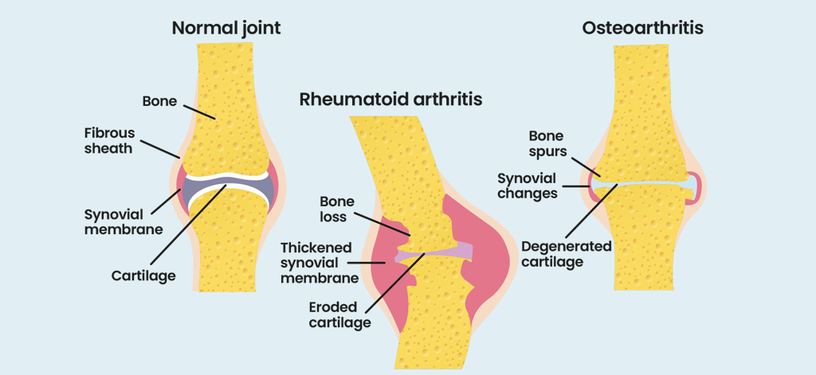
Figure 1: Arthritis and its symptoms
(Source: Sergeant et al., 2018)

Public health measures available
The arthritis program promotes different measures in order to detect the science of arthritis so that individuals can take necessary measures to mitigate these issues. The steps are as follows:
Learning arthritis management methods
The individuals must learn some methods and strategies in order to detect the basic symptoms and manage their conditions in different stages of arthritis. The self-management skills can also be learnt from the local communities, which can help people to learn the ways to manage their levels of pain, safe exercises and get control of their arthritis condition (Sergeant et al., 2018). The risks and severity of this disease increase if it is not detected in the early stages and therefore this program can help individuals to manage the disease.
Being active
Different physical activities need to be done by patients with arthritis in order to stay fit in the long term. It also improves the mobility of the joints and increases their functionalities to delay the severity of arthritis. Adults who are diagnosed with arthritis must get a minimum of 150 minutes of physical exercise per week in order to derive certain physical benefits for striving in the long term (Nikiphorou et al., 2018). This tenure of exercises can be divided into shorter terms for making it feasible for the people. Different groups and personnel provide different physical training and exercise programs, which can help people with arthritis to train safely and comfortably.
Detecting weight growth
People who are at risk of getting affected by arthritis need to maintain their weight regularly. Through regular exercise, they can lose excess weight. A 5% reduction for overweight people can help them to reduce the risks of getting affected severely by the symptoms of arthritis (Wells et al., 2020).Statistics state that for every pound lost in overall body weight, almost 4 pounds wait on the knees can be reduced.
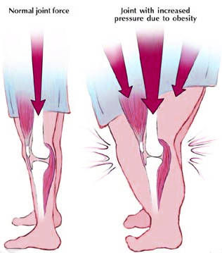
Figure 2: Arthritis and obesity
(Source: Wells et al., 2020)
Consulting health professionals
If any individual is facing any health issues regarding the joints, they must seek medical help for the diagnosis process if they have arthritis. The doctors can recommend certain medications for reducing the pain levels of the patients and some exercises to stay fit in the long term.
Protecting the joints
The joints must be protected from any external injuries minimising the risks of getting affected by the symptoms of arthritis. The people who are associated with jobs involving heavy physical activities must be careful specifically (Tarallo et al., 2019). Avoiding injuries to the joints can prevent any kind of bleeding and inflammation in terms of reducing pain levels.

The key determinants/risk factors of arthritis
Since arthritis is a very common disease, the symptoms and key risk factors are also very common. Therefore, it is very essential to detect them in the early stages to proceed with further treatment for this disease (Lewis et al., 2019). There are some factors, which the individual can control, and some factors cannot be controlled by the efforts of the people since they are congenital. The risk factors are stated below:
Factors that can be controlled
Obesity: This is the most alarming factor for people who have a risk of being infected with arthritis. Overweight people have a very high chance of getting knee osteoarthritis as their knees carry almost four times more than a regular person gets (Fautrel et al., 2018). People can eat healthy foods and indulge themselves in physical activities so that they cannot gain any weight beyond their natural state.
Infection: Several microbial agents such as viruses and bacteria can affect them. The infections can harm the joints, which can lead to arthritis in the long term. Any kind of discomfort in the joints must be consulted with the doctors in order to seek medication to avoid the risk of arthritis.
Injuries: Any injuries or repetitive stress on the joints can cause long-term damages, which can result in osteoarthritis. The people who have the greater extent of being infected from this type of injury are the people working in jobs including heavy physical activities (Raterman and Lems, 2019). Regular exercise and seeking medical attention can help these people to get over this situation.
Smoking: Smoking in a long term can facilitate the risk of a person in terms of developing rheumatoid arthritis. Several other problems can also result from smoking and therefore, people should quit smoking as soon as possible in order to avoid getting sick in the long term.
Factors that cannot be controlled
Genetic traits: People who are born with genetic disorders have a tendency to catch several types of arthritis such as systemic lupus erythematous and rheumatoid arthritis. There are not any specific reasons for people getting affected with arthritis and hence, no proper medication for this disease can be prescribed (Picchianti-Diamanti et al., 2018). It can only be delayed by staying fit and healthy in the long term.
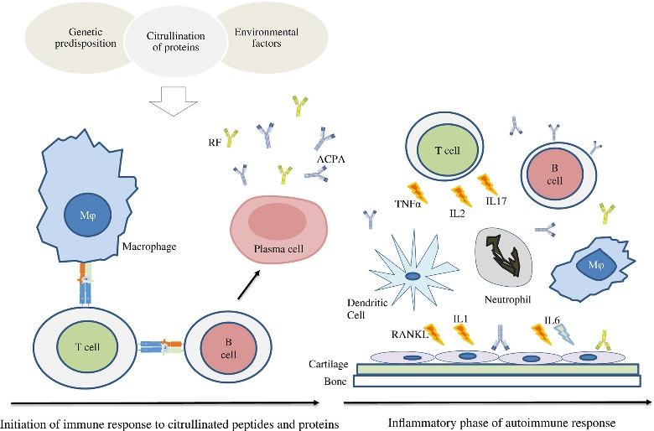
Figure 3: Genetic diagnosis of rheumatoid arthritis
(Source: Picchianti-Diamanti et al., 2018)
Age and gender: Most elderly people have a higher chance of getting affected by arthritis. Studies have shown that women have a greater vulnerability towards arthritis. The factors cannot be reverted and people must take necessary measures in order to stay fit and avoid getting this disease in the long term.

Short-term public health consequences of arthritis in a health or social care setting
Different health and social care settings can take necessary measures in terms of treating people with proper care. These practices can be categorised into two segments - short-term and long-term (Bullock et al., 2018). If the health and social care facilities use segmented strategies, more people can be treated easily and in a proper manner. Some of the short-term solutions are given below:
Detection of the symptoms: The symptoms exhibited by the people at these facilities need to be analysed and they must become sure of the fact that the person has arthritis or not. After suspecting any kind of weaknesses in the physical attributes of an individual, they must contact a healthcare professional in order to be prescribed medication.
Using medications: The people at these facilities or in the need of a proper medication routine to reduce the levels of pain caused by arthritis. However, these medicines can have immediate side effects, which can trigger other health complications in that specific person (Conigliaro et al., 2019). For this reason, the usage of medicine must be reduced to a lower extent in order to avoid these side effects.
Reducing pain without medication: For reducing the side effects of the medicines utilised for pain relieving, no medications are used in certain facilities and the focus is on only physical training instead (Moshayedi et al., 2020). It helps them to stay fit in the long term and delays the process of being caught in the severe symptoms of arthritis that can stop the mobility of the joints.
However, there are some long-term consequences regarding the disease and the associated treatments in the health and social care facilities which are to be discussed in the following section of this work.

Long-term public health consequences of arthritis in a health or social care setting
The short-term consequences of arthritis and its associated treatments in the facilities are limited since this disease mostly affects the health of the patients in the long term. Some long-term consequences are listed below for a better understanding.
Monitoring the development process of the patients: The people in charge of the health and social care facilities need to constantly track the progress of the patient to check whether the treatment process is going properly or not (Aletaha and Smolen, 2018). This monitoring process must include the checking of proper implications of the self-management strategies, the engagement of patience in the physical activities and maintaining the weights properly.
Heart diseases: People suffering from arthritis also have a higher chance of getting affected by heart diseases. It can also incorporate other diseases such as diabetes. Healthcare facilities need to take care of the collateral diseases occurring to the patients.
Obesity: It can be an alarming factor for people having arthritis and hence, the patients must not get overweight and these facilities must take care of this fact (Sergeant et al., 2018). They must organise several physical training programs and exercises for better maintenance of the physical health of the patients admitted to these facilities.
Employment: Before employing any candidate in any respective organisation, their medical status is checked. The arthritis-affected patients can face difficulty in terms of being employed in different organisations. The people with physical weaknesses will certainly deliver laser productivity rates than the other employees.
Immune system: The immune systems of the patients can be degraded over the course of time due to arthritis in the long term (Nikiphorou et al., 2018). The health issues of the people need to be constantly monitored by the staff of the health and social care authorities in order to detect any kind of imbalance in the immune system and take necessary actions for resolving these issues.
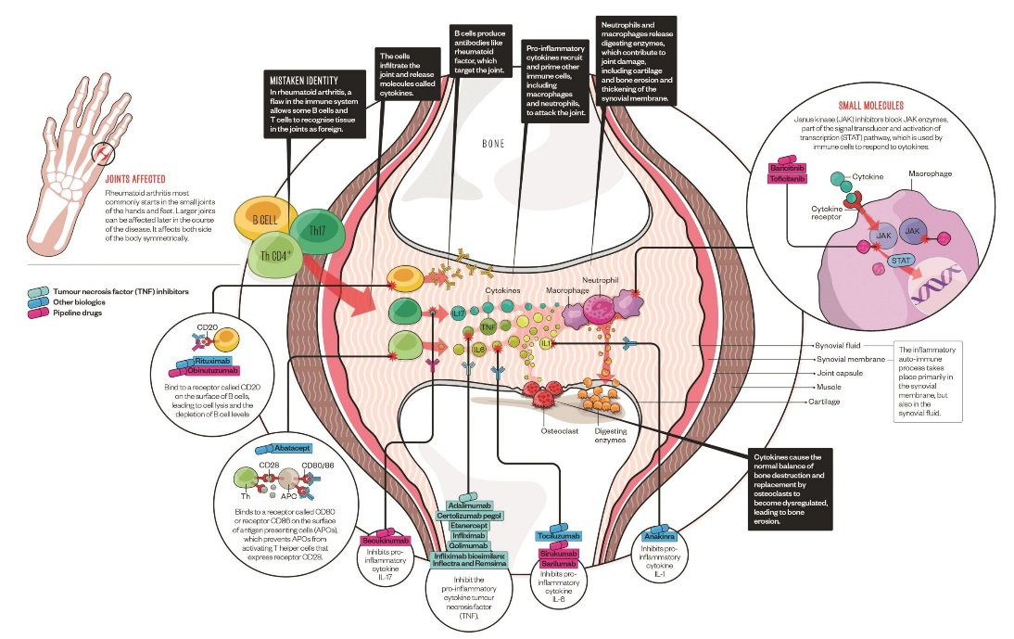
Figure 4: Interruptions in immune system due to arthritis
(Source: Nikiphorou et al., 2018)

Conclusion
This particular work regarding arthritis has provided a brief insight into the disease and the associated impacts and mitigation strategies in health and social care facilities. The statistics and data provided in this report have exhibited a clear Idea regarding the severity of this disease across the entire United Kingdom. Around 430000 people have rheumatoid arthritis in the country based on data collected in 2021. Children are not also safe from this disease as almost 12000 children have juvenile idiopathic arthritis. Osteoporosis can also be caused by a side effect of arthritis and almost 3 million people are suffering from it in the United Kingdom. Studies have also shown that women have a better affinity for being infected from arthritis than men and hence, women are more likely to indulge themselves in physical activities.
The NHS provides proper healthcare services to people suffering from arthritis in the United Kingdom and they can take several steps in order to help the people in need in the health and social facilities. They mainly classify the two common types of arthritis - osteoarthritis and rheumatoid arthritis. After classifying the types of arthritis, they take the essential steps to mitigate them according to the health condition of the patients in the facilities. The short and long-term consequences of the arthritis patients in the facilities have also been discussed here which also exhibits the extent of medical attention the patients are getting in these facilities. A brief overview of the situation regarding patients of arthritis in the United Kingdom has been derived from the overall discussion conducted in this report.

References
Aletaha, D. and Smolen, J.S., (2018). Diagnosis and management of rheumatoid arthritis: a review. Jama, 320(13), pp.1360-1372.
Bullock, J., Rizvi, S.A., Saleh, A.M., Ahmed, S.S., Do, D.P., Ansari, R.A. and Ahmed, J., (2018). Rheumatoid arthritis: a brief overview of the treatment. Medical Principles and Practice, 27(6), pp.501-507.
Conigliaro, P., Triggianese, P., De Martino, E., Fonti, G.L., Chimenti, M.S., Sunzini, F., Viola, A., Canofari, C. and Perricone, R., (2019). Challenges in the treatment of rheumatoid arthritis. Autoimmunity reviews, 18(7), pp.706-713.
Fautrel, B., Alten, R., Kirkham, B., de la Torre, I., Durand, F., Barry, J., Holzkaemper, T., Fakhouri, W. and Taylor, P.C., (2018). Call for action: how to improve use of patient-reported outcomes to guide clinical decision making in rheumatoid arthritis. Rheumatology international, 38(6), pp.935-947.
Lewis, M.J., Barnes, M.R., Blighe, K., Goldmann, K., Rana, S., Hackney, J.A., Ramamoorthi, N., John, C.R., Watson, D.S., Kummerfeld, S.K. and Hands, R., (2019). Molecular portraits of early rheumatoid arthritis identify clinical and treatment response phenotypes. Cell reports, 28(9), pp.2455-2470.
Moshayedi, S., Tasorian, B. and Almasi-Hashiani, A., (2022). The prevalence of osteoporosis in rheumatoid arthritis patient: a systematic review and meta-analysis. Scientific reports, 12(1), pp.1-11.
Nikiphorou, E., Norton, S., Young, A., Dixey, J., Walsh, D., Helliwell, H., Kiely, P. and Early Rheumatoid Arthritis Study and the Early Rheumatoid Arthritis Network, (2018). The association of obesity with disease activity, functional ability and quality of life in early rheumatoid arthritis: data from the Early Rheumatoid Arthritis Study/Early Rheumatoid Arthritis Network UK prospective cohorts. Rheumatology, 57(7), pp.1194-1202.
Picchianti-Diamanti, A., Panebianco, C., Salemi, S., Sorgi, M.L., Di Rosa, R., Tropea, A., Sgrulletti, M., Salerno, G., Terracciano, F., D’amelio, R. and Laganà, B., (2018). Analysis of gut microbiota in rheumatoid arthritis patients: disease-related dysbiosis and modifications induced by etanercept. International journal of molecular sciences, 19(10), p.2938.
Raterman, H.G. and Lems, W.F., (2019). Pharmacological management of osteoporosis in rheumatoid arthritis patients: a review of the literature and practical guide. Drugs & aging, 36(12), pp.1061-1072.
Sergeant, J.C., Hyrich, K.L., Anderson, J., Kopec-Harding, K., Hope, H.F., Symmons, D.P., Barton, A. and Verstappen, S.M., (2018). Prediction of primary non-response to methotrexate therapy using demographic, clinical and psychosocial variables: results from the UK Rheumatoid Arthritis Medication Study (RAMS). Arthritis research & therapy, 20(1), pp.1-11.
Tarallo, M., Onishchenko, K. and Alexopoulos, S.T., (2019). Costs associated with non-medical switching from originator to biosimilar etanercept in patients with rheumatoid arthritis in the UK. Journal of Medical Economics, 22(11), pp.1162-1170.
Wells, P.M., Adebayo, A.S., Bowyer, R.C., Freidin, M.B., Finckh, A., Strowig, T., Lesker, T.R., Alpizar-Rodriguez, D., Gilbert, B., Kirkham, B. and Cope, A.P., (2020). Associations between gut microbiota and genetic risk for rheumatoid arthritis in the absence of disease: a cross-sectional study. The Lancet Rheumatology, 2(7), pp.e418-e427.

