University of Wales
Trinity Saint David

Designing a kiteboard Hydrofoil wing:
Structural Design

By Carissa George
ACMA6010: Structural & Fluid Analysis
26/10/2025
Word count: 3000

Abstract
This report provides a structural analysis and optimisation study of a kiteboard hydrofoil wing using Finite Element Analysis (FEA) in Design Studio. The primary objective was to reduce the wing's mass while achieving a deflection performance equivalent to the original steel design by the use of carbon fibre reinforced polymer (CFRP). By optimising ply thickness and orientation, the CFRP wing obtained a mass reduction from 0.465 kg to 0.116 kg and enhanced the stiffness-to-weight ratio from 126 N/mm to 518 N/mm. A further discrete optimisation enhanced the layup for manufacturability, yielding feasible ply thicknesses and a final deflection of 7.5 × 10⁻³ m with a stiffness-to-weight ratio of 358 N/mm. The report demonstrates that FEA-based optimisation allows the development of lightweight, high-performance hydrofoil designs by efficiently balancing mass reduction and structural stiffness while using discrete optimisation to guarantee manufacturability.

Contents
Introduction 3
Task 1: FEA optimisation techniques 4
1.1 What is FEA optimisation? 4
1.2. Historical development 6
1.3. Current Techniques 6
1.4. Future developments 7
1.5. Benefits of FEA optimisation 7
Task 2: Create an FE model 8
2.1. Steel Wing Baseline Analysis 8
2.2. Composite Wing Setup and Material Definition 8
2.3. Composite Wing Performance Evaluation 10
Task 3: Optimise the structure 11
3.1. Optimisation Process 11
3.2. Design history plot 14
3.3. Discrete Variable Optimisation 15
3.4. Modify to Discrete Variables 15
3.5. Re-optimisation 16
3.6. Structural Performance Evaluation 16
3.7. Stiffness-to-Weight Ratio Analysis 16
3.8. Deflection summary: 17
Task 4: Proposed experimental validation methods 17
4.1. Prototype testing: 17
4.2. Forces applied: 17
4.3. Data comparison 18
4.4. Acquire and analyse data 18
4.5. Model modification 19
Task 5: Literature research 19
5.1. BSI or ISO standards 19
5.2. Transition from steel to CFRP in the kiteboard wing model. 19
5.3 . Mass and Stiffness-to-Weight Ratio 20
5.4. Deflection and Structural Response 20
5.5. Manufacturing considerations 20
References 20
Table of Figures 27
Table of equations 28
Appendix 28
Appendix A 28
Appendix B 29
Appendix C 29
Appendix D 30
Appendix E 30
Appendix F 31
Appendix G 31
Appendix H 32
Appendix I 32
Appendix J 33
Appendix K 33
Appendix L 34

Introduction
This report presents an analysis and optimisation study of a kiteboard wing using Design Studio. Steel and CFRP were compared through FEA modelling to identify the best material. The goal was to match the steel wing’s stiffness while reducing mass by refining the composite layup.

Task 1: FEA optimisation techniques

1.1 What is FEA optimisation?
FEA is widely used to model component performance under stress and environmental factors (Plumb, 2025). While traditionally analytical, it now supports design optimisation (Nicholas et al., 2019; Liu et al., 2025). This involves adjusting geometry, ply orientation, thickness, and material properties to meet stress or displacement limits (Consarnau & Whisler, 2024; Li et al., 2020). Objectives are defined, parameters selected, and simulations repeated until the design meets its goals (Li et al., 2022; Suat Coemert et al., 2020).
Figure 1 demonstrates the Finite Element Analysis (FEA) process flow, outlining three main phases: pre-processing, solution, and post-processing . Pre-processing involves setting up the model geometry, material properties, meshing, boundary conditions, and loads (Siemens, 2025b); solution, which involves solving the equations that apply to find stress, strain, heat, and displacement (Suvo, 2018); and post-processing, which involves analysing the data to find potential failures, reduce material use, and improve overall product performance(Niharika Institute of Computational Engineering 2023), ((Łukasz Skotny Ph.D, 2017).

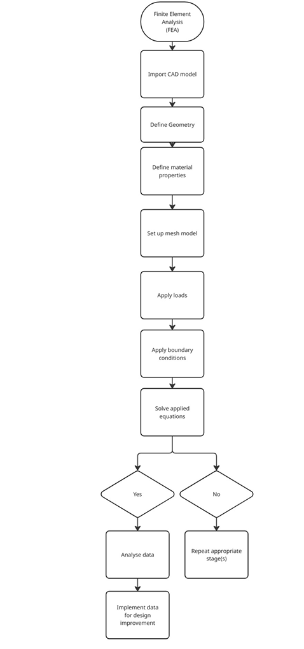
Figure 1 - Finite Element Analysis (FEA) process flow (McGarry, 2025)

1.2. Historical development
FEA optimisation began with Lucien Schmit in 1960, who combined FEA with mathematical optimisation (A. Schmit, Jr., 2025). In the 1970s, Rozvany advanced topological methods (Rozvany, 2008), and in 1988, Bendsøe and Kikuchi introduced the SIMP method through homogenisation-based topology (Bendsoe & Kikuchi, 1988). Their work laid the foundation for modern engineering design optimisation.

1.3. Current Techniques
Over the years, FEA has evolved and in today’s day in age it has integrated with a variety of modern computational and optimisation software’s.

1.3.1. Advanced Structural Optimisation Techniques
FEA supports the development of lighter, durable structures through structural optimisation. Techniques like SIMP guide material distribution within design limits (Dassault Systèmes, 2025), while level-set and ESO methods refine designs by adding or removing material, with performance analysed via FEA (Jia et al., 2011; Tanskanen, 2002).

1.3.2. Multidisciplinary Design Optimisation (MDO)
Engineering systems involve heat, fluid, and stress. MDO combines these factors, unlike FEA, which focuses on structure. This integration supports high-performance aerospace and automotive designs by optimising strength, weight, and aerodynamics efficiently (Sobieszczanski-Sobieski & Haftka, 2024).

1.3.3. High-Performance FEA Techniques
As FEA advances, computational techniques like adaptive meshing improve accuracy and efficiency (Soundararajan et al., 2021). Reduced-order modelling (ROM) enables faster calculations (The MathWorks, Inc., 2025), while parallel computing supports high-detail simulations for fields like aerospace and civil engineering (Vollaire et al., 1998).

1.3.4. Uncertainty and Robust Design
Variations in loads, materials, and environments affect performance. RDO and RBDO are integrated with FEA to address these factors, ensuring designs remain safe and reliable under real-world conditions (Most and Will, 2017; Chun, 2021; Massobrio, 2024).

1.3.5. Additive Manufacturing and FEA
Additive manufacturing (AM) has expanded FEA-based design, allowing printed components to be optimised for strength, weight, and thermal performance (ZHU et al., 2021). Together, FEA and AM enable efficient, custom parts once difficult to produce.
However, risks arise if not applied correctly:
- Geometry & Boundaries: Oversimplified models or misidentified boundaries can distort simulation accuracy (Solid Solutions, 2017; Rahimi et al., 2018).
- Material Properties: Inaccurate definitions may overlook mechanical failure, affecting validation (duodesign.co.uk, 2016; Fong et al., 2006).
- Mesh Quality: Poor mesh can cause numerical errors or miss stress variations, reducing result reliability (NAFEMS, 2016; Pisarciuc et al., 2023).
- Post-Processing: Misinterpreting results or relying on defaults without verification can lead to flawed decisions (Lava et al., 2020).

1.4. Future developments
Engineers are combining AI and FEA to simulate faster and more intelligently. AI can automate mesh setup, boundary conditions, solver settings, and result analysis. Surrogate models enable rapid FEA predictions (Siemens, 2025a), enhancing digital twins and real-time optimisation (Balu et al., 2022). Generative design lightens structures (Charalampous et al., 2024), while PINNs ensure physics-based accuracy (Haghighat et al., 2021). AI streamlines FEA, allowing engineers to focus on innovation (Kristin et al., 2024).

1.5. Benefits of FEA optimisation
EA optimisation enhances performance, reliability, and safety while reducing weight, material use, and costs. Simulations accelerate development and reduce prototypes, supporting sustainable, high-performance designs (McGarry, 2025; Kumar N et al., 2025; ToffeeX, 2025). It also enables complex geometries through generative design (Shi et al., 2025) and, with digital twins, supports real-time decisions and predictive maintenance for lighter, efficient solutions (Adolphsen, 2025).

Task 2: Create an FE model

2.1. Steel Wing Baseline Analysis
In the initial simulation, a 500 N vertical load was applied to the steel wing, rotating on one end of the X-axis. Defined as isotropic, the material showed uniform properties in all directions. The model produced a deflection of 8.6 × 10⁻³ m (Figure 2), which was set, with properties adjusted to meet the specification (see Appendix A).
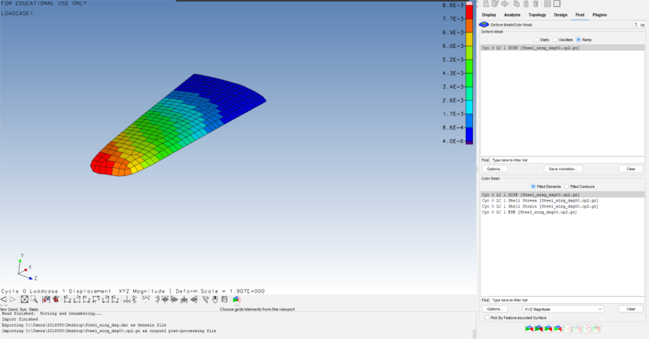
Figure 2 - Simulation of a deflection of 8.6x10⁻³m

Design Studio calculated the steel wing’s mass as 0.465 kg (see Appendix B), with a stiffness-to-weight ratio of 126 N/mm (see Appendix C).

2.2. Composite Wing Setup and Material Definition
CFRP was added to the CAD model to explore lighter options, with its properties defined in Design Studio (see Appendix D). As an orthotropic material, its stiffness depends on fibre direction, so theta vectors were generated to ensure accurate simulation results (Figure 3).
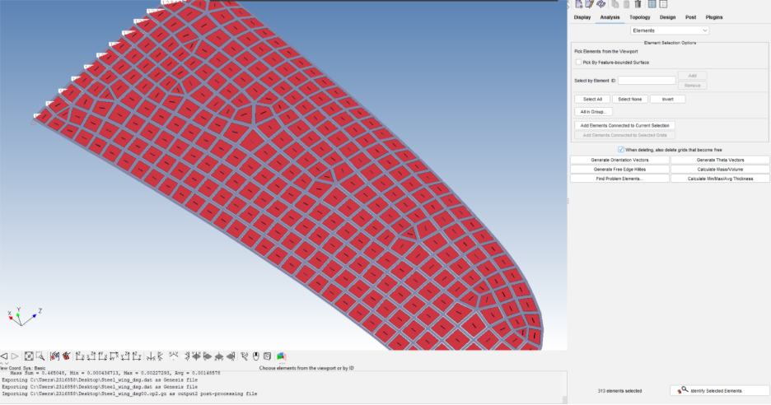
Figure 3 - theta Vectors

The CAD model includes both isotropic and orthotropic materials. Isotropic materials have uniform strength in all directions, while orthotropic materials vary in stiffness based on orientation, making accurate part placement essential.

The main stiffness direction (E1) followed the wing’s length, while the secondary (E2) ran across its cross-section. Theta vectors were generated and adjusted to align with this orientation (Figure 4).
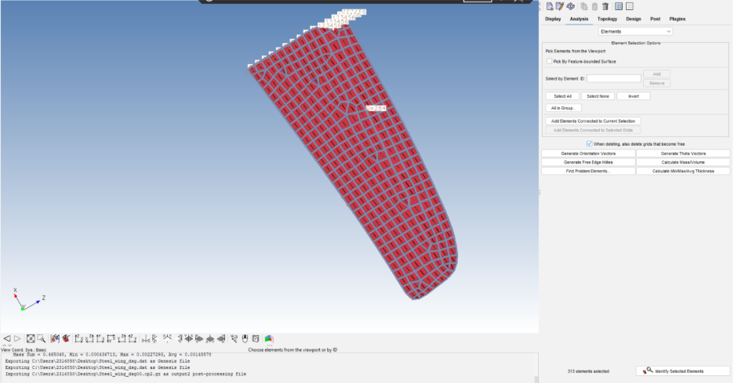
Figure 4 - theta Vectors adjusted to reflect direction

Ply thickness and layer definitions were added based on the specification (Figure 5), updating the model to reflect CFRP properties. After applying the material settings, the element colour changed from grey to green, confirming the successful switch from steel (see Appendix E).

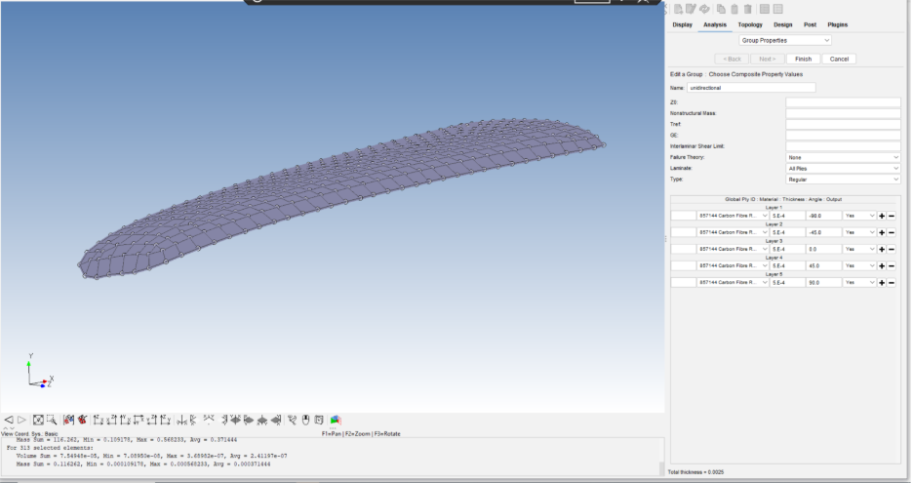
Figure 5 - ply thickness and the layer definitions created

2.3. Composite Wing Performance Evaluation
After switching to CFRP, the same 500 N load produced a deflection of 8.4 × 10⁻³ m (Figure 6), slightly less than the steel wing. The CFRP wing weighed 116 g (see Appendix F), and this reduced mass led to a higher stiffness-to-weight ratio of 518 N/mm (see Appendix G).

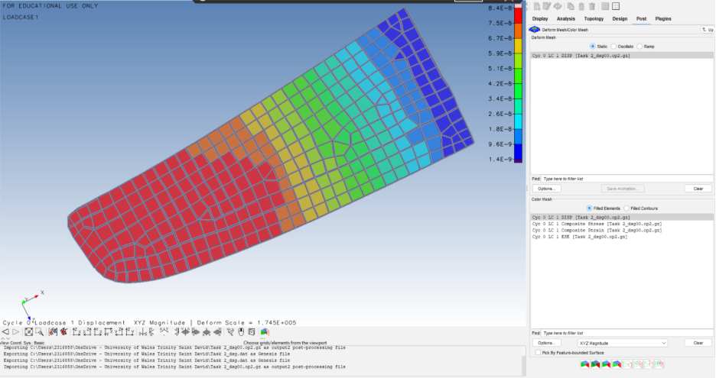
Figure 6 - Simulation of a deflection of 8.4x10⁻³m

In comparison, 126N/mm was the value for the steel wing whereas, 518N/mm is the value for the carbon fibre wing. The carbon fibre wing is stiffer now as by adding and extra ply increasing the bending stiffness. Therefore, by adding one extra ply increases the stiffness more than the weight which increases the stiffness overweight ratio number.

Task 3: Optimise the structure

3.1. Optimisation Process
The next step was to optimise the kiteboard wing in Design Studios by adjusting ply thickness to balance durability and weight. Variables, objectives, and constraints were defined to determine the number of plies needed in each layer to match the stiffness of the steel wing.

3.1.1. Objective
The primary objective of the optimisation was to minimise the mass of the wing structure (Figure 7), aligning with the design requirement to lower weight while maintaining stiffness.
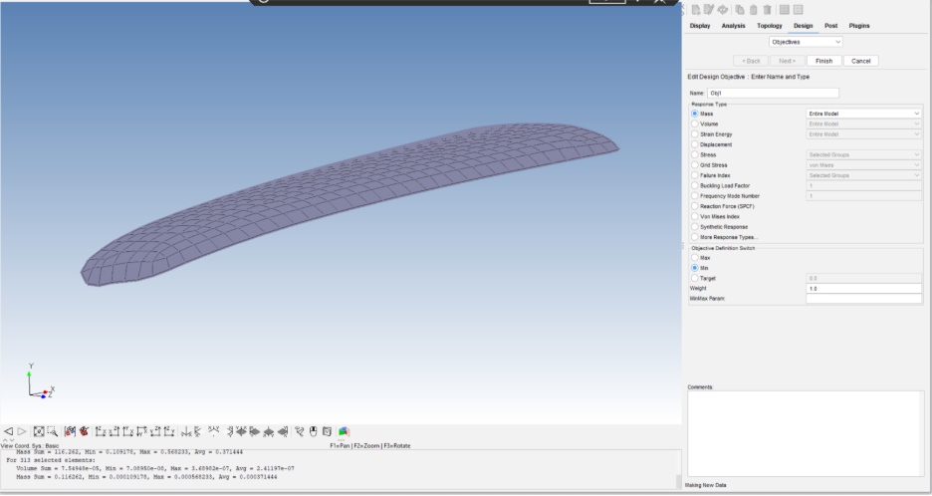
Figure 7 - minimising the mass

3.1.2. Constraints
The key constraint was that maximum deflection must not exceed 8.4×10⁻³m, (Figure 8) matching the performance of the steel wing. This limit was applied across all wing elements to maintain structural uniformity.
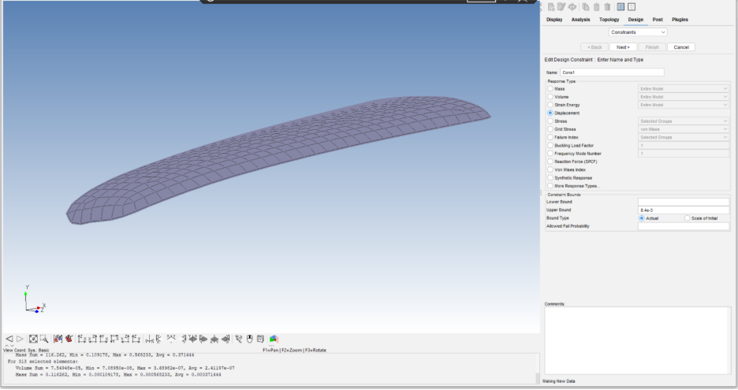
Figure 8 - constraint of maximum deflection

3.1.3. Variables
Five design variables were defined, each representing the thickness of an individual ply layer. These variables were initialised with a value of 0.1 × 10⁻³ m and constrained between a lower bound of 0.1 × 10⁻³ m and an upper bound of 5 × 10⁻³ m. They were linked to the physical properties of the composite material and adjusted during each optimisation cycle. However, once the five variables were added (see Appendix H), they did not indicate the physical properties of the model. As a result, changes to their values did not influence the mechanical behaviour of the wing. This issue was identified and corrected by reassigning the sizing parameters to the relevant composite layers (see Appendix I), ensuring that each variable directly affected the stiffness and mass of the structure during optimisation.
Across 17 design cycles (Figure 9), the model’s displacement dropped from 8.4 × 10⁻⁸ m to 8.3 × 10⁻³ m. This shift reflects reduced constraint violations as structural mass increased, improving stability and alignment with design limits.
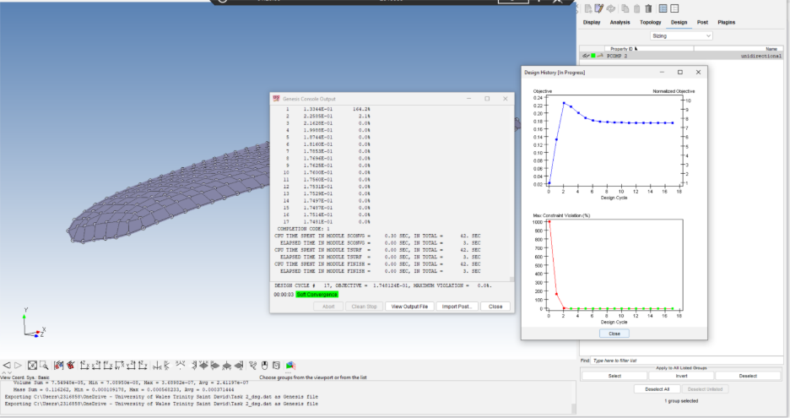
Figure 9 - 17 Design cycles generated

By Cycle 17, displacement reached 8.3 × 10⁻³ m, meeting the Design Studio specification (Figure 6). At this point, the CFRP structure matched the stiffness of the steel wing, confirming its performance.

3.2. Design history plot
Figure 10 shows how the optimisation evolved over 17 design cycles, focusing on five design variables. The graph tracks thickness changes, with Design Variable 3 reaching about 3 mm — safely below the 5 mm limit and within design requirements.
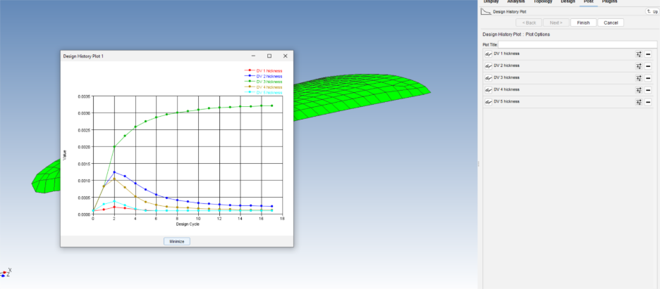
Figure 10 - Design history plot
The Design History plot shows how the objective function and constraints changed during the optimisation process. The top graph shows how the objective function, indicates stabilisation after a few cycles. The bottom graph, on the other hand, shows how the number of constraints decreased over time, which shows that the result was optimised within the design boundaries that were defined.
The history file was generated to monitor these constraints and objectives across all 17 optimisation cycles, providing an understanding of the model’s performance improvement.
Over 17 design cycles, the kiteboard wing’s objective and constraint values were evaluated. At Cycle 0, the objective was 0.232 with a 999.9% constraint violation, showing the design didn’t meet requirements. By Cycle 17, the objective dropped to 0.179, and all violations reached 0%, confirming that the final design met all constraints through steady optimisation of geometry and material.
The optimised design meets all constraints and specifications, with the CFRP structure delivering the required stiffness and improved performance, confirming it as a feasible solution.

3.3. Discrete Variable Optimisation
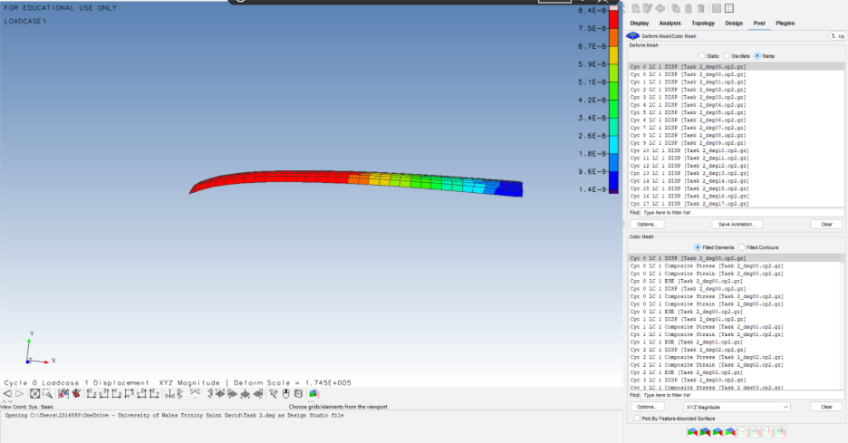
The CFRP wing model was fixed at one end to replicate boundary conditions under a single load. A ramp function was used in the simulation to track displacement response (Figure 11).
Figure 11 - Simulated using ramp
The wing’s free end showed the highest displacement at 8.3 × 10⁻³ m. While the composite material was lighter than steel and had a higher stiffness-to-weight ratio. Since the variables were established using non-discrete, ply thickness values, such as 2.3 plies at Cycle 17, the optimised design was deemed as non-manufacturable.

3.4. Modify to Discrete Variables
To support manufacturability, all design variables were converted to discrete values. Five variables—one per wing layer—were linked to physical ply thicknesses to guide optimisation (Figure 4). Each variable became a discrete design variable instead of an independent continuous variable (See Appendix J).Each was set to start at 0.1 × 10⁻³ m with 50 increments of 0.1 × 10⁻³ m, allowing Design Studio to select practical thicknesses during the process. These values were applied consistently across all five layers (Figure 12).
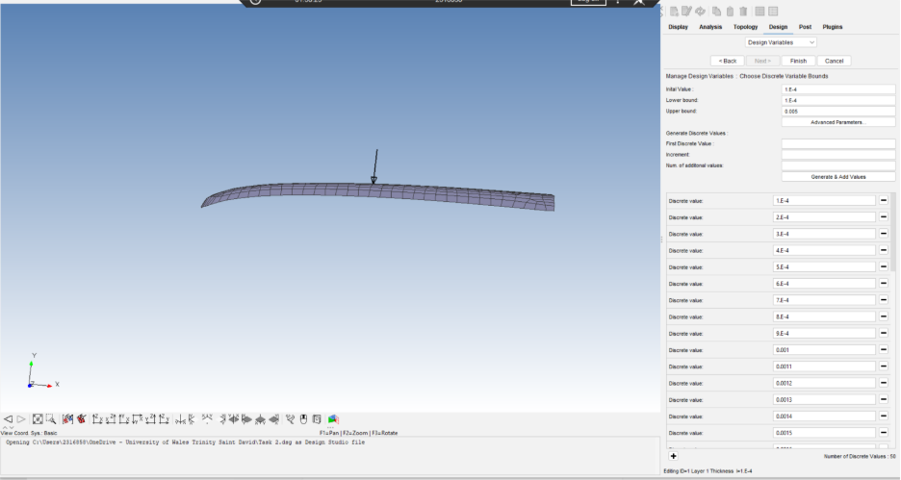
Figure 12 - modified to discrete values

3.5. Re-optimisation
Over 15 design cycles, the discrete optimisation refined ply thicknesses while staying within design limits. The final structure showed a reduced displacement of 7.5 × 10⁻³ m, compared to 8.3 × 10⁻³ m from the non-discrete model (see Appendix K). By Cycle 15, the design converged with practical ply values of 0.2 mm, 0.3 mm, 0.3 mm, 0.2 mm, and 0.2 mm — balancing structural performance with manufacturability.

3.6. Structural Performance Evaluation
Following discrete optimisation, a 500N load was reapplied to the CFRP wing. The model results in a maximum deflection of 7.5 × 10⁻³m. The mass of the optimised CFRP wing was calculated as 191g (0.0191 kg). The stiffness-to-weight ratio for the discretely optimised CFRP wing was found to be 358 N/mm (See Appendix L).

3.7. Stiffness-to-Weight Ratio Analysis
When compared to the previous variable optimisation, the reduced stiffness-to-weight ratio reflects a trade-off between performance and manufacturability. The discrete model still meets structural requirements and maintains a realistic stiffness level for production. Despite rounding ply thicknesses, the design remains both efficient and feasible to manufacture.

3.8. Deflection summary:
To summarise, the displacement values decreased at each stage of material and design optimisation. The steel wing had a maximum displacement of 8.6 × 10⁻³ m, which decreased to 8.4 × 10⁻³ m with CFRP, and further to 8.3 × 10⁻³ m post-optimisation. After modifying to discrete ply variables, displacement decreased to 7.5 × 10⁻³ m, indicating manufacturability. These results highlight how FEA effectively balances stiffness, weight, and deflection to enhance overall structural performance.

Task 4: Proposed experimental validation methods
To evaluate the accuracy of the FEA results from Task 3, a physical experiment will be carried out with strain gauges under controlled loading conditions (Rafal Sulwinski and Johnston, 2023). This experiment aims to replicate the conditions and constraints used in the simulation setup and validate the structural performance of the optimised kiteboard wing design when subjected to real-world loading. The primary steps in the process are as follows:

4.1. Prototype testing:
A prototype of the optimised CFRP wing will be built using the same five-layer layup, with ply thicknesses between 0.2 mm and 0.3 mm, to validate the FEA results. A 500 N vertical load will be applied at the midsection using a ramp function to match simulation conditions and reduce dynamic effects. Universal testing machines and servo-hydraulic actuators will ensure precise control of load and displacement for accurate static measurements (Enrico Cestino et al., 2020), (Hichem Djadoudi, 2025).

4.2. Forces applied:
The experiment will match the loading and boundary conditions used in the simulation to ensure consistency. A vertical load of 500 N will be applied at the wing’s midsection, with one end fully fixed to replicate the FEA constraints. The load will be applied gradually to capture displacement accurately and reduce dynamic effects. All equipment will be calibrated to maintain precision and repeatability throughout testing (Ernst, 2024).

4.3. Data comparison
To understand how the wing responds under load, strain gauges will be placed on its upper and lower surfaces, especially near the fixed end and midsection where stress changes most. Surface movement will be tracked using a laser monitor or DIC system. All sensor data will be fed into a DAQ device to record load, strain, and displacement simultaneously (Mohammed Abbas Mousa et al., 2023). The test will be repeated three times to confirm consistency and validate the results.

4.4. Acquire and analyse data
The model will be validated by comparing experimental results with FEA predictions. Key metrics include maximum deflection, where the experimental value will be compared to the simulated result of 7.5 × 10⁻³ m (Grant, 2016). To check accuracy, the percentage error between the measured and simulated displacement will be calculated using the following equation (guyver, 2025):
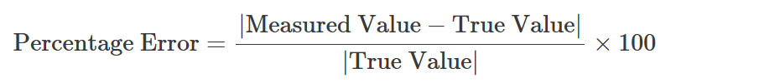
Equation 1 - Percentage error equation (physicscatalyst, 2020)

This calculation demonstrates that the FEA predictions are accurate and helps determine whether the model falls within an acceptable tolerance range, typically ±10% (Alade and Ibrahim, 2023), (University of North Carolina, 2025).

To validate the model, FEA stress and strain results will be compared with strain datasheets to check accuracy and guide engineering decisions. The experimental stiffness-to-weight ratio will also be measured and compared to the simulated value of 358 N/mm, helping assess the structural efficiency of the optimised CFRP wing. This validation process confirms that the design is both practical and capable of performing under real-world loads (Grant, 2016).

4.4.1. Topology optimisation
Topology optimisation techniques, including SIMP (Solid Isotropic Material with Penalisation) (Solidworks, 2025), are frequently applied to direct material distribution in structural design, despite this report focusing just on ply thickness optimisation (Bendsoe and Kikuchi, 1988). Experiments must be conducted for SIMP-based systems to ensure the accuracy of the simulations (Yago et al., 2021). Although SIMP was not applied, the methodology of evaluating deflection and stiffness-to-weight ratios under controlled loading is a reliable way to validate designs, whether they’re based on ply optimisation or topology techniques like SIMP (Zhuang and Zeng, 2025).

4.5. Model modification
The FEA model may require improvement if significant discrepancies are identified during the experiment. This may involve altering the boundary conditions, modifying the material properties, or increasing the mesh density to reflect real-world behaviour (Lee, 2025a).

Task 5: Literature research

5.1. BSI or ISO standards
International guidelines for using Finite Element Analysis (FEA) in structural engineering are well established. BS EN 1993 outlines design standards for steel structures and often relies on FEA for complex shapes and loading (bsi.knowledge, 2025). For composites like CFRP, standards such as ISO 527-5 and BS EN ISO 14126 provide testing methods for tensile and compressive behaviour (bsi.knowledge, 2021), (bsi.knowledge, 2023). These frameworks help ensure that simulation-based designs are safe, reliable, and consistent across both metal and composite applications.

5.2. Transition from steel to CFRP in the kiteboard wing model.
The substitution of steel with carbon fibre-reinforced polymer (CFRP) in the kiteboard wing model led to significant improvements in mechanical performance and simulation accuracy. These improvements are supported in existing academic literature research.
Studies by Pasquale and Coluccia (2023) highlight the need to shift from isotropic to orthotropic modelling when using CFRP, due to its directional properties — a behaviour also noted by Marszałek and Stadnicki (2023). In this study, the steel wing showed uniform stress fields, while the CFRP wing displayed directional stiffness based on fibre orientation, consistent with findings by Memarzadeh et al. (2024). Some researchers, like Song et al. (2024), suggest that standard orthotropic models may still be suitable for stiffness predictions when local failure isn’t a major concern.

5.3 . Mass and Stiffness-to-Weight Ratio
Replacing steel with CFRP typically reduces mass by 70–80% while improving stiffness-to-weight performance (Rajak and Mehboob, 2021). In this study, the steel wing weighed 0.465 kg with a stiffness-to-weight ratio of 126 N/mm, while the CFRP version reduced mass to 0.116 kg and increased the ratio to 518 N/mm. This exceeds typical literature gains of 2–3× and is largely due to fibre alignment along the wing span and the addition of an extra ply (Liu et al., 2023). However, excessive ply stacking can lead to interlaminar stress and delamination risks (Zhang, Shao and Nie, 2024), though this design remained within safe limits.

5.4. Deflection and Structural Response
The simulation results reflect typical composite behaviour, with CFRP showing slightly less deflection than steel due to its higher specific stiffness (Gendy et al., 2025). Deflection dropped from 8.6 × 10⁻³ m with steel to 8.4 × 10⁻³ m using CFRP under the same load. Further optimisation reduced displacement to 7.5 × 10⁻³ m — a 13% improvement over the steel baseline. This mirrors findings by Nie, Zhang and Zeng (2025), who saw similar gains in composite marine foils through ply thickness and layout control (Wu et al., 2019). The results show how simulation and interface modelling help balance low weight with strong structural performance.

5.5. Manufacturing considerations
Many optimisation studies use continuous ply thickness, but this often leads to designs that are hard to manufacture. This project instead used discrete ply layers with realistic thicknesses (0.2–0.3 mm), following the practical approach outlined by Wu et al. (2019). Although this reduced the stiffness-to-weight ratio from 518 N/mm to 358 N/mm, it made the design more manufacturable — a trade-off also noted in composite design research by Fernández (2025).

References
ReA. Schmit, Jr., L. (2025). Vanderplaats. [online] Vanderplaats. Available at: https://www.vrand.com/resources/publications/archive/structural-design-by-systematic-synthesis/ [Accessed 1 Oct. 2025].
Adolphsen, M. (2025). How Digital Twin Simulation Software Improves Decision-Making | Simio. [online] Simio. Available at: https://www.simio.com/how-digital-twin-simulation-software-improves-decision-making [Accessed 8 Oct. 2025].
Alade, A. and Ibrahim, A. (2023). Application of Finite Element Method for Mechanical Characterization of Wood and Reconstituted Lignocellulosic-Based Composites – A Review. Recent Progress in Materials, [online] 5(1), pp.1–37. doi:https://doi.org/10.21926/rpm.2301003.
Balu, A., Sarkar, S., Ganapathysubramanian, B. and Krishnamurthy, A. (2022). Physics-aware machine learning surrogates for real-time manufacturing digital twin. Manufacturing Letters, 34, pp.71–74. doi:https://doi.org/10.1016/j.mfglet.2022.08.013.
bsi.knowledge (2021). BS EN ISO 527-5:2021 - TC | 31 Dec 2021 | BSI Knowledge. [online] Bsigroup.com. Available at: https://knowledge.bsigroup.com/products/plastics-determination-of-tensile-properties-test-conditions-for-unidirectional-fibre-reinforced-plastic-composites-2 [Accessed 26 Oct. 2025].
bsi.knowledge (2023). BS EN ISO 14126:2023 - TC | 31 Oct 2023 | BSI Knowledge. [online] Bsigroup.com. Available at: https://knowledge.bsigroup.com/products/fibre-reinforced-plastic-composites-determination-of-compressive-properties-in-the-in-plane-direction-3 [Accessed 26 Oct. 2025].
bsi.knowledge (2025). BS EN 1993-1-14:2025 | 31 Oct 2025 | BSI Knowledge. [online] Bsigroup.com. Available at: https://knowledge.bsigroup.com/products/eurocode-3-design-of-steel-structures-design-assisted-by-finite-element-analysis [Accessed 26 Oct. 2025].
Charalampous, P., Pelekoudas, A., Kostavelis, I., Ioannidis, D. and Tzovaras, D. (2024). An Integrated Modeling Framework for Automated Product Design, Topology Optimisation, and Mechanical Simulation. Journal of Manufacturing and Materials Processing, 8(6), p.285. doi:https://doi.org/10.3390/jmmp8060285.
Chun, J. (2021). Reliability-Based Design Optimisation of Structures Using the Second-Order Reliability Method and Complex-Step Derivative Approximation. Applied Sciences, 11(11), p.5312. doi:https://doi.org/10.3390/app11115312.
Consarnau, R.G. and Whisler, D. (2024). Designing optimised geometry and fibre orientation of composites for dynamic tension via artificial intelligence. Journal of Composite Materials. doi:https://doi.org/10.1177/00219983241292773.
Cristian Pisarciuc, Dan, I. and Cioară, R. (2023). The Influence of Mesh Density on the Results Obtained by Finite Element Analysis of Complex Bodies. Materials, 16(7), pp.2555–2555. doi:https://doi.org/10.3390/ma16072555.
Dassault Systèmes (2025). SIMP Method for Topology Optimization - 2021 - SOLIDWORKS Help. [online] help.solidworks.com. Available at: https://help.solidworks.com/2021/english/SolidWorks/cworks/c_simp_method_topology.htm [Accessed 7 Oct. 2025].
Enrico Cestino, Frulla, G., Piana, P. and Renzo Duella (2020). Numerical/Experimental Validation of Thin-Walled Composite Box Beam Optimal Design. Aerospace, 7(8), pp.111–111. doi:https://doi.org/10.3390/aerospace7080111.
Ernst, L. (2024). Vertical Load Transfer In Structural Engineering [2024] - Structural Basics. [online] Structural Basics - Structural Engineering for everyone. Available at: https://www.structuralbasics.com/vertical-load-transfer/ [Accessed 26 Oct. 2025].
Fernández, F. (2025). Optimal design strategy for variable-stiffness composite laminates addressing strength and manufacturing challenges. Optimization and Engineering. doi:https://doi.org/10.1007/s11081-025-10013-0.
Fong, J., Filliben, J.J., deWit, R., Fields, R.J., Bernstein, B. and Marcal, P.V. (2006). Uncertainty in Finite Element Modeling and Failure Analysis: A Metrology-based Approach. NIST, [online] 128, pp.141–147. Available at: https://www.nist.gov/publications/uncertainty-finite-element-modeling-and-failure-analysis-metrology-based-approach [Accessed 18 Oct. 2025].
Gendy, M.E., Arabi, I.E., ELbarbary, A. and Hamed, M. (2025). Comparative study of structural behavior of CFRP tubes and traditional steel for pile and column applications compliance with international codes. Deleted Journal, 2(1). doi:https://doi.org/10.1007/s44290-025-00244-6.
Grant, E.V. (2016). Verifying Your Finite Element Analysis Results - Engineering.com. [online] Engineering.com. Available at: https://www.engineering.com/verifying-your-finite-element-analysis-results/ [Accessed 26 Oct. 2025].
guyver (2025). How to Calculate Percent Error in Physics Lab Reports. [online] CosmoMath – Free Online Calculators for Every Need. Available at: https://cosmomath.com/calculate-percent-error/ [Accessed 26 Oct. 2025].
Haghighat, E., Raissi, M., Moure, A., Gomez, H. and Juanes, R. (2021). A physics-informed deep learning framework for inversion and surrogate modeling in solid mechanics. Computer Methods in Applied Mechanics and Engineering, 379, p.113741. doi:https://doi.org/10.1016/j.cma.2021.113741.
Hichem Djadoudi (2025). Mastering Composite Materials in FEA: A Complete Guide for CFRP and GFRP Analysis. [online] WorQuick. Available at: https://www.worquick.com/post/mastering-composite-materials-in-fea-a-complete-guide-for-cfrp-and-gfrp-analysis [Accessed 26 Oct. 2025].
Jia, H., Beom, H.G., Wang, Y., Lin, S. and Liu, B. (2011). Evolutionary level set method for structural topology optimization. Computers & structures, 89(5-6), pp.445–454. doi:https://doi.org/10.1016/j.compstruc.2010.11.003.
Kristin, Flaßkamp, K., Ströhla, T., Sattel, T., Bestle, D., Röder, B., Eberhard, P., Peitz, S., Stoffel, M., Rutwik, G., Aditya, B., Wohlleben, M., Sextro, W., Raff, M., David, R.C., Yadav, M., Stender, M., Delden, van, Lüddecke, T. and Langer, S.C. (2024). The impact of AI on engineering design procedures for dynamical systems. [online] arXiv.org. Available at: https://arxiv.org/abs/2412.12230 [Accessed 8 Oct. 2025].
Kumar N, K., C M, M., Kumar B K, P. and Bali, M. (2025). Reinforcement learning-based topology optimization for generative designed lightweight structures. MethodsX, [online] 15, p.103539. doi:https://doi.org/10.1016/j.mex.2025.103539.
Lava, P., Jones, E., Wittevrongel, L. and Pierron, F. (2020). Validation of finite-element models using full-field experimental data: Levelling finite-element analysis data through a digital image correlation engine - ePrints Soton. Soton.ac.uk. [online] doi:https://eprints.soton.ac.uk/438957/1/Validation_Part1_Synthetic_accepted.pdf.
Lee, S. (2025a). Mastering Model Updating in FEA. [online] Numberanalytics.com. Available at: https://www.numberanalytics.com/blog/ultimate-guide-model-updating-fea-structural-engineering [Accessed 26 Oct. 2025].
Li, M., Torah, R., Liu, J., Tudor, J. and Beeby, S. (2020). Finite element analysis (FEA) modelling and experimental verification to optimise flexible electronic packaging for e-textiles. Microsystem Technologies. doi:https://doi.org/10.1007/s00542-020-04813-w.
Li, Z., Liu, Y., Qi, L., Mei, Z., Gao, R., Yu, M., Sun, Z. and Wang, M. (2022). Optimization of the Laminate Structure of a Composite Cylinder Based on the Combination of Response Surface Methodology (RSM) and Finite Element Analysis (FEA). Molecules, [online] 27(21), p.7361. doi:https://doi.org/10.3390/molecules27217361.
Liu, Q., Wang, X., Guan, Z., Li, Z. and Yang, L. (2025). Ply Optimization of Composite Laminates for Processing-Induced Deformation and Buckling Eigenvalues Based on Improved Genetic Algorithm. Materials, 18(2), pp.345–345. doi:https://doi.org/10.3390/ma18020345.
Liu, Y., Zhang, H., Wu, Q., Yao, Z., Huang, B. and Wang, G. (2023). Bend-twist coupling effects on the cavitation behavior and hydroelastic response of composite hydrofoils. International Journal of Multiphase Flow, 158, p.104286. doi:https://doi.org/10.1016/j.ijmultiphaseflow.2022.104286.
Łukasz Skotny Ph.D (2017). Finite Element Analysis workflow. [online] Enterfea. Available at: https://enterfea.com/fea-workflow/ [Accessed 7 Oct. 2025].
Marszałek, J. and Stadnicki, J. (2023). Experimental and Numerical Study on Mechanical Behavior of Steel/GFRP/CFRP Hybrid Structure under Bending Loading with Adhesive Bond Strength Assessment. Materials, [online] 16(14), p.5069. doi:https://doi.org/10.3390/ma16145069.
Massobrio, A. (2024). What Is Design for Reliability (DFR)? Overview & Applications. [online] Neuralconcept.com. Available at: https://www.neuralconcept.com/post/design-for-reliability-process-ai-applications [Accessed 7 Oct. 2025].
McGarry, S. (2025). The Ins and Outs of FEA in Manufacturing. [online] Design & Manufacturing. Available at: https://www.autodesk.com/blogs/design-and-manufacturing/the-ins-and-outs-of-fea-in-manufacturing [Accessed 8 Oct. 2025].
Memarzadeh, A., Onyibo, E.C., Asmael, M. and Safaei, B. (2024). Dynamic Effect of Ply Angle and Fiber Orientation on Composite Plates. Spectrum of Mechanical Engineering and Operational Research, [online] 1(1), pp.90–110. doi:https://doi.org/10.31181/smeor11202410.
Mohammed Abbas Mousa, Yussof, M.M., Hussein, T.S., Assi, L.N. and SeyedAli Ghahari (2023). A Digital Image Correlation Technique for Laboratory Structural Tests and Applications: A Systematic Literature Review. Sensors, [online] 23(23), pp.9362–9362. doi:https://doi.org/10.3390/s23239362.
Most, T. and Will, J. (2017). Robust Design Optimization Methods for Industrial Applications. NAFEMS World Congress. [online] Available at: https://www.researchgate.net/publication/330778773_Robust_Design_Optimization_Methods_for_Industrial_Applications [Accessed 7 Oct. 2025].
NAFEMS (2016). NAFEMS - The Importance of Mesh Convergence - Part 1. [online] www.nafems.org. Available at: https://www.nafems.org/publications/knowledge-base/the-importance-of-mesh-convergence-part-1/ [Accessed 18 Oct. 2025].
Nicholas, P.E., C Dharmaraja, Sofia, A.S. and Vasudevan, D. (2019). Optimization of laminated composite plates subjected to nonuniform thermal loads. Polymers and Polymer Composites, 27(6), pp.314–322. doi:https://doi.org/10.1177/0967391119846242.
Niharika Institute of Computational Engineering (2023). What Are the Three Stages of Finite Element Analysis? [online] Nicecfd.com. Available at: https://www.nicecfd.com/blog/what-are-the-three-stages-of-finite-element-analysis [Accessed 7 Oct. 2025].
Pasquale, G.D. and Coluccia, A. (2023). Modeling and Experimental Validation of CFRP–Metal Joints Utilizing 3D Additively Manufactured Anchors. Journal of Manufacturing Science and Engineering, 145(11). doi:https://doi.org/10.1115/1.4063110.
physicscatalyst (2020). How to calculate percentage error. [online] physicscatalyst’s Blog. Available at: https://physicscatalyst.com/article/percentage-error/ [Accessed 23 Oct. 2025].
Plumb, J. (2025). Finite Element Analysis – Predicting the Real World | CDT. [online] Cambridge Design Technology. Available at: https://www.cambridge-dt.com/finite-element-analysis-predicting-the-real-world [Accessed 30 Sep. 2025].
Rafal Sulwinski and Johnston, R. (2023). Methodology for Validation of Finite Element Analysis Utilizing Strain Gauge Measurements. doi:https://doi.org/10.1115/vvuq2023-108749.
Rahimi, N., Kerfriden, P., C, L.F. and R, M.R. (2018). CAD Model simplification error estimation for electrostatics problems -ORCA. Cardiff.ac.uk. [online] doi:https://orca.cardiff.ac.uk/id/eprint/103848/3/SimpErrES.pdf.
Rozvany, G.I.N. (2008). A critical review of established methods of structural topology optimization. Structural and Multidisciplinary Optimization, 37(3), pp.217–237. doi:https://doi.org/10.1007/s00158-007-0217-0.
Sebaey, T.A., Kumar Rajak, D. and Mehboob, H. (2021). Internally stiffened foam-filled carbon fiber reinforced composite tubes under impact loading for energy absorption applications. Composite Structures, 255, p.112910. doi:https://doi.org/10.1016/j.compstruct.2020.112910.
Shi, C., Huang, M., Su, S., Hu, Q., Wang, W. and Li, X. (2025). Energy-resilient performance-based generative design to adapt to future climate change using urban building energy model: A case study of residential block design. Sustainable Cities and Society, [online] 131, p.106769. doi:https://doi.org/10.1016/j.scs.2025.106769.
Siemens (2025a). AI-accelerated gear stress analysis - Simcenter. [online] Simcenter. Available at: https://blogs.sw.siemens.com/simcenter/ai-accelerated-gear-stress-analysis [Accessed 8 Oct. 2025].
Siemens (2025b). Finite element pre/post-processing. [online] Siemens Digital Industries Software. Available at: https://plm.sw.siemens.com/en-US/simcenter/simulation-test/finite-element-pre-post-processing/ [Accessed 7 Oct. 2025].
Sobieszczanski-Sobieski, J. and Haftka, R. (2024). Multidisciplinary aerospace design optimization - Survey of recent developments | Aerospace Sciences Meetings. Aerospace Sciences Meetings. [online] doi:https://doi.org/10.2514/MASM96;csubtype:string:Conference.
Solid Solutions (2017). Idealisation Error Within SOLIDWORKS Simulation. [online] Solidsolutions.co.uk. Available at: https://www.solidsolutions.co.uk/blog/2017/06/idealisation-error-within-solidworks-simulation [Accessed 18 Oct. 2025].
Solidworks (2025). 2019 SOLIDWORKS Help - SIMP Method for Topology Optimization. [online] help.solidworks.com. Available at: https://help.solidworks.com/2019/English/SolidWorks/cworks/c_simp_method_topology.htm [Accessed 26 Oct. 2025].
Song, Q., Xu, J., Chen, X., Huang, W., Zeng, Y. and Guo, Z. (2024). Multiscale simulation and prediction of mechanical properties for carbon fiber reinforced polymer orthotropic laminate. Polymer Composites, [online] 45(8), pp.7150–7163. doi:https://doi.org/10.1002/pc.28256.
Soundararajan, B., Sofia, D., Barletta, D. and Poletto, M. (2021). REVIEW ON MODELING TECHNIQUES FOR POWDER BED FUSION PROCESSES BASED ON PHYSICAL PRINCIPLES. Additive Manufacturing, p.102336. doi:https://doi.org/10.1016/j.addma.2021.102336.
Suat Coemert, Baturay Yalvac, Bott, V., Sun, Y. and Lueth, T.C. (2020). Development and validation of an automated FEM-based design optimization tool for continuum compliant structures. International Journal of Mechanics and Materials in Design, 17(2), pp.245–269. doi:https://doi.org/10.1007/s10999-020-09506-w.
Suvo (2018). Flow Chart for Finite Element Analysis – Overall Steps for FEA, FEM or CAE. [online] Bright Hub Engineering. Available at: https://www.brighthubengineering.com/cad-autocad-reviews-tips/66732-what-are-the-steps-required-to-perform-a-finite-element-analysis/ [Accessed 7 Oct. 2025].
Tanskanen, P. (2002). The evolutionary structural optimization method: theoretical aspects. Computer Methods in Applied Mechanics and Engineering, 191(47-48), pp.5485–5498. doi:https://doi.org/10.1016/s0045-7825(02)00464-4.
The MathWorks, Inc. (2025). Reconstruct Structural Solution from ROM Results. [online] Mathworks.com. Available at: https://www.mathworks.com/help/pde/ug/reduced-order-models-for-faster-structural-and-thermal-analysis.html [Accessed 7 Oct. 2025].
ToffeeX (2025). Shaping a Greener Tomorrow with Sustainable Generative Design - ToffeeX. [online] ToffeeX - The pioneer of Physics-driven Generative Design. Available at: https://toffeex.com/shaping-a-greener-tomorrow-with-sustainable-generative-design [Accessed 8 Oct. 2025].
University of North Carolina (2025). Introduction to Measurements & Error Analysis. [online] Introduction to Measurements & Error Analysis . Available at: https://astro.pas.rochester.edu/~aquillen/phy141/lectures/pdfs/uncertainty_nc.pdf [Accessed 26 Oct. 2025].
Vollaire, C., Nicolas, L. and Nicolas, A. (1998). Parallel computing for the finite element method. The European Physical Journal Applied Physics, [online] 1(03), pp.305–314. doi:https://doi.org/10.1051/epjap:1998151.
Wu, C., Gao, Y., Fang, J., Lund, E. and Li, Q. (2019). Simultaneous Discrete Topology Optimization of Ply Orientation and Thickness for Carbon Fiber Reinforced Plastic-Laminated Structures. Journal of Mechanical Design, 141(4). doi:https://doi.org/10.1115/1.4042222.
www.duodesign.co.uk (2016). NAFEMS Determination and Use of Material Properties for Finite Element Analysis. [online] NAFEMS. Available at: https://www.nafems.org/publications/resource_center/r0119/ [Accessed 18 Oct. 2025].
Yago, D., Cante, J., Lloberas-Valls, O. and Oliver, J. (2021). Topology Optimization Methods for 3D Structural Problems: A Comparative Study. Archives of Computational Methods in Engineering, 29(3), pp.1525–1567. doi:https://doi.org/10.1007/s11831-021-09626-2.
Zhang, W., Shao, W. and Nie, Y. (2024). An Analysis of the Flexural Stiffness and Horizontal Bearing Capacity of CFRP Composite Pipe Piles in Marine Environments. Journal of Marine Science and Engineering, [online] 12(10), pp.1870–1870. doi:https://doi.org/10.3390/jmse12101870.
ZHU, J., ZHOU, H., WANG, C., ZHOU, L., YUAN, S. and ZHANG, W. (2021). A review of topology optimization for additive manufacturing: Status and challenges. Chinese Journal of Aeronautics, 34(1), pp.91–110. doi:https://doi.org/10.1016/j.cja.2020.09.020.
Zhuang, J. and Zeng, F. (2025). Research and Experimental Verification of an Efficient Subframe Lightweighting Method Integrating SIMP Topology and Size Optimization. Applied Sciences, [online] 15(15), p.8192. doi:https://doi.org/10.3390/app15158192.ferences

Table of Figures
Figure 1 - Finite Element Analysis (FEA) process flow (McGarry, 2025) 3
Figure 2 - Simulation of a deflection of 8.6x10⁻³m 6
Figure 3 - theta Vectors 7
Figure 4 - theta Vectors adjusted to reflect direction 7
Figure 5 - ply thickness and the layer definitions created 8
Figure 6 - Simulation of a deflection of 8.4x10⁻³m 9
Figure 7 - minimising the mass 10
Figure 8 - constraint of maximum deflection 10
Figure 9 - 17 Design cycles generated 11
Figure 10 - Design history plot 12
Figure 11 - Simulated using ramp 13
Figure 12 - modified to discrete values 14

Table of equations
Equation 1 - Percentage error equation (physicscatalyst, 2020) 16

Appendix

Appendix A
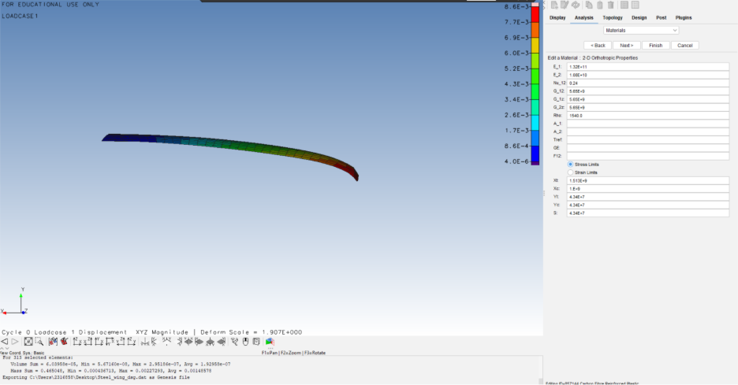

Appendix B
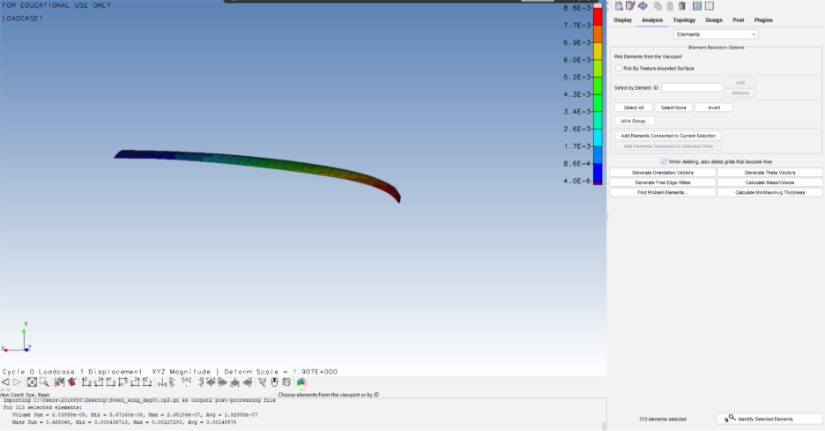

Appendix C
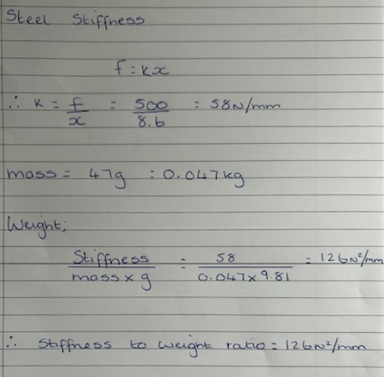

Appendix D

Appendix E
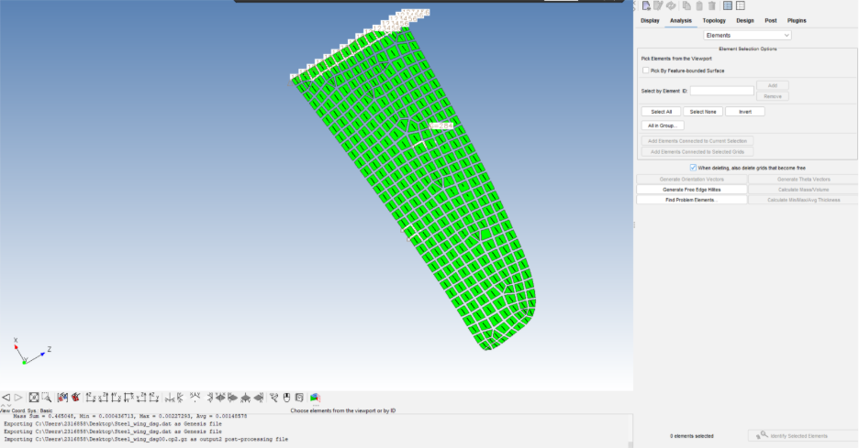

Appendix F
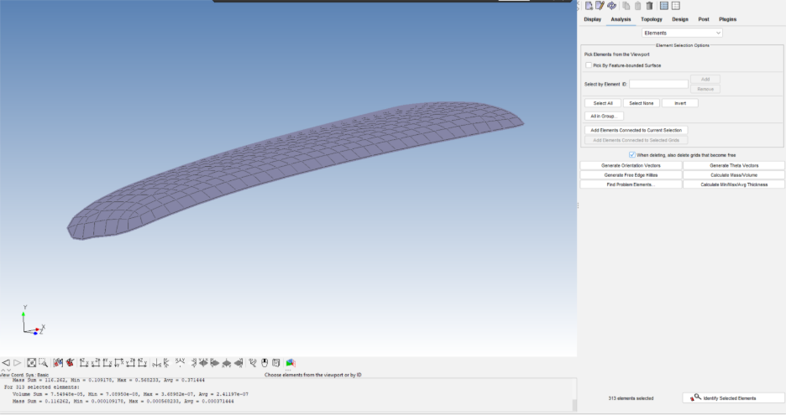

Appendix G
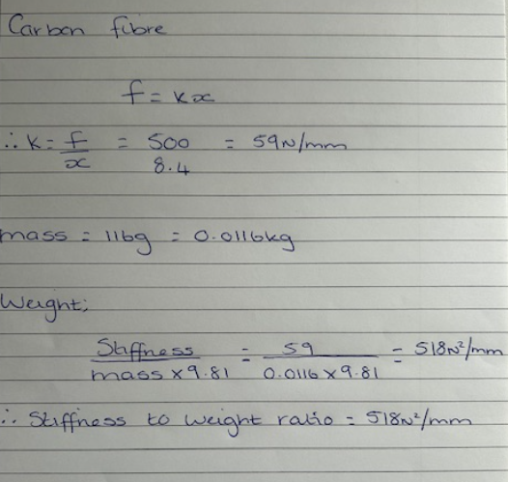

Appendix H
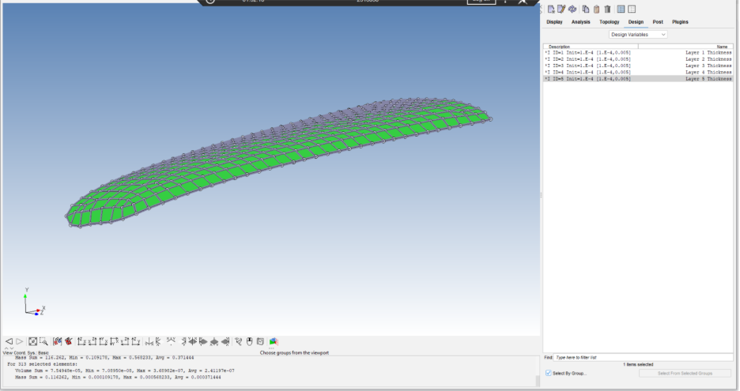

Appendix I
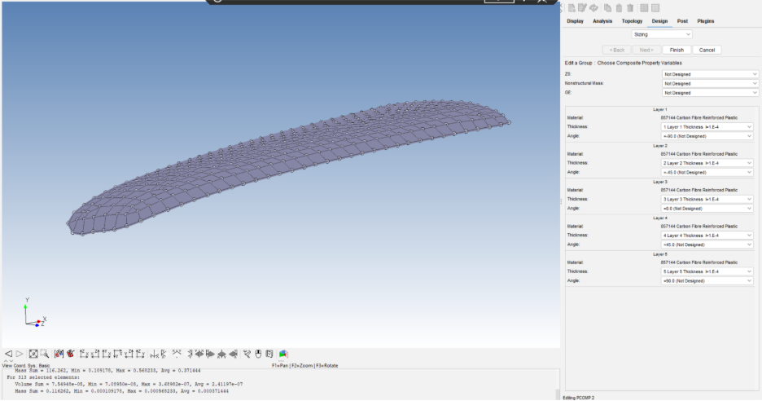

Appendix J
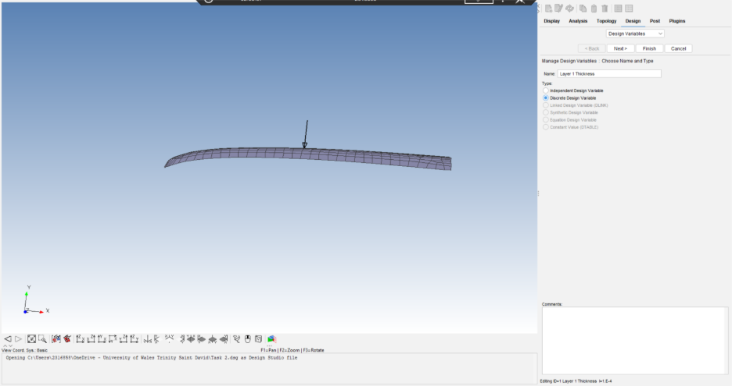

Appendix K
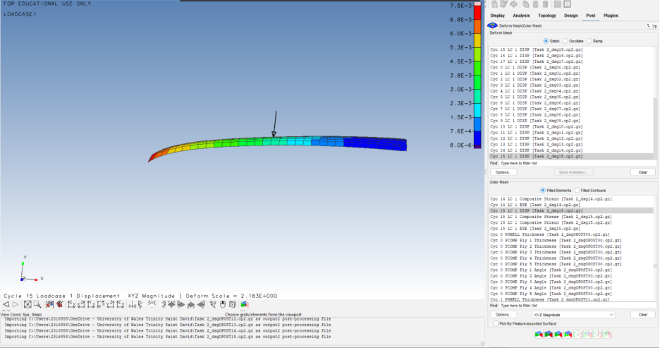

Appendix L


