Programme: MBA – Master of Business Administration

Module: Marketing Management

Assignment Title: Essay (Assignment 1)

Module Code: LCMB7001

Lecturer: Efua Adams

Student Name: Kholsuma Ahmed

Student ID: 1815239

Table of Content

Introduction / Overview………………………………………..…………………….……..3-4

Concepts and Importance of Marketing………………………………………………….4-5

The Internal Macro- and Micro-Environment of the Organisation………………...….5

Target Markets………………………………………………………………………….……5-7

Selection of Media……………………………………………………………………….…….7

Measuring Success…………………………………………………………………………8-9

Task 2: Managerial implications on the Organisation’s Marketing Strategy ……9-10

Task 3: Based on the managerial Implication’s drawn in Task 2, Provide recommendations as to how the organisation’s marketing Strategy could be improved………………………………………………………..……………………………10-15

References…………………………………………………………………………………………16-17

Introduction / Overview

As a Marketing consultant and being aware of the importance of the marketing strategy, and its concept can be helpful to advice Christos, for scanning through their marketing activities. By implementing the marketing strategies, it will help the restaurant to attract new customers and gain competitive advantage in the market, advertising your brand for recognition and the product or service are offered will be delivered to the existing or potential customers (Bhasin, What is the importance of marketing strategy? 2018).
for Christos Greek Cypriot Restaurant, to conduct a report to identify the company's marketing initiatives and determine whether these initiatives were successful. Also, establish how the current functions are operating which are in place and how it might be improved. Then, clarify any choices using examples, and offer suggestions for modifications that might help the marketing methods. When educating customers about the benefits of a product or service with the intention of selling those products or services, marketing functions can be extremely important, especially to attract customers, this feature is highly helpful for businesses (Kotler,2000).
The Greek Cypriot restaurant in Midlands provides for the community. In 1980, the committee converted to an Approachable Society, which afforded them significant advantages like the ability to legally hold real estate in the name of their trustees.

They began by renting a small structure on Station Road in Erdington as they searched for a place for the neighbourhood to host their social activities. However, more space was needed since the population of the Greek Cypriot rapidly outgrew the centre ground.
Greek Cypriot community members bought The Magnet Centre from the GEC in May 1984, with help from grants supplied by the old West Midlands County Council and Inner-City Partnership programme. It facilitates for Football, cricket, bowls, tennis, and hockey. It has only been possible since 1985 after purchase of the adjacent 13.5 acres of Magnet recreation fields from the GEC with the help of Birmingham City Council. Additionally, the purchase provided plenty of room for unorganised play and conservation among Erdington's Greek Cypriot and local population. Magnet Sports and Social Club, through which the original football team (now renamed Kypros FC) are actively involved, is in charge of managing the fields.
As of 2006, the Friendly Society is an FSA-managed Industrial and Provident Society. This change in status allowed it to become a limited liability association, providing protection to the trustees, and enabling the issuance of shares on the "one share, one vote" basis upon membership. The Association, which is a separate legal body, now owns the Magnet Centre outright. The Midlands Greek and Cypriot Association obtained exempt charitable status from HMRC in 2008, allowing it to claim gift assistance on the significant donations required to keep its presence in the UK's second city.
The restaurant is run by Christos and his family, which is known as The Midlands Greek & Cypriot community centre, located in Erdington Birmingham.
Christos worked in the restaurant industry for the most of his working life, managing a Greek Restaurant in Tamworth, as its head chef, manager, and musician for about 15 years.
The region is accessible to a Greek church, a cafe, an entertainment space, and Greek school in addition to the restaurant.
This is the place to go if you like to socialise with the locals where they serve mostly the residents and visitors of the community.
Researched Information has been conducted and applied to recognise and identify opportunities and problems, generate, refine, and evaluate actions, monitor performance, and enhance understanding of it as a whole. Marketing research is a crucial link which creates a unique relationship between the consumer and the brand which ultimately will determine whether they return for repeat purchases. It collates the data required to address these issues, develops the information gathering strategy, coordinates and carries out the data collection methods, and implements an analysis process to convey the conclusions and outcomes (approved 2017).
Concepts and Importance of Marketing
The term "concept marketing" describes the application of data in marketing to target the objectives and wants of customers, in order to create strategies. Marketing concepts are the methods used in marketing that give you a variety of ways to reach your target audience. These ideas necessitate an understanding of your ambitions, the aims of the organisation, and the state of the economy. This type of marketing enables businesses to provide goods and services that satisfy the requirements and objectives of their target market. The marketing strategy boosts a company's ability for competition, and efficiently increasing revenues, by showcasing the ways in which the brand provides customers with higher value compared to its rivals. Therefore, understanding the target market and identifying its demands is essential (Epperson, 2020).
Your restaurant's guiding principles and a crucial component of your business plan are its goal, vision, and values. They assist you in ensuring that all your business choices, from your logo to your suppliers, are strategic and in line with your objectives (Meyer-Cuno, 2022).
Target Markets
Your restaurant's success or failure will depend on how well you can identify a viable market niche. You can only compete in this way against bigger, more well-known brands. Finding your target market is necessary before identifying your market niche.
The secret to any business' success is figuring out who your target market is and how to get in touch with them. The restaurant business is similar. If you want to be successful, you must identify who your target market is (O'Donnell, 2021).
Examine the restaurant scene in your neighbourhood. What restaurants are the most well-liked, and why? What kinds of eateries are underrepresented, and why?
What do you know about the local populace, the folks who could be your customers? Are they young or old, wealthy or poor, college-educated, etc.? Your judgements will be more well-informed the more you understand the demographics of your consumer base (O'Donnell, 2021).
The Christos Restaurants target customers are the mainly Greek Community as they serve Greek Food in the restaurant. They also attract the diverse community for dining and events. For the purpose of email marketing, they are attracting clients from 18 to 34 years age group, they also have the regulars who come to the Church service on Sundays.

Marketing Mix

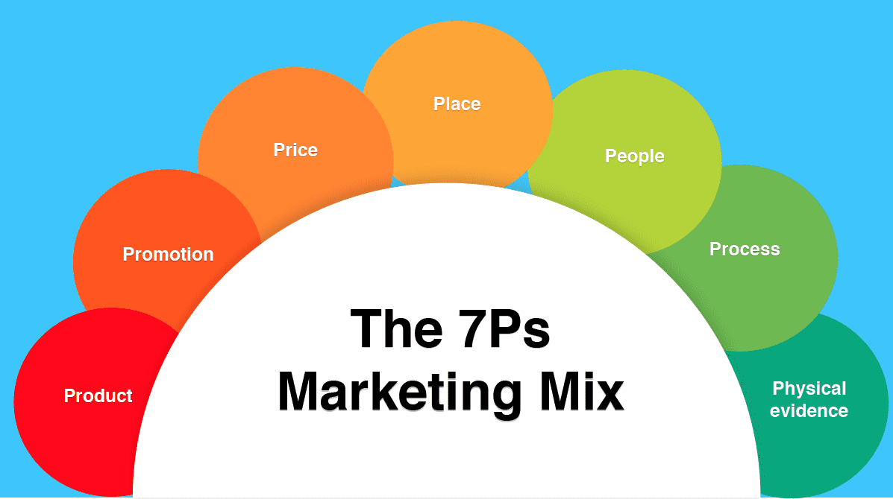

(Hanlon, How to use the 7PS marketing mix strategy model? 2022)
The marketing mix, often known as the 4Ps and 7Ps of marketing, is a group of strategies used by businesses to sell their brands. It is a cornerstone of marketing strategy. The four Ps are product, price, place, and promotion, and the seven Ps are processes, people, and physical environment (Belyh, The elements of product mix 2022).
Price
By using a target Marketing mix framework, it helps an organisation to generate income after expenses. So, it's essential to get the pricing correct to not only cover costs but maximise the profits too! Before prices are set, information on what customers are willing to pay must be gathered and to gain an understanding of the market demand for that product/service. This is because price is a strong indicator of market positioning against competitors (low prices=value brand), prices must be set with competitors in mind (Barrington, Understanding the 7PS of the marketing mix 2020).
Products
This element is the core of the brand because without the product there is no company. The product is essentially what the company produces (whether it is an item, a service, or a combination of the two) it must be useful and designed to meet the customer's core needs. The challenge is to develop the appropriate 'bundle of benefits' to meet this requirement. So, what happens when customer demands shift, competitors outperform, or new may opportunities even emerge from it. It is always best to improve the offering of the brand’s products, we must add to the 'bundle of benefits,' create new versions of existing products, or launch brand new products. A great brand will think beyond the product itself when improving the product offering - value can be added and differentiation achieved through guarantees, warranties, after-sales or online support, a user-friendly app, or digital content such as a video that assists the user in making the most of the product (Barrington, Understanding the 7PS of the marketing mix 2020).
Physical Evidence
The quality of the experience that a business is giving can be clearly seen through physical qualities and characteristics. For example, when selling a product it is great to boost the morale of the customer by upping their confidence in purchasing the item or service and tailoring this to their needs, knowing if they have ever made a purchase from the company before can be especially helpful to tailoring to their needs. The environment, staff appearance, menus, and online evaluations for a restaurant could all provide as tangible proof of the type of experience one can anticipate. For an agency, the website itself will contain valuable evidence such as client testimonials, case studies, and the contracts that businesses are provided to illustrate the services they can anticipate receiving (Barrington, Understanding the 7PS of the marketing mix 2020).
Process
The process must be seamless, effective, and customer-friendly by implementing proper back-end procedures by knowing the stages of the journey of your customers—from initiating an online inquiry to asking for information and making a purchase—helps us think through the processes that must be in place to guarantee the customer has a good experience. How long will it take until a consumer receives an answer to their inquiry? How long does it take for a meeting to be scheduled with the sales team before it happens? Following their order, what happens? How should an employee inform customers for their feedback after their visit? How can the process be faster by using digital means? These variables add to a positive customer experience (Barrington, Understanding the 7PS of the marketing mix 2020).
Place
Direct customer feedback should give you an insight on where and how your product is sold. It will be obvious where you should promote and sell your products as well as how that fits into your online and offline marketing mix once you have a thorough understanding of their buying habits and are able to target them at the proper point in their buying cycle (Assemblo, What are the 7 PS of Marketing? 2022).
Promotion
A marketer must accurately depict the product in its real form of usage within the market via multi-channel, multi-level marketing communications through advertising, direct calling, social media platforms, and print media. There are numerous examples of how promotional activities have distinguished a product from its competitors in the industry by using a variety of creative flairs (Alpha, 7Ps of marketing mix: Explained well with examples 2022).
People
Those individuals who participate in the innovation, distribution, and sale of the product are an essential part of the marketing mixes for services (intangible offerings). Each employee has an important role to play i.e. a delivery personnel and sales executives, leave a lasting impression on customers. For example, ensuring stock is out and available to customers and gathering the correct information to make the right choice in purchasing a product. Hotels such as the Taj, Hyatt, and JW Marriott are well-reputed for the people who work there to serve customers. Because of the people they employ, these brands have established themselves and developed a massive and loyal customer base (Barrington, Understanding the 7PS of the marketing mix 2020).
Selection of media:
Social Media websites are being used by Christos restaurant to promote their brand they use Instagram, Facebook, Twitter and their own website, where most of the information is shared. This includes opening times, events, special offers or discounts, menus and other facilities offered within such as a banqueting hall that can accommodate 270 people, sports facility, a church and a Greek School. The information should be available to the community because they need to be aware of everything.

There are so many social media sites that are expanding. Targeting folks who resemble your consumers is a good place to start. It's crucial to keep in mind that since this is social media, we have the chance to engage with customers and potential customers, cultivate connections with them, and earn their trust.

The ability to target certain demographics, geographic regions, behaviours, and influences can help you get closer to your ideal buying audience. Social media is one of the digital marketing technologies with the quickest growth. Several advertisers use different social media channels to announce new items, run contests, and operate online stores (Social Media Marketing Birmingham).
Social media is the most powerful tool in marketing besides verbal word of mouth. But this is much faster in real-time interaction with a large amount of customers to share information. You may sell and promote your goods and services via social media, as well as better reach your clients.
Yet, adopting social media for business comes with danger. Be cautious and educate yourself on the advantages and disadvantages before you begin (Social Media for Business 2022).

Measuring Success:
In the neighbourhood, Christos Greek Cypriot restaurant might offer the nicest ambiance or the tastiest appetisers. The restaurant's profitability could suffer if they don't monitor its strengths and weaknesses or recognise the possibilities and challenges it faces. This is where completing a SWOT analysis for the restaurant might be your best line of defence against losing ground to your rivals.
SWOT
Strength
*Large free car Parking Facilities available.
* Christos is the property's direct owner.
* Christos is recognised as a Michelin-starred chef.
* Banqueting Suite can host events for up to 270 guests.
* Banqueting suite can be hired for large Greek weddings to family christenings.
* For both catered and self-catered events, reasonable rates are available.
* A restaurant with more than 100 seats serves traditional Greek Cypriot cuisine that is grilled over charcoal and in clay ovens.
Weaknesses
- They don’t serve Halal food.
- Opening times varies.
- They do not offer vegan or vegetarian menu.
- Not enough description of dishes on menu’s
- Only serve Greek food
- Christos managing to many jobs by himself.
Opportunity
- Can introduce Halal foods.
- Can introduce Vegan foods.
- Downstairs of the buildings Interiors needs updating.
- Stakeholders are the community members who may associate with funding.
- Christos has 15 years of Managerial Experience as well as a musician and working as a head chef.
- Christos can train his staff.
Threat
- Competition with another Greek restaurant.
- Interior is out-dated.
- They closed two days a week costumer might go elsewhere.
- When making reservation for certain days they charge £10 booking fee.
Task 2: Provide a managerial implication on the organisation’s marketing strategy

As a result, internationalising a business requires a strong focus on global marketing, which has the following benefits:
- reducing inefficiencies in costs and duplication of effort between national and regional subsidiaries; providing chances for subsidiaries to transfer products, brands, and concepts;
- appearance of international customers; strengthening of connections between national infrastructures, resulting in the creation of a global marketing infrastructure (Costa, 2018).

A visual framework for organising and deconstructing the various elements of a restaurant business's services is called a restaurant service blueprint. It aids in simplifying complicated procedures into manageable steps and identifies areas for customer service enhancement.
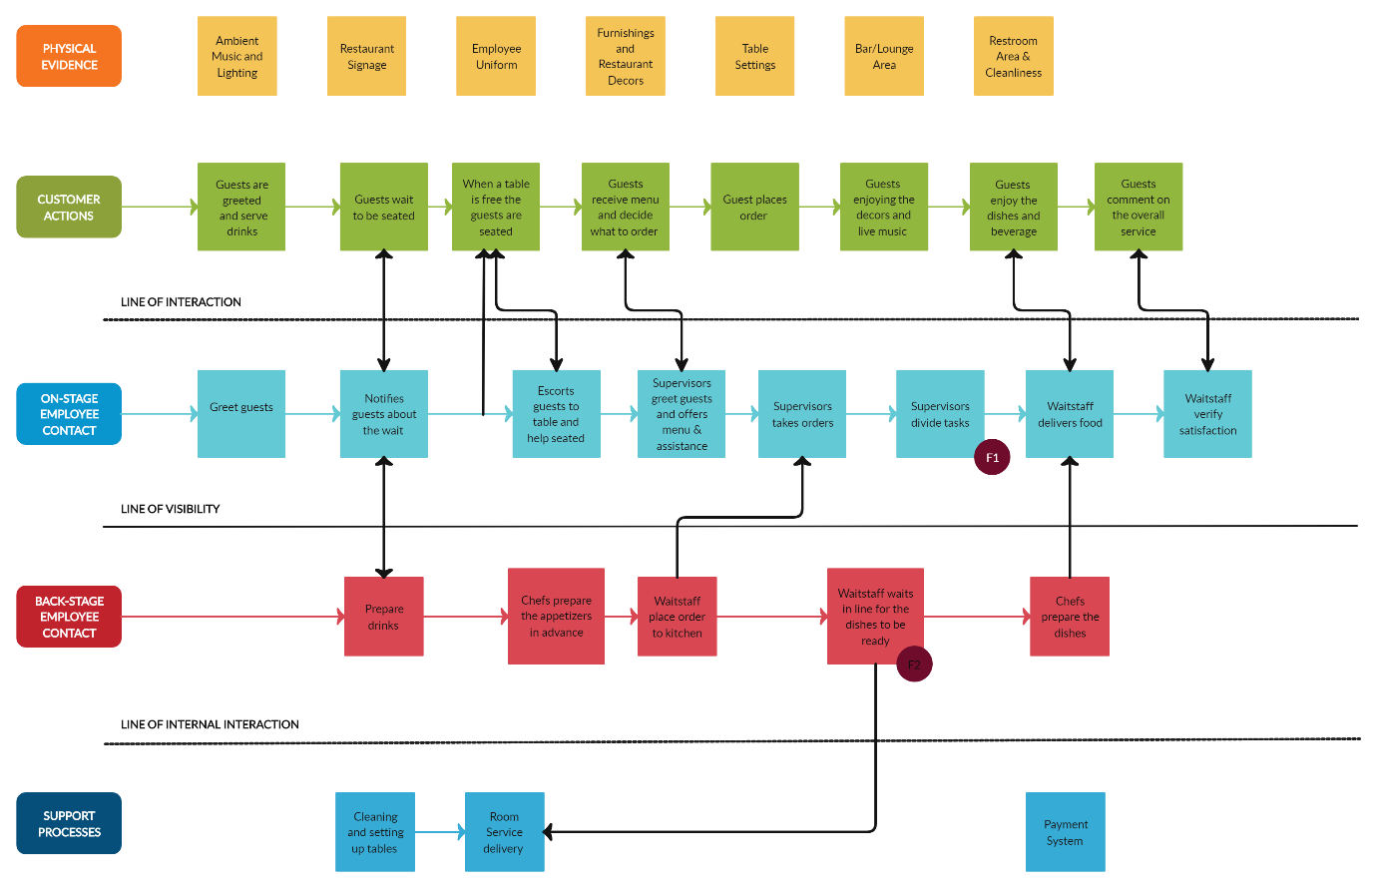
(Google Images)

A service blueprint
A service blueprint is a diagram that represents the relationships between various service components and understanding an organization's services, resources, and processes is made easier by its service blueprint. Another purpose of this tool is a thorough analysis of the service process for example, if Christos was to use is physical experience being a Michelin Star chef, he would attract more customers who will be trusting him to deliver quality food. And if the restaurant was to introduce Halal food that will attract more customers from different cultures, ie the Muslim communities also if Vegan or Vegetarian food were to introduce in the menu it will generate even more customers, which will give an end result increasing in sales meaning increasing profit. Therefore, Christos will need to sequence the needs for his restaurant by Visibly recognizing with a time scale with tolerance.

The service blueprint's essential components
The main parts of the service blueprint indicate the job that the staff does onstage and behind the scenes. No matter how it appears or what it covers, every service blueprint must include the following components:

- Customer activities are highlighted at the top of the map since they are essential for creating the service plan. Included are the decisions, actions, acts, and interactions a consumer takes when thinking about, buying, or using a service.
- Physical Evidence: At the top of the diagram, this term refers to the real evidence of the service. Usually, each contact point's clear presentation of the information is above it.
- Frontage/Visible Employee Contact: This refers to the tasks that frontline contact staff members carry out when speaking with clients face-to-face.
- Backstage/Invisible Employee Activities Taken Behind the Scenes or Invisibly: The customer is not aware of the contact staff' activity. All non-displayed customer interaction activities include calls and other frontline-supporting activities.
- Support processes: They include any acts, communications, and internal services taken by those unrelated to the contact employees.
- Time: If you offer a service where punctuality is essential, you may use a timeline to indicate how long you expect each step to take.
- Emotions: You may emphasise employee feelings at each stage of service delivery, much as how a customer journey map presents client emotions at each step (Masud, Service blueprint: What it is & why it's important 2022).
Task 3: Based on the managerial implications drawn in Task 2, provide recommendations as to how the organisation’s marketing strategy could be improved.
As a Marketing consultant for the Christos Greek Cypriot Restaurant, I was hired to carry out research and identify the company’s current marketing activities and if these were effective or not. Also find out on how it can be improved on existing functions explaining my decisions with evidence and make any recommendations on any changes to improve the marketing strategies. As marketing functions can be very critical when socializing or communicating the value of product or service to the customer with an aim to sell the services or products. And this function is very useful for a business to attract the consumers (Kotler,2000).
After my research I have come to a conclusion that all these marketing strategies they are using may be correct but, in my opinion, not using it to its best. For example, the menus need to be specified and simplified, it has no mention of or options of any vegetarian, non- vegetarian or vegan foods.
The other was there’s too much information on their web page yet not the information clients may be searching for, i.e. Cost-cutting is a key component of business management as it helps organisations boost profits, remain competitive, and run efficiently.
Businesses can enhance their financial performance and their chances of long-term success by placing cost-cutting measures in place. (Importance of cost reduction in business 2022)

Christos may create a brand image, contribute to ideas in improving the company's operations, employ qualified staff via job networking sites like LinkedIn, raise website traffic and search engine rankings, and observing the behaviour and movements of competitors.
Christos can face the risk of getting negative comments, having information stolen or leaked, getting hacked, and having misleading statements posted about the Restaurant on social media sites (by Christos or a customer). Consumer law may be relevant to these claims. The business may potentially be issued a fined. For example, if a client or fan publishes false or misleading information about their goods or services, particularly in relation to those of competitors (Social Media for Business 2022).

These below some advantages and dis-advantages which reflects the use of social media by Christos Restaurant.

Advantages
- Connecting with potential customers on social media and learn what can be improved
- Giveaways, Influencer advertising and monetisation are easily available onlinw
- Social media will attract new clients, their feedback, and cultivating client loyalty.
- Brand can become global through making online networks with other industry experts
- Lowering the cost of marketing by doing this market research yourself

Disadvantages
- Without having the correct knowledge to use social media, a business can lose revenue and time.
- Further resources may be required which could increase costs.
- Social media needs constant active monitoring since it is immediate so is time-consuming.
(Social Media for Business 2022)
I would recommend Christos to follow a Gap Model for his business needs as I can see many things are not fulfilled by Christos, as specified as below.
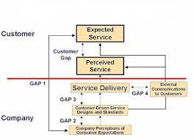

The Gap Model of Service Quality aids in discovering discrepancies between the perceived levels of customer service that they experience and what they anticipate.

- Expected Service Misinterpretation of the client’s needs can create a disruption in the company’s growth. This can occur from poor communication between the employees and consumers meaning the niche is not there and so the market is not segmented nor in demand, hence there is a missing gap in the marketing. For example, a café owner may believe that customers desire a better atmosphere in the café, but they care more about the food and coffee being served.

- Perceived Service This gap explores the discrepancy between management's notion of high-quality service and the steps necessary to deliver it. Although managers may be aware of what customers want, they haven't set up the appropriate standards or training to deliver. For instance, supervisors at a fast-food restaurant may direct personnel to complete orders rapidly without indicating the acceptable turnaround time.

- Service Delivery This gap evaluates the discrepancy between the standard of service management instructs workers to provide and the actual level of service customers experience. If team members can't live up to standards, customers could get lower-quality service than management would want. To find opportunities for improvement at this point, managers may audit the customer experience. This kind of circumstance frequently calls for further training for the team, which could be advantageous. When hiring new employees, management may need to re-evaluate its procedures to make sure they are choosing applicants who are qualified and eager to deliver good customer service.

- Customer Driven Service Designs and Standards This gap covers the discrepancy between the degree of service that customers perceive and the level they expect. This might happen when a customer misinterprets the company's claims despite them being sincere. The kind of experience that customers anticipate may also depend on interactions with other customers and prior interactions with your business.

- Company Perceptions of consumer expectations The satisfaction of customers must be exceeded in order to make them come back again. By asking directly or indirectly it is possible to nail customer service and tailor their needs appropriately by obtaining this clear and accurate perception of what the consumers want. Not having this information will lead to low brand performance and a bad reputation with dissatisfied customers who will not be coming back for these services or products.

The customer’s expectation from the Christos restaurant perception restaurant is very high because Christo himself is the owner, manager and a Micheline star chef; therefore, customers will always be expecting more. The quality may be up to standard nevertheless the property its self’s indeed of modernisation. As the interiors and the deco’s are very outdated but traditional, and people like changes with time. While maintaining Customer Driven service Designs. Christos can show the level of service delivery and quality food that can be perceived for the customer’s experience, here the gap can be filled if a question air or a survey is done for feedbacks, then this can be used to minimise any unexpected or poor service received.

Reference
Alpha (2022) 7Ps of marketing mix: Explained well with examples, CaseReads. Available at https://casereads.com/7ps-of-marketing-mix-explained-well-with-examples/ (Accessed: March 3, 2023).
Assemblo (2022) What are the 7 PS of Marketing?, Assemblo. Available at: https://assemblo.com/guides/what-are-the-7-ps-of-marketing/ (Accessed: March 3, 2023).
Barrington, R. (2020) Understanding the 7PS of the marketing mix, Oxford College of Marketing Blog. Available at: https://blog.oxfordcollegeofmarketing.com/2020/10/08/understanding-the-7ps-of-the-marketing-mix/ (Accessed: March 3, 2023).
Belyh, A. (2022) The elements of product mix, FounderJar. Available at: https://www.founderjar.com/elements-of-product-mix/ (Accessed: March 2, 2023).
Bhasin, H. (2018) What is the importance of marketing strategy?, Marketing91. Available at: https://www.marketing91.com/what-is-the-importance-of-marketing-strategy/ (Accessed: March 3, 2023).
Costa, D. (2018) The importance of global marketing, Tech.co. Available at: https://tech.co/news/importance-global-marketing-2015 (Accessed: February 27, 2023).
Definitions of marketing (2023) American Marketing Association. Available at: https://www.ama.org/the-definition-of-marketing-what-is-marketing/ (Accessed: February 28, 2023).
Epperson, M. (2020) The five marketing concepts explained: Avalaunch Media, Avalaunch Media - Full Service Digital Marketing Agency. Available at: https://avalaunchmedia.com/the-five-marketing-concepts/ (Accessed: February 24, 2023).
Hanlon, A. (2022) How to use the 7PS marketing mix strategy model?, Smart Insights. Available at: http://www.smartinsights.com/marketing-planning/marketing-models/how-to-use-the-7ps-marketing-mix/ (Accessed: March 2, 2023).
Importance of cost reduction in business (no date) Importance of cost reduction in business. Cost Management in the Banking Industry. 2022-11-02. Available at: http://complianceportal.american.edu/importance-of-cost-reduction-in-business.php (Accessed: March 1, 2023).
Kotler, P. (2000) Marketing management: The millenium edition. 10th edn. Upper Saddle River, NJ: Prentice-Hall.
Masud, A.A. (2022) Service blueprint: What it is & why it's important, QuestionPro. Available at: https://www.questionpro.com/blog/service-blueprint/ (Accessed: March 3, 2023).
Meyer-Cuno, D. (2022) Author post: Is a vision statement important?, Forbes. Forbes Magazine. Available at: https://www.forbes.com/sites/forbesbooksauthors/2021/02/24/is-a-vision-statement-important/ (Accessed: February 28, 2023).
(no date) Google Images. Google. Available at: https://images.google.com/imghp?hl=en&gl=ar&gws_rd=ssl (Accessed: March 2, 2023).
O'Donnell, J. (2021) The importance of a target market, Automated Temperature Monitoring and Control. Hubworks. Available at: https://ziptemperature.com/en/target-market.html (Accessed: February 28, 2023).
Social Media for Business (2022) Support for businesses in Australia. Available at: https://business.gov.au/online/social-media-for-business (Accessed: February 28, 2023).
Social Media Marketing birmingham (no date) Wirefox Digital Marketing Agency. Available at: https://wirefox.co.uk/social-media-marketing-birmingham/ (Accessed: February 27, 2023).

