

Programme: Master of Business Administration
Module Title: Financial Management
Module Code: LCMB7002

Student Name: keshavala Nisha Lakhubhai
Student ID: 2538593
Table of contents
1. Financial Health Check of Marriott International (2021–2025) 4
1.1 Overview of Five-Year Financial Performance 4
1.1.1 Income statement analysis 4
1.1.2 Balance sheet analysis 4
1.2 Liquidity Ratios 5
1.3 Efficiency Ratios 7
1.4 Profitability Ratios 8
1.5 Gearing Ratios 9
1.6 Investment Ratios 10
1.7 Cash Flow Ratios 11
1.8 Liquidity Benchmarking Against Industry Standards 12
1.8.1 Evaluation with Liquidity Industrial Benchmark 12
1.8.2 Liquidity Comparison with benchmark reliable with sector 12
2. Working Capital Management Analysis 14
2.1 Cash Operating Cycle 14
2.1.1 Receivables Collection Period 14
2.1.2 Payables Deferral Period 14
2.1.3 Cash Operating Cycle Evaluation 14
2.2 Working Capital Challenges 15
2.3 Recommendation to improve liquidity of working capital 15
2.3.1 Management of Account Receivables 15
2.3.2 Monitoring Account Payables 15
2.3.3 Cash Management Reforms 15
2.4 Comparison of financing option 16
2.4.1 Short-Term Financing Options 16
2.4.2 Long-Term Financing Options 17
2.4.3 Comparative Analysis 17
3. Strategic Financial Restructuring Plan 18
3.1 Challenges related to Financial Restructuring Option 18
3.2 Recommended Financial Restructuring Options 18
3.2.1 Divestiture of Non-Core Assets 18
3.2.2 Equity Injection Strategy 19
3.2.3 Merger and Acquisition Opportunities 19
3.3 Impact on financial restructuring 20
3.3.1 Significance on Shareholder Value 20
3.3.2 Significance on Debt Structure 20
3.3.3 Significance on Operational Flexibility 20
3.4 International Financial Considerations 21
3.4.1 Taxation Considerations 21
3.4.2 Currency Risk 21
3.4.3 Inflation Risk 22
3.5 Discussion on the Ethical and ESG Operations 23
3.5.1 Corporate Social Responsibility 23
3.5.2 Environmental Sustainability 23
3.5.3 ESG Performance and Reporting 24
4. Investment Appraisal and Capital Budgeting 25
4.1 Project Overview 25
4.2 Discuss About Project Viability 25
4.2.1 Project A Appraisal 25
4.2.2 Project B Appraisal 27
4.2.3 Project C Appraisal 29
4.3 Recommendation based on company's financial performance 31
4.3.1 Selection of project 31
4.3.2 Financial Justification 31
4.3.3 Non-Financial Risk Assessment 32
4.4 Capital Rationing Analysis (£100 Million Limit) 32
5. Critical Reflection on Artificial Intelligence Usage 34
5.1 Identification of AI tools and Acknowledgement 34
5.2 Verification of AI Outputs 34
5.3 Contribution Analysis 34
5.3.1 AI-Generated Contributions 34
5.3.2 Independent Critical Analysis 35
5.4 Ethical and Professional Reflection 35
References 36
Appendices 42
Appendix 1: Ratio analysis 42
Appendix 2: Capital investment analysis 46
Appendix 3: Income Statement of 2021 and 2022 47
Appendix 4: Income Statement of 2023 to 2025 48

1. Financial Health Check of Marriott International (2021–2025)

1.1 Overview of Five-Year Financial Performance

1.1.1 Income statement analysis
Annual revenue of Marriott International steadily rose about 4% with approximate value $26.19 billion in 2025 for adoption of the “free-driven” model (Yahoo Finance, 2025). On the other hand, net income in 2025 is about $2.601 billion, leading to rising demand for the luxury accommodation segment in the market. In 2021, Gross Profit is about $5,354and in 2025 with its growth rate about 97.64% (Yahoo Finance, 2025). Thus, the company demonstrated its profit of about $1,398 million in 2026 drove its demand towards the hotel segment to enhance corporate booking (Marriott, 2026).
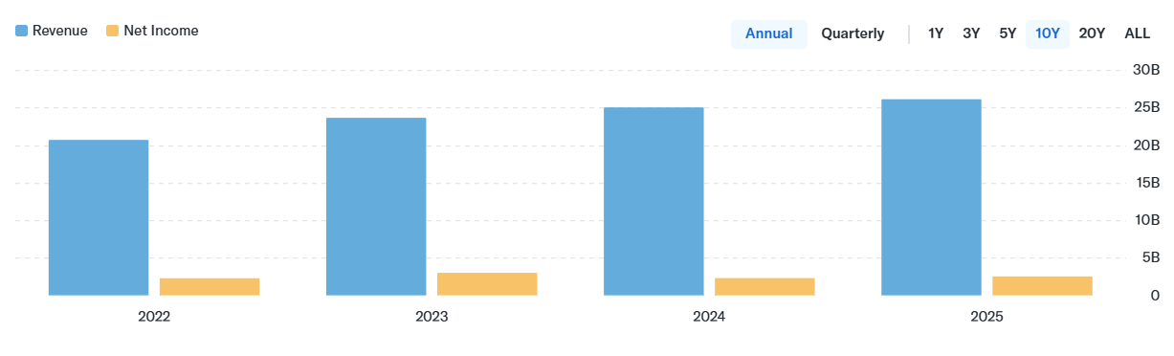
Figure 1: Net income and revenue of Marriott International
(Source: Yahoo Finance, 2025)

1.1.2 Balance sheet analysis
As per the balance sheet analysis, Marriott International has achieved a growth of 5.61% in its equity value in 2025 as compared to 2024. The company has diversified its investments for meeting the financial requirements of its business operations. For instance, the organisation has acquired 9900 properties with an intent to enhance its customer base in 2026 (Marriott International, 2025). On the other hand, Marriott International has also increased its debt value to $14995m in 2025. Thus, the expansion of the financial investments has helped Marriott International in overcoming market uncertainty.
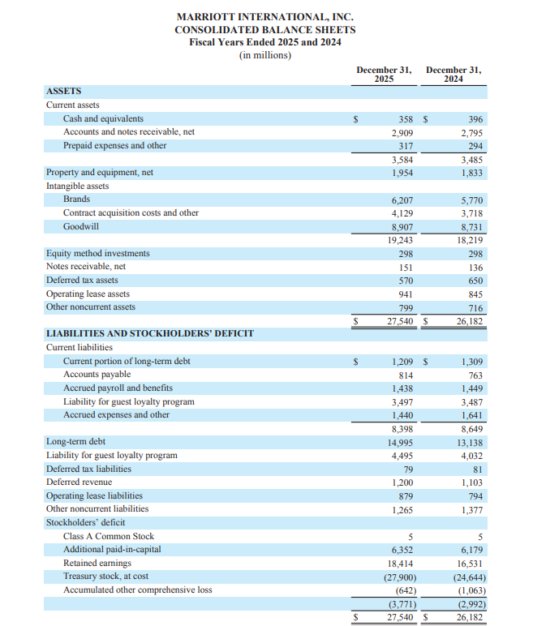
Figure 2: Balance sheet Analysis
(Source: Marriott, 2025)

1.2 Liquidity Ratios
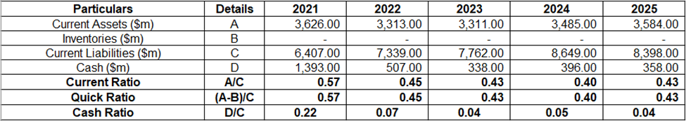
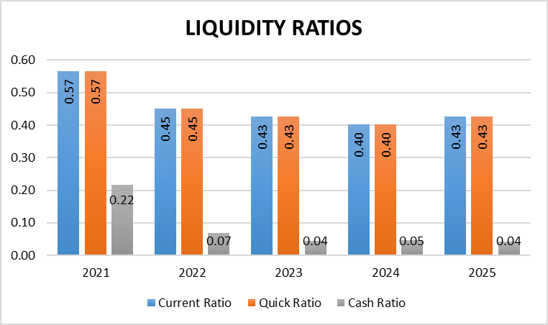
Figure 3: Liquidity Ratios
(Source: Marriott, 2021; Marriott, 2023; Marriott, 2025)
Identification of trend
Liquidity Ratios measure the ability of a company to deal with short-term debt that helps investors in managing financial health of the business. Current ratio is calculated through “Current Assets ÷ Current Liabilities” which decreases about 24.56%. The declining trend is due to high rises in financial risk, as the company engages with short-term debts (Marriott, 2025). Quick ratio is calculated through “(Current Assets - Inventory) ÷ Current Liabilities” which decrease about 24.56%. The decreasing of the quick ratio encounters an operational shift by ability to slow down cash reserves and through investment. Cash ratio is calculated through “(Cash ÷ Current Liability)” which decreases about 81.82%. The decline in cash reserve is due to paying off long term debt and increasing its liabilities which is due to cash generation.
Opportunities
High liquidity affects Marriott International by serving growth opportunities through “Revenue Per Available Room” and "accommodation services".
Threats
Marriott International faced operational challenges due to rises of short-term debt by responding with the weak economic condition.

1.3 Efficiency Ratios
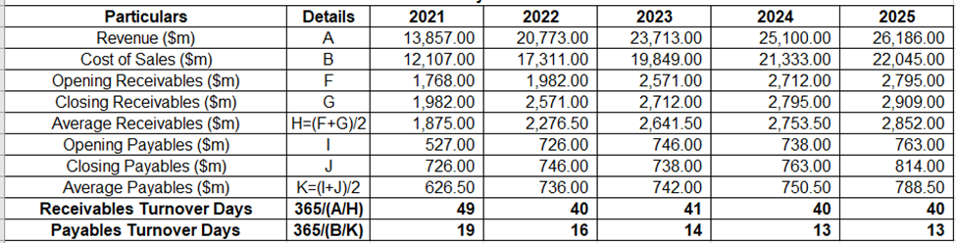
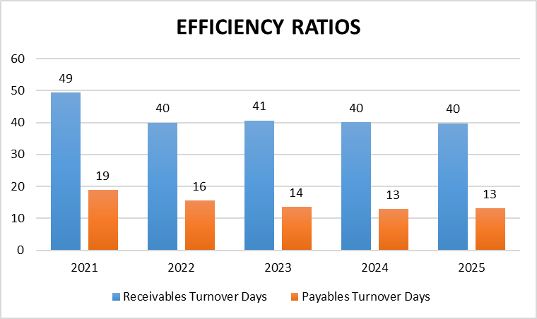
Figure 4: Efficiency Ratios
(Source: Marriott, 2021; Marriott, 2023; Marriott, 2025)
Identification of Trends
Marriott International has reduced its growth in receivable turnover days “(Revenue ÷ Average Receivables) ÷ 365” by 18.36% due to the execution of large-scale investments in its business operations in 2025 (Marriott, 2025). In addition, the company has also adopted partnership techniques with an intent to improve its supply chain operations. For instance, Marriott Internationals have collaborated with OCBC for executing payment invoices of 12000 suppliers in 2025 (OCBC, 2026). On the other hand, the hotel company has also reduced its account payable value “365 ÷ (Cost of Sales ÷ Average Payables)" to 13 days due to improvement in the payment services to its creditors. Thus, the strengthening of the supply chain operations has helped the company in enhancing its productivity.
Strength
The improvement in the payment services has helped Marriott Internationals in strengthening creditor relationships
Weakness
The enhancement in the involvement of the creditors has adversely influenced the internal financial resources of the organisation.

1.4 Profitability Ratios
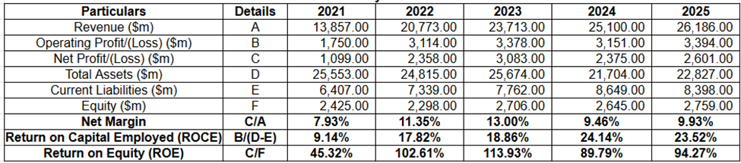
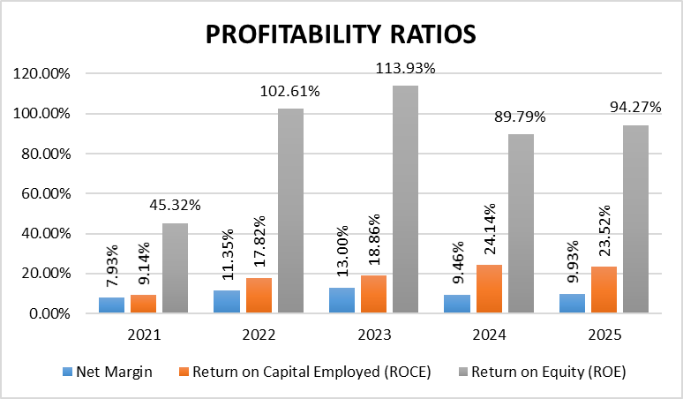
Figure 5: Profitability ratios
(Source: Marriott, 2021; Marriott, 2023; Marriott, 2025)
The fluctuating trend is also identified in net profit margin with highest volatility in 2023-2024 about declining 9.64% calculated by “(Net Profit ÷ Revenue) × 100”. Hence, this value was also higher in previous year $23,713 million revenue while declination of net profit marginal value by $2,375 million impacted financial performance of organizations. In addition, ROCE calculated “Operating Profit ÷ (Total Assets − Current Liabilities) × 100” that also rose from 9.14% to 24.14% by 2024 due to efficient management of assets with better investment capital recognition (Marriott, 2025). Also, ROE decline by 89.79% in 2024 followed by an uprising of 94.27% calculated by “(Net Profit ÷ Shareholders' Equity) × 100” also indicated improved earning potential with a strong shareholder base.
Strength
Strong profitability recovery and efficient capital utilisation effectively increasing shareholders confidence with support changing market conditions.
Weakness
The sharp declination of net profit margin during 2024 indicates rising operating costs and pressure on overall profitability performance.

1.5 Gearing Ratios
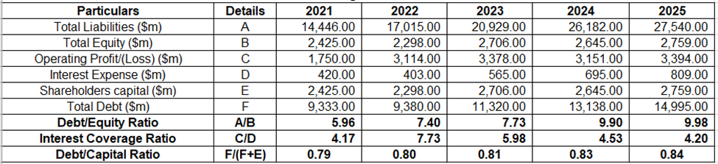
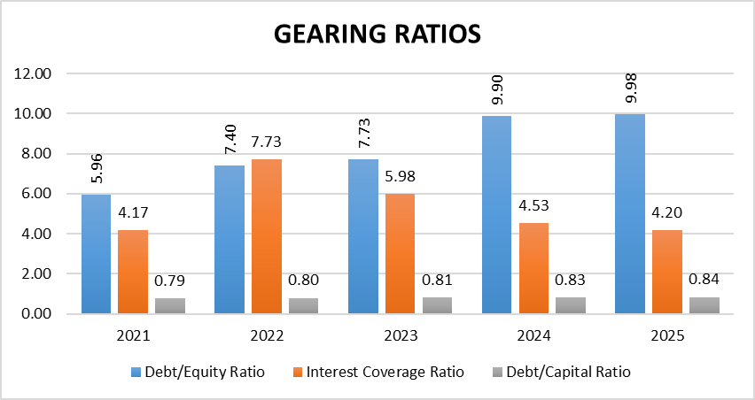
Figure 6: Gearing Ratios
(Source: Marriott, 2021; Marriott, 2023; Marriott, 2025)
Identification of Trends
Marriott International has improved its debt/capital value “Total Debts ÷ (Total Debts+Total Equity)” by 6.32% due to improvement in the internal investments in 2025. On the other hand, Marriott has also increased its debt/equity value to 9.98% due to high level risk in its management activities. In addition, the organisation has also increased its interest coverage ratios “Operating Income ÷ Interest Expense” to 4.20 due to enhancement in its net margins in 2025 (Marriott, 2025). Overall, the expansion of the internal capital has helped Marriott International in achieving financial stability.
Strength
The enhancement in the debt/capital value has strengthened the financial resources of the organisation and reduced market competition.
Weakness
The enhancement in the business risk levels has adversely influenced its trust level among the investors.

1.6 Investment Ratios
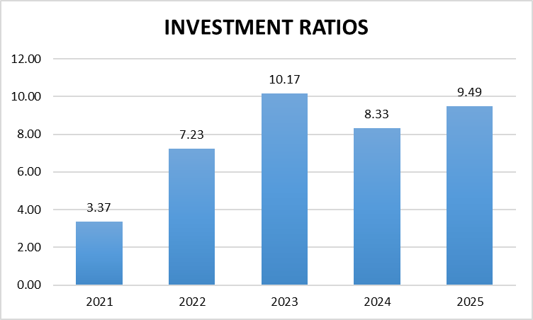
Figure 7: Investment Ratios
(Source: Marriott, 2021; Marriott, 2023; Marriott, 2025)
Identification of trend
The Investment Ratios help investors by their ability to manage the price of product through informed decisions in gathering cash returns. “Earnings per share” is calculated through “(Net Income ÷ Outstanding Shares)” which increased by about 181.60%. Increase in earnings per share is due to high rises of net income and repurchase of shares, which affect overall profitability. The company has the ability to repurchase about 2.1 million shares that have been addressed through "substantial cash flow” (Yahoo Finance, 2025). Thus, this led to rising demand of the RevPAR which is about 2%, by highlighting its demand and encountering business growth (Marriott, 2025). Marriott International has the ability to invest capital through “Quest loyalty programme,” and portfolio expansion leads to enhancing overall brand value.
Strength
Marriott International has its ability to increase “earnings per share” by continuing to boost luxury hotel demand through aggressive repurchasing of shares.
Weakness
Marriott International drives its "negative shareholder equity” that is addressed through the repurchasing of shares and tight liquidity.

1.7 Cash Flow Ratios
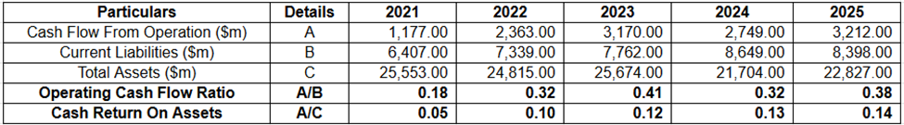
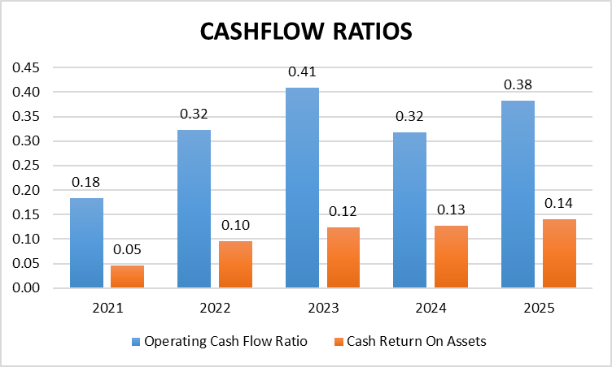
Figure 8: Cashflow Ratios
(Source: Marriott, 2021; Marriott, 2023; Marriott, 2025)
The operating cash flow is generally measured by “Cash Flow from Operations ÷ Current Liabilities” that effectively illustrates the potentiality of an organization towards meeting short term obligations effectively. The ratio represented boat increasing 0.43 in 2021 with following declination 0.32 in 2024. However, it was recovered by 18.8% in 2025 due to stronger cash generation of approximately $3,212 million (Marriott, 2025).
On the other hand, management of operating cash potentiality is measured by “Cash Flow from Operations ÷ Total Assets” based on asset value of the organization. Thus, in this case successive enhancement will also be identified in 8.3% of 2024 to 7.7% in 2025. Hence, this operational management better assets utilization with triple the value of cash flow from $1,177 million to $3,212 million (Marriott, 2025).
Strength
The effective management of cash flow defined stronger cash generation capability, efficient asset utilisation, and enhanced liquidity.
Weakness
The cash flow below 1.0 also indicates insufficient cash to fully cover the current liabilities position of Marriott International.

1.8 Liquidity Benchmarking Against Industry Standards

1.8.1 Evaluation with Liquidity Industrial Benchmark
As per the financial performance, Marriott has reduced its liquidity ratio in comparison to the industry standard of 2.0 in 2025.The decline in the inventory management services has lowered the product popularity of the organisation among the customers. For instance, Marriott Internationals has reduced its operating income to $445m due to inferior quality services in 2025 (Marriott Group, 2026). The decline in the income has increased the market competition level for the company. Overall, the lowering of the liquidity value has hampered the financial stability of the company.

1.8.2 Liquidity Comparison with benchmark reliable with sector
Liquidity benchmark of Marriott International is 2.0 which showcases “short-term liabilities” by ability to exceed its asset management. Marriott international manages its aggressive cash return through significant paying of dividend buyback share which leads to managing its standard liquidity. On the other hand, the UK hospitality industry constantly raises its standard hourly wages by 30% with an approximate value of $22.70 that enhances additional expanse cost for Marriott internationals (Vidakovic, 2025). Overall, this leads to rising operating loss apart from managing the short term position of the organisation.
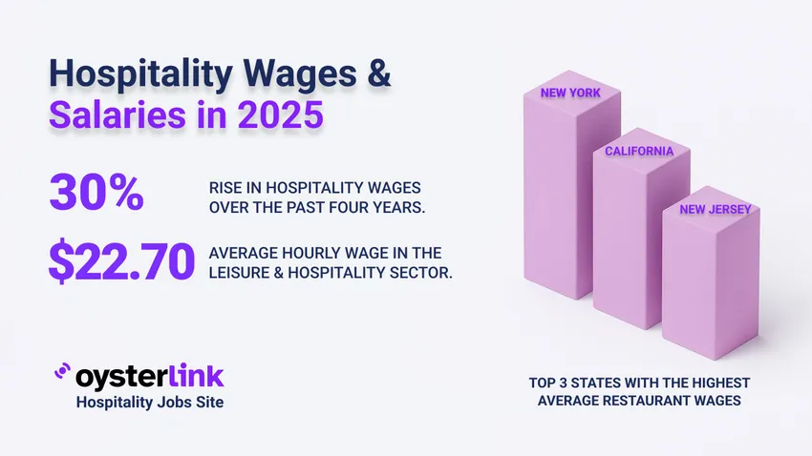
Figure 9: Hospitality wages
(Source: Vidakovic, 2025)

2. Working Capital Management Analysis

2.1 Cash Operating Cycle

2.1.1 Receivables Collection Period
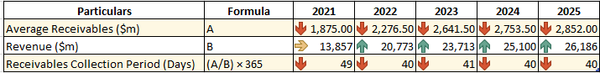
Figure 10: Receivable Collection Period
(Source: Marriott, 2021; Marriott, 2023; Marriott, 2025)
Marriott Internationals has increased its receivable value to $2852m in 2025. In addition, the organisation has also achieved a revenue growth of 89.01% due to improvement in the service demand in 2025 (Marriott, 2025). Overall, the strengthening of the business income has helped Marriott Internationals in acquiring competitive advantage over other companies.

2.1.2 Payables Deferral Period
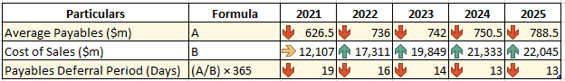
Figure 11: Payable deferral period
(Source: Marriott, 2021; Marriott, 2023; Marriott, 2025)
The average number of paying premium terms among suppliers also raise more effectively with management debenture value associated with Marriott International. The declination of periodical value will also be reduced in 13 days and also be helpful towards more potentiality of reducing interest expected rate and managing better cash inflow of business (Marriott, 2025).

2.1.3 Cash Operating Cycle Evaluation
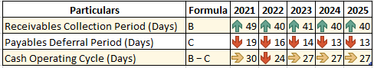
Figure 12: Cash Operating Cycle
(Source: Marriott, 2021; Marriott, 2023; Marriott, 2025)
Marriott Internationals has reduced its cash operating cycle to 40 days due to diversification of its business investments in 2025 (Marriott, 2025). Overall, the consistent supply of operational funds has helped the hotel company in ensuring timely completion of its projects.

2.2 Working Capital Challenges
The enhancement in the operational expenses is a critical issue for Marriott Internationals that has hampered its market stability. For example, the product cost of the company has increased to $5.96bn due to enhancement in its credit card fees in 2025 (Tripathy, 2026). In addition, Marriott Internationals has also observed a rise in the inflation value that has adversely influenced its service demand among customers. Overall, the availability of high inventory costs has hampered the operational efficiency of the hotel company.

2.3 Recommendation to improve liquidity of working capital

2.3.1 Management of Account Receivables
Marriott Internationals have focused on including a third party payment strategy for recovering debts from the customers. For example, the organisation has organised the “MAG Payment Conference" for adopting credit and debit card services in 2025 (Chargebacks, 2025). In addition, the seminar has also assisted the organisation in reducing its bad debts. Marriott Internationals has recovered around $14.4bn dues from the customers in 2025 (Marriott , 2026). Hence, the infrastructural enhancement has helped the company in improving its brand image.

2.3.2 Monitoring Account Payables
Marriott Internationals has also utilized digitalisation with an intent to monitor the requirements of its stakeholders. For example, the company has developed platforms such as “Supplier.io” that has helped in monitoring the payment requirements of its creditors in 2025 (Marriott Group, 2025). Thus, the adoption of the digital techniques has helped Marriott Internationals in improving its organisational harmony.

2.3.3 Cash Management Reforms
Marriott Internationals has also focused on improving its financial resources for meeting the expenses incurred in its business operations. For instance, the company has increased its gross profit margin by -95% in 2020 to 3% in 2025 (Agarwal, 2025). Hence, the improvement in the income has helped Marriott Internationals in strengthening its fund requirements significantly.
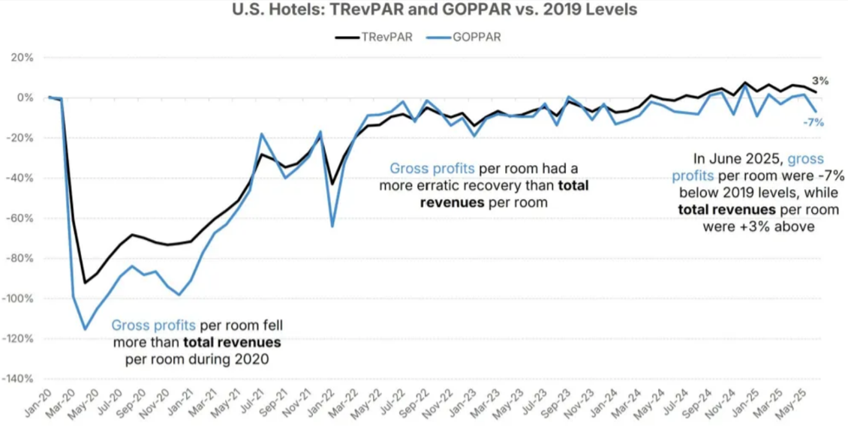 Figure 13: Gross Profit Margin of Marriott
(Source: Agarwal, 2025)

2.4 Comparison of financing option

2.4.1 Short-Term Financing Options
Trade credit
Trade credit of Marriott International, which is about $763M by ability to deal with cash flow through reliable payment (Trading Economics, 2026). The trade credit boosted “short-term liquidity” by ability to deal with cash flow in managing “day-to-day operation”. Hence, the improvement in the payment services has helped Marriott International in strengthening its credit relationships and meeting business requirements.
Loans
Marriott International has its ability to manage its loan through the “asset-light” model by showcasing its push towards debt maintenance. The company manages its loan capital about $15.32B address through backend notes and upgradation of credit facilities (Trading Economics, 2026). Apart from that, the company has its ability to minimize loans through resolving credit and corporate obligations.

2.4.2 Long-Term Financing Options
Equity Financing
Marriott International repurchased its shares by about 3.1 million, which boosts EPS leads to enhance investor confidence through demand of RevPAR (Marriott, 2026). Although, the company manages its shareholder return which is about $4.3billion through dividend maintenance and repurchasing of buyback shares. Overall, this financing also be helpful towards improving key capital raising potentiality of Marriott International with managed debenture value effectively.
Debt Financing
Marriott International manages its total debt of $16.53 which slightly increases due to robust operational maintenance and through cash equivalence (Trading Economics, 2024). This effective management of debenture value also raises a better management of short term liquidity position with supporting financial progression for attributed long term business opportunity.

2.4.3 Comparative Analysis
Marriott has its ability to manage liquidity addresses through resolving of credit terms which in term ensure overall interest rate of the business. However, the company repurchased its share address through strategic expansion of business in the market.

3. Strategic Financial Restructuring Plan

3.1 Challenges related to Financial Restructuring Option
Marriott International demonstrated its negative share price return about 11.3% with its shareholder return about 27.7% (Simply Wall, 2026). On the other hand, the company declined its net income about 3% which dropped about $648 million in 2025 leading to high rises of geopolitical conflicts and ability to respond with the volatility in the market. However, the company slowed down its revenue growth about 5.1%, leading to its digital transformation, access travel and accommodation demand, which affect revenue (Trading view, 2025)
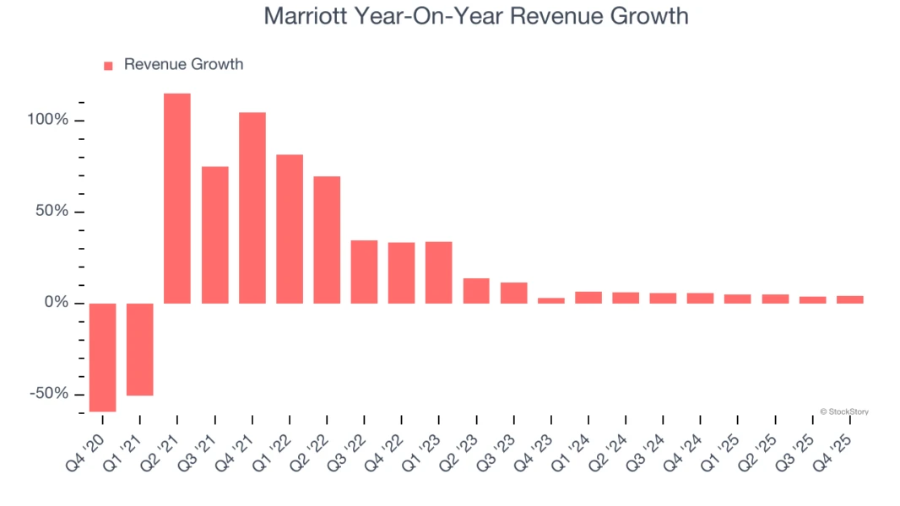
Figure 14: Revenue growth of Marriott
(Source: TradingView, 2025)

3.2 Recommended Financial Restructuring Options

3.2.1 Divestiture of Non-Core Assets
Marriott International has adopted an asset sale strategy for enhancing its financial resources. For instance, the organisation has sold its Waterfront Seattle property to Braemar Hotels for $145m in 2025 (Braemar Hotels, 2025). In addition, the selling of the assets has also helped the hotel company in meeting its debt capital requirements effectively. Thus, the lowering of the business properties has helped Marriott Internationals in strengthening its productivity.

3.2.2 Equity Injection Strategy
The equity injection strategy has helped companies in strengthening its internal financial resources for meeting product requirements. Marriott has observed improvement in its market capitalization to $107.3bn in 2025(Marriott Group, 2025b). Hence, the availability of higher income has assisted the company in reducing market insolvency.
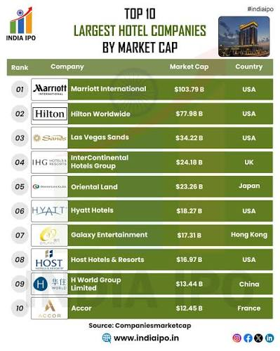
Figure 15: Market Capital
(Source: Marriott Group, 2025b)

3.2.3 Merger and Acquisition Opportunities
The merger and acquisition techniques have helped Marriott Internationals in expanding its business operations. For instance, the company has acquired “CitizenM hotels” for $355bn with an intent to occupy its 37 properties in 2025. In addition, the acquisition has also helped Marriott in expanding its business united in 26 cities in the USA. Overall, the adoption of acquisition techniques has helped Marriott in improving its operational productivity.

3.3 Impact on financial restructuring

3.3.1 Significance on Shareholder Value
Marriott international has its ability to enhance shareholder value through “asset driven transition" which leads to enhanced operational earning. The company has the ability to generate its cash flow which is about $3.1 billion for managing shareholder return through buyback of shares (Marriott, 2026). The company showcases its capital return through maximizing its equity value with long term growth.

3.3.2 Significance on Debt Structure
Marriott international has its ability to manage its debt structure through revolving credit facilities and is dominated due to unsecured notes. On the other hand, the company issued $1.45billion for unsecured notes that leads to rises 4.5% by 2033 (News, 2026). Thus, this helps the company showcase its strategic realignment by reduction of administrative cost and acquisition which in term showcases stable liquidity.

3.3.3 Significance on Operational Flexibility
The free cash flow at Marriott International is about $2,258 that is due to shareholder returns and recurring revenue which is more reliable in managing capital cost (Beren, 2026). On the other hand, the company showcases its operational flexibility through performance-based conservation and flexible workflow which leads to enhanced overall revenue.
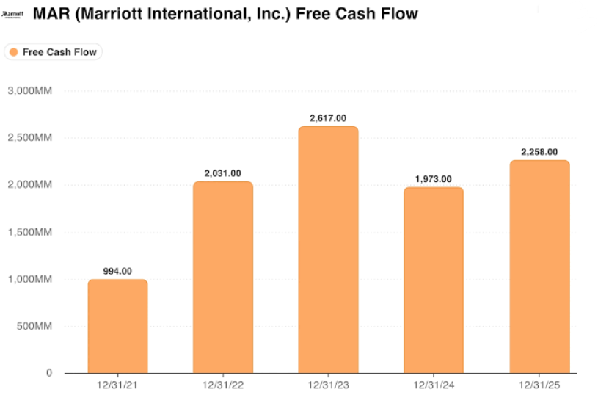
Figure 16: Free cash flow at Marriott International
(Source: Beren, 2026)

3.4 International Financial Considerations

3.4.1 Taxation Considerations
The existence of high taxes has also lowered the financial stability of hotels such as Marriott Internationals. For instance, the company has increased the value of its legal expenses to $3.57bn in 2025 (Yahoo Finance, 2025b). Thus, the enhancement in the statutory cost has reduced the operational efficiency of the organisation.
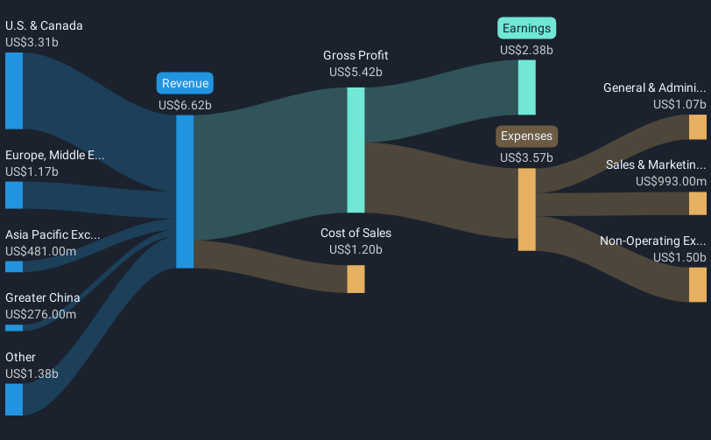
Figure 17: Financial Results of Marriott Internationals
(Source: Yahoo Finance, 2025b)

3.4.2 Currency Risk
The existence of currency risks has also reduced the service demand of Marriott Internationals among the customers. For example, the value of US Dollar to Euro has reduced by €0.8 in 2025 (Statista, 2026). Thus, the existence of high volatility in the currency value has increased the service expenses of Marriott Internationals.
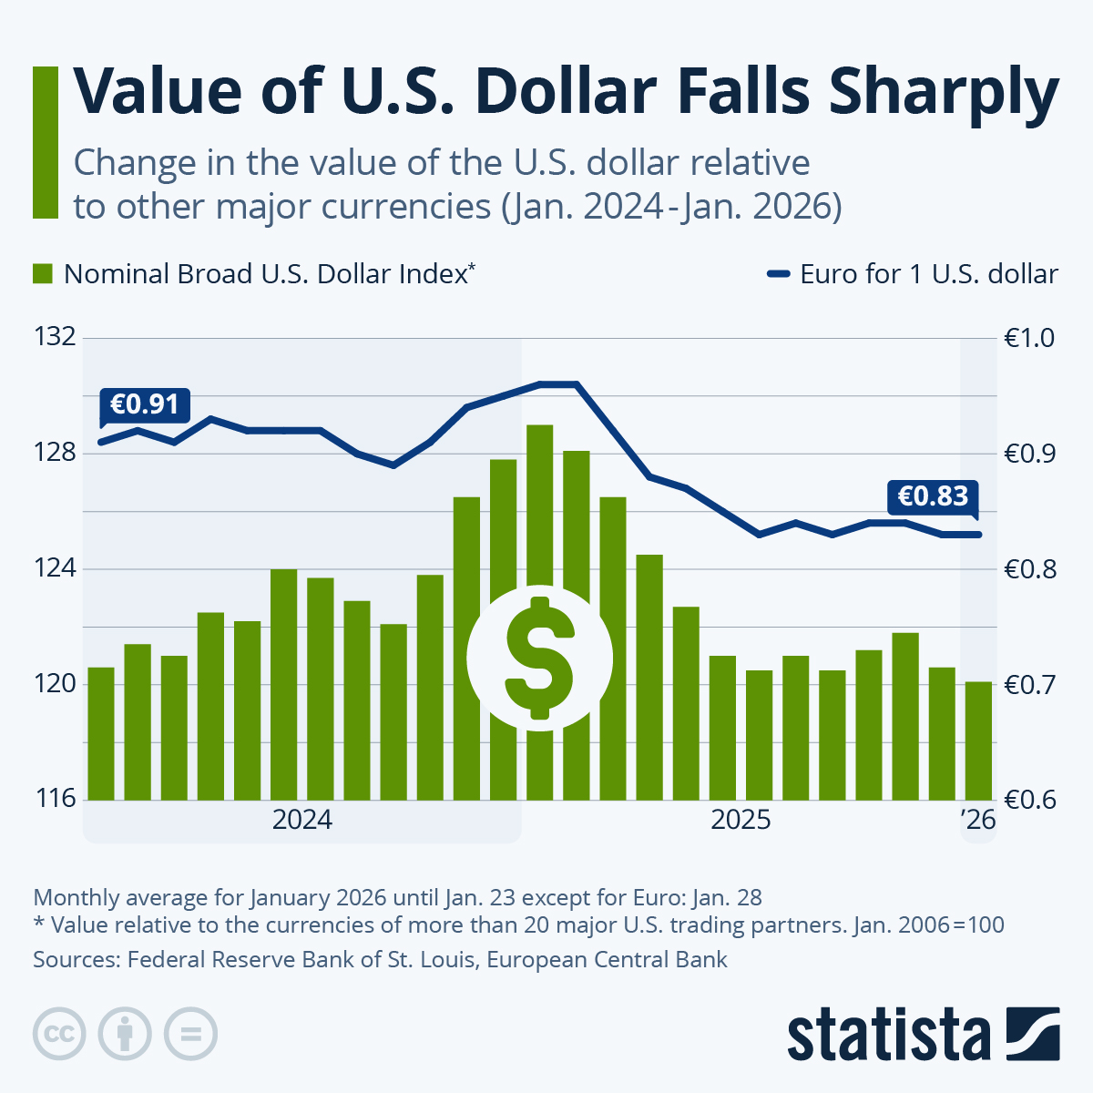
Figure 18: Currency Rate
(Source: Statista, 2026)

3.4.3 Inflation Risk
The USA inflation rate has declined from 8% in 2022 to around 2.8% in 2025 (Iacurci, 2025). Hence, the enhancement in the cost of living index has reduced the service demand of luxury hotels such as Marriott Internationals among customers.
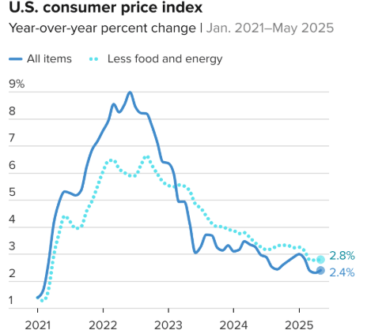
Figure 19: CPI Rate
(Source: Iacurci, 2025)

3.5 Discussion on the Ethical and ESG Operations

3.5.1 Corporate Social Responsibility
The CSR activities have provided opportunities for the company to improve its goodwill among the local communities. Marriott has reduced its waste generation by 35% through the adoption of the “Waste Water Initiative” in 2024 (Dudovskiy, 2023). Thus, the monitoring of the water consumption has helped Marriott International in improving its goodwill among communities.

3.5.2 Environmental Sustainability
Marriott International drives its environmental sustainability by serving "green building” certification achievement in 2026. Although, the company achieves its “net zero carbon emissions” through significant uses of energy usage which have a positive impact in achieving sustainability (Nicholls, 2024). Thus, this helps Marriott by significantly investing in renewable energy and adoption of circular economic models which enhance improvement in the hospitality value chain.

3.5.3 ESG Performance and Reporting
Marriott follows ESG disclosure by its ability to achieve its sustainability goals, which enhances improvement in business operations. The company, through adoption of the “Serve 360 platform,” showcases its significant progress in highlighting ESG protocols, which in turn outline overall business performance (Marriott International, 2024). Although the company showcases its operational resilience by adopting the "Climate action programme” which is more reliable to achieve decarbonisation.

4. Investment Appraisal and Capital Budgeting

4.1 Project Overview
According to Kaoma, Mwanaumo and Nsefu (2025), the investment appraisal is the most significant technique that measures future cashflow flow potentiality of a business with adopted fixed discounting rate. The application of investment appraisal techniques for three different projects considered such as project A, B and C that effectively need support to better improve the business potential of Marriott International. Thus, a key consideration for the discounting rate for all projects is to acknowledge a future cash flow rate of 8%. The initial investment in case of project A is generally £50 million with a stipulated time period of five years. Hence, five different cashflow forecasts predict a volatility in periodical inflow. On the other hand, the Project will also be considered as the same capital raise of £50 million following a time period of five years. In this case a difference can also be modified due to stable management of cashflow orientation throughout the whole time period. Hence, annual cash inflows of £11 million also be raised every year without any fluctuation for project B. Also, project C also be considered an initial investment of £50 million about back loaded cash flow pattern in five years’ time period. A major volatility in generating cash flow originated that produced more risk factors associated with this project in adhering completion in an effective manner.

4.2 Discuss About Project Viability

4.2.1 Project A Appraisal
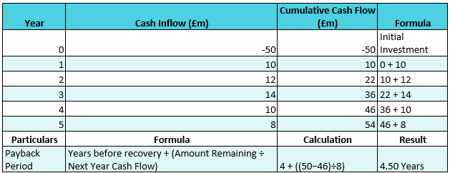
Figure 20: PBP
(Source: Self-developed)
The PBP is most significant to identify the recovery time of the actual investment value of investors (Kagan, 2026). The recovery period of initial invested £50 million for project A is approximately 4.50 years. Thus, in this case recovery of £46 million by the end of four years and remaining £4 million covered in the third quarter of the fifth consecutive year.
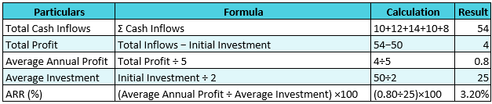
Figure 21: ARR
(Source: Self-developed)
The key average profit from investors is also calculated by shareholders for analysis of its risk adherence for the long term (Fernando, 2026b). Thus, in this case total cash flow generated from project A is approximately £54 million. Hence, excluding initial investment profitability aspect £4 million and cover average annual value £0.8 million. Overall, ARR 3.20% also indicated low return value from the project.
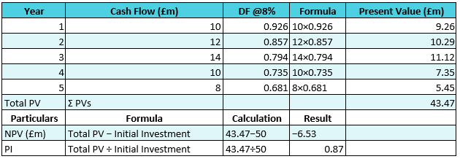
Figure 22: NPV and PI
(Source: Self-developed)
The NPV also illustrates discounted cash flow prediction against selected time period completion of projects (Fernando, 2024). Hence, consolidated present value accumulated of project A about £43.47 million. As it is also indicated negative NPV £6.53 million reduce shareholders interest with generating below 1.0 industrial standard of 0.87.
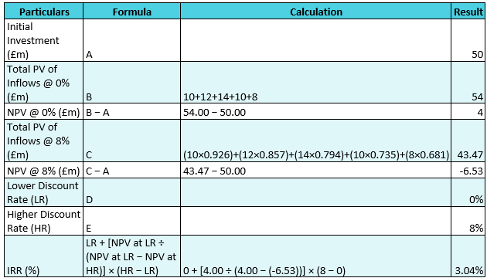
Figure 23: IRR
(Source: Self-developed)
The reason for IRR proclamation measure NPV must be zero with diluted risk factor associated capital investment (Fernando, 2026). Thus, two different discount factors are also assumed as 0% and 8% for proper analysis IRR that also raise 3.04% through the year. As IRR value of 8% also be lower compared to required rate for maximise flow of return.

4.2.2 Project B Appraisal
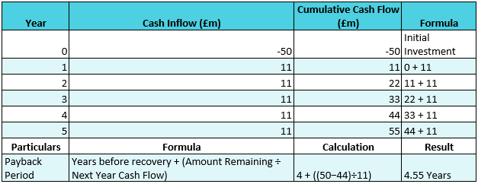
Figure 24: PBP
(Source: Self-developed)
In case of project B the PBP value will also be raised 4.55 years for covering all initial investment value for gaining revenue potential. Thus, cumulative cash flow also predictably returns an approximately value of £44 million by Year 4. However, remaining £6 million needs to be covered with additional acquired two specific quarters in the fifth consecutive year.
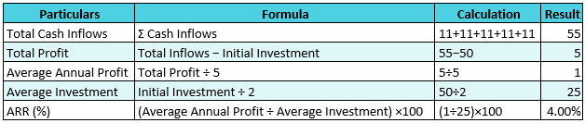
Figure 25: ARR
(Source: Self-developed)
The ARR is generally illustrated with a positive return value against cash inflow of £55 million effectively generating a return potential of £5. Thus, based on this calculated annual average profit also raised £1 million. Due to this ARR value also calculated as 4.00% assured better standardized benchmark of profit for organisation.
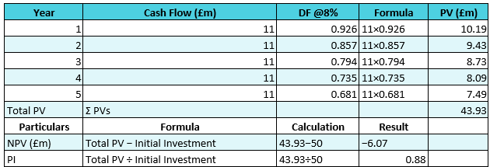
Figure 26: NPV and PI
(Source: Self-developed)
The value of NPV also illustrates the present value of cash flow within an 8% discounting rate about £43.93 million. As a result, it positions a negative NPV of £6.07 million after excluding all of the initial investment criteria of £50 million. Also, PI value less than 1 indicated less attractiveness for investors.
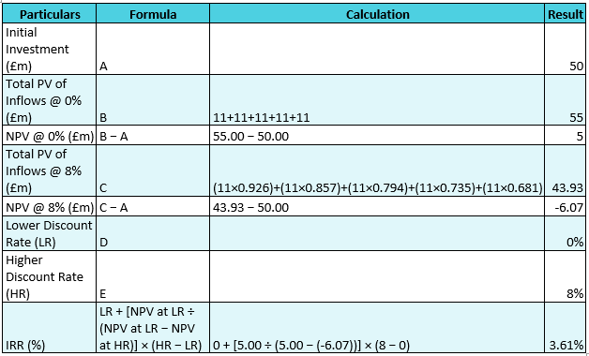
Figure 27: IRR
(Source: Self-developed)
In case of project B calculated IRR value will also be raised 3.61% by conjugation of two different discounting factors such as 0% and 8%. Hence, an 8% cost of capital also raises lower return values that are less viable and high risk for investors.

4.2.3 Project C Appraisal
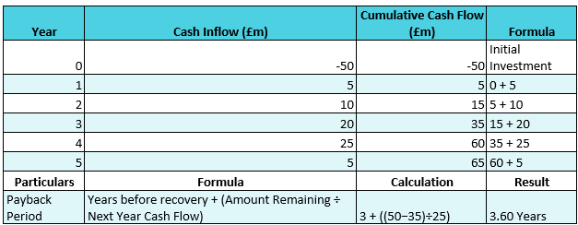
Figure 28: PBP
(Source: Self-developed)
In the case of a project, the invested value of £50 million can also be recovered more quickly with a raised time period of 3.60 years. Hence, almost 75% of initial investment of about £35 million recovered by the end of the third year and remained £3 million second quarter of fourth consecutive years.
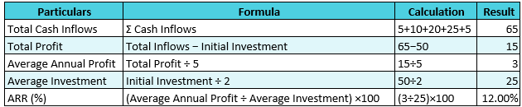
Figure 29: ARR
(Source: Self-developed)
The cash inflow pattern in case of project C also be higher with capture £65 million that also generated profitability value of £15 million. As a result, it generated average profit in the year £3 million with captured ARR value of 12%.
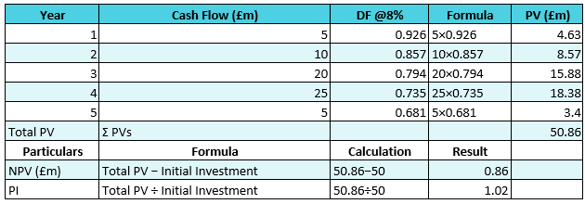
Figure 30: NPV and PI
(Source: Self-developed)
The project C also captured a total present value of £50.86 million that also generated a positive NPV rate of £0.86 million with all initial investment. Also, PI value above industry benchmark 1 indicated a more sustainable return from the investment of project C.
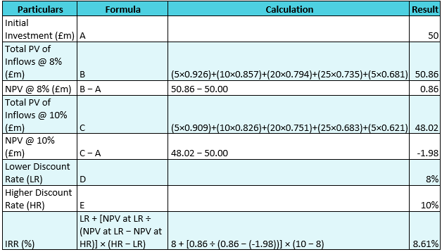
Figure 31: IRR
(Source: Self-developed)
The use of interpolation with an adopted discounting rate of 8% and 10% indicated IRR value of 8.61%. Hence, this value also exceeds organization return potential to make more attractive investors to enable risk free return.

4.3 Recommendation based on company's financial performance

4.3.1 Selection of project
Project C has its investment option that is based on positive NPV and capital cost which leads to enhancing the overall value of firms. On the other hand, Project C addresses its efficiency through IRR and ARR which in term maximises its profitability. Thus, the Project has the ability to showcase shareholder return through future cash inflow.

4.3.2 Financial Justification
Marriott International prioritized Project C for its ability to expand its operating margin, which delivered overall profit. The company showcases its profit with adjusted EBITDA 9% leading to high demand of “Revenue Per Available Room” (Marriott, 2025b). This company serves Project C to manage its high-rise accounting with its high ARR of about 12%. This leads to enhancing the overall shareholder wealth address through significant cash flow adoption. Project C showcases a payback period of about 3.6 years, achieved through improved liquidity via long-term asset exposure. The company manages its short-term liabilities through steady cash flow which leads to enhanced shareholder return (Bishwas and Hossain, 2025). However, the company manages its liquidity demand through reducing cash flow volatility and encountering recovery in managing working capital.

4.3.3 Non-Financial Risk Assessment
Project C showcases its political risk leading to unexpected changes in taxation and government policy which in term affect overall cash flow of business. For example, the UK hospitality industry faced political pressure due to a 20% to 10% VAT rate which enhanced operating loss of business (Davies, 2026). On the other hand, this project addressed its initial higher cash flow by highlighting its long term invested capitalised value about £50 million that have been made volatile with decline in stock price.
Customer loyalty
Project C demonstrates its cash inflow through robust customer retention and responds to market needs. Marriott significantly lowered its customer rate 50% for “revenue per available room growth,” showcasing its cautious environment in Canada and in the US (Wroten, 2025). On the other hand, the consumer reduces its customer acquisition cost from the "Marriott Bonvoy programme” which is due to high rises of internal friction of business.

4.4 Capital Rationing Analysis (£100 Million Limit)
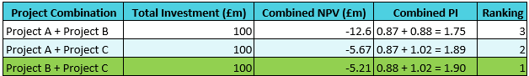
Figure 32: Capital rationing
(Source: Self-developed)
The use of capital rationing is the most significant method that ensures smooth choice of fund raise minimal capital invested towards diluted risk factor (Hayes, 2026). Hence, in this case Project B and Project C are most effective due to combining the highest PI value of 1.90. On another hand, it is also assured less negative NPV –£5.21 million as compared –£5.67 million for project A and C. Overall, project B has stable cash flow of £11 million and project C IRR 8.61% most attractive towards diluted risk factor for organisation.

5. Critical Reflection on Artificial Intelligence Usage

5.1 Identification of AI tools and Acknowledgement
The report has involved the application of diversified AI tools such as “Google Gemini” that has helped me in improving the quality of the investigation process. In addition, the tool has also provided me with opportunities of developing a flexible structure associated with the topic. As stated by Masalkhi et al., (2024), the inclusion of Google Gemini also helps in reducing delays in the accumulation of data associated with the company, which increases the quality of the investigation process. On the other hand, I have also used the “Paperpal tools” for improving the grammatical quality of my report. The inclusion of the technique mentioned above has helped in carrying out a critical analysis on the operational activities of the hotel company. Overall, the availability of diversified AI tools has assisted me in improving the quality of my investigation process.

5.2 Verification of AI Outputs
Managing accuracy in financial interpretation through AI has been addressed through source tracking, human oversight to prevalent analytical errors (Celestin, 2023). This has been addressed through ”multi-layered verification ability to showcase traceability of the source to draw out significant conclusions. The primary sources used for "cross referencing” are SEC filing and checking of errors addressed through mathematical recalculation. The generation of ratio through uses of AI serves different output addresses through a reliable auditing process. Uses of traceability citation is more reliable to manage systematic workflow to verify financial statements through uses of audit logic. Identification of “logical errors” and hallucinations in financing addressed through “strict grounding” and programmatic validation which in turn draw out financial conclusions. On the other hand, Financial analysts through use of AI showcases its significant alignment by ability to respond with currency fluctuation and dealing with market trends to respond with market assumption.

5.3 Contribution Analysis

5.3.1 AI-Generated Contributions
The adoption of AI tools such as “Google Gemini” and “Paperpal” for improving the layout of my report. As stated by Do, (2025), the inclusion of the digital techniques mentioned above has helped in improving the presentation quality of the investigation process. Thus, the availability of the AI tools has helped me in ensuring the timely completion of my report.

5.3.2 Independent Critical Analysis
As per my experience from the report, I utilized tools such as ratio analysis for evaluating the financial performance of Marriott Internationals. As stated by Costello (2025), the inclusion of ratio methods assist in acquiring accurate knowledge regarding the internal and external management operations of the organisations. On the other hand, I also executed graphical representations for improving the efficiency of my investigation process.

5.4 Ethical and Professional Reflection
The adoption of AI in financial roles profoundly significant risk leading to adoption of the “Black-box” algorithm, over-resilience of AI and Data privacy. Navigating these challenges have been addressed through uses of a "robust governance framework" which in term showcases its accountability in the market (Byrne, 2024). Adoption of loan underwriting and credit scoring is more reliable for continuous evaluation of algorithms by showcasing its fairness in the market. The financial institution faced significant risk due to lack of consent in collecting data and data aggregation in managing transaction histories. On the other hand, AI-generated recommendations have been addressed through managing organizational culture and dealing with unexpected changes which in term align with overall ethical goals of business. The decision making tool in handling financial analysis addresses through valid assumption and significant checking of calculation which leads to enhancing overall productivity of business.

References
Agarwal, P. (2025). This Marriott Metric Points to Profit Pressure. [online] Skift. Available at: https://skift.com/2025/11/03/what-marriotts-incentive-management-fees-tell-us-about-a-u-s-recession-threat/.
Beren, D. (2026). Marriott Keeps Delivering Strong Results. At $350, the Valuation Model Says Most of the Good News Is Already Priced In. [online] TIKR.com. Available at: https://www.tikr.com/blog/marriott-keeps-delivering-strong-results-at-350-the-valuation-model-says-most-of-the-good-news-is-already-priced-in.
Braemar Hotels (2025). Available at: https://braemar.q4ir.com/investor/news-events/press-releases/news-details/2025/BRAEMAR-HOTELS--RESORTS-ANNOUNCES-SALE-OF-MARRIOTT-SEATTLE-WATERFRONT/default.aspx.
Byrne, A. (2024). NAVIGATING THE DIGITAL EVOLUTION: UNCOVERING GOVERNANCE CHALLENGES AND STRATEGIES FOR SUCCESSFUL TRANSFORMATION. EDPACS: The EDP Audit, Control, and Security Newsletter Online, pp.1–7. doi:https://doi.org/10.1080/07366981.2024.2325010.
Celestin, M. (2023). AI-DRIVEN FINANCIAL REPORTING: ENHANCING ACCURACY AND REDUCING HUMAN ERRORS IN RWANDA. [online] 7(2), pp.108–117. Available at: https://www.researchgate.net/publication/390099469_AI-DRIVEN_FINANCIAL_REPORTING_ENHANCING_ACCURACY_AND_REDUCING_HUMAN_ERRORS_IN_RWANDA.
Chargebacks (2025). Available at: https://chargebacks911.com/event/mag-payments-conference-2025/.
Costello, M.R. (2025). From numbers to insights: Applying financial ratios in competitive intelligence research. Journal of Business & Finance Librarianship, pp.1–23. doi:https://doi.org/10.1080/08963568.2025.2488695.
Davies, R. (2026). Hospitality VAT cut: can it help the sector and at what cost to UK taxpayers? [online] the Guardian. Available at: https://www.theguardian.com/business/2026/jun/30/hospitality-vat-cut-can-it-help-sector-what-cost-to-uk-taxpayer
Do, H.M. (2025). Potentials and pitfalls of Google Gemini in writing: Implications for educators. Assessing Writing, [online] 65, p.100955. doi:https://doi.org/10.1016/j.asw.2025.100955.
Dudovskiy, J. (2023). Marriott CSR: a brief overview. [online] Research-Methodology. Available at: https://research-methodology.net/marriott-csr-a-brief-overview/.
Fernando, J. (2024). Net present value (NPV): What it Means and Steps to Calculate It. [online] Investopedia. Available at: https://www.investopedia.com/terms/n/npv.asp.
Fernando, J. (2026a). Internal Rate of Return (IRR): Formula and Examples. [online] Investopedia. Available at: https://www.investopedia.com/terms/i/irr.asp.
Fernando, J. (2026b). What Is Return on Investment (ROI) and How to Calculate It. [online] Investopedia. Available at: https://www.investopedia.com/terms/r/returnoninvestment.asp.
Hayes, A. (2026). Introduction to Capital Rationing. [online] Investopedia. Available at: https://www.investopedia.com/terms/c/capitalrationing.asp.
Iacurci, G. (2025). Here’s the inflation breakdown for May 2025 — in one chart. [online] CNBC. Available at: https://www.cnbc.com/2025/06/11/heres-the-inflation-breakdown-for-may-2025-in-one-chart.html.
Kagan, J. (2026). Payback period: Definition, formula, and calculation. [online] Investopedia. Available at: https://www.investopedia.com/terms/p/paybackperiod.asp.
Kaoma, M., Mwanaumo, E. and Nsefu, M.K. (2025). The Role of Investment Appraisal Techniques in Enhancing Financial Sustainability of Small and Medium Enterprises in Solwezi, Zambia. African Journal of Commercial Studies, [online] 6(6), pp.200–212. doi:https://doi.org/10.59413/ajocs/v6.i6.17.
Kitterman, T. (2025). How Marriott International Makes Training Accessible for a Global Frontline Workforce. [online] Great Place To Work®. Available at: https://www.greatplacetowork.com/resources/blog/how-marriott-international-makes-training-accessible-frontline-workforce.
Marriott (2021). Available at: https://marriott.gcs-web.com/static-files/33ba0a19-8a68-4f3f-9f73-fef2c458c22e.
Marriott (2023). 2 0 2 3 A N U A L R E P O R T. [online] Available at: https://marriott.gcs-web.com/static-files/bb2be39e-790e-49c3-b247-3ce75f0e3ee8.
Marriott (2025). Available at: https://marriott.gcs-web.com/static-files/9cf0e9b0-bbfa-48a6-9e21-ffbdbc4b2d78.
Marriott (2025a). Marriott International 2025 Annual Report. [online] Available at: https://marriott.gcs-web.com/static-files/9cf0e9b0-bbfa-48a6-9e21-ffbdbc4b2d78.
Marriott (2025b). Marriott International Reports Fourth Quarter and Full Year 2025 Results | Marriott International. [online] Marriott International. Available at: https://marriott.gcs-web.com/news-releases/news-release-details/marriott-international-reports-fourth-quarter-and-full-year-2025.
Marriott (2026). MAR-2025.Q3-EX99Earnings Release. [online] Available at: https://marriott.gcs-web.com/static-files/f7342c28-9d94-4455-a26d-37bf2d27ae6c.
Marriott (2026). Marriott International Reports First Quarter 2026 Results | Marriott International. [online] Marriott International. Available at: https://marriott.gcs-web.com/news-releases/news-release-details/marriott-international-reports-first-quarter-2026-results.
Marriott Group (2025a). Sustain responsible operations. [online] csr-marriott. Available at: https://serve360.marriott.com/sustain/.
Marriott Group (2025b). Available at: https://www.threads.com/@india_ipo1/post/DZh_lGzASmO/marriott-international-leads-the-worlds-largest-hotel-companies-with-a-b-market/.
Marriott International (2024). csr-marriott. [online] csr-marriott. Available at: https://serve360.marriott.com/.
Marriott International (2025). About Marriott International | Corporate Information. [online] marriott. Available at: https://www.marriott.com/marriott/aboutmarriott.mi.
Masalkhi, M., Ong, J., Waisberg, E. and Lee, A.G. (2024). Google DeepMind’s gemini AI versus ChatGPT: a comparative analysis in ophthalmology. Eye, [online] pp.1–6. doi:https://doi.org/10.1038/s41433-024-02958-w.
News, G. (2026). Marriott International (MAR) Announces $1.45 Billion Notes Offering. [online] Gurufocus.com. Available at: https://www.gurufocus.com/news/8638128/marriott-international-mar-announces-145-billion-notes-offering?mobile=true
Nicholls, C. (2024). Marriott’s carbon-reduction goals: from rooftop greenhouses in Heathrow to coffee fertiliser. [online] The Caterer. Available at: https://www.thecaterer.com/indepth/how-marriott-is-meeting-its-carbon-reduction-goals.
OCBC (2026). Available at: https://www.ocbc.com/group/media/release/2025/12000-marriott-international-suppliers-in-sg-my-and-indo-to-get-same-day-invoice-financing-by-ocbc.
Simply Wall (2026). Assessing Marriott International (MAR) Valuation After Recent Share Price Weakness. [online] Available at: https://finance.yahoo.com/news/assessing-marriott-international-mar-valuation-071030969.html.
Statista (2026). [online] Statcdn.com. Available at: https://cdn.statcdn.com/Infographic/images/normal/35764.jpeg.
Trading economics (2024). Marriott International | MAR - Debt. [online] Tradingeconomics.com. Available at: https://tradingeconomics.com/mar:us:debt.
Trading Economics (2026). Marriott International | MAR - Loan Capital. [online] Available at: https://tradingeconomics.com/mar:us:loan-capital.
Trading economics (2026). Marriott International | MAR - Trade Creditors. [online] tradingeconomics.com. Available at: https://tradingeconomics.com/mar:us:trade-creditors.
Trading view (2025). Marriott (NASDAQ:MAR) Posts Q4 CY2025 Sales In Line With Estimates. [online] Available at: https://www.tradingview.com/news/stockstory:0a97a51a7094b:0-marriott-nasdaq-mar-posts-q4-cy2025-sales-in-line-with-estimates/.
Tripathy, A. (2026). Marriott sees jump in co-branded card fees on ‘insatiable’ luxury travel demand. Reuters. [online] 10 Feb. Available at: https://www.reuters.com/business/marriott-forecasts-in-line-annual-profit-amid-uneven-us-travel-demand-2026-02-10/.
Vidakovic, S. (2025). Hospitality Wages & Salaries: 2025 Data and Trends. [online] Oysterlink.com. Available at: https://oysterlink.com/spotlight/hospitality-wages-2025/.
Wroten, B. (2025). Marriott lowers its full-year outlook slightly over softening hotel demand concerns. [online] CoStar. Available at: https://www.costar.com/article/1245585563/marriott-lowers-its-full-year-outlook-slightly-over-softening-hotel-demand-concerns.
Yahoo Finance (2025a). Marriott International (MAR) Income Statement - Yahoo Finance. [online] finance.yahoo.com. Available at: https://finance.yahoo.com/quote/MAR/financials/.
Yahoo Finance (2025b). Available at: https://finance.yahoo.com/news/marriott-international-full-2024-earnings-132658437.html?guccounter=1&guce_referrer=aHR0cHM6Ly93d3cuZ29vZ2xlLmNvbS8&guce_referrer_sig=AQAAAHSlTJtnVz2STuYmxY9Ui_uZNGT3k4tigtOT_hiGmdnD2aWybE8_kk0UOjUq7G7Hk2qpX1Dmago9FMuDrWiScr215KComjwrqLWcqinEFGwJr-sxrdusmkCBqYoMCZP4UlJd19I0CCn2ZJBO03_w7M-Zl8IDdVtYCuT46zw26iGg.
Yahoo Finance (2026). Marriott (NASDAQ:MAR) Posts Q4 CY2025 Sales In Line With Estimates. [online] Yahoo Finance. Available at: https://finance.yahoo.com/news/marriott-nasdaq-mar-posts-q4-124807462.html.

Appendices

Appendix 1: Ratio analysis
Profitability Ratios:
Particulars | Details | 2021 | 2022 | 2023 | 2024 | 2025
Revenue ($m) | A | 13,857.00 | 20,773.00 | 23,713.00 | 25,100.00 | 26,186.00
Operating Profit/(Loss) ($m) | B | 1,750.00 | 3,114.00 | 3,378.00 | 3,151.00 | 3,394.00
Net Profit/(Loss) ($m) | C | 1,099.00 | 2,358.00 | 3,083.00 | 2,375.00 | 2,601.00
Total Assets ($m) | D | 25,553.00 | 24,815.00 | 25,674.00 | 21,704.00 | 22,827.00
Current Liabilities ($m) | E | 6,407.00 | 7,339.00 | 7,762.00 | 8,649.00 | 8,398.00
Equity ($m) | F | 2,425.00 | 2,298.00 | 2,706.00 | 2,645.00 | 2,759.00
Net Margin | C/A | 7.93% | 11.35% | 13.00% | 9.46% | 9.93%
Return on Capital Employed (ROCE) | B/(D-E) | 9.14% | 17.82% | 18.86% | 24.14% | 23.52%
Return on Equity (ROE) | C/F | 45.32% | 102.61% | 113.93% | 89.79% | 94.27%
Liquidity Ratios:-
Particulars | Details | 2021 | 2022 | 2023 | 2024 | 2025
Current Assets ($m) | A | 3,626.00 | 3,313.00 | 3,311.00 | 3,485.00 | 3,584.00
Inventories ($m) | B | - | - | - | - | -
Current Liabilities ($m) | C | 6,407.00 | 7,339.00 | 7,762.00 | 8,649.00 | 8,398.00
Cash ($m) | D | 1,393.00 | 507.00 | 338.00 | 396.00 | 358.00
Current Ratio | A/C | 0.57 | 0.45 | 0.43 | 0.40 | 0.43
Quick Ratio | (A-B)/C | 0.57 | 0.45 | 0.43 | 0.40 | 0.43
Cash Ratio | D/C | 0.22 | 0.07 | 0.04 | 0.05 | 0.04
Gearing Ratios:-
Particulars | Details | 2021 | 2022 | 2023 | 2024 | 2025
Total Liabilities ($m) | A | 14,446.00 | 17,015.00 | 20,929.00 | 26,182.00 | 27,540.00
Total Equity ($m) | B | 2,425.00 | 2,298.00 | 2,706.00 | 2,645.00 | 2,759.00
Operating Profit/(Loss) ($m) | C | 1,750.00 | 3,114.00 | 3,378.00 | 3,151.00 | 3,394.00
Interest Expense ($m) | D | 420.00 | 403.00 | 565.00 | 695.00 | 809.00
Shareholders capital ($m) | E | 2,425.00 | 2,298.00 | 2,706.00 | 2,645.00 | 2,759.00
Total Debt ($m) | F | 9,333.00 | 9,380.00 | 11,320.00 | 13,138.00 | 14,995.00
Debt/Equity Ratio | A/B | 5.96 | 7.40 | 7.73 | 9.90 | 9.98
Interest Coverage Ratio | C/D | 4.17 | 7.73 | 5.98 | 4.53 | 4.20
Debt/Capital Ratio | F/(F+E) | 0.79 | 0.80 | 0.81 | 0.83 | 0.84
Efficiency Ratios:-
Particulars | Details | 2021 | 2022 | 2023 | 2024 | 2025
Revenue ($m) | A | 13,857.00 | 20,773.00 | 23,713.00 | 25,100.00 | 26,186.00
Cost of Sales ($m) | B | 12,107.00 | 17,311.00 | 19,849.00 | 21,333.00 | 22,045.00
Opening Receivables ($m) | F | 1,768.00 | 1,982.00 | 2,571.00 | 2,712.00 | 2,795.00
Closing Receivables ($m) | G | 1,982.00 | 2,571.00 | 2,712.00 | 2,795.00 | 2,909.00
Average Receivables ($m) | H=(F+G)/2 | 1,875.00 | 2,276.50 | 2,641.50 | 2,753.50 | 2,852.00
Opening Payables ($m) | I | 527.00 | 726.00 | 746.00 | 738.00 | 763.00
Closing Payables ($m) | J | 726.00 | 746.00 | 738.00 | 763.00 | 814.00
Average Payables ($m) | K=(I+J)/2 | 626.50 | 736.00 | 742.00 | 750.50 | 788.50
Receivables Turnover Days | 365/(A/H) | 49 | 40 | 41 | 40 | 40
Payables Turnover Days | 365/(B/K) | 19 | 16 | 14 | 13 | 13
Investment Ratios:-
Particulars | Details | 2021 | 2022 | 2023 | 2024 | 2025
No Of Share (m) | A | 326.00 | 326.00 | 303.00 | 285.00 | 274.00
Net Income ($m) | B | 1,099.00 | 2,358.00 | 3,083.00 | 2,375.00 | 2,601.00
Earning Per Share | B/A | 3.37 | 7.23 | 10.17 | 8.33 | 9.49
Cash Flow Ratios:-
Particulars | Details | 2021 | 2022 | 2023 | 2024 | 2025
Cash Flow From Operation ($m) | A | 1,177.00 | 2,363.00 | 3,170.00 | 2,749.00 | 3,212.00
Current Liabilities ($m) | B | 6,407.00 | 7,339.00 | 7,762.00 | 8,649.00 | 8,398.00
Total Assets ($m) | C | 25,553.00 | 24,815.00 | 25,674.00 | 21,704.00 | 22,827.00
Operating Cash Flow Ratio | A/B | 0.18 | 0.32 | 0.41 | 0.32 | 0.38
Cash Return On Assets | A/C | 0.05 | 0.10 | 0.12 | 0.13 | 0.14

Appendix 2: Capital investment analysis
Criteria | Project A | Project B | Project C
Initial Investment (£m) | 50 | 50 | 50
Total Cash Inflows (£m) | 54 | 55 | 65
Total Profit (£m) | 4 | 5 | 15
Payback Period (Years) | 4.5 | 4.55 | 3.6
Average Annual Profit (£m) | 0.8 | 1 | 3
Average Investment (£m) | 25 | 25 | 25
ARR (%) | 3.20% | 4.00% | 12.00%
Total PV of Inflows @ 8% (£m) | 43.47 | 43.93 | 50.86
NPV (£m) | -6.53 | -6.07 | 0.86
PI | 0.87 | 0.88 | 1.02
IRR (%) | 3.04% | 3.61% | 8.61%
Investment Decision | Reject | Reject | Accept

Appendix 3: Income Statement of 2021 and 2022
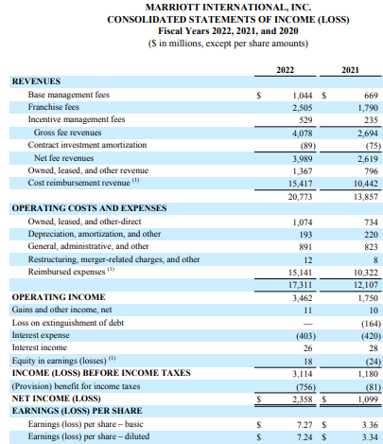

Appendix 4: Income Statement of 2023 to 2025


