

MARKETING ENVIRONMENT ANALYSIS

MASTER OF BUSINESS ADMINISTRATION

Module: Marketing Management
Module Code: LCMB7024

Lecturer: Laila Maazouz, Taonga Kaonga Sobere-Snithers

Student Name: Ankitaben Shaileshkumar Thakor
ID: 2541590

Word Count: 2547
Submission Deadline: Friday 24th July 2026

Table of Contents
Task 1: Marketing Environment Analysis 3
1.1 Company Selection and Context 3
1.2 External Marketing Environment Actor 1: Natural Environment 3
1.3 External Marketing Environment Actor 2: Political and Regulatory Environment 4
Task 2: Strategic Growth and Competitive Positioning 6
2.1 Strategic Growth Recommendation Using the Ansoff Matrix 6
2.2 Competitive Advantage Through a Lower-Carbon Business Model 8
Task 3: Critical Reflection on AI Usage 10
3.1 Tool Disclosure 10
3.2 Critical Evaluation of AI Output 10
3.3 Contribution Analysis 11
3.4 Ethical and Professional Reflection 11
References 12

Task 1: Marketing Environment Analysis

1.1 Company Selection and Context
BHP Group Limited is the largest diversified mining corporation with a market capitalisation in the world, with its headquarters in Melbourne, Australia. With copper, iron ore, nickel, potash, and metallurgical coal operations, the company has more than 80,000 employees and contractors in six different continents (BHP Group, 2025). The metals and mining sector is responsible for approximately 25% of global GHG emissions among the world's largest companies, placing BHP under sustained stakeholder and regulatory pressure to transition toward lower-carbon operations (IPCC, 2023). BHP, in turn, has set an objective to reach net-zero operational emissions, both Scope 1 and 2, by 2050, with a target of a 30-percent reduction (compared to its FY2020 level) by FY2030 (BHP Group, 2026). BHP's exit from thermal coal in 2022 and its acquisition of OZ Minerals confirm active repositioning toward transition-critical minerals (BHP Group, 2025).

1.2 External Marketing Environment Actor 1: Natural Environment
The most significant natural environment force that rekindles marketing environment at BHP is climate change. According to the IPCC Sixth Assessment Report, the world temperature must not exceed the 1.5 degrees Celsius limit, which would necessitate a rapid, profound, and sustained reduction of emissions in all sectors of the industry, with extractive industries being identified as those that experience the most significant decarbonisation pressures (IPCC, 2023).
On the threat definition, BHP's copper business in the Atacama Desert, Chile, is experiencing an increasing water shortage due to the hydrological change occasioned by the climate. The Escondida Mine, the largest copper mine in the world, uses seawater purification and water recycling in closed-loop desalination to maintain its production in one of the driest locations in the world (IEA, 2023). Accelerating glacial retreat and declining aquifer recharge increase capital requirements for water management and long-term production risk. In Australia, rising cyclone frequency in the Pilbara and flooding in Queensland reduce export reliability and elevate remediation costs (Fankhauser et al., 2021). Maechler and Graz (2024) maintain that ecological crises produce Knightian uncertainty, the impact of which is essentially incalculable (not merely probabilistic) and afflicts government-sponsored strategic complexity among resource-intensive companies in the ecological transition process.
Table 1 shows the reported BHP emissions trend compared to BHP decarbonization goals, highlighting its quantifiable, yet partial advance toward net-zero aspiration.
Emissions Category | FY2020 Baseline | FY2024 Reported | FY2030 Target | FY2050 Target
Scope 1 and 2 (Mt CO2e) | 15.7 | 11.1 | Below 11.0 (-30%) | Net Zero
Scope 3 (Mt CO2e, approx.) | 395 | 339 | Reduction pathway agreed | Net Zero
Table 1: BHP Scope 1 and 2 Emissions Trajectory and Decarbonisation Targets (FY2020 to FY2050)
(Source: BHP Group, 2025)
Nature provides market opportunity as a feature of structure at the same time. The world energy transition has created an unprecedented pressure on copper, nickel, and other rare minerals needed in the battery of EVs, the infrastructure of renewable energy sources, and grid modernisation (IEA, 2024). Global copper demand is projected to rise substantially through the 2030s, driven by accelerating electrification, creating a sustained demand trajectory that BHP's expanded copper portfolio is directly positioned to serve (World Bank Group, 2025).

1.3 External Marketing Environment Actor 2: Political and Regulatory Environment
The political and regulatory environment has been chosen as the second form of external actor since it will translate the global climate promises into legal binding tools that impact directly on cost structures, product development strategies and business standing in the major jurisdictions that the company operates in (World Bank Group, 2025).
In Australia, GHG obligations on 215 large industrial facilities (some of which operated by BHP) were reformed by the Safeguard Mechanism (Crediting) Amendment Act of 2023. In the updated framework, the relevant facilities have an emission baseline of 4.9% per year that decreases to 2025 under FY, and any surpasses must make a surrender of Australian Carbon Credit Units (Australian Government, 2023). This increasing cost of compliance itself is a direct financial incentive to BHP to speed up the electrification of mine fleets, purchases of renewable energy on its Australian sites, and systematic gains in energy efficiency across the entire scope of its operational investments.
Table 2 provides a summary of the major regulatory tools that will influence BHP marketing environment in major jurisdictions.
Regulation | Jurisdiction | Key Mechanism | Nature of Impact on BHP
Safeguard Mechanism Amendment Act 2023 | Australia | Declining baselines; ACCU compliance | Escalating cost; decarbonisation incentive
CBAM Regulation (EU) 2023/956 | European Union | Carbon price on industrial imports | Downstream demand for lower-carbon products
H.R.5376 (2021) | United States | Clean energy and critical minerals investment | Critical minerals demand stimulus
Australian Critical Minerals Strategy 2023 | Australia | Investment facilitation; export incentives | Supply chain and market access opportunity
Table 2: Key Regulatory Instruments Shaping BHP's Marketing Environment (2021 to 2026)
(Source: Australian Government, 2023; European Union, 2023; US Congress, 2021)
On the international level, the European Union has instituted the European Union Carbon Border Adjustment Mechanism (CBAM) through the introduction of Regulation (EU) 2023/956 that provides a price on imported iron, steel, aluminium, and other industrial materials entering the European Union starting in 2026 (European Union, 2023). Though BHP never directly exports processed steel to the EU markets, the spillovers on regulation in the downstream supply chain are seriously felt, though it is not directly involved. Asian steel factories refining BHP iron ore to export to Europe are increasingly under pressure to deliver lower-carbon feedstocks to keep their CBAM liability as low as possible, and downstream market has a growing need of certified lower-carbon iron ore product streams, which BHP could produce as a differentiated and high-priced market solution.
The H.R.5376 bill pledged significant federal funding of clean energy technologies and critical minerals supply chains within the United States that spurred enduring demand toward copper and nickel produced by geopolitically secure, ESG-credible sources (US Congress, 2021; IEA, 2024). Collectively, these regulatory developments reframe competitive dynamics across the sector, rewarding proactive decarbonisation investment with premium capital access and differentiated market positioning while amplifying the natural environment pressures identified in Section 1.2 (Whittington et al., 2022; Fankhauser et al., 2021).

Task 2: Strategic Growth and Competitive Positioning

2.1 Strategic Growth Recommendation Using the Ansoff Matrix
Building on the environmental and regulatory analysis in Task 1, this section applies the Ansoff Matrix to identify BHP's most appropriate strategic growth direction for its low-carbon transition. The framework defines four growth pathways: Market Penetration, Market Development, Product Development, and Diversification (Ansoff, 1957; Whittington et al., 2022). The Product Development and Diversification quadrants tend to be where pioneering organisations are developing processes that cause market change via sustained innovation and that use first-mover advantage and product differentiation product portfolios as key competitive means. By comparison, follower organisations are more inclined towards Market Penetration and Market Development and compete based on the efficiency of the cost and adaptive imitation (Whittington et al., 2022; Covin, Slevin and Heeley, 2000). The Ansoff Matrix based on the recommendations on the strategic position of BHP is provided in Figure 1.
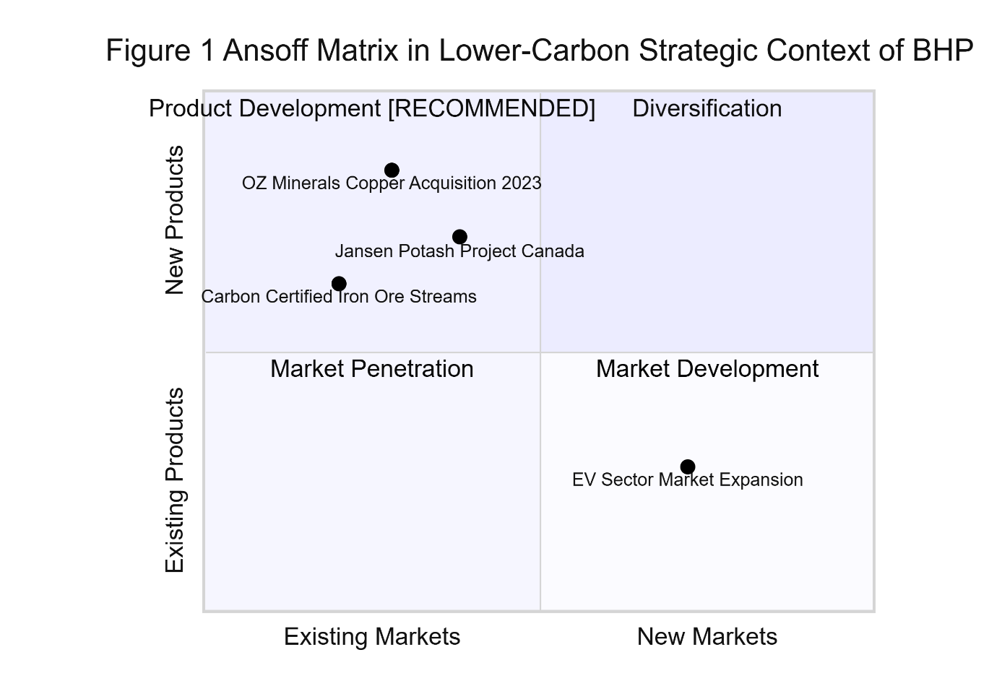
Figure 1: The Ansoff Matrix in Lower-Carbon Strategic Environment of BHP.
(Source: Adapted from Ansoff, 1957 and Whittington et al., 2022)
BHP would be suggested to go on with Product Development as its main strategic growth strategy. This quadrant assumes creating new products of a large-scale novelty (or refinement of existing products), building on existing and neighbouring market relationships, existing operations and customer trust, and supply chain networks instead of taking the high risk of completely new ventures in unfamiliar markets (Whittington et al., 2022). As a pioneering firm in the sector's sustainability transition, BHP's competitive advantage rests on product innovation and first-mover positioning rather than cost-based imitation, aligning naturally with the Product Development quadrant (Covin, Slevin and Heeley, 2000).
BHP has three strategic investments on record that indicate its efforts to invest in this quadrant. Primarily, the acquisition of OZ Minerals, which was achieved in May 2023 at an estimated USD 9.6 billion added to the copper portfolios of BHP with the Prominent Hill and Carrapateena facilities in South Australia, directly responding to the transition-mineral demand opportunity identified in Section 1.2 (BHP Group, 2025; World Bank Group, 2025). Second, in Saskatchewan, Canada, the Jansen Potash Project presents a new sustainable input product in the agricultural field, broadening BHP's transition-aligned portfolio beyond conventional metals (BHP Group, 2025). Third, BHP is developing carbon-certified iron ore streams for steelmakers integrating hydrogen-based direct reduction technologies, responding to the CBAM-driven downstream demand signal identified in Section 1.3 (BHP Group, 2026; IEA, 2023).
Market Penetration offers limited value given BHP's existing dominant position. Diversification carries disproportionate risk without established relationships in unfamiliar sectors. Product Development most precisely reflects BHP's documented investment trajectory and is consistent with evidence that pioneering firms in complex industrial environments outperform through differentiated innovation rather than price competition (Covin, Slevin and Heeley, 2000; Whittington et al., 2022).

2.2 Competitive Advantage Through a Lower-Carbon Business Model
This section critically examines how BHP can gain and maintain a competitive advantage by lowering its carbon transition, considering the Generic Strategies outlined by Porter and evidence in the industry. According to Porter (1980), there are four generic competitive strategies: Cost Leadership, Differentiation, Cost Focus, and Differentiation Focus, each reflecting a distinct basis for competitive advantage in the marketplace. Table 3 compares the way pioneering and follower organisations typically utilise these strategies in the resource heavy industrial sectors of the economy.
Porter's Strategy | Pioneer Orientation | Follower Orientation
Cost Leadership | Rare at early stage; emerges later with achieved scale | Common: imitating pioneer efficiencies to undercut on price
Differentiation | Primary strategy: first-mover innovation and brand equity | Incremental: adaptive modification of pioneer products
Cost Focus | Occasional use in niche, price-sensitive segments | Frequent: targeting lower-cost niche market positions
Differentiation Focus | Premium or sustainability-oriented niche leadership | Replication of niche differentiation at reduced cost
Table 3: Porters Generic Strategy to Pioneer and Follower Firms in Mining industry
(Source: Adapted from Porter, 1980 and Whittington et al., 2022)
The competitive strategy suggested is differentiation, which is the main strategy of BHP. Porter (1980) refers to Differentiation as the development of unique customer value that is based on innovation, quality and brand equity, which are hard to be imitated by the competitors so that premium pricing can be charged and enduring loyalty in the market can be secured. For BHP, verified sustainability credentials have become core value drivers for institutional investors, EV manufacturers, and industrial buyers under growing ESG procurement requirements, making Differentiation both strategically coherent and commercially necessary.
BHP can attain and maintain Differentiation based on three main mechanisms. On the one hand, third-party approved responsible sourcing certifications present a justifiably privileged positioning. By taking part in the Copper Mark certification programme, backed by Scope 1 and 2 performance data independently audited, BHP will be capable of offering its customers who demand verified sustainable mineral inputs as contractual procurement requirement (BHP Group, 2026). This differentiation by certification aligns with that by Fankhauser et al. (2021), who prove that credible and verifiable net-zero commitments create sustainable reputation positioning between organisations and sustainability-sensitive capital markets and procurement networks, and between the genuine transition leaders and fake actors.
Second, the operational decarbonisation involving the electrification of mine fleets and acquisition of renewable energy gradually drives down the carbon intensity of both copper and iron ore produced by BHP in a tonne. Such a technical performance benefit cannot be easily replicated in the short term by smaller players or state-owned counterparts that have operations in less regulated jurisdictions, establishing a sustainable competitive advantage in line with buyer needs in downstream markets, exposed to CBAM identified in Section 1.3 (BHP Group, 2025; IEA, 2023).
Third, BHP model is geographically diversified, which offers supply security and predictability following environmental regulations through politically stable and stable governments in Australia and the Americas, that single-jurisdiction producers would not be able to achieve. Supply chain resilience has become a procurement criterion comparable to price in many industrial buyer relationships, extending BHP's competitive differentiation beyond the physical commodity (IEA, 2024; Whittington et al., 2022). A combination of these three mechanisms places BHP in a strategy of maintaining competitive advantage in the energy transition based on proven value creation as opposed to price competition with lower-cost producers, a position analytically coherent and directly responsive to the environmental and regulatory forces identified in Task 1 (Covin, Slevin and Heeley, 2000; Porter, 1980).

Task 3: Critical Reflection on AI Usage

3.1 Tool Disclosure
This report was developed using two AI tools that fall within the mentioned range of the use of the assignment brief. Research support was undertaken by Claude AI (Anthropic), and other academic sources and industry reports about the problem that might be of interest were identified with the view to its further independent verification, as well as proofreading finalised sections to verify the correctness of grammar and clarity of the expression words. The MyBib helped me organize reference entries, and all citations were produced manually and tested separately to make sure they were bibliographically correct. There was no AI tool to create, organize, or arrive at any analytical content, strategy planning, or framework choices, and conclusions in this submission.

3.2 Critical Evaluation of AI Output
All the selected sources have also been validated by Google Scholar, institutional library databases and publisher websites before being added. Several inaccurate publication years, incorrect journal volume numbers, or misattributed article titles, reflecting documented hallucination patterns in MyBib outputs. These misconceptions were detected using primary sources and fixed as well. This submission has not cited any reference, unless it is personally confirmed to exist, be bibliographically correct and to be available via a verifiable source.

3.3 Contribution Analysis
The analytical content of this report reflects entirely independent student reasoning, informed by module learning materials and critical engagement with academic and industry literature. The BHP company was chosen to focus on, the Natural Environment and Political and Regulatory actors were identified, the Product Development was suggested as the Ansoff quadrant, differentiation as the necessary Porters Generic Strategy was chosen, and all arguments and conclusions were drawn on the basis of independent critical analysis of the brief and the attributed literature. AI only helped to identify sources of research to be further investigated independently.

3.4 Ethical and Professional Reflection
Ethical disciplines are required concerning the application of generative AI in academic assessment. Academic integrity requires that submitted work authentically reflects student analytical capability; using AI to generate substantive content misrepresents that capability and constitutes academic dishonesty regardless of output quality. A further professional risk lies in over-reliance on AI in rapidly evolving fields such as carbon regulation and ESG disclosure, where training data may be incomplete or outdated, a limitation encountered directly when verifying AI-suggested references for this report. Biases in AI training datasets also present the possibility of biasing analysis of regulatory or geopolitical context, which is particularly of concern in marketing with sustainability priorities, incomplete or biased framing of which results in the wrong strategic suggestions. More importantly, AI cannot demonstrate the contextual professional judgment that is needed to integrate marketing structures, assess company-specific strategic choices, as well as provide ethical reasoning to circumstances in a business context. Marketing practitioners should hence consider AI solely as a research tool and not as a critical judgement tool and should retain personal responsibility to all statements made in the professional outputs and use high levels of critical scrutiny to all AI-generated insights in the analysis process.

References
Ansoff, I. (1957) “Strategies for diversification,” Management science, 4(4), pp. 113–124. Available at: https://www.casrilanka.com/casl/images/stories/2017/2017_pdfs/sab_portal/course_material/strategies_for_diversification.pdf (Accessed: July 23, 2026).
Australian Government (2023) Safeguard mechanism (crediting) amendment act 2023 - federal register of Legislation, Legislation.gov.au. Available at: https://www.legislation.gov.au/details/c2023a00014 (Accessed: July 23, 2026).
BHP Group (2025) Annual report 2025, Bhp.com. Available at: https://www.bhp.com/investor-hub/reports-and-presentations/annual-report (Accessed: July 23, 2026).
BHP Group (2026) Climate change | BHP, Bhp.com. Available at: https://www.bhp.com/climate (Accessed: July 23, 2026).
Covin, J.G., Slevin, D.P. and Heeley, M.B. (2000) “Pioneers and followers,” Journal of Business venturing, 15(2), pp. 175–210. Available at: https://doi.org/10.1016/s0883-9026(98)00015-9.
European Union (2023) Regulation - 2023/956 - EN - cbam regulation - EUR-Lex, Europa.eu. Available at: https://eur-lex.europa.eu/legal-content/EN/TXT/?uri=CELEX:32023R0956 (Accessed: July 23, 2026).
Fankhauser, S., Smith, S.M., Allen, M., Axelsson, K., Hale, T., Hepburn, C., Kendall, J.M., Khosla, R., Lezaun, J., Mitchell-Larson, E., Obersteiner, M., Rajamani, L., Rickaby, R., Seddon, N. and Wetzer, T. (2021) “The meaning of net zero and how to get it right,” Nature climate change, 12(1), pp. 1–7. Available at: https://www.nature.com/articles/s41558-021-01245-w (Accessed: July 23, 2026).
IEA (2023) Critical minerals market review 2023 – analysis, IEA. Available at: https://www.iea.org/reports/critical-minerals-market-review-2023 (Accessed: July 23, 2026).
IEA (2024) World energy outlook 2024, IEA. Available at: https://www.iea.org/reports/world-energy-outlook-2024 (Accessed: July 23, 2026).
IPCC (2023) “Climate change 2022 - mitigation of climate change.” Available at: https://doi.org/10.1017/9781009157926.
Maechler, S. and Graz, J.-C. (2024) “Uncertainty in times of ecological crisis: A knightian tale of how to face future states of the world,” European journal of International relations, 30(4), pp. 818–841. Available at: https://doi.org/10.1177/13540661241226473.
Porter, M.E. (1980) Competitive strategy: Techniques for Analyzing industries and competitors. Free Press.
US Congress (2021) H.R.5376 - 117th congress (2021-2022): Build back better act, www.congress.gov. Available at: https://www.congress.gov/bill/117th-congress/house-bill/5376 (Accessed: July 23, 2026).
Whittington, R., Regner, P., Angwin, D., Johnson, G. and Scholes, K. (2022) Exploring strategy, text & cases. Pearson.
World Bank Group (2025) Minerals for Climate action : The mineral intensity of the clean energy transition, World Bank. Available at: https://documents.worldbank.org/en/publication/documents-reports/documentdetail/099052423172525564 (Accessed: July 23, 2026).

