MSC CYBERSECURITY AND DIGITAL FORENSICS
Cloud Engineering Principles and Practice
A Critical Examination of Virtualisation, Containerisation,
Cloud Scalability, and the Serverless Paradigm
Date:
April 2026

Student Name: | Hetvi Patel
Student Id: | 2529465
Module: | Cloud Computing Principles & Practices
Module Code: | ACCA7027

Table of Contents
Table of Contents
Video Demonstration
1. Introduction
2. Principles of Virtualisation
2.1 What Virtualisation Is
2.2 Dimensions of Virtualisation
2.3 Benefits and Limitations
3. Containerisation: Principles, Benefits, and Practical Implementation
3.1 Principles and Benefits
3.2 Hands-on Docker Practical
3.2.1 Building an Image (Dockerfile)
3.2.2 Running a Container
3.2.3 Publishing to Docker Hub
3.2.4 Container Volumes for Persistence
3.2.5 Container Networking
3.3 Overall Process Demonstration
4. Cloud Computing Concepts: Load Balancing, Scalability, and Application Gateways
4.1 Load Balancing
4.2 Scalability
4.3 Application Gateway
4.4 Complementarity of Load Balancing and Scaling
4.5 Combined Benefits
5. Driving Forces Behind Cloud Expansion and the Rise of Serverless
5.1 Main Driving Forces
5.2 Serverless Functions (FaaS)
5.3 Serverless vs. Containerisation
5.4 Which Driving Force Each Paradigm Serves Best
6. Conclusion
References

Video Demonstration

Docker Practical Demonstration Video
YouTube Link: https://www.youtube.com/watch?v=HnRpGGMT5xQ&feature=youtu.be

1. Introduction
The rise of cloud computing is now the preferred approach to delivering IT services, allowing organisations to request compute, storage and networking services on demand, under a pay-as-you-go model [1]. In 2025, global public cloud spending amounted to $723 billion, up 21.5% annually [2], supported by two key technologies: virtualisation and containerisation. This report critically explores these technologies, grounded in a Docker practical where a custom image of an NGINX-based web server was created, executed locally with persistent storage and custom networking, and published to Docker Hub with the repository name of hetvivi/hetvi-web. The report also explores the principles of load balancing, scalability and application gateways with reference to a student portal and assesses the economic and technical drivers of cloud computing and the merits of containerisation versus serverless.
2. Principles of Virtualisation
2.1 What Virtualisation Is
Virtualisation creates multiple isolated software containers or virtual machines (VMs) from physical computing resources (processors, memory, storage and network interfaces) through a software layer known as the hypervisor or Virtual Machine Monitor (VMM) [3]. The hypervisor traps calls to the physical resources from the guest OSs, so that each VM believes it has its own set of hardware resources, even when sharing them with other VMs.
There are two architectural types. Type 1 (bare-metal) hypervisors directly access hardware without a host OS (such as VMware ESXi, Microsoft Hyper-V, and KVM). Type 1 hypervisors have direct access to hardware, thus providing better performance and are the de facto standard in enterprise datacentres and public IaaS clouds [4]. Type 2 (hosted) hypervisors run on a traditional OS - examples include Oracle VirtualBox. They add a software layer of indirection that degrades performance, and are suitable for use in development and testing, but not for production environments.
In addition to these two categories, there are two types of virtualisation: full virtualisation, where the hypervisor presents each VM with an interface identical to the underlying hardware enabling unmodified guest OSes to run, and paravirtualisation, where the guest OS is modified to call a new hardware interface, reducing the overhead of trap and emulate and thus increasing throughput for I/O-intensive workloads, but requiring modified guest OSes [5].
In cloud providers, like AWS EC2 and Microsoft Azure Virtual machines Type 1 Hypervisors, are the fundamental layer of the whole IaaS infrastructure services and thus virtualisation becomes the hidden core infrastructure in the clouds.
2.2 Dimensions of Virtualisation
Virtualisation can be applied beyond compute. Storage virtualisation pools physical disk arrays into logical storage pools that support thin provisioning, snapshots and data mobility without service interruption. Network virtualisation abstracts logical networks from physical wiring, using technologies like VLANs and VXLAN overlays, to support multi-tenancy and micro segmentation [6]. These three aspects provide the architectural basis of IaaS clouds.
These three aspects (compute, storage and network virtualisation) don't work in isolation. For instance, in a real-world production cloud service, like the one AWS offers, a user can start an EC2 instance (compute virtualisation) which requires access to an EBS volume (storage virtualisation) and is available via a VPC (network virtualisation). This is how the three levels contribute together to provide IaaS.
2.3 Benefits and Limitations
Virtualisation provides many benefits. Consolidation of servers usually increases average CPU utilisation from 5-15% on bare-metal hosts to 60-80% on virtualised platforms, substantially reducing hardware and maintenance costs [4]. Migration tools - such as VMware vMotion - allow VMs to be transferred between physical hosts without noticeable downtime, aiding maintenance and load balancing. Virtualisation provides good isolation: a compromised guest OS should not affect other VMs on the host [3].
But virtualisation comes at a cost. A VM's guest OS kernel consumes disk and memory (typically many gigabytes and hundreds of megabytes) before the actual process begins. The hypervisor must trap privileged instructions from guest kernels, creating delays even with hardware virtualisation support (Intel VT-x / AMD-V) [7]. More importantly, the minutes required to boot a VM stands in contrast to the millisecond scale required to start a container: a crucial difference in an auto-scaling, elastic cloud. These were the driving factors in containerisation. Figure 1 below illustrates the progressive reduction in redundant OS layers across deployment models.
One significant security issue in shared virtualised environments is the class of vulnerabilities known as Spectre/Meltdown. These exploit speculative execution to steal data between VMS and is particularly relevant for multi-tenancy in public clouds. Service providers like AWS and Azure attempt to mitigate this issue with their Dedicated Host products where they offer exclusive access to physical hardware for an individual tenant. Although the support of hardware virtualization like Intel VT-x and AMD-V has effectively lowered the hypervisor's overhead VM boot times are on the order of minutes, which is why containerization was considered in the first place
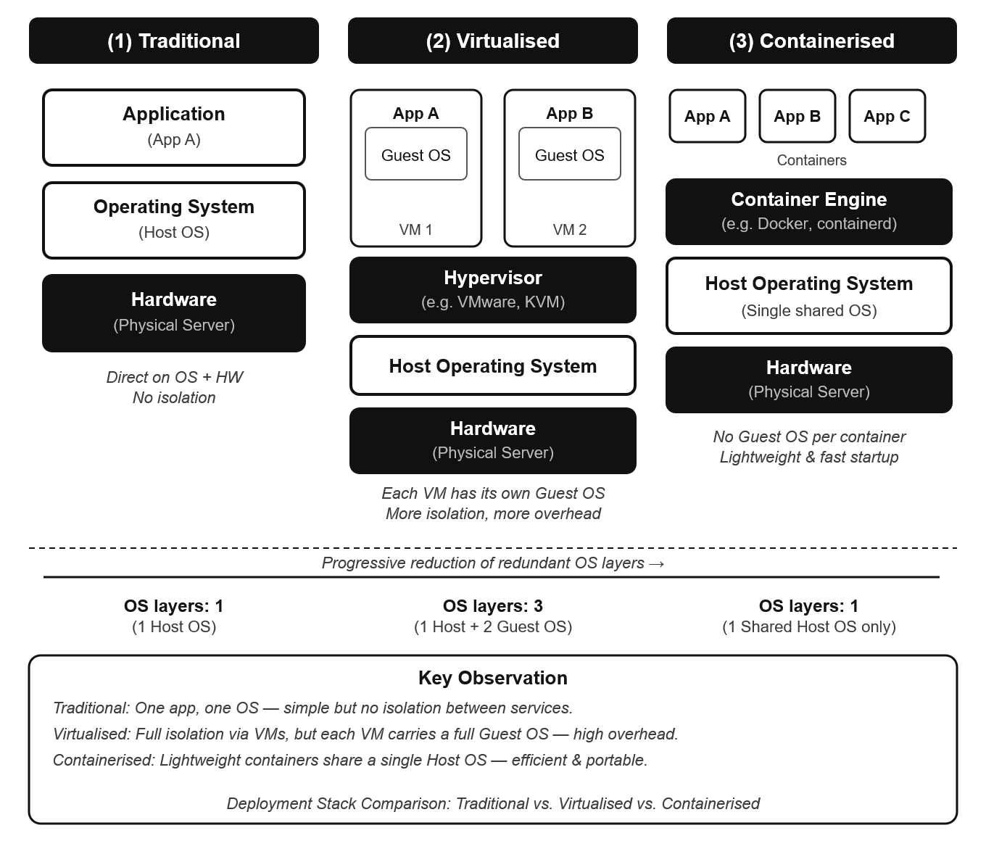
Figure 1: Three-column architecture stack comparing: (1) traditional deployment — application on OS and hardware; (2) virtualised deployment — hypervisor hosting multiple VMs each with a full guest OS; (3) containerised deployment — container engine on a single shared host OS hosting multiple application containers.

3. Containerisation: Principles, Benefits, and Practical Implementation

3.1 Principles and Benefits
Containerisation is a form of operating system (OS)-level virtualisation that uses the host kernel to isolate multiple user-space instances (containers), each containing an application and its dependencies, but no guest OS. Processes, networks and file systems are isolated via Linux namespaces so each container believes it has access to the entire system, while control groups (cgroups) impose hard limits on CPU, memory and I/O [8]. Docker, launched in 2013, formalised the container image and toolset, setting the model of client daemon registry that is still in wide use today.
The major components of the Docker platform are the Docker client (CLI or API user), the Docker daemon (dockerd) which creates images, manages the lifecycle of containers, and communicates with lower-level runtimes such as containerd, and registries such as Docker Hub to store and distribute versioned images [8]. Containers share the host kernel, making them much smaller than VMs (an NGINX image is less than 25 MB compared to gigabytes for a VM image), and faster to start (milliseconds instead of minutes) [9]. Consistency is also crucial: a container image created locally runs exactly the same in a CI/CD pipeline, a staging environment and a production Kubernetes cluster, removing the "it works on my machine" conundrum.
The namespaces are where each container gets their own, unique view of processes, the network and the file system; essentially a process running within one container cannot see and influence another. Control groups (cgroups) can be used to complement the namespaces by providing kernel-level hard limits for each container, they limit the share of CPU and memory a container gets at the kernel scheduler level. The combination of these two kernel primitives can provide true isolation without a completely separate kernel. Storage driver OverlayFS, used by Docker, extends this to layer every image diff as a SHA-256 and while conceptually every layer is being written to, in practice with only the html file changing, Docker could use its cached nginx:alpine image layer and only build the COPY layer.
A security note: all containers on a host share the same kernel, which means if the kernel is compromised, a container can escape its boundaries to the host and any other containers - an issue not present with VMs. Best-practice security therefore requires minimal base images, non-root users and image scanning [9].
The Docker architecture is depicted in Figure 2 below.
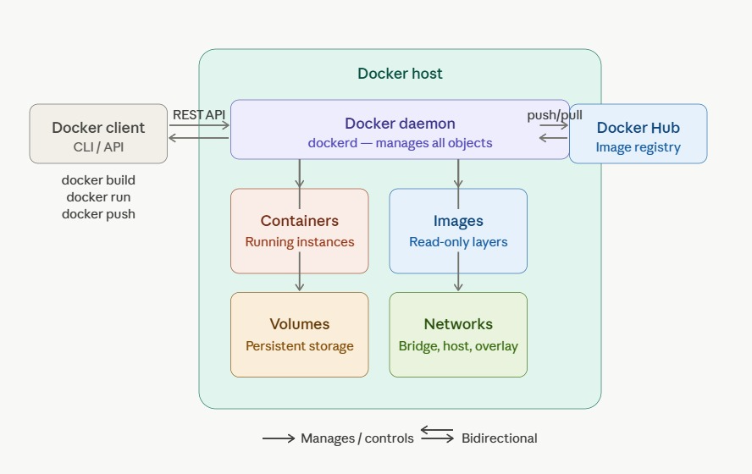
Figure 2: Docker architecture diagram showing the Docker client communicating via REST API with the Docker daemon on the host, which manages images, containers, networks, and volumes locally. The daemon pulls and pushes images from/to a remote registry (Docker Hub).

3.2 Hands-on Docker Practical

A video walkthrough of the practical is available at:
3.2.1 Creating an Image (Dockerfile)
The practical started with the creation of a Dockerfile containing three instructions. The FROM instruction identifies the base image to be nginx: alpine, an Alpine Linux version of NGINX (23.3 MB) which was chosen for its lightweight nature and smaller attack surface (the Debian version is more than 130 MB [8]). The COPY instruction overlays a custom index.html file - showing the student name and course code ACCA7027 - into the NGINX web root directory. The EXPOSE instruction records port 80 as the container's port.
We built the image using the command: docker build -t hetvi-web .
Each instruction results in a distinct layer, with a cryptographic hash of the files, stored by the Docker Union File System (OverlayFS). Docker's layer caching implies that when the build is repeated, and only the HTML file is changed, the daemon will re-use the base layer from the nginx: nginx: alpine image and only rebuild the COPY layer, speeding up the development process [10]. The Dockerfile used in the practical is shown in Figure 3.

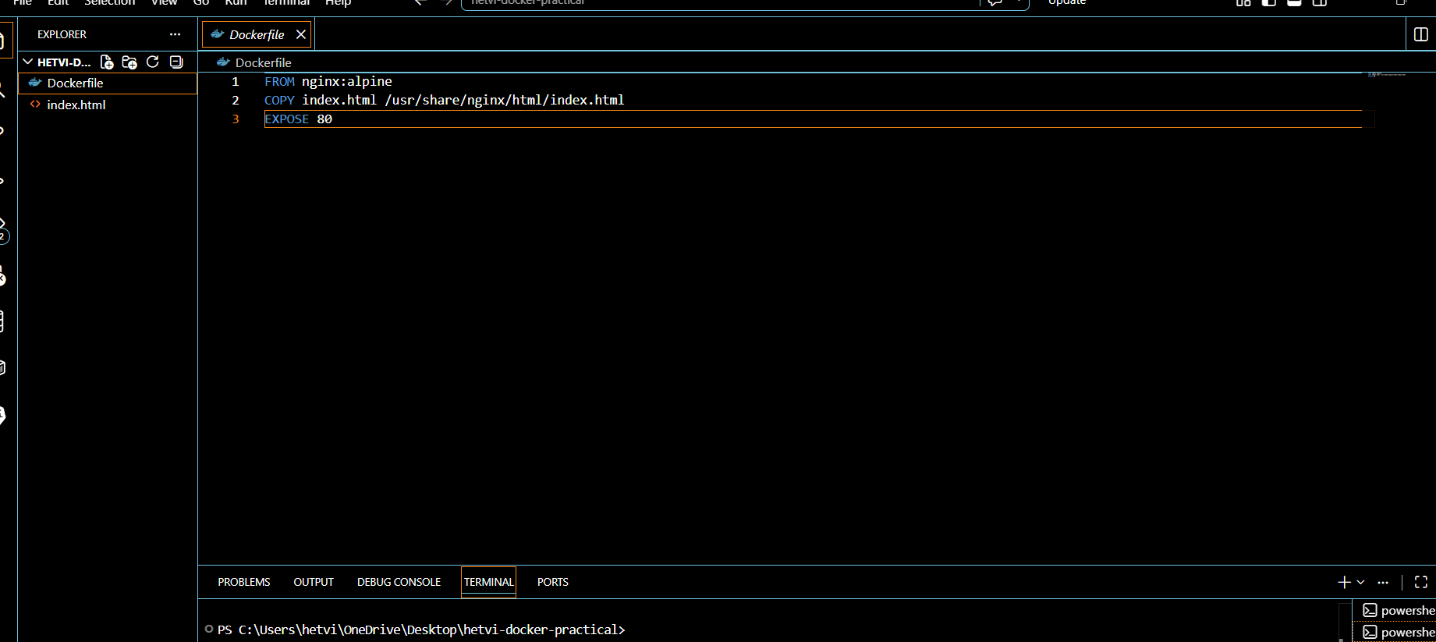
Figure 3: Screenshot of Dockerfile content showing FROM nginx: nginx: alpine, COPY, and EXPOSE instructions as displayed in the VS Code editor during the practical.
3.2.2 Running a Container
Having built the image, a container was started by running: docker run -d -p 8080:80 --name hetvi-container hetvi-web
The -d argument detaches the container from the terminal, making it run in the background - a crucial feature for services that require long-running processes. The -p 8080:80 flag binds port 8080 on the Docker host to port 80 on the container, which is in its own network namespace implemented by Docker's iptables-based networking. Accessing http://localhost:8080 showed that the NGINX web server served our customised HTML page, immediately confirming the successful containerised deployment [8]. This is shown in Figure 4.
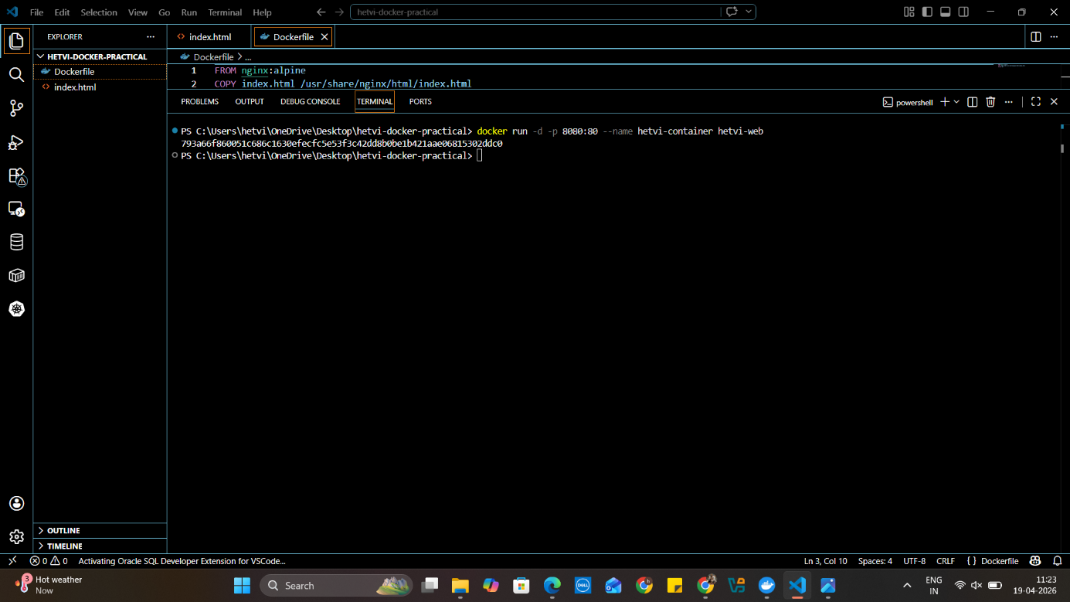
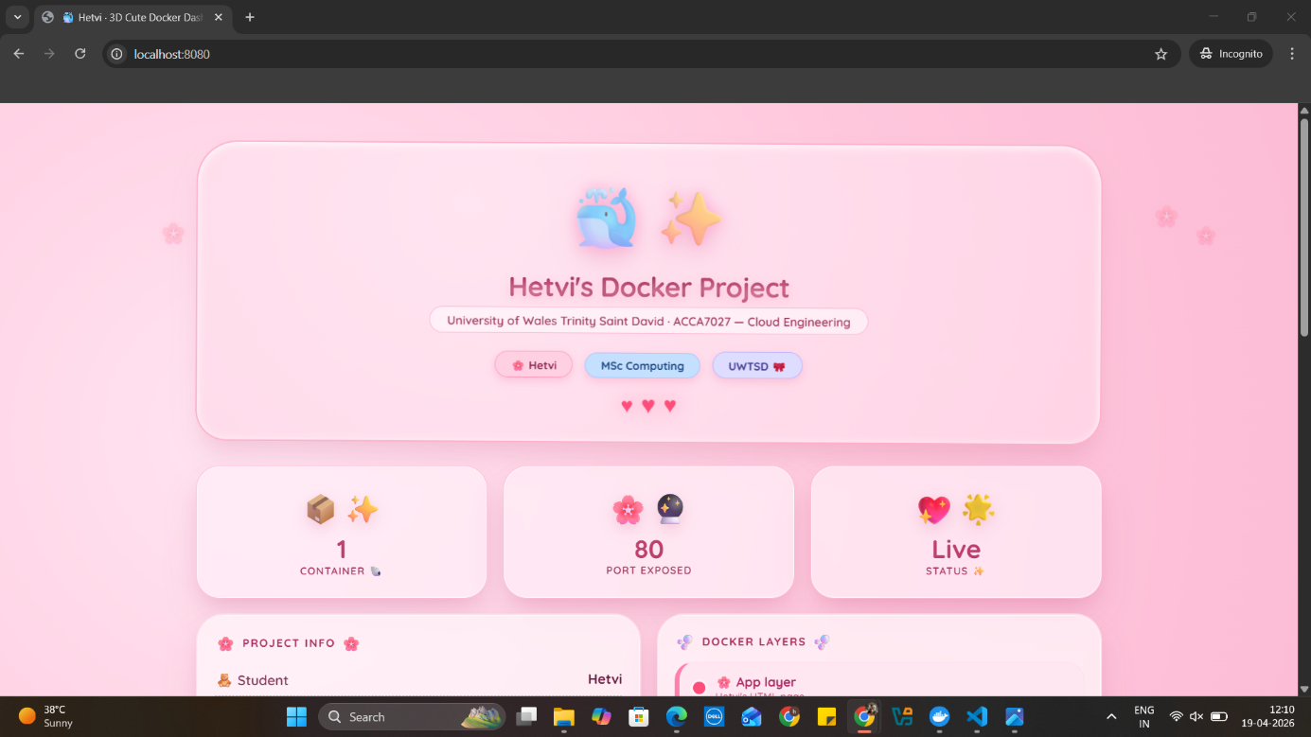

Figure 4: Screenshot of the browser window displaying the customised HTML page served by hetvi-container at http://localhost:8080 which shows the student name and module code ACCA7027.

3.2.3 Publishing to Docker Hub
Docker Hub is the default public registry, allowing any Docker host globally to download and run an image. The image was tagged to correspond to the Docker Hub namespace, logged in, and pushed. The push operation sent only those layers not already existing in the registry, showcasing Docker's layering model. The result of the push is a publicly available repository at hetvivi/hetvi-web, demonstrating the portability principle: the image can now be deployed on any Docker host (cloud or on-premises) by simply issuing a docker pull command [9]. The published repository is shown in Figure 5.
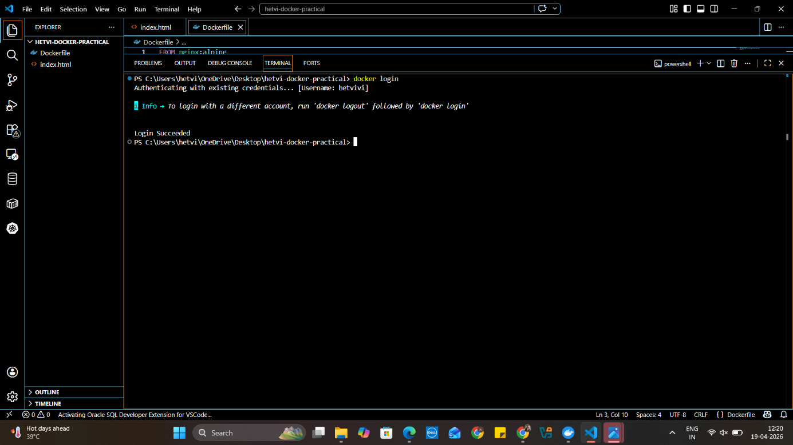
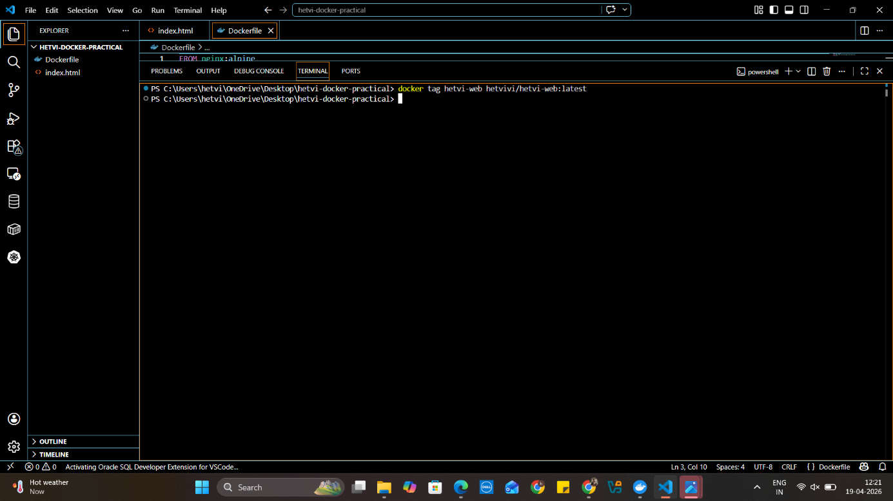
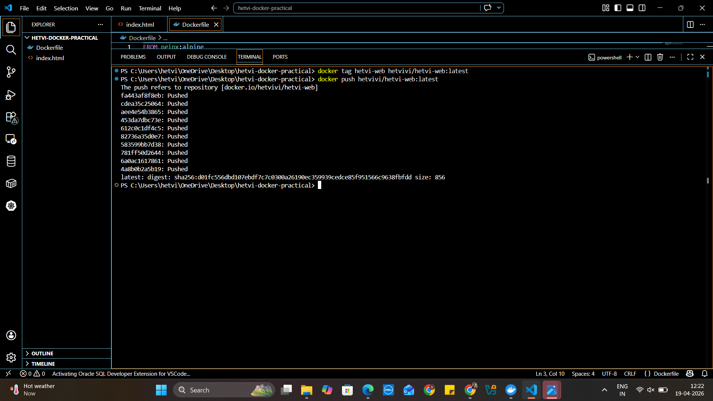
Figure 5: Docker Hub web interface screenshot of the hetvivi/hetvi-web repository with the successfully pushed image (tag, size and last pushed date).
3.2.4 Persistent Storage with Container Volumes
The writable layer of a container is temporary and when a container is deleted, its content is lost. This is intended behaviour - it ensures containers are stateless and reproducible - but is not suitable for stateful applications like databases and file systems [8]. Docker volumes overcome this with a storage mechanism that is managed by the daemon and is independent of the container lifecycle. The volume hetvi-volume was created and verified with docker volume create and docker volume ls respectively. Runtime linking of the volume is achieved with -v hetvi-volume:/data, which means all writes to the /data directory within the container are stored persistently on the host. Importantly, the volume can be shared between containers and will persist across container and host restarts [10]. The volume creation is confirmed in Figure 6.
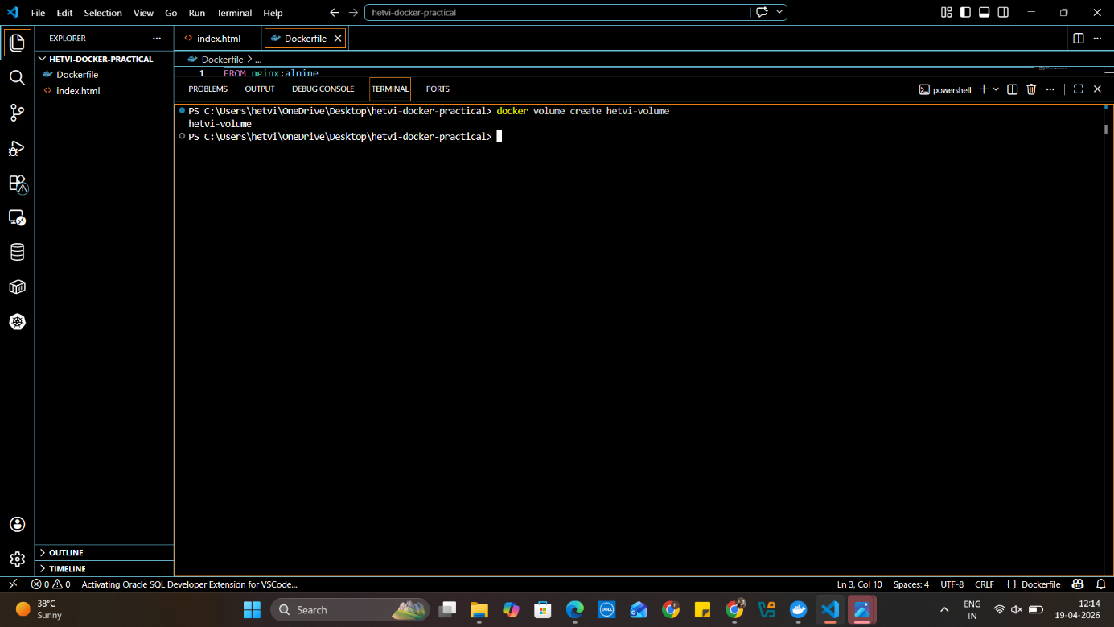
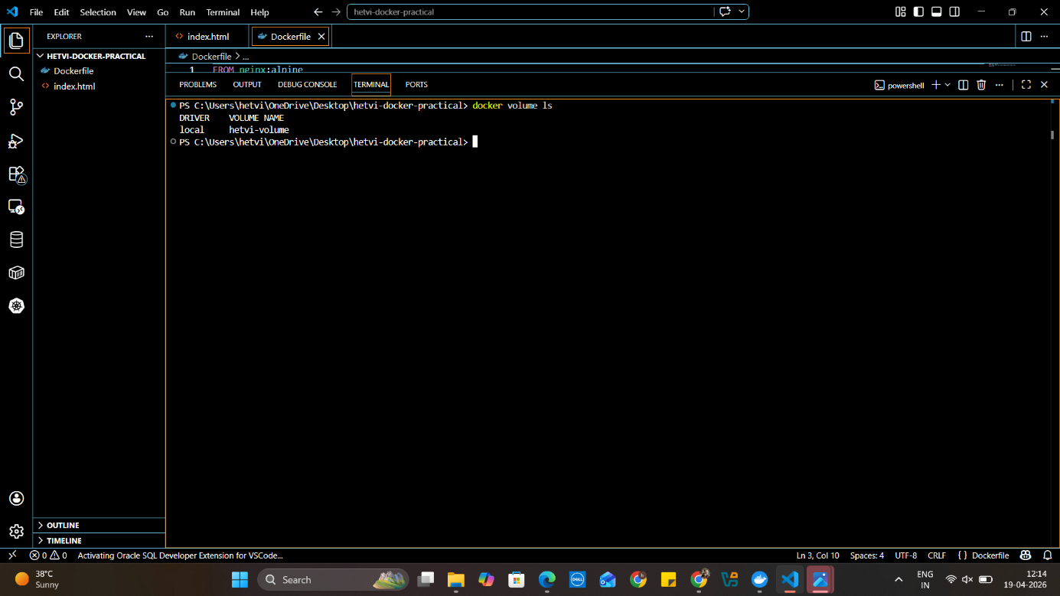
Figure 6: Terminal screenshot showing output of docker volume ls, listing hetvi-volume with the local driver.

3.2.5 Container Networking
Docker provides several built-in network drivers. The default bridge network permits basic inter-container communication but does not provide DNS-based service discovery: containers must reference each other by dynamic IP address, which is fragile in elastic environments [8]. User-defined bridge networks overcome this. A custom network hetvi-network was created, and two containers—hetvi-container1 and hetvi-container2—were launched attached to it. Docker's embedded DNS server on user-defined networks automatically resolves container names to IP addresses, enabling hetvi-container1 to reach hetvi-container2 by name. This was verified with docker exec hetvi-container1 ping hetvi-container2, which returned successful responses, confirming name resolution and packet delivery. User-defined networks also enforce network isolation, implementing a principle of least-privilege networking [10]. Figure 7 confirms both containers running on the custom network.
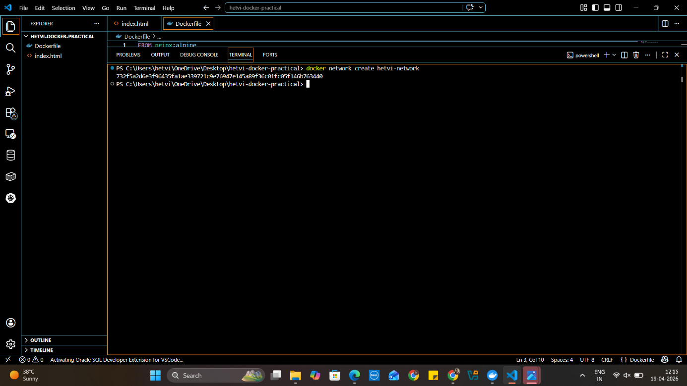
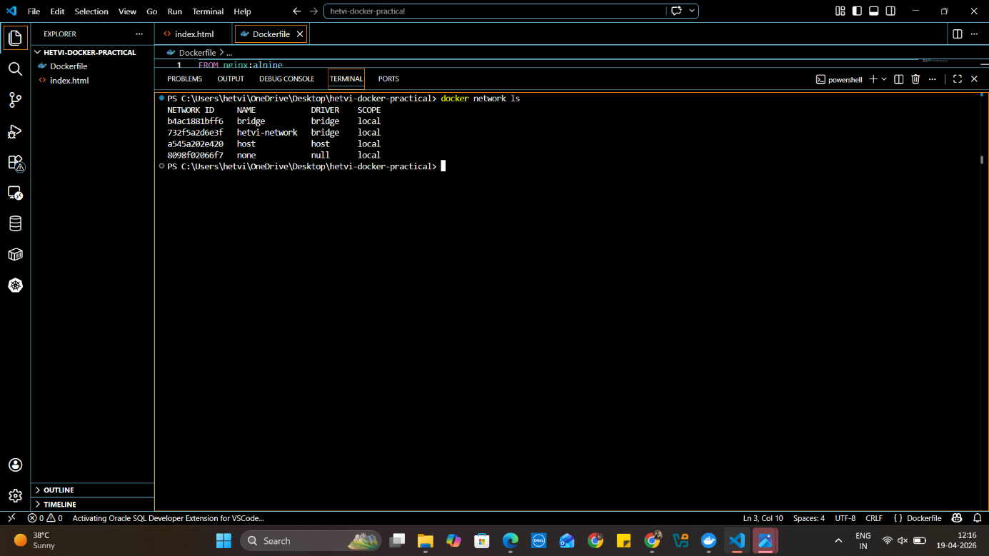
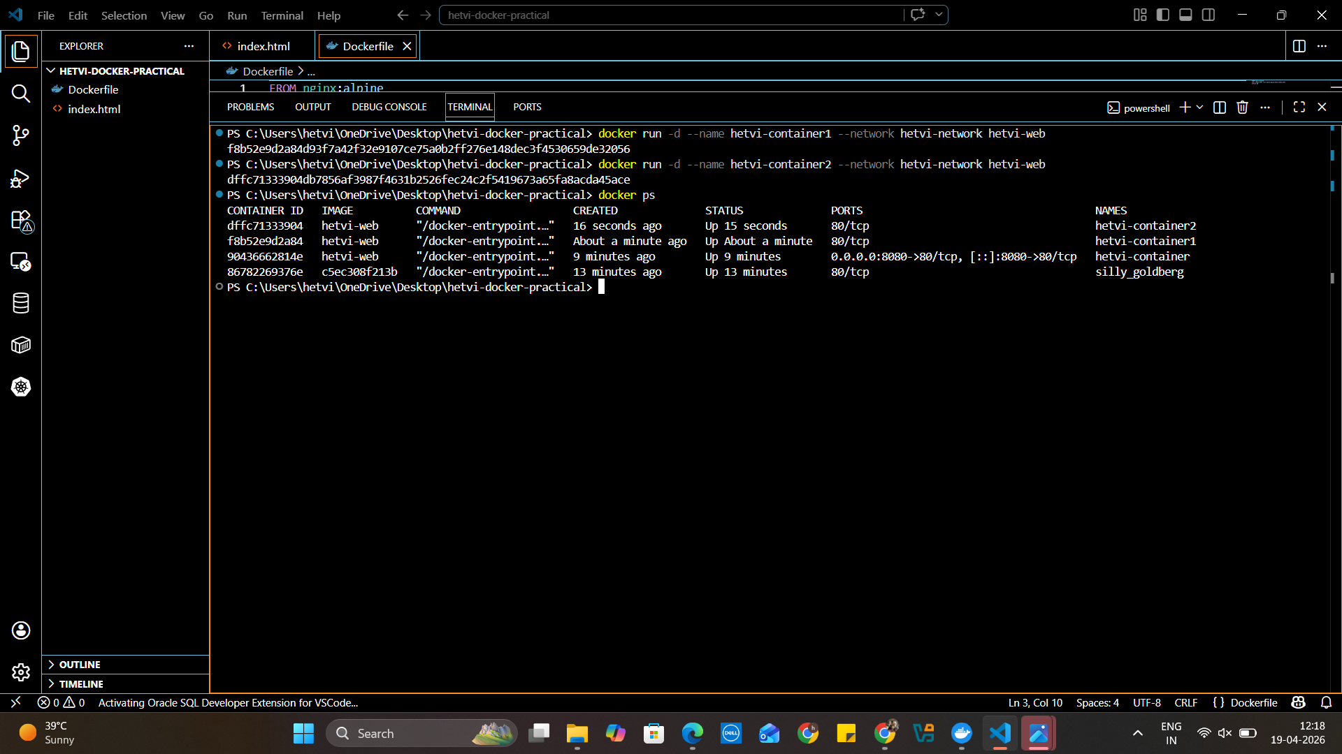
Figure 7: Terminal screenshot of docker ps output showing both hetvi-container1 and hetvi-container2 running, attached to hetvi-network, with port mappings and status.

3.3 Overall Process Demonstration

The entire process of authoring a Dockerfile, building an image, launching a container with port mapping, volume-based persistence, custom bridge network, and publishing to Docker Hub, represents the containerisation lifecycle. It shows how a declarative Dockerfile declaration describes application logic and produces a portable, versioned artefact that can be deployed the same way on any Docker-capable host, be it a developer laptop or AWS ECS or Azure Container Instances (ACI). These are precisely the actions that are taken in production deployments on managed container services.

4. Cloud Computing: Load Balancing, Scalability and Application Gateways

For the sake of concreteness, let's take a university enrolment system. At peak times, users can reach 10 times normal levels; the rest of the year, usage is minimal. This pattern calls for elasticity, efficient request allocation, and secure request processing: the three features discussed below.

4.1 Load Balancing

A load balancer spreads client requests over a cluster of backend servers or containers to avoid bottlenecks, and to increase overall throughput and resilience [11]. There are a number of scheduling policies that may be used. Round-robin distributes requests in a circular manner - a good choice when the capacity of the servers is the same and the processing time per request is constant. Least connections allocates requests to the server with the least number of connections, making it more suitable when session times are variable, as would be the case with course registration systems that perform complicated database queries.

AWS Elastic Load Balancing provides two key services. The Application Load Balancer (ALB) routes traffic on OSI Layer 7, inspecting HTTP/HTTPS headers to support content-based routing (path-based, host-based, and WebSocket), among other features [11]. The Network Load Balancer (NLB) operates at OSI Layer 4, and has low latency for TCP/UDP traffic, maintaining the client source IP address. Both ALB and NLB perform continuous health checks - configurable HTTP health checks that monitor a specific endpoint on the backend instance - and automatically remove unhealthy instances from the pool, reintegrating them when healthy [11]. The ALB is the better option for the student registration portal due to the need for path-based routing between the frontend and admin API services.

Serverless and containerized compute are also converging: "AWS Fargate and Azure Container Apps allow containers to be packaged and then executed on serverless backend infrastructure. Expect this trend toward portability on top of serverless infrastructure to define the future direction of cloud-native application development."

4.2 Scalability

Scalability is the ability of a system to perform as it grows. Vertical scaling increases RAM or CPU on an instance - easy to manage but limited by hardware and requires downtime. Horizontal scaling means adding more instances, theoretically unlimited, can be applied to zero-downtime deployments, and is economically viable in cloud environments [12].

AWS Auto Scaling Groups track CloudWatch metrics - average CPU usage, number of HTTP requests per minute to an ALB target, or custom metrics from the application - to automatically add or remove EC2 instances to keep these metrics at target levels [13]. A scale-out policy could add instances when average CPU utilisation is greater than 70% for three minutes; a scale-in policy could remove instances when utilisation is less than 30% for ten minutes. Microsoft Azure Virtual Machine Scale Sets (VMSS) offer the same features, including burst-to-spot mode for cost-effective peak load. Both offer scheduled scaling, allowing pre-warming of capacity in advance of busy periods like enrolment opening days.

Scaling metric selection is critical: CPU is popular but not ideal. A memory-intensive registration system could be swamped while CPU is low. New systems increasingly use application metrics (request queue depth, latency percentiles) for better scaling [12].

4.3 Application Gateway

An Application Gateway is a Layer 7 reverse proxy with more advanced traffic management and security features than a traditional load balancer. The Azure Application Gateway v2 is a member of this category, providing a fully managed application delivery controller [14].

The features include: SSL/TLS termination, which decrypts HTTPS traffic at the gateway and sends requests to backends over HTTP, relieving application servers of the processing overhead of decryption; URL path-based routing, which uses the URL path to route requests to an API container pool for /api/* and a content-serving pool for /static/*, enabling multiple microservices to share a single public entrypoint; and a built-in Web Application Firewall (WAF), which examines incoming traffic for OWASP Core Rule Set signatures and blocks SQL injection, cross-site scripting, and HTTP request smuggling before it reaches the code [14]. The WAF feature is especially important for the student registration portal, which processes sensitive student information, as it provides defence against automated credential-stuffing attacks.

So the difference between this and a simple load balancer is that while a load balancer is simply a traffic distributor, an Application Gateway provides security, content-based traffic routing, and SSL management at Layer 7.4.4 Complementarity of Load Balancing and Scaling
Load balancing and auto-scaling have a symbiotic relationship. The load balancer is both the traffic router and the sensor: as the rate of incoming requests grows, the load balancer's count of requests per target metric grows, and the auto-scaling group responds by provisioning more instances, which the load balancer adds to its target pool. Similarly, as load drops, scale-in events eliminate excess capacity, and the load balancer deregisters them once they have drained existing connections [11]. This closed loop provides elasticity (adjusting provision to demand) which is a key economic benefit of cloud computing.
4.5 Combined Benefits:
Health checks guarantee traffic only reaches healthy instances; the auto-scaling group dynamically grows the pool of instances to handle enrolment spikes. This delivers a low-latency response in the face of varying load, no single points of failure, and no over-provisioning costs in low demand. This is depicted in Figure 8.
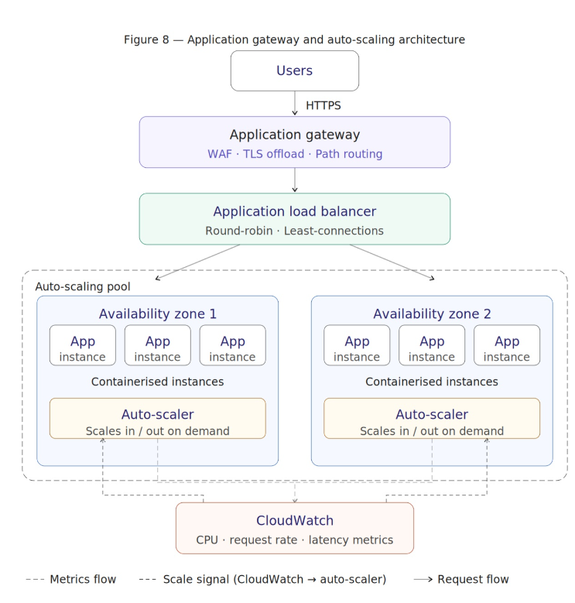
Figure 8: Architectural diagram showing: Users → HTTPS → Application Gateway (WAF + TLS offload + path routing) → Application Load Balancer → Auto-Scaling pool of containerised application instances across multiple Availability Zones, with CloudWatch metrics feeding the auto-scaler.

5. Why the Cloud is Growing and the Emergence of Serverless

5.1 Main Driving Forces

The continued growth in public cloud adoption is a result of a combination of economic, operational and technological factors.

The most widely recognised is cost transformation. Cloud computing transforms capital expenditure (CAPEX) on the purchase, installation and maintenance of servers into operational expenditure (OPEX) with predictable costs based on a pay-as-you-go model. Flexera's 2025 State of the Cloud Report reveals cost efficiency is the most common way enterprises measure their cloud success, with 87% of firms listing it as a key objective [15]. But managing cloud costs is not a matter of course: the report finds companies are 17% over budget in their cloud costs, and estimate that 27% of cloud spending is wasted [15]. This has given rise to FinOps - the practice of applying finance, engineering and operations to manage cloud costs - that highlights the economic advantage of cloud needs to be managed, not simply moved.

The second factor is operational agility. Cloud providers create infrastructure in seconds using APIs and Infrastructure-as-Code tools like AWS CloudFormation and HashiCorp Terraform, reducing procurement cycles from months to minutes. This fits well with DevOps and continuous delivery: the ability to provision isolated test stacks, execute integration tests, and destroy resources as part of a CI/CD build is commonplace [16]. AWS now has 33 geographic regions and more than 105 Availability Zones, allowing organisations to bring services closer to users around the world and comply with data sovereignty laws without having to set up infrastructure in every region [11].

Other drivers include native disaster recovery (with cross-region replication); edge computing capabilities (such as AWS Lambda@Edge); and the rapid growth of AI/ML workloads, with 79% of organisations already using or trialling AI PaaS services [15]. Such workloads demand scalable GPU capacity that hyperscalers can deliver, compelling even reluctant organisations to migrate to public clouds.

5.2 Serverless Functions (FaaS)

Function-as-a-Service (FaaS) is the highest level of cloud service model abstraction. With the serverless model, developers upload functions, a unit of business logic, to a platform that provides infrastructure provisioning, scaling, patching and availability without the user having to manage server infrastructure. Introduced in 2014, AWS Lambda was the first to offer this capability; Microsoft Azure Functions and Google Cloud Functions offer similar features [17].

Usage is event-driven: functions are launched in response to a trigger (HTTP request via API Gateway, file upload to S3 storage, message on an SQS queue, scheduled rule) and the platform creates a runtime environment, runs the function, and then shuts down. Costs are charged at a millisecond granularity by invocation and duration of execution; if a function is not invoked, it costs nothing [17]. This makes FaaS an ideal fit for unpredictable, intermittent or event-driven workloads: image processing triggered by file uploads, ingesting telemetry from Internet of Things devices, API backends for mobile apps with widely varying traffic, and scheduled batch processing.

But FaaS comes with limitations. FaaS functions have a limited execution time (AWS Lambda's limit is 15 minutes), precluding FaaS for batch processing. Crucially, cold starts create latency, as the platform has to create a new execution environment for the code to run in, potentially delaying response by hundreds of milliseconds [17]. Cold starts can be reduced with provisioned concurrency (warm instances) but at a cost, negating some of the cost benefit for latency-critical APIs.5.3 Serverless vs. Containerisation

Serverless and containers are two paradigms of scalable cloud-native compute. Comparison along important dimensions shows an overlap rather than clash of paradigms.

Cost: For functions with uncertain or sporadic traffic profiles, serverless eliminates the cost of idle capacity since an unused function costs nothing. For high volume workloads with a continuous traffic profile, though, the per-call cost model can be greater than the cost of a long-running containerised service on reserved instances [18]. The cost driver thus doesn't universally favour one model over the other; it favours the model that matches the traffic profile.

Flexibility: Containers are nearly completely unconstrained - any language, framework, binary that runs on Linux, hours or days-long execution time, and arbitrary networking and persistent storage. Serverless functions are only supported on a given runtime, are stateless and have a defined maximum execution time [16]. This makes containers the preferred option for compute-intensive tasks, stateful services and legacy software with system-level requirements.

Operational overhead: This is the most significant serverless advantage. The cloud provider takes over the management of OS patches, runtime upgrades, autoscaling and high availability. Container deployments (even in managed environments such as Amazon EKS or Azure Kubernetes Service) still require management of cluster architecture, node pool sizes, Kubernetes version upgrades and container security policy [19]. This represents a considerable burden for smaller teams, and requires platform engineering resources.

Scalability: Serverless scales instantly and individually per function, creating thousands of parallel execution contexts for sudden spikes in demand, with no warm-up. Container orchestrators scale at the pod level, with scheduling and image pull latencies of 10-30 seconds during scale-out [19]. Cold-start is the trade-off of serverless, especially for low-latency, user-facing responses.

Portability: Container images conforming to the OCI (Open Container Initiative) specification can run anywhere that supports OCI images (e.g. local Docker desktop, any Kubernetes cluster or cloud provider, bare metal on premises), significantly reducing the risk of vendor lock-in [16]. Serverless functions are bound to the provider's trigger model, IAM, and SDK, making it challenging to port functions across providers. This comes at the expense of the managed simplicity of serverless.5.4 Which Driving Force Each Paradigm Serves Best Mapped against the main driving forces for cloud adoption, the two paradigms have complementary strengths. Containers most directly address agility and flexibility: their portability, environmental consistency and CI/CD integration make them ideal for DevOps teams looking to speed up delivery without compromising the execution environment. Serverless best serves the cost optimisation and developer velocity driving forces for event-driven workloads: it removes the cost of idle infrastructure and almost eliminates operational costs.

The most realistic architecture for most organisations is neither container-only nor serverless-only, but hybrid. AWS Fargate and Azure Container Apps realise this: they deploy OCI-compliant containers on top of serverless infrastructure, avoiding the need to manage nodes while preserving container portability [19]. A pragmatic hybrid for the student registration portal might run the main web application in Fargate tasks behind an ALB, and use Lambda functions to trigger image resizing and email notifications in response to events from the web application - thus achieving cost and operational efficiencies.

6. Conclusion

This report has charted a logical journey from the enabling virtualisation to containerisation, to scalable service patterns in cloud computing, to serverless. Virtualisation laid the basic concept of resource abstraction and isolation that underpins shared cloud infrastructure, but its overhead and poor startup performance prompted search for a leaner alternative. Containerisation provides that alternative - offering portability, millisecond startup times and consistency, in a format that integrates seamlessly with CI/CD and DevOps practices.

The "real-world" Docker practical - the construction of a custom image from a Dockerfile based on an nginx: alpine base, the launch of a networked container on port 8080, a persistent datastore with a hetvi-volume, an internal communication network between containers on the hetvi-network bridge network and the publishing to the Docker Hub registry ashetvivi/hetvi-web-illustrated all of the above. Those operations, to a one, describe the underpinnings of production container deployments on the cloud on platforms such as AWS Fargate, Azure Container Applications, and Google Kubernetes Engine.

Load balancing, autoscaling, and Application Gateways are the missing architectural pieces that "productize" our distributed containers into resilient, internet-reachable, self-healing applications. Load balancers dispatch our traffic efficiently, autoscalers add or remove resources depending on the demand and an Application Gateway adds traffic management, security, and intelligent routing. The synergy among these disparate components is the cost-benefit provided by cloud computing.

The Serverless model takes abstraction as far as it can go: developers can concentrate on their code, with the provider managing the entire stack. This model excels at event-driven, ephemeral workloads, providing unmatched efficiency and development speed, while Containers should be preferred for steady, complex, or stateful applications. Combining the cloud native serverless and container model (illustrated on AWS asFargate) may be the best way forward. Moving forward the lines between serverless and containerised compute will only blur - with platforms like AWS Fargate, and Azure Container Apps already allowing container portability on top of serverless infra, this combination of two is set to define next gen of cloud-native application design.

References
[1] P. Mell and T. Grance, "The NIST Definition of Cloud Computing," NIST Special Publication 800-145, National Institute of Standards and Technology, Gaithersburg, MD, 2011.
[2] Gartner, "Gartner Forecasts Worldwide Public Cloud End-User Spending to Reach $723 Billion in 2025," Press Release, Dec. 2024. [Online]. Available: https://www.gartner.com/en/newsroom/press-releases/2024-12-25-gartner-forecasts-worldwide-public-cloud-end-user-spending-to-reach-723-billion-in-2025. [Accessed: Apr. 2026].
[3] I.-C. Donca, O. Stan, and L. Miclea, "A Performance Evaluation of Modern Virtualization Techniques," in Proc. IEEE AQTR, Cluj-Napoca, Romania, 2022, pp. 1–6.
[4] S. Lozano, T. Lugo, and J. Carretero, "A Comprehensive Survey on the Use of Hypervisors in Safety-Critical Systems," IEEE Access, vol. 11, pp. 36244–36263, 2023.
[5] P. Barham et al., "Xen and the Art of Virtualization," in Proc. 19th ACM SOSP, Bolton Landing, NY, 2003, pp. 164–177, doi: 10.1145/945445.945462.
[6] B. Pfaff et al., "The design and implementation of Open vSwitch," in Proc. 12th USENIX NSDI, Oakland, CA, 2015, pp. 117–130.
[7] W. Felter, A. Ferreira, R. Rajamony, and J. Rubio, "An updated performance comparison of virtual machines and Linux containers," in Proc. IEEE ISPASS, Philadelphia, PA, 2015, pp. 171–172, doi: 10.1109/ISPASS.2015.7095802.
[8] Docker Inc., "Docker Overview," Docker Documentation, 2024. [Online]. Available: https://docs.docker.com/get-started/overview/. [Accessed: Apr. 2026].
[9] Datadog, "10 Insights on Real-World Container Use," Datadog State of Containers Report, 2023. [Online]. Available: https://www.datadoghq.com/container-report/.
[10] Docker Inc., "Best practices for writing Dockerfiles," Docker Documentation, 2024. [Online]. Available: https://docs.docker.com/develop/develop-images/dockerfile_best-practices/. [Accessed: Apr. 2026].
[11] Amazon Web Services, "Elastic Load Balancing features," AWS Documentation, 2024. [Online]. Available: https://aws.amazon.com/elasticloadbalancing/features/. [Accessed: Apr. 2026].
[12] M. Kleppmann, Designing Data-Intensive Applications. Sebastopol, CA: O'Reilly Media, 2017.
[13] Amazon Web Services, "Amazon EC2 Auto Scaling," AWS Documentation, 2024. [Online]. Available: https://docs.aws.amazon.com/autoscaling/. [Accessed: Apr. 2026].
[14] Microsoft Azure, "Azure Application Gateway documentation," Microsoft Docs, 2024. [Online]. Available: https://learn.microsoft.com/en-us/azure/application-gateway/. [Accessed: Apr. 2026].
[15] Flexera, "2025 State of the Cloud Report," Flexera Software, Itasca, IL, 2025. [Online]. Available: https://info.flexera.com/CM-REPORT-State-of-the-Cloud. [Accessed: Apr. 2026].
[16] N. Kratzke and P.-C. Quint, "Understanding cloud-native applications after 10 years of cloud computing," J. Systems and Software, vol. 126, pp. 1–16, Apr. 2017, doi: 10.1016/j.jss.2017.01.001.
[17] Amazon Web Services, "AWS Lambda – Serverless Compute," AWS Documentation, 2024. [Online]. Available: https://docs.aws.amazon.com/lambda/latest/dg/welcome.html. [Accessed: Apr. 2026].
[18] C. Lin et al., "Demystifying Serverless Costs on Public Platforms: Bridging Billing, Architecture, and OS Scheduling," arXiv preprint arXiv:2506.01283, 2025. [Online]. Available: https://arxiv.org/abs/2506.01283.[
19] Amazon Web Services, "AWS Fargate," AWS Documentation, 2024. [Online]. Available: https://docs.aws.amazon.com/AmazonECS/latest/userguide/what-is-fargate.html. [Accessed: Apr. 2026].

